Hydrogen embrittlement evaluation and prediction in press-hardened steels

Z.H. Cao^{a,b}, Z. Wang^{c}, Y. Ngiamª, Z.C. Luo^{d,e}, Z.Y. Geng^{f,g}, J.J. Wang^{f,g}, Y. Zhang^{f,g}, M.X. Huang^{a,b*}

ª Department of Mechanical Engineering, The University of Hong Kong, Pokfulam Road, Hong Kong 999077, China
^{b} Shenzhen Institute of Research and Innovation, The University of Hong Kong, Shenzhen 518000, China
^{c} General Motors China Science Lab, Shanghai 201206, China
^{d} Institute of New Materials, Guangdong Academy of Sciences, Guangzhou 510000, China
^{e} Guangdong Provincial Key Laboratory of Metal Toughening Technology and Application, Guangzhou 510000, China
^{f} Ansteel Beijing Research Institute, Beijing 102209, China
^{g} State Key Laboratory of Metal Material for Marine Equipment and Application, Anshan Liaoning 114009, China

* Corresponding author: M.X. Huang, E-mail: mxhuang@hku.hk

Keywords: hot stamping, press-hardened steels, hydrogen embrittlement, test method, hydrogen risk prediction

Abstract
The application of press-hardened steels (PHS) in automotive body-in-white components using the hot stamping technique is growing thanks to its impressive strength and formability. Unfortunately, hydrogen embrittlement, an issue that generally exists in high-strength steels, impedes PHS’s rising application trend by causing catastrophic mechanical property degradation. Thus, detailed evaluation and prediction of hydrogen embrittlement risk throughout PHS’s manufacture and service condition are necessary. This work highlights techniques to characterize the hydrogen content and distribution, techniques to evaluate hydrogen embrittlement susceptibility, and potential models to simulate the in-service performance of PHS. The survey of existing works has revealed the gaps between laboratory measurement and industry application, including but not limited to (1) the accelerated experiments induced discrepancies against real-life applications, (2) a selection of the appropriate hydrogen embrittlement indicators, (3) an accurate risk prediction model, and (4) efficient feedback to the industry based on both experimental and simulated results. Based on the review, future works are expected to establish a conclusive hydrogen embrittlement evaluation standard for PHS.

1. Introduction
Hydrogen embrittlement (HE) has been an industrial challenge in steel since its first documented report more than a century ago.^{[1]} Only a few parts per million (ppm) of diffusible hydrogen atoms are enough to degrade overall performance and cause catastrophic damage to the structural integrity.^{[2–5]} Accordingly, it has become a dilemma that advanced high-strength steels (AHSS), originally designed to enhance safety levels, may suffer from a severer hydrogen embrittlement risk.^{[6–8]} Typical examples that reveal high HE susceptibility can be found in quenching and partitioning (Q&P) steels and medium Mn steels with ultimate tensile strength (UTS) over 1000 MPa.^{[9–12]}

In recent years, ultra-high-strength press-hardened steels (PHS) have been widely adopted in the automotive industry to build safety components, including A-/B-pillars and bumpers.^{[13–16]} After stamping, conventional PHS can reach a UTS over 1500 MPa, which efficiently enhances lightweight and help realize the net-zero goal. Novel PHS with higher carbon content and the UTS of 1700-2000 MPa are under commercialization, potentially leading to a lightweight ratio of 5-9 % for the designated components. However, the hydrogen embrittlement risk of PHS also increases with the strength level, jeopardizing the vehicle’s structural integrity and threatening human safety.^{[17–19]} Moreover, the hydrogen-induced cracking of freshly formed parts was even observed before the assembly. Thus, it leads to an urgent need to investigate the HE in PHS, particularly where the hydrogen comes from and how it embrittles PHS.

There are several challenges in evaluating the hydrogen embrittlement risk of PHS: (1) characterization of diffusible hydrogen; (2) a convincing correlation between accelerated experiments and service conditions; (3) prediction models for hydrogen embrittlement risk. First, it is crucial to quantitatively characterize hydrogen content for hydrogen embrittlement evaluation and understand hydrogen distribution to relate the evaluation results. Hydrogen can be introduced into PHS during hot stamping,^{[20–22]} painting,^{[17]} in-service corrosion,^{[17]} and electrochemical charging in laboratory tests^{[23,24]} and exists either as diffusible hydrogen or non-diffusible hydrogen. Both diffusible and non-diffusible hydrogen are possible to cause embrittlement depending on the trapping sites, such as lattice interstitials, dislocations, precipitates, and inclusions.^{[25–30]}

Up to now, thermal desorption spectroscopy (TDS) has been established to obtain quantitative hydrogen content in the bulk sample,^{[25,31]} while a combination of TDS and hydrogen permeation technique (HPT) provides valuable information on hydrogen diffusivity and trapping sites, despite discrepancies between experimental procedures and data analysis.^{[28,32,33]} On the contrary, as hydrogen is the smallest atom, it is much more challenging to analyze hydrogen distribution around various microstructural constituents. Recently, state-of-the-art techniques have been developed: cryo-transfer system assisted atom probe tomography (APT) has been applied to visualize hydrogen distribution at the nano-scale,^{[34,35]} while techniques such as micro-printing have been applied at the micro-scale.^{[36,37]} Other applications of the advanced characterization techniques on microstructural hydrogen mapping (e.g., hydrogen microprint technique, scanning Kelvin probe force microscopy, and secondary ion mass spectroscopy) are not covered in the present review as they have been thoroughly reviewed in other work.^{[38]}

Second, laboratory evaluation should be designed to reflect hydrogen embrittlement in practical conditions of PHS. In terms of duration, it commonly takes weeks, months, or even years for hydrogen embrittlement to occur in real-life components. In contrast, most laboratory tests like slow strain rate tests (SSRT) finish within a much shorter time, mostly several hours. In experimental conditions, the hydrogen content is usually lower, while the stress and strain levels are not significant, which accounts for the longer lead time for hydrogen embrittlement.^{[18]} More importantly, the hydrogen embrittlement mechanism may alter under different hydrogen content, stress and strain condition. For example, the dominant fracture mode changes from transgranular to intergranular with increasing hydrogen levels.^{[39]} Other factors, such as stress triaxiality and surface quality in practical conditions, can also be very important, and the influences of these factors on different materials are different.^{[40–42]} Therefore, it is necessary to understand various testing methods and build a reliable relationship between laboratory evaluation and practical hydrogen embrittlement performance for PHS.

Finally, a prediction model is valuable for assessing the validity of laboratory evaluation and determining whether a particular steel is free of hydrogen embrittlement risk under certain in-service conditions, especially for novel PHS over 1700 MPa. However, hydrogen embrittlement in steels is a complex multi-physics process involving hydrogen diffusion and trapping, microstructure evolution, and crack initiation and propagation.^{[43–45]} The recent progress in the crystal plasticity finite element method (CPFEM) and phase-field simulation have shown excellent potential in dealing with the hydrogen embrittlement problem.^{[46–48]} In particular, the phase-field method may couple the martensite transformation during quenching with the subsequent hydrogen embrittlement processes, acquiring more insights from the forming process to practical service conditions.

To summarize, this review overviews the evaluation and prediction techniques for hydrogen embrittlement, aiming to provide a practical guidance to solve the hydrogen embrittlement problem in PHS. The review begins with a discussion on hydrogen characterization, including the source of hydrogen and the techniques for hydrogen analysis. Then, various laboratory mechanical tests are discussed, including constant loading tests, slow strain rate tests, and pre-cracked fracture tests. The characteristic features of these laboratory tests are compared in terms of test duration, hydrogen source, stress and strain level, and potential errors. Finally, risk prediction models of hydrogen embrittlement are reviewed, putting an emphasis on hydrogen diffusion and cracking simulation.

2. Hydrogen ingress and characterization

2.1. Hydrogen ingress
The source of hydrogen in steels is diverse. Hydrogen in steel can be divided into internal hydrogen introduced previously during the steel manufacturing, or external hydrogen picked up afterward, either from the environment or artificially introduced.^{[49]} It should be noted that the internal and external hydrogen shall follow similar mechanisms for diffusion and embrittlement behaviors despite their different chronological orders of introduction. However, it is essential to make such a classification as it helps monitor the stepwise hydrogen accumulation during each period and benefits the academic/industry to make targeted improvements to reduce HE risk.

The adsorption of hydrogen atoms at the surface ($MH_{ads})$ is the first step that hydrogen enters into steel.^{[50,51]} The adsorped hydrogen atom could come from the dissociated hydrogen molecules in a gaseous environment or a hydrogen evolution reaction (HER) in a water-containing environment^{[52]}:
In acid: $H_{3}O^{+}+M+e^{-}→MH_{ads}+H_{2}O$ (1)
In alkaline: $H_{2}O+M+e^{-}→MH_{ads}+{OH}^{-}$ (2)
As the hydrogen adsorption increases, hydrogen atoms either recombine to form gas molecules and desorb, or they could be absorbed into the matrix through a diffusion process:
Recombination: $MH_{ads}+MH_{ads}→2M+H_{2}$ (3)
Absorption: $MH_{ads}→MH_{abs}$ (4)

According to literature, the internal hydrogen can be introduced during electroplating, pickling, etching, coating, welding, and other processes that may involve the HER.^{[17,52–54]} In the case of PHS, the internal H mainly comes from the hot stamping process during steelmaking.^{[20,21]} The austenitizing duration and the dew point, which describes the extent of moisture in the stamping furnace, play a crucial role in determining the hydrogen content right after the stamping (Figure 1). Longer duration and higher dew point significantly increase the internal diffusible hydrogen content to almost 1 wppm. This amount is sufficient to trigger hydrogen-induced delayed fracture in the PHS car components. Therefore, properly controlling the austenitizing condition, dew point, and a post-heat treatment are recommended to the industry.

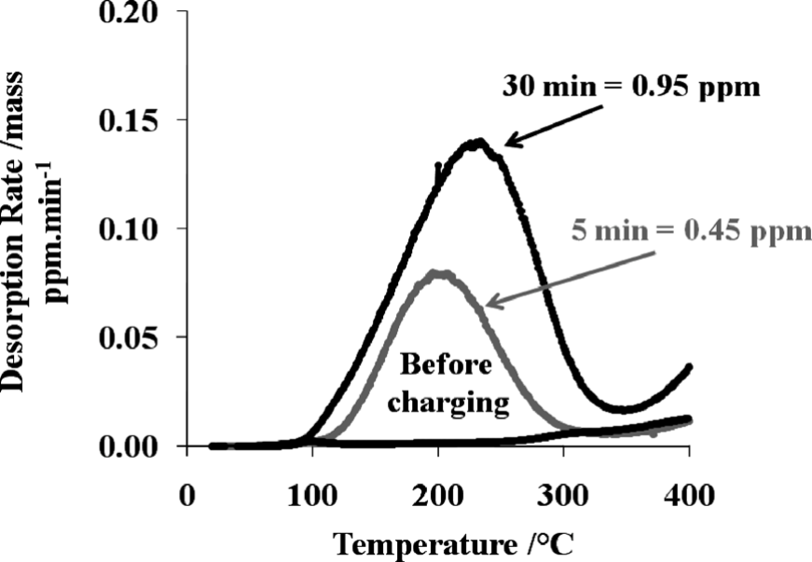
Figure 1. Typical thermal desorption curves of AlSi-coated 22MnB5 PHS before and after an austenitizing at 920°C for 5 min or 30 min. ‘Charging’ of hydrogen was controlled by the dew point (+19°C), and the heating rate was 20°C/min.
Reproduced under terms of the CC-BY license.^{[20]} Copyright 2013, The Authors, published by Iron and Steel Institute of Japan.

External hydrogen is the hydrogen that enters the steel during an atmospheric corrosive process. A typical example of the atmospheric corrosion behavior of automotive parts is the corrosion caused by de-icing salts.^{[55–57]} It has been demonstrated by both field and accelerated tests that such corrosion causes extensive deterioration of components.^{[58,59]} During the metal’s corrosion and hydrolysis, the atmospheric pH value and corrosion potential continuously decrease, promoting the external hydrogen entry.^{[50]} An elevated temperature and 40-60% humidity could speed up the corrosion rate and accumulate more hydrogen.^{[60]} Comparatively, pitting corrosion is a more localized reaction for hydrogen entry. Active surface sites such as inclusions can trigger pitting on steel surfaces.^{[61,62]} A micro-corrosion cell is formed during the pitting process, where the pit acts as an anode, and the metal surface acts as the cathode.^{[63]} Although pitting corrosion occurs in a restricted area, it induces significant acidification accompanying highly concentrated hydrogen, thus being even more detrimental than uniform corrosion. Certain alloying elements such as Cr, Mo, Si, and V have been identified to impart high resistance to pitting corrosion in stainless steels and Fe-Cr alloys.^{[64–66]} Such alloying strategies are expected to be extended to PHS to avoid pitting and the following hydrogen entry.

In the laboratories, hydrogen can be introduced into PHS via (1) direct exposure to acid or salt solution, (2) electrochemical charging in an aqueous solution, or (3) gaseous charging in a sealed, high-pressure chamber.^{[67–71]} These charging methods essentially stem from the way that hydrogen is introduced from the service environment, but the charging process can be accelerated by modifying the physical conditions or applying specific chemical reactions. For example, an elevated working temperature and pressure, a high charging current density, a strong acid with a low pH value, and the addition of hydrogen recombination poisons all contribute to rapid hydrogen charging.^{[40,72,73]}

Advantages and disadvantages coexist in the three hydrogen charging methods. The direct exposure charging method provides a charging atmosphere closest to the practical service. However, the applied aqueous solution increases the risk of corrosion damaging the specimen’s surface. Consequently, microcracks can be readily initiated from the damaged surface upon loading following the hydrogen-induced stress corrosion cracking (HISCC) theory.^{[74]} Meanwhile, the electrochemical charging method is the most efficient way to precisely control the charging process, hence is most widely adopted by the community. The gaseous charging method avoids corrosion damage to the surface. On the other hand, the hydrogen outgassing between the end of charging and the test start needs to be addressed since it is a common feature for all charging methods.^{[37,75]} Particularly, if the ex-situ gaseous charging is adopted at high temperature and pressure, an outgassing process is inevitable when releasing the high pressure and cooling down to a designated temperature. In this case, the time interval between the charging and test start is generally longer than the other two methods, causing a more significant reduction of the initially stored hydrogen. An in-situ gaseous charging and testing seem optimal, but the experiment setup and maintenance costs are considerable. Another choice to inhibit outgassing is the practice of cryogenic freezing treatment to the H-charged specimen.^{[17,20]} The hydrogen diffusion kinetics are greatly reduced at cryogenic conditions, preserving the hydrogen until the measurement.

Due to the complexity, it is almost impossible to unify the hydrogen charging methods. Therefore, a clear and comprehensive record of the charging conditions is recommended to minimize the influence of laboratory charging methods.

2.2. Hydrogen characterization techniques
This section focuses on three hydrogen characterization techniques: thermal desorption spectroscopy (TDS), hydrogen permeation technique (HPT), and atom probe tomography (APT). Specifically, the hydrogen content, desorption activation energy, hydrogen diffusion coefficient, hydrogen solubility, and hydrogen trapping site density are of interest. These parameters are of essential importance in understanding the hydrogen diffusion and trapping behaviors throughout the embrittlement process. Since some of these parameters are material-dependent, the hydrogen characterization techniques are often employed together with other mechanical tests (introduced in Section 3) for better interpretations.

2.2.1. Thermal desorption spectroscopy (TDS)
Figure 2 displays the schematic of the TDS apparatus.^{[76]} A hydrogen-containing sample is heated under a programmed heating procedure inside a vacuum or gas-sealed chamber. With increasing temperature, hydrogen is released when enough thermal energy fills the energy gap between the trapping and the diffusion state.^{[77]} The released hydrogen is then detected by a quadrupole mass spectrometer and post-processed by a central processor to relate the hydrogen desorption signal with the temperature, i.e., the hydrogen desorption curve (Figure 1). Integration over time yields the total hydrogen content of the bulk sample. Ideally, each hydrogen trap should contribute to one single desorption peak, while in reality, the peaks of multiple traps with similar hydrogen binding energies may overlap, making it difficult to quantify the hydrogen content from a specific trap site. The resolution could reach 0.1 μg/g (0.1 weight ppm) with a proper gas calibration procedure, enabling accurate measurement of diffusible hydrogen content in steels with low solubility yet high hydrogen susceptibility.^{[24,78,79]} A further rigorous determination of the hydrogen activation energy associated with each type of hydrogen trap can be achieved by monitoring the respective desorption peak’s shift upon various heating rates.^{[80–83]} Briefly summarized, the activation energies of grain boundaries, dislocations, and microvoids in pure iron are determined to be 17.2 kJ/mol, 26.8 kJ/mol, and 35.2 kJ/mol in the early research done by Choo and Lee.^{[80]} More recent studies carried out by Wei et al.^{[84]} with Ti-added steels and Kang et al.^{[85]} with Cr-, CrMo-, and Si-added steels obtained similar grain boundary activation energies ranging from 17.8 kJ/mol to 21.9 kJ/mol. Although the results are relatively consistent, it must be noticed that precise identification of activation energies for reversible trap sites is challenging due to the overlapping peaks with similar activation energies.

Regarding PHS, the main focus of most studies that applied the TDS technique could be categorized into three species: (1) to determine the diffusible hydrogen content within the martensitic matrix upon hydrogen ingress; (2) to identify the reversible/irreversible trapping nature of the second phase (i.e., retained austenite, carbide precipitates, and inclusions if any); and (3) to reveal the coating effect on the hydrogen diffusion kinetics. As previously stated, martensite is highly susceptible to hydrogen, yet its hydrogen solubility is low. Despite the various chemical compositions and charging conditions, the diffusible hydrogen content measured by TDS generally ranges from 0.3-1.4 wppm when an apparent hydrogen-induced property degradation can be observed.^{[86–88]} The microalloying strategy of adding Nb, V, Mo, and Ti in PHS to introduce carbide precipitates as irreversible hydrogen trapping sites is popular. However, these carbides’ number density is usually insufficient to produce an identifiable peak on the desorption curve compared to the peak of the matrix. Lin et al.^{[86]} managed to tackle this issue through room-temperature aging, during which the hydrogen reversibly trapped by the PHS martensite matrix gradually leaves the specimen, maintaining the hydrogen strongly/irreversibly trapped by the precipitates. An activation energy of 48.0 kJ/mol was thus calculated and related to the V-carbides. Lately, the coating strategy has been employed to avoid severe oxidation and decarburization of the steel surface during the hot stamping process.^{[15,89,90]} Al-Si and Zn are PHS’s two most widely adopted coating materials. Regardless of their impact on the mechanical property, a coating layer is generally regarded to decelerate the hydrogen diffusion kinetics, as confirmed by the TDS measurements on the time evolution of hydrogen content for coated and bare PHS.^{[21,91]} However, it is difficult to make an overall judgment about whether the coating is beneficial to PHS’s HE performance since the suppressed diffusion kinetics inhibits hydrogen uptake from the environment and hinders the internal hydrogen from diffusing out.

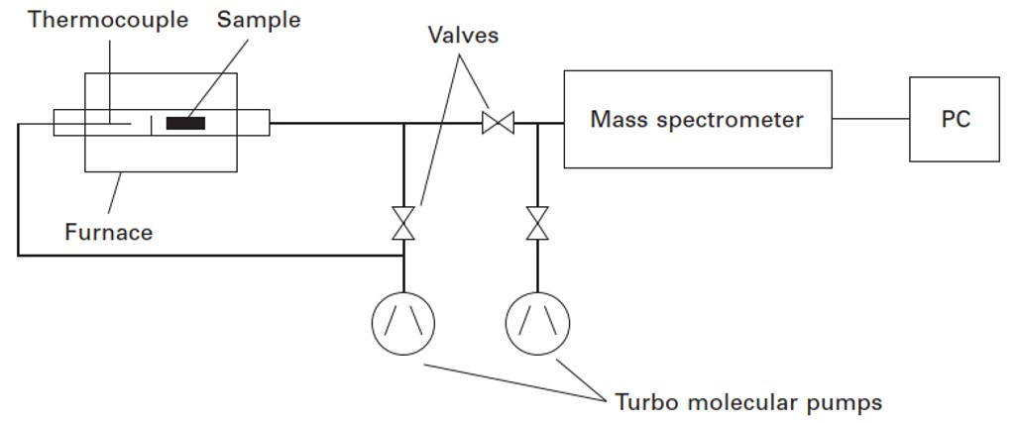
Figure 2. Schematic of the conventional TDS apparatus.
Reproduced with permission.^{[76]} Copyright 2012, Elsevier.

The development of low-temperature TDS (L-TDS), which can start the measurement from -200°C, serves as a possible solution to resolve the overlapped desorption peak.^{[25,38]} This development enables a precise differentiation of hydrogen desorption peaks within a low-temperature range associated with relatively weak traps such as dislocations, grain boundaries, and vacancies. In other words, the sampling zone for temperature is further expanded, and the detection accuracy is improved. Thus, the desorption peak profile of each trap site could be attained through a peak split process. Moreover, applying L-TDS has brought opportunities to complement existing HE mechanisms. A recent study with L-TDS found that the carbon content is closely associated with the low-temperature peak.^{[92]} A significant hydrogen desorption profile variation under the low-temperature region is detected in two Fe-C alloys with 6 and 50 mass ppm C, respectively. Both the peak position and intensity are altered, indicative of possible changes in trap sites’ density and activation energies due to the carbon addition. As carbon is probably the most effective and efficient strengthening element in PHS, more discoveries utilizing the L-TDS technique are encouraged.^{[93,94]}

2.2.2. Hydrogen permeation technique (HPT)
Devanathan and Stachurski^{[95]} proposed the hydrogen permeation technique to study the hydrogen diffusion behavior in palladium, and this technique is further extended to other systems, such as steels and alloys.^{[81,96,97]} The test specimen is placed between two electrochemical cells (Figure 3a). One is for hydrogen charging through an electrochemical process, and the other is for hydrogen detection through an oxidation process. Residual hydrogen is first released from the oxidation cell before the hydrogen charging until a designated low current density is achieved. The time evolution of the oxidation current reflects the hydrogen diffusion behavior and is monitored throughout the process. HPT technique is a non-destructive test method both mechanically and thermally. This enables a repeat test on the same sample to determine the composition and fractions of reversible and irreversible hydrogen traps.^{[96,98]}

Figure 3b presents typical hydrogen permeation curves of a 22MnB5 PHS.^{[99]} The sample thickness and charging current density were kept constant to reveal the effect of different pH values of the electrolyte on the permeation behavior. It was found that the pH values imposed significant changes on the effective diffusion coefficient and the subsurface hydrogen concentration. The hydrogen diffusion rate increased rapidly once tested in acidic electrolytes. An average diffusion coefficient of 4×10⁻¹¹ mm²/s for the 22MnB5 PHS was calculated amongst all test conditions. This magnitude is in good agreement with the steels of a martensitic matrix. Despite the difference in test conditions, the diffusion coefficient of PHS can be significantly affected by adding Nb and Mo to realize grain refinement and introduce strong hydrogen trapping sites such as carbide precipitates. The Nb addition alone (0.05 wt.%) has been reported to decrease the diffusivity of a 1.9GPa-grade PHS from 11.0×10⁻¹¹ to 7.08×10⁻¹¹ mm²/s. An additional 0.10 wt.% of Mo decreased its diffusivity almost by half to reach 5.73×10⁻¹¹ mm²/s.^{[81]} Similarly, the 0.15 wt.% Mo addition to a reference 1.9GPa-grade PHS results in a diffusivity decrease from 14.2×10⁻¹¹ to 6.33×10⁻¹¹ mm²/s.^{[100]} Further quantitative analysis on the hydrogen solubility, permeability, density of trapping sites, and respective trapping energies could be carried out with varying test conditions and microstructure characterizations.^{[33,51,101]} The HPT is highly sensitive to the test conditions (such as temperature, charging electrolyte, and charging current) and thus is recommended when exploring a novel material to identify the most suitable test condition.

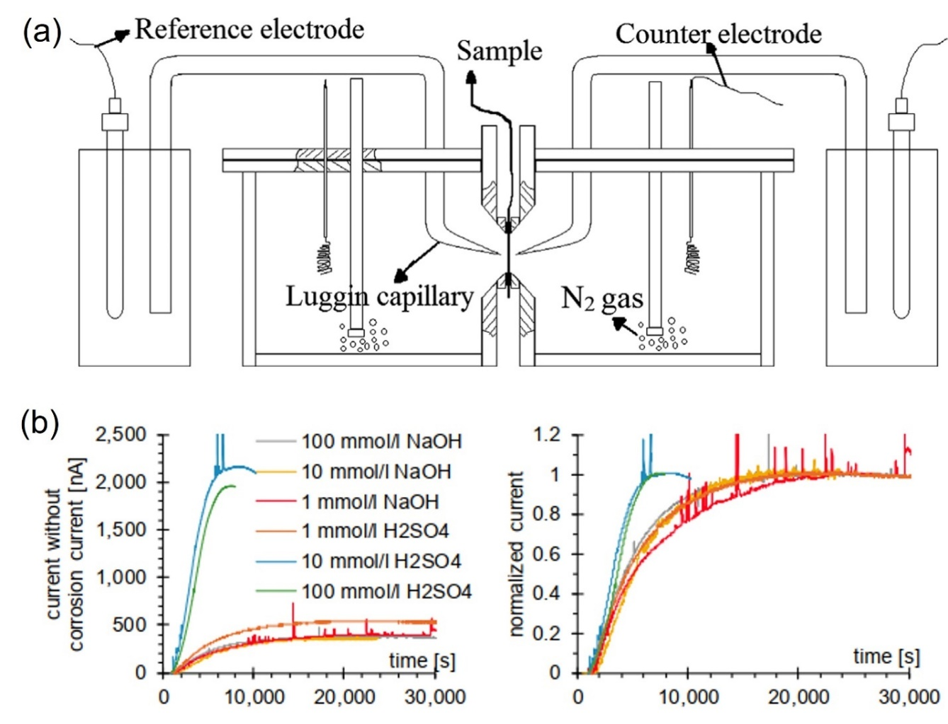
Figure 3. (a) Schematic of the HPT apparatus; (b) Typical hydrogen permeation plot and normalized current curves of a 22MnB5 PHS at different pH values.
Reproduced with permission.^{[96]} Copyright 2015, Elsevier.
Reproduced under terms of the CC-BY license.^{[99]} Copyright 2019, The Authors, published by MDPI.

One common feature of TDS and HPT is that both characterization techniques are designed for bulk specimens, lacking spatial resolution. In addition, unlike HPT, the heating procedure of TDS measurement will alter the specimen’s microstructure, thus being recognized as a destructive characterization method. Despite the drawbacks, these techniques help build up an overall image of the material’s general behavior in the presence of hydrogen, upon which comparison can be made under a relatively similar condition.

2.2.3. Atom probe tomography (APT)
The APT technique is a natural selection when the interaction between hydrogen and microstructural features such as dislocations, boundaries, precipitates, and element segregations are of interest since these features could already be well characterized by APT with high spatial and mass resolution.^{[87,100]} Additional modifications to conventional APT are required to minimize the hydrogen loss during sample transfer and distinguish the intentionally charged hydrogen atoms from environmentally existing ones. Chen et al.^{[34,35]} adopted deuterium charging and a cryo-transfer system to cope with such difficulties and confirmed the trapping of hydrogen/deuterium atoms at dislocations, grain boundaries, and NbC precipitates experimentally. While there has been no report on applying the APT technique to PHS, some conclusions drawn from other systems with similar microstructural features could be used to explain the HE in PHS and guide the design and application. For example, the novel PHS design intends to use V-microalloying to simultaneously increase the strength grade and hydrogen resistance by introducing vanadium carbide (VC) precipitates, a powerful hydrogen trap, to PHS’s matrix. However, the APT analysis on V-containing low-carbon steel suggested that VC’s trapping capacity largely depended on its chemical composition.^{[102,103]} Only the V₄C₃ with abundant surface carbon vacancies could provide sufficient hydrogen trapping. This result might explain the sometimes unsatisfactory HE resistance of V-containing PHS that could not meet expectations. More studies are required to optimize the VC composition in PHS for better HE performance.

3. Test methods for HE evaluation in PHS
Over the decades, many test methods and evaluation standards have been developed to assess the HE susceptibility of steels. Although most tests are done in laboratories where the environment cannot be precisely the same as in in-service scenarios, useful information can be summarized by comparing several materials following a standard procedure. The evaluation standard is usually given empirically based on the statistical analysis of existing materials. Such comparison benefits the industry by realizing a quick screening process of novel materials. In this regard, the following passages will introduce a few types of experimental methods that provide basic yet essential information on the determination of HE performance.

3.1. Constant load test (CLT)
CLT is regarded as the test method that is most similar to the actual service state. In a typical CLT, the pre-charged or in-situ charged specimens are loaded at a constant load (or stress).^{[104,105]} When examining the HE of PHS, a fraction of its yield strength (YS) is usually applied since the performance beyond the YS is not the main focus and is barely achieved in service. A timer is linked to the loading system to record the total experiment time (time to fracture) in the case of the final fracture. Otherwise, the specimen is considered qualified if the experiment time exceeds a predefined time limit. Usually, a TDS measurement is included before and immediately after the CLT to quantify the hydrogen content. It is noticed that sometimes a notched specimen with a calculated stress concentration factor (K_{t}) is used in CLT.^{[106–108]} In that case, the net stress at the notch tip should reach the target stress while the other part remains elastically deformed. However, the high-stress concentration area ahead of the notch simultaneously leads to hydrogen accumulation, and the local concentration could reach several times higher than the mean value.^{[41,109]} While TDS cannot characterize the local hydrogen distribution, a few simulation works that account for stress-assisted diffusion are able to model the hydrogen concentration profile inside the specimen.^{[106,107]} These HE models will be discussed in detail in Section 4.

The key outcome of CLT is to build a relationship between the applied load and the measured hydrogen concentration for the test material. The experiment can be carried out in two ways: (1) the constant loading stress is fixed while different hydrogen content is introduced into the specimen. The plot of hydrogen content against time to fracture is used to evaluate the critical hydrogen concentration (H_{crit}) below which the specimen does not fracture; (2) The hydrogen content is fixed while different loading stress is applied. Similarly, the critical stress (σ_{crit}) corresponding to the preset hydrogen content can be acquired. These two CLT setups can be selected based on the specimens’ potential service conditions. For instance, high-strength bolts are often employed under a known stress state, thus suitable for the fixed-load CLT setup. The determined H_{crit} gives the upper limit hydrogen concentration that the bolt could absorb from the environment. For steels used in a predefined corrosive environment such as seashore engineering or deep-sea pipelines, a fixed hydrogen content CLT setup helps determine the σ_{crit,} which is essential for the safety design.

Figure 4 shows a typical CLT plot, where the HE susceptibility of four low-carbon martensitic steels that underwent different heat treatments are compared through the H_{crit}.^{[36]} The loading stress for each specimen is set as 90% of the respective tensile strength, and the time limit is 140 hr. With higher tempering temperatures, the tensile strength gradually decreased from 1278-1310 MPa to 1203-1211 MPa, while the H_{crit} increased from 0.08-0.11 mass ppm to 0.26-0.29 mass ppm. No significant variation of H_{crit} was found in steels treated with different heating rates to achieve a similar strength level. This work presented a classic illustration using CLT to determine the dominant HE factor, in this case, the tensile strength rather than the heating rate, and could be expanded to other potential factors.

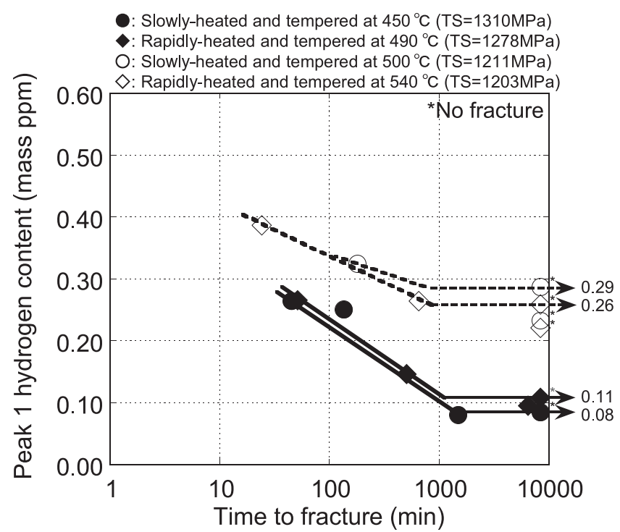
Figure 4. Relationship between the diffusible hydrogen content and time to fracture by a constant load test. The specimens are low-C martensitic steel with various heat treatments.
Reproduced under terms of the CC-BY license.^{[36]} Copyright 2012, The Authors, published by Iron and Steel Institute of Japan.

3.2. Tensile tests
The group of tensile experiments is the most popular among all test methods, including the constant extension rate test (CERT) and linearly increasing stress test (LIST).^{[110]} The HE susceptibility can be directly compared through the charged and uncharged specimens’ stress-strain (or load-displacement) curves. Ductility or elongation loss, fracture stress, and area reduction of the fracture surface are commonly adopted HE indicators, while sample geometry and loading mode vary with research.^{[100,107,111]}

The constant extension rate test (CERT) has been widely utilized to study the HE susceptibility.^{[104,112]} According to the magnitude of the extension rate, the CERT can be subdivided into slow strain rate test (SSRT) and conventional strain rate test (CSRT). The former usually requires an extremely slow strain rate below 10⁻⁵/s, and the latter is 2-3 orders of magnitude higher. Both tests will strain the specimen until the final fracture, revealing the fracture surface for fractography identification. One of the major differences between SSRT and CSRT is the overall test duration. SSRT generally consumes a prolonged time, during which the diffusible hydrogen could redistribute significantly.^{[39,41,46]} Once the local hydrogen accumulation reaches a threshold value, it facilitates the initiation of intergranular (IG) and/or quasi-cleavage (QC) fractures. For CSRT, the overall test duration is usually several minutes, providing limited time for hydrogen redistribution. Thus, the HE susceptibility is relatively mild under CSRT and more intense via SSRT, i.e., the strain rate effect on HE.^{[104,113,114]}

An example of SSRT data is shown in Figure 5 from a study on the effect of different microalloying on HE in 32MnB5 PHS.^{[81]} Based on the engineering stress-strain performances and the ductility loss evaluation, the SSRT suggested that Nb+Mo microalloying induced the optimal HE resistance by almost doubling the ductility. Such improvement remained valid whether it was tested in a low H or high H environment.

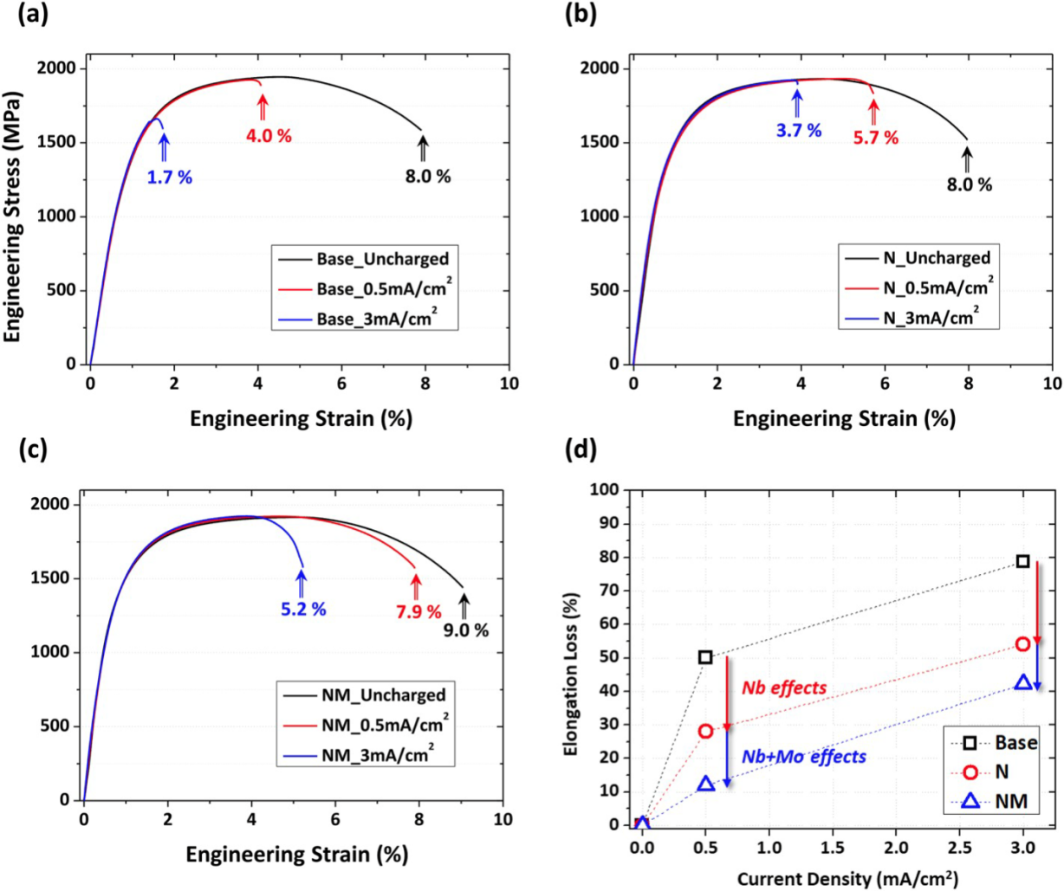
Figure 5. Hydrogen embrittlement resistance of 32MnB5 with SSRT at room temperature. Engineering stress-strain curves of the (a) 32MnB5 as a base material, (b) 32MnB5 + 0.05 wt% Nb, (c) 32MnB5 + 0.10 wt% Mo + 0.05 wt% Nb, (d) The change of elongation loss as a function of hydrogen charging current density summarized from the SSRT.
Reproduced with permission.^{[81]} Copyright 2020, Elsevier.

The drawback of CERT is straightforward in that it cannot provide detailed information precisely reflected from the HE cracks initiation moment. Through the aid of simulation, it is revealed that during CERT at the applied potential, the crack initiation of tested Monel K-500 Ni-alloys could have already occurred as early as 40-60% of the total experiment time.^{[115]} Unfortunately, this can hardly be captured by the stress-strain curve unless these microcracks grow to a critical extent. Therefore, the strength/ductility loss from the CERT, especially from a time-consuming SSRT, is a complex HE indicator that involves the material’s fracture toughness evaluation and its degradation with hydrogen.^{[116]} The potential drop method provides a solution to detect the H-induced crack initiation if high-performance detectors are available.^{[117,118]}

The linearly increasing stress test (LIST) method proposes another approach by changing the loading mode from the strain rate control to load control (Figure 6a).^{[30]} The stress is applied by moving the designated weight along a lever beam at a constant rate controlled by the synchronous motor. Once the H-induced crack initiates in the LIST sample, it undergoes rapid plastic instability due to the continuously increasing load. Consequently, the time for sub-critical crack growth is limited, and the corresponding fracture stress/strain is more precise than the SSRT. In addition, combined with the potential drop method, LIST could effectively monitor the threshold stress corresponding to the crack initiation moment (Figure 6b).^{[119]} In the two investigated martensitic steel, the effect of hydrogen on the threshold stress of an 1180 MPa strength grade steel (MS1180) was negligible. Nevertheless, the threshold stress of the 1500 MPa strength grade steel (MS1500) reduced over 100 MPa, from 1340 MPa to 1225 MPa. Therefore, the superior HE resistance of MS1180 can be distinguished by the change of the threshold stress monitored by LIST.

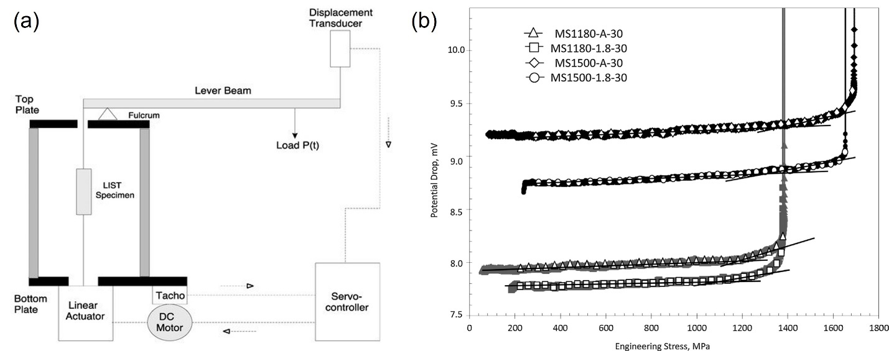
Figure 6. (a) Schematic of the linearly increasing stress test (LIST) apparatus; (b) Typical plots of potential drop versus applied stress, illustrating the determination of threshold stress at crack initiation.
Reproduced under terms of the CC-BY license.^{[30]} Copyright 2018, The Authors, published by MDPI.
Reproduced with permission.^{[119]} Copyright 2015, Elsevier.

Similar to CLT, the geometry design of the tensile test specimen includes smooth and notched samples.^{[68,107,120]} The notch promotes H-induced crack initiation and thus is better for the study of fracture behavior. Nevertheless, care must be taken since the deformation is limited within the notch tip area with the notch design. Hence, ductility loss is no longer an appropriate HE indicator than fracture stress in the presence of notches. Another issue is that even with a slow displacement rate applied remotely, the local strain rate is still high. Finite element analysis (FEA) or digital image correlation (DIC) are promising solutions to help determine the accurate strain rate.

3.3. Bending tests
The stress-strain state and hydrogen content are highly controllable in the tensile tests. However, the real application of PHS involves much more complicated stress states that the tensile experiments cannot cover. Recently, bending tests have received more attention. The reason is that PHS’s primary application is to withstand lateral impacts during a crash, such as the B-pillar and the bumper.^{[13,16,121]} Bending tests better describe the mechanical performance under such practical circumstances.

U-bending, two-point bending, three-point bending, and four-point bending tests are the most popular bending experiments.^{[122,123]} All bending test specimens are maintained at a constant strain (deflection) condition through a stressing jig and a specimen holder. For the two-point bending, the stressing jig is detached from the specimen after loading, so the constant strain is maintained by the specimen holder alone. For the three- and four-point bending, the stressing jig is in contact with the specimen throughout the test. Given the bending deflections and the specimen geometries, the stress-strain states of these three bending tests can be accurately determined since only the elastic deformation is involved. In the case of U-bending, determining the strain state is much more complicated. U-bending is considered the most stringent test condition for smooth specimens because its specimens contain both elastic and plastic deformation. Therefore, extra experimental techniques such as DIC or strain gauges are required to measure the local strain. Hydrogen can be introduced before or after the bending via electrochemical charging or the simple immersion method. The time to fracture and the hydrogen content are used to evaluate the specimen’s HE resistance against bending.

An appropriate selection among the bending tests can be made based on their characteristics listed below. For instance, the U-bending test is more suitable for specimens that would undergo plastic deformation. Contrastingly, the two-, three- and four-point bending tests can be adopted if the material is mainly utilized within the elastic range. Compared with the other two test methods, the three-point bending possesses a relatively harsh test condition at the specimen’s centerline, where the maximum strain and stress are achieved at the outer surface. Meanwhile, the contact between the central support and the specimen may induce crevice corrosion and facilitate HE. Therefore, the two-point bending test is preferred if crevice corrosion issues prevail and no protection is made for these critical contact areas. In the four-point bending test, the maximum strain and stress of the bent specimen are maintained over a wide range between the two central supports. Hence, the four-point bending test can minimize the effect of local variations, such as non-metallic inclusions, and ensure good repeatability.

Aside from crevice corrosion, the contact between specimens and holders may also change the entire stress/strain distribution. The stress/strain distribution alteration is especially pronounced if the bent specimen undergoes large plastic deformation, e.g., in a U-bending test. Most U-bent specimens are tightened through bolts and nuts that generate a localized contact area. A universal jointing method is applied to create a uniform contact for comparison (Figure 7a).^{[124]} The different jointing methods lead to a noticeable difference in the fracture positions of hydrogen-charged U-bent specimens (Figure 7b). Traditional bolt-jointed samples were fractured within the corner between the deformed and non-deformed regions, whereas universal-jointed samples were fractured near the centerline, where the deformation is most extensive. This fracture position variation implied a totally different stress-strain-hydrogen distribution inside these U-bent PHS specimens. Thus, the contact behavior in the bending tests must be treated with caution in case it interferes with the specimens’ HE performance.

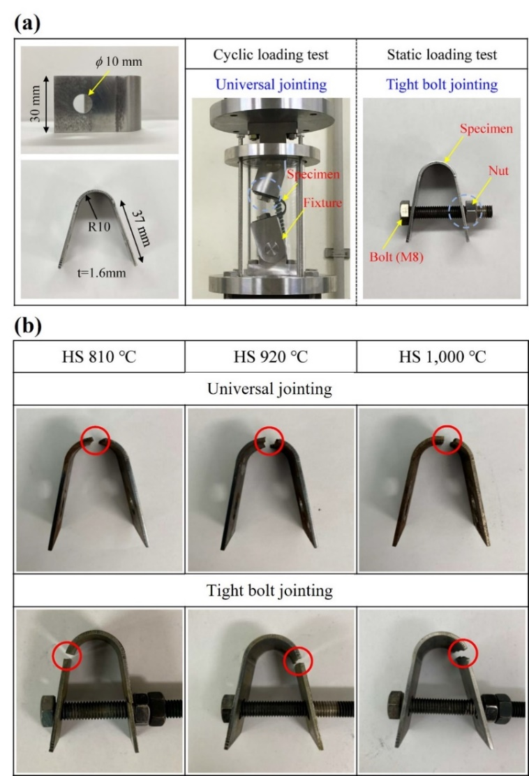
Figure 7. (a) Geometry of U-bent specimen and different jointing methods for the delayed fracture tests in uncoated 22MnB5 PHS; (b) Fracture location variation due to different jointing methods.
Reproduced with permission.^{[124]} Copyright 2021, Elsevier.

Some classic HE indicators, such as the H_{crit}, are still available for bending tests, but their values deviate with different test methods. In the work done by Valentini et al.,^{[125]} they compared the impact of testing methods and sample geometries on H_{crit} in both 1500 and 2000 MPa grade PHS (Figure 8). For 1500 MPa grade PHS, the SSRT resulted in the highest H_{crit} (0.74 wppm), followed by the standard four-point bending test (0.71 wppm). The lowest threshold was measured from a four-point bending test with a hole in the specimen’s center (0.61 wppm). Increasing the PHS’s strength to 2000 MPa not only led to the decrease of H_{crit} but also exaggerated their difference. The measured H_{crit} showed a geometry and test method dependence in both PHS. This comparison clearly reveals the absence of standardized HE test methods for ultra-high-strength PHS, especially those over 1500 MPa strength grades. A more systematic comparison of the test methods regarding HE performances and evaluations is expected in the future.

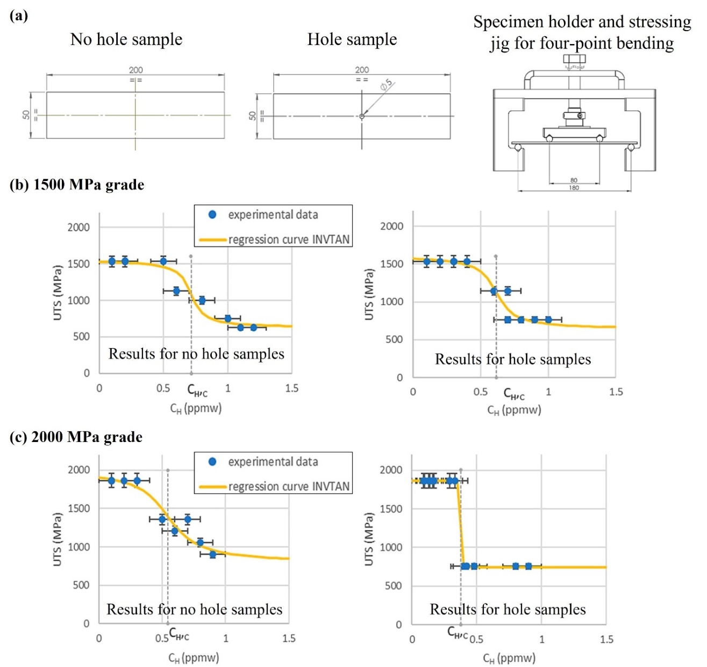
Figure 8. (a) Four-point bending sample geometry and test setup; The critical hydrogen concentration of PHS without/with a center hole measured by a four-point bending test for (b) 1500 MPa grade and (c) 2000 MPa grade. The SSRT results are not shown here.
Reproduced under terms of the CC-BY license.^{[125]} Copyright 2019, The Authors, published by MDPI.

The bending angle is a unique indicator for the bending tests that provides a solid prediction of bending toughness and crashworthiness.^{[89,126]} Instead of being kept at a constant strain condition, the specimen is gradually loaded on a three-point bending frame until reaching the maximum load recorded by a load cell. The bending angle can be calculated from the displacement of the loading punch or by a manual post-measurement.^{[127]} Recently, this method has been extended to examine the HE effects on coated PHS. In the case of AlSi-coated and bare 35MnB5 PHS, their HE susceptibility was analyzed by comparing the bending angles and the number and morphology of surface cracks (Figure 9).^{[91]} AlSi-coated PHS showed a limited bending angle (28°) that reflected a poor resistance to the bending test. It was discovered that the AlSi coating was detrimental to the bending toughness of PHS.

Interestingly, the SSRT was also adopted in the same research, enabling a direct comparison between the tensile and bending tests. The total elongation for the CA+HPF, CA+HPF+BH, CA+Al+HPF, and CA+Al+HPF+BH treated specimens were 6.3 ± 1.3%, 7.2 ± 0.6%, 2.8 ± 0.3%, and 6.9 ± 0.6%, respectively. (CA: continuous annealing, HPF: hot press forming, BH: bake hardening, Al: aluminizing.) Noticeably, in the case of CA+Al+HPF+BH, the total elongation almost fully recovered, whereas the bending angle suggested that the HE risk remained. Therefore, the bending test has a higher level of sensitivity and shall better reflect the HE performance for AlSi-coated PHS in practical applications.

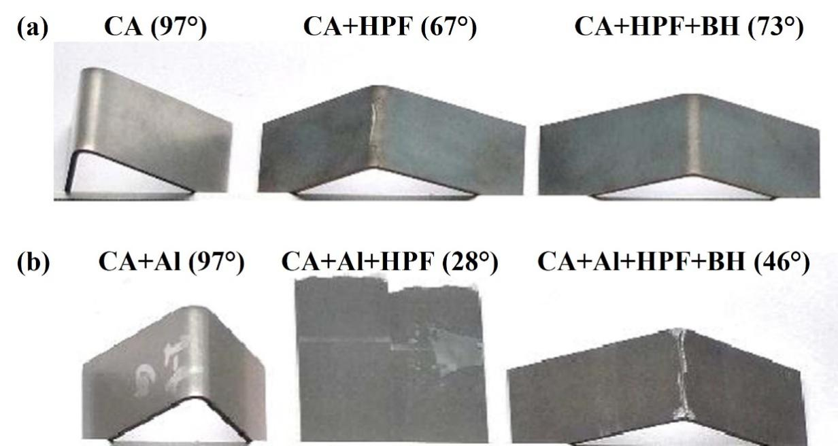
Figure 9. Effect of sequential heat treatment and AlSi coating on the three-point bending performance of 35MnB5 PHS. The bending angles are labeled behind heat treatment.
Reproduced with permission.^{[91]} Copyright 2018, Elsevier.

3.4. Pre-cracked fracture tests
Pre-cracked fracture tests are useful test methods based on fracture mechanics, particularly fracture toughness and fatigue measurement. In the fracture tests, compact tension (C(T)) and single-edge bend (SE(B)) specimens are frequently adopted.^{[128–130]} An additional in-situ or ex-situ hydrogen charging device is applied to the original fracture toughness or fatigue test apparatus. Since the specimens are usually pre-cracked via the fatigue procedure, the hydrogen-assisted crack initiation process is less emphasized than tensile or bending experiments. Instead, the main focus is on the hydrogen-assisted crack propagation behavior under monotonic or cyclic loading. As a result, the threshold stress intensity factor, the J-integral, the fatigue crack growth rate (CGR), and crack opening displacement (COD) are all effective HE indicators in the pre-cracked fracture tests.

By far, few pre-cracked fracture tests have been exploited to characterize the hydrogen embrittlement in PHS, partly because PHS is usually manufactured in the form of thin sheets with a thickness ranging from 1-3 mm. It adds difficulty to qualitatively measure the mode-I fracture toughness or fatigue performance following the standards where a prevailing plane strain condition is the prerequisite.^{[131]} Some researchers applied the essential work of fracture (EWF) method on double edge-notched tensile (DENT) specimens to evaluate the specific essential work (w_{e}) and non-essential plastic work (w_{p}). Both values can be related to the J-based fracture toughness measurement.^{[132–134]} Alternatively, it has been proved that accurate measurement of the fracture toughness of a high-strength thin sheet could be achieved through sub-sized geometry and side groove.^{[131,135–137]} The ultra-high strength and moderate fracture toughness of AHSS effectively reduce the qualification for thickness, and the side grooves help modify the crack tip triaxiality and mitigate the crack tunneling effect.^{[131,138,139]} The authors have managed to measure the fracture toughness values of two types of PHS (1500 and 2000 MPa strength grade) by applying the side groove strategy to subsidized C(T) specimens.^{[116]} The qualified hydrogen-free crack-initiation and crack-growth toughness in terms of K (K_{JIc} and K_{Jss}) for the traditional 22MnB5 PHS (PHS1500) were 91.5 ± 4.4 and 124.5 ± 3.6 MPa·m^{1/2}. Both values of the 2000 MPa grade PHS (PHS2000) were decreased by ~20% to 73.0 ± 10.1 and 91.5 ± 10.0 MPa·m^{1/2}. Such degradation in fracture toughness agrees with the known strength-toughness trade-off and is ascribed to the carbon content in the investigated PHS: most of the carbon exists at a solid solution state; hence the higher carbon content, the more aggressive lattice distortion. The presence of hydrogen further exacerbated the initially poor fracture resistance of PHS2000, where it merely exhibited resistance against the hydrogen-induced intergranular cracks. These results by pre-cracked fracture tests are self-consistent with the PHS’s tensile performances with hydrogen. As the fracture toughness and fatigue measurement in PHS continuously matures, more fracture mechanics-based tests shall be considered to evaluate the impact of hydrogen on fracture toughness.

3.5. Summary of the HE test methods for PHS
With an increasing demand for high-strength PHS, many studies have focused on developing HE-resistant PHS through microalloying, coating, and heat treatment, as summarized in Table 1.

Table 1. Summary of the recent research on HE in PHS and the applied test methods (GC: gaseous charging, EC: electrochemical charging, IC: immersion charging)
PHS strength grade [MPa] | Main focus | Hydrogen charging method & test method | HE indicator | Ref.
1500 | Austenitizing condition | GC + SSRT | Strength/ductility loss | ^{[67]}
1500 | Nb microalloying | EC + SSRT | Strength loss | ^{[68]}
1500 | Charging condition | EC + SSRT | Strength/ductility loss | ^{[73]}
1500 | Ti-Nb-V microalloying | EC + HPT | Hydrogen-induced blisters & cracks | ^{[82]}
1500 | Austenitizing condition, specimen loading/jointing methods | EC + CSRT & U bending | Strength/ductility loss & time to fracture | ^{[124]}
1500 | Al-Si coating, austenitizing condition | EC + three-point bending | Bending angle | ^{[79]}
1500 | Al-Si coating, austenitizing condition | EC + four-point bending | Time to fracture | ^{[140]}
1500 & 2000 | Test methods | EC + SSRT & four-point bending | Critical H concentration | ^{[125]}
1500 & 2000 | V microalloying | EC + SSRT | Strength/ductility loss | ^{[86]}
1800 | Stamping and tempering condition | EC + SSRT | Strength loss | ^{[120]}
1800 | Austenitizing and quenching condition | IC + CSRT | Ductility loss | ^{[71]}
1900 | Nb & Nb-Mo microalloying | EC + SSRT | Strength/ductility loss | ^{[81]}
1900 | Mo microalloying | EC + SSRT | Ductility loss | ^{[100]}
1900 | Ti microalloying | EC + SSRT | Ductility loss | ^{[141]}
2000 | Al-Si & Zn coating, austenitizing condition | Pre-introduced during hot stamping + SSRT & CSRT | Strength/ductility loss | ^{[21]}
2000 | Al-Si coating & tempering condition | Pre-introduced during hot stamping + SSRT & three-point bending | Strength/ductility loss & bending angle | ^{[91]}

The investigated PHS strength level ranges between 1500 to 2000 MPa. Over half of the studies involve novel PHS of 1800 MPa or higher strength grades, indicating that the primary focus is to increase strength grades and HE resistance simultaneously. Microalloying using Nb, Mo, Ti, and V is the most widely adopted strategy to form hydrogen traps of high activation energies to improve HE performance. Some beneficial synergistic effects coexist, such as the strengthening via precipitation formation and grain refinement by the Zener pinning effect or solute drag effect.^{[68,86]} Meanwhile, reducing grain size induces a higher grain boundary density. These grain boundaries serve as effective hydrogen trap sites that help slow the hydrogen diffusion process. Moreover, if the overall hydrogen contents are comparable, a denser grain boundary helps reduce the localized hydrogen concentration trapped at these boundaries and improves the hydrogen resistance.

In terms of the HE evaluation, including the hydrogen charging and subsequent test method, the electrochemical charging method and SSRT are still most frequently adopted in these studies, thanks to their high efficiency and broad adaptability. By contrast, gaseous charging and immersion charging methods are less popular. For the coated PHS, the charging process is sometimes omitted in order to evaluate the effect of residual hydrogen generated during the austenitization process. The utilization of bending tests is gradually increasing, especially in studies evaluating coating systems’ influence on bendability and HE. Meanwhile, as the bending performance strongly resembles the component’s crash performance, the bending tests might gain more application in the near future.

Based on the choice of test methods, the strength/ductility loss concluded from an SSRT test serves as the most popular HE indicator for PHS. However, it is worth mentioning that even with the same EC+SSRT experiment setup, a direct comparison of PHS’s HE performances based on the HE indicators among different studies is still unavailable because the arbitrarily selected charging and testing parameters of each study could have influenced or even altered the dominant HE mechanism. For instance, the charging electrolyte, current density, charging duration, ambient temperature, strain rate, and sample geometry are constantly found to be different in each research, so the PHS’s HE performances cannot be compared on an equal basis. Accordingly, other critical HE indicators, such as the hydrogen content and diffusivity, are to be evaluated for better comparison and interpretation.

To sum up, the present dilemma is that there are limitations for conventional HE indicators, such as H_{crit} and strength/ductility loss, to be utilized to evaluate PHS’s HE susceptibility. Additional effort is expected to improve and unify the evaluation methods toward building an efficient and reliable evaluation standard. In particular, a charging process similar to its service condition is the optimal choice for hydrogen ingress. Therefore, a correlation between the lab and the field environment is expected. Moreover, systematic comparisons of the HE test methods are still lacking, making the screening process for novel PHS ambiguous and problematic. A current expedient is made by comparing the HE performances of novel PHS against conventional ones, i.e., 22MnB5. The HE performances of 22MnB5 hereby become a lower limit to be reached. However, such validation is usually inefficient and costly. In this regard, proper modeling of the HE processes in PHS might be more meaningful since it only requires a minimal number of experiments for calibration, which is our focus in the next section.

4. Modeling the hydrogen embrittlement in PHS
Ever since the discovery of HE, efforts have been made to visualize its distribution in metals. However, experimental observations are often limited to bulk quantities or inapplicable to steels with complex microstructures.^{[34]} By far, the most successful attempt is through the advanced APT technique equipped with a cryo-transfer system,^{[34,35]} which enables the observation of hydrogen/deuterium atoms in various trapping sites. However, these methods are demanding in instruments. As such, theoretical modeling and simulations are the most straightforward approach to studying the dynamic hydrogen diffusion and distribution on a microscopic scale.

The two most widely discussed HE mechanisms for PHS steels are hydrogen-enhanced decohesion (HEDE) and hydrogen-induced plasticity (HELP).^{[37,142]} HEDE explains HE through the lowered cohesive energy between the interfaces and grain boundaries as the hydrogen weakens the atomic bonds in these regions.^{[143]} HELP, on the other hand, hypothesizes that the presence of hydrogen increases the local dislocation mobility, causing localized plastic deformation and crack growth.^{[144]} The two mechanisms are not mutually exclusive. In fact, a combination of two theories has been proposed to explain the interactions between decohesion and plasticity in HE in the range of hydrogen concentration where both mechanisms could be simultaneously active.^{[37,145–147]}

From a computational perspective, HE can be simulated through a wide range of models, from atomic to the macroscopic scale. Ab initio methods, such as density functional theory (DFT), have been used to calculate the fracture energy of the material in HE^{[148,149]} and the interactions and affinity of hydrogen with the microstructure, such as dislocations.^{[150]} Molecular dynamics enables studies of the dynamic crack propagation and hydrogen diffusion in the length scale of 10 nm.^{[151,152]} From the mesoscopic scale (about 1 to 10 μm) up to the macroscopic scale, continuum models through finite element analysis (FEA) provide insight into the mechanical stress state and hydrogen diffusion process over a large number of grains. Phase-field and crystal plasticity models are often used in conjunction with FEA to simulate the evolution of microstructures, cracks, and plastic deformation.^{[153,154]} It can be seen that each approach has its strength and limitations, and it is essential to choose an approach suitable for the timescale and length scale of the interest for a particular study.

The case of modeling HE in PHS is more challenging than many other AHSS for the following reasons. First, during the hot-stamping process, PHS typically acquires a martensite lath morphology from martensitic transformation. The martensite laths are organized into packets and blocks according to their orientations.^{[155]} This complex microstructure contains a large number of interfaces, which are excellent trapping sites for hydrogen. For models concerned with the diffusion and embrittlement of the interfaces, the effect of microstructure must be accounted. Second, due to the large deformation during the hot-stamping process and the martensitic transformation, PHS usually has a high dislocation density of magnitude 10¹⁵ m⁻².^{[91]} A large number of dislocations also enables effective hydrogen trapping, which is one reason for the high HE sensitivity in hardened steels.^{[156]} Therefore, studying hydrogen diffusion in PHS inevitably requires an evaluation of the dislocation density after the hot-stamping process.

We hereby review some well-accepted theories and models for studying HE in PHS, focusing on models within the mesoscopic to the macroscopic scale. We will also cover some of the work and opinions of the current authors. Potential applications and current challenges will also be discussed at the end of this section.

4.1. Martensite transformation during stamping
As discussed above, the martensitic transformation plays an important role in HE, for not only does it induce a large number of lath boundaries (LB) and prior austenite grain boundaries (PAGB), but also the complex dislocation network that results in the inhomogeneous diffusion and segregation behavior of hydrogen in PHS.

Crystallographically, the martensitic transformation can be described by an orientation relationship. One of the earliest models is the Bain model, where the formation of a body-centered-tetragonal (BCT) lattice from a face-centered-cubic (FCC) lattice without significant displacement of atoms is possible by identifying atoms from one lattice to another.^{[157]} However, the orientation relationship obtained from the Bain model does not match the experimental observation because possible rotation and shearing of the material are not modeled.^{[155]} Several new orientation relationships have been proposed to resolve the discrepancy between the experimental data and the prediction from the Bain model. Among them, Kurdjumov-Sachs (K-S),^{[158]} Nishiyama-Wassermann (N-W),^{[159]} and Greninger-Troiano (G-T)^{[160]} orientation relationships are widely accepted and offer good agreement with the experimental observation.

Olson and Cohen propose a simple, early model for the kinetics of martensitic transformation.^{[161]} In their model, the fraction of martensite ($f_{mart}$) is related to the plastic strain ($ϵ_{p}$) by the following equation^{[161]}:
$f_{mart}=1-exp\left(-β{\left(1-exp\left(-αϵ_{p}\right)\right)}^{n}\right)$ (5)
where $α$, $β$, and $n$ are fitting parameters. This model is widely accepted and validated by experiments.^{[155,161]} However, the Olson-Cohen model is insufficient for studies requiring a physically accurate martensite morphology. One of the more sophisticated solutions is the phase-field model. The pioneering works were by Artemev, Wang, and Khachaturyan,^{[162–165]} who formulated the phase-field model for martensitic transformation. Yeddu et al.^{[166,167]} adopted the model to study the martensitic transformation in steels. Figure 10 shows the evolution of three Bain variants starting from a randomly placed nucleus in a polycrystal representative volume element (RVE) using the phase-field model.^{[168]} It is demonstrated that the phase-field model can generate relatively accurate martensite morphology. Nevertheless, implementing a high-resolution phase-field model is more complex and resource-demanding. Thus, simpler models, such as the Olson-Cohen model, are usually sufficient for studying macroscopic phenomena in PHS.

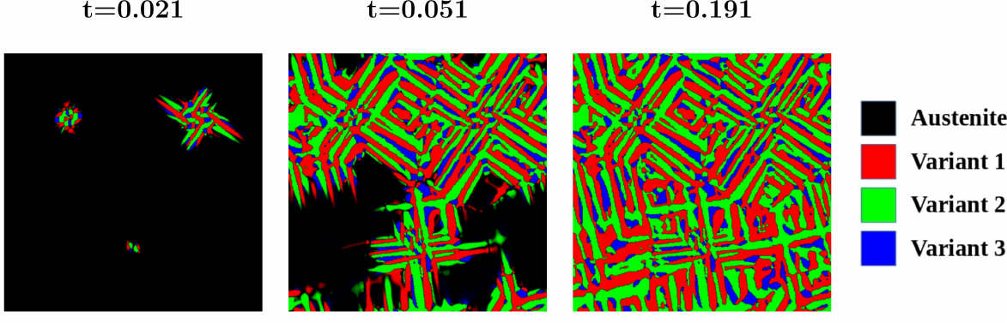
Figure 10. Time evolution of three Bain variants in a polycrystal RVE. The simulation is based on a phase-field model calibrated for 22MnB5 PHS.
Reproduced with permission.^{[168]} Copyright 2022, Elsevier.

4.2. Hydrogen diffusion
In general, the dynamics of hydrogen diffusion are governed by the diffusion equation, which is a result of the conservation of mass:
$\frac{∂c}{∂t}=∇⋅j$ (6)
where $c$ is the concentration of hydrogen and $j$ is the flux vector.

In the framework by McNabb and Foster,^{[169]} hydrogen is categorized into lattice hydrogen, which resides in ordinary sites in the lattice, and trapped hydrogen, which resides in trapping sites such as dislocation, interfaces, and grain boundaries. Naturally, lattice hydrogen has significantly higher mobility than trapped hydrogen. In this section, we adopt the convention to denote the quantities related to lattice hydrogen with subscript ‘L’ and quantities related to trapped hydrogen by the subscript ‘T’.

The trapping-detrapping kinetics in the McNabb-Foster model is described by the following equation^{[169,170]}:
$\frac{∂θ_{T}}{∂t}=k_{trap}\left(1-θ_{T}\right)θ_{L}-k_{detrap}θ_{T}$ (7)
where $θ_{L}=\frac{c_{L}}{n_{L}}$ and $θ_{T}=\frac{c_{T}}{n_{T}}$ are the fraction of occupation for lattice and trapped hydrogen, respectively. $k_{trap}$ and $k_{detrap}$ are the rate constants for the trapping and detrapping process, respectively. $n$ is the total number of trapping sites. For lattice hydrogen, $n_{L}$ can be estimated by the number of solvent atoms in the material.^{[40]} The number of trapping sites $n_{T}$ depends on the nature of the sites under consideration. In the literature, this quantity is usually estimated from plastic strain in the following form^{[40,171,172]}:
$\text{log}\left(n_{T}\right)=A+B\text{exp}\left(-Cϵ_{p}\right)$ (8)
where $A$, $B$, and $C$ are fitting parameters. The current authors have recently proposed an alternative model based on geometrically necessary dislocations (GND), where the GND density is calculated from the Nye tensor.^{[168]}

The well-known Oriani model^{[173]} is the McNabb-Foster model at local equilibrium. Putting $\frac{∂θ_{T}}{∂t}=0$ yields:
$K=\frac{1}{θ_{L}}\frac{θ_{T}}{1-θ_{T}}$ (9)
where $K=\text{exp}\left(-\frac{E_{a}}{k_{B}T}\right)$ is the equilibrium constant, and $E_{a}$ is the activation energy of the trapping sites.

Both the McNabb-Foster model and Oriani model assume that hydrogen exists as two different species that can be converted to each other. The Oriani model assumes that such a trapping–detrapping process is sufficiently fast compared with the diffusion process, and only when the ratio between the lattice diffusion and the trapping–detrapping rate is sufficiently small, a local equilibrium can be reached.^{[173]} Obviously, this assumption is valid when the thermal vibration frequency of hydrogen atoms is sufficiently high and the binding energy is sufficiently low. These two models are suitable for both simulation and experimental data analysis of hydrogen diffusion and desorption behavior.^{[170,174]} For PHS, dislocations, lath boundaries, prior austenite grain boundaries, and carbides are to be considered when evaluating the density of trapping sites.^{[28,175,176]}

While the above models correctly predict hydrogen’s behaviors in the trapping sites, it does not model hydrogen transport under the influence of local stress. Hydrogen diffusion under external loading has been experimentally studied in the literature.^{[39,177]} In PHS, this effect may be more pronounced due to the residual stress and service loading. Progress in modeling stress-driven hydrogen diffusion has been made by Sofronis and McMeeking.^{[40]} In their model, the proposed diffusion flux for lattice hydrogen $c_{L}$ is:
$j=-D∇c_{L}-M∇μ_{σ}$ (10)
where $-D∇c_{L}$ is the usual diffusion flux due to concentration gradient, with $D$ as the diffusivity of lattice hydrogen, and $-M∇μ_{σ}$ is the diffusion flux driven by hydrostatic stress with $M=\frac{Dc_{L}}{k_{B}T}$ as the mobility. The effect of stress is captured by the latter term, which is related to the hydrostatic stress $σ_{H}=\frac{1}{3}σ_{ii}$ through $μ_{σ}=-σ_{H}V_{H}$, where $V_{H}$ is the partial molar volume of hydrogen. Inserting Equation 10 into Equation 6 and simplifying, the diffusion equation in the Sofronis-McMeeking model becomes^{[40]}:
$\frac{∂c_{L}}{∂t}=D∇^{2}C-∇⋅\left(MV_{H}∇σ_{H}\right)$ (11)
Combining Equation 9 and 11, we arrived at the model for hydrogen diffusion with the local equilibrium assumption. A model without the local equilibrium assumption can be obtained in a similar manner by substituting Equation 7 into Equation 6.^{[168]}

The models presented in this section are applicable to both mesoscopic and macroscopic studies of hydrogen diffusion, with or without external loading. The Sofronis-McMeeking model has been used extensively to study hydrogen segregation at the crack tip and precipitates.^{[40,146,178]} Figure 11 shows hydrogen segregation near the carbide precipitates (highlighted by the red circle in Figure 11(b)) in the simulated hydrogen in martensitic steel. At the microscopic level, the characteristic length of the hydrogen diffusion is no longer small compared to the characteristic size of microstructure features, such as the thickness of interfaces. Specific treatments may be needed to model the effect of microstructure over the path of hydrogen diffusion.^{[168]}

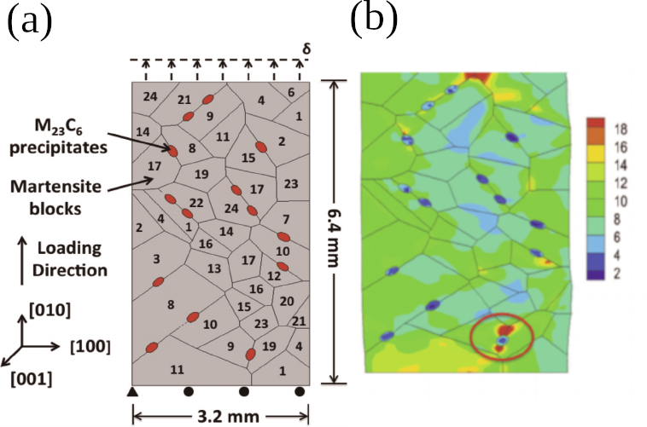
Figure 11. (a) Arrangement of martensite blocks and carbide precipitates in the simulation model. (b) Hydrogen concentration distribution (in ppm) at 6% nominal strain.
Reproduced with permission.^{[178]} Copyright 2015, Elsevier.

4.3. Modeling hydrogen embrittlement
The final stage of HE is the fracture strength and toughness degradation, leading to material failure. A study of the fracture process could provide information about crack initiation and propagation behavior under the influence of hydrogen. In general, all existing methods used in computational fracture mechanics can be adopted in modeling HE. A common strategy is to link the fracture criterion or the constitutive equation in the fracture model with the local hydrogen concentration.^{[48,148,149,154,179]}

For HE governed by the HEDE mechanism, the cohesive zone model (CZM) is a natural choice. In CZM, the fracture behavior of a predefined weak interface is modeled by a special cohesive element whose constitutive relationship is dictated by a traction-separation law.^{[180]} The fracture energy of the cohesive element is frequently obtained from DFT calculations.^{[148,149]} In the study of HE in iron and aluminum by Jiang and Carter,^{[148]} the fracture energy of the material, estimated through the Born-Haber cycle using DFT, is shown to be negatively and almost linearly related to the hydrogen coverage. The fracture energy from atomistic calculations can be directly used to specify the traction-separation law under different local hydrogen coverage, and results such as the force-displacement curve and fracture toughness can be extracted and validated by experiments.^{[149,179]}

Another popular approach is the continuum damage model (CDM). In CDM, the crack is modeled by a damage parameter governed by a damage initiation criterion and a damage evolution law.^{[181]} One of the most important models in this category is the phase-field damage model, where the evolution law is directly derived from the variation principle and thermodynamically consistent.^{[182]} In the model by Martínez-Pañeda et al.,^{[48,115]} the critical energy release rate of the phase-field damage model is assumed to be negatively related to the hydrogen coverage. In a recent work by Huang and Gao,^{[154]} the yield condition is also affected by the local hydrogen content, aside from modifying the critical energy release rate. Through CDM, it is possible to model both HELP and HEDE mechanism, thus, the ductile-to-brittle transition under HE can be studied.

While fracture can be readily simulated through the methods discussed above, a simple failure criterion is often desirable for experimental studies and theoretical models focusing on the transformation or diffusion aspects. One example is the concept of critical hydrogen concentration discussed in Section 3, which directly predicts the HE behavior based on experimentally measured hydrogen concentration or controlled charging conditions. Caution must be taken in correlating the local hydrogen concentration with the hydrogen content from experimental measurements such as TDS. In general, the local hydrogen concentration can deviate from the global average concentration. Figure 12 shows the relationship between the local hydrogen concentration and the global average obtained from the hydrogen diffusion simulation of a polycrystal representative volume element in 22MnB5 PHS.^{[168]} It can be seen that while the local hydrogen concentration increases with the global average, its value varies with both the local hydrostatic stress and the microstructure. The PAGB within the high hydrostatic stress regions is likely to have a local hydrogen concentration 2-3 times of the global average value. Crack initiation and propagation at these sites due to the decohesion of the interfaces under the influence of high local hydrogen content is expected. Meanwhile, if the local hydrogen content is insufficient to trigger an interface decohesion and a crack is initially formed due to plastic instability during deformation, the transgranular and quasi-cleavage fracture modes are expected to occur.
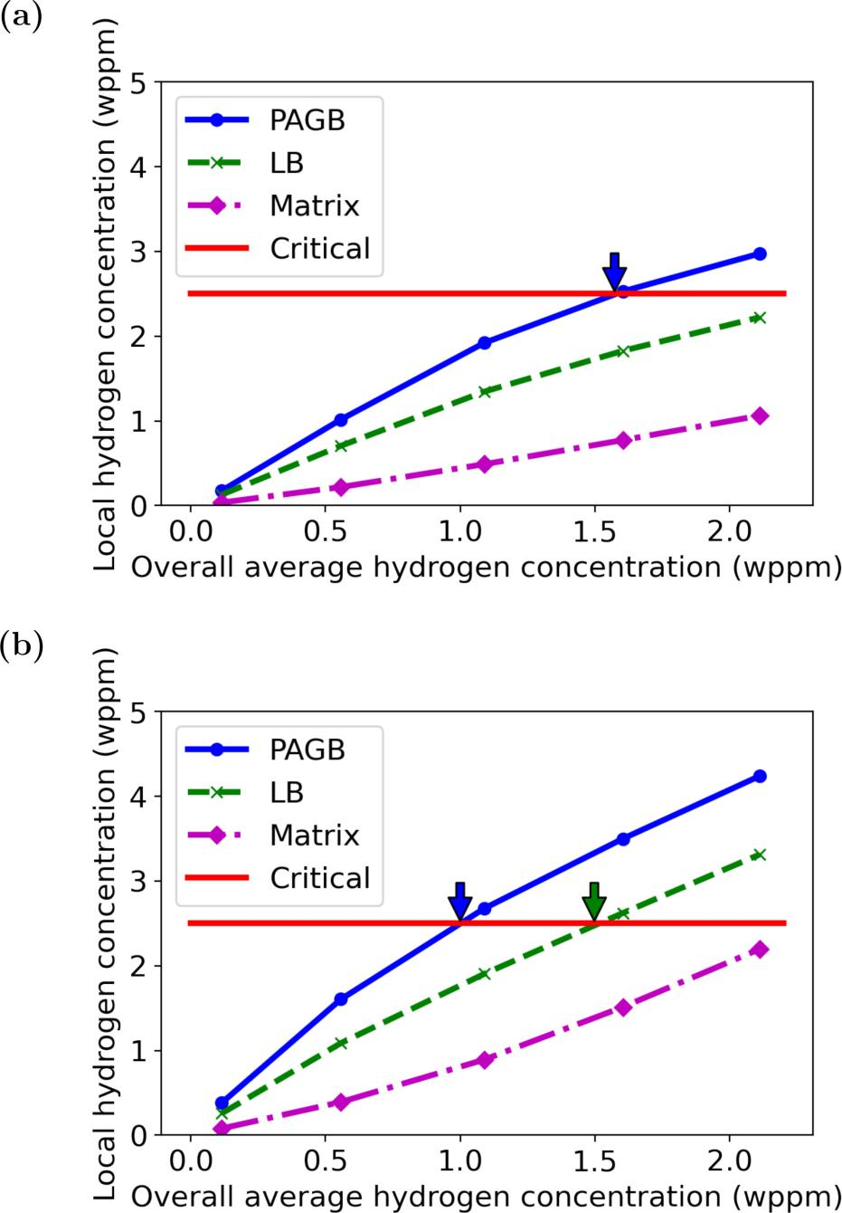
Figure 12. Relationship between the simulated local hydrogen concentration in different microstructures and the global average hydrogen concentration in PHS1500 in (a) low-stress regions and (b) high-stress regions. A local critical hydrogen concentration (the red line) is hypothesized to explain the different fracture modes observed in experiments.
Reproduced with permission.^{[168]} Copyright 2022, Elsevier.

Several other critical HE indicators have been established and applied to the modeling, which can be related to the local hydrogen concentration. An early model by Oriani and Josephic^{[183]} suggested the critical mode-I stress intensity factor $K_{c}$ for the onset of crack propagation is linearly related to the local hydrogen concentration:
$K_{c}=-Ac_{H}+B$ (12)
where the negative sign in front of constant $A$ signifies the detrimental effect of hydrogen and $B$ is a constant. Akhurst and Baker^{[184]} performed beam-loading tests on NiCrMoV steel and obtained a similar linear relationship between the critical fracture stress and the local hydrogen concentration. Wang et al.^{[23]} performed SSRT tests on ANSI 4135 steel and suggested the following power-law relationship between the critical fracture stress $σ_{c}$ and the local hydrogen concentration:
$σ_{c}=σ_{c0}c_{H}^{-m}$ (13)
where $σ_{c0}$ and $m$ are fitting parameters. Another model from the energy perspective is by Novak et al.^{[146]} In their model, the effective work of decohesion on carbide/matrix interfaces $γ_{eff}$ is the sum of the reversible work of decohesion $γ_{int}$, which depends on the local hydrogen content, and the plastic work $γ_{p}$.

4.4. Current challenges in modeling HE in PHS
The review of models in this section is by no means exhaustive of the vast number of models in the literature. It can be seen that every model relies on a specific set of assumptions, such as loading conditions or the active HE mechanism. Therefore, the predictions offered by these models are only valid when the assumptions are met. A comprehensive model would require a multi-scale study involving interactions between hydrogen and the local microstructure on a microscopic scale and the loading conditions on a macroscopic scale. Such a model would necessarily couple mechanical deformation, martensitic transformation, hydrogen diffusion, and fracture. This incredible challenge requires a deep understanding of the underlying physics and the numerical techniques to tackle. Attempts have been made to couple fracture and hydrogen diffusion,^{[48,154]} obtaining parameters for continuum models from DFT calculation^{[179]} and coupling martensitic transformation and hydrogen diffusion.^{[168]} Studies of martensitic steels could provide insights into some HE phenomena in PHS,^{[28,37]} but a comprehensive model for PHS is yet to be desired. As discussed in the introduction section, the great complexity of HE behavior in PHS has its root in its intricate microstructure introduced in the hot-stamping process. A systematic study of modeling HE in PHS could help make PHS more HE-resistant by optimizing the composition design and processing parameters.

5. Summary
This paper reviewed the evaluation and prediction techniques for hydrogen embrittlement in PHS. The primary focus is to build a comprehensive understanding of the evaluation techniques and models, based on which we can discuss their relevance to the practical service condition. In particular, HE experiments carried out with PHS are emphasized, highlighting the suitability of the adopted technique and the HE susceptibility indicator. The aim is to promote a consensus on fast and accurate HE evaluation in PHS to bridge the gap between lab and industry. The realization of this aim relies on thoroughly comparing the effect of various evaluation techniques on specimens and components made from PHS. However, despite the considerable demands, such studies are rarely made or documented.

Among the currently utilized evaluation techniques, CLT and the group of tensile experiments are still in the dominant position for a general HE characterization. The choice towards the group of bending experiments is gradually increasing for their advantages in evaluating the coating and crashworthiness of PHS. By contrast, fracture mechanics-based evaluation techniques are less followed. Since fracture toughness performances are essential to PHS’s application, future HE studies should consider more qualitative evaluations based on the fracture toughness measurements.

Apart from the experiments, a few models that address the hydrogen embrittlement effect in PHS have been discussed. Such models are urgently needed for the industry as they avoid the costly trial-and-error process that most industries are experiencing. Specifically, a component scale model that predicts the residual hydrogen content and distribution during practical stamping would escalate the steelmakers’ efficiency and quality control. Unfortunately, few works covering the PHS’s overall process from manufacture to service are performed. Therefore, the transfer from academia to industry shall be greatly considered for the best interest.

Last, hopefully, that high hydrogen-resistant PHS can be designed under the guidance of novel evaluation standards and prediction models. Meanwhile, these experiences could shed light on the HE evaluation and prediction in other AHSS with more complex microstructures and applications.

Acknowledgements
M.X.H. acknowledges the support from National Natural Science Foundation of China (No. U1764252), Guangzhou Municipal Science and Technology Project (No. 202007020007), National Key Research and Development Program of China (No. 2019YFA0209900), Research Grants Council of Hong Kong (No. R7066-18).

Conflict of Interest
The authors declare no conflict of interest.

References
[1] W.H. JOHNSON, Nature 1875, 11, 393, DOI: 10.1038/011393a0.
[2] M.R. Louthan, G.R. Caskey, J.A. Donovan, D.E. Rawl, Mater. Sci. Eng. 1972, 10, 357, DOI: 10.1016/0025-5416(72)90109-7.
[3] J.P. Hirth, Metall. Trans. A 1980, 11, 861, DOI: 10.1007/BF02654700.
[4] C.D. Beachem, Metall. Trans. 1972, 3, 441, DOI: 10.1007/BF02642048.
[5] A. Pundt, R. Kirchheim, Annu. Rev. Mater. Res. 2006, 36, 555, DOI: 10.1146/annurev.matsci.36.090804.094451.
[6] P. Sofronis, J. Mech. Phys. Solids 1995, 43, 1385.
[7] J.H. Liu, L. Wang, Y. Liu, X. Song, J. Luo, D. Yuan, Int. J. Miner. Metall. Mater. 2015, 22, 820, DOI: 10.1007/s12613-015-1139-2.
[8] H.K.D.H. Bhadeshia, ISIJ Int. 2016, 56, 24.
[9] Q. Liu, Q. Zhou, J. Venezuela, M. Zhang, A. Atrens, Eng. Fail. Anal. 2018, 94, 249, DOI: 10.1016/j.engfailanal.2018.08.011.
[10] C. Huang, C. Hu, Y. Liu, Z. Liang, M. Huang, Mater. Futur. 2022, 1, 032001, DOI: 10.1088/2752-5724/ac7fae.
[11] J. Zhang, M. Huang, B. Sun, B. Zhang, R. Ding, C. Luo, W. Zeng, C. Zhang, Z. Yang, S. van der Zwaag, H. Chen, Scr. Mater. 2021, 190, 32, DOI: 10.1016/j.scriptamat.2020.08.025.
[12] B. Sun, W. Krieger, M. Rohwerder, D. Ponge, D. Raabe, Acta Mater. 2020, 183, 313, DOI: 10.1016/j.actamat.2019.11.029.
[13] O. Bouaziz, H. Zurob, M. Huang, Steel Res. Int. 2013, 84, 937, DOI: 10.1002/srin.201200288.
[14] T. Taylor, A. Clough, Mater. Sci. Technol. 2018, 34, 809, DOI: 10.1080/02670836.2018.1425239.
[15] H. Karbasian, A.E. Tekkaya, J. Mater. Process. Technol. 2010, 210, 2103, DOI: 10.1016/j.jmatprotec.2010.07.019.
[16] E. Billur, in Automotive Steels: Design, Metallurgy, Processing and Applications, Elsevier Ltd 2016, 387–411, DOI: 10.1016/B978-0-08-100638-2.00012-2.
[17] G. Lovicu, M. Bottazzi, F. D’aiuto, M. De Sanctis, A. Dimatteo, C. Santus, R. Valentini, Metall. Mater. Trans. A Phys. Metall. Mater. Sci. 2012, 43, 4075, DOI: 10.1007/s11661-012-1280-8.
[18] M. Nagumo, K. Takai, Mater. Sci. Technol. 2020, 36, 1003, DOI: 10.1080/02670836.2019.1639009.
[19] Z. Wang, Q. Lu, Z.H. Cao, H. Chen, M.X. Huang, J.F. Wang, Acta Metall. Sin. (English Lett. 2022, 1, DOI: 10.1007/s40195-022-01408-4.
[20] C. Georges, T. Sturel, P. Drillet, J.M. Mataigne, ISIJ Int. 2013, 53, 1295, DOI: 10.2355/isijinternational.53.1295.
[21] K.R. Jo, L. Cho, D.H. Sulistiyo, E.J. Seo, S.W. Kim, B.C. De Cooman, Surf. Coatings Technol. 2019, 374, 1108, DOI: 10.1016/j.surfcoat.2019.06.047.
[22] S.Y. Cho, J.J. Kim, H.J. Jang, Corros. Sci. Technol. 2019, 18, 24, DOI: 10.14773/cst.2019.18.1.24.
[23] M. Wang, E. Akiyama, K. Tsuzaki, Corros. Sci. 2007, 49, 4081, DOI: 10.1016/j.corsci.2007.03.038.
[24] J. Venezuela, E. Gray, Q. Liu, Q. Zhou, C. Tapia-Bastidas, M. Zhang, A. Atrens, Corros. Sci. 2017, 127, 45, DOI: 10.1016/j.corsci.2017.08.011.
[25] Y. Sugiyama, K. Takai, Acta Mater. 2021, 208, 116663, DOI: 10.1016/j.actamat.2021.116663.
[26] J. Hou, X.S. Kong, C.S. Liu, J. Song, Acta Mater. 2020, 201, 23, DOI: 10.1016/j.actamat.2020.09.048.
[27] Y. Momotani, A. Shibata, T. Yonemura, Y. Bai, N. Tsuji, Scr. Mater. 2020, 178, 318, DOI: 10.1016/j.scriptamat.2019.11.051.
[28] E.I. Galindo-Nava, B.I.Y. Basha, P.E.J. Rivera-Díaz-del-Castillo, J. Mater. Sci. Technol. 2017, 33, 1433, DOI: 10.1016/j.jmst.2017.09.011.
[29] Y. Liang, P. Sofronis, J. Mech. Phys. Solids 2003, 51, 1509, DOI: 10.1016/S0022-5096(03)00052-8.
[30] A. Atrens, Q. Liu, C. Tapia-Bastidas, E. Gray, B. Irwanto, J. Venezuela, Q. Liu, Corros. Mater. Degrad. 2018, 1, 3, DOI: 10.3390/cmd1010002.
[31] F. Von Zeppelin, M. Haluška, M. Hirscher, Thermochim. Acta 2003, 404, 251, DOI: 10.1016/S0040-6031(03)00183-7.
[32] A. Turk, G.R. Joshi, M. Gintalas, M. Callisti, P.E.J. Rivera-Díaz-del-Castillo, E.I. Galindo-Nava, Acta Mater. 2020, 194, 118, DOI: 10.1016/j.actamat.2020.05.007.
[33] A. Turk, S.D. Pu, D. Bombač, P.E.J. Rivera-Díaz-del-Castillo, E.I. Galindo-Nava, Acta Mater. 2020, 197, 253, DOI: 10.1016/j.actamat.2020.07.039.
[34] Y.S. Chen, D. Haley, S.S.A. Gerstl, A.J. London, F. Sweeney, R.A. Wepf, W.M. Rainforth, P.A.J.J. Bagot, M.P. Moody, Science 2017, 355, 1196, DOI: 10.1126/science.aal2418.
[35] Y.S. Chen, H. Lu, J. Liang, A. Rosenthal, H. Liu, G. Sneddon, I. McCarroll, Z. Zhao, W. Li, A. Guo, J.M. Cairney, Science 2020, 367, 171, DOI: 10.1126/science.aaz0122.
[36] A. Nagao, K. Hayashi, K. Oi, S. Mitao, ISIJ Int. 2012, 52, 213, DOI: 10.2355/isijinternational.52.213.
[37] A. Nagao, M. Dadfarnia, B.P. Somerday, P. Sofronis, R.O. Ritchie, J. Mech. Phys. Solids 2018, 112, 403, DOI: 10.1016/j.jmps.2017.12.016.
[38] M. Koyama, M. Rohwerder, C.C. Tasan, A. Bashir, E. Akiyama, K. Takai, D. Raabe, K. Tsuzaki, Mater. Sci. Technol. 2017, 33, 1481, DOI: 10.1080/02670836.2017.1299276.
[39] A. Shibata, T. Yonemura, Y. Momotani, M. heom Park, S. Takagi, Y. Madi, J. Besson, N. Tsuji, Acta Mater. 2021, 210, 116828, DOI: 10.1016/j.actamat.2021.116828.
[40] P. Sofronis, R.M. McMeeking, J. Mech. Phys. Solids 1989, 37, 317, DOI: 10.1016/0022-5096(89)90002-1.
[41] O. Barrera, E. Tarleton, H.W. Tang, A.C.F. Cocks, Comput. Mater. Sci. 2016, 122, 219, DOI: 10.1016/j.commatsci.2016.05.030.
[42] J. Venezuela, J. Blanch, A. Zulkiply, Q. Liu, Q. Zhou, M. Zhang, A. Atrens, Corros. Sci. 2018, 135, 120, DOI: 10.1016/j.corsci.2018.02.037.
[43] I.M. Robertson, P. Sofronis, A. Nagao, M.L. Martin, S. Wang, D.W. Gross, K.E. Nygren, Metall. Mater. Trans. A Phys. Metall. Mater. Sci. 2015, 46, 2323, DOI: 10.1007/s11661-015-2836-1.
[44] M. Nagumo, Fundamentals of hydrogen embrittlement, Springer 2016, DOI: 10.1007/978-981-10-0161-1.
[45] B. Sun, D. Wang, X. Lu, D. Wan, D. Ponge, X. Zhang, Acta Metall. Sin. (English Lett. 2021, 34, 741, DOI: 10.1007/s40195-021-01233-1.
[46] A. Hussein, A.H.M. Krom, P. Dey, G.K. Sunnardianto, O.A. Moultos, C.L. Walters, Acta Mater. 2021, 209, 116799, DOI: 10.1016/j.actamat.2021.116799.
[47] M. Isfandbod, E. Martínez-Pañeda, Int. J. Plast. 2021, 144, 103044, DOI: 10.1016/j.ijplas.2021.103044.
[48] E. Martínez-Pañeda, A. Golahmar, C.F. Niordson, Comput. Methods Appl. Mech. Eng. 2018, 342, 742, DOI: 10.1016/j.cma.2018.07.021.
[49] V. Colla, R. Valentini, Steel Res. Int. 2020, 91, 2, DOI: 10.1002/srin.202000126.
[50] T. Tsuru, Y. Huang, M.R. Ali, A. Nishikata, Corros. Sci. 2005, 47, 2431, DOI: 10.1016/j.corsci.2004.10.006.
[51] S. Frappart, A. Oudriss, X. Feaugas, J. Creus, J. Bouhattate, F. Thébault, L. Delattre, H. Marchebois, Scr. Mater. 2011, 65, 859, DOI: 10.1016/j.scriptamat.2011.07.042.
[52] J. Venezuela, Q. Liu, M. Zhang, Q. Zhou, A. Atrens, Corros. Rev. 2016, 34, 153, DOI: 10.1515/corrrev-2016-0006.
[53] D. Rudomilova, T. Prošek, G. Luckeneder, Corros. Rev. 2018, 36, 413, DOI: 10.1515/corrrev-2017-0106.
[54] C.D. Horvath, in Materials, Design and Manufacturing for Lightweight Vehicles, Elsevier Ltd. 2021, 39–95, DOI: 10.1016/b978-0-12-818712-8.00002-1.
[55] R. Schulze, SAE Tech. Pap. 1986, 95, 1136, DOI: 10.4271/862026.
[56] D. Davidson, L. Thompson, F. Lutze, B. Tiburcio, K. Smith, C. Meade, T. MacKie, D. McCune, H. Townsend, R. Tuszynski, SAE Tech. Pap. 2003, 112, 1236, DOI: 10.4271/2003-01-1238.
[57] I. Schoukens, F. Cavezza, J. Cerezo, V. Vandenberghe, V.C. Gudla, R. Ambat, Mater. Corros. 2018, 69, 881, DOI: 10.1002/maco.201709907.
[58] L. Anuar, A. Amrin, R. Mohamad, S.A. Aziz, M. Toozandehjani, Int. J. Automot. Mech. Eng. 1967, 16, 5.
[59] N. Lebozec, N. Blandin, D. Thierry, Mater. Corros. 2008, 59, 889, DOI: 10.1002/maco.200804168.
[60] T. Omura, T. Kudo, S. Fujimoto, Mater. Trans. 2006, 47, 2956, DOI: 10.2320/matertrans.47.2956.
[61] J. Stewart, D.E. Williams, Corros. Sci. 1992, 33, 457, DOI: 10.1016/0010-938X(92)90074-D.
[62] D.E. Williams, M.R. Kilburn, J. Cliff, G.I.N. Waterhouse, Corros. Sci. 2010, 52, 3702, DOI: 10.1016/j.corsci.2010.07.021.
[63] L. Wang, C. fang Dong, C. Man, Y. bo Hu, Q. Yu, X. gang Li, Int. J. Miner. Metall. Mater. 2021, 28, 754, DOI: 10.1007/s12613-020-2242-6.
[64] N.D. TOMASHOV, G.P. CHERNOVA, O.N. MARCOVA, Corrosion 1964, 20, 166t, DOI: 10.5006/0010-9312-20.5.166t.
[65] Y.C. Lu, M.B. Ives, C.R. Clayton, Corros. Sci. 1993, 35, 89, DOI: 10.1016/0010-938X(93)90137-6.
[66] Y. Kobayashi, S. Virtanen, H. Böhni, J. Electrochem. Soc. 2000, 147, 155, DOI: 10.1149/1.1393169.
[67] L. Cho, P.E. Bradley, D.S. Lauria, M.J. Connolly, E.J. Seo, K.O. Findley, J.G. Speer, L. Golem, A.J. Slifka, Int. J. Hydrogen Energy 2021, 46, 24425, DOI: 10.1016/j.ijhydene.2021.05.005.
[68] L. Lin, B. Li, G. Zhu, Y. Kang, R. Liu, Mater. Sci. Eng. A 2018, 721, 38, DOI: 10.1016/j.msea.2018.02.021.
[69] A. Kuduzović, M.C. Poletti, C. Sommitsch, M. Domankova, S. Mitsche, R. Kienreich, Mater. Sci. Eng. A 2014, 590, 66, DOI: 10.1016/j.msea.2013.10.019.
[70] Y. Song, M. Chai, W. Wu, Y. Liu, M. Qin, G. Cheng, Materials 2018, 11, 1, DOI: 10.3390/ma11040499.
[71] M. Okayasu, L. Yang, J. Mater. Sci. 2019, 54, 5061, DOI: 10.1007/s10853-018-3175-6.
[72] K. Horikawa, Scr. Mater. 2021, 199, 113853, DOI: 10.1016/j.scriptamat.2021.113853.
[73] Y. Chen, Z. Xu, X. Zhang, T. Zhang, J.J. Tang, Z. Sun, Y. Sui, X. Han, Mater. Des. 2021, 199, 109404, DOI: 10.1016/j.matdes.2020.109404.
[74] J. Woodtli, R. Kieselbach, Eng. Fail. Anal. 2000, 7, 427, DOI: 10.1016/S1350-6307(99)00033-3.
[75] J. Venezuela, Q. Zhou, Q. Liu, M. Zhang, A. Atrens, Corros. Sci. 2016, 111, 602, DOI: 10.1016/j.corsci.2016.05.040.
[76] K. Verbeken, in Gaseous Hydrogen Embrittlement of Materials in Energy Technologies: Mechanisms, Modelling and Future Developments, Woodhead Publishing Limited 2012, 27–55, DOI: 10.1533/9780857095374.1.27.
[77] E.J. Song, Pohang University of Science and Technology 2015.
[78] M. Nagumo, M. Nakamura, K. Takai, Metall. Mater. Trans. A Phys. Metall. Mater. Sci. 2001, 32, 339, DOI: 10.1007/s11661-001-0265-9.
[79] J. Yoo, S. Kim, M.C. Jo, S. Kim, J. Oh, S.-H. Kim, S. Lee, S.S. Sohn, Acta Mater. 2022, 225, 117561, DOI: 10.1016/j.actamat.2021.117561.
[80] J.Y. Lee, W.Y. Choo, Metall. Trans. A 1982, 13A, 135.
[81] M.C. Jo, J. Yoo, S. Kim, S. Kim, J. Oh, J. Bian, S.S. Sohn, S. Lee, Mater. Sci. Eng. A 2020, 789, 139656, DOI: 10.1016/j.msea.2020.139656.
[82] W. Huang, H. Gu, Q. Liu, T. Si, Mater. Chem. Phys. 2020, 256, 123729, DOI: 10.1016/j.matchemphys.2020.123729.
[83] K. Saito, K. Takai, Metall. Mater. Trans. A Phys. Metall. Mater. Sci. 2021, 52, 531, DOI: 10.1007/s11661-020-06096-2.
[84] F.G. Wei, T. Hara, K. Tsuzaki, Metall. Mater. Trans. B Process Metall. Mater. Process. Sci. 2004, 35, 587, DOI: 10.1007/s11663-004-0057-x.
[85] H.J. Kang, J.S. Yoo, J.T. Park, S.T. Ahn, N. Kang, K.M. Cho, Mater. Sci. Eng. A 2012, 543, 6, DOI: 10.1016/j.msea.2012.02.008.
[86] Y.T. Lin, H.L. Yi, Z.Y. Chang, H.C. Lin, H.W. Yen, Front. Mater. 2021, 7, 1, DOI: 10.3389/fmats.2020.611390.
[87] H. Mohrbacher, T. Senuma, Metals 2020, 10, 1, DOI: 10.3390/met10070853.
[88] L. Cho, E.J. Seo, D.H. Sulistiyo, K.R. Jo, S.W. Kim, J.K. Oh, Y.R. Cho, B.C. De Cooman, Mater. Sci. Eng. A 2018, 735, 448, DOI: 10.1016/j.msea.2018.08.027.
[89] Z. Wang, Z.H. Cao, J.F. Wang, M.X. Huang, Scr. Mater. 2021, 192, 19, DOI: 10.1016/j.scriptamat.2020.10.008.
[90] D.W. Fan, B.C. De Cooman, Steel Res. Int. 2012, 83, 412, DOI: 10.1002/srin.201100292.
[91] L. Cho, D.H. Sulistiyo, E.J. Seo, K.R. Jo, S.W. Kim, J.K. Oh, Y.R. Cho, B.C. De Cooman, Mater. Sci. Eng. A 2018, 734, 416, DOI: 10.1016/j.msea.2018.08.003.
[92] N. Abe, H. Suzuki, K. Takai, N. Ishikawa, H. Sueyoshi, in Proceedings of the Materials Science and Technology Conference and Exhibition, Elsevier, Columbus, OH, USA, 2011.
[93] G. Krauss, Mater. Sci. Eng. A 1999, 273–275, 40, DOI: 10.1016/s0921-5093(99)00288-9.
[94] Z. Wang, M.X. Huang, Int. J. Plast. 2020, 134, 102851, DOI: 10.1016/j.ijplas.2020.102851.
[95] M.A. V Devanathan, Z. Stachurski, Proc. R. Soc. London. Ser. A. Math. Phys. Sci. 1962, 270, 90, DOI: 10.1098/rspa.1962.0205.
[96] Q. Liu, A. Atrens, Corros. Sci. 2015, 96, 112, DOI: 10.1016/j.corsci.2015.04.011.
[97] C.B. Zheng, B.H. Yan, K. Zhang, G. Yi, Int. J. Miner. Metall. Mater. 2015, 22, 729, DOI: 10.1007/s12613-015-1128-5.
[98] P. Zhou, W. Li, H. Zhao, X. Jin, Int. J. Hydrogen Energy 2018, 43, 10905, DOI: 10.1016/j.ijhydene.2018.04.241.
[99] M. Kuhlmann, N. Mitzschke, S. Jüttner, Metals 2019, 9, 1007, DOI: 10.3390/met9091007.
[100] J. Yoo, M.C. Jo, M.C. Jo, S. Kim, S.-H. Kim, J. Oh, S.S. Sohn, S. Lee, Acta Mater. 2021, 207, 116661, DOI: 10.1016/j.actamat.2021.116661.
[101] J. Venezuela, Q. Zhou, Q. Liu, M. Zhang, A. Atrens, Adv. Eng. Mater. 2018, 20, 1, DOI: 10.1002/adem.201700468.
[102] J. Takahashi, K. Kawakami, T. Tarui, Scr. Mater. 2012, 67, 213, DOI: 10.1016/j.scriptamat.2012.04.022.
[103] J. Takahashi, K. Kawakami, Y. Kobayashi, Acta Mater. 2018, 153, 193, DOI: 10.1016/j.actamat.2018.05.003.
[104] T. Chida, Y. Hagihara, E. Akiyama, K. Iwanaga, S. Takagi, M. Hayakawa, H. Ohishi, D. Hirakami, T. Tarui, ISIJ Int. 2016, 56, 1268, DOI: 10.2355/isijinternational.ISIJINT-2015-565.
[105] Y. Matsumoto, K. Takai, Metall. Mater. Trans. A Phys. Metall. Mater. Sci. 2018, 49, 490, DOI: 10.1007/s11661-017-4435-9.
[106] M. Wang, E. Akiyama, K. Tsuzaki, Corros. Sci. 2006, 48, 2189, DOI: 10.1016/j.corsci.2005.07.010.
[107] M. Wang, E. Akiyama, K. Tsuzaki, Mater. Sci. Eng. A 2005, 398, 37, DOI: 10.1016/j.msea.2005.03.008.
[108] E. Akiyama, K. Matsukado, S. Li, K. Tsuzaki, Appl. Surf. Sci. 2011, 257, 8275, DOI: 10.1016/j.apsusc.2011.03.037.
[109] A. Díaz, J.M. Alegre, I.I. Cuesta, Int. J. Mech. Sci. 2016, 115–116, 360, DOI: 10.1016/j.ijmecsci.2016.07.020.
[110] M. Henthorne, Corrosion 2016, 72, 1488, DOI: 10.5006/2137.
[111] Q. Liu, Q. Zhou, J. Venezuela, M. Zhang, A. Atrens, Corros. Sci. 2017, 125, 114, DOI: 10.1016/j.corsci.2017.06.012.
[112] A. Atrens, C.C. Brosnan, S. Ramamurthy, A. Oehlert, I.O. Smith, Meas. Sci. Technol. 1993, 4, 1281, DOI: 10.1088/0957-0233/4/11/017.
[113] Y. Momotani, A. Shibata, D. Terada, N. Tsuji, Int. J. Hydrogen Energy 2017, 42, 3371, DOI: 10.1016/j.ijhydene.2016.09.188.
[114] T. Depover, A. Elmahdy, F. Vercruysse, P. Verleysen, K. Verbeken, EPJ Web Conf. 2018, 183, 1, DOI: 10.1051/epjconf/201818303015.
[115] E. Martínez-Pañeda, Z.D. Harris, S. Fuentes-Alonso, J.R. Scully, J.T. Burns, Corros. Sci. 2020, 163, 108291, DOI: 10.1016/j.corsci.2019.108291.
[116] Z.H. Cao, B.N. Zhang, M.X. Huang, J. Mater. Sci. Technol. 2022, 124, 109, DOI: 10.1016/j.jmst.2022.02.020.
[117] K. Ikeda, M. Yoshimi, C. Miki, Int. J. Fract. 1991, 47, 25, DOI: 10.1007/BF00037037.
[118] L. Gandossi, S.A. Summers, N.G. Taylor, R.C. Hurst, B.J. Hulm, J.D. Parker, Int. J. Press. Vessel. Pip. 2001, 78, 881, DOI: 10.1016/S0308-0161(01)00103-X.
[119] J. Venezuela, Q. Liu, M. Zhang, Q. Zhou, A. Atrens, Corros. Sci. 2015, 99, 98, DOI: 10.1016/j.corsci.2015.06.038.
[120] Y. Zhang, W. Hui, X. Zhao, C. Wang, H. Dong, Materials 2018, 11, 2507, DOI: 10.3390/ma11122507.
[121] A. Taub, E. De Moor, A. Luo, D.K. Matlock, J.G. Speer, U. Vaidya, Annu. Rev. Mater. Res. 2019, 49, 327, DOI: 10.1146/annurev-matsci-070218-010134.
[122] ASTM Standard G30-97, in American Society for Testing and Materials, ASTM International, West Conshohocken, PA 2000.
[123] ASTM Standard G39-99, in ASTM Book of Standards, ASTM International, West Conshohocken, PA 2011.
[124] M. Okayasu, T. Fujiwara, Int. J. Hydrogen Energy 2021, 46, 19657, DOI: 10.1016/j.ijhydene.2021.03.092.
[125] R. Valentini, M.M. Tedesco, S. Corsinovi, L. Bacchi, M. Villa, Metals 2019, 9, 934, DOI: 10.3390/met9090934.
[126] P. Larour, H. Pauli, T. Kurz, T. Hebesberger, in Proc. of the Int. Deep Drawing Res. Group IDDRG: 2009, Graz, Austria, 2010.
[127] R. Neuhaus, M. Borsutzki, Mater. Test. 2013, 55, 654.
[128] ASTM E647−13, in American Society for Testing and Materials, ASTM International, West Conshohocken, PA 2014, 1–50, DOI: 10.1520/E0647-08E01.2.
[129] R. Fernández-Sousa, C. Betegón, E. Martínez-Pañeda, Acta Mater. 2020, 199, 253, DOI: 10.1016/j.actamat.2020.08.030.
[130] G. Álvarez, L.B. Peral, C. Rodríguez, T.E. García, F.J. Belzunce, Int. J. Hydrogen Energy 2019, 44, 15634, DOI: 10.1016/j.ijhydene.2019.03.279.
[131] ASTM Standard E1820, in ASTM Book of Standards, ASTM International, West Conshohocken, PA 2013, 1–56, DOI: 10.1520/E1820-13.Copyright.
[132] S. Golling, D. Frómeta, D. Casellas, P. Jonsén, Mater. Sci. Eng. A 2019, 743, 529, DOI: 10.1016/j.msea.2018.11.080.
[133] D. Frómeta, A. Lara, S. Molas, D. Casellas, J. Rehrl, C. Suppan, P. Larour, J. Calvo, Eng. Fract. Mech. 2019, 205, 319, DOI: 10.1016/j.engfracmech.2018.10.005.
[134] D. Frómeta, S. Parareda, A. Lara, S. Molas, D. Casellas, P. Jonsén, J. Calvo, Eng. Fract. Mech. 2020, 229, 106949, DOI: 10.1016/j.engfracmech.2020.106949.
[135] L. Liu, Q. Yu, Z. Wang, J. Ell, M.X. Huang, R.O. Ritchie, Science 2020, 368, 1347, DOI: 10.1126/science.aba9413.
[136] X.K. Zhu, Procedia Eng. 2015, 130, 784, DOI: 10.1016/j.proeng.2015.12.195.
[137] X.K. Zhu, B.N. Leis, J. ASTM Int. 2010, 7, 130, DOI: 10.1520/JAI102510.
[138] J. Chen, Y. Verreman, J. Lanteigne, 13th Int. Conf. Fract. 2013, ICF 2013 2013, 5, 3561.
[139] J. Stampfl, O. Kolednik, Int. J. Fract. 2000, 101, 321, DOI: 10.1023/A:1007500325074.
[140] W. Yang, E. Hwang, H. Kim, S. Ahn, S. Kim, H. Castaneda, Surf. Coatings Technol. 2019, 378, 124911, DOI: 10.1016/j.surfcoat.2019.124911.
[141] J. Yoo, M.C. Jo, M.C. Jo, S. Kim, J. Oh, J. Bian, S.S. Sohn, S. Lee, Mater. Sci. Eng. A 2020, 791, 139763, DOI: 10.1016/j.msea.2020.139763.
[142] W. Gerberich, in Gaseous Hydrogen Embrittlement of Materials in Energy Technologies, Elsevier 2012, 209–246, DOI: 10.1533/9780857095374.2.209.
[143] R.A. Oriani, Berichte der Bunsengesellschaft für Phys. Chemie 1972, 76, 10.
[144] H.K. Birnbaum, P. Sofronis, Mater. Sci. Eng. A 1994, 176, 191, DOI: 10.1016/0921-5093(94)90975-X.
[145] W.W. Gerberich, R.A. Oriani, M.-J. Lji, X. Chen, T. Foecke, Philos. Mag. A 1991, 63, 363, DOI: 10.1080/01418619108204854.
[146] P. Novak, R. Yuan, B.P. Somerday, P. Sofronis, R.O. Ritchie, J. Mech. Phys. Solids 2010, 58, 206, DOI: 10.1016/j.jmps.2009.10.005.
[147] M.B. Djukic, G.M. Bakic, V. Sijacki Zeravcic, A. Sedmak, B. Rajicic, Eng. Fract. Mech. 2019, 216, 106528, DOI: 10.1016/j.engfracmech.2019.106528.
[148] D.E. Jiang, E.A. Carter, Acta Mater. 2004, 52, 4801, DOI: 10.1016/j.actamat.2004.06.037.
[149] A. Alvaro, I. Thue Jensen, N. Kheradmand, O.M. Løvvik, V. Olden, Int. J. Hydrogen Energy 2015, 40, 16892, DOI: 10.1016/j.ijhydene.2015.06.069.
[150] T. Hickel, R. Nazarov, E.J. McEniry, G. Leyson, B. Grabowski, J. Neugebauer, JOM 2014, 66, 1399, DOI: 10.1007/s11837-014-1055-3.
[151] J. Song, W.A. Curtin, Nat. Mater. 2013, 12, 145, DOI: 10.1038/nmat3479.
[152] R. Matsumoto, S. Taketomi, S. Matsumoto, N. Miyazaki, Int. J. Hydrogen Energy 2009, 34, 9576, DOI: 10.1016/j.ijhydene.2009.09.052.
[153] E. Pouillier, A.-F.F. Gourgues, D. Tanguy, E.P. Busso, Int. J. Plast. 2012, 34, 139, DOI: 10.1016/j.ijplas.2012.01.004.
[154] C. Huang, X. Gao, Int. J. Hydrogen Energy 2020, 45, 20053, DOI: 10.1016/j.ijhydene.2020.05.015.
[155] P. Elena, V.E. David, Phase Transformations in Steels, vol.2, Woodhead Publishing Limited 2012.
[156] S.-J. Lee, J.A. Ronevich, G. Krauss, D.K. Matlock, ISIJ Int. 2010, 50, 294, DOI: 10.2355/isijinternational.50.294.
[157] E.C. Bain, N.Y. Dunkirk, trans. AIME 1924, 70, 25.
[158] G. Kurdjumow, G. Sachs, Zeitschrift für Phys. 1930, 64, 325, DOI: 10.1007/BF01397346.
[159] Z. Nishiyama, Sci. Rep. Tohoku Univ. 1934, 23, 637.
[160] A.B. Greninger, A.R. Troiano, JOM 1949, 1, 590, DOI: 10.1007/BF03398900.
[161] G.B. Olson, M. Cohen, Metall. Trans. A 1975, 6, 791, DOI: 10.1007/BF02672301.
[162] Y. Wang, A.G. Khachaturyan, Acta Mater. 1997, 45, 759, DOI: 10.1016/S1359-6454(96)00180-2.
[163] Y. Wang, A.G. Khachaturyan, Mater. Sci. Eng. A 2006, 438--440, 55, DOI: 10.1016/j.msea.2006.04.123.
[164] A. Artemev, Y. Jin, A.G. Khachaturyan, Acta Mater. 2001, 49, 1165, DOI: 10.1016/S1359-6454(01)00021-0.
[165] A. Artemev, Y. Wang, A.G. Khachaturyan, Acta Mater. 2000, 48, 2503, DOI: 10.1016/S1359-6454(00)00071-9.
[166] H.K. Yeddu, A. Malik, J. Gren, G. Amberg, A. Borgenstam, J. Ågren, G. Amberg, A. Borgenstam, Acta Mater. 2012, 60, 1538, DOI: 10.1016/j.actamat.2011.11.039.
[167] H.K. Yeddu, V.I. Razumovskiy, A. Borgenstam, P.A. Korzhavyi, A. V. Ruban, J. Ågren, Acta Mater. 2012, 60, 6508, DOI: 10.1016/j.actamat.2012.08.012.
[168] Y. Ngiam, Z.H. Cao, M.X. Huang, Mater. Sci. Eng. A 2022, 834, 142523, DOI: 10.1016/j.msea.2021.142523.
[169] A. McNabb, P.K. Foster, Trans. Metall. Soc. AIME 1963, 227, 618.
[170] O. Barrera, D. Bombac, Y. Chen, T.D. Daff, E. Galindo-Nava, P. Gong, D. Haley, R. Horton, I. Katzarov, J.R. Kermode, C. Liverani, M. Stopher, F. Sweeney, J. Mater. Sci. 2018, 53, 6251, DOI: 10.1007/s10853-017-1978-5.
[171] A. Taha, P. Sofronis, Eng. Fract. Mech. 2001, 68, 803, DOI: 10.1016/S0013-7944(00)00126-0.
[172] V. Olden, C. Thaulow, R. Johnsen, Mater. \& Des. 2008, 29, 1934, DOI: 10.1016/j.matdes.2008.04.026.
[173] R.A. Oriani, Acta Metall. 1970, 18, 147, DOI: 10.1016/0001-6160(70)90078-7.
[174] A.H.M.M. Krom, A.D.A.D. Bakker, Metall. Mater. Trans. B Process Metall. Mater. Process. Sci. 2000, 31, 1475, DOI: 10.1007/s11663-000-0032-0.
[175] J. Lee, T. Lee, Y.J. Kwon, D.-J. Mun, J.-Y. Yoo, C.S. Lee, Met. Mater. Int. 2016, 22, 364, DOI: 10.1007/s12540-016-5631-7.
[176] Q. Liu, Q. Zhou, J. Venezuela, M. Zhang, A. Atrens, Mater. Sci. Eng. A 2018, 715, 370, DOI: 10.1016/j.msea.2017.12.079.
[177] B. Kan, W. Wu, Z. Yang, J. Li, Mater. Sci. Eng. A 2020, 775, 138963, DOI: 10.1016/j.msea.2020.138963.
[178] Q. Wu, M.A. Zikry, J. Mech. Phys. Solids 2015, 85, 143, DOI: 10.1016/j.jmps.2015.08.010.
[179] S. Serebrinsky, E.A. Carter, M. Ortiz, J. Mech. Phys. Solids 2004, 52, 2403, DOI: 10.1016/j.jmps.2004.02.010.
[180] K. Park, G.H. Paulino, Appl. Mech. Rev. 2011, 64, 60802, DOI: 10.1115/1.4023110.
[181] J.L. Chaboche, J. Appl. Mech. 1988, 55, 59, DOI: 10.1115/1.3173661.
[182] C. Miehe, F. Welschinger, M. Hofacker, Int. J. Numer. Methods Eng. 2010, 83, 1273, DOI: 10.1002/nme.2861.
[183] R.A. Oriani, P.H. Josephic, Acta Metall. 1974, 22, 1065, DOI: 10.1016/0001-6160(74)90061-3.
[184] K.N. Akhurst, T.J. Baker, Metall. Trans. A 1981, 12, 1059, DOI: 10.1007/BF02643487.

Biographies
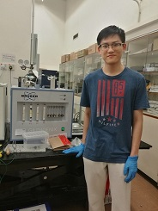
Z.H. Cao received his BSc degree in Engineering Mechanics from Shanghai Jiao Tong University, China, in 2014. He is currently studying at the University of Hong Kong as a Ph.D. candidate. His research interest focuses on hydrogen embrittlement and delayed fracture in press-hardened steel.

M.X. Huang received his Ph.D. from Delft University of Technology and is currently a professor in the Department of Mechanical Engineering, The University of Hong Kong. His research interest focus on the deformation and phase transformation mechanisms of steel.

