Precast concrete pavement applications, design and joint load transfer characteristics
Jiachen GUOª, Tak-Ming CHAN^{b,,*}, Yuhong WANGª
ª Department of Civil and Environmental Engineering, The Hong Kong Polytechnic University, Hong Kong, China
^{b} Department of Civil Engineering, The University of Hong Kong, Pokfulam Road, Hong Kong, China
* Corresponding author: tak-ming.chan@hku.hk
Abstract
Precast concrete pavement (PCP) technology represents a highly effective method for accelerating construction processes and minimising traffic disruptions. This paper provides a comprehensive overview of various PCP systems by introducing their configurations, applications, and advantages. Key design considerations are summarised, with a focus on the design of pavement slabs, base layers, and pavement joints. To further interpret joint performance, the load transfer characteristics of dowel bars are systematically analysed, including load transfer efficiency, mechanisms, and dowel group action. Both elastic and plastic models for analysing the behaviour of dowel bars embedded into concrete are explored in depth. To address critical issues such as stress concentration and steel corrosion in jointed concrete pavements, this paper recommends appropriate retrofitting approaches regarding materials and connection design. The application of finite element analysis (FEA) in modelling jointed concrete pavements is also investigated, with five typical modelling techniques introduced. Significant observations on pavement joint design are summarised in the conclusion. In the future, to align with the trend of carbon reduction and expand the application of PCP technology, the use of reusable pavement systems with demountable connections and integrated sensors is recommended. Such innovations will support the sustainable development of civil infrastructure.
Keywords: precast concrete pavement applications and design, load transfer characteristics of pavement joints, analytical models of dowel bar embedded into concrete, dowel bar retrofitting approaches, novel pavement connections, joint modelling techniques.
- Introduction
With the growth of economy and the expansion of metropolitan regions, there is a great demand for improving current urban infrastructure, especially municipal traffic systems [1]. As stated by Vaitkus et al. [2], passenger and freight transport in European countries are projected to expand by 42 % and 60 %, respectively, by 2050. However, owing to the dramatic increase in traffic volume over past the two decades, current road systems gradually undergo unavoidable damages and deterioration, thereby calling for regular rehabilitation and maintenance [1-4].
However, as onsite construction-related traffic closures always lead to severe traffic congestions in urban areas, pavement repair and rehabilitation are great ongoing challenges. Cookson [5] conducted a statistical analysis among 19 European countries and found that the total economic impact induced by traffic congestions will exceed 160 billion Euros by 2025. Therefore, highway agencies and construction industries are trying to explore viable solutions to address traffic congestions caused by rehabilitation and maintenance works and minimise the costs generated from such issues [1, 4].
Although the construction of flexible pavements is faster than that of cast-in-situ concrete pavements, short service life of these pavements may require frequent maintenance and rehabilitation [6]. However, the relatively long curing time for concrete pavements to reach the target strength is also not expected after accounting for issues induced by traffic congestions [1, 3, 6, 7]. As a result, to address the conflict between quick construction and high durability, precast concrete pavement (PCP) technology has been recommended and applied to concrete pavement rehabilitation and new pavement construction [6, 8, 9]. According to the traffic data collected by the Missouri Department of Transport (DOT), the user expenditure spent on traffic lane closures has been reduced by 25 % by applying PCP [10, 11].
The utilisation of PCP technology in new pavement construction could date back to the 1960s [12]. Generally, precast concrete units are fabricated offsite and then transported to construction sites and installed on prepared base layers. Through practical applications in various projects over the past few decades, PCP technology has been proven to be technically feasible and economically justifiable [3]. In contrast to cast-in-situ concrete pavement systems, there are several advantages of PCP systems:
- High quality of concrete: concrete mixes used in the fabrication of PCP slabs are designed by experienced workers; well-graded aggregates and the controlled water-to-cement ratio (w/c) ensure sound workability and homogeneity of concrete [1, 6, 7, 13, 14].
- Better curing condition: after concrete casting, PCP units are cured under controlled temperature and moisture [4, 13-15].
- Less weather and climate restrictions: conducting onsite concrete casting in cold and rainy conditions is challenging; while PCP slabs are cast in fabrication plants, which is less affected by temperature and climate changes [1, 7, 9, 16].
- Short traffic closure: with the application of PCP technology, curing time for concrete reaching sufficient strength is not required; and fast installation of PCP units significantly minimises the duration of traffic closure [9, 17-21].
- Low maintenance cost and high durability: high-quality precast components improve durability and wear resistance of PCP systems; as a result, maintenance cost within the pavement service life is reduced [1, 7, 22, 23].
- Low safety risks: road users and construction workers are less exposed to construction sites; therefore, construction-related safety risks are decreased [1, 6, 24-26].
To reduce disruption to local traffic, PCP construction works can be implemented at night and finish in the morning [1, 4]. According to technical reports, design guidelines and practical experience from real projects, critical design considerations for the PCP system design are constructability, concrete durability, load transfer and panel support condition [3, 4, 6, 7, 9, 27].
- Constructability: developed equipment and technologies are applied in new pavement construction and existing concrete pavement maintenance.
- Concrete durability: PCP slabs fabricated in construction plants generally exhibit excellent quality and durability.
- Load transfer at joints: PCP systems are installed with discrete load transfer devices to achieve an effective load transfer between individual pavement slabs.
- Panel support condition: stiff and well-prepared support promotes a uniform stress distribution between PCP slabs and the base layer. As a result, uneven pavement settlements and the degradation of the base layer are greatly improved.
Nowadays, although the PCP technology has been widely adopted in the pavement industry, existing literature does not comprehensively introduce PCP systems in terms of their applications and design. As one of commonly used jointing methods, dowel bars are installed to connect pavement slabs and serve as load transfer devices to transfer wheel loads. So far, although laboratory and field tests have been conducted to assess the local performance of dowel bars and the overall behaviour of pavement systems, there are still some research gaps to be filled in the pavement joint design, including:
- Joint load transfer characteristics: further research is required to fully understand the load transfer characteristics of dowel bars, including the efficiency and mechanisms of load transfer, and the behaviour of dowel groups in transferring wheel loads.
- Analytical models: a lack of analytical models to predict the behaviour of the dowel bar embedded into concrete considering both elastic and plastic states.
- Joint performance and durability: there are needs for in-depth studies on critical issues that influence the performance of PCP systems, particularly focusing on stress concentration, steel corrosion, and investigating various retrofitting approaches.
- Advanced modelling techniques: there is a gap in developing advanced and accurate modelling techniques that can better predict the behaviour of jointed pavement systems.
- Novel pavement connections: the existing literature does not summarise other pavement connections that can overcome the shortcomings of dowel bars.
Therefore, to fill the gaps mentioned above, a comprehensive review is conducted to systematically explore the PCP systems. As introduced in Fig. 1, applications and design requirements of PCP systems are introduced and compared. The joint characteristics of dowel bars are discussed from various aspects, in which both the elastic and plastic analytical models are clearly introduced. To address stress concentration and steel corrosion issues, existing dowel bar retrofitting approaches are also recommended from alternative dowel bar materials, shapes and other novel pavement connections. Available joint modelling techniques are also classified into five categories according to different types of elements used.
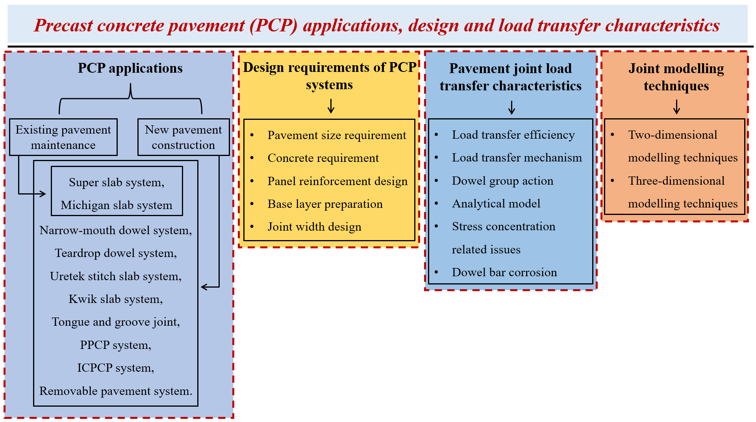
Fig. 1. Layout of the review on precast concrete pavement systems.
- Applications of PCP systems
The applications of PCP systems can be roughly divided into two categories including existing pavement maintenance and new pavement construction [1, 4, 22, 24, 28]. These two parts will be introduced in the following subsections.
  - Existing pavement maintenance
There are four primary requirements that should be satisfied in pavement maintenance with the application of PCP systems [4, 24].
- Preparing a strong and firm base for panel installation.
- Providing effective load transfer devices between new panels and existing pavements.
- Controlling the elevation difference between new panels and existing pavements.
- Ensuring long service life of rehabilitated concrete pavements.
Considering the situations of different base layers, the following installation methods are recommended to carry out pavement repair works [4].
- If the original pavement base is intact and well compacted, new panels can be directly placed on the base layer.
- If the pavement base is partially damaged, PCP panels are designed to be thinner than the existing pavement. Expandable polyurethane foam or other grouting materials are used to level the base layer and raise panels to the same level as existing pavements.
Different types of PCP systems have been employed in highway pavement repair. Fig. 2 introduces the super slab system applied in pavement maintenance. The damaged section is cut and removed. Then horizontal holes are drilled in existing pavements to accommodate dowel bars. After placing PCP panels on the support, flowable bedding materials are grouted into bottom slots from the top surface. Due to the rapid hardening characteristic of grouting materials, repaired pavements can be reopened within a few hours.
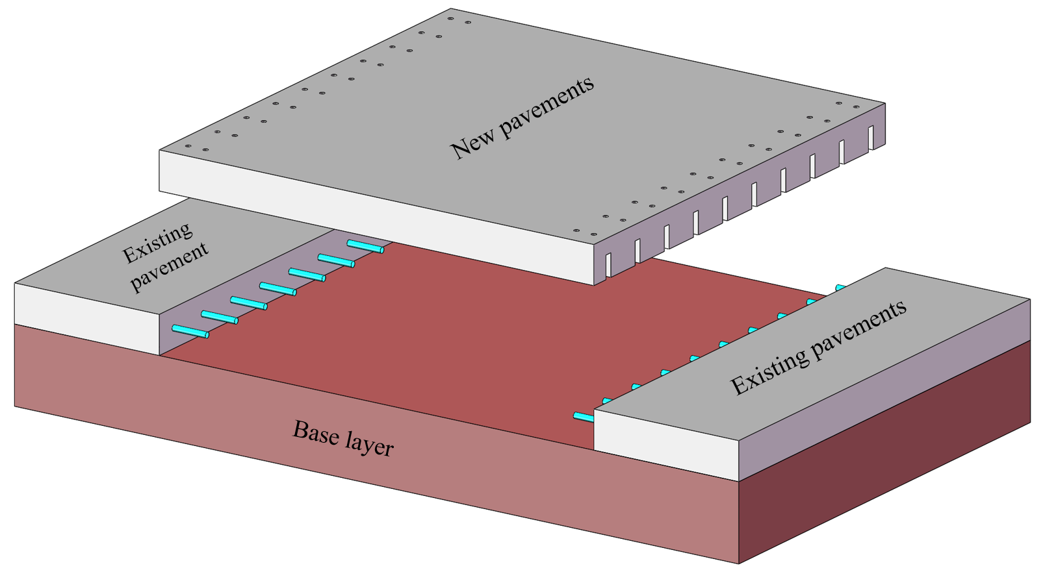
Fig. 2. Super slab system in road repairing work.
Besides, the Michigan slab system is also a viable solution to repair existing pavements. In contrast to the super slab system, before the installation of the Michigan panels, vertical slots are firstly created on the top surface of the existing pavement as shown in Fig. 3(a). Then precast Michigan panels with embedded dowel bars are installed on the prepared base layer as described by Fig. 3(b). Fast-setting materials are then used to fill grouts and fix dowel bars as displayed in Fig. 3(c) [1, 24, 26, 29].
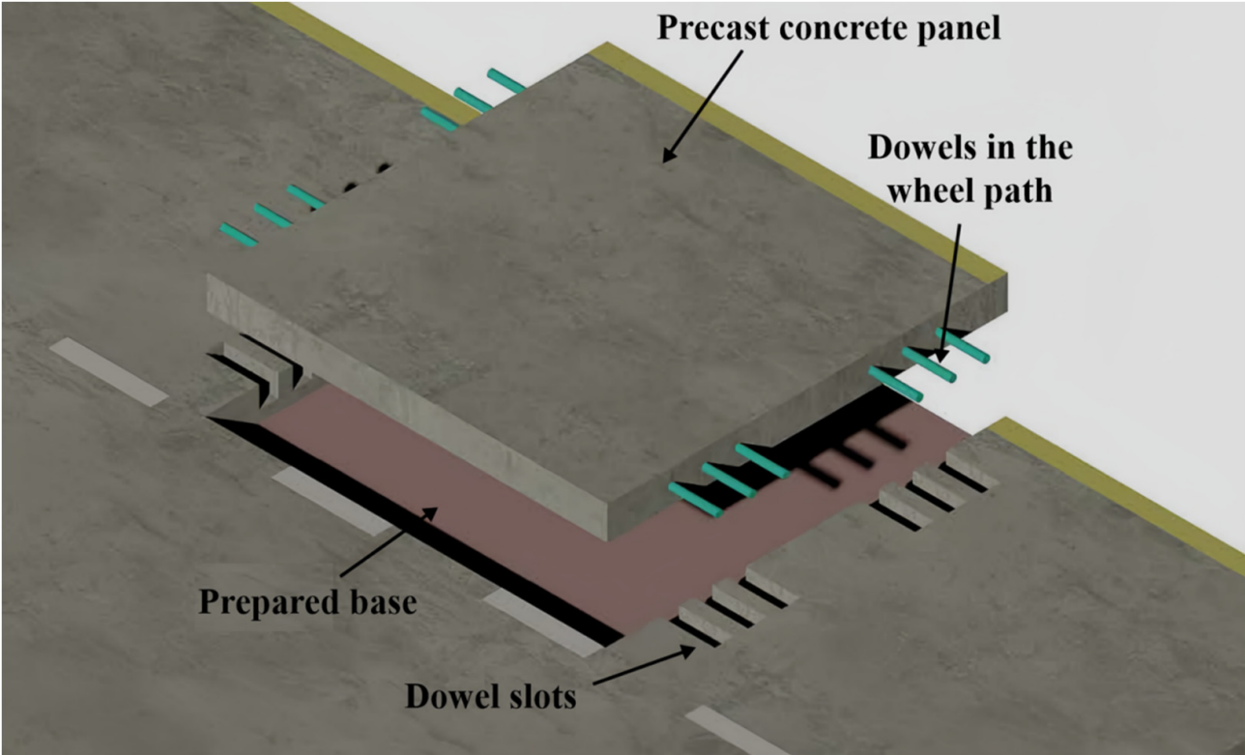 | 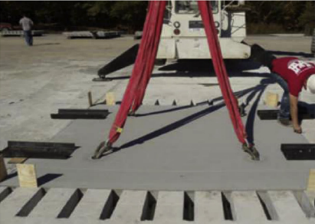 | 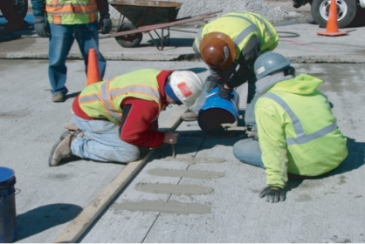
(a) | (b) | (c)
Fig. 3. Michigan slab system in pavement maintenance (a) existing pavement with top slots [4], (b) installation of precast Michigan slab [26], (c) grouting fast-setting material [24].
In repairing existing pavements, the quality of the maintenance with the application of PCP systems primarily depends on the prepared base layer and fast-setting grout materials. If the compressive strength of the grouting material is not sufficient after traffic reopening, premature failures may occur under repeated loads [1, 4, 7].
  - New pavement construction
Apart from pavement maintenance, PCP technology can also be applied in new pavement construction. Basically, PCP systems adopted in new pavement construction can be classified into three categories including jointed precast concrete pavement (JPrCP) systems, prestressed precast concrete pavement (PPCP) systems as well as incrementally connected precast concrete pavement (ICPCP) systems [1, 4, 6, 7, 9, 30]. Owing to excellent durability, the application of PCP technology to build removable pavement systems is also a promising strategy to reuse existing pavement slabs and thus reduce construction waste generation [8, 21, 23].
    - Jointed Precast concrete pavement (JPrCP) systems
To achieve the effective load transfer between pavement slabs, epoxy-coated steel bars are always installed along pavement transverse joints. There are several JPrCP systems that have been applied in practice [1, 6-9, 20, 22].
      - Super slab system
The super slab system developed by Fort Miller Company can also be applied in new pavement construction [6, 8]. Two types of PCP pavements including the male slab with embedded dowel bars and the female slab with bottom slots and are fabricated offsite. The application of the super slab system in new pavement construction is shown in Fig. 4. After placing the male and the female panels on the prepared base, fast-setting materials are grouted through top grouting channels.
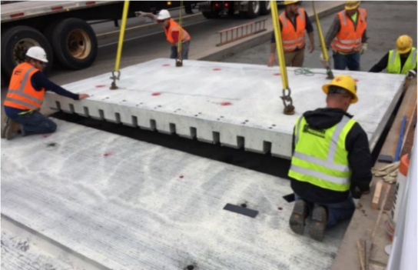 | 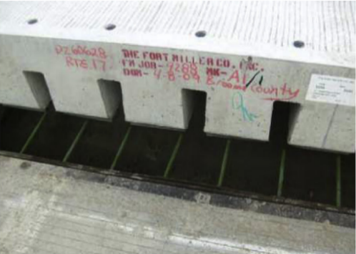
(a) | (b)
Fig. 4. Installation of super slab panels (a) female panel lifting and installation, (b) male panel with dowel bars [31, 32].
      - Michigan slab system
Michigan slab system is also available in new pavement construction. After transporting slab units to construction sites, panels with top grooves and with embedded dowel bar are placed on the prepared base layer sequentially. Fast-setting materials are then adopted to fill grooves [6, 7, 9, 22]. Fig. 5 introduces the installation procedure of the Michigan slab system in new pavement construction. Compared with the super slab system, top grooves in PCP panels facilitate material grouting and quality control, so that the durability of the constructed pavements can be significantly improved.
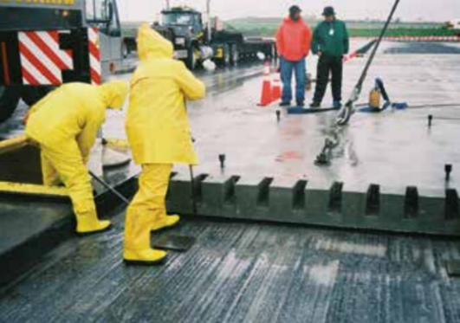 | 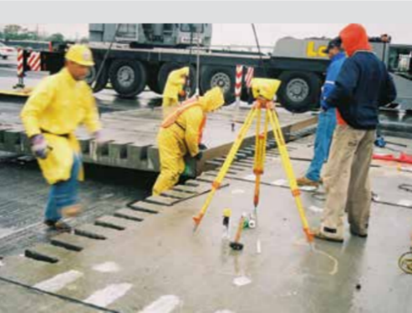
(a) | (b)
Fig. 5. Applying precast Michigan slabs in new pavement construction, (a) installation of precast slab with grooves, (b) installation of precast slab with dowel bars [4].
      - Narrow-mouth dowel system
As shown in Fig. 6, the narrow-mouth dowel system is developed based on the concept of the super slab system, with the width of slots equal to 1 in (25.4 mm) on the top surface [20]. Prior to material grouting, this PCP system can be used for temporary traffic [8, 20]. On construction sites, dowel bars are firstly installed into pavements with narrow slots. After placing the panel with drilled holes on the prepared base layer, embedded dowel bars are slid into horizontal holes in the adjacent panel. Fast-setting grouting materials are then utilised to fill slots and fix embedded dowel bars.
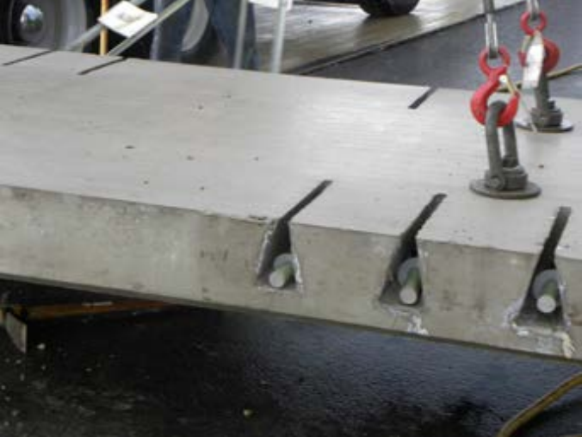
Fig. 6. Precast concrete pavement (PCP) panel with narrow-mouth dowel system [20].
      - Teardrop dowel system
The teardrop dowel system is also a viable alternative to achieve an effective load transfer between PCP slabs [20]. Fig. 7 describes the configuration of the PCP slab with the teardrop dowel system which is similar to the narrow-mouth dowel system. The only difference is the shape of the dowel slot. Applying a circular slot to replace the original triangular slot can mitigate stress concentration related issues and thus expand the service life of the PCP system.
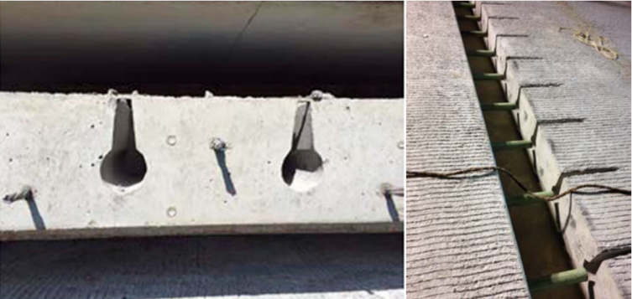
Fig. 7. PCP panel with teardrop dowel system [20].
      - Uretek stitch slab system
The Uretek stitch slab system is an innovative PCP system and the load transfer between adjacent slabs is achieved through the proposed Uretek stitch devices [33]. Fig. 8(a) and (b) shows the Uretek stitch connection device made of glass fibre reinforced polymer (GFRP) [31], which exhibits the excellent corrosion resistance because of anti-corrosion properties. After installing the Uretek stitch devices into top slots, fast-setting grouting materials are then used to fill top slots as shown in Fig. 8(c). The stagger-arranged holes in the Uretek stitch device greatly improve the interlocking effect between connection devices and grouting materials, thereby ensuring high load transfer ability.
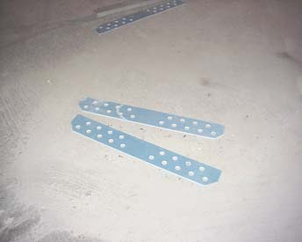 | 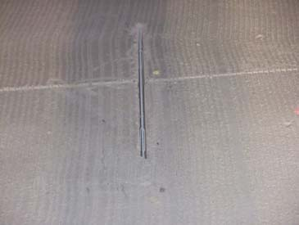 | 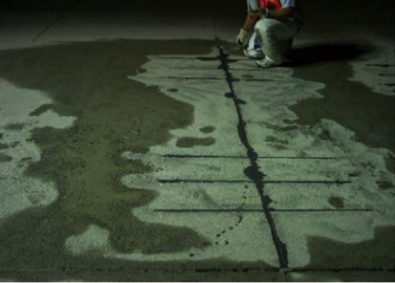
(a) | (b) | (c)
Fig. 8. Uretek stitch slab system (a) uretek stitch connection device [30], (b) install uretek stitch connection device in top slots [30], (c) fill top slots with grouting materials [33].
      - Kwik slab system
The Kwik slab system belongs to a proprietary precast concrete pavement system which consists of the Kwik joints and the embedded steel couplers [16, 22, 30]. The steel coupler in the PCP panel is shown in Fig. 9(a). After splicing individual PCP panels on the prepare base, as described in Fig. 9(b), the interlock between precast slabs is achieved by the Kwik joints and the embedded steel couplers. Once the installation process is finished, fast-setting grouting materials are used to fill steel couplers and pavement joints as shown in Fig. 9(c).
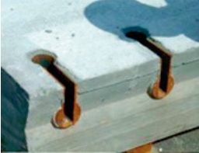 | 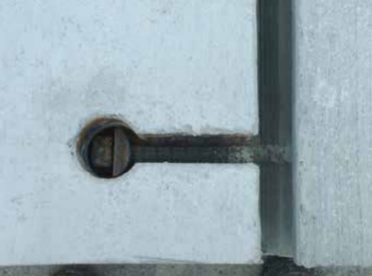 | 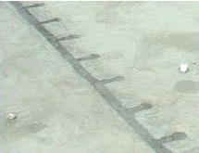
(a) | (b) | (c)
Fig. 9. Kwik slab system (a) steel coupler in the PCP panel [22], (b) interlock effect in Kwik slab system [16], (c) fast-setting material grouting [30].
    - Tongue and groove joint
Tongue and groove joint is also a reliable load transfer device to transfer wheel loads from the loaded slab to the unloaded slab as shown in Fig. 10 [34]. According to experimental test results, it was observed that the maximum tensile stress in pavement slabs and pavement joint deflections were effectively reduced after applying tongue and groove joints [35, 36]. Yan and Peng [37] analysed the mechanical behaviour of circular tongue and groove joints through finite element analysis (FEA). Fig. 11 shows the profile of this joint and the span-to-vector ratio is defined as the tongue width (a) over the tongue height (b). Results of FEA indicated that the best load transfer ability was achieved with a span-to-vector ratio of 3.5. Qu et al. [38] experimentally studied the structural behaviour of the prestressed precast airport pavement system with tongue and groove joints as shown in Fig. 12. Results revealed that an effective load transfer was achieved with the application of tongue-and-groove joints and prestress. Compared with the central locations, the edges of pavement joints showed relatively poor load transfer ability under vertical loads.
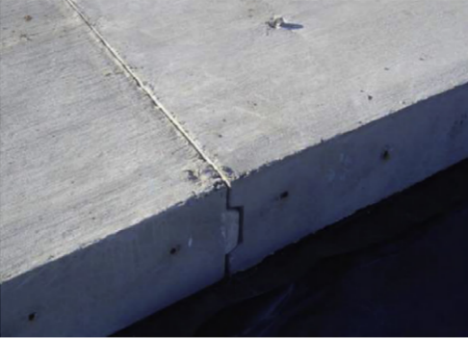 | 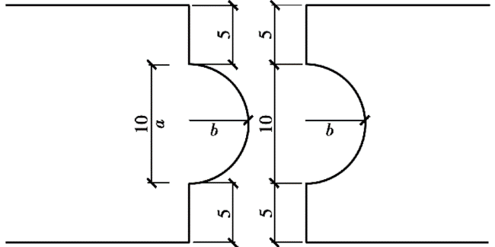
Fig. 10. Tongue and groove joint applied in PCP systems [34]. | Fig. 11. Profile of the circular tongue and groove joint.
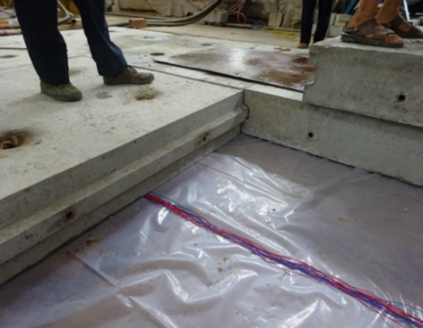 | 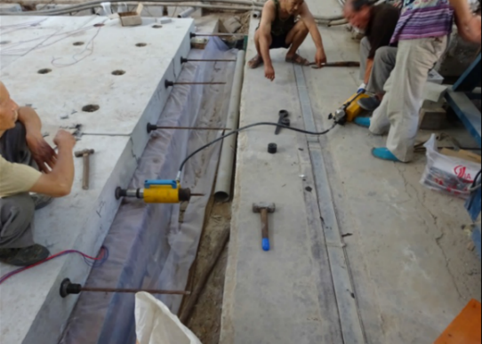
(a) | (b)
Fig. 12. Tongue and groove joint applied in prestressed precast airport pavement system (a) tongue and groove joint, (b) applying prestress [38].
    - Prestressed precast concrete pavement (PPCP) systems
Prestressed precast concrete pavement systems (PPCP) are also viable solutions to new pavement construction and are extensively applied in different countries [39]. The main purpose for incorporating prestress in PCP systems is to improve the tensile resistance of concrete and prevent the initiation of tensile cracks during transportation, installation and under heavy wheel loads [1, 4, 8, 19, 38-40].
In general, the construction of PPCP systems has used both pre-tensioning and post-tensioning prestressing technologies [1, 3, 4, 9, 19, 39, 41]. When fabricating pavement slabs in factories, pre-tensioning technology is applied before concrete casting as shown in Fig. 13(a) and (b) [41]. After cured to the target concrete compressive strength, PPCP panels are transported to construction sites, at which these panels are post-tensioned along the longitudinal direction as depicted in Fig. 14 [42].
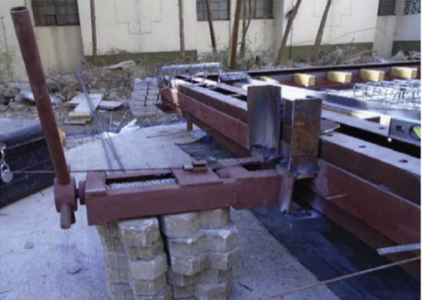 | 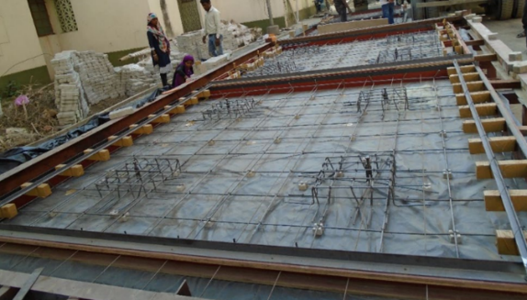
(a) | (b)
Fig. 13. Applying pre-tensioning prestress before concrete casting (a) applying prestress, (b) PCP panel formwork with prestressed reinforcement [41].

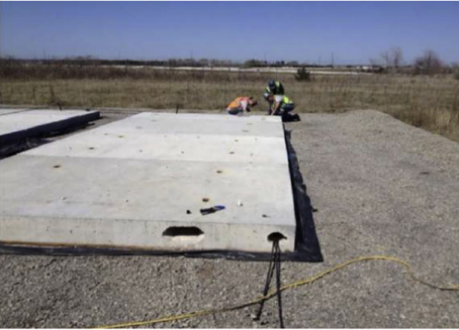
Fig. 14. Applying post-tensioning prestress on construction sites [42].
In practice, three types of PPCP systems have been developed in terms of the prestressing locations, namely the central stressing at top surface, the end stressing at top surface as well as the end stressing at the vertical joint surface [1, 4, 9]. For PPCP systems with the central and end prestressing at top surface, as shown in Fig. 15(a) and (b), the posttensioning prestresses are applied from the top slot of central and end PPCP panels, respectively. Regarding the end stressing at the joint surface, prestress is applied at the joint surface of end PPCP panels and gap slabs are installed to connect PPCP panels as depicted in Fig. 15(c).
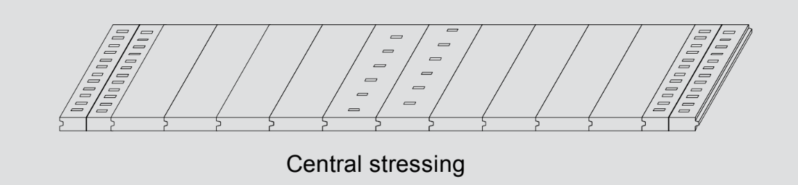
(a)
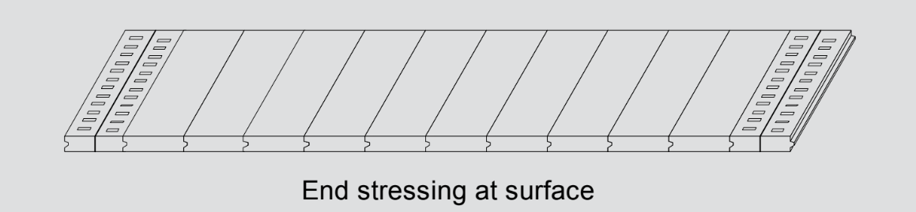
(b)
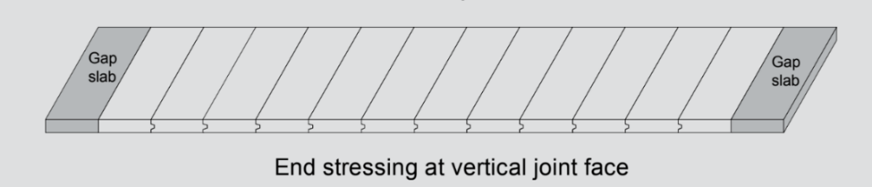
(c)
Fig. 15. Prestressed precast concrete pavement (PPCP) systems (a) central stressing, (b) end stressing at surface, (c) end stressing at the vertical joint surface [4].
    - Incrementally connected precast concrete pavement (ICPCP) systems
Incrementally connected precast concrete pavement (ICPCP) systems are similar to JPrCP systems that consist of PCP slabs and effective load transfer devices. However, the typical difference between these two pavement systems is the number of active joints. In JPrCP systems, all transverse joints are active joints. While in ICPCP systems, most joints are locked, and active joints are only placed at a large spacing. Fig. 16 shows the typical ICPCP system, in which individual precast panels are connected by dowel bars [4]. As the length of the PCP unit in ICPCP systems is shorter than those in PPCP and JPrCP systems, the ICPCP system is suitable for temporary applications that call for less requirements on the base layer flatness [6].
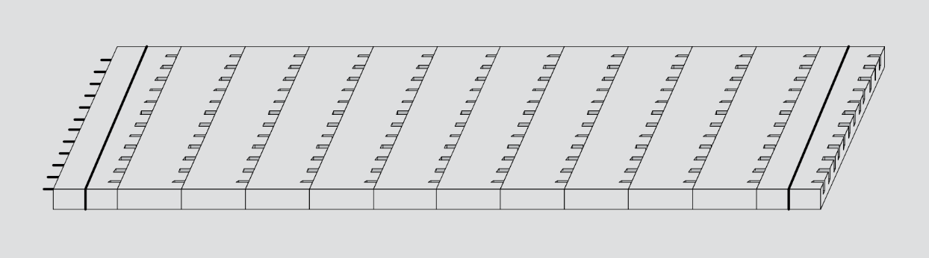
Fig. 16. Incrementally connected precast concrete pavement (ICPCP) systems [4].
    - Removable pavement systems
In pavement industry, the application of PCP slabs to achieve the reusability of pavement systems is an efficient approach to minimise the generation of construction waste. However, due to the lack of demountable load transfer devices, removable pavement systems can be only applied in light traffic scenarios. Fig. 17 introduces a common removable pavement system consisting of hexagonal-shaped PCP panels [21, 23]. Discrete rectangular PCP panels can also serve as reusable pavements to facilitate temporary construction work as shown in Fig. 18 [8, 43].
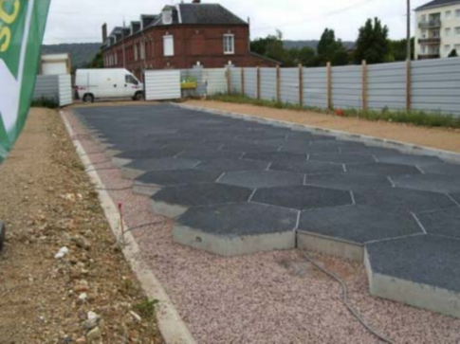 | 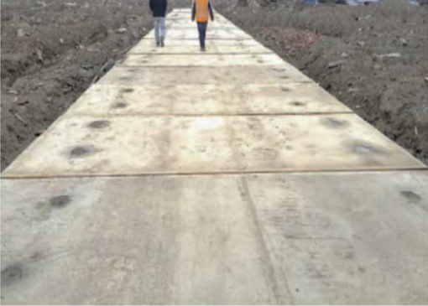
Fig. 17. Hexagonal-shape removable PCP system [23]. | Fig. 18. Rectangular precast reinforced concrete pavement slab [43].
By introducing different types of PCP systems from configurations and applications, the advantages and disadvantages of each type of pavement system are compared as reported in Table 1. The load transfer between pavement slabs is achieved through three different approaches including dowel bars, tongue and groove joints and aggregate interlock, among which dowel bars are most effective in load transfer due to the close contact with surrounding concrete. However, in spite of widespread applications in PCP systems, dowel bars always suffer premature failures caused by misalignments, temperature changes and stress concentration. The installation of dowel bars also makes pavement slabs difficult to be reused in different situations. Although tongue and groove joints enable slabs to be demounted, the requirement for large construction space to remove pavement slabs from both sides cannot be easily satisfied. So far, removable pavement systems without loading transfer devices are only adopted for temporary situations with light traffic. To extend their applications, PCP systems are suggested to be equipped with demountable load transfer devices, so that wheel loads can be effectively transferred.
Table 1. Comparison of Precast concrete pavement (PCP) systems.
Types of PCP systems | Advantages | Disadvantages
Jointed Precast Concrete Pavement (JPrCP) systems | - Reliable load transfer ability  - Mature construction methods  - Multiple types | - Premature joint failure  - Durability issues  - Non-reusable
Tongue and groove joints | - Simple to construct  - Reusability of precast pavement slabs | - Less effective load transfer  - Premature joint failure  - Large construction space
Prestressed precast concrete pavement (PPCP) systems | - Effective load transfer  - Light weight  - High integrity  - High durability | - Complex construction techniques  - High construction cost  - Construction safety  - Loss of prestress
Incrementally connected precast concrete pavement (ICPCP) systems | - Flexible panel length  - Less active joints | - Sensitive to temperature and climate change  - Premature joint failure  - Non-reusable
Removable pavement systems | - Simple and fast to construct  - Mature construction methods  - Temporary applications | - Less effective load transfer
- Design considerations of PCP systems
On the basis of the fabrication, transportation and installation of PCP panels, specific design considerations are discussed from the panel size, concrete requirements, reinforcement design, base layer preparation as well as joint width design five perspectives.
  - Panel dimension requirements
The dimension of PCP panels has significant influences on the transportation cost and maximum flexural stress induced during the panel lifting [1, 3, 6, 7, 31]. Generally, the width of the prefabricated concrete pavement slabs is smaller than the common lane width. While for the panel length, it generally depends on the types of PCP panels. For JPrCP systems, the panel length normally ranges from 1.8 m to 4.6 m [1, 9]. However, for PPCP slabs, the incorporation of prestress extensively enhances the tensile resistance of concrete and therefore mitigates the crack initiation. According to design recommendations suggested by Tayabji et al. [1], the maximum length of PPCP panels is up to 6.1 m.
  - Concrete requirements
The quality of concrete in fabricating PCP panels is of great importance on the structural performance of PCP systems. Generally, there is no significant differnece in concrete material properties between PCP systems and cast-in-situ pavements. Basic requirements of concrete are summarised in Table 2 as recommended by Tayabji et al. [1].
Table 2 Concrete requirements for precast concrete pavement systems.
Concrete material properties | Recommendations
Cylinder compressive strength | 27.5 MPa
Flexural strength | 4.5 MPa
Water to cementitious ratio (w/c) | 0.5 in non-freeze areas, 0.45 in freeze areas
Workability | Slump: 150 mm to 200 mm
  - Panel reinforcement design
Regarding panel reinforcement, it is not as significant as the design requirements of concrete. The main role of the reinforcement in PCP units is to resist the flexural stress induced during the panel lifting and to restrict the propagation of horizontal cracks. Basically, the amount of reinforcement in PCP panels is about 0.2 percent of the cross-section area of PCP panels along both longitudinal and transverse directions.
  - Base layer design requirements
The base layer is another component that affects the long-term structural performance of the PCP system. A firm and uniform base can effectively transfer compressive stress between the panel and base layer [1, 4, 7, 8, 24, 44-46]. According to different applications of PCP systems, the base layer design requirements are roughly divided into two aspects including existing base handling and new base construction.
    - Existing base handling
Treatment of existing pavement base layers is a primary concern in concrete pavement maintenance. An additional interlayer had better be placed between the bottom surface of PCP panels and a base layer to ensure a close contact. In general, the treatment of base layers, namely the base preparation method (BPM), is roughly divided into three categories considering various filling materials [1, 3, 4, 6, 9, 23, 45, 47]:
- Flowable fill
Flowable cementitious grouting materials with excellent workability are recommended to level the existing base layer. The high flowability of grouting materials can ensure the flatness of the rehabilitated base layer.
- Polyurethane foam
Due to the inherent swelling characteristic, the application of polyurethane foam can lift PCP panels to the target height. After placing precast panels at target locations, polyurethane foam is injected through drilled holes to the bottom surface of PCP slabs.
- Granular bed
Granular bed, characterised by the flexible deformation and easy compaction, is also applicable to create a bedding layer between PCP panels and the base layer [1, 4, 6, 7, 9, 16, 22]. Before laying PCP panels, common granular bed, namely cement sand cushion, must be well compacted to provide a uniform and firm support.
    - New base construction
For new base construction, to ensure the proper seating of PCP panels, two types of supports are suggested including dense-graded, free-draining granular base and rapid setting lean concrete base (RSLCB) [4, 6, 8, 9, 22, 24, 31, 32, 47].
In the construction of a granular base, compactness and moisture are two main factors that influence the performance of pavement support. The moisture of granular materials must be seriously controlled to ensure the maximum compaction density. In terms of RSLCB, it is not frequently applied as granular bases due to durability and strength requirements [1, 4, 7]. Generally, RSLCB is mixed in plants and then transported to construction sites. Because of superior workability, flowable RSLCB is easy to be placed and screeded. Cylinder compressive strength requirements of RSLCB at different stages are summarised below [1].
- After curing concrete for two hours at panel installation: at least 0.7 MPa.
- At the time of traffic reopening: at least 3.4 MPa.
- After curing concrete for 7 days: at least 5.2 MPa.
  - Joint width design
In jointed concrete pavement systems, well-designed joints can accommodate pavement slabs free to shrink and expand without inducing any stress [1, 27, 48-52]. There are three main types of joints including contraction joint, expansion joint as well as construction joint in jointed concrete pavements [1, 27, 53, 54]. According to the primary function of each type of joint and the mechanical properties of concrete, contraction joint design is the most critical to prevent the initiation of horizontal tensile cracks. Table 3 summarises pavement joint width requirements recommended in various design codes [1, 27, 55, 56], in which the majority of pavements are generally designed with joint widths from 0.25 in to 0.5 in.
Table 3 Joint width requirements.
Design code | Joint width
Guide for Design of pavement structures (AASHTO 1993) [28] | 1/4 in, 1/2 in
Guide for Design of Jointed Concrete Pavements for Streets and Local Roads (ACI 325) [56] | 6 mm
Standard Method of Test for Coated Dowel Bars (AASHTO T253) [57] | 3/8 in
Precast Concrete Pavement Technology [1] | 3/8 in to 1/2 in
- Pavement joint load transfer characteristics
Because of discontinuity, pavement joints are vulnerable regions which are susceptible to premature damages within pavement service life [51, 57-61]. To promote load transfer between pavement slabs, load transfer devices are installed along transverse joints to improve the integrity of the whole pavement.
  - Load transfer efficiency
Pavement joint load transfer ability can be evaluated from deflection and stress two perspectives [48-51]. For the deflection-based load transfer efficiency (LTE), two definitions are considered as expressed by Eqs. (1) and (2), where δ_{unloaded} and δ_{loaded} are deflections of the unloaded pavement slab and the loaded pavement slab, respectively [27, 48-51]. Regarding the stress-based LTE, it is assessed based on the flexural stress caused in the pavement slab as expressed by Eqs. (3) and (4), where σ_{unloaded} and σ_{loaded} are the maximum flexural stresses of the unloaded and the loaded slabs, respectively [48-51].
  - Dowel bar load transfer mechanism
Among various connections applied in jointed concrete pavements, epoxy-coated steel dowel bars are frequently adopted to transfer vertical loads between pavement slabs [1, 7, 8, 27, 32]. As shown in Fig. 19(a), the effective load transfer is achieved through the relative deflection between adjacent slabs. Because of high stiffness, surrounding concrete could provide a rigid support for embedded dowel bars [57, 61, 62]. However, due to a limited contact area between the dowel bar and concrete, high bearing stress is caused in concrete around the dowel slot. To balance this bearing stress, concrete is subjected to high tensile stress at both sides of the dowel slot. Fig. 19(b) plots the distributions of compressive and tensile stresses of concrete along the dowel slot [63]. It is found that high compressive and tensile stresses are concentrated at the pavement joint and reduce rapidly with the increase of the distance from the joint surface.
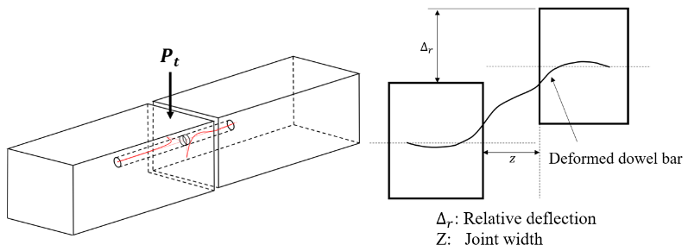
(a)
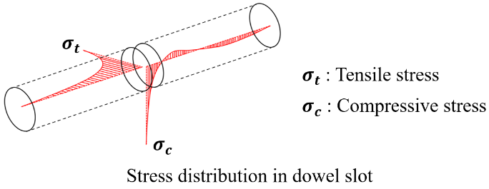
(b)
Fig. 19. Load transfer mechanism of jointed concrete pavement (a) load transfer mechanism, (b) stress distribution within dowel slot [63].
  - Dowel group action
Dowel group action indicates the shear force distribution among dowel bars in transferring wheel loads [64-69]. Westergaard [64] and Sutherland [65] demonstrated that only the two closest dowel bars near the wheel could achieve an effective load transfer. However, Friberg et al. [66] indicated that the applied load was transferred by dowel bars within a distance of 1.8l_{r} at each side and l_{r} referred to the radius of the relative stiffness computed by Eq. (5), where h is the thickness of the concrete slab, E_{c} is the modulus of elasticity of concrete, μ is the Poisson’s ratio of concrete and k_{s} is the support stiffness. As shown in Fig. 20, the maximum shear force is transferred by the critical dowel bar under the wheel and the forces transferred by other dowel bars are reduced linearly as the distance from the wheel load increases [66]. However, although the linear shear force distribution was also suggested by Tabatabaie and Barenberg [67] and Heinrichs et al. [68], the range of the force distribution at each side should be 1.0l_{r} rather than 1.8l_{r}.
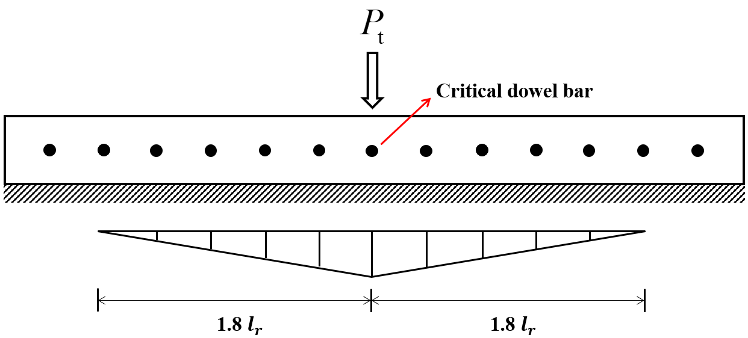
Fig. 20. Dowel group action with linear force distribution.
Despite that the linear shear force distribution is straightforward to determine the force transferred by each dowel bar, this distribution was challenged by Maitra et al. [69], who insisted that the dowel group action should follow a parabolic-shape distribution and the shear force transferred by the critical dowel bar depended on the radius of the relative stiffness l_{r}, the dowel bar spacing and the moduli of elasticity of steel and concrete.
  - Analytical models of dowel bar embedded into concrete
To quantify the shear force transferred by the dowel bar embedded into concrete, the corresponding analytical models under both elastic and plastic states have been proposed.
    - Elastic model
The elastic model of the dowel bar embedded into concrete is described by the Friberg’s theoretical analysis developed based on the Timoshenko’s infinite beam on Winkler foundation model [57, 66, 67, 70]. In this model, dowel bar and concrete are simulated by the elastic beam and the Winkler foundation, respectively. Eq. (6) expresses the differential equation of the Friberg’s theory, which is derived based on the free body diagram of a beam element as shown in Fig. 21, where k is the reaction of dowel support (N/mm²), y is the vertical deformation of the dowel bar, E is the modulus of elasticity of dowel bar and I is the moment inertia of dowel bar.
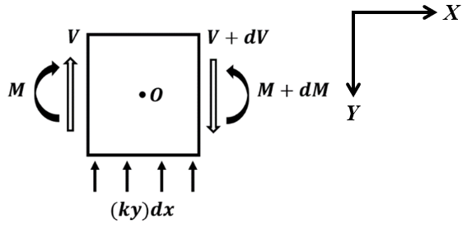
Fig. 21. Beam element free body diagram.
By solving Eq. (6), the vertical deformation of dowel bar is derived as Eqs. (7) and (8), where, β is the relative stiffness of dowel bar; is the modulus of dowel support (N/mm³); d is the dowel bar diameter; A, B, C and D are four coefficients determined by considering boundary conditions.
After taking into account the transferred shear force P_{t} and no vertical deformation when x→∞, Eqs. (9) to (11) are then derived, where M₀ is the moment of the dowel bar at the joint surface; z is pavement joint width; y₀ is the vertical deformation of the dowel bar at the joint surface.
In order to calculate k₀, y₀ is firstly calculated by the relative deflection between the loaded and the unloaded blocks. As shown in Fig. 22, the relative deflection Δ_{r} consists of four components including the vertical deformation y₀ at the joint surface, the deformation due to the slope of the dowel bar zdy₀/dx, the flexural deformation P_{t}z³/12EI and the shear deflection δ.
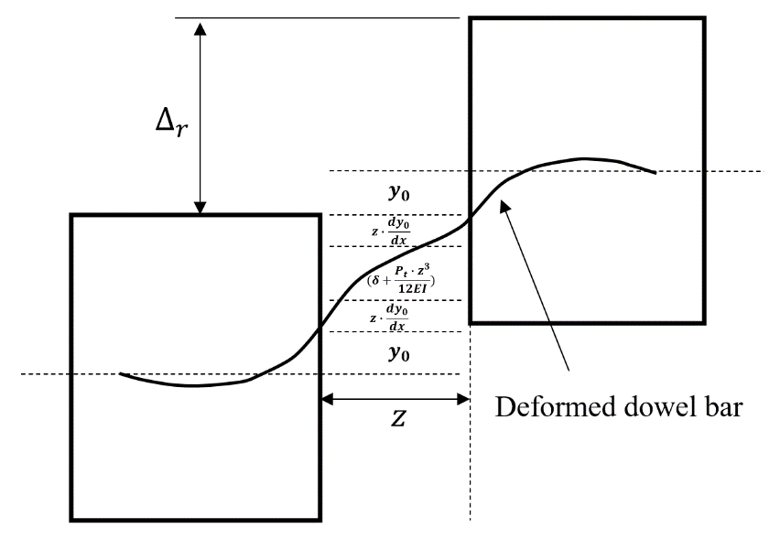
Fig. 22. Relative deflection between two concrete blocks [71].
To simplify the calculation, the flexural deformation and the deformation due to the slope of the dowel bar are always neglected [57, 66, 72]. Thus, Eq. (12) is finally derived to calculate y₀ and, once determining k₀ through Eqs. (8) and (11), the maximum concrete compressive stress σ₀ at joint surface is determined by Eq. (13), where, δ=λP_{t}z/AG; λ is the dowel bar shape factor equal to 10/9; A is the cross-section area of the dowel bar; G is the shear modulus.
    - Plastic model
The plastic model of the dowel bar embedded into concrete can be studied by considering the deformations of the dowel bar and surrounding concrete. As suggested by Rasmussen [73], under the ultimate load, a plastic hinge tended to develop in the dowel bar and localised concrete crushing occurred at the pavement joint surface. Eqs. (14) to (16) were proposed to determine the ultimate load of dowel bar embedded into concrete with and without considering the pavement joint width, where V_{F,max} is the maximum shear force transferred by the dowel bar, k₁ is a coefficient equal to 1.3, f_{y} is the yield strength of the dowel bar, f_{c} is the cylinder compressive strength of concrete.
Vintzēleou et al. [74] also recommended similar expressions to determine the ultimate load of the dowel bar embedded into concrete under vertical loads. Considering the confinement effect provided by surrounding concrete, as indicated in Eq. (17), the maximum compressive strength of concrete was greatly increased and could be evaluated with a strength improvement factor β_{c}. After taking into account the force and moment diagrams of the dowel bar as shown in Fig. 23, Eqs. (18) and (19) were derived by Guo et al. [75] to calculate the maximum force transferred by the embedded dowel bar, where M_{max} is the maximum moment of the dowel bar at the plastic hinge, l₀ is the distance between the plastic hinge and the pavement joint surface. Furthermore, under the ultimate limit state, the maximum moment at the plastic hinge M_{max} is also equal to the plastic moment resistance of the dowel bar as expressed by Eq. (20). Therefore, the maximum shear force V_{F,max} can be calculated through Eqs. (21) to (23). However, since there is no theoretical analysis model to obtain the strength improvement factor β_{c}, researchers generally adopted different values which could better fit their test results. Rasmussen [73] firstly recommended β_{c} ranging from 3 to 5 after considering the confinement effect. And Randl [76] insisted that this value should be 3 to 4 times the cube compressive strength of concrete. However, Zhao et al. [77] stated that β_{c} equal to $\sqrt{3}$ could provide accurate predictions for his test results. In the future, to generate an accurate prediction, a comprehensive expression to calculate consistent β_{c} considering different types of concrete and dowel bars should be proposed.
The elastic and plastic models summarised in this section can accurately predict the structural behaviour of the dowel bar embedded into concrete under both the service limit state and the ultimate limit state. After calculating the maximum shear force that can be undertaken by an individual dowel bar, the total shear force transferred by the transverse joint can be determined by taking into account the dowel group action.
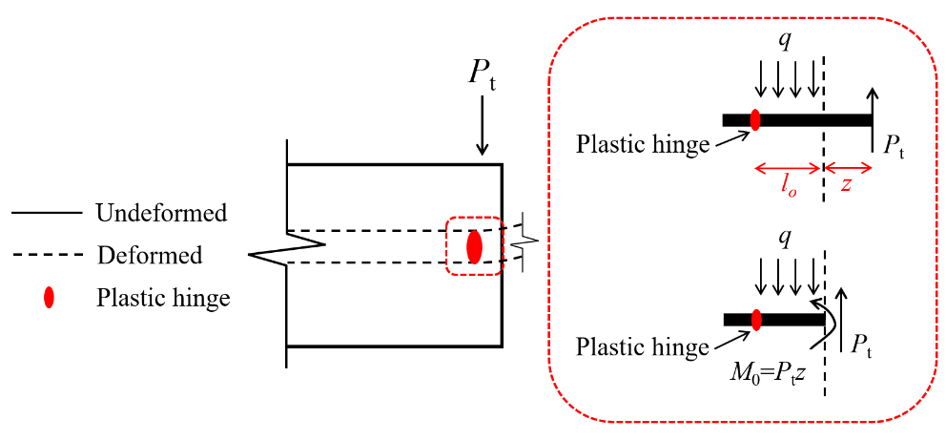
Fig. 23. Force and moment diagrams of dowel bar embedded into concrete [75].
  - Stress concentration in dowel bar application
Although dowel bars have been applied as effective load transfer devices for more than 100 years [54], concrete around the dowel bar always suffers high compressive and tensile stress concentration in transferring wheel loads. Therefore, to better investigate the effects of stress concentration on the behaviour of the dowel bar embedded into concrete, the related work conducted by others is comprehensively reviewed in this section.
    - Compressive stress concentration
After millions of load repetitions, compressive stress concentration in concrete around dowel bars causes localised concrete crushing, thereby resulting in the loss of joint stiffness and the reduction of LTE [78-81]. Ioannides et al. [81] conducted a two-dimensional FEA to determine the maximum concrete compressive stress in jointed concrete pavements after considering LTE, dowel bar diameter and spacing of dowel bars. With a similar modelling technique, Guo et al. [82] numerically studied the maximum concrete bearing stress in the vicinity of the critical dowel bar. The effects of the modulus of elasticity of concrete, the subgrade stiffness and the slab thickness on the concrete bearing stress were studied. After the development of high-speed computers, Mackiewicz [83] implemented three-dimensional FEA to investigate the interaction between dowel bar and concrete. FEA results revealed that considerable compressive stress concentration occurred around the dowel slot at the joint surface. With the FEA data, the relationship among dowel diameter, LTE and maximum concrete compressive stress was developed and visualised by 3D maps [83]. Three-dimensional FEA carried out by other researchers also indicted that high compressive stress was concentrated at the top and bottom of the dowel slot [59, 60, 84-86]. Riad et al. [84] studied the pavement joint performance through three-dimensional FEA, by which the state of stress at the dowel-concrete interface was clearly plotted as displayed in Fig. 24(a). It was clearly observed that compressive stress concentrated on the top of the dowel slot while tensile stress focused at both sides. Guo and Chan [87] also numerically investigated the concrete crushing failure at the pavement joint surface. As shown in Fig. 24(b), the localised crushing zone around the joint could be reproduced by using the compression damage variable (D_{c}) which was defined in the concrete damaged plasticity (CDP) model. The calculation of the maximum bearing stress in concrete can be done by two steps [82]. The first step is to calculate the maximum shear force transferred by the critical dowel bar. Then the second step is the determination of the maximum bearing stress of concrete with the application of the elastic analytical model of the dowel bar embedded into concrete. Nevertheless, because the Friberg’s theoretical analysis model cannot describe compressive stress concentration at the top and bottom of the dowel slot, the modified Friberg’s theoretical analysis model proposed by Guo and Chan [71] should be adopted to accurately capture the true contact stress distribution within the dowel slot and calculate the maximum concrete compressive stress.
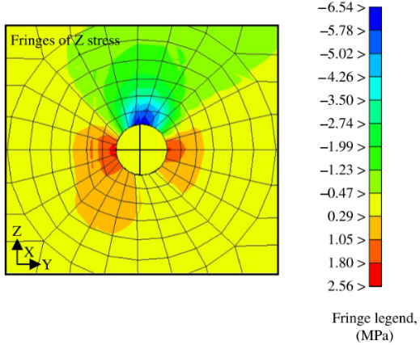 | 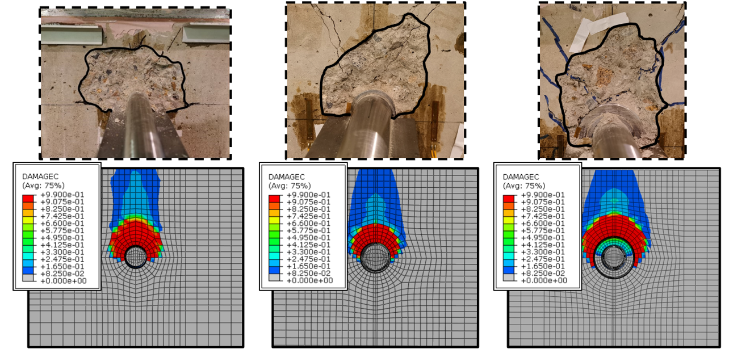
(a) | (b)
Fig. 24. Localised concrete crushing predicted from finite element analysis and observed from experimental tests (a) vertical stress (S33) predicted from finite element analysis [84], (b) severe concrete crushing observed from experimental tests [87].
    - Tensile stress concentration
Horizontal tensile cracks initiating at both sides of the dowel bar were firstly pointed out by Friberg et al. [66]. Over the past two decades, tensile stress concentration in jointed concrete pavements has been studied from the perspectives of experimental tests and FEA [57, 59, 60, 66, 84, 85, 88-90].
By conducting elemental tests, Shoukry et al. [57] observed tensile cracks at both sides of the dowel bar under vertical loads [66]. As shown in Fig. 25, elemental tests carried out by Guo and Chan [59], and Mackiewicz and Szydło [60] revealed that the failure of the concrete block with an embedded dowel bar was attributed to propagated horizontal tensile cracks. Zuzulova et al. [89] also implemented shear tests to evaluate the performance of dowel bar embedded into concrete. Through the strain measurement in the vicinity of dowel bars, high tensile strain was concentrated at both sides of the dowel slot.
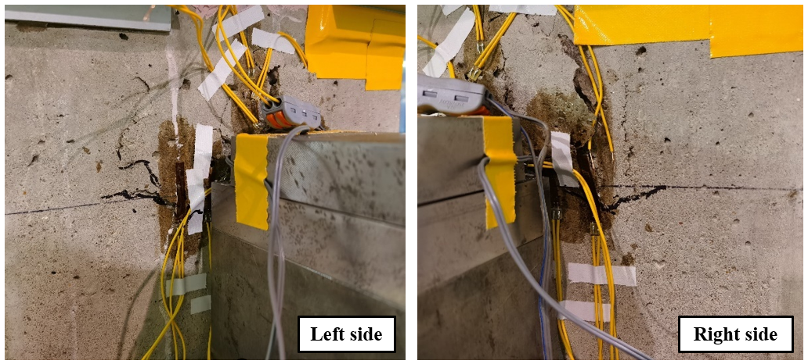 | 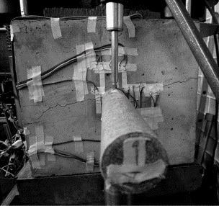
(a) | (b)
Fig. 25. Horizontal tensile cracks in concrete pavement (a) tensile cracks around GFRP dowel bar [87], (b) tensile cracks observed in elemental shear test [60].
Tensile stress concentration around dowel bars can also be predicted through FEA. Shoukry et al. [57] and Riad et al. [84] carried out three-dimensional FEA and found that high tensile stress at both sides of concrete might initiate horizontal cracks. Mackiewicz and Szydło [60] numerically investigated the influences of the dowel diameter on the stress development and the failure modes. FEA results indicated that the embedded dowel bar with a small diameter suffered an excessive vertical deformation under vertical loads. As the dowel bar diameter increased, the failure of the model was dominated by horizontal tensile cracks and localised concrete crushing [60].
Although stress concentration around the dowel bars has been analysed through experimental tests and FEA, the corresponding solutions to relieve the stress concentration effect are not systematically reported. In the subsequent sections, this issue will be further studied, and viable solutions will be proposed.
  - Dowel bar corrosion
Epoxy-coated steel dowel bars are widely used to achieve effective load transfer between pavement slabs. However, after the abrasion of epoxy coating, dowel bars are susceptible to corrosion at localised zones [91]. Fig. 26 shows corroded dowel bars observed in field applications, which significantly impairs the performance of pavement joints and shortens pavement service life [1, 80, 92, 93]. In harsh environment, the application of deicing salts also accelerates the corrosion of steel and leads to the dowel bar volume expansion as well as the effective section area reduction [94, 95]. In addition, expanded dowel bars may lock pavement joints and prevent free expansion and shrinkage of pavement slabs when suffering thermal and environmental changes. As a result, owing to the weak tensile resistance of concrete, horizontal cracks always initiate and lead to the rapid deterioration of pavement slabs [58]. In terms of pavement joints, dowel bar volume expansion also induces localised concrete crushing and creates a void space, referring to oblonging, around dowel bars [96, 97]. As a result, the deterioration of pavement joints is exacerbated and the load transfer ability of dowel bar is further reduced [79]. In the design of the PCP systems, apart from improving the durability of PCP panels, it is also necessary to design pavement connections with superior corrosion resistance to prevent the occurrence of premature joint failures.
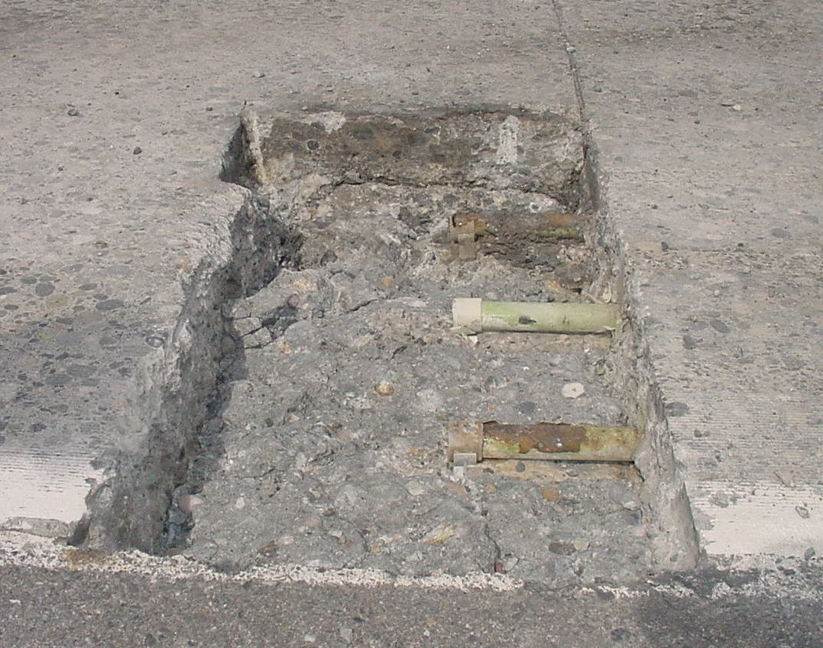 | 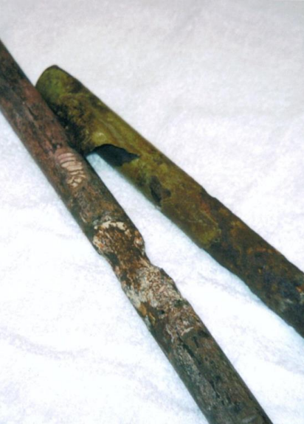
(a) | (b)
Fig. 26. Dowel bar corrosion (a) corroded dowel bars embedded in concrete [92], (b) corroded dowel bars [1].
- Dowel bar retrofit (DBR)
As discussed in sections 4.5 and 4.6, stress concentration and steel corrosion are two primary issues observed in dowel bar applications. To address these two issues, the corresponding dowel bar retrofitting approaches are discussed.
  - Alternative dowel bar materials
The application of glass fibre-reinforced polymer (GFRP) in the fabrication of dowel bars improves the corrosion resistance and thus reduces the life cycle costs of JPCP systems. Brown and Bartholomew [98] conducted laboratory tests and indicated that GFRP dowel bars was able to achieve a comparable performance as steel dowel bars after increasing the dowel bar diameter by 20 to 30 percent. Eddie et al. [99] carried out both static and cyclic load tests for concrete blocks with FRP dowel bars. Test results indicated that concrete bearing failure and dowel looseness were considerably mitigated in specimens with 38.1 mm diameter FRP dowel bars compared with those with 28.6 mm steel dowel bars. Benmokrane et al. [100] also investigated the mechanical behaviour of GFRP dowel bars under both static and cyclic loads. In static load tests, the crack loads of specimens with GFRP dowel bars were greater than the standard load of 40 kN. After 1 million cycles of fatigue loads, specimens with GFRP and epoxy-coated dowel bars could exhibit similar performances [100]. To further evaluate the performance of GFRP dowel bars, AASHTO-T253 test method [56] was improved and the dowel bar diameter, dowel bar section and pavement joint width were assessed through experimental tests [72, 96, 101, 102]. As GFRP dowel bars exhibited low strength and stiffness along the transverse direction, a new concrete-filled GFRP dowel bar was proposed by Murison et al. [94, 95] to improve the shear resistance along the transverse direction. Through cyclic load tests, no fatigue damage was observed in concrete and the GFRP tube.
Stainless steel is also a promising material to improve the corrosion resistance of the dowel bar. Through monotonic load tests, Porter [101], Porter and Pierson [72] and Guo and Chan [63, 87] claimed that stainless steel dowel bars exhibited comparable performance as epoxy-coated steel dowel bars. Due to high material costs, Khazanovich et al. [78] conducted accelerated load tests for concrete blocks with hollow stainless steel dowel bars. After being subjected to 10 million cycles of fatigue loads, specimens with hollow stainless steel dowel bars showed sufficient LTE in accordance with the design requirement specified in AASHTO Guide for Design of Pavement Structures [27]. To avoid the local bearing failure of the hollow stainless steel tube, Black et al. [103] studied concrete-filled stainless steel dowel bars through experiments. Test results indicated that the application of concrete-filled stainless-steel dowel bars could effectively reduce the vertical deflection and concrete bearing stress at the joint surface [103]. According to experimental tests introduced above, both GFRP and stainless steel are effective corrosion-free materials to fabricate dowel bar. Considering the high material cost of stainless steel, the application of concrete-filled stainless steel tubes as dowel bars is also a reasonable solution.
  - Alternative dowel bar sections
According to the load transfer characteristic of the dowel bar embedded into concrete, severe compressive stress concentration is induced on the top and bottom of the dowel slot. As a result, to mitigate compressive stress concentration, a large contact area is recommended between the dowel bar and concrete. Porter and Cable [96], Porter [101] and Porter and Pierson [72] experimentally studied elliptical dowel bars and results of tests showed that although the low flexural stiffness of elliptical dowel bars increased the vertical deflection of the loaded block, the expanded contact area between steel and concrete effectively lowered the created compressive stress. To further assess the structural performance of dowel bars with various cross sections, Hu et al. [93] carried out cyclic load tests to compare elliptical, square and circular dowel bars with the same section area as shown in Fig. 27. After 864 thousand load cycles, specimens with elliptical dowel bars exhibited the best performance in mitigating compressive stress concentration and could reduce the maximum bearing stress of concrete by 40 percent [93]. Apart from laboratory tests, field applications of elliptical dowel bars were also reported by Cable [104] and results showed that the application of elliptical dowel bars did not lead to any issue in the pavement construction. Both circular and elliptical dowel bars exhibited similar performances in terms of joint deflection and LTE. Dowel bars with other cross sections were also proposed by American Concrete Pavement Association [105]. Fig. 28 shows the typical diamond-shape and taper-shape dowel bars that expand the contact area between concrete and steel. With the application of these dowel bars, compressive stress generated in concrete can be effectively reduced.
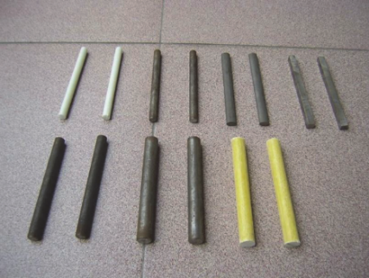
Fig. 27. Dowel bars with different shapes [93].
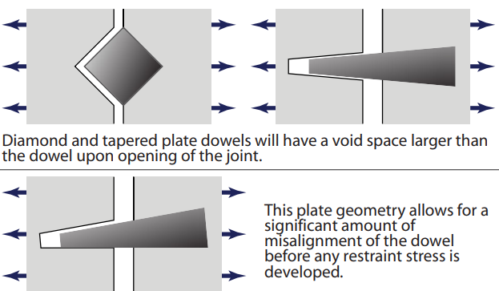 | 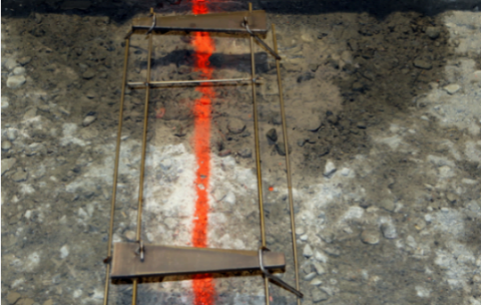
(a) | (b)
Fig. 28. Diamond-shape and taper-shape dowel bars (a) configurations, (b) field application of taper-shape dowel bar [105].
5.3 Novel pavement connections
Apart from dowel bars with different cross sections and made of different materials, some innovative pavement connections were also developed by other researchers. As shown in Fig. 29, Zeinali et al. [106] proposed an innovative hinge dowel bar system to replace traditional dowel bars. The expanded contact area between concrete and steel could minimise the created contact stress. Curing as well as warping stress was able to be relieved through the rotation of the hinge joint. In addition, to improve the reusability of PCP panels and reduce the generation of construction waste, demountable pavement connections are attractive alternatives to dowel bars. As displayed in Fig. 30, Guo and Chan [87, 107] developed a removable dowel bar connection system and a demountable steel connection system which not only mitigated concrete crushing at the pavement joint surface, but also made individual pavement panels reusable. Both test and FEA results indicated that these two pavement connections could exhibit better structural performance than dowel bars, especially in relieving stress concentration.
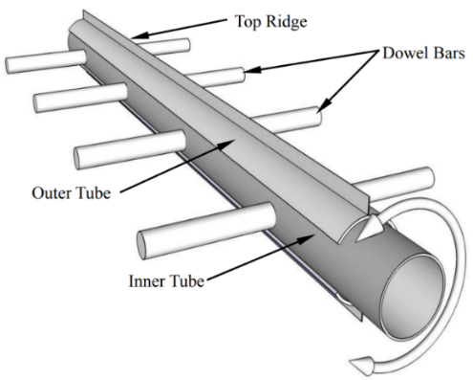 |  | 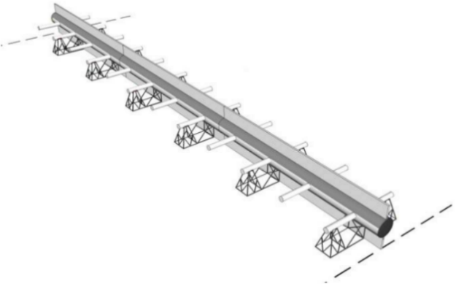
(a) |  | (b)
Fig. 29. Hinge dowel bar system (a) configuration, (b) installation [106].
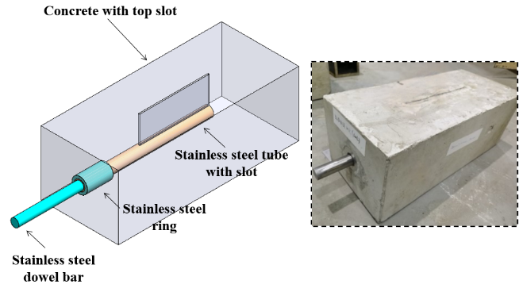 | 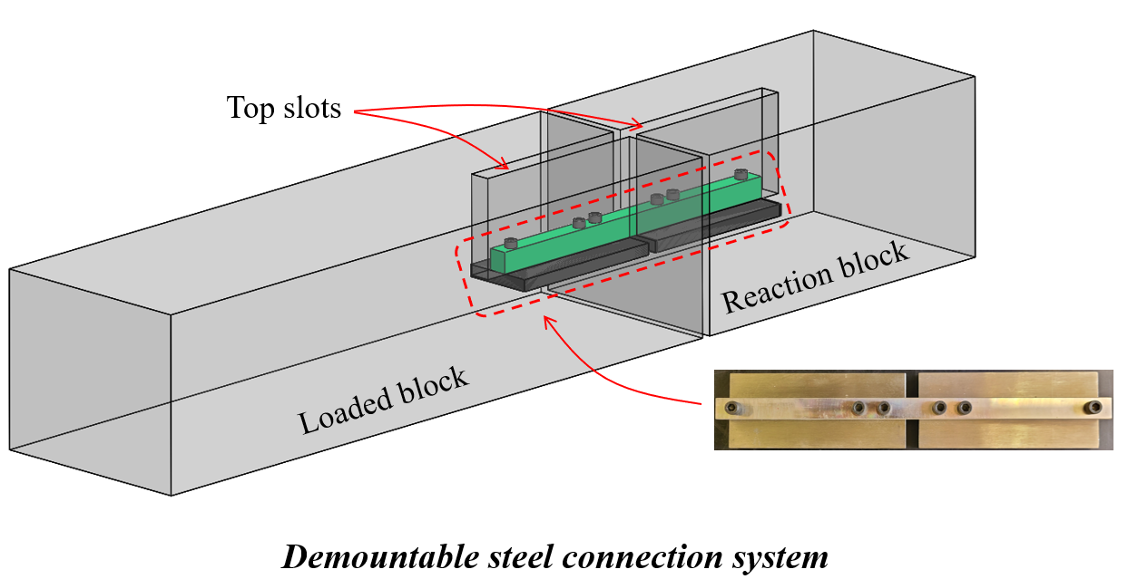
(a) | (b)
Fig. 30. Demonutable pavement connections (a) removable dowel bar connection system [87], (b) demountable steel connection system [107].
- Joint modelling techniques
FEA is an efficient approach to analyse the structural performance of the jointed concrete pavement systems. Due to high computational efforts, models were initially established by two-dimensional FEA. As the development of high-speed computers, three-dimensional FEA was gradually adopted. So far, a total of five modelling approaches have been applied to simulate the mechanical behaviour of the jointed concrete pavement system as introduced below:
- Dowel bars and concrete pavements are modelled by bending beams and two-dimensional plate elements, respectively. The interaction between dowel bars and concrete is simulated by contact elements [108].
- Concrete pavements are simulated by two-dimensional plate elements. Spring elements are adopted between pavement slabs to simulate the role of dowel bars [109-111]. Considering a constant spring stiffness, a specific LTE can be achieved in FEA [109, 110]. Mahboub et al. [111] modelled dowel bars by nonlinear springs to connect concrete blocks.
- Two-dimensional plate elements are used to model concrete pavements and beam elements are chosen to model dowel bars. Separated vertical spring elements with the stiffness equal to the modulus of dowel support are adopted to model the interaction between concrete and the dowel bar [67, 108, 112-115].
- Concrete pavement blocks are modelled by three-dimensional solid elements and dowel bars are modelled by beam elements. The dowel-concrete interaction is modelled by vertical spring elements [69, 116-122].
- Concrete pavement slabs and dowel bars are modelled by three-dimensional solid elements. The surface-to-surface contact modelling technique is used to model the interaction between dowel bars and concrete [57-60, 62, 83, 85, 86, 88, 123-128].
- Conclusions and future development
This paper discusses the applications and design considerations of PCP technology. Various types of PCP systems are introduced and compared in terms of pavement maintenance and construction. The design considerations are introduced from various aspects including PCP dimensions, concrete and reinforcement requirements, base layer and joint width design. As one of the commonly used load transfer devices, the load transfer characteristics of dowel bars are comprehensively analysed. Typical issues observed in their applications are studied and the corresponding solutions are recommended. As an effective tool in structural analysis, the application of FEA in the modelling of jointed concrete pavements is also discussed to improve the pavement joint design. Critical observations of this review are summarised below:
- The advantages and disadvantages of various PCP systems are systematically summarised and compared.
- Typical pavement connections are difficult to be dismantled at the end of pavement service life. Therefore, PCP panels cannot be easily reused in different situations.
- The elastic model to analyse the behaviour of the dowel bar embedded into concrete should be improved by considering the contact stress distribution within the dowel slot. While the plastic model is effective in predicting the maximum shear force transferred by the dowel bar.
- Stress concentration observed in dowel bar applications is systematically reviewed in terms of experimental tests and FEA.
- Alternative materials and dowel bar shapes are discussed to address corrosion and stress concentration issues observed in dowel bar applications.
- Novel pavement connections that relieve stress concentration and enable the reuse of PCP panels are introduced.
- Both two-dimensional and three-dimensional modelling techniques are summarised to accurately model jointed concrete pavements.
Owing to their fast installation and excellent durability, PCP systems have great potential for reusable applications that effectively minimise construction-related costs and the production of construction waste. To meet the target of reusability and improve the integrity of PCP systems, demountable pavement connections exhibiting high load transfer ability need to be further developed. Both laboratory and field tests should be carried out to evaluate the performance of these connections. In addition, PCP panels are encouraged to incorporate various sensors that can conduct real-time health monitoring of pavement structures and make full use of renewable resources. Together with the application of demountable pavement connections, these ‘smart pavement’ systems can significantly support the sustainable development of civil infrastructure.
Acknowledgement
The research work presented in this paper was supported by a grant from the Research Grants Council of the Hong Kong Special Administrative Region, China (Project no. R5007-18).

References
- Tayabji S., Ye D., and Buch N. Precast concrete pavement technology. Transportation Research Board 2013.
- Vaitkus A., Šernas O., Gražulytė J. Modular pavements: Developing high performance concrete. Construction Building Materials 2021, 292, 123362.
- Tomek R. Advantages of precast concrete in highway infrastructure construction. Procedia engineering 2017, 196, 176-180.
- Tayabji S., Ye D., Buch N. Precast concrete pavements: Technology overview and technical considerations. PCI journal 2013, 58, 112-128.
- Cookson G. Europes Traffic Hotspots Measuring the impact of congestion. INRIX research. 2016.
- Syed A. and Sonparote R. A Review of Precast Concrete Pavement Technology. Baltic Journal of Road and Bridge Engineering 2020, 15, 22-53.
- Smith P. and Snyder M.B. Manual for Jointed Precast Concrete Pavement. National Precast Concrete Association 2019.
- Fang M.J., Zhou R., Ke W.H., Tian B., Zhang Y.B. and Liu J.J. Precast system and assembly connection of cement concrete slabs for road pavement: A review. Journal of Traffic and Transportation Engineering-English Edition 2022, 9, 208-222.
- Vaitkus A., Gražulytė J., Kleizienė R., Vorobjovas V. and Šernas O. Concrete modular pavements–types, issues and challenges. The Baltic Journal of Road and Bridge Engineering 2019, 14, 80-103.
- Gopalaratnam V.S., Donahue J., Davis B. and Dailey C. Precast Prestressed Panels for Rapid Full-Depth Pavement Repairs. Structures Congress 2006: Structural Engineering and Public Safety 2006. 1-10.
- DoT, U.S. and FHWA, F. Status of the Nation's Highways, Bridges, and Transit: Conditions and Performance. Report to Congress, 2006.
- Rollings R.S. and Chou Y.T. Precast Concrete Pavements. 1981.
- Tsuji T. Joint structure for coupling precast concrete pavement slabs. Google Patents 1996.
- Merritt D.K. and Tayabji S. Precast Prestressed Concrete Pavement for Reconstruction and Rehabilitation of Existing Pavements. 2009.
- Merritt D.K., Mccullough B.F. and Burns N.H. Texas Tests Precast for Speed and Usability. Public Roads 2002, 66, 30-34.
- Novak J., Kohoutková A., Křístek V. and Vodička J. Precast concrete pavement-systems and performance review. IOP Conference Series: Materials Science and Engineering. IOP Publishing 2017, 012030.
- Schexnayder C., Ullman G. and Anderson S. Pavement reconstruction scenarios using precast concrete pavement panels. Practice Periodical on Structural Design 2007, 12, 186-199.
- Chen Y.-T. and Chang L.-M. Paving for the future-Precast Prestressed Concrete Pavement (PPCP). Scientific Cooperations Journal of Civil Engineering Architecture 2015, 1, 7-12.
- Syed A. and Sonparote R. Analysis of prestressed precast concrete pavement. Materials Today: Proceedings 2017, 4, 9713-9717.
- Offenbacker D., Cleary D., Ali A. and Mehta Y. Developing specifications for precast concrete highway pavements. International Journal of Pavement Engineering 2022, 23, 1791-1799.
- De Larrard F., Balay J., Sedran T., Laurent G., Leroux A., Maribas J., Vulcano-Greullet N., Sagnard N., Masson J. and Bélouard R. Development of a removable urban pavement technology. 10th International Symposium on Concrete Roads 2006, 18-22.
- Priddy L.P., Bly P.G. and Flintsch G.W. Review of precast portland cement concrete panel technologies for use in expedient portland cement concrete airfield pavement repairs. 2013.
- De Larrard F., Sedran T. and Balay J.-M. Removable urban pavements: an innovative, sustainable technology. International Journal of Pavement Engineering 2013, 14, 1-11.
- Tayabji S., Ye D. and Buch N. Joint Load Transfer and Support Considerations for Jointed Precast Concrete Pavements. Transportation Research Record 2012, 2305, 74-80.
- Tayabji S., Buch N. and Kohler E. Precast concrete pavement for intermittent concrete pavement repair applications. National conference on preservation, repair, and rehabilitation of concrete pavements 2009. 317-334.
- Priddy L.P., Bly P.G., Jackson C.J. and Flintsch G.W. Full-scale field testing of precast Portland cement concrete panel airfield pavement repairs. International Journal of Pavement Engineering 2014, 15, 840-853.
- AASHTO guide for design of pavement structure. Washington D.C: American Association of State Highway and Transportation Officials 1993.
- Kamali M. and Hewage K. Development of performance criteria for sustainability evaluation of modular versus conventional construction methods. Journal of cleaner production 2017, 142, 3592-3606.
- Buch N., Barnhart V. and Kowli R. Precast concrete slabs as full-depth repairs: Michigan experience. Transportation research record 2003, 1823, 55-63.
- Tayabji S., Buch N. and Kohler E. Precast Concrete Pavements: Current Technology and Future Directions. 9th International Conference on Concrete Pavements International Society for Concrete Pavements Federal Highway Administration 2008.
- Tayabji S. and Tyson S. Precast concrete pavement implementation. Concrete International 2017, 39, 41-46.
- Tayabji S.D. Precast concrete pavement technology implementation. United States, Federal Highway Administration, Office of Infrastructure, 2019.
- Anderson K.W., Pierce L.M. and Uhlmeyer J. S. URETEK Stitch-In-Time®, 2007.
- Alwehaidah N. Development of precast, prestressed concrete pavement technology. Oklahoma State University, 2013.
- Tian Z., Meng Y., Han Y. and Hang M. Analysis on Load Stress of Fabricated Cement Concrete Pavement Slabs and Joint Optimization. Journal of Shandong Agricultural University 2016, 47, 753-759.
- Li Y., Yao Z., Sun X. and Zhang C. Stress analysis on keyed joints for cement concrete airport pavement. Journal of Tongji University 2003, 31, 697-701.
- Yan Q. and Peng Q. Stress-Strain Response of Prefabricated Cement Concrete with Circular Tongue and Groove Joints. Journal of Chongqing Jiaotong University 2017, 36, 28.
- Qu B., Weng X.-Z., Zhang J., Mei J.-J., Guo T.-X., Li R.-F. and An S.-H. Analysis on the deflection and load transfer capacity of a prefabricated airport prestressed concrete pavement. Construction and Building Materials 2017, 157, 449-458.
- Cable N.D., Mccullough B.F. and Burns N.H. New concepts in prestressed concrete pavement. 1986.
- Kim K., Chun S., Park B. and Han S. Precast prestressed concrete pavement (PPCP): Effect of thermal gradient on curling deflection and stress. Construction and Building Materials 2021, 274.
- Syed A. and Sonparote R.S. Construction of Pretensioned Precast Concrete Pavement. Iranian Journal of Science Technology 2020, 44, 507-514.
- Chen H., Ling J.-M., Zhao H., Zeng M. and Wu D. Vibration Characteristics of Cross-tensioned Concrete Pavement. China Journal of Highway Transport Policy 2020, 33, 32-41.
- Sun S., Li J., Zhang Y., Zhou X. and Zhang X. Application of Reusable and Customized Precast Reinforced Concrete Road Slab. Foundation Bed and Foundation 2018, 40, 1902-1904.
- Tayabji S. Precast concrete pavement practices overview. 2016.
- Smith K. D., Harrington D.S., Pierce L., Ram P. and Smith K.L. Concrete Pavement Preservation Guide. United States, Federal Highway Administration, 2014.
- Anderson I. A. Assessment of super-slab, a precast concrete bridge approach slab. Vermont, Agency of Transportation, 2018.
- Gillen S., Gancarz D.J. and Tayabji S. Precast concrete panels for rapid full-depth repair of CRCP. Concrete International 2018, 40, 39-44.
- Hammons M.J. Advanced pavement design: Finite element modeling for rigid pavement joints, Report II: Model development. Army Engineer Waterways Experiment Station Vicksburg MS, 1998.
- Khazanovich L. and Gotlif A. Evaluation of joint and crack load transfer final report. United States. Federal Highway Administration. 2003.
- Deshpande Y.S., Hiller J.E., Li Y. and Yin Y.J. Performance prediction of the dowel bar retrofit technique using statistical modelling. Road materials pavement design 2010, 11, 701-723.
- Wadkar A., Mehta Y., Cleary D., Guo E., Musumeci L., Zapata A. and Kettleson W. Load-transfer efficiencies of rigid airfield pavement joints based on stresses and deflections. Journal of Materials in Civil Engineering 2011, 23, 1171-1180.
- Ioannides A.M. and Korovesis G.T. Analysis and design of doweled slab-on-grade pavement systems. Journal of Transportation Engineering 1992, 118, 745-768.
- Papagiannakis A.T. and Masad E.A. Pavement design and materials. John Wiley and Sons, 2008.
- Snyder M.B. Guide to dowel load transfer systems for jointed concrete roadway pavements. 2011.
- ACI Committee 325: Guide for Design of Jointed Concrete Pavements for Streets and Local Roads. 2002.
- AASHTO T253: Standard Method of Test for Coated Dowel Bars. 2011.
- Shoukry S.N., William G. and Riad M. Characteristics of concrete contact stresses in doweled transverse joints. International Journal of Pavement Engineering 2002, 3, 117-129.
- Zhou Z.-F. Stress concentration analysis in concrete round dowels for airport jointed rigid pavement system. Third International Conference on Transportation Engineering 2011.
- Li L.-K., Tan Y.-Q., Gong X.-B. and Li Y.-L. Characterization of Contact Stresses Between Dowels and Surrounding Concrete in Jointed Concrete Pavement. 2012.
- Mackiewicz P. and Szydło A. The analysis of stress concentration around dowel bars in concrete pavement. Magazine of Concrete Research 2020, 72, 97-107.
- Yin W., Lu H., Yuan J. and Huang B.-S. Mechanical characteristics of dowel bar-concrete interaction: based on substructure experiment. International Journal of Pavement Engineering 2020, 23, 2392-2404.
- Al-Humeidawi B.H. and Mandal P. Evaluation of performance and design of GFRP dowels in jointed plain concrete pavement–part 2: numerical simulation and design considerations. International Journal of Pavement Engineering 2014, 15, 752-765.
- Guo J.C. and Chan T.-M. Stainless steel ring strengthened removable dowel bar connection system: Effect of key parameters and design recommendations. Structures 2022, 44, 1767-1782.
- Westergaard, H. Spacing of dowels. Highway Research Board Proceedings 1929.
- Kushing J.W., Fremont W.O. and Sutherland E.C. Design of Load Transfer Joints in Concrete Pavements. Proceedings of Highways Research Board 1941, 20, 481-497.
- Friberg B., Richart F. and Bradbury R. Load and deflection characteristics of dowels in transverse joints of concrete pavements. Highway Research Board Proceedings 1939.
- Tabatabaie A.M. and Barenberg E. Finite-element analysis of jointed or cracked concrete pavements. Transportation Research Record 1978.
- Heinrichs K.W., Liu M.-J., Darter M.I., Carpenter S. and Ioannides A. M. Rigid pavement analysis and design. United States, Federal Highway Administration 1989.
- Maitra S.R., Reddy K. and Ramachandra L. Load transfer characteristics of dowel bar system in jointed concrete pavement. International Journal of Fracture 2009, 135, 813-821.
- Timoshenko S. and Lessells J.M. Applied elasticity. Westinghouse technical night school press 1925.
- Guo J.C. and Chan T.-M. Characteristics of compressive stress around dowel joint in concrete pavement system. International Journal of Pavement Engineering 2022, https://doi.org/10.1080/10298436.2022.2115041.
- Porter M. and Pierson N. Laboratory evaluation of alternative dowel bars for use in Portland cement concrete pavement construction. Transportation research record 2007, 2040, 80-87.
- Rasmussen B. The carrying capacity of tranceversely loaded bolts and dowels embedded in concrete. Bygings Statiske Meddelser 1963:34.
- Vintzēleou E, Tassios T. Mathematical models for dowel action under monotonic and cyclic conditions. Magazine of concrete research 1986;38:13-22.
- Guo, J.C., Chan, T.-M., and Wang, Y.H. Experimental investigation on the structural performance of the high-strength ring strengthened dowel connection under monotonic load. Engineering Structures 2023, 292, 116423.
- Randl N. Load bearing behaviour of cast‐in shear dowels. Beton‐und Stahlbetonbau 2007;102:31-37.
- Zhao Y, Zou R, Ding T, Xiao J. Experimental study of the shear behaviour of concrete-grout-concrete joints. Journal of Building Engineering 2021;43:103095.
- Khazanovich L., Yut I., Tompkins D. and Schultz A. Accelerated loading testing of stainless steel hollow tube dowels. Transportation research record 2006, 1947, 101-109.
- Harrington J.F. Comparison of alternative laboratory dowel bar testing procedures 2006.
- Al-Humeidawi B.H. and Mandal P. Evaluation of performance and design of GFRP dowels in jointed plain concrete pavement–part 1: experimental investigation. International Journal of Pavement Engineering 2014, 15, 449-459.
- Ioannides A.M., Lee Y.-H. and Darter M.I. Control of faulting through joint load transfer design. Transportation Research Record 1990, 1286, 49.
- Guo H., Pasko T. and Snyder M. Maximum bearing stress of concrete in doweled portland cement concrete pavements. Transportation Research Record 1993, 1388, 19.
- Mackiewicz P. Analysis of stresses in concrete pavement under a dowel according to its diameter and load transfer efficiency. Canadian Journal of Civil Engineering 2015, 42, 845-853.
- Riad M.Y., Shoukry S.N., William G.W. and Fahmy M.R. Effect of skewed joints on the performance of jointed concrete pavement through 3D dynamic finite element analysis. International Journal of Pavement Engineering 2009, 10, 251-263.
- Priddy L.P., Doyle J.D., Flintsch G. W., Pittman D. W. and Anderton G. L. Three-dimensional modelling of precast concrete pavement repair joints. Magazine of Concrete Research 2015, 67, 513-522.
- Shoukry S.N., William G.W. and Riad M. Application of LS-DYNA in Identifying Critical Stresses Around Dowel Bars. 8th Int. LS-DYNA Users Conference 2011.
- Guo J.C. and Chan T.-M. Experimental and numerical study on the structural performance of the stainless steel ring strengthened removable dowel bar connection system. International Journal of Pavement Engineering 2022, https://doi.org/10.1080/10298436.2022.2126977.
- Mackiewicz P. Finite-element analysis of stress concentration around dowel bars in jointed plain concrete pavement. Journal of Transportation Engineering 2015, 141, 06015001.
- Zuzulova A., Grosek J. and Janku M. Experimental laboratory testing on behavior of dowels in concrete pavements. Materials 2020, 13, 2343.
- Grosek J., Zuzulova A. and Brezina I. Effectiveness of dowels in concrete pavement. Materials 2019, 12, 1669.
- Larson R.M. and Smith K.D. Evaluation of alternative dowel bar materials and coatings. Ohio. Dept. of Transportation. Office of Research and Development 2011.
- Li H. Evaluation of jointed plain concrete pavement (JPCP) with FRP dowels. 2004.
- Hu C.C., Ma J.X., Zhao J.Y., Leng Z. and Jelagin D. Experimental study of dowel bar alternatives based on similarity model test. Advances in Materials Science Engineering 2017, 2017.
- Murison S. Evaluation of concrete-filled GFRP dowels for jointed concrete pavements. 2004.
- Murison S., Shalaby A. and Mufti A. Concrete-Filled, Glass Fiber–Reinforced Polymer Dowels for Load Transfer in Jointed Rigid Pavements. Transportation research record, 1919, 54-64, 2005.
- Porter M. and Cable J. Alternative FRP Dowel Joint Reinforcement. Composites 2006.
- Al-Humeidawi B.H. and Mandal P. Experimental investigation on the combined effect of dowel misalignment and cyclic wheel loading on dowel bar performance in JPCP. Engineering Structures 2018, 174, 256-266.
- Brown V. and Bartholomew C. FRP dowel bars in reinforced concrete pavements. Special Publication 1993, 138, 813-830.
- Eddie D., Shalaby A. and Rizkalla S. Glass fiber-reinforced polymer dowels for concrete pavements. ACI Structural Journal 2001, 98, 201-206.
- Benmokrane B., Ahmed E.A., Montaigu M. and Thebeau D. Performance of Glass Fiber-Reinforced Polymer-Doweled Jointed Plain Concrete Pavement under Static and Cyclic Loadings. ACI Structural Journal 2014, 111(2), 331-341.
- Porter M.L. Testing structural behavior of alternative dowel Bars. 2006.
- Porter M.L., Guinn R.J., Lundy A.L., Davis D.D. and Rohner J.G. Investigation of glass fiber composite dowel bars for highway pavement slabs. 2001.
- Black K.N., Larson R. and Staunton L. Evaluation of Stainless-Steel Pipes for Use as Dowel Bars. Public Roads 1988, 52.
- Cable J.K. Changing the shape and location of pavement load transfer devices. Transportation research record 2005, 1907(1), 95-101.
- ACPA. An Alternative to Traditional Round Dowel Bars. American Concrete Pavement Association 2008.
- Zeinali A., Mahboub K.C. and Southgate H.F. Effects of Hinged dowel system on the performance of concrete pavement joints. International Journal of Pavement Research and Technology 2013, 6, 243.
- Guo, J.C., Chan, T.-M. and Wang, Y.H. Test, modelling and design of a demountable stainless steel bar connection system for precast concrete pavements. Engineering Structures 2024, 301, 117231.
- Zaman M. and Alvappillai A. Contact-element model for dynamic analysis of jointed concrete pavements. Journal of transportation engineering 1995, 121, 425-433.
- Huang Y. and Wang S. Finite-element analysis of concrete slabs and its implications for rigid pavement design. Highway Research Record 1973.
- Huang Y.H. A computer package for structural analysis of concrete pavements. Third International Conference on Concrete Pavement Design and Rehabilitation, Purdue University 1985.
- Mahboub K.C., Liu Y. and Allen D.L. Evaluation of temperature responses in concrete pavement. Journal of Transportation Engineering 2004, 130, 395-401.
- Guo H., Sherwood J.A. and Snyder M.B. Component dowel-bar model for load-transfer systems in PCC pavements. Journal of Transportation Engineering 1995, 121, 289-298.
- Tayabji S.D. and Colley B.E. Analysis of jointed concrete pavements. 1986.
- Tia M., Armaghani J.M., Wu C., Lei S. and Toye K.L. FEACONS III computer program for analysis of jointed concrete pavements. Transportation Research Record 1987.
- Nishizawa T., Fukuda T. and Matsuno S. A Refined Model of Doweled Joints for Concrete Pavement Using FEM Analysis. 4th International Conference on Concrete Pavement Design and Rehabilitation, Purdue University 1989.
- Bhattacharya K. Nonlinear response of transverse joints of airfield pavements. Journal of transportation engineering 2000, 126, 168-177.
- Channakeshava C., Barzegar F. and Voyiadjis G.Z. Nonlinear FE analysis of plain concrete pavements with doweled joints. Journal of Transportation Engineering 1993, 119, 763-781.
- Kuo C.M., Hall K.T. and Darter M.I. Three-dimensional finite element model for analysis of concrete pavement support. Transportation Research Record 1995.
- Nishizawa T., Koyanagawa M., Takeuchi Y. and Kimura M. Study on mechanical behavior of dowel bar in transverse joint of concrete pavement. Proceedings of the 7th International Conference on Concrete Pavements, Orlando, FL, 2001.
- Davids W.G. 3D finite element study on load transfer at doweled joints in flat and curled rigid pavements. International Journal of Geomechanics 2001, 1, 309-323.
- Davids W.G., Wang Z., Turkiyyah G., Mahoney J.P. and Bush D. Three-dimensional finite element analysis of jointed plain concrete pavement with EverFE2.2. Transportation Research Record 2003, 1853, 92-99.
- Kim J. and Hjelmstad K.D. Three-dimensional finite element analysis of doweled joints for airport pavements. Transportation Research Record 2003, 1853, 100-109.
- Kim K., Chun S., Han S. and Tia M. Effect of dowel bar arrangements on performance of jointed plain concrete pavement (JPCP). International Journal of Concrete Structures 2018, 12, 1-11.
- Prabhu M., Varma A. and Buch N. Analytical investigation of the effects of dowel misalignment on concrete pavement joint opening behaviour. International Journal of Pavement Engineering 2009, 10, 49-62.
- Prabhu M., Varma A.H. and Buch N. Experimental and analytical investigations of mechanistic effects of dowel misalignment in jointed concrete pavements. Transportation research record 2007, 2037, 12-29.
- Sadeghi V. and Hesami S. Finite element investigation of the joints in precast concrete pavement. Computers Concrete 2018, 21, 547-557.
- Sadeghi V. and Hesami S. Investigation of load transfer efficiency in jointed plain concrete pavements (JPCP) using FEM. International Journal of Pavement Research and Technology 2018, 11, 245-252.
- Saxena P., Hoegh K., Khazanovich L. and Gotlif A. Laboratory and finite element evaluation of joint lockup. Transportation research record 2009, 2095, 34-42.

Formerly, Department of Civil and Environmental Engineering, The Hong Kong Polytechnic University, Hong Kong, China

