Interfacial bond-slip performances of CFRP tube-ultra lightweight cement composite-stainless steel tubular pipe
Zhenyu HUANG¹, Zhouyuan LAI¹, Lijie CHEN²*, Yingwu ZHOU¹
1 Guangdong Provincial Key Laboratory of Durability for Marine Civil Engineering, Shenzhen University, Shenzhen, China
2 Department of Civil Engineering, The University of Hong Kong, Pokfulam Road, Hong Kong, China

Abstract
This paper introduces a novel solution for marine structures facing harsh environmental conditions—a CFRP tube-ultra lightweight cement composite (ULCC)-stainless steel tube tubular pipe. ULCC plays a crucial role in significantly reducing the self-weight of the pipe without compromising its mechanical performance. The study mainly focuses on investigating the bond-slip behavior between ULCC and stainless steel tube, as well as between ULCC and CFRP tube, considering a range of bond lengths, tube diameters, and tube thicknesses. To gain insight into this behavior, the distribution of strain and stress within the stainless-steel tube and CFRP tube was effectively measured using optical fiber sensors and digital imaging correlation techniques. The findings reveal that increasing tube diameter can lead to a reduction of 69.8% and 70.3% on ultimate bond strengths for stainless steel tube and CFRP tube, respectively. Conversely, increasing the thickness of the stainless-steel tube leads to a reduction of 56.9% in ultimate bond strength, while the bond strength between CFRP tube and ULCC benefits from CFRP tube thickness (61.0% improvement). Increasing bond length can reduce the bond strengths. Empirical equations have been provided to facilitate the calculation of average and local bond strengths based on bond length, tube diameter, and thickness. Additionally, constitutive models have been developed to accurately represent the bond-slip behavior of stainless-steel tube-ULCC and CFRP tube-ULCC specimens. Understanding the bond behaviors of CFRP-ULCC-stainless tubular pipe allows for enhanced load transfer mechanism and composite action, and optimized structural design.
Keywords: bond-slip behavior, FRP-concrete-steel tubular structure, CFRP, ultra lightweight cement composite (ULCC), stainless steel tube
- Introduction
Hybrid fiber reinforced polymer (FRP)-concrete-steel tubular column is a novel type of composite column first proposed by Teng et.al. [1, 2] to address the durability problem of marine structures. It consists of an FRP outer tube, an internal steel tube, and interlayer concrete [3-6]. Compared to traditional steel-concrete composite column, hybrid FRP-concrete-steel composite structures have the following advantages: 1) the superior corrosion-resistant FRP outer tube can prevent corrosion issues in steel structures [7-10] caused by harmful ions (chloride and sulphate ions) in the exposed environment [11, 12]; 2) good ductility and resistance to seismic and fatigue loads; 3) the hollow design significantly reduces the structural weight; 4) the FRP outer tube and inner steel tube can serve as permanent moulds for casting concrete[13-15]. The core concrete, constrained by both the FRP outer tube and steel inner tube, exhibits enhanced strength, ultimate strain capacity, toughness, etc. Moreover, the constrained core concrete can effectively prevent local buckling of the FRP outer tube and steel inner tube [3, 16, 17].
In recent years, ultra-lightweight cement composite (ULCC) [18-22] with apparent density of only 1450 kg/m³ and compressive strength close to 60 MPa at 28 days of age has been adopted in hybrid FRP-concrete-steel composite structure [17] by the first author of this study. The lightweight and high-strength characteristics of ULCC make it ideal for replacing normal weight concrete in hybrid FRP-concrete-steel tubular member in marine structures, with significantly reduced efforts in component manufacturing, transportation and installation. For hybrid FRP-concrete-steel tubular column, both the bond-slip performances between FRP and concrete [23-26], and between steel and concrete [27, 28], are vital. A good bond-slip performance is crucial for ensuring that the composite column can work in a synergic way to resist external loads especially near the end connections [29]. Moreover, increasing the interfacial bonding performances can significantly improve the stiffness of concrete-filled-FRP [30].
Bazli et.al. [31] studied the bond-slip behaviour of seawater seasand concrete-filled FRP tubes. Main variables included the types of fiber (CFRP, GFRP and BFRP), fiber orientations, manufacture methods of FRP (pultruded and filament winding), and diameter-to-thickness ratios. The contributions of bond strength from chemical binding and mechanical binding were quantified under different confinement pressures. The results indicated that CFRP and BFRP tubes showed the highest and lowest bond strengths, respectively. The bond strength of concrete-filled FRP tube was mostly contributed by the friction between FRP tube and concrete as compared with chemical adhesion. Change of fiber orientation from 0° (pultrusion) to 15°, 40° and 75° (filament winding) can significantly improve the interfacial bond strength. Ali et. al. [30] investigated the bond behavior of concrete-filled FRP tube by experimental, numerical and analytical methods. It was found that the interfacial bond strength can be significantly improved from 0.022 MPa to 1.00 MPa by sand-coating. A coulomb stick-slip friction model was proposed and implemented in finite element analysis. The experimental bond-slip behavior was accurately depicted by the numerical model. Mustafa et al. [32] studied the bond performance of FRP with different widths, lengths, thicknesses, and layering directions in double-shear tests for both normal concrete and lightweight concrete. They discovered that the bond strength and slip of lightweight concrete were significantly lower than those of normal concrete. When the length of the FRP reached a threshold value, further increase in length did not enhance the bond load-bearing capacity. The direction of the FRP layering influenced the bond strength, while the thickness of the FRP affected both normal and lightweight concretes in the same way.
Regarding the bond performance between concrete and steel, Chen et al. [33] studied the bond performance of 32 circular and square stainless steel-concrete interfaces. The results indicated that the interfacial strength of stainless steel-concrete was lower than that of carbon steel-concrete. This was due to that the stainless steel surface was smoother than that of carbon steel. Natalli et.al. [34] investigated the bond performances of thin-walled steel tubes filled with conventional concrete, lightweight concrete and lightweight concrete with expansive agent. They found that expansive admixture can improve bond performance between lightweight concrete and steel tube by strengthening adhesion performance of concrete.
As a promising composite structure in marine engineering, numerous studies have been conducted on the compressive and flexural performances [2, 3, 6, 35] of hybrid FRP-concrete-steel tubular structures, however, for which the existing studies on the bond-slip behavior of concrete-filled FRP tubes are far from enough [30, 31] especially for lightweight concrete.
To fill the research scarcity of the bond performances of hybrid FRP-concrete-steel tubular structure, this study thoroughly investigates the bond-slip performances of CFRP tube-ULCC specimens and ULCC specimens-stainless steel tube. The experimental variables include bond length, tube diameter and tube thickness. The effects of the experimental variables have been presented and discussed, upon which prediction models for predicting the bond strengths of ULCC bonded with stainless steel tube and CFRP tube were proposed. Besides, the strain distributions of stainless steel tube and CFRP tube under various loading levels have been recorded by using optical fiber sensor and digital imaging correlation respectively. Therefore, the stress distributions of the tubes have been derived based on the strain distributions. This paper ends with theoretical constitutive models for describing the bond-slip behaviour of ULCC bonded with stainless steel tube and CFRP tube respectively.
- Experiments

2.1 Raw materials
Table 1 lists the mix proportions of the ULCC used in the experiments. The water-cementitious materials ratio for the ULCC was set at 0.33. The cementitious materials included 62.7% of 52.5R Ordinary Portland Cement and 7.0% of silica fume by weight. Hollow cenosphere with average diameters ranging from 20-300μm were used in place of fine aggregates while coarse aggregates were excluded, resulting in the lightweight and high-strength characteristics of ULCC. Silica fume is incorporated to enhance the interfacial zone of cenospheres. Polyethylene (PE) fibers were incorporated into the cementitious matrix to reduce the brittleness of ultra-lightweight concrete. The basic properties of the PE fibers are presented in Table 2. To ensure good workability of fresh ULCC, a polycarboxylic high-performance water reducer was used to give a spread diameter of 700 mm. The 28 day cubic compressive strengths of ULCC are 41.31 MPa, 43.07 MPa, and 43.25 MPa, with an average of 42.54 MPa.
According to GB/T 228.1-2021 [36], dog-bone specimens were cut from the stainless-steel tube of the specimens and tested to obtain the fundamental mechanical properties of the stainless-steels with various thicknesses, which are listed in Table 3.
The FRP used in this study was made of carbon fiber by filament winding. The CFRP in this study has a complex laminate structure, designated as [(90/±15/90/±45₃)₅/±45₃]. To obtain the fundamental mechanical properties of the CFRP, tensile tests for the CFRP were conducted in accordance with the GB/T 1447 [37]. Table 4 lists the results of the mechanical property tests for CFRP laminates with various thicknesses.

2.2 Test setup for ULCC-stainless steel tube specimen
In this study, a total of 8 stainless steel tube-ULCC specimens were fabricated. The experimental variables include the diameter of the stainless steel tube, the thickness of the stainless steel tube, the bond length, and the presence of strengthening ribs. Table 5 lists the properties of each specimen.
Figure 1 presents a schematic diagram of the stainless steel tube-ULCC specimen. The outer diameter of the specimens was kept as 208 mm. For the ease of imposing loading, the stainless steel tube extends both above and below the ULCC by 20mm and 50mm, respectively. Figure 1 also shows that an optical fiber was longitudinally installed inside the stainless steel tube to measure the strain with high precision. As a result, the distribution of bond strain along the bond length can be easily obtained during the loading process.
In this study, a 300-ton MTS machine was used to test the bond performance between stainless steel tube and ULCC. As shown in Figure 2, the loading was imposed on the upper end of the stainless steel tube. The specimen was placed on a hollow base with hole such that the lower end of the stainless steel tube can move downward during the loading. Two linear variable differential transformers (LVDTs) were installed on the loading head and two LVDTs were installed on the lower end of the stainless steel tube in order to measure the slip between stainless steel tube and ULCC. Prior to the peak load, the tests were conducted at a speed of 0.2 mm/min. The loading speed after the peak load was increased from 0.2 mm/min to 2 mm/min. The tests were terminated at a slip of 35mm.

2.3 Test setup for ULCC-CFRP tube specimen
A total of 8 CFRP tube-ULCC specimens were manufactured in this study, for which the properties are listed in Table 6. The experimental variables include bond length, CFRP tube diameter, CFRP tube thickness, and laminate type. Figure 3 presents the schematic diagram of the CFRP tube-ULCC specimen. Two steel rods with circular plates were placed in the CFRP tube prior to casting. The steel rod was threaded to prevent the slip between the rod and ULCC during the loading. A LVDT was installed between the top of CFRP tube and the upper steel rod while another LVDT was installed between the bottom of CFRP tube and the bottom of the loading device [38]. Therefore, the slip between the CFRP tube and ULCC can be determined accordingly. To obtain the strain of the CFRP tube, digital image correlation (DIC) technique [39, 40] was used in this study by spraying black speckles on the outer surface of CFRP tube. Figure 4 presents the 20-ton MTS loading device for testing the bond performance between CFRP tube and ULCC. The lower steel rod was fixed by the clamp of the machine while the upper steel rod was pulled upward to impose the loading. The test loading procedures are similar to those in Section 2.2.
- Experimental results

3.1 Bond behavior between ULCC and stainless steel tube
At the end of the test, the total slip of all stainless steel tube-ULCC specimens was about 35mm, and the bond interface completely failed. Figure 5 shows the photos of the specimens after failure. For specimens without stiffening ribs as shown in Figure 5 (a)~(g), the specimens intermittently produced cracking sounds prior to peak load. A loud sound appeared at peak load. After tests, the ULCCs remain intact with only minor cracks on external surface as shown in Figure 5 (a)~(g). As for the specimen with stiffening ribs as shown in Figure 5 (h), the specimens intermittently produced cracking sounds prior to peak load. No loud sound appeared at peak load. After tests, major cracks were concentrated near the stiffening ribs.
Figure 6 shows the load-slip curves of the 8 stainless steel tube-ULCC specimens. In this figure, P_{u} is the ultimate bond load, that is, the peak load value, and the ultimate bond slip S_{u} is the corresponding slip at P_{u}; P_{b} is the rebound bond load, i.e., the load value after a sudden drop and the first rebound, and the rebound bond slip S_{b} is the corresponding slip at P_{b}; P_{r} is the residual bond load, i.e., the load value after the load drops to a stable stage, and the residual bond slip S_{r} is the corresponding slip at P_{r}. There are two load-slip curves corresponding to the slips measured at the loading end and free end for each specimen as shown in Figure 6. This study focuses on the curve corresponding to the loading end to keep consistent with the results in existing literatures [41-44].
The bond slip relationship of stainless steel tube- ULCC specimens without stiffening ribs can be divided into three stages as shown in Figure 6 (a)~(g): (1) Linear stage. Before the peak load, the load-slip curve of the specimen basically showed a linear relationship. The slip was limited, and the slip of the free end was smaller as compared with that of the loading end due to the elastic compression deformation of the stainless steel tube. (2) Rebound stage. The slip of the loading end of the specimen was between 1.28mm~2.06mm when the load reached its peak, after which the load-slip curve showed a cliff-like drop to a certain load value, and began to rebound. The rebound occurred 1~3 times. At this time, the chemical bond force disappeared, and the load was carried by friction. As the cracks in the ULCC developed, the load-slip curve slowly dropped to a stable value, and the load-slip curve of the loading end of the specimen basically overlapped with that of the free end. (3) Stable stage. With the further increase in slip, the load carried by the specimen did not drop significantly.
As the load increased, the load-slip curve of the specimen with stiffening ribs as shown in Figure 6 (h) basically showed a linear relationship growth at the first stage. After maintaining a plateau at peak load, the bond slip performance of the specimen with stiffening ribs was more ductile as compared with those of specimens without stiffening ribs. More specifically, the bond load slowly decreased after peak load without sudden change as shown in Figure 6 (h).
Figure 7 shows the strain distribution of the stainless steel tube at various load levels. The strain of the stainless steel tube follows a negative exponential distribution. The strain distributions of stainless steel tube-ULCC specimens without ribs are consistent with the findings in [42, 43, 45]. The strain distribution of stainless steel tube-ULCC specimens under various load levels can be summarized as:
$$ε(x)=(aη)e^{-kx}$$
where a and k are fitting parameters, η is relative loading level.
Table 7 provides the equations for determining the strain distribution in stainless steel tube-ULCC specimens at various load levels.
Figure 8 (a) illustrates the bond strengths of stainless steel tube-ULCC specimens (SS-135-2.5-400, SS-135-4-400, and SS-135-6-400) with different stainless steel tube thicknesses. Notably, a clear trend emerges, revealing that the bond strengths progressively decrease as the thickness of the stainless steel tube increases. This relationship exhibits strong correlations, with coefficients ranging from 0.854 to 0.989. Increasing the thickness of the stainless-steel tube from 2.5 mm to 6.0 mm can lead to a reduction of 56.9% in ultimate bond strength. The diminishing bond strengths in stainless steel tube-ULCC specimens with thicker steel tubes can be attributed to the inherent stiffness of the materials. When subjected to loads, steel and concrete undergo deformation, which, due to their differing stiffness, may lead to some disparity in their deformation patterns. Consequently, this can cause a slight separation at the interface, particularly under heavy loads, resulting in a reduction in the effective contact area and a weakening of the bond.
In Figure 8 (b), a similar trend is observed as the bond strengths of stainless steel tube-ULCC specimens (specifically SS-95-4-400, SS-115-4-400, and SS-135-4-400) consistently decrease with an increase in the diameter of the stainless steel tube. Increasing stainless steel tube diameter from 95 mm to 135 mm can lead to a reduction of 69.8% in ultimate bond strength. This decline can be elucidated by the reduced confinement effect of ULCC on the stainless steel tube as the steel tube diameter is enlarged.
The bond strengths of stainless steel tube-ULCC specimens with varying bond lengths (SS-135-4-200, SS-135-4-400, and SS-135-4-600) are presented in Figure 8 (c). Notably, an intriguing pattern emerges as the bond length increases. With a longer bond length, there is a larger area of steel surface in direct contact with the concrete. This expanded contact area provides an increased surface for adhesive forces to act upon, thereby enhancing the capacity to transfer loads from the steel to the concrete. While the ultimate bond strength increases with the bond length within the effective bond length range, the maximum local bond strength decreases as the bond length extends. This observation suggests that extending the bond length results in a more uniform distribution of bond stress along the longitudinal axis of the stainless steel tube. However, Figure 8 (c) demonstrates that the linear fit coefficient for rebound bond strength concerning bond length is merely 0.585, indicating that there isn't a linear relationship between rebound bond strength and bond length. Furthermore, the slope of the fit for residual bond strength is significantly lower than that of ultimate bond strength and maximum local bond strength, underscoring the insignificance of the correlation between residual bond strength and bond length.
Based on the linear correlations as revealed in Figure 8, the following equations are given to predict the bond strengths between stainless steel tube and ULCC assuming the bond stress is uniformly distributed along the stainless steel tube:
$$τ_{up}=4.1562-0.0852t-0.0260d+0.0027l_{a}$$
$$τ_{bp}=2.0706-0.0409t-0.0120d$$
$$τ_{rp}=1.5189-0.0216t-0.0088d$$
where τ_{up} is predicted value of ultimate bond strength in MPa; τ_{bp} is predicted value of rebound bond strength in MPa; τ_{rp} is predicted value of residual bond strength in MPa; t is thickness of stainless steel tube; d is diameter of stainless steel tube in mm; l_{a} is bond length in mm.
Figure 9 compares the predicted bond loads calculated by the proposed equations assuming the bond stress is uniformly distributed with the experimental bond loads. It can be observed that the proposed equations can accurately predict the bond loads with a R-squared value of 0.99.
The local strain at the loading end has a clear linear relationship with the thickness of the stainless steel tube, the diameter of the stainless steel tube, and the bond length. Therefore, multivariate linear regressions on the thickness of the stainless steel tube, the diameter of the stainless steel tube, and the bond length were conducted to predict the critical parameters of local strain in Eq.(1), as shown in Eqs.(5-7):
$ε_{max}=4499-223t-27.5d+1.5l_{a}$ (R²=0.76)
$k=12.207-0.843t+0.071d-0.026l_{a}$ (R²=0.89)
$a=\text{2178}-\text{225}t-\text{9.5}d+1.2l_{a}$ (R²=0.98)
where $ε_{max}$ is the maximum local strain at the loading end in $με$; t is thickness of stainless steel tube in mm; d is diameter of stainless steel tube in mm; l_{a} is bond length in mm.

3.2 Bond behavior between ULCC and CFRP tube
Figure 10 displays photographs of the CFRP tube-ULCC specimens after the bond tests. Throughout these tests, only one failure mode was observed. The specimens emitted intermittent rustling sounds prior to reaching their peak load, which was marked by a distinct, loud sound. After the tests, a thin layer of ULCC was found to remain on the interior of the CFRP tube.
Figure 11 presents the load-slip relationships for eight CFRP tube-ULCC specimens. In this context, P₀ represents the maximum load within the linear ascending segment of the load-slip curve, denoting the elastic bond load, while S₀ is the corresponding elastic bond slip. P_{u} signifies the peak load, or the ultimate bond load, and S_{u} is the corresponding ultimate bond slip. P_{r} denotes the residual load observed once the load stabilizes, signifying the residual bond load, and S_{r} represents the corresponding residual bond slip. Figure 11 illustrates a distinct bond-slip process observed in the CFRP tube-ULCC specimen, characterized by three stages. Initially, during the initial stage marked by linear ascension, the chemical bond force between the CFRP tube and ULCC primarily resists deformation, particularly when the applied load is relatively low [46, 47]. In the subsequent non-linear ascension stage, as the load continues to rise, the chemical bond between the CFRP tube and ULCC gradually weakens, allowing slip to occur between the inner surface of the CFRP tube and ULCC. It is noteworthy that this slip is counteracted by the frictional forces between the CFRP tube and ULCC. Finally, in the descending segment, following the attainment of the peak load, the load decreases progressively as slip increases. During this phase, the frictional forces between the sliding surfaces of the CFRP tube and ULCC emerge as pivotal factors influencing bond strength.
Figure 12 shows the strain cloud maps for the 8 CFRP tube-ULCC specimens during the tests. As the applied load increased, the strain distribution became increasingly non-uniform, with the maximum strain concentrated at the specimen's center and the minimum strain primarily observed at both ends of the specimen.
In Figure 13, the strain distribution curves of the CFRP tube at different load levels for the CFRP tube-ULCC specimens are presented. It is important to note that due to limitations in the sampling frequency of the strain acquisition equipment, the surface strain of the CFRP tube at certain load levels could not be measured, and consequently, only the available measured strain data is presented. Throughout the loading process, the strain distribution curves along the bond length of the CFRP tube exhibit a negative exponential trend, with the exception of the SC-75-2-200-F specimen. The following equation can be employed to calculate the strain distribution of the CFRP tube-ULCC specimen under various load levels:
$$ε(x)=\left(aη\right)e^{-kx}$$
Table 8 gives the equations for calculating the strain distribution of CFRP tube-ULCC specimen under various load levels. The fitting equations of strain distribution are also plotted in Figure 13.
Consider Equation with the stress-strain relationship of CFRP tube, one can obtain the equation to calculate the stress of CFRP tube [48]:
$$τ(x)=-\frac{A_{a}dσ\left(x\right)}{C_{a}dx}=-\frac{A_{a}E_{a}}{C_{a}}\frac{dε\left(x\right)}{dx}=\frac{A_{a}E_{a}k}{C_{a}}(aη)e^{-kx}$$
where A_{a} is the cross-sectional area of CFRP tube; C_{a} is the perimeter of CFRP tube; E_{a} is the elastic modulus of CFRP tube.
As depicted in Figure 14, during the initial stage, the stress distribution along the bonding direction closely resembled an exponential function, consistent with the behavior observed in stainless steel tube-ULCC specimens. However, upon reaching a certain threshold load, the bond strength at the loading end ceased to increase and began a gradual decline. Simultaneously, the position of maximum bond stress progressively shifted toward the free end. The stress at the loading end stabilized at a certain value and exhibited minimal change, indicating that the interface had delaminated, and the primary load-bearing mechanism was friction.
Figure 15(a) illustrates the bond strengths of CFRP tube-ULCC specimens with various bond lengths (specifically SC-75-2-100, SC-75-2-150, SC-75-2-200). Notably, the data reveal that as the bond length increases, the bond strengths linearly decrease. A similar trend in the influence of bond length on bond strengths is observed when comparing Figure 15(a) with Figure 8(c), both for stainless steel tube-ULCC specimens and CFRP tube-ULCC specimens, with the exception of ultimate bond strength. In contrast to stainless steel tube-ULCC specimens, where extending the bond length can increase the ultimate bond strength, the impact of bond length on the ultimate bond strength of CFRP tube-ULCC specimens appears to be negligible.
In Figure 15(b), the bond strengths of CFRP tube-ULCC specimens with varying CFRP tube diameters (SC-50-2-200, SC-75-2-200, SC-100-2-200) are presented. Similar to the behavior observed in stainless steel tube-ULCC specimens in Figure 8(b), the bond strengths of CFRP tube-ULCC specimens exhibit a linear decrease, with an R-squared value exceeding 0.90, as the CFRP tube diameter increases. Increasing the CFRP tube diameter from 50 mm to 100 mm can lead to a reduction of 70.3% in ultimate bond strength. This suggests that the diameter's influence is significant for all bond strengths investigated in this study. This phenomenon can be elucidated by considering the confinement provided by the CFRP tube on the ULCC. There appears to be an effective confinement zone where the ULCC is well-confined by the CFRP tube. The thickness of this effective confinement zone closely corresponds to the diameter of the CFRP tubes used in this study. For specimens with smaller CFRP tube diameters, the composite confinement effect is maximized. Conversely, increasing the CFRP tube diameter reduces the confinement effect, resulting in lower bond strengths.
Figure 15(c) presents the bond strengths of CFRP tube-ULCC specimens with different CFRP tube thicknesses (SC-75-2-200, SC-75-4-200, SC-75-6-200). In contrast to the effects observed with stainless steel tube thickness, as depicted in Figure 8(a), it is noteworthy that the bond strengths of CFRP tube-ULCC specimens can be significantly enhanced by increasing the thickness of the CFRP tube. For example, increasing CFRP tube thickness from 2 mm to 6 mm can improve the ultimate bond strength for 61%. The thicker CFRP tube provides enhanced confinement during the lateral expansion of ULCC under longitudinal loading conditions.
Based on the insights from Figure 15, a clear linear relationship can be observed between the ultimate bond strength and both the diameter and thickness of the CFRP tube. The residual bond strength also exhibits a linear relationship with the bond length and CFRP tube diameter. Furthermore, the elastic bond strength demonstrates a linear relationship with the bond length, CFRP tube diameter, and CFRP tube thickness. For comprehensive analysis, the following equations can be employed to calculate the bond strengths through multivariate linear regression:
$$τ_{0p}=63.7553+6.4792t-\text{0.6760}d-\text{0.0313}l_{a}$$
$$τ_{up}=\text{63.4212 + 4.556}t-\text{0.5798}d$$
$$τ_{rp}=45.7838-0.2340d-0.0645l_{a}$$
where τ_{0p} is the predicted value of elastic bond strength, in kPa, τ_{up} is the predicted value of ultimate bond stress, in kPa, τ_{rp}​ is the predicted value of residual bond strength, in kPa, t is the thickness of the CFRP tube, in mm, d is the diameter of the CFRP tube, in mm, l_{a} is the bond length, in mm.
Once τ_{0p}, τ_{up}, and τ_{rp} are determined using the aforementioned formulas, assuming that the bond stress is evenly distributed along the bond length, the bond carrying capacity of CFRP tube-ULCC specimens can be calculated. Figure 16 provides a comparison between the predicted bond loads derived from the proposed equations and the bond test loads obtained through experiments. Remarkably, the predicted bond loads closely align with the experimental test loads, as indicated by an impressive R-squared value of 0.96.
As Figure 15 suggests, there is a clear linear relationship between the local maximum bond strain and the bond length, CFRP tube diameter, and CFRP tube thickness. Consequently, this study employs experimental data to perform multivariate linear fitting for bond length, CFRP tube diameter, and CFRP tube thickness, facilitating the calculation of critical parameters pertaining to local strain distribution, as shown in Eqs.(13)-(15).
$ε_{max}=211.39-9.267t-3.064d+0.635l_{a}$ (R²=0.92)
$k=26.257+2.036t-0.003d-0.08l_{a}$ (R²=0.53)
$a=\text{210.35}-9.67t-3.06d+0.65l_{a}$ (R²=0.96)
Where $ε_{max}$ is maximum local strain at the loading end in $με$; t is thickness of CFRP tube in mm; d is diameter of CFRP tube in mm; l_{a} is bond length in mm.
- Constitutive models

4.1 ULCC-stainless steel tube bond
From the analysis conducted in Section 3.1, it is evident that the average bond stress-slip curves exhibit distinct trends depending on whether stiffening ribs are present or absent. However, it should be noted that this paper possesses limited test data regarding the bond-slip behavior of stainless steel tubes with ULCC that incorporate stiffening ribs. Consequently, this section is dedicated to developing the bond-slip model specifically for stainless steel tube-ULCC specimens without stiffening ribs, with the exception of SS-135-4-400-S.
The bond stress-slip curve observed in the stainless steel tube-ULCC specimens initially demonstrates a linear rising stage, followed by a noticeable abrupt drop stage, and ultimately transitions into a softening stage leading to a residual plateau, as illustrated in Figure 17. This model can be mathematically represented by the following formulas:
$$τ=\left\{\begin{aligned}&kS 0<S≤S_{u} \\ &\frac{S}{mS+n} S>S_{u}\end{aligned}\right.$$
where
$$k=\frac{τ_{u}}{S_{u}}$$
$$m=\frac{\frac{S_{u}}{τ_{b}}-\frac{S_{r}}{τ_{r}}}{S_{u}-S_{r}}$$
$$n=\frac{S_{u}S_{r}}{τ_{b}τ_{r}}\frac{τ_{b}-τ_{r}}{S_{u}-S_{r}}$$
where S_{u} is the ultimate bond slip value; S_{b} is the rebound bond slip; S_{r} is the residual bond slip value; τ_{u} is the ultimate bond strength; τ_{b} is the rebound bond strength; and τ_{b} is the residual bond strength.
By inputting the experimental bond strengths and slips into Equations (17), (18), and (19), the parameters for this constitutive model can be derived, as detailed in Table 9. A comparison between the constitutive model and experimental curves for different stainless steel tube-ULCC specimens is presented in Figure 18. The established constitutive model exhibits excellent agreement with the experimental average stress-slip curve. Consequently, it can be concluded that the proposed constitutive model effectively characterizes the bond-slip relationship between stainless steel tubes and ULCC.

4.2 ULCC-CFRP tube bond
Ahmed [30] has introduced a bond-slip model for FRP tube-concrete, which comprises both a rising stage and a softening stage, as depicted in Figure 19. The bond-slip expression for the rising stage (S ≤ S_{u}) of this model is given by:
$$\frac{τ}{τ_{u}}=α{\left(\frac{S}{S_{u}}\right)}^{3}+β{\left(\frac{S}{S_{u}}\right)}^{2}+γ\left(\frac{S}{S_{u}}\right)$$
where α, β, and γ are empirical parameters determined by fitting the relationship to the experimental curve; S is the relative slip value of the CFRP tube-ULCC specimen, τ_{u} is the ultimate bond strength; and S_{u} is the slip value at the ultimate bond strength.
The bond-slip relationship for the softening stage (S ≥ S_{u}) of the model was first proposed by Malvar [49] in the bond-slip model for FRP rebar as following:
$$\frac{τ}{τ_{u}}=\frac{a\left(\frac{S}{S_{u}}\right)+(b-1){\left(\frac{S}{S_{u}}\right)}^{2}}{1+(a-2)\left(\frac{S}{S_{u}}\right)+b{\left(\frac{S}{S_{u}}\right)}^{2}}$$
where a and b are empirical parameters determined by fitting the relationship to the experimental curve.
Table 10 presents the empirical parameters for all CFRP tube-ULCC specimens investigated in this study. The comparison between the proposed constitutive model and the experimental curve of the CFRP tube-ULCC specimen is illustrated in Figure 20. Overall, the proposed constitutive model closely aligns with the average stress-slip relationship observed in experiments. This indicates that the proposed constitutive model effectively captures the average bond stress-slip curve between the stainless steel tube and ULCC, providing a realistic representation of the entire bond-slip process.
- Comparison with existing studies

5.1 Lightweight concrete and steel
Figure 21 compares the bond strength of ULCC-wrapped stainless-steel tube in this study with the bond strength of steel tube-confined lightweight concrete [34] as well as the calculated bond strength of steel-concrete composite as specified in ANSI/AISC 360-16 [50]. It can be observed that most of bond strengths of ULCC-wrapped stainless steel tube specimen in this study are above the bond strength values as specified by ANSI/AISC 360-16 [50], except for some specimens with large tube thickness. With similar tube thickness and tube diameter, the bond strength of ULCC-wrapped stainless steel tube specimen in this study is lower than those of steel tube-confined lightweight concrete specimen in [34]. This may be explained by the lack of confinement effect for the ULCC-wrapped stainless steel tube in this study as compared to the steel tube-confined lightweight concrete specimen in [34].
For cases where the interfacial bonding strength is not the most critical issue, the slight insufficient bond strength between ULCC and stainless-steel tube could be ignored since it can be expected that the confinement effect from outer CFRP tube would provide additional enhancement on the bond strength between ULCC core and inner stainless-steel tube in CFRP tube-ULCC- stainless steel tubular pipe. On the other hand, if the interfacial bonding strength is critical, one shall carefully design the tube thickness and diameter of stainless-steel tube in accordance with the results in this study, or rough the inner surface of the stainless-steel tube for improving the interfacial bonding strength.

5.2 Concrete and FRP
Table 11 lists the bond strength of concrete-filled FRP tube in existing studies and this study. It should be noted that only the bond strength of lightweight concrete-filled FRP tube is investigated in this study, while all of the concretes in existing studies [30, 31, 51-53] are normal weight concrete. One may conclude that the interfacial bond strengths of ULCC-filled CFRP tube in this study (0.012-0.048 MPa) are significantly lower than those of normal weight concrete-filled FRP tube in existing studies (0.022-1.21 MPa). This may be due to the low elastic modulus of ULCC (estimated as 11 GPa) in this study. Similar limitations can be expected for other lightweight aggregates with low elastic modulus.
One may choose roughening the inner surface of the FRP tube for improving the interfacial bond strength with lightweight concrete, which has been found to increase the interfacial bond strength of concrete-filled FRP tube from 0.022 MPa to 1.00 MPa [30]. Further research efforts can be paid on this regard.
- Conclusions
This paper investigates the bond performance of tubular pipe consisting of CFRP tube, ultra-lightweight cement composite (ULCC), and stainless steel tube components. Both the bond-slip behavior of stainless steel tube-ULCC specimens and CFRP tube-ULCC specimens, considering variations in bond lengths, tube diameters, and tube thicknesses, have been comprehensively explored through both experimental and analytical approaches. The experimental effects of bond length, tube diameter and tube thickness and relevant equations can help engineers to select optimal bond length, tube diameter and tube thickness for achieving desirable interfacial bond strength of CFRP tube-ULCC-stainless steel tubular pipe. The study has yielded valuable insights into strain and stress distributions within the stainless steel and CFRP tubes at various loading levels. These insights can help engineers to understand the load transfer mechanism and efficiency of the materials through the effective bond length. Furthermore, the research offers empirical equations for calculating bond strengths and constitutive models to describe the bond-slip behavior of these specimens. The experimental results and constitutive model of this study form a strong basis for a parametric analysis by conducting numerical study. Overall, the research results in this study can help engineers in designing CFRP tube-ULCC-stainless steel tubular pipe with good composite action.
The following conclusions can be drawn based on the findings of this study:
(1) All specimens experienced failure primarily due to debonding at the interfaces. Notably, the failure mode did not significantly vary with changes in bond length, tube diameter, or tube thickness. For stainless steel tube-ULCC specimens, the incorporation of stiffening ribs effectively increased the ductility of the interfacial bonding.
(2) The bond strengths were notably influenced by bond length, tube diameter, and tube thickness. Specifically, extending the bond length and increasing the tube diameter led to substantial reductions in bond strengths (e.g. around 70% of reduction in ultimate bond strength for stainless steel tube and CFRP tube specimens due to the increase in tube diameter). Conversely, a thicker CFRP tube improved bond strength by 61% due to enhanced confinement, while increasing stainless steel tube thickness had a detrimental effect (-56.9%) on ultimate bond strengths between stainless steel tube and ULCC.
(3) The bond strengths exhibited linear correlations with bond length, tube diameter, and tube thickness. Empirical equations for calculating bond strengths of ULCC bonded with stainless steel tube and CFRP tube were established through multivariate linear regression.
(4) Maximum strains were observed at the loading end for both stainless steel tube-ULCC and CFRP tube-ULCC specimens. However, in the case of CFRP tube-ULCC specimens, increasing loading led to a shift in the location of maximum stress towards the free end. The distribution of strains could be described by exponential functions.
(5) Utilizing the experimental data, constitutive models for ULCC bonded with stainless steel tube and CFRP tube were proposed. These models were compared with experimental data, demonstrating good agreement and consistency.

AUTHOR BIOGRAPHIES
 | Zhenyu Huang, Associate professor  College of Civil and Transportation Engineering  Shenzhen University  Shenzhen, China  huangzhenyu@szu.edu.cn
 | Zhouyuan Lai, Master student graduate  College of Civil and Transportation Engineering  Shenzhen University  Shenzhen, China  971277437@qq.com
 | Lijie Chen, Post-doctoral Fellow  Department of Civil Engineering  The University of Hong Kong  Hong Kong, China  chenlj@connect.hku.hk
 | Yingwu Zhou, Professor  College of Civil and Transportation Engineering  Shenzhen University  Shenzhen, China  ywzhou@szu.edu.cn

Acknowledgments
The authors would like to acknowledge the research grant received from the National Natural Science Foundation of China (Grants No. 51978407), Guangdong Outstanding Youth Fund (Grant No. 2022B1515020037), Shenzhen high-level talent team project (Grant No. KQTD20200820113004005), Shenzhen Key Laboratory for Low-carbon Construction Material and Technology (No. ZDSYS20220606100406016) and Guangdong Provincial Key Laboratory of Durability for Marine Civil Engineering (SZU) (Grant No. 2020B1212060074).

References
[1] J. Teng, T. Yu, Y. Wong, S. Dong, Hybrid FRP–concrete–steel tubular columns: concept and behavior, Constr. Build. Mater. 21(4) (2007) 846-854.
[2] T. Yu, J. Teng, Y. Wong, Stress-strain behavior of concrete in hybrid FRP-concrete-steel double-skin tubular columns, Journal of structural engineering 136(4) (2010) 379-389.
[3] Y. Zhou, X. Liu, F. Xing, D. Li, Y. Wang, L. Sui, Behavior and modeling of FRP-concrete-steel double-skin tubular columns made of full lightweight aggregate concrete, Constr. Build. Mater. 139 (2017) 52-63.
[4] B. Zhang, Y. Peng, Y. Gao, Y. Wang, G. Chen, C. Zhou, N. Zhang, Seismic performance of elliptical FRP-concrete-steel tubular columns under combined axial load and reversed lateral load, Eng. Struct. 286 (2023) 116135.
[5] B. Zhang, Y. Gao, H. Zheng, F. Xu, Q. Zhang, S. Wang, Seismic behaviour and modelling of rectangular FRP-concrete-steel tubular columns under axial compression and cyclic lateral loading, Struct. 48 (2023) 1505-1518.
[6] J.-J. Zeng, Y.-Z. Zheng, Y.-L. Long, Axial compressive behavior of FRP-concrete-steel double skin tubular columns with a rib-stiffened Q690 steel tube and ultra-high strength concrete, Compos. Struct. 268 (2021) 113912.
[7] L. Chen, R.K.L. Su, Service life modelling of carbonated reinforced concrete with supplementary cementitious materials considering early corrosion propagation, Constr. Build. Mater. 413 (2024) 134861.
[8] Q. Liu, G. Pei, L. Chen, K. Duan, F. Zhang, R.K.-L. Su, Effects of Chloride, Humidity, and Concrete Mix on the Electrochemical Parameters of Steel Reinforcement Corrosion, J. Mater. Civ. Eng. 36(8) (2024) 04024240.
[9] L. Chen, R.K.L. Su, On the corrosion rate measurement of reinforcing steel in chloride induced macrocell corrosion, Cem. Concr. Compos. (2022) 104775.
[10] L. Chen, R.K.L. Su, Corrosion rate measurement by using polarization resistance method for microcell and macrocell corrosion: Theoretical analysis and experimental work with simulated concrete pore solution, Constr. Build. Mater. 267 (2021) 121003.
[11] W.-H. Liu, M.-F. Kai, P. Zhang, T. Yu, J.-G. Dai, Three-dimensional finite element modeling of debonding failure of skew FRP-bonded concrete joints, Eng. Struct. 303 (2024) 117537.
[12] K. Iwama, M.-F. Kai, J.-G. Dai, P. Zhang, P. Wang, C.-S. Poon, C.K.-Y. Leung, K. Maekawa, Physicochemical-mechanical simulation of the short-and long-term performance of FRP reinforced concrete beams under marine environments, Eng. Struct. 308 (2024) 118051.
[13] S.T.N. Aghamaleki, M. Naghipour, J.V. Amiri, M. Nematzadeh, Compression behavior of the concrete-filled double skin steel tube columns under hydrostatic pressure: Experimental and modeling study, Struct., Elsevier, 2023, p. 105505.
[14] S. Mohammad-Ebrahimzadeh-Sepasgozar, M. Naghipour, M. Nematzadeh, Experimental hysteretic behavior of CFST column-foundation connections with novel detailing in embedded region, Struct., Elsevier, 2024, p. 105711.
[15] F. Rezaeicherati, A. Arabkhazaeli, A. Memarzadeh, M. Naghipour, A. Vahedi, M. Nematzadeh, Experimental study of post-fire bond behavior of concrete-filled stiffened steel tubes: A crucial aspect for composite structures, Struct., Elsevier, 2024, p. 106203.
[16] J. Zhao, J.G. Teng, T. Yu, L. Li, Behavior of large-scale hybrid FRP–concrete–steel double-skin tubular beams with shear connectors, J. Compos. Constr. 20(5) (2016) 04016015.
[17] Z. Huang, Y. Zhou, G. Hu, W. Deng, H. Gao, L. Sui, Flexural resistance and deformation behaviour of CFRP-ULCC-steel sandwich composite structures, Compos. Struct. 257 (2021) 113080.
[18] Z. Huang, K. Padmaja, S. Li, J.R. Liew, Mechanical properties and microstructure of ultra-lightweight cement composites with fly ash cenospheres after exposure to high temperatures, Constr. Build. Mater. 164 (2018) 760-774.
[19] Z. Huang, T. Liang, L. Chen, Experimental studies on durability performances of ultra-lightweight low-carbon LC3 cement composites against chloride ingression and carbonation, Constr. Build. Mater. 395 (2023) 132340.
[20] Z. Huang, T. Liang, B. Huang, Y. Zhou, J. Ye, Ultra-lightweight high ductility cement composite incorporated with low PE fiber and rubber powder, Constr. Build. Mater. 312 (2021) 125430.
[21] Z. Huang, F. Wang, Y. Zhou, L. Sui, P. Krishnan, J.-Y.R. Liew, A novel, multifunctional, floatable, lightweight cement composite: development and properties, Materials 11(10) (2018) 2043.
[22] J.-Y. Wang, M.-H. Zhang, W. Li, K.-S. Chia, R.J. Liew, Stability of cenospheres in lightweight cement composites in terms of alkali–silica reaction, Cem. Concr. Res. 42(5) (2012) 721-727.
[23] Z. Shan, K. Liang, L. Chen, Bond behavior of helically wound FRP bars with different surface characteristics in fiber-reinforced concrete, J. Build. Eng. (2022) 105504.
[24] K. Liang, L. Chen, Z. Shan, R.K.L. Su, Experimental and theoretical study on bond behavior of helically wound FRP bars with different rib geometry embedded in ultra-high-performance concrete, Eng. Struct. 281 (2023) 115769.
[25] L. Chen, K. Liang, Z. Shan, Experimental and theoretical studies on bond behavior between concrete and FRP bars with different surface conditions, Compos. Struct. 309 (2023) 116721.
[26] W. Li, P. Huang, Z. Chen, X. Zheng, Y. Yang, X. Guo, Bond behavior of fully bonded CFRP-concrete interface with improved double shear tests, J. Build. Eng. 43 (2021) 102866.
[27] B. Yan, Q. Chen, M. Qiu, Y. Zhu, B. Tu, X. Shao, Comparative study on flexural performance of ultra‐high performance concrete beams reinforced with steel rebar and steel plate, Struct. Concr. (2024).
[28] B. Yan, L. Li, M. Qiu, Y. Zhu, P. Yang, G. Qin, X. Shao, Study on transverse structural performance of large cantilever steel-UHPC composite bridge deck, Journal of Constructional Steel Research 217 (2024) 108667.
[29] M. Qiu, Y. Sun, Y. Qian, Interfacial bonding performance of 3D-printed Ultra-High Performance Strain-Hardening Cementitious Composites (UHP-SHCC) and cast normal concrete, J. Build. Eng. 82 (2024) 108268.
[30] A.M. Ali, L. Dieng, R. Masmoudi, Experimental, analytical and numerical assessment of the bond-slip behaviour in concrete-filled-FRP tubes, Eng. Struct. 225 (2020).
[31] M. Bazli, X.-L. Zhao, Y. Bai, R.K. Singh Raman, S. Al-Saadi, Bond-slip behaviour between FRP tubes and seawater sea sand concrete, Eng. Struct. 197 (2019).
[32] M.H. Al-Allaf, L. Weekes, L. Augusthus-Nelson, P. Leach, An experimental investigation into the bond-slip behaviour between CFRP composite and lightweight concrete, Constr. Build. Mater. 113 (2016) 15-27.
[33] Y. Chen, R. Feng, Y. Shao, X. Zhang, Bond-slip behaviour of concrete-filled stainless steel circular hollow section tubes, Journal of Constructional Steel Research 130 (2017) 248-263.
[34] J.F. Natalli, E.M. Xavier, L.C.B. Costa, B.H. Rodrigues, A.M.C. Sarmanho, R.A.F. Peixoto, New methodology to analyze the steel–concrete bond in CFST filled with lightweight and conventional concrete, Mater. Struct. 54(1) (2021).
[35] B. Zhang, T. Yu, J. Teng, Behavior and modelling of FRP-concrete-steel hybrid double-skin tubular columns under repeated unloading/reloading cycles, Compos. Struct. 258 (2021) 113393.
[36] GB/T 228.1-2021, Metallic materials—Tensile testing—Part 1: Method of test at room temperature, National Steel Standardization Technical Committee, 2021.
[37] GB/T 1447-2005, Fiber-reinforced plastics composites. Determination of tensile properties, China Building Materials Industry Association, 2005.
[38] W.-w. Li, J.-q. Huang, Y. Lu, Y.-w. Zhou, W. Mansour, M.-f. Kai, S.-f. Qin, P. Wang, Steel corrosion induced shear performance deterioration of RC beams: Experimental investigation and numerical simulation, Case Stud. Constr. Mater. 20 (2024) e03266.
[39] Q. Liu, R.K.L. Su, A displacement-based inverse analysis method to estimate in-situ Young’s modulus of steel rust in reinforced concrete, Eng. Fract. Mech. 192 (2018) 114-128.
[40] Q. Liu, D.T.-W. Looi, H.H. Chen, C. Tang, R.K.L. Su, Framework to optimise two-dimensional DIC measurements at different orders of accuracy for concrete structures, Struct. 28 (2020) 93-105.
[41] H. Xin, Experimental study on constitutive bond slip relationship of concrete filled steel tube, Xi'an university of architecture and technology, 2008.
[42] J. Wu, Study on fundamental performance of bond slip of concrete-filled sqaure steel tube, Xi'an university of architecture and technology, 2011.
[43] L. Liu, Study on bond slip performance of square steel tube confined UHPC, Xi'an university of architecture and technology, 2020.
[44] Y. Liu, Mechnical performance test on interfacial bond slip of concrete filled steel tube, Jounral of guangxi university (science and technology) 35(01) (2010) 17-23.
[45] Y. Long, Study on interfacial bond performance of hollow steel tube and UHTCC, Shenyang Jianzhu University, 2022.
[46] M.-F. Kai, W.-M. Ji, J.-G. Dai, Atomistic insights into the debonding of Epoxy–Concrete interface with water presence, Eng. Fract. Mech. 271 (2022) 108668.
[47] M.-F. Kai, J.-G. Dai, Understanding geopolymer binder-aggregate interfacial characteristics at molecular level, Cem. Concr. Res. 149 (2021) 106582.
[48] K. Wu, F. Chen, C. Chen, H. Zheng, J. Xu, Load-transfer mechanism and bond-stress components in steel and steel fiber–reinforced concrete structure, Journal of Structural Engineering 145(12) (2019) 04019160.
[49] L.J. Malvar, Bond stress-slip characteristics of FRP rebars, Naval Facilities Engineering Service Center Port Hueneme, CA, USA1994.
[50] ANSI/AISC 360-16, Specification for Structural Steel Buildings, AMERICAN INSTITUTE OF STEEL CONSTRUCTION, 2016.
[51] J. Chen, N. Chouw, Effect of the interface condition on the bond between flax FRP tube and coconut fibre reinforced concrete composites, Constr. Build. Mater. 167 (2018) 597-604.
[52] L. Yan, N. Chouw, B. Kasal, Experimental study and numerical simulation on bond between FFRP and CFRC components, Journal of Reinforced Plastics and Composites 36(4) (2017) 305-320.
[53] G. Li, S. Torres, W. Alaywan, C. Abadie, Experimental study of FRP tube-encased concrete columns, Journal of composite materials 39(13) (2005) 1131-1145.

Table 1 Mix proportion of ULCC (Unit: kg/m³)
Water to cementitious material ratio | Ordinary Portland cement | Cenosphere | Silica fume | Water | Fiber | Super plasticizer | Shrinkage reducer
0.33 | 702.0 | 339.9 | 78.0 | 259.0 | 5.8 | 8.2 | 9.0

Table 2 Basic properties of PE fibers
Density  (g/cm3) | Length  (mm) | Diameter  (mm) | Elastic modulus  (GPa) | Tensile strength  (MPa) | Tensile elongation  (%)
0.97 | 12 | 24 | 120 | 3000 | 2-3

Table 3 Properties of stainless steel
Thickness (mm) | E_{s} (GPa) | σ_{0.2} (MPa) | σ_{u} (MPa) | ε_{0.2} | ε_{u}
2.5 | 213.95 | 482.84 | 785.72 | 0.0043 | 0.55
4 | 210.65 | 461.50 | 724.14 | 0.0042 | 0.46
6 | 207.23 | 465.89 | 734.65 | 0.0042 | 0.43
* E_{s} denotes elastic modulus；σ_{0.2} denotes stress corresponding to residual strain of 0.2%, namely nominal yield strength；σ_{u} denotes ultimate strength；ε_{0.2} denotes strain corresponding to nominal yield strength；ε_{u} denotes strain corresponding to ultimate strength.

Table 4 Properties of CFRP
Thickness (mm) | Laminate type | σ_{u} (MPa) | E_{s} (GPa)
2 | [(90/±15/90/±45₃)₅/±45₃] | 212.30 | 31.96
4 | [(90/±15/90/±45₃)₅/±45₃] | 209.87 | 30.69
6 | [(90/±15/90/±45₃)₅/±45₃] | 211.99 | 28.09

Table 5 Parameters of stainless steel tube- ULCC specimens
Number | Specimen name | Type of loading | Steel tube diameter  /mm | Thickness of steel tube  /mm | Bond length  /mm | Stiffener
1 | SS-135-4-400 | Static | 135 | 4 | 400 | No
2 | SS-135-2.5-400 | Static | 135 | 2.5 | 400 | No
3 | SS-135-6-400 | Static | 135 | 6 | 400 | No
4 | SS-95-4-400 | Static | 95 | 4 | 400 | No
5 | SS-115-4-400 | Static | 115 | 4 | 400 | No
6 | SS-135-4-600 | Static | 135 | 4 | 600 | No
7 | SS-135-4-200 | Static | 135 | 4 | 200 | No
8 | SS-135-4-200-S | Static | 135 | 4 | 400 | Yes
*Steel tube diameter denotes inner diameter of steel tube; spacing of stiffener is 100 mm.

Table 6 Parameters of CFRP tube-ULCC specimens
Number | Specimen name | Type of loading | Diameter pf CFRP tube  /mm | Thickness of CFRP tube  /mm | Bond length  /mm | Laminate type
1 | SC-75-2-200 | Static | 75 | 2 | 200 | Complex
2 | SC-75-2-150 | Static | 75 | 2 | 150 | Complex
3 | SC-75-2-100 | Static | 75 | 2 | 100 | Complex
4 | SC-50-2-200 | Static | 50 | 2 | 200 | Complex
5 | SC-100-2-200 | Static | 100 | 2 | 200 | Complex
6 | SC-75-4-200 | Static | 75 | 4 | 200 | Complex
7 | SC-75-6-200 | Static | 75 | 6 | 200 | Complex
8 | SC-75-2-200-F | Static | 75 | 2 | 200 | [±45°]
*Diameter of CFRP tube denotes inner diameter of CFRP tube; Complex denotes [(90/±15/90/±45₃)₅/±45₃].

Table 7 Equations for calculating strain distribution of stainless steel tube-ULCC specimen under various load levels
ID | Specimen name | Equations | R-squared values
1 | SS-135-4-400 | $$ε(x)=\left(\text{499.22}η\right)e^{-\text{5.79}×10^{-3}x}$$ | 0.95
2 | SS-135-2.5-400 | $$ε(x)=\left(846.08η\right)e^{-9.85×10^{-3}x}$$ | 0.97
3 | SS-135-6-400 | $$ε(x)=\left(52.67η\right)e^{-6.73×10^{-3}x}$$ | 0.98
4 | SS-95-4-400 | $$ε(x)=\left(829.95η\right)e^{-5.70×10^{-3}x}$$ | 0.94
5 | SS-115-4-400 | $$ε(x)=\left(745.66η\right)e^{-5.18×10^{-3}x}$$ | 0.93
6 | SS-135-4-600 | $$ε(x)=\left(683.22η\right)e^{-3.39×10^{-3}x}$$ | 0.96
7 | SS-135-4-200 | $$ε(x)=\left(190.87η\right)e^{-13.92×10^{-3}x}$$ | 0.94

Table 8 Equations for calculating strain distribution of CFRP tube-ULCC specimen under various load levels
Number | Specimen name | Equations | R-squared values
1 | SC-75-2-200 | $$ε(x)=\left(\text{81.324}η\right)e^{-\text{22.615}×10^{-3}x}$$ | 0.90
2 | SC-75-2-150 | $$ε(x)=\left(\text{53.127}η\right)e^{-\text{17.233}×10^{-3}x}$$ | 0.96
3 | SC-75-2-100 | $$ε(x)=\left(\text{27.533}η\right)e^{-\text{27.273}×10^{-3}x}$$ | 0.97
4 | SC-50-2-200 | $$ε(x)=\left(\text{171.63}η\right)e^{-\text{12.558}×10^{-3}x}$$ | 0.97
5 | SC-100-2-200 | $$ε(x)=\left(\text{22.316}η\right)e^{-\text{14.474}×10^{-3}x}$$ | 0.98
6 | SC-75-4-200 | $$ε(x)=\left(\text{52.415}η\right)e^{-\text{24.411}×10^{-3}x}$$ | 0.97
7 | SC-75-6-200 | $$ε(x)=\left(\text{60.012}η\right)e^{-\text{23.966}×10^{-3}x}$$ | 0.97

Table 9 Parameters for proposed constitutive model of stainless steel tube- ULCC
Number | Specimen name | k | m | n
1 | SS-135-4-400 | 0.21 | 4.25 | -3.76
2 | SS-135-2.5-400 | 0.40 | 4.12 | -2.48
3 | SS-135-6-400 | 0.10 | 5.35 | -1.46
4 | SS-95-4-400 | 0.73 | 1.81 | -1.39
5 | SS-115-4-400 | 0.46 | 2.36 | -1.79
6 | SS-135-4-600 | 0.28 | 4.85 | -3.79
7 | SS-135-4-200 | 0.23 | 3.96 | -1.65

Table 10 Parameters for proposed constitutive model of CFRP tube- ULCC
Number | Specimen name | α | β | γ | a | b
1 | SC-75-2-200 | 3.39 | -6.21 | 3.91 | 0.06 | 1.94
2 | SC-75-2-150 | 3.64 | -6.90 | 4.27 | 3.80 | 2.10
3 | SC-75-2-100 | 3.79 | -7.47 | 4.69 | 2.05 | 2.80
4 | SC-50-2-200 | 1.16 | -3.53 | 3.34 | 20.70 | 1.57
5 | SC-100-2-200 | 3.61 | -6.55 | 3.93 | 3.51 | 2.13
6 | SC-75-4-200 | 3.53 | -6.98 | 4.48 | 1.62 | 1.42
7 | SC-75-6-200 | 2.73 | -5.96 | 4.25 | 6.56 | 1.42

Table 11 Comparison between bond strength between concrete and FRP tube
Reference | FRP type | Concrete type | Fiber orientation angle with the axial direction | D/t | Results
[51, 52] | Flax | Fibre reinforced | Warp and weft directions (0° and 89°) | 100 mm/(4 or 6 layers of flax fabric) | 0.31-0.63 MPa
[53] | E-glass | Normal to very high strength | 54° | 22.3 | 0.42-0.62 MPa
[31] | Glass | Seawater seasand concrete | 0°/89° or three directions (15°,40° and 75°) | 11.7-49 | 0.13-1.21 MPa
[30] | N/A | C35 normal concrete | 0° | 24-32 | 0.022-0.035 MPa
This study | CFRP | Ultra-lightweight cementitious composite (ULCC) | [(90/±15/90/±45₃)₅/±45₃] | 12.5-50 | 0.012-0.048 MPa

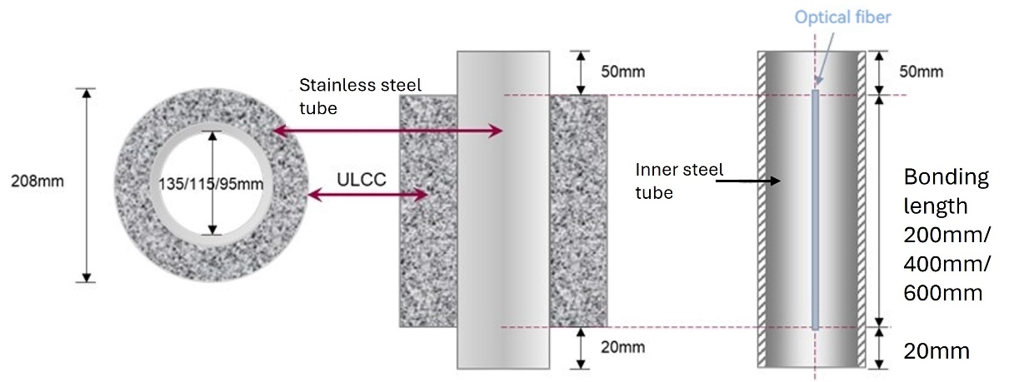
Figure 1 Schematic diagram of stainless steel tube-ULCC specimen

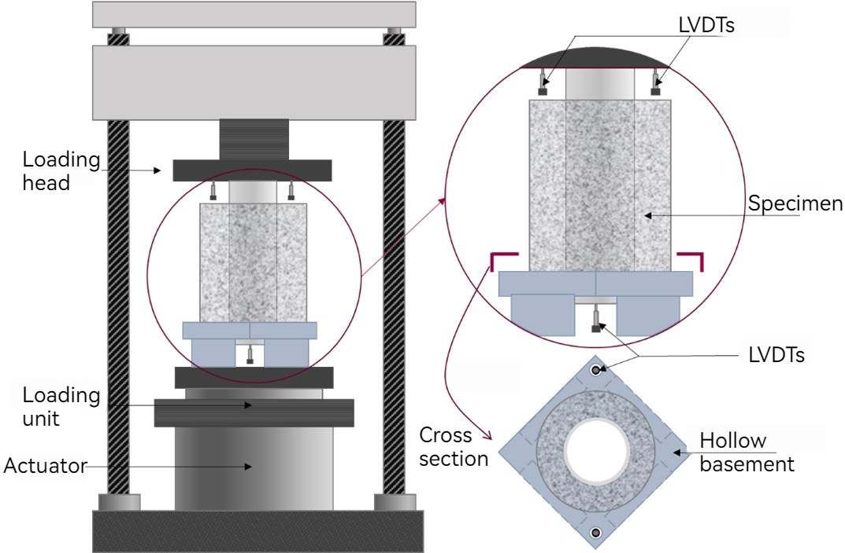
Figure 2 Schematic diagram of load setup for stainless steel tube- ULCC specimen

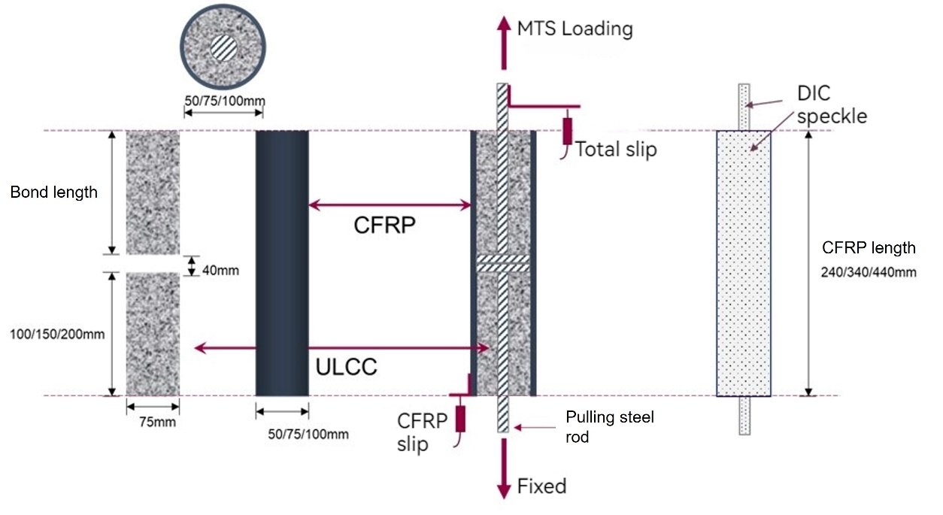
Figure 3 Schematic diagram for CFRP tube-ULCC specimen
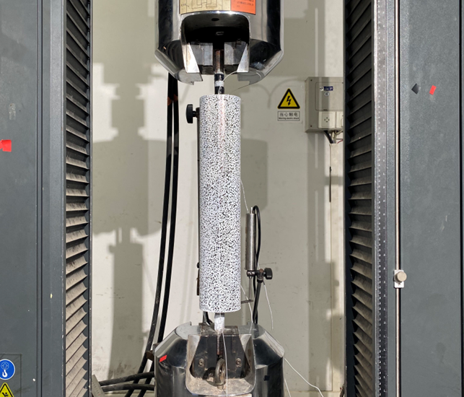
Figure 4 Test setup for CFRP tube-ULCC specimen

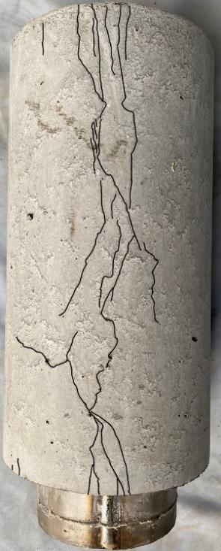 | 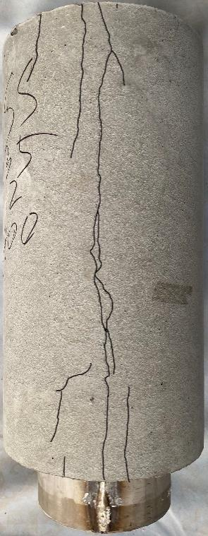 | 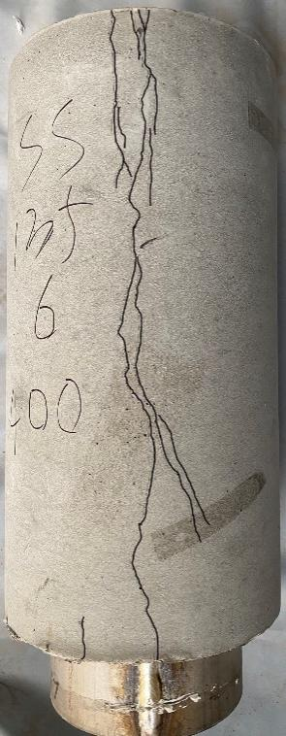 | 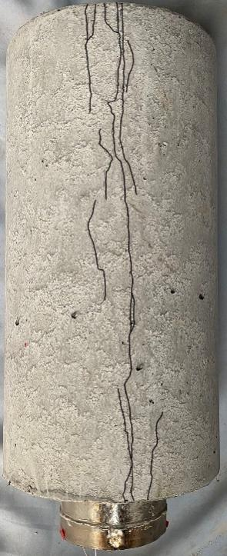
(a) SS-135-4-400 | (b) SS-135-2.5-400 | (c) SS-135-6-400 | (d) SS-95-4-400
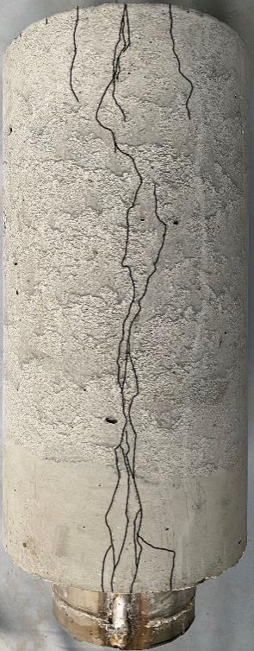 | 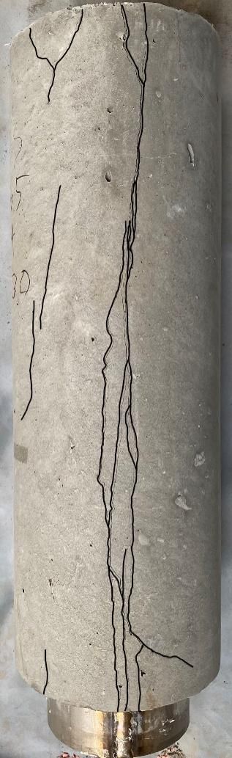 | 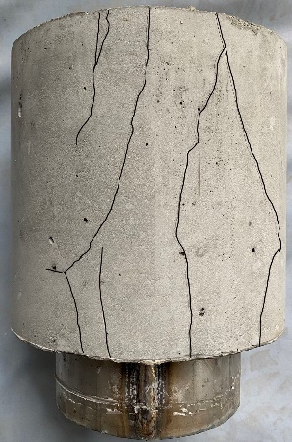 | 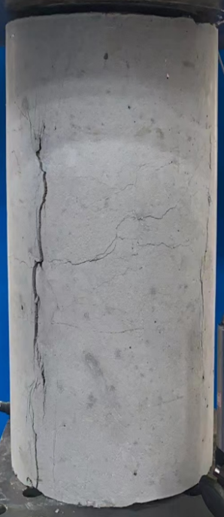
(e) SS-115-4-400 | (f) SS-135-4-600 | (g) SS-135-4-200 | (h) SS-135-4-200-S
Figure 5 Failure mode and cracks of stainless steel tube-ULCC specimen (Cracks were highlighted in black)

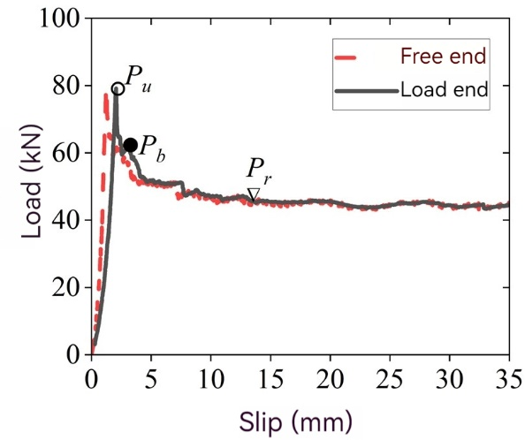 | 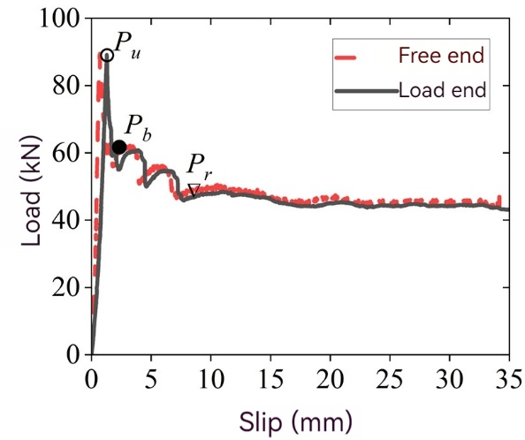
(a) SS-135-4-400 | (b) SS-135-2.5-400
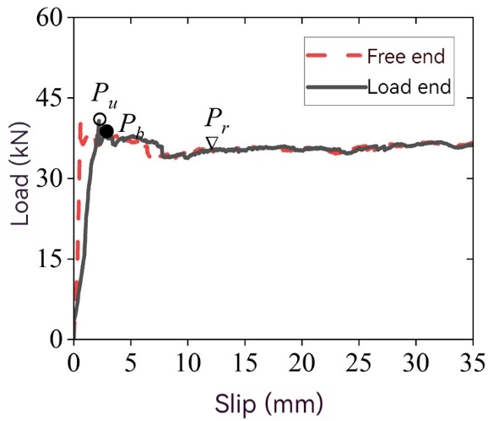 | 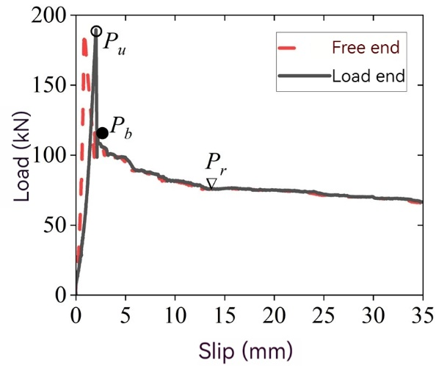
(c) SS-135-6-400 | (d) SS-95-4-400
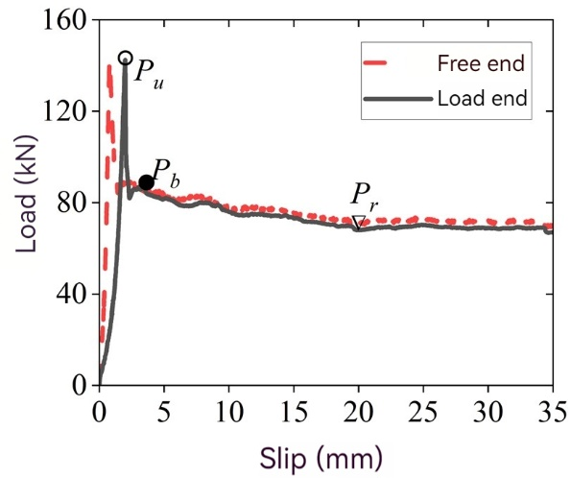 | 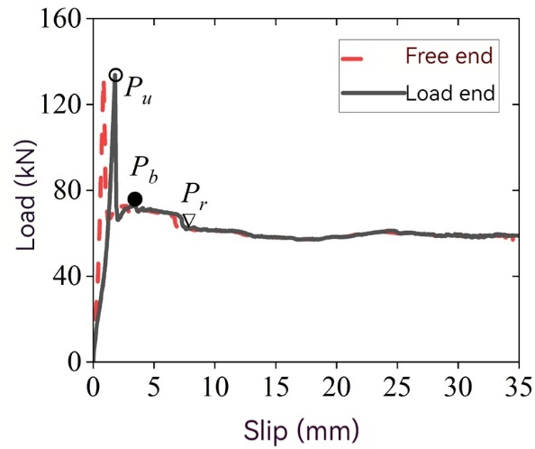
(e) SS-115-4-400 | (f) SS-135-4-600
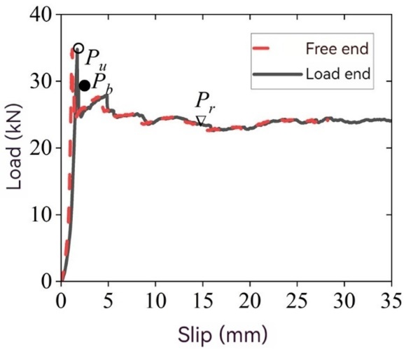 | 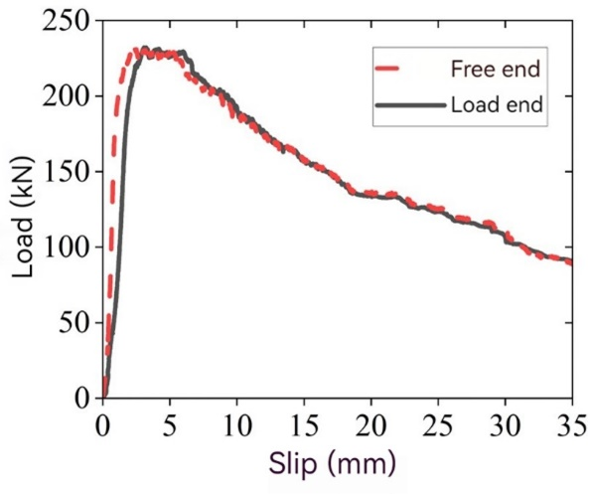
(g) SS-135-4-200 | (h) SS-135-4-200-S
○Ultimate bond load P_{u}；●rebound bond load P_{b}，▽residual bond load P_{r}
Figure 6 Load-slip curves for stainless steel tube-ULCC specimens
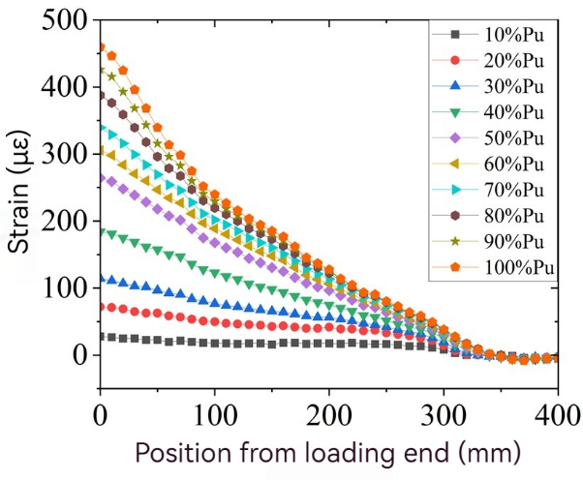 |  | 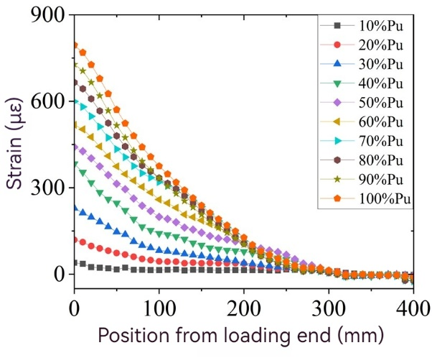
(a) SS-135-4-400 |  | (b) SS-135-2.5-400
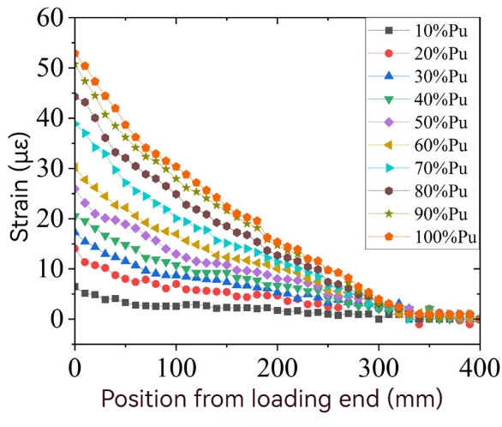 |  | 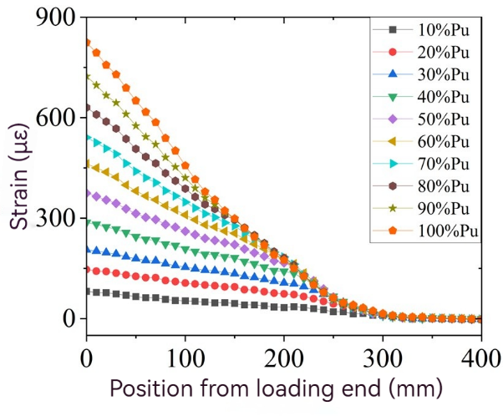
(c) SS-135-6-400 |  | (d) SS-95-4-400
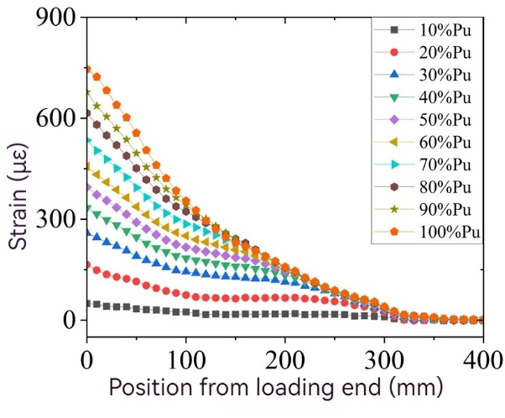 |  | 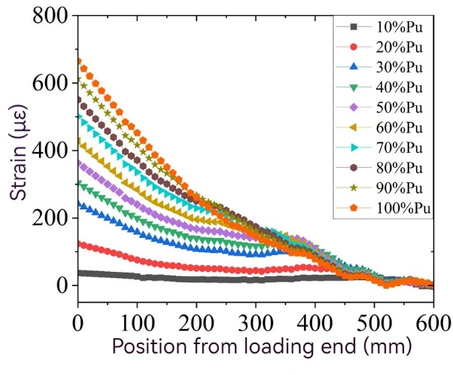
(e) SS-115-4-400 |  | (f) SS-135-4-600
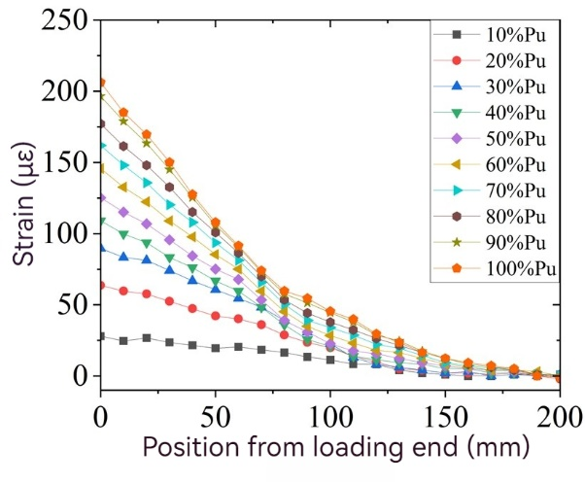 |  | 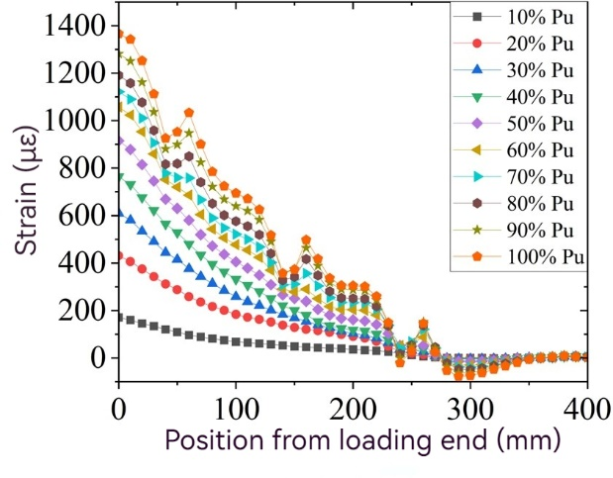
(g) SS-135-4-200 |  | (h) SS-135-4-200-S
Figure 7 Strain distribution of stainless steel tube-ULCC specimen under various load levels

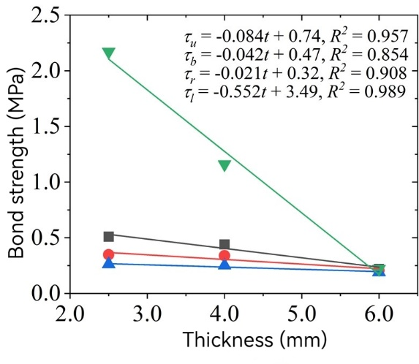
■Ultimate bond strength ● Rebound bond strength ▲Residual bond strength ▼Maximum local bond strength
(a) Effects of thickness of stainless steel tube
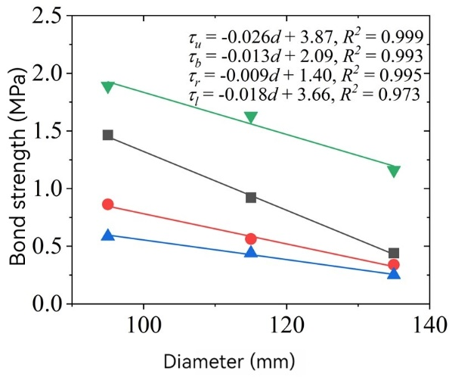
■Ultimate bond strength ● Rebound bond strength ▲Residual bond strength ▼ Maximum local bond strength
(b) Effects of diameter of stainless steel tube
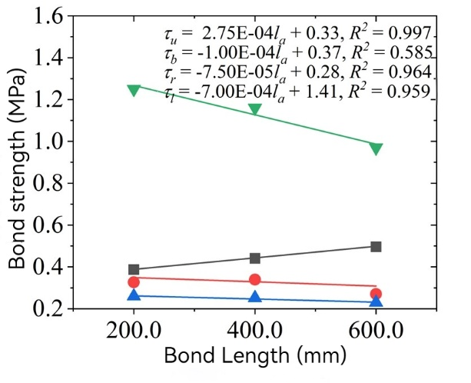
■Ultimate bond strength ● Rebound bond strength ▲Residual bond strength ▼ Maximum local bond strength
(c) Effects of bond length of stainless steel tube
Figure 8 Effects of different parameters on bond strength between stainless steel tube and ULCC
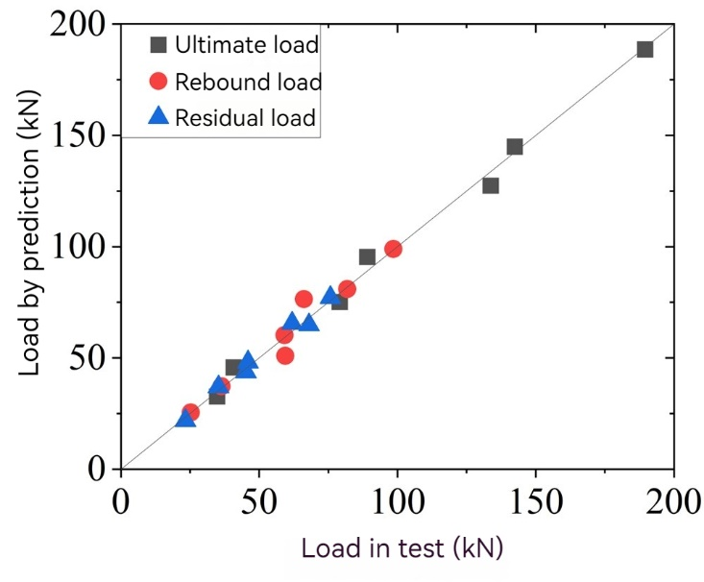
R-squared value: 0.99
Figure 9 Comparison between test load and predicted load of stainless steel tube-ULCC specimens

(a) SC-75-2-200 | 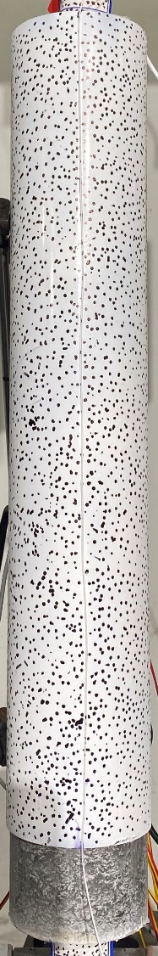
(b) SC-75-2-150 | 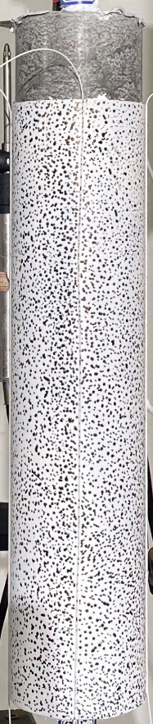
(c) SC-75-2-100 | 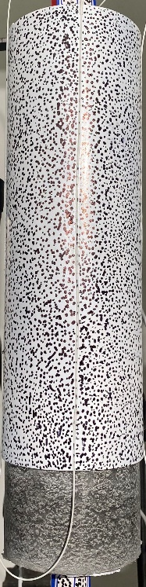
(d) SC-50-2-200 | 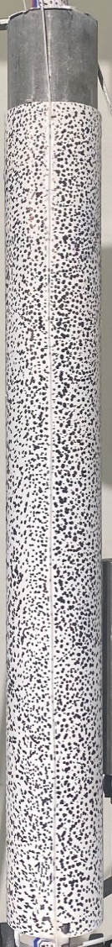
(e) SC-100-2-200 | 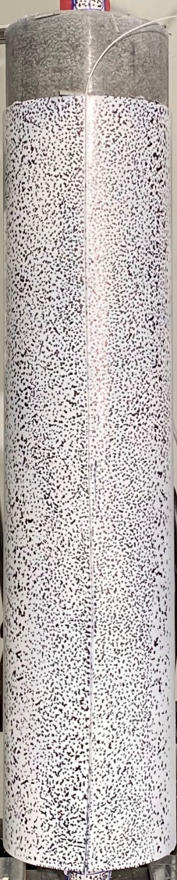
(f) SC-75-4-200 | 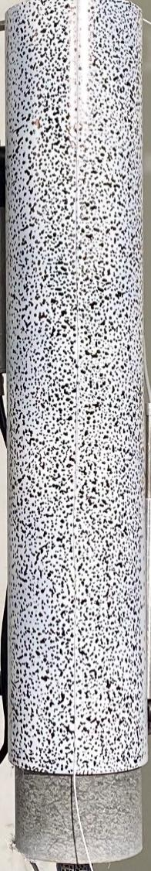
(g) SC-75-6-200 | 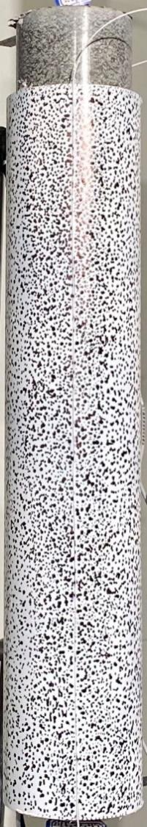
(h) SC-75-2-200-F | 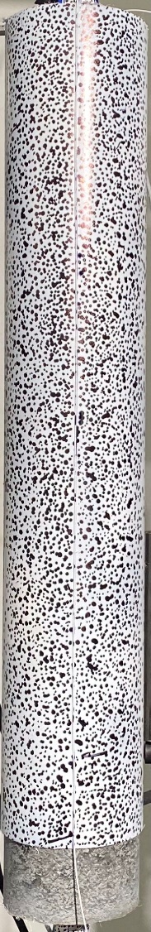
Figure 10 Photos of CFRP tube-ULCC specimens at end of loading.
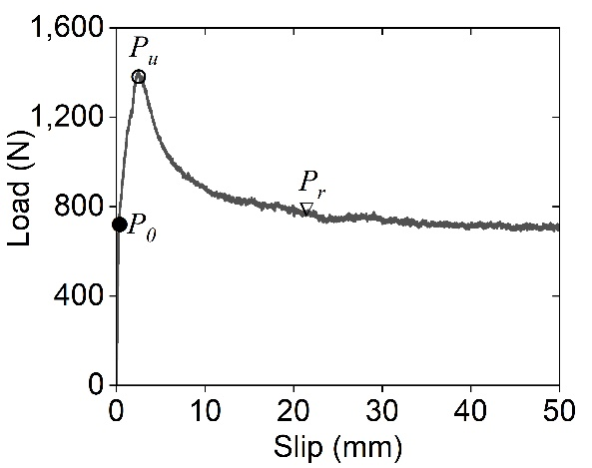 |  | 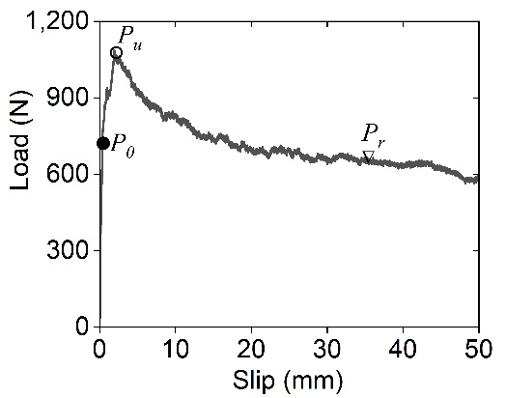
(a) SC-75-2-200 |  | (b) SC-75-2-150
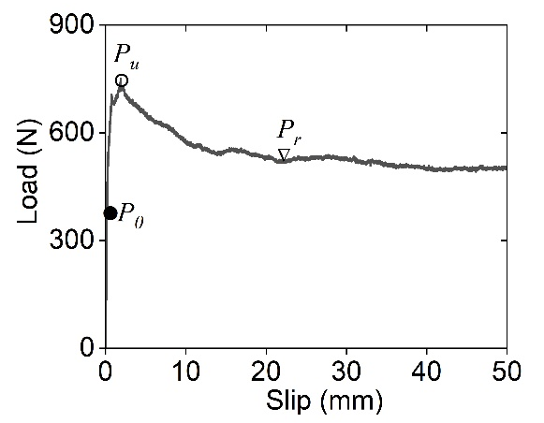 |  | 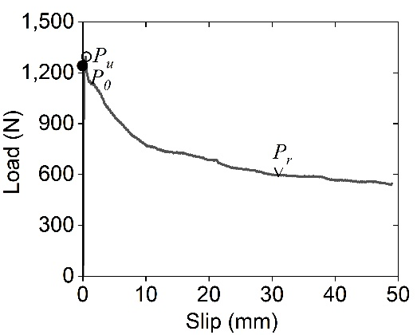
(c) SC-75-2-100 |  | (d) SC-50-2-200
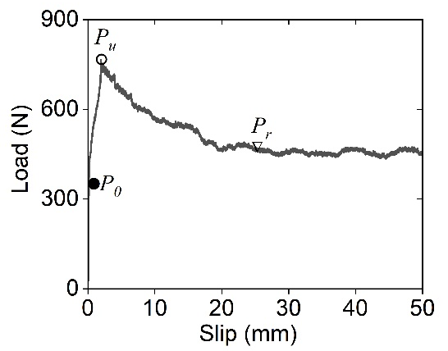 |  | 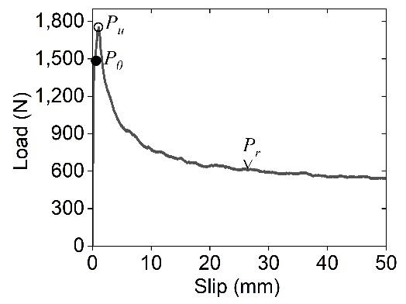
(e) SC-100-2-200 |  | (f) SC-75-4-200
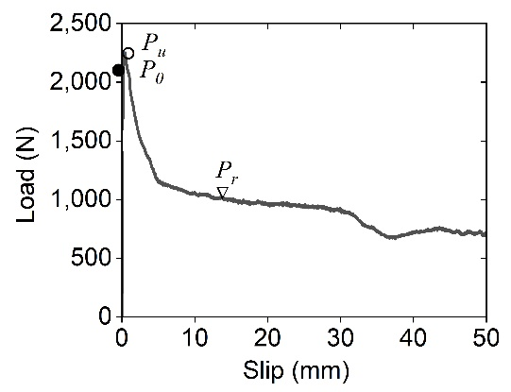 |  | 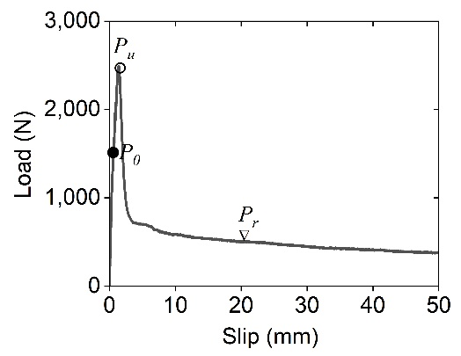
(g) SC-75-6-200 |  | (h) SC-75-2-200-F
●Linear bond loadP₀, ○Ultimate bond loadP_{u}, ▽Residual bond load P_{r}
Figure 11 Load-slip curves of CFRP tube-ULCC specimens

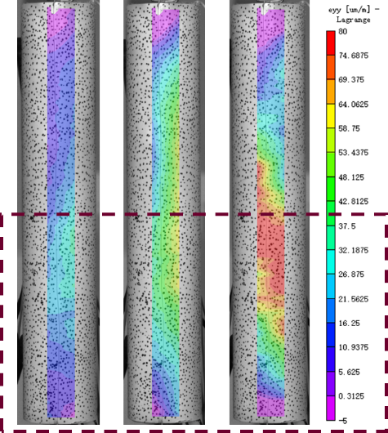 | 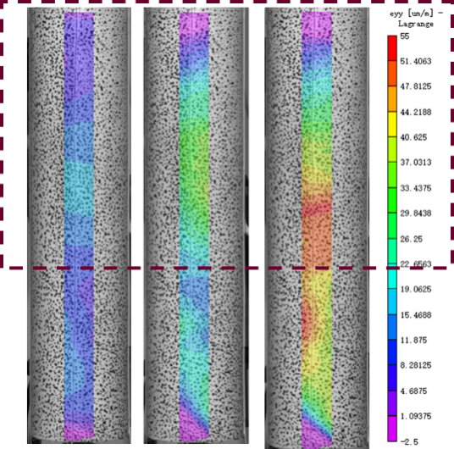
(a) SC-75-2-200 | (b) SC-75-2-150
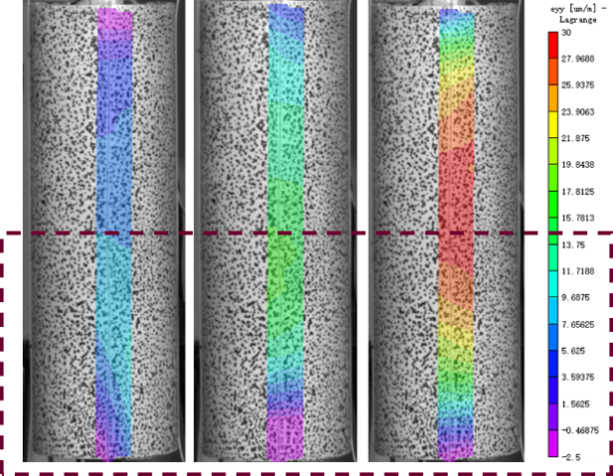 | 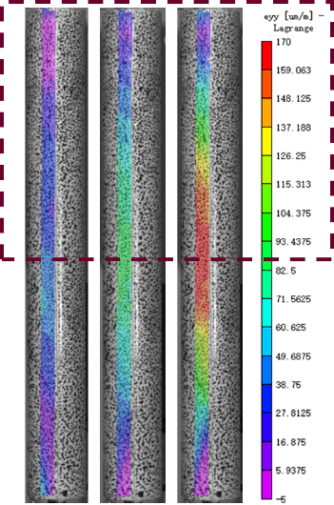
(c) SC-75-2-100 | (d) SC-50-2-200
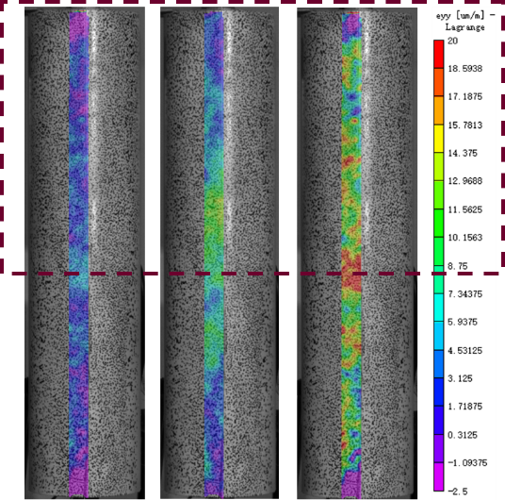 | 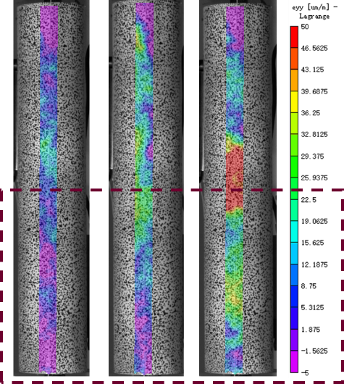
(e) SC-100-2-200 | (f) SC-75-4-200
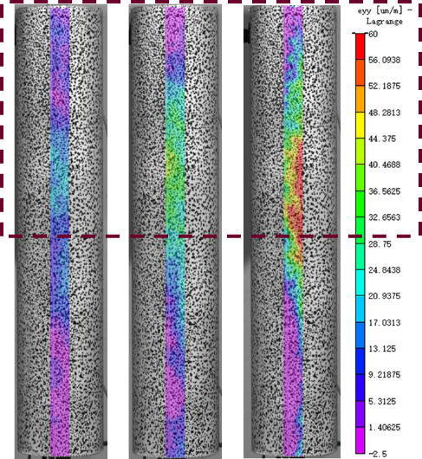 | 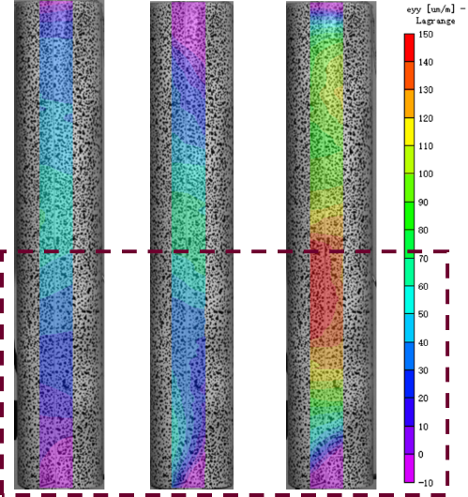
(g) SC-75-6-200 | (h) SC-75-2-200-F
Figure 12 Contour diagram of strain distribution of CFRP tube-ULCC specimens.
(Dashed frames locate the failure area. The load level increased subsequently from left to right)

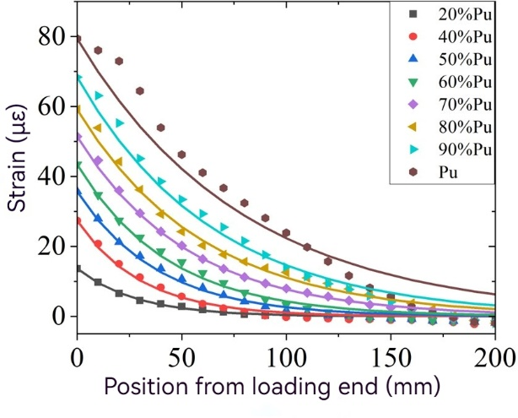 | 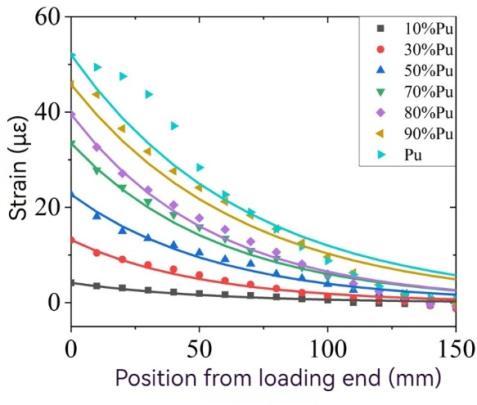
(a) SC-75-2-200 | (b) SC-75-2-150
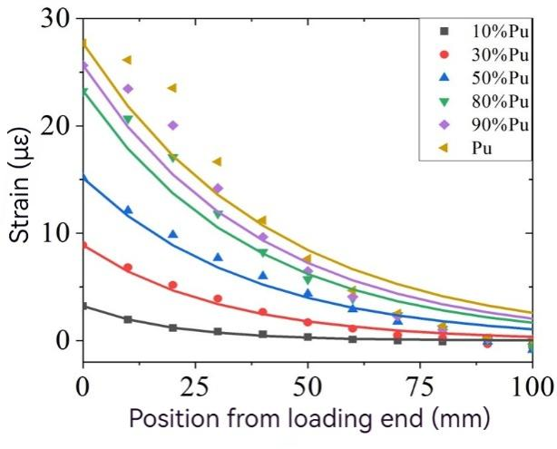 | 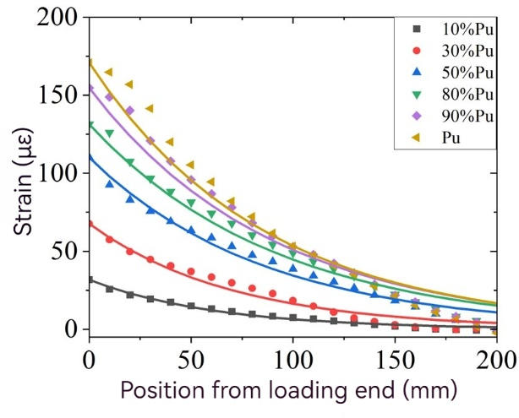
(c) SC-75-2-100 | (d) SC-50-2-200
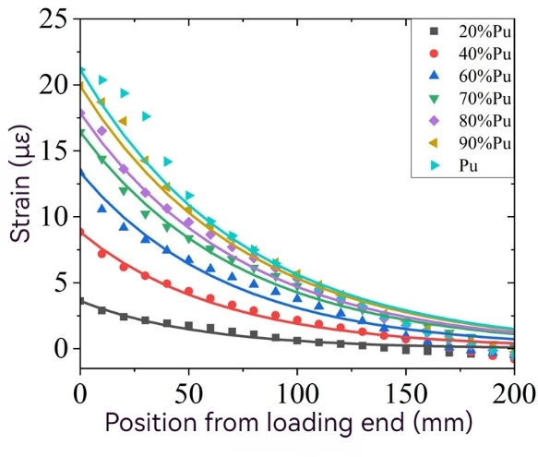 | 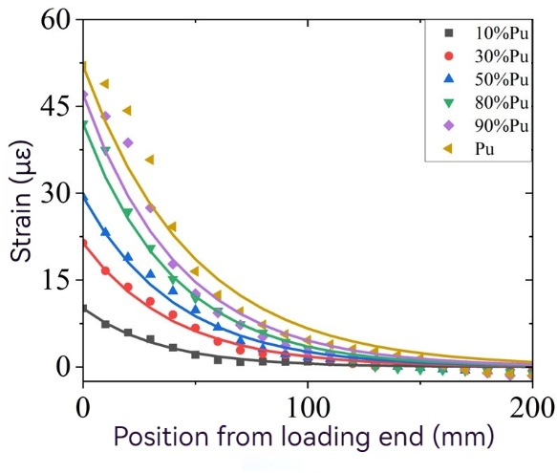
(e) SC-100-2-200 | (f) SC-75-4-200
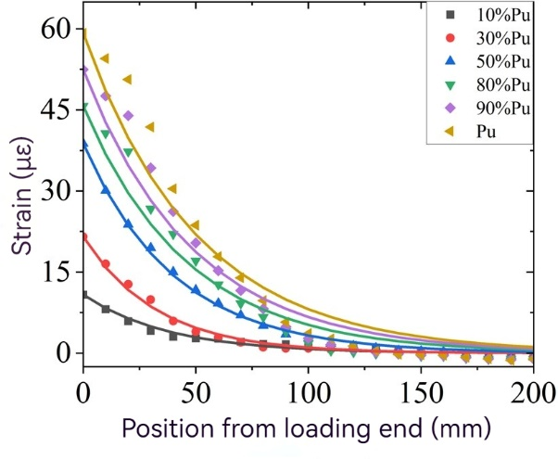 | 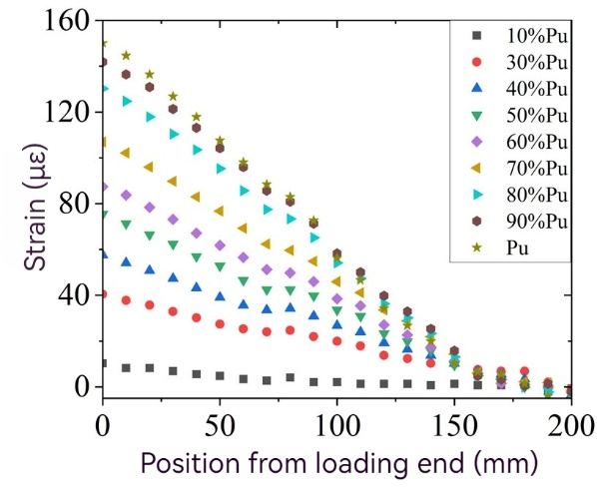
(g) SC-75-6-200 | (h) SC-75-2-200-F
Figure 13 Strain distribution of CFRP tube-ULCC specimens under various load levels.
(Test values are represented by scatters while smooth curves indicate fitting equations)

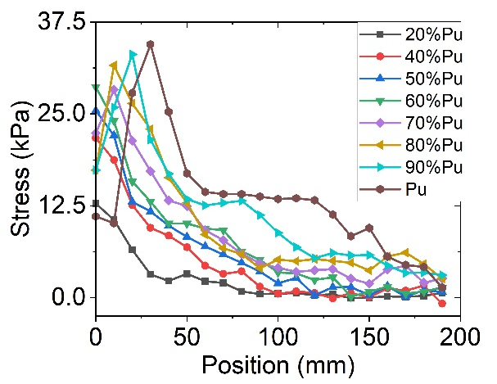 | 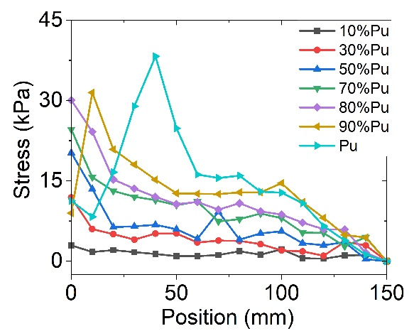
(a) SC-75-2-200 | (b) SC-75-2-150
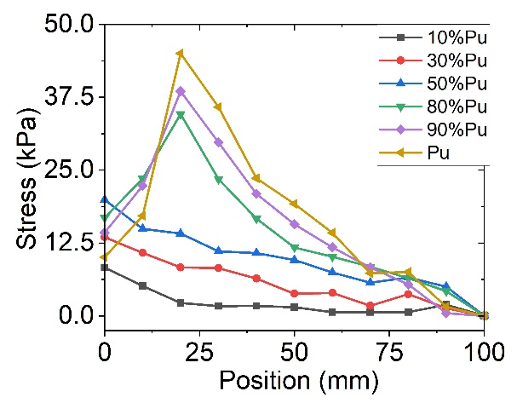 | 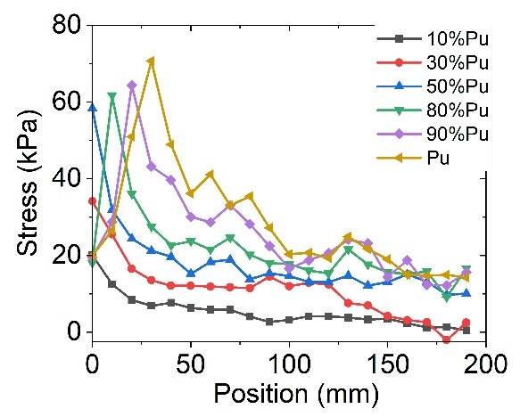
(c) SC-75-2-100 | (d) SC-50-2-200
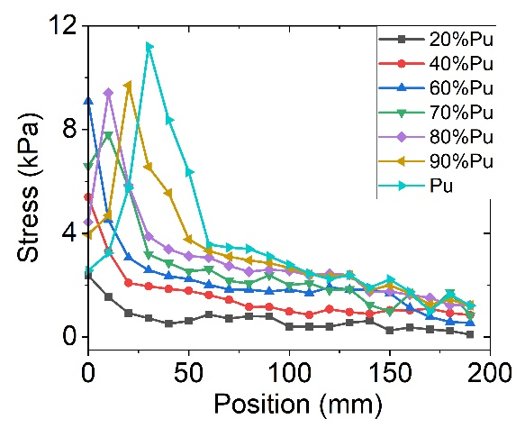 | 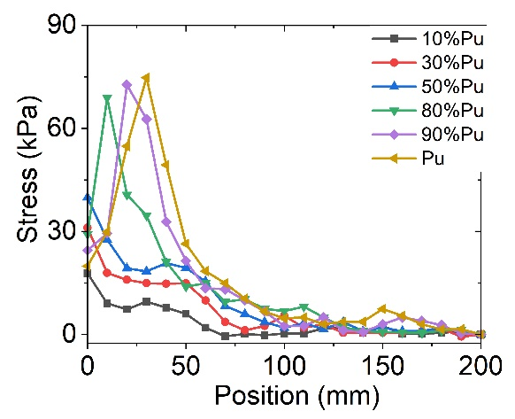
(e) SC-100-2-200 | (f) SC-75-4-200
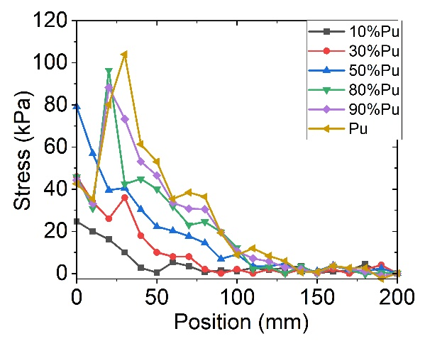
(g) SC-75-6-200
Figure 14 Stress distribution of CFRP tube-ULCC specimens

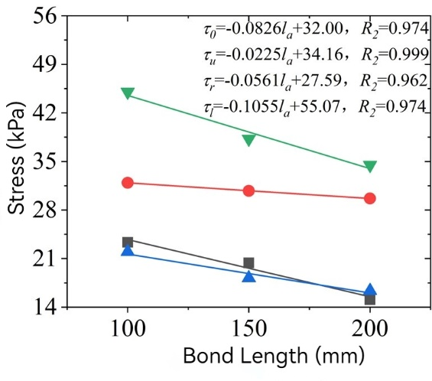
■Elastic bond strength ●Ultimate bond strength ▲Residual bond strength ▼ Maximum local bond strength
(a) Effects of bond length
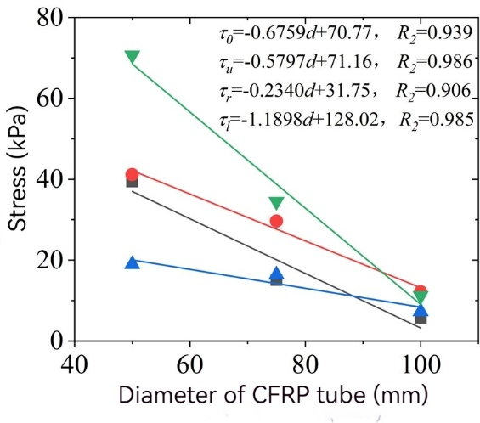
■Elastic bond strength ●Ultimate bond strength ▲Residual bond strength ▼ Maximum local bond strength
(b) Effects of CFRP tube diameter
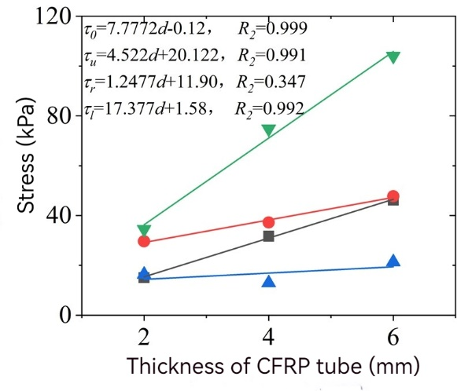
■Elastic bond strength ●Ultimate bond strength ▲Residual bond strength ▼ Maximum local bond strength
(c) Effects of CFRP tube thickness
Figure 15 Effects of different parameters on bond strength of CFRP tube-ULCC specimens
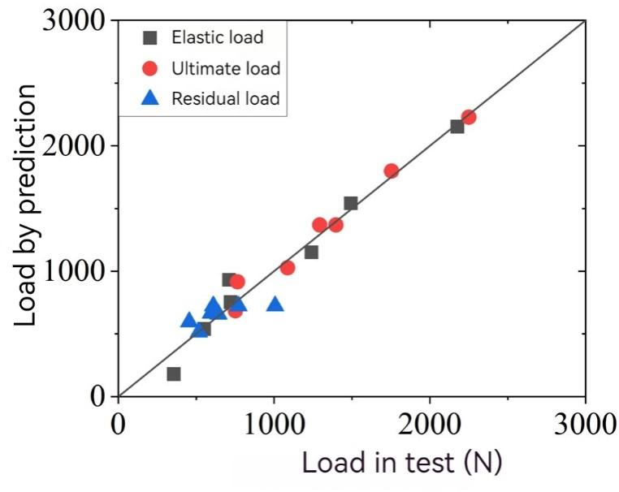
R-squared value: 0.96
Figure 16 Comparison between test load and predicted load of CFRP tube-ULCC specimens

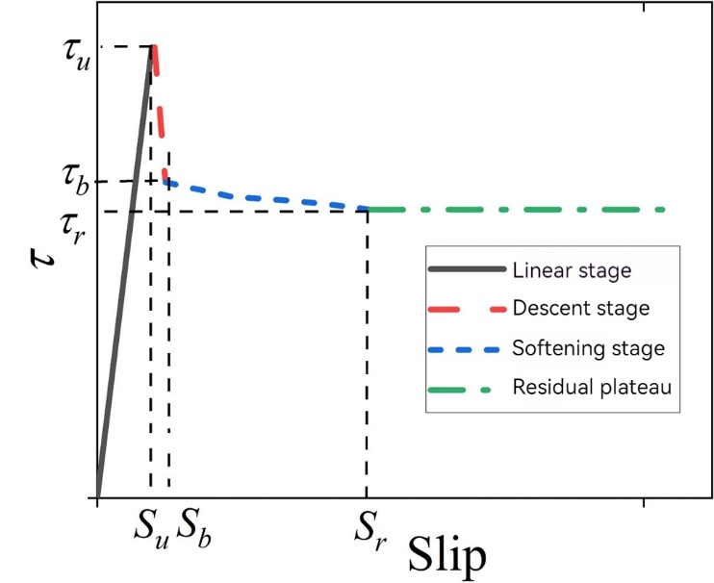
Figure 17 Proposed bond constitutive model between stainless steel tube and ULCC

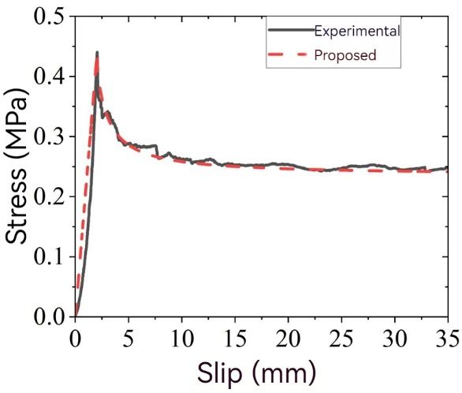 | 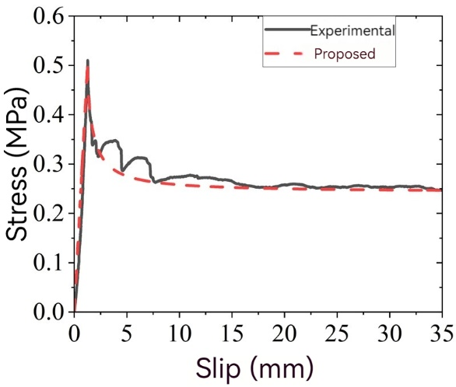
(a) SS-135-4-400 | (b) SS-135-2.5-400
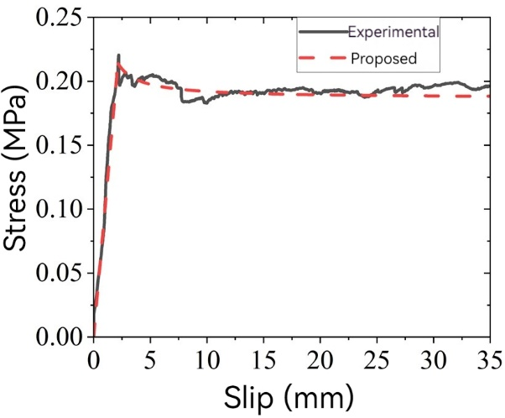 | 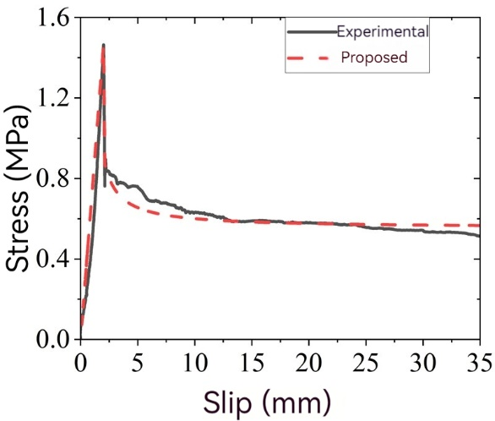
(c) SS-135-6-400 | (d) SS-95-4-400
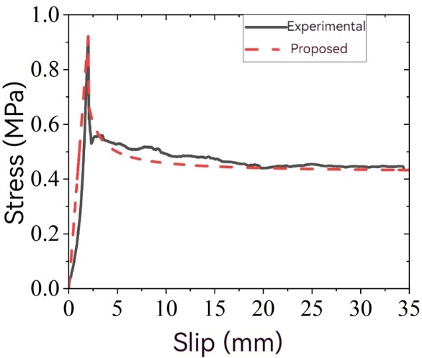 | 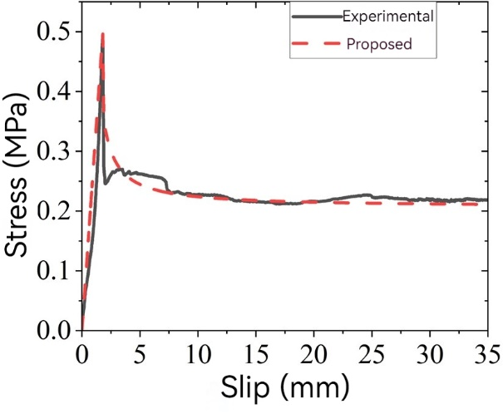
(e) SS-115-4-400 | (f) SS-135-4-600
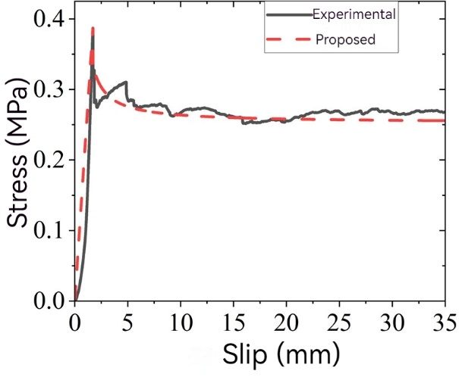
(g) SS-135-4-200
Figure 18 Comparison between test and proposed constitutive model for bond between stainless steel tube and ULCC

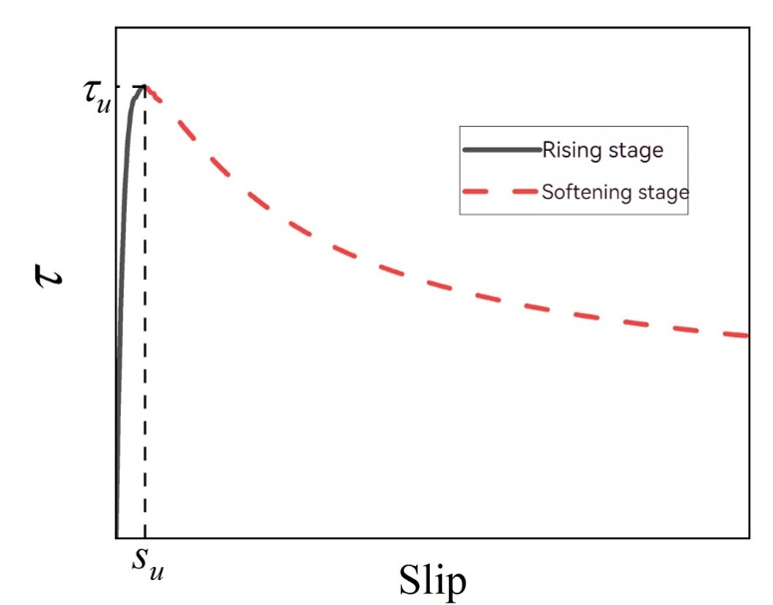
Figure 19 Proposed constitutive model for bond between CFRP tube and ULCC
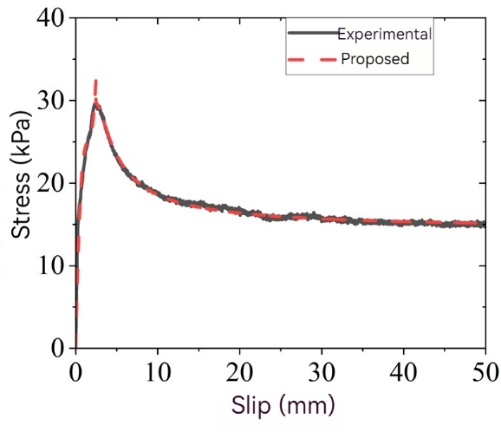 | 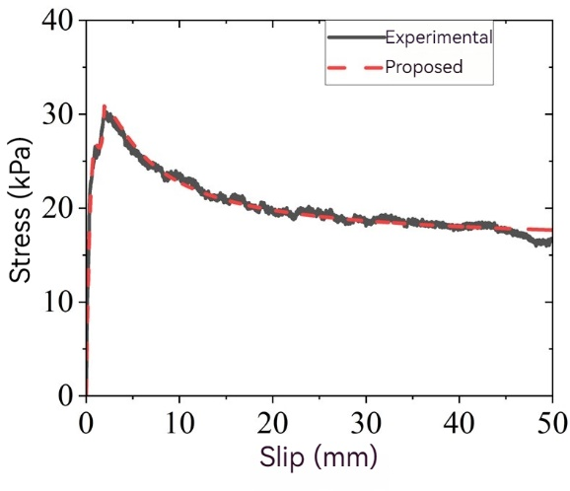
(a) SC-75-2-200 | (b) SC-75-2-150
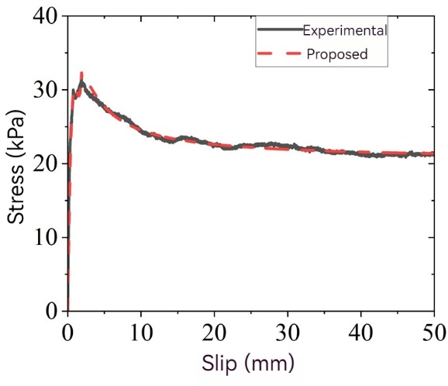 | 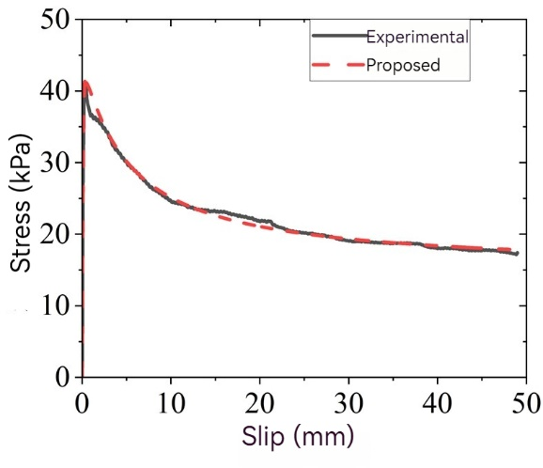
(c) SC-75-2-100 | (d) SC-50-2-200
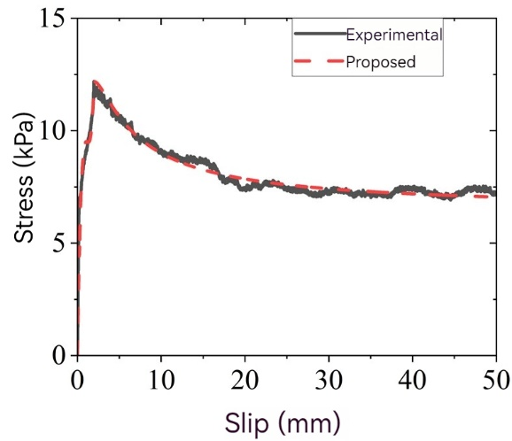 | 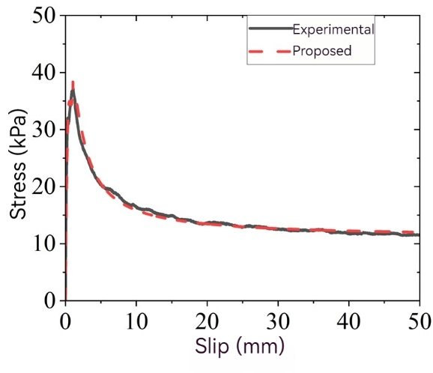
(e) SC-100-2-200 | (f) SC-75-4-200
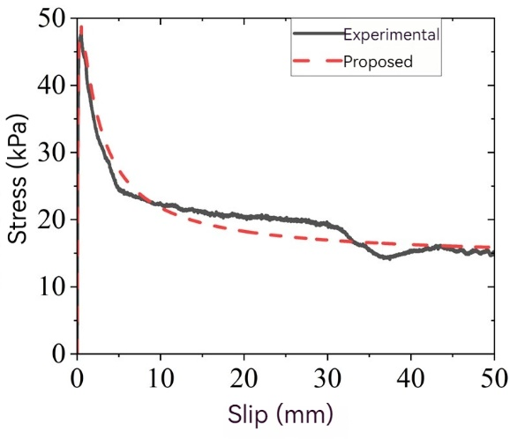
(g) SC-75-6-200
Figure 20 Comparison between test and proposed constitutive model for bond between CFRP tube and ULCC

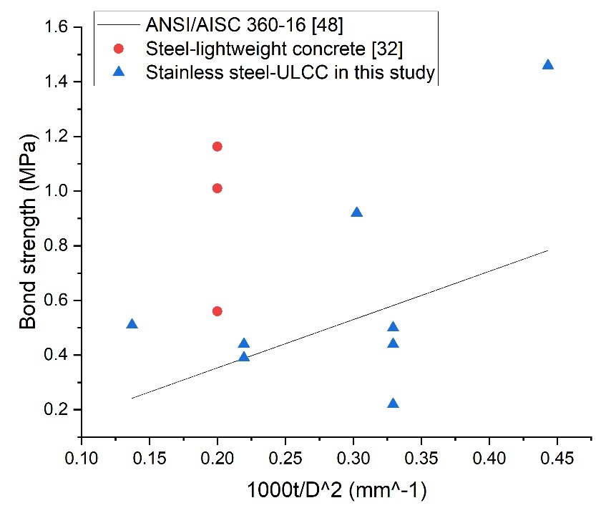
Figure 21 Comparison of bond strengths between lightweight concrete and steel

