Improving the hydrogen embrittlement property of 1.8 GPa press-hardened steel by controlling the prior austenite grain size
D.H.Du^{a,b}, Y.Zhang^{c}, Z.Y.Geng^{c}, B.B.He^{b*}, M.X.Huang^{a*}
ª Department of Mechanical Engineering, The University of Hong Kong, Pokfulam Road, Hong Kong, China
^{b} Department of Mechanical and Energy Engineering, Southern University of Science and Technology, Shenzhen, 518055, China
^{c}Ansteel Beijing Research Insitute Co., Ltd., Beijing 102211, China
Corresponding author: Dr. B.B.He: e-mail: hebb@sustech.edu.cn. Tel:+86 -755-88015374
Corresponding author: Dr. M.X.Huang: e-mail: mxhuang@hku.hk, Tel: +85228597906; Fax:+85228585415
Abstract
Press-hardened steel (PHS) with a tensile strength of 1.8 GPa exhibits significant potential for lightweight applications in automobile industry. Nevertheless, H embrittlement (HE) remains a serious concern in the practical applications of PHS. Nb alloying can improve the HE property of PHS by introducing extensive nanosized niobium carbides (10–20 nm in diameter), which are irreversible H traps in the steel matrix, into PHS. Interestingly, herein, we discovered that even without the formation of a large amount of nanosized niobium carbides, Nb alloying was beneficial for improving the HE property of a 1.8 GPa press-hardened PHS. Addition of Nb to this PHS resulted in complex submicron-sized (Nb,Ti)(C,N) precipitates rather than nanosized NbC precipitates. These submicron-sized (Nb,Ti)(C,N) precipitates effectively refined the prior austenite grain (PAG) size, leading to a higher density of low-angle grain boundaries, which reduced the H diffusion rate and also acted as H traps. Consequently, the average amount of H at the PAG boundary was substantially low, thereby improving the resistance to HE.
Keywords: Press-hardened steel; Hydrogen embrittlement; Prior austenite grain size; Hydrogen diffusion; Niobium carbide

1. Introduction
Press-hardened steels (PHSs) are widely used in the automotive industry owing to their high strengths and facile processing routes. Car components including A/B pillars and bumpers are the main products composed of PHS. Typical PHS, namely, 22MnB5, demonstrates a tensile strength of 1500 MPa and is extensively employed in the automotive industry. Compared to conventional cold rolling, hot stamping is a promising lightweight technology to produce ultra-high-strength PHS as it leads to PHS with a fully martensite structure and enables low spring back after stamping [1-3]. Recently, higher-strength stamping steels achieving the tensile strengths of 1.8–2.0 GPa have been developed by appropriately increasing the C content and introducing multi-alloying elements, such as Nb, V, and Ti, into PHSs to induce precipitates for hardening and have attracted considerable attention as promising candidates for application in next-generation reinforcement parts. However, the fully martensite structure in PHS is sensitive to diffusible H atoms due to its body-centered cubic (bcc) lattice, and the risk of H embrittlement (HE) increases with an increase in the strength level [3-8]. Therefore, improving the resistance of PHS to HE is essential for the automotive industry.
Relevant issues on HE have been examined for decades [9-12], and the main mechanisms by which H induces brittle fracture in hot-stamped steels include, but not limited to, (i) H-enhanced local plasticity (HELP), (ii) H-enhanced strain-induced vacancy (HESIV), (iii) H-enhanced decohesion (HEDE), and (iv) adsorption-induced dislocation emission (AIDE) [13-15]. To overcome the intrinsic H-induced cracking of hot-stamped steels, two concepts have been proposed in terms of microstructural evolutions [16, 17]. First, grain refinement is beneficial for improving HE [6, 7]. Its positive effect has been appropriately verified in pipeline, twinning-induced plasticity, and hot-stamped steels. Refined grains decrease the diffusible H content per unit boundary area, thereby impeding the diffusion and accumulation of H atoms during deformation [16]. Second, specific precipitates acting as strong irreversible H traps have been extensively reported. Formation of nanosized precipitates transforms diffusible H atoms into non-diffusible H atoms owing to high binding energy of carbides, thereby significantly increasing H trap density and consequently increasing the HE resistance [18-21].
Microalloying elements, for example, Nb, V, and Ti, not only generate precipitates, but also refine the grain size; therefore, they are widely adopted as effective elements to increase the HE resistance in the automotive industry. Zhang et al. claimed that the HE resistance of PHS improved upon alloying with Nb and attributed this improvement to the enhancement in the number of irreversible H traps and grain refinement effect of NbC [22, 23]. Production of NbC precipitates is advantageous because the interface of these precipitates with the martensite matrix is a strong H-trapping site [24, 25]. Xu et al. also confirmed the beneficial role of NbC in improving the HE resistance of a high-strength steel prepared by quenching–partitioning–tempering [25]. Furthermore, dual precipitation of NbC and VC particles substantially improved the HE resistances of tempered martensitic steels, which was ascribed to grain refinement and coprecipitation, thereby generated numerous hydrogen traps with variant binding energies.[26]. Although microalloying with these elements increases the HE resistances of steels to some extent, appropriate additions of these elements is crucial because misuse of alloying elements frequently leads to severe degradation of the mechanical properties and HE resistances of steels, which is attributed to the formation of inclusions and coarsening of precipitates [27-29]. According to Wei et al., TiC exhibits different H-trapping characteristics, which depend on the sizes, morphologies, and interfacial coherencies of TiC particles with the steel matrix [19]. Although nanosized TiC is advantageous to the mechanical properties and HE resistances of steels, coarse Ti(C,N) (up to 10 μm in size) is also readily generated during hot rolling due to unsatisfactory impurity control. Owing to the hard and brittle characteristics of Ti(C,N), microcracks frequently initiate in the vicinity of Ti(C,N), which deteriorates the mechanical properties such as bending and impact toughness, thereby significantly affect the mechanical behaviors of steels in automotive industry[30, 31]. Moreover, NbC, verified as a beneficial precipitate for improving the HE resistances of experimental-level materials, still demonstrates uncertainties in industrial production as the mechanism of interaction between the microalloying element and impurities is still unclear.
Therefore, in this study, dispersed precipitates are introduced into an industrial-grade PHS by adding Nb to it. The steel contains trace amounts of impurities and exhibits a tensile strength of 1800 MPa. Effects of Nb introduction on the mechanical properties, H trapping and diffusion behaviors, and HE resistance of this steel are systematically investigated. A Nb-free steel with comparable strength was fabricated as a reference steel. HE resistance provided by Nb microalloying was elucidated by understanding the microstructural evolution, H diffusion behavior, and precipitation mechanisms. The corresponding experimental results provide guidance for the design of automotive industrial-grade PHSs for next-generation reinforcement components.

2. Experimental
Chemical compositions of the two 1.8-GPa-grade hot-stamped steels employed herein are presented in Table 1, and both steels were cold-rolled and annealed sheets with 1.2–1.3 mm thicknesses. The steel without Nb microalloying is referred to as Nb-free steel, and the steel with Nb addition (0.045 wt%) is termed Nb steel hereinafter. These two as-received steels were provided by the steel industry and were hot-rolled to 1.3 mm thicknesses via a standard production line. A batch of 10 × 10 cm² plates was machined from the as-received sheets by electrical discharge machining (EDM). For hot stamping, the prepared plates were initially heated to 930 °C for 5 min in an air furnace for austenization; then, the resulting plates were stamped by a Cu plate to simulate quenching and stamping followed by isothermal tempering at 170 °C for 20 min to not only simulate “baking” in the automobile industry, but also ensure complete desorption of inner H. C in different contents was incorporated into both steels to obtain steels with comparable tensile strengths as strength is highly sensitive to HE. To elucidate the mechanism of H-induced property degradation, slow strain rate tensile test (SSRT) was performed to assess the H sensitivity in martensitic structure. Tensile specimens with different gauge geometries (namely, smooth and notch) were machined by EDM, and the corresponding mechanical properties were analyzed by a MTS810 universal tensile machine. Tensile test was conducted at a strain rate of 3 × 10⁻⁵/s for the smooth sample and at a displacement rate of 4 × 10⁻⁴ mm/s for the notch sample. A round notch sample with a radius of 2 mm was designed to induce stress concentration in front of the notch tip for ensuring a H accumulation area and thereby enlarge the insignificant difference between HE degradations of smooth and notch samples.
The geometrical specifications of the tensile specimens used in this study and the electrochemical charging parameters applied can be found in Table 2. Prior to the tensile test, the samples were charged with H via electrochemical charging in an electrolyte comprising a mixture of 0.3% ammonium thiocyanate and 3% NaCl (wt.%) at a current density of 0.1 mA/cm². Same charging parameters were employed in the permeation test and thermal desorption spectroscopy (TDS). The tensile test was performed after less than 10 min of electrochemical charging. Elongation loss (EL) and ultimate tensile strength (TS) were calculated using the following equations and indicated the HE resistance:
$$\begin{aligned}{El}_{loss} = \frac{{El}_{uncharged} -{ El}_{charged}}{{El}_{uncharged}} × 100\%\#\left(1\right)\end{aligned}$$

$$\begin{aligned}{TS}_{loss} = \frac{{TS}_{uncharged} - {TS}_{charged}}{{TS}_{uncharged}} × 100\%\#\left(2\right)\end{aligned}$$
where ${El}_{loss}$ and ${TS}_{loss}$ represent EL and ultimate TS after charging as compared to those before charging, respectively.
Samples for scanning electron microscopy (SEM) performed using Zeiss Sigma 300 at 5 kV were synthesized by conventional grinding and polishing, followed by etching in a solution of 10% perchloric acid and 90% acetic acid (in vol.%) for 180 s. Fracture morphologies of the tensile samples after SSRT were also examined by SEM. Electron backscatter diffraction (EBSD) with a step size of 0.2 μm at 20 kV was conducted on the etched sample to determine the prior austenite grain (PAG) boundaries (PAGBs). Furthermore, multiple precipitates were characterized using Thermo Scientific Talos F200X in the scanning transmission electron microscopy (STEM)/energy-dispersive X-ray spectroscopy (EDS) mode, where chemical composition of the carbide was fully revealed. TEM samples were prepared via grinding and polishing the steel samples to thicknesses of 120 μm followed by twin-jet electropolishing using a solution of 5% perchloric acid, 25% glycerol, and 70% ethanol at 0 °C and a voltage of 30 V.
Plate samples with dimensions of 20 × 15 × 1 mm³ were charged in a mixture of 0.3% ammonium thiocyanate and 3% NaCl (wt.%) at a current density of 0.1 mA/cm² for different time periods and utilized for H content measurement. A Bruker G4 PHOENIX H analyzer with a resolution of 0.01 wppm was applied for H content measurement. To evaluate the activation energy (E_{D}) values for different H traps, the plate samples were heated to 500 °C at three different heating rates (i.e., 3.34, 6, and 18 K/min), and E_{D} was determined by the following Kissinger equation [32]:
$$\begin{aligned}E_{D} = -R\frac{∂(ln∅/{{T_{P}}^{2})}}{∂\left(1/{T_{P}}\right)}\#\left(3\right)\end{aligned}$$
where T_{p} refers to the peak temperature of the thermal desorption analysis (TDA) curve, $∅$ is the heating rate (K/min), and R = 8.314 J/(K mol) is the gas constant.
The H permeation test was performed to investigate the diffusion behavior of H in PHS using a modified Devanathan-Stachurski dual electrolytic cell at room temperature. Square samples with 0.7 mm thickness were carefully ground on both sides up to final mechanical finishing using 4000 grit. A 0.1 M NaOH solution was employed, and constant potential mode at 150 mV was adopted in the oxidation cell. Background current of <100 nA/cm² was set as the threshold for the complete consumption of inner H. Effective H diffusion coefficient (D_{eff}) was determined by the following equation [33, 34]:
$$\begin{aligned}D_{eff} = \frac{L^{2}}{{6t}_{lag}}\#\left(4\right)\end{aligned}$$
where L denotes the samples thickness and t_{lag} is the time lag reaching 0.63 times the steady permeation current density.
Table 1
Chemical composition (in wt.%) and stamping parameters of PHS1800.
 | C | Mn | Si | Ti | B | Nb | Fe | Stamping
Nb steel | 0.29 | 1.62 | 0.27 | 0.019 | 0.0024 | 0.045 | Bal. | 930 °C, 5 min
Nb-free steel | 0.33 | 1.31 | 0.31 | - | 0.0013 | - | Bal. | 930 °C, 5 min
Table 2
Specimen geometries and experiment conditions
Type No. | Mechanical test | Gauge length/width (mm) | Notch Geometry
1 | Slow strain rate tensile (SSRT) test | 12/4 | Smooth sample
2 | Slow strain rate tensile (SSRT) test | 10/3 | Round notch with a radius of 2mm

3. Results and discussion
Microstructures of both steels were characterized by SEM (Figure 1(a) and (d)). Both steels were composed of full martensite, where the lath morphology of martensite was observed in PAGs with boundaries marked by red lines. EBSD was conducted to characterize the lath martensite in the Nb-free steel (Figure 1(b)). The hierarchical structure of martensite with lath, block, and packet was revealed by EBSD. No evident texture was detected, suggesting that hot stamping did not result in significant variant selection of martensite. PAGBs were determined using the open-source software “MTEX” and are marked with black lines in Figure 1(c) and (f). PAG size calculated from the reconstructed EBSD map by the line intercept method was 17.57 ± 4.22 μm for the Nb-alloyed steel (Figure 1(e)). Similarly, SEM and EBSD were conducted on the Nb steel (Figure 1(d)–(f)). Lath morphology of martensite with weak variant selection similar to that in the Nb-free steel was detected in the Nb steel (Figure 1(d) and (e)). PAG size of the Nb steel was determined to be 7.61 ± 0.82 μm via EBSD. Average PAG size of the Nb steel was lower than that of the Nb-free steel, indicating that Nb alloying led to higher grain refinement efficiency. Furthermore, the hierarchical structure of martensite allows for the observation of typical PAG, packet, and block boundaries in the present samples. The reduction of PAG size in Nb steel leads to an increase in the proportion of both packet and block boundaries, highlighting the significant role of Nb in refining the substructure grain size. It is important to highlight that, in the case of HE in PHSs, the dimensions of the martensite packet and block are particularly crucial. For a standard lath martensite structure, a scaling rule is frequently used to explain the changes in packet and block boundaries in relation to PAGS [35]:
$$\begin{aligned}d_{packet}=0.40d_{PAG}, d_{block}=0.067d_{PAG}\#\left(5\right)\end{aligned}$$
The size of the martensite packet and block are regarded as the primary structure in trapping diffusible hydrogen. Hence, the effective grain size of these structures is directly related to HE. Ultimately, with a precise PAGS measurement, it is reasonable to obtain a good estimate of the size of the substructure [36]. The notable grain refinement effect ascribed to Nb agreed with the findings of the studies reported in the literature, which claimed that a Zener pinning effect stemmed from the formation of carbides [22-24, 26].

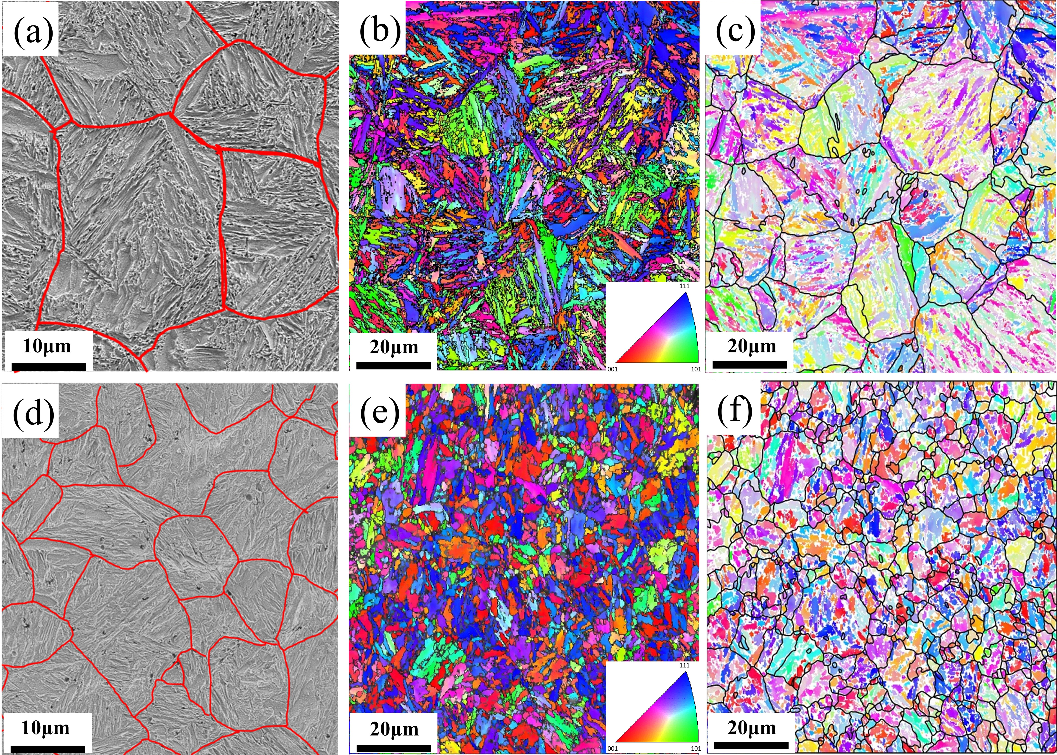
Fig. 1 (a and d) SEM images, (b and e) EBSD inverse pole figure (IPF) maps, and (c and f) post-processed EBSD maps of the two PHSs acquired using MTEX: (a–c) Nb-free steel and (d–f) Nb steel. Red lines in a and d and black lines in c and f denote the prior austenite grain boundaries (PAGB).

Distribution of the grain boundary misorientation can be extracted from the EBSD inverse pole figure (IPF) maps. Fractions of low-angle grain boundaries (LAGBs) (2° < θ < 15°) and high-angle grain boundaries (HAGBs) (15° < θ < 65°) in both Nb-free and Nb steels are shown in Figure 2. Fractions of both types of boundaries of these two steels are comparable (Figure 2), implying that Nb microalloying does not considerably change the grain boundary misorientation. Generally, LAGBs correspond to the lath boundaries (~10º), whereas HAGBs exhibit the block, packet, and PAG boundaries. Similar fractions of these boundaries indicate that the addition of Nb does not change the martensite size:PAG size ratio. However, considering the smaller grain size of the Nb steel as compared to that of the Nb-free steel, the Nb steel is expected to demonstrate higher boundary density than that of the Nb-free steel based on the similar fractions of LAGBs and HAGBs.
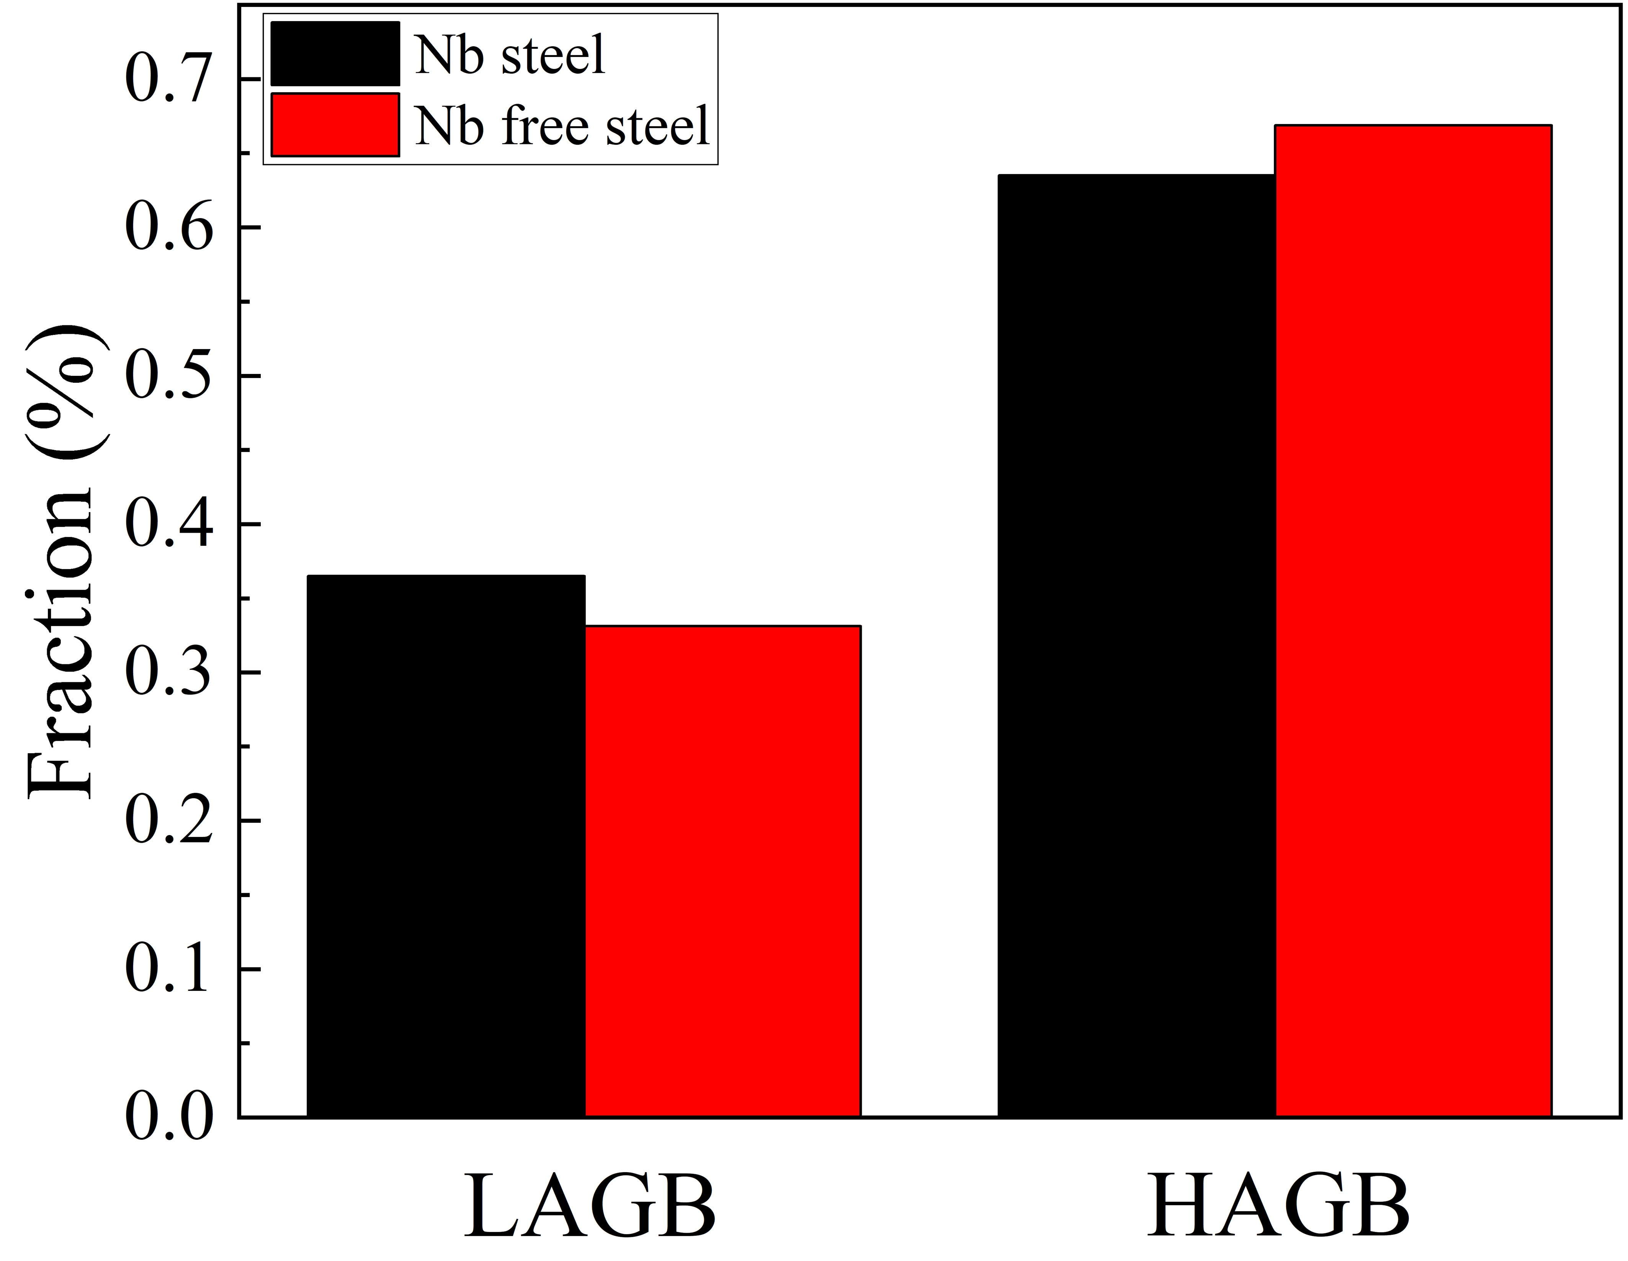
Fig. 2 Distributions of the misorientations of grain boundaries, including low-angle grain boundaries (LAGBs) (2° < θ < 15°) and high-angle grain boundaries (HAGBs) (15° < θ < 65°), in the Nb and Nb-free steels.
Mechanical properties of the Nb and Nb-free steels were characterized by tensile tests using both smooth and notch samples. Nb-free steel exhibits slightly higher tensile strength than that of the Nb steel (Figure 3(a) and (b)), which is attributed to the higher C content of the Nb-free steel (Table 1). In contrast, the total elongation of the Nb-free steel is relatively lower than that of the Nb steel. Typically, the tensile properties of the Nb steel are comparable to that of the Nb-free steel. Nevertheless, both steels demonstrate severe property degradation after H charging for 1 h (Figure 3(a) and (b)), and strength loss is less severe than ductility loss (Table 2). In the smooth sample test, the ductility losses are 73.2 and 74.6% for the Nb-free and Nb steels, respectively. Thus, HE behaviors of these smooth samples of the two steels are comparable after H charging. Hence, differentiating their resistances to HE via the smooth sample tensile test is difficult. To increase the difference between HE resistances of PHSs after H charging, notch samples were fabricated and examined. Notch design introduces stress concentration and a limited crack initiation area. Hence, the notch samples after charging exhibit fixed crack initiation sites where both crack initiation and propagation are facilitated. Before the commencement of the tensile test, the H contents of the two steels were plotted against charging times at the same charging current density (Figure 3(c)). Upward trends of the two curves reveal different H uptake and diffusion capacities, where the Nb steel demonstrates a relatively low H content at the same charging time. Strength losses of the two steels with notch designs after charging with H in different contents are depicted in Figure 3(d). Fracture stress was evaluated as the peak force over the original cross-sectional area before the test. Additionally, the H content was measured by TDA and correlated with fracture stress. Although both steels exhibit significant strength degradations with an increase in the H content, the trends of these degradations are substantially different. Nb-free steel demonstrates severe strength loss in the initial H charging stage (0–0.4 wppm), and the decreasing trend flattens after 0.8 wppm (Figure 3(d)). Contrarily, for the Nb steel, a platform indicating no detectable HE is noticed when the H content is in the range of 0–0.4 wppm (Figure 3(d)). However, severe strength degradation was observed in the Nb steel when H charging increased up to 0.9 wppm (Figure 3(d)). Using critical hydrogen content (H_{crit}) as the HE indicator in this test, the critical H contents were determined to be 0.81 and 0.27 wppm for the Nb and Nb-free steels, respectively. Tensile tests of the notch samples revealed that the ductile–brittle transition behavior was delayed in the Nb steel. Moreover, in Figure 3(d), by defining the x-axis as the macroscopic H concentration, the HE behaviors of the two steels with the same H content were visualized and directly compared. That is, the Nb steel exhibits better resistance to H-induced delayed cracking at low H concentrations.

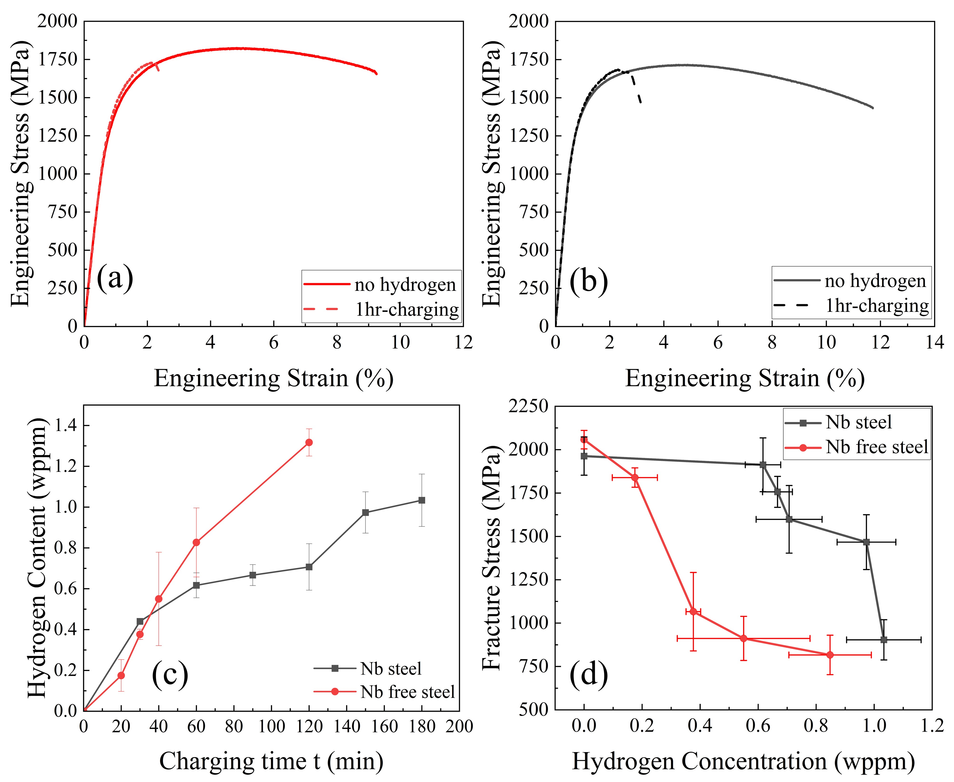
Fig. 3 Engineering stress–strain curves of (a) Nb-free steel and (b) Nb steel with and without H charging acquired using smooth tensile samples; (c) total H contents obtained via TDS after charging the samples at a current density of 0.1 mA/cm² for different times. Error bars are plotted to indicate the range of H content achieved via three tests; and (d) Plots of fracture stress versus H concentrations of the Nb and Nb-free steels acquired using the notch tensile samples. Error bars of the fracture stress represent the standard deviation of three pre-charge tensile tests for the same charging time.
Table 2
Tensile properties of the steels with and without H charging obtained from smooth and notch sample tests.
Steel | Tensile strength (MPa) | Elongation (%) | H-Smooth Sample  TS_{loss} (%) | H-Smooth Sample  El_{loss} (%) | Notch Sample H_{crit} (wppm)
Nb-free steel | 1824 | 9.2 | 5.2 | 74.6 | 0.27
Nb steel | 1715 | 11.7 | 1.7 | 73.2 | 0.85
To clarify the HE mechanisms of PHSs, fracture surfaces of the notched samples with charging densities of 0.1 mA/cm² were investigated by SEM. Overall fracture surfaces of both steels are divided into blue and red areas with different ratios. For the Nb-free steel, the fracture surface consists of brittle and ductile fracture zones (Figure 4(a)). Magnified view of the brittle zone reveals the presence of sugar-like facets (Figure 4(b)), which are typical intergranular crack features due to HEDE. High-magnification image of the slanted ductile zone demonstrates dimple features where microvoid coalescence occurred. H-induced crack is initiated ahead of the notch root surface and extends to the interior of the sample (Figure 4(a)).
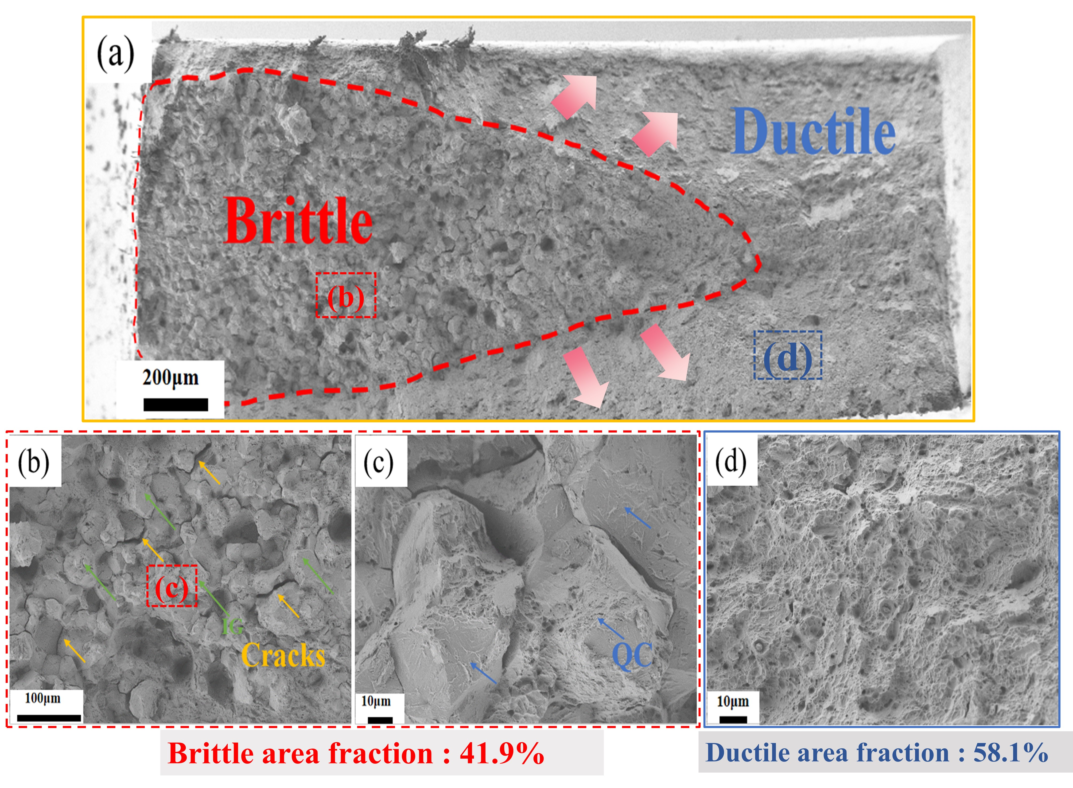
Fig. 4 SEM images showing the fracture surface of the notched Nb-free steel sample with H charging at 0.1 mA/cm² for 1 h. (a) Overview of the fracture surface, (b and c) magnified views of the brittle fracture zone depicted by the red dashed line in (a); QC, quasi-cleavage crack feature; and (d) magnified view of the ductile fracture zone represented by the blue dashed box in (a).
Nevertheless, compared to the case of the Nb-free steel, the area affected by H charging was significantly less for the Nb steel (brittle area fraction reduced from 41.9 to 14.4% upon Nb microalloying) despite an increase in the charging time from 1 to 2 h. Brittle region depicted by the red dashed line in Figure 5(a) comprises sugar-like facets, implying that the HEDE mechanism also takes place during HE. Additionally, the quasi-cleavage fracture feature is interspersed between intergranular facets (Figure 5(b)), and existence of this crack feature is ascribed to dislocation motion. The quasi-cleavage fracture feature is distinguished by its serrated features and tear ridges, which indicate the presence of localized plastic deformation during HE. The interaction between diffusible hydrogen and mobile dislocations is believed to cause significant dislocation multiplication and motion in various local regions between the smooth facets and intergranular cracks. In addition, Kazuho et al. asserted that the primary mechanism of quasi-cleavage fracture in hydrogen embrittled martensitic steel is hydrogen-enhanced screw dislocation motion along the {110} slip planes[37]. Current steels exhibit both brittle morphologies and local plastic characteristics; indicating that the HE mechanisms are likely dominated by hydrogen-enhanced decohesion (HEDE) and hydrogen enhanced local plasticity (HELP). Dimple features are also detected in areas that are not far from the crack initiation area (Figure 5(b)), which indicate a brittle-to-ductile fracture transition. Multiple cracks are observed in the magnified image. Small cleavage facets (Figure 5(b)) demonstrate that the Nb steel is less sensitive to HE. Note that the samples used for fractography analysis exhibit comparable H contents (0.77 wppm for the Nb-free steel and 0.73 wppm for the Nb steel). Although a different charging time was applied, the comparable H contents ensured reliable fractography results for HE analysis. The measured H contents of these two samples also appropriately correlated with the charging curves shown in Figure 3(c).
Fractography results clearly elucidate the crack initiation mechanism. Surfaces of both Nb and Nb-free steels demonstrated crack initiations, and subsequent crack propagation extended to the interior (Figure 4(a) and Figure 5(a)). This was attributed to the short charging duration and unavoidable inhomogeneous distribution of H across the sample thickness. Because of high H content on the surface and low critical H content for H decohesion, cracks exhibit typical features of initiation on the surface and propagation toward the center [38]. As the sensitivity to HE increased with an increase in the brittle fracture area fraction and fracture features, the fracture surface images (Figure 4 and 5) indicated that Nb alloying enhanced the HE resistance of PHS.
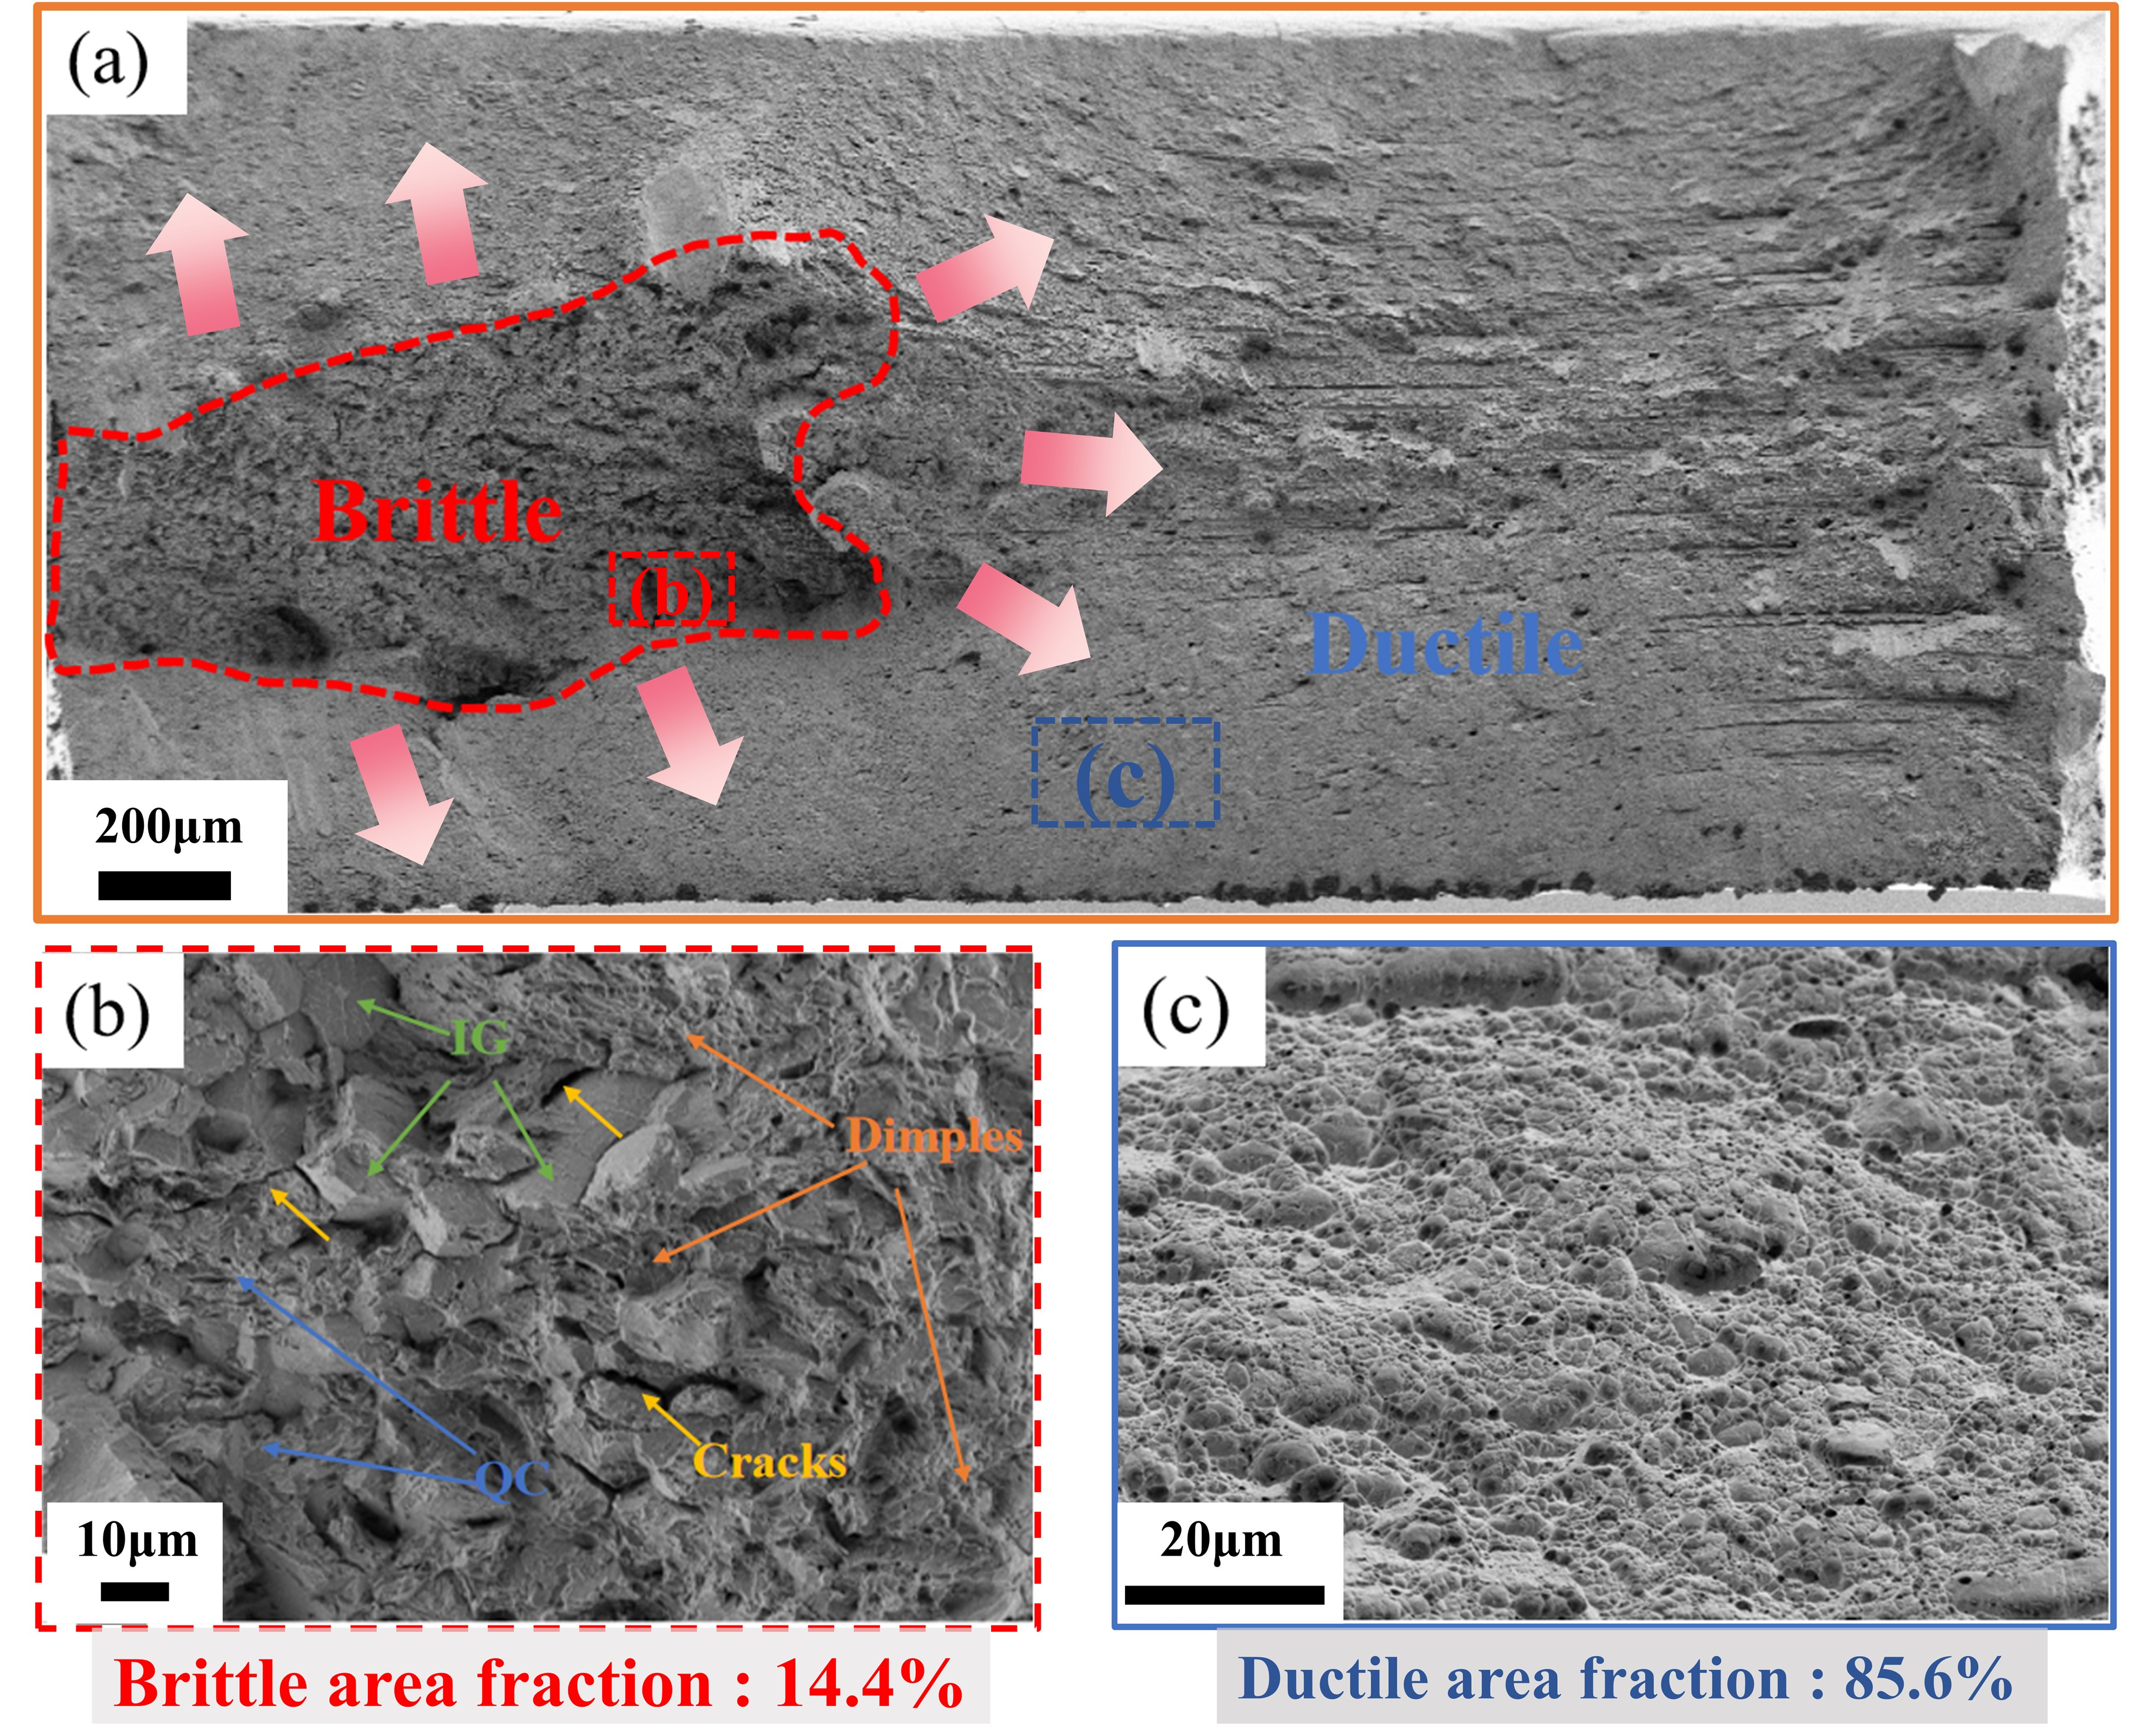
Fig. 5 SEM images depicting the fracture surface of the notched Nb-free steel sample after H charging at 0.1 mA/cm² for 2 h. (a) Overview of the fracture surface and (b and c) magnified views of the brittle fracture zones depicted by the red dashed line in (a).
Formation of carbide in the Nb steel was comprehensively analyzed by TEM. Coarse cuboidal precipitates are detected in the martensite matrix of the Nb steel (Figure 6(a)). These precipitates are enriched with Nb and Ti, which are confirmed by EDS elemental mapping (Figure 6(c) and (d)). Non-equiaxed Nb-Ti precipitates observed in Figure 6(a) have been regularly noticed in another study [39]. Generally, the majority of Ti(C,N) and NbC precipitates start to produce at high temperatures, implying that Ti(C,N) and NbC can separately precipitate during reheating or hot rolling. Microalloying of Nb enhances the formation of various precipitates at different stages of manufacturing. According to the phase diagram shown in Figure 7, the Ti(C,N) precipitate begins to form at a higher temperature (1360 °C) than the case of the NbC precipitate and easily coarsens up to 0.13 μm (Figure 6b). Complex carbides, such as (Nb,Ti)C, are generated based on Ti(C,N) formed at high temperatures. This is because the presence of Ti(C,N) can lower the activation energy barrier for NbC nucleation and thus for the production of NbC on the Ti(C,N) core precipitates [39-41]. Consequently, the morphologies of the Ti(C,N) precipitates determine the morphologies of the (Nb,Ti)C precipitates. Accordingly, the early formed Ti precipitates govern the structures and morphologies of Nb-based precipitates. Furthermore, the precipitations of complex (Nb,Ti)C precipitates consume most of the solute Nb atoms in the martensite matrix (Figure 6(b)–(d)), which inhibits the generation of nanosized NbC precipitates during quenching to lower temperatures. Figure 6(e) depicts a high-magnification TEM image of the martensite matrix, which verified the absence of nanocarbides (<20 nm). Hence, the formation of these large (Nb,Ti)C precipitates contributes to most of the grain refinement effect in the Nb steel (Figure 1).
As PHS is an industrial-grade steel, the presence of impurities, including Ti(C,N), in it is inevitable. As Ti(C,N) demonstrates a sharp cuboidal shape, local stress concentration can be readily induced at particle interfaces, particularly in the presence of H atoms, that eventually renders Ti(C,N) a pre-existing defect [30]. Ti(C,N) has been extensively verified to deteriorate the mechanical properties such as fracture toughness [30, 39, 40]. Considering the actual PHS production conditions, H atoms unavoidably adsorb on steels and are transported by mobile dislocations. Although dislocations are concentrated in the vicinities of Ti(C,N) particles, H accumulates on the surface and ultimately induces crack initiation. Therefore, Ti(C,N) is regarded as sensitive to HE [42]. Moreover, the larger the particle, the lower the critical stress needed for crack initiation. However, in this study, the sizes of the Ti(C,N) particles were considerably smaller than the normal average size (0.2 μm in the present steel as compared to the average size of 2–5 μm in other studies), which was caused by the inhibition of the growths of cuboidal particles by the precipitation of NbC on the Ti(C,N) surface [30, 31, 38]. Therefore, the negative effects of Ti(C,N) on HE can be slightly alleviated.
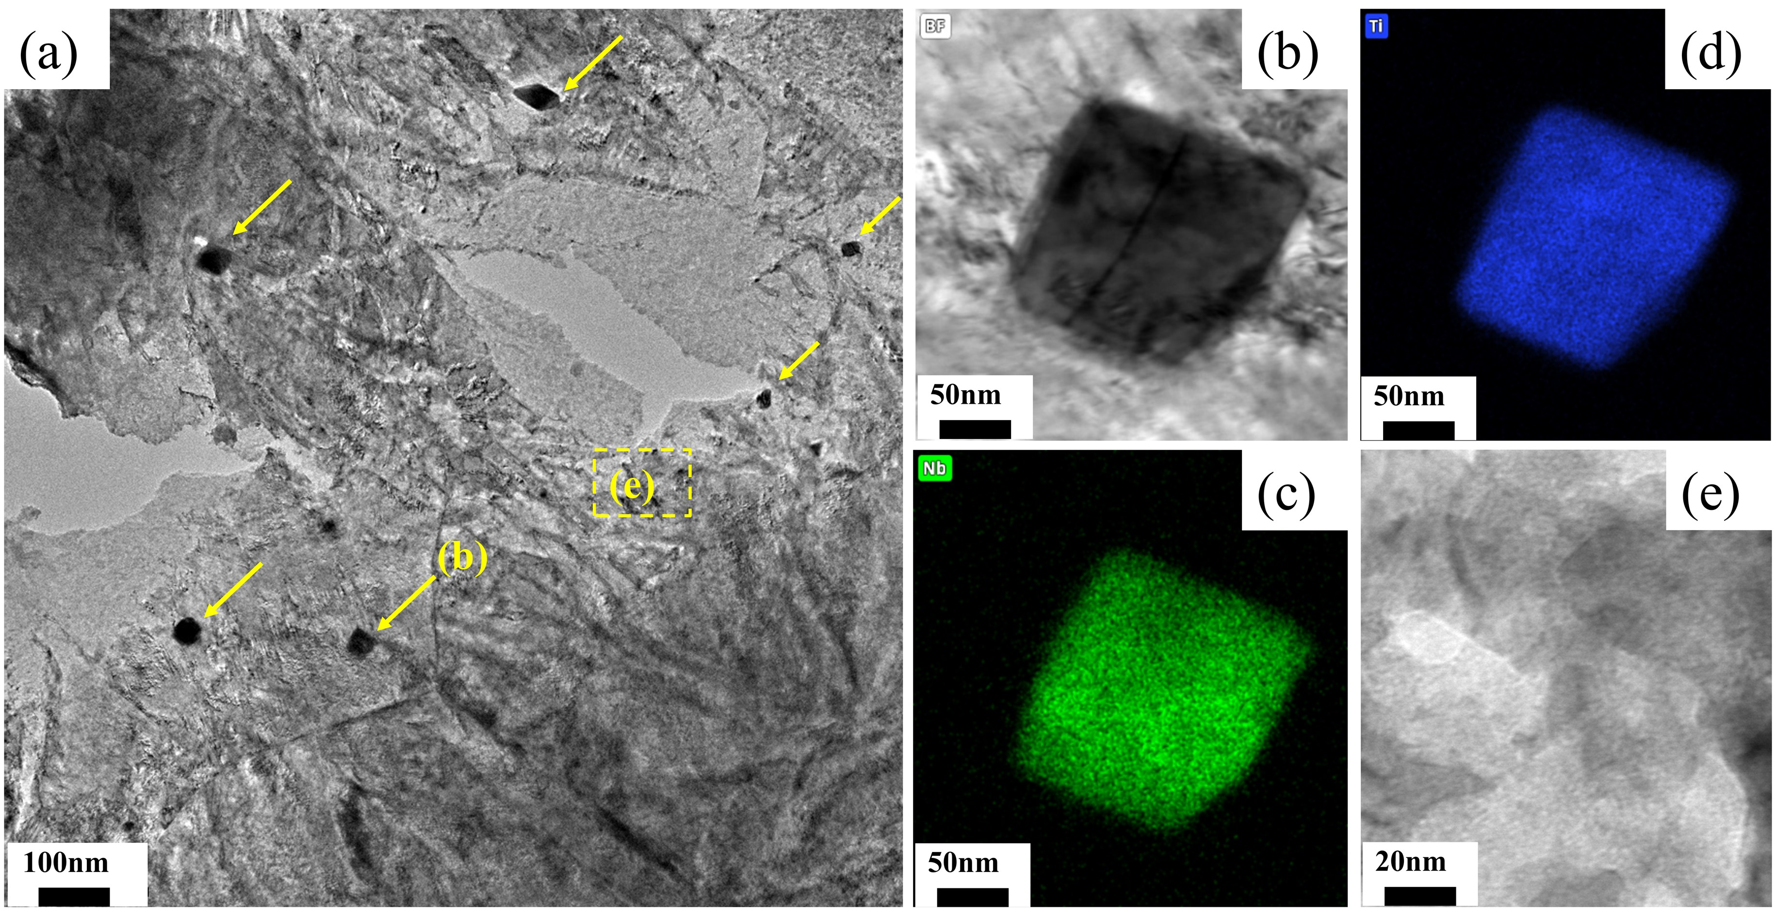
Fig. 6 Morphology and chemistry of Nb carbide characterized by scanning transmission electron microscopy coupled with energy-dispersive X-ray spectroscopy (STEM-EDS). (a) Overall TEM image exhibiting the distributions of coarse Nb-Ti particles. EDS mappings of (b) Nb, (c) Ti, and (d) C in the Nb steel. (e) High-magnification image of the yellow dashed box area.
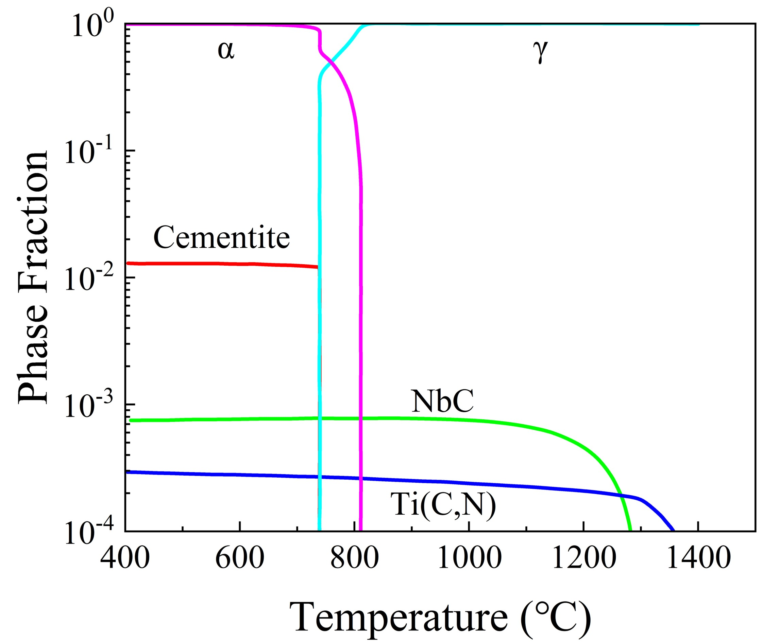
Fig. 7 Equilibrium phase diagram of the Nb steel; phase fractions were calculated by Thermo-Calc using the TCFE8 database.
To reveal the H adsorption behaviors of the steel samples, TDS was performed on the Nb and Nb-free steel, and the corresponding profiles are shown in Figure 8(a) and (b). TDS curve was adequately fitted by two Gaussian peaks. Total H contents were calculated to be 0.87 and 0.55 wppm for the Nb-free and Nb steels, respectively, via integration of the area under the curve. No signal was detected over 300 °C in the TDS curve (Figure 8(a)), indicating the absence of irreversible H trapped by nanosized carbides [39]. Hence, the effects of carbides as irreversible H traps can be ignored in the case of the Nb steel. Inefficacies of the (Nb,Ti)C precipitates in trapping H were ascribed to the large sizes of (Nb,Ti)C precipitates with cuboidal morphologies that lost coherence with the matrix and the abilities to trap diffusible H at the interface (Figure 6(b)) [39]. The position of the centering temperatures led to the conclusion that H corresponding to the low-temperature peak was trapped by dislocations. Ease of desorption suggests relatively low activation energies of the trapping sites, for example, dislocations and cementite [43, 44]. Nevertheless, for reliable measurements, a low-temperature TDS (L-TDS) apparatus is required to initiate thermal desorption below room temperature (RT); otherwise, the peak shift is incorrectly detected. Hence, only a high-temperature subpeak, denoted as peak B, is available for binding energy calculation. The Kissinger relations with x-axis representing the reciprocal peak temperature of peak B and y-axis indicating a function related to temperature and heating rate are shown in Figure 8(c). Several heating rates were adopted for calculation, and the binding energies for the Nb and Nb-free steels were evaluated to be 36.04 and 36.24 kJ/mol, respectively.
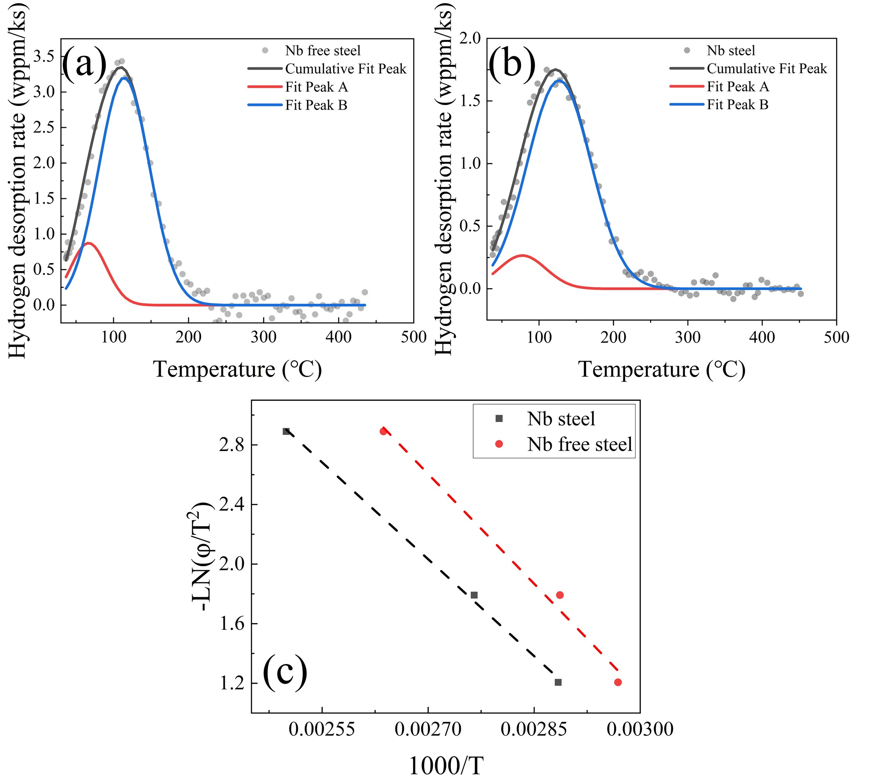
Fig. 8 (a and b) Plots of H desorption rate versus temperature for Nb-free and Nb steels acquired at a heating rate of 0.3 K/s up to 450 °C and (c) corresponding fitting Peak A data for the Kissinger plot.
To evaluate the H diffusion rate, permeation tests were conducted on the Nb and Nb-free steels, and the corresponding results are shown in Figure 9. Typically, steady-state current density demonstrated distinct values, and PHS with Nb addition exhibited higher value than that of the Nb-free PHS (Figure 9). H diffusivity was affected by both trap densities and binding energies of traps. According to the TDS result (Figure 8), two main H traps, namely, dislocations and grain boundaries, were expected, which were reversible H traps, as calculated by the Kissinger equation. Grain boundary demonstrated higher trapping capacity as the correlated peak covered larger area as compared to that of the low-binding-energy peak of dislocations. Effective permeation coefficients were evaluated to be 1.29 × 10⁻⁵ and 2.13 × 10⁻⁵ mm²/s for the Nb-free and Nb steels, respectively, using equation (4). Note that the calculated data were comparable to those reported in other studies [26, 28, 45]. The abovementioned calculation substantiates the important role of grain refinement in hindering H diffusion. Compared with the case of the Nb-free steel, the number of H traps in the Nb steel was notably high due to significant grain refinement, which induced numerous grain boundaries.
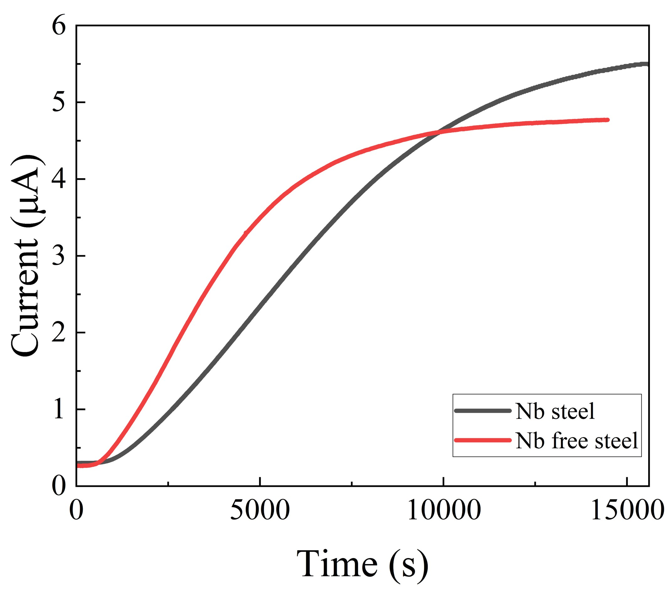
Fig. 9 H permeation curves of Nb-free and Nb steels.
Influences of Nb on the HE resistances of press-hardened martensitic steels, such as 22MnB5 [46, 47] and 32MnB5 [48], have been investigated. These studies reveal that Nb improves the HE resistances of steels. For instance, Okayasu et al. [49] examined HE in Fe-C-Mn-Nb steels and discovered that NbC precipitates reduced the severity of HE in both water-quenched and quenched plus tempered samples. Similarly, 0.045 wt% Nb alloying improved the HE resistance of the present 1800 MPa-grade PHS. However, contrary to the cases of previous studies, herein, niobium carbide is discovered to itself play a minimal role as a H trap in trapping diffusible H. This is because the precipitate is coarse and in a non-congruent state with the substrate, which results in its inferior H trapping capacity as compared to those of the nanosized NbC precipitates. Furthermore, the (Nb,Ti)C precipitate in steel cannot change a diffusible H atomic state to a non-diffusible H state. Consequently, the composite precipitate exerts less influence on the HE resistance than those observed in other studies [39-41]. The abovementioned explanation is supported by the TDS data (Figure 7), in which only peaks below 250 °C are detected and no H signal is noticed at higher temperatures. Split-peak characterization of the low-temperature profile also reveals that the binding energies of the sub-peak B only correspond to the binding energies of the grain boundaries, whereas those of the other peak belong to the binding energies of H trapped by dislocation and the addition of Nb does not introduce additional sub-peaks (Figure 7(a)).
Although the binding energies of the B peaks for the Nb and Nb-free steels are not substantially different (Figure 7(a) and (b)), the Nb steel indeed demonstrates higher HE resistance (Figure 3(c)). The Nb steel comprises a higher density of grain boundaries, implying that refined PAGS is one of the primary causes for the high HE resistance of this steel. As the diffusible H contents of the two steels are nearly comparable, the H concentration per unit boundary area is lower in the Nb steel owing to its higher grain boundary density. Higher boundary areas of HAGBs, including PAGB, blocks, and packet boundaries, increase the densities of possible trapping sites, dispersing mobile H atoms and inhibiting their aggregation in highly stressed locations.
Therefore, this study reveals that the introduction of 0.045 wt% Nb into an ultra-high-strength PHS can improve the HE resistance of PHS mainly by increasing the grain boundary density. When the concentration of accumulated H reaches a critical value, cracks initiate and propagate along the grain and/or sub-grain boundaries via the HEDE mechanism. The resultant grain refinement by precipitates significantly decreases the accumulation of H per grain boundary per unit volume. Thus, when the H content is low, Nb steel exhibits a delayed ductile–brittle transition; this is ascribed to the mitigation of H enrichment and delayed accumulation of H on PAGBs caused by a large amount of grain boundary structures; this indicates that a higher general H concentration is needed to initiate H-induced cracking on a microscopic scale.
4. Conclusion
In this study, the HE resistances of two 1800 MPa-grade PHSs are evaluated via tensile tests using both smooth and notch steel samples with and without H charging. Microstructures are charactered by various techniques. H contents are measured by TDS and permeation tests. The following conclusions are drawn based on the systematic studies：
- Nb microalloying effectively refines the grain size, leading to hot-stamped steels with PAG sizes of ~6 μm, which are considerably finer than the counterparts without Nb microalloying (~16 μm). Although Nb microalloying does not change the fraction of grain boundary misorientation, it elevates the grain boundary density by reducing the PAG size.
- In the pre-charged tensile tests, the smooth PHS samples with and without Nb demonstrate similar HE resistances, which is substantiated by their comparable HE indices. Nevertheless, in the tensile tests of the notched samples, the Nb-microalloyed PHS exhibits a delayed ductile–brittle transition behavior, which is manifested by the fact that PHS demonstrates no detectable HE when the H content is lower than 0.4 wppm. In contrast, PHS without Nb alloying exhibits evident HE during the early stage of H charging.
- Addition of Nb results in complex submicron-sized (Nb,Ti)(C,N) precipitates rather than nanosized NbC precipitates. Formation of (Nb,Ti)(C,N) precipitates can efficiently refine PAG, leading to a larger density of HAGBs (packet, block boundaries) that reduce the H diffusion rate and also act as H traps, thereby improving the HE resistance.

CRediT authorship contribution statement
D.H. Du: Conceptualization, Investigation, Data curation, Formal analysis, Writing – original draft. Y.Zhang, Z.Y.Geng. B.B. He: Project administration, Conceptualization, Supervision, Writing – review & editing, Funding acquisition. M.X. Huang: Project administration, Conceptualization, Supervision, Writing – review & editing, Funding acquisition.
Declaration of Competing Interest
The authors declare that they have no known competing financial interests or personal relationships that could have appeared to influence the work reported in this paper.
Data availability
The raw data required to reproduce these findings are available from the corresponding author of this paper. The processed data required to reproduce these findings are available from the corresponding author of this paper.
Acknowledgment
M. X. Huang acknowledges the support from National Key Research and Development Program of China (grant No. 2019YFA0209900), National Natural Science Foundation of China (grant No. 52130102), Research Grants Council of Hong Kong (grant No. R7066-18), and the XPLORER PRIZE and New Cornerstone Science Foundation. B. B. He is grateful for the financial support from the National Natural Science Foundation of China (grant No. U52071173), Science and Technology Innovation Commission of Shenzhen (Project No. JCYJ20210324120209026; KQTD2019092917250571) and Major Talent Programs of Guangdong Province (Contract No. 2019QN01C435).

Reference

1. Jiangtao Liang, Hongzhou Lu, Leilei Zhang, Feng Li, Ronghua Cao, Kun Liu, Hui Pan, Huaxiang Teng, Xuetao Li, Aimin Guo, and Zhengzhi Zhao: Materials Science and Engineering: A 2021, vol. 801, p. 140419.
2. Marion Merklein, Michael Wieland, Michael Lechner, Stefania Bruschi, and Andrea Ghiotti: Journal of Materials Processing Technology 2016, vol. 228, pp. 11-24.
3. H. Karbasian and A. E. Tekkaya: Journal of Materials Processing Technology 2010, vol. 210, pp. 2103-18.
4. Perng Tsong-Pyng and C. J. Altstetter: Acta Metallurgica 1986, vol. 34, pp. 1771-81.
5. Pravin Kumar and R. Balasubramaniam: Journal of Alloys and Compounds 1997, vol. 255, pp. 130-34.
6. Bian Jian, Li Wang, Hardy Mohrbacher, Hong Zhou Lu, and Wen Jun Wang: Advanced Materials Research 2014, vol. 1063, pp. 7-20.
7. Hong Zhou Lu, Shi Qi Zhang, Bian Jian, Hardy Mohrbacher, and Ai Min Guo: Advanced Materials Research 2014, vol. 1063, pp. 32-36.
8. Shiqi Zhang, Yunhua Huang, Bintang Sun, Qingliang Liao, Hongzhou Lu, Bian Jian, Hardy Mohrbacher, Wei Zhang, Aimin Guo, and Yue Zhang: Materials Science and Engineering: A 2015, vol. 626, pp. 136-43.
9. Thorsten Michler and Joerg Naumann: International Journal of Hydrogen Energy 2010, vol. 35, pp. 821-32.
10. J. A. Ronevich, J. G. Speer, and D. K. Matlock: SAE International Journal of Materials and Manufacturing 2010, vol. 3, pp. 255-67.
11. Gianfranco Lovicu, Mauro Bottazzi, Fabio D’Aiuto, Massimo De Sanctis, Antonella Dimatteo, Ciro Santus, and Renzo Valentini: Metallurgical and Materials Transactions A 2012, vol. 43, pp. 4075-87.
12. TB Hilditch, SB Lee, JG Speer, and DK Matlock: Report No. 0148-7191, SAE Technical Paper, 2003.
13. O. Barrera, D. Bombac, Y. Chen, T. D. Daff, E. Galindo-Nava, P. Gong, D. Haley, R. Horton, I. Katzarov, J. R. Kermode, C. Liverani, M. Stopher, and F. Sweeney: J Mater Sci 2018, vol. 53, pp. 6251-90.
14. M. Dadfarnia, P. Novak, D. C. Ahn, J. B. Liu, P. Sofronis, D. D. Johnson, and I. M. Robertson: Adv Mater 2010, vol. 22, pp. 1128-35.
15. Jeffrey Venezuela, Qinglong Liu, Mingxing Zhang, Qingjun Zhou, and Andrej Atrens: Corrosion Reviews 2016, vol. 34, pp. 153-86.
16. Na Zan, Hua Ding, XiaoFei Guo, ZhengYou Tang, and Wolfgang Bleck: International Journal of Hydrogen Energy 2015, vol. 40, pp. 10687-96.
17. Ayesha J. Haq, K. Muzaka, D. P. Dunne, A. Calka, and E. V. Pereloma: International Journal of Hydrogen Energy 2013, vol. 38, pp. 2544-56.
18. Eun Ju Song, Seung-Wook Baek, Seung Hoon Nahm, and Dong-Woo Suh: Metals and Materials International 2018, vol. 24, pp. 532-36.
19. Fu-Gao Wei, Toru Hara, and Kaneaki Tsuzaki: In Advanced Steels: The Recent Scenario in Steel Science and Technology, Springer: 2011, pp 87-92.
20. Hye-Jin Kim, Soon-Hyeok Jeon, Won-Seog Yang, Byung-Gil Yoo, Yoo-Dong Chung, Heon-Young Ha, and Hyun-Young Chung: Journal of Alloys and Compounds 2018, vol. 735, pp. 2067-80.
21. Nicholas Winzer, Oliver Rott, Richard Thiessen, Ingo Thomas, Klemens Mraczek, Thomas Höche, Louise Wright, and Matous Mrovec: Materials & Design 2016, vol. 92, pp. 450-61.
22. Y. Zhang, W. Hui, X. Zhao, C. Wang, and H. Dong: Materials (Basel) 2018, vol. 11, p. 2507.
23. Renzo Valentini, Michele Maria Tedesco, Serena Corsinovi, Linda Bacchi, and Michele Villa: Metals 2019, vol. 9, p. 934.
24. Masato Ohnuma, Jun-ichi Suzuki, Fu-Gao Wei, and Kaneaki Tsuzaki: Scripta Materialia 2008, vol. 58, pp. 142-45.
25. Jilan Yang, Feng Huang, Zhenghong Guo, Yonghua Rong, and Nailu Chen: Materials Science and Engineering: A 2016, vol. 665, pp. 76-85.
26. Lintao Gui, Yan Zhao, Yi Feng, Mingtu Ma, Hongzhou Lu, Kun Tan, Po-Han Chiu, Aimin Guo, Jian Bian, Jer-Ren Yang, Fatong Jiang, Hui Song, and Yangwei Wang: Materials & Design 2023, vol. 227, p. 111763.
27. T. Depover and K. Verbeken: Corrosion Science 2016, vol. 112, pp. 308-26.
28. Junmo Lee, Taekyung Lee, Young Jin Kwon, Dong-Jun Mun, Jang-Yong Yoo, and Chong Soo Lee: Metals and Materials International 2016, vol. 22, pp. 364-72.
29. Jian Bian, Hardy Mohrbacher, Hongzhou Lu, and Wenjun Wang: In HSLA Steels 2015, Microalloying 2015 & Offshore Engineering Steels 2015: Conference Proceedings, Wiley Online Library: 2015, pp 571-76.
30. J. C. Pang, H. L. Yi, Q. Lu, C. M. Enloe, and J. F. Wang: Jom 2019, vol. 71, pp. 1329-37.
31. Yulin Shen and Steven S. Hansen: Metallurgical and Materials Transactions A 1997, vol. 28, pp. 2027-35.
32. H. E. Kissinger: Analytical Chemistry 2002, vol. 29, pp. 1702-06.
33. S. K. Yen and I. B. Huang: Materials Chemistry and Physics 2003, vol. 80, pp. 662-66.
34. C. F. Dong, Z. Y. Liu, X. G. Li, and Y. F. Cheng: International Journal of Hydrogen Energy 2009, vol. 34, pp. 9879-84.
35. E. I. Galindo-Nava and P. E. J. Rivera-Díaz-del-Castillo: Acta Materialia 2015, vol. 98, pp. 81-93.
36. S. Morito, H. Saito, T. Ogawa, T. Furuhara, and T. Maki: ISIJ International 2005, vol. 45, pp. 91-94.
37. Kazuho Okada, Akinobu Shibata, and Nobuhiro Tsuji: Scripta Materialia 2023, vol. 234.
38. Hye-Jin Kim, Geonjin Shin, Jinheung Park, Myoung-Gyu Lee, Ki-Jung Kim, and Seung-Chae Yoon: Acta Materialia 2024, vol. 263, p. 119524.
39. Monica Kapoor, Ronald O’Malley, and Gregory B. Thompson: Metallurgical and Materials Transactions A 2016, vol. 47, pp. 1984-95.
40. R. M. Poths, R. L. Higginson, and E. J. Palmiere: Scripta Materialia 2001, vol. 44, pp. 147-51.
41. Changchun Zhao, Yefei Zhou, Xiaolei Xing, Sha Liu, Xuejun Ren, and Qingxiang Yang: Journal of Alloys and Compounds 2018, vol. 763, pp. 670-78.
42. Il-Jeong Park, Seo Yeon Jo, Minwoo Kang, Sang-Min Lee, and Young-Kook Lee: Corrosion Science 2014, vol. 89, pp. 38-45.
43. Andrej Turk, Gaurav R. Joshi, Marius Gintalas, Mauro Callisti, Pedro E. J. Rivera-Díaz-del-Castillo, and Enrique I. Galindo-Nava: Acta Materialia 2020, vol. 194, pp. 118-33.
44. E. I. Galindo-Nava, B. I. Y. Basha, and P. E. J. Rivera-Díaz-del-Castillo: Journal of Materials Science & Technology 2017, vol. 33, pp. 1433-47.
45. Jisung Yoo, Min Chul Jo, Min Cheol Jo, Seongwoo Kim, Jinkeun Oh, Jian Bian, Seok Su Sohn, and Sunghak Lee: Materials Science and Engineering: A 2020, vol. 791.
46. Min Chul Jo, Jisung Yoo, Selim Kim, Seongwoo Kim, Jinkeun Oh, Jian Bian, Seok Su Sohn, and Sunghak Lee: Materials Science and Engineering: A 2020, vol. 789, p. 139656.
47. Shiqi Zhang, Dayang Xu, Feng Huang, Wenqiang Gao, Jifang Wan, and Jing Liu: Materials & Design 2021, vol. 210, p. 110090.
48. S. Yamasaki and H. K. D. H. Bhadeshia: Proceedings of the Royal Society A: Mathematical, Physical and Engineering Sciences 2006, vol. 462, pp. 2315-30.
49. Mitsuhiro Okayasu, Masaya Sato, Daiki Ishida, and Takehide Senuma: Materials Science and Engineering: A 2020, vol. 791, p. 139598.

