Direct monitoring of nanoscale deformations across all layers in 3D-stacked structures

Xiangyu Zhao¹, Hao Jiang^{1,3}, Jiamin Liu¹, Changqing Liu¹, Hui Deng⁴, Renjie Zhou⁵, Nicholas X. Fang⁶, Shiyuan Liu^{1,3}, and Jinlong Zhu^{1,2,3*}

¹State Key Laboratory of Intelligent Manufacturing Equipment and Technology, Huazhong University of Science and Technology, Wuhan 430074, China
²Research Institute of Huazhong University of Science and Technology Shenzhen, Shenzhen 518057, China
³Optics Valley Laboratory, Wuhan, Hubei 430074, China
⁴Department of Mechanical and Energy Engineering, Southern University of Science and Technology, No. 1088, Xueyuan Road, Shenzhen, Guangdong 518055, China
⁵Department of Biomedical Engineering, The Chinese University of Hong Kong, Shatin, New Territories, Hong Kong, China
⁶Department of Mechanical Engineering, University of Hong Kong, Hong Kong, China

*Corresponding author: jinlongzhu03@hust.edu.cn and shyliu@hust.edu.cn

ABSTRACT：
Due to its high bandwidth, low latency, low power consumption, and compact size, three-dimensional (3D) integration of semiconductor chips holds the promise of boosting the performance of integrated circuit systems. However, the applications of 3D-stacked structures are constrained by the surface deformation of each thin layer induced by thermal effects, vibration, gravity, and other environmental stresses. Therefore, ensuring the performance and reliability of 3D-stacked structures necessitates precise measurement of nanoscale deformation in each layer. Furthermore, the spacing between layers in 3D-stacked structures using modern microelectronics and packaging technologies is exceedingly small, making current top-down-based optical measurement techniques impossible to measure the deformation of all layers. Here, we present a novel optical endoscope that fuses a miniaturized interferometry array, a laser-fabricated microprobe, and a highly efficient profile reconstruction algorithm, for the precise measurements of surface deformation across all layers in 3D-stacked structures. Our method offers a potentially effective and non-invasive way to address the challenges associated with in-line deformation measurement across all layers in real 3D-stacked wafers and chips.

KEYWORDS：3D-stacked structures, surface deformation metrology, optical endoscope, nanoscale deformation, non-invasive

INTRODUCTION
Integrated circuits (ICs) are reaching their physical limits, as elements on a dense IC can only be so small and tightly packed before interfering with each other and losing their functionality. To keep Moore’s law going, there is a potential paradigm shift towards 3D transformation in chips to sustain continuous improvements in semiconductor device performance and computational speed^{1,2}. IC products based on 3D chip stackings are characterized by a high degree of integration, lightweight, compact packaging size, and low manufacturing costs. These attributes enable a drastic increase in transistor density, which is promising for further miniaturization, high-density integration, high reliability, and low power consumption ³⁻⁸. Fabricating a 3D-stacked chip involves overlaying multiple layers with different functionalities through micro-machining and interconnecting processes, such as using Through Silicon Vias (TSVs) and Cu Pillars.
However, the increase in the number of layers is typically accompanied by the decrease in the thickness of each layer, which amplifies the impact of thermal and gravity effects as well as environmental stress on the deformation (for example, warping and bending) of 3D-stacked structures. As the deformation can significantly reduce the device’s lifespan^{9,10}, accurate measurement of deformation in 3D-stacked structures is essential for predicting the device's performance. Current techniques for measuring surface morphology and deformation include optical interferometry¹¹ (e.g., laser interferometry^{12,13}, white light interferometry (WLI) ^{14,15}, and other methods), laser confocal techniques^{16,17}, spectral confocal techniques^{18,19}, scanning electron microscopy (SEM) ^{20,21}, atomic force microscopy (AFM) ^{22,23}, and others. However, the spacing in a 3D-stacked chip is typically between tens to hundreds of micrometers ^{24,25}, making it impossible for these traditional top-down surface measurement techniques to measure the deformation across all layers due to the limited penetration depth of photons and electrons. Therefore, there is an urgent need for developing a high-precision, nondestructive, and efficient system to measure the deformation of all layers in 3D-stacked structures.
In this work, we present a stacked interferometry array system (SIAS), which consists of an embedded micro-mirror array and a multi-beam while-light interferometer, for the precise monitoring of nanoscale deformation of all layers in an in-house fabricated 3D-stacked structures. Our experiments demonstrate that SIAS could measure the deformations of all layers in a 3D-stacked structure with nanometer accuracy, which may find applications in large-scale and high-volume manufacturing scenarios such as integrated circuits and additive manufacturing. We believe this work not only offers a promising avenue for addressing the challenges associated with the precise deformation measurement for 3D-stacked wafers and chips, but also paves the way for many other fields where geometrical measurement in micrometer scale spacing is impossible using conventional measurement techniques.

METHODOLOGY
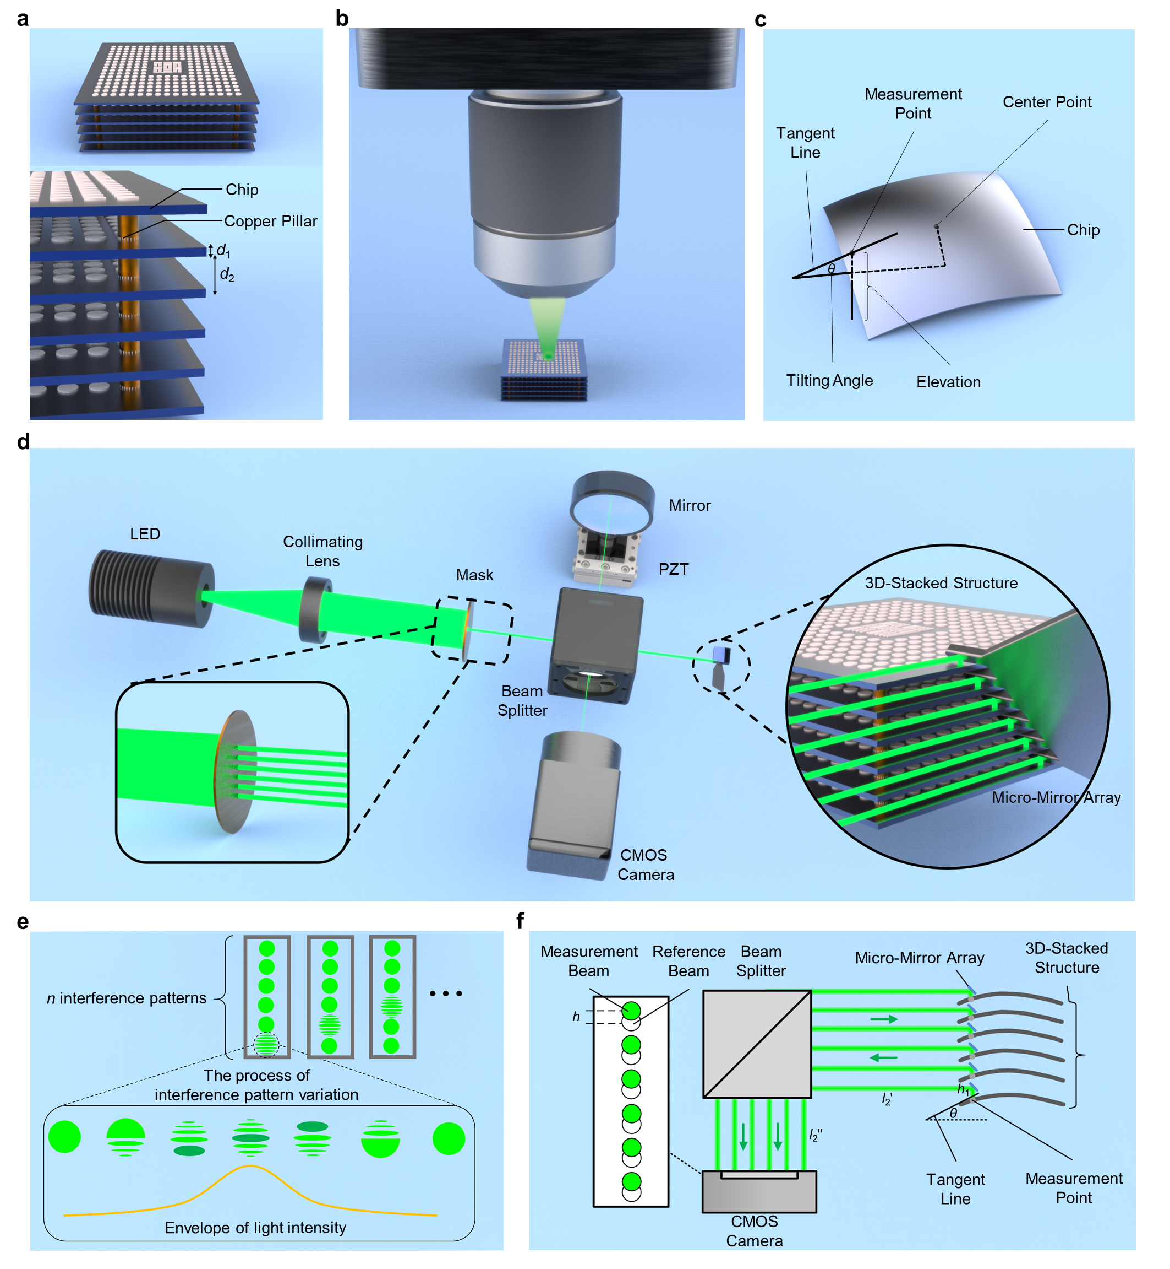
Figure 1. A representative 3D-stacked structure and the principle of SIAS. (a) Schematic diagram of a representative 3D-stacked structure with six layers connected by copper pillars. (b) Schematic diagram of a conventional top-down measurement technique. (c) Schematic diagram showing the measurands (i.e., the elevation and tilting angle of a measurement point on a layer of 3D-stacked structure) of our SIAS. (d) Schematic diagram of SIAS. The mask pattern shown in the lower left corner is a linear array of pinholes with a period of d₁+d₂. The zoomed-in image shown on the right side reveals the position of the 3D-stacked structure relative to the micro-mirror array during the measurement. (e) Schematic diagram showing the elevation measurement process. The upper side shows n types of interference patterns acquired by the camera, where n denotes the number of layers in the 3D-stacked structure. The lower side shows the variation of one of the interference patterns during the measurement process. A Gaussian envelope of intensity at the center of the interference pattern can be observed. (f) Schematic diagram showing the tilting angle measurement process. h₁ is the distance between the micro-mirror and the measurement point on the layer surface. θ is the angle between the tangent line to the measurement point on the 3D-stacked structure and the horizontal line. l₂' is the distance between the micro-mirror and the beam splitter. l₂'' is the distance between the beam splitter and the CMOS camera. h is the center offset of the reflected light in the measurement beam with respect to that in the reference beam captured by the CMOS camera.

The measurement system and deformation reconstruction method
In recent years, various studies on 3D-stacked structures such as 3D-stacked chips have emerged^{26,27}. The geometry of a typical 3D-stacked structure, as shown in Figure 1a, involves multiple layers of structures at certain intervals along the z-axis, interconnected by copper pillars. In the diagram, d₁ and d₂ represent the thickness of a single layer and the spacing, respectively. The deformation map of a layer in the 3D-stacked structure can be obtained by fitting the deformations at multiple measurement points on the layer surface. This method allows rapid measurement of surface deformations across all the layers in a 3D-stacked structure compared to the conventional WLI. The deformation of a measurement point can be fully characterized by the elevation and the tilting angle at this point. The elevation is defined as the height of a measurement point relative to the horizontal plane, and the tilting angle is defined as the angle between the tangent line to the measurement point and the horizontal plane (see the definition of elevation and tilting angle in Figure 1c).
The schematic diagram of SIAS is illustrated in Figure 1d. We use a fiber-coupled LED with a central wavelength of 530 nm and a bandwidth of 30 nm as the light source (Model M530F2; Thorlabs Inc.). The light source is firstly collimated through a collimating lens, after which the beam passes through a mask for beam splitting before it goes through a beam splitter. The mask is used to split the beam into n sub-beams, where n equals the number of layers in the 3D-stacked structure. As a result, n sub-beams passing through the beam splitter are reflected by the micro-mirror array that is inserted into the 3D-stacked structure to illuminate the layer surface vertically. The positioning of the micro-mirror array is governed by an XYZ movement stage and a side-view microscope (not shown in Figureure 1d). The reflected beams from the layer surfaces are reflected by the same micro-mirror array, after which the beams are collected by a complementary metal oxide semiconductor (CMOS) camera. Another n sub-beams split by the beam splitter is reflected by a high-quality reference mirror followed by being captured by the same CMOS camera. By controlling the piezoelectric transducer (PZT) stage to drive the displacement of the reference mirror, the optical path difference of the two sets of sub-beams can be adjusted, thus generating n interference patterns in the CMOS camera (see the schematic of n interference patterns in a frame in the inset of Figure 1e).
In order to measure the elevation, the WLI is introduced. By controlling the PZT stage to drive the displacement of the reference mirror, the optical path difference between the reference beam and the measurement beam can be adjusted. During this process, the variation of the interference pattern captured by the CMOS camera is schematically shown in Figure 1e. The light intensity at the center of the interference pattern is maximum when the optical paths of the reference and measurement beams are equal. The phase-shifting algorithm²⁹ can be used to process the interference pattern to obtain an accurate value of the current position (noted as a₂) of the PZT stage (see more details in Supporting Information). The initial position of the PZT is noted as a₁, then the distance between a₁ and a₂ is the elevation of the measurement point. In order to measure the tilting angle at the measurement point, we obtain the positions of the reference beam and the measurement beam in the CMOS camera separately. Here the position of a beam is defined as the coordinates of the center of the beam. The center offset between the reference beam and the measurement beam reflects the magnitude of the tilting angle of the measurement point (see the schematic in Figure 1f). Based on the geometric relation of the propagation path of the measurement beam, the tilting angle of the measurement point can be calculated approximately. Figureure 1f shows the schematic diagram of the measurement process of the tilting angle at a measurement point. The calculation of the tilting angle of the measurement point can be expressed as , where θ is the tilting angle of the measurement points on the layer surface, h is the center offset between the measurement beam and the reference beam captured by the CMOS camera, l₁ is given by, where h₁ is the distance from the position where the beam enters the micro-mirror array to the measurement point on the 3D-stacked structure, l₂ is the sum of distances between the CMOS camera and the micro-mirror array, i.e. , as shown in Figure 1f. In contrast to traditional top-down surface measurement techniques (see Figure 1b), our measurement system (i.e., SIAS) could achieve the direct monitoring of the nanoscale deformation of all layers in a 3D-stacked structure in a fast and nondestructive mode.
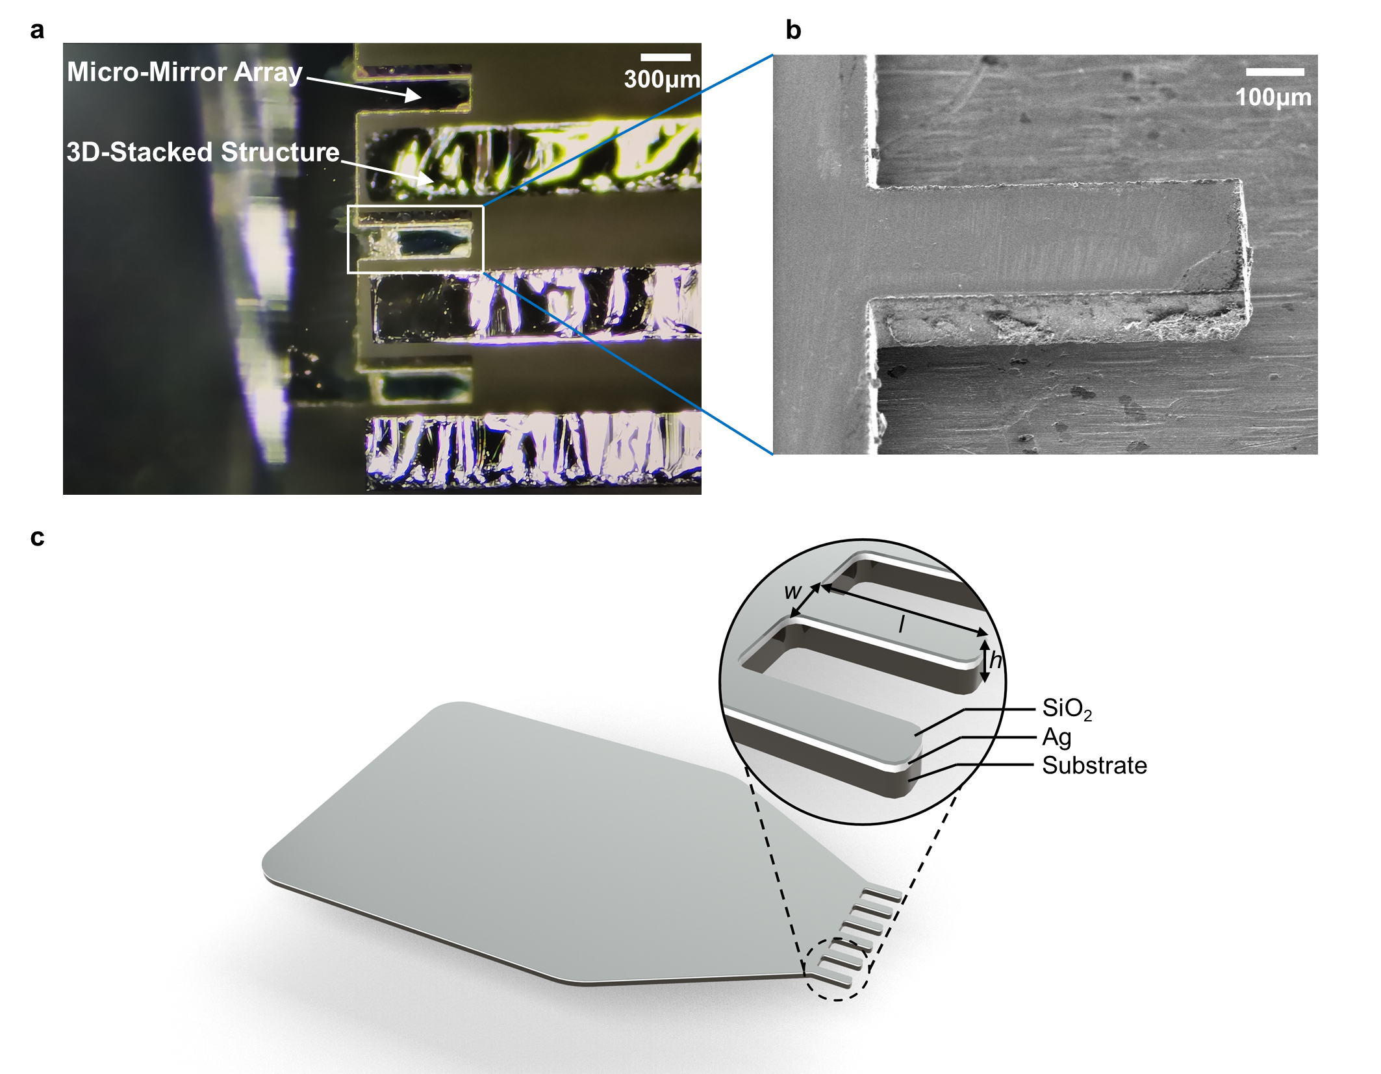
Figure 2. The fabricated micro-mirror array. (a) The optical image showing the position of the micro-mirror array relative to the 3D-stacked structure in working condition. The micro-mirror array was loaded on a fixture on the left (not shown) and the 3D-stacked structure was mounted on the right. (b) The scanning electron micrograph of a single micro-mirror. (c) The schematic diagram of the designed micro-mirror array.

As shown in Figure 1d, the mask pattern is designed as a vertically arranged circular pinhole array with a period of d₁+d₂, where d₁ and d₂ equal the thickness of a single layer and the spacing in the chip, respectively. The function of the mask is to split the collimated beam into multiple parallel beams at the preset spacing (i.e., d₁+d₂). For the diameter of the pinhole on the mask larger than approximately 2λ and the thickness of the Cr layer on the mask less than approximately 0.5λ (where λ denotes the wavelength of the light source), diffraction effects can be neglected²⁸. Therefore, the size of the pinholes on the mask can be as small as around 1 µm. The function of the micro-mirror array is to reflect the parallel beam passing through the beam splitter followed by illuminating the surface of each layer vertically. The reflected beam from each layer is then reflected by the same micro-mirror array. The geometrical structure of the micro-mirror array, as shown in Figure 2c, has a large and planar area on the left for the purpose of clamping and easy installation at a 45° angle in SIAS, while the comb-like geometry on the right-hand side functions as a mirror array to be inserted into the 3D-stacked structure for bending the propagation direction of the sub-beam array. The period, thickness, width, and length of the comb-like geometry are d₁+d₂, h, w, and l, respectively. The micro-mirror array is fabricated on a silicon substrate with a polished surface, covered with a 0.2 µm silver film and a 0.1 µm silicon dioxide protective film. The relationship between the spacing d₂ of 3D-stacked structures, the probe thickness h and the design width w is given by . If the micro-mirror array is fabricated using a commercially available silicon substrate with a thickness h of 20 µm and a design width w that can receive a beam diameter of 10 µm, the smallest spacing d₂ that SIAS can be applied is approximately 24.4 µm. Figure 2a shows the position of the micro-mirror array relative to the 3D-stacked structure in working condition, and the SEM image of the fabricated micro-mirror array is shown in Figure 2b. The PZT stage used in our system has a built-in Si-HR sensor for feedback. Its motion stage travel is 100 μm, and its closed-loop resolution is 0.1 nm with 0.02% linearity and 0.2 nm repeatability. The longitudinal resolving power of the measurement system is better than 1 nm. The resolution, pixel size, and frame rate of the monochrome CMOS camera used in the system are 1936×1216, 5.86 µm, and 155 fps, respectively. The system architecture also encompasses a measurement auxiliary motion system for clamping and moving the micro-mirror array, a side-viewing microscope for micro-mirror array alignment, and a system support structure for reducing the environmental vibration (not shown in Figure 1; see more details in Supporting Information). The designed micro-mirror array is affixed to an XYZ-axis platform, facilitating easy adjustments and replacements. The 3D-stacked structure under test is positioned on a multi-degree-of-freedom pose adjustment platform for configureuring the measurement pose. This mechanism comprises electrically controlled XY-axis and rotary platforms. A horizontal microscope is employed to observe the positions of the micro-mirror array and the tested 3D-stacked structure. The measurement system is placed on a passive air-floating platform to mitigate the impact of environmental vibrations.

RESULTS AND DISCUSSION

Wafer deformation monitoring
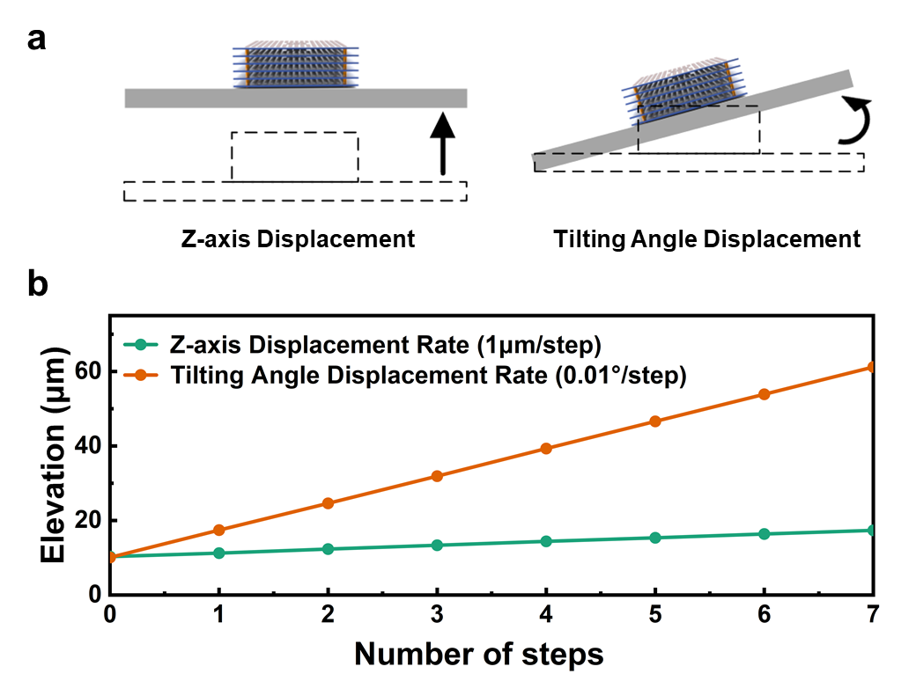
Figure 3. Monitoring of surface deformation. (a) Schematic diagram showing the definition of z-axis displacement error and the tilting angle displacement error. (b) The measured elevation as a function of displacements when linear (the green line) and rotary (the orange line) displacements are introduced, respectively.

To validate the capability of SIAS in deformation measurement, we placed a wafer on a platform that consists of a z-axis displacement stage and a rotary stage. By adjusting the linear stage and the rotary stage, we can mimic the scenario where a chip or a wafer has different levels of deformation. The movement of the z-axis displacement stage allows us to capture the elevation information of the measurement points at each step. The step size of the z-axis displacement stage was set to 1μm/step. Additionally, we conducted the measurements at different tilting angles (see the definition of tilting angle in Figure 3a) implemented by the rotary stage. The step size for the tilting angle was set to 0.01°/step. Here we should mention that the tilting angle should be small enough such that we can measure the change of height instead of the change of angle. Fortunately, the deformation of a layer in an actual 3D-stacked structure (for example, the 3D-stacked chip) is relatively small, which automatically satisfies the assumption of small deformation. As shown in Figure 3b, the fitted curves present a high degree of linearity, indicating that our measurement system could accurately reconstruct the surface deformation. We should mention that there are still small errors between the measured values and the theoretical ones, which mainly arise from the positioning error of the z-axis and rotary stages as well as the environmental vibration. Here we should emphasize that the z-axis and rotary stages are only used to mimic the deformation of the chip and are not included in SIAS. Therefore, the positioning errors of the z-axis and rotary stages do not affect the measurement results of the 3D-stacked structures below.

Deformation measurement for 3D-stacked structures
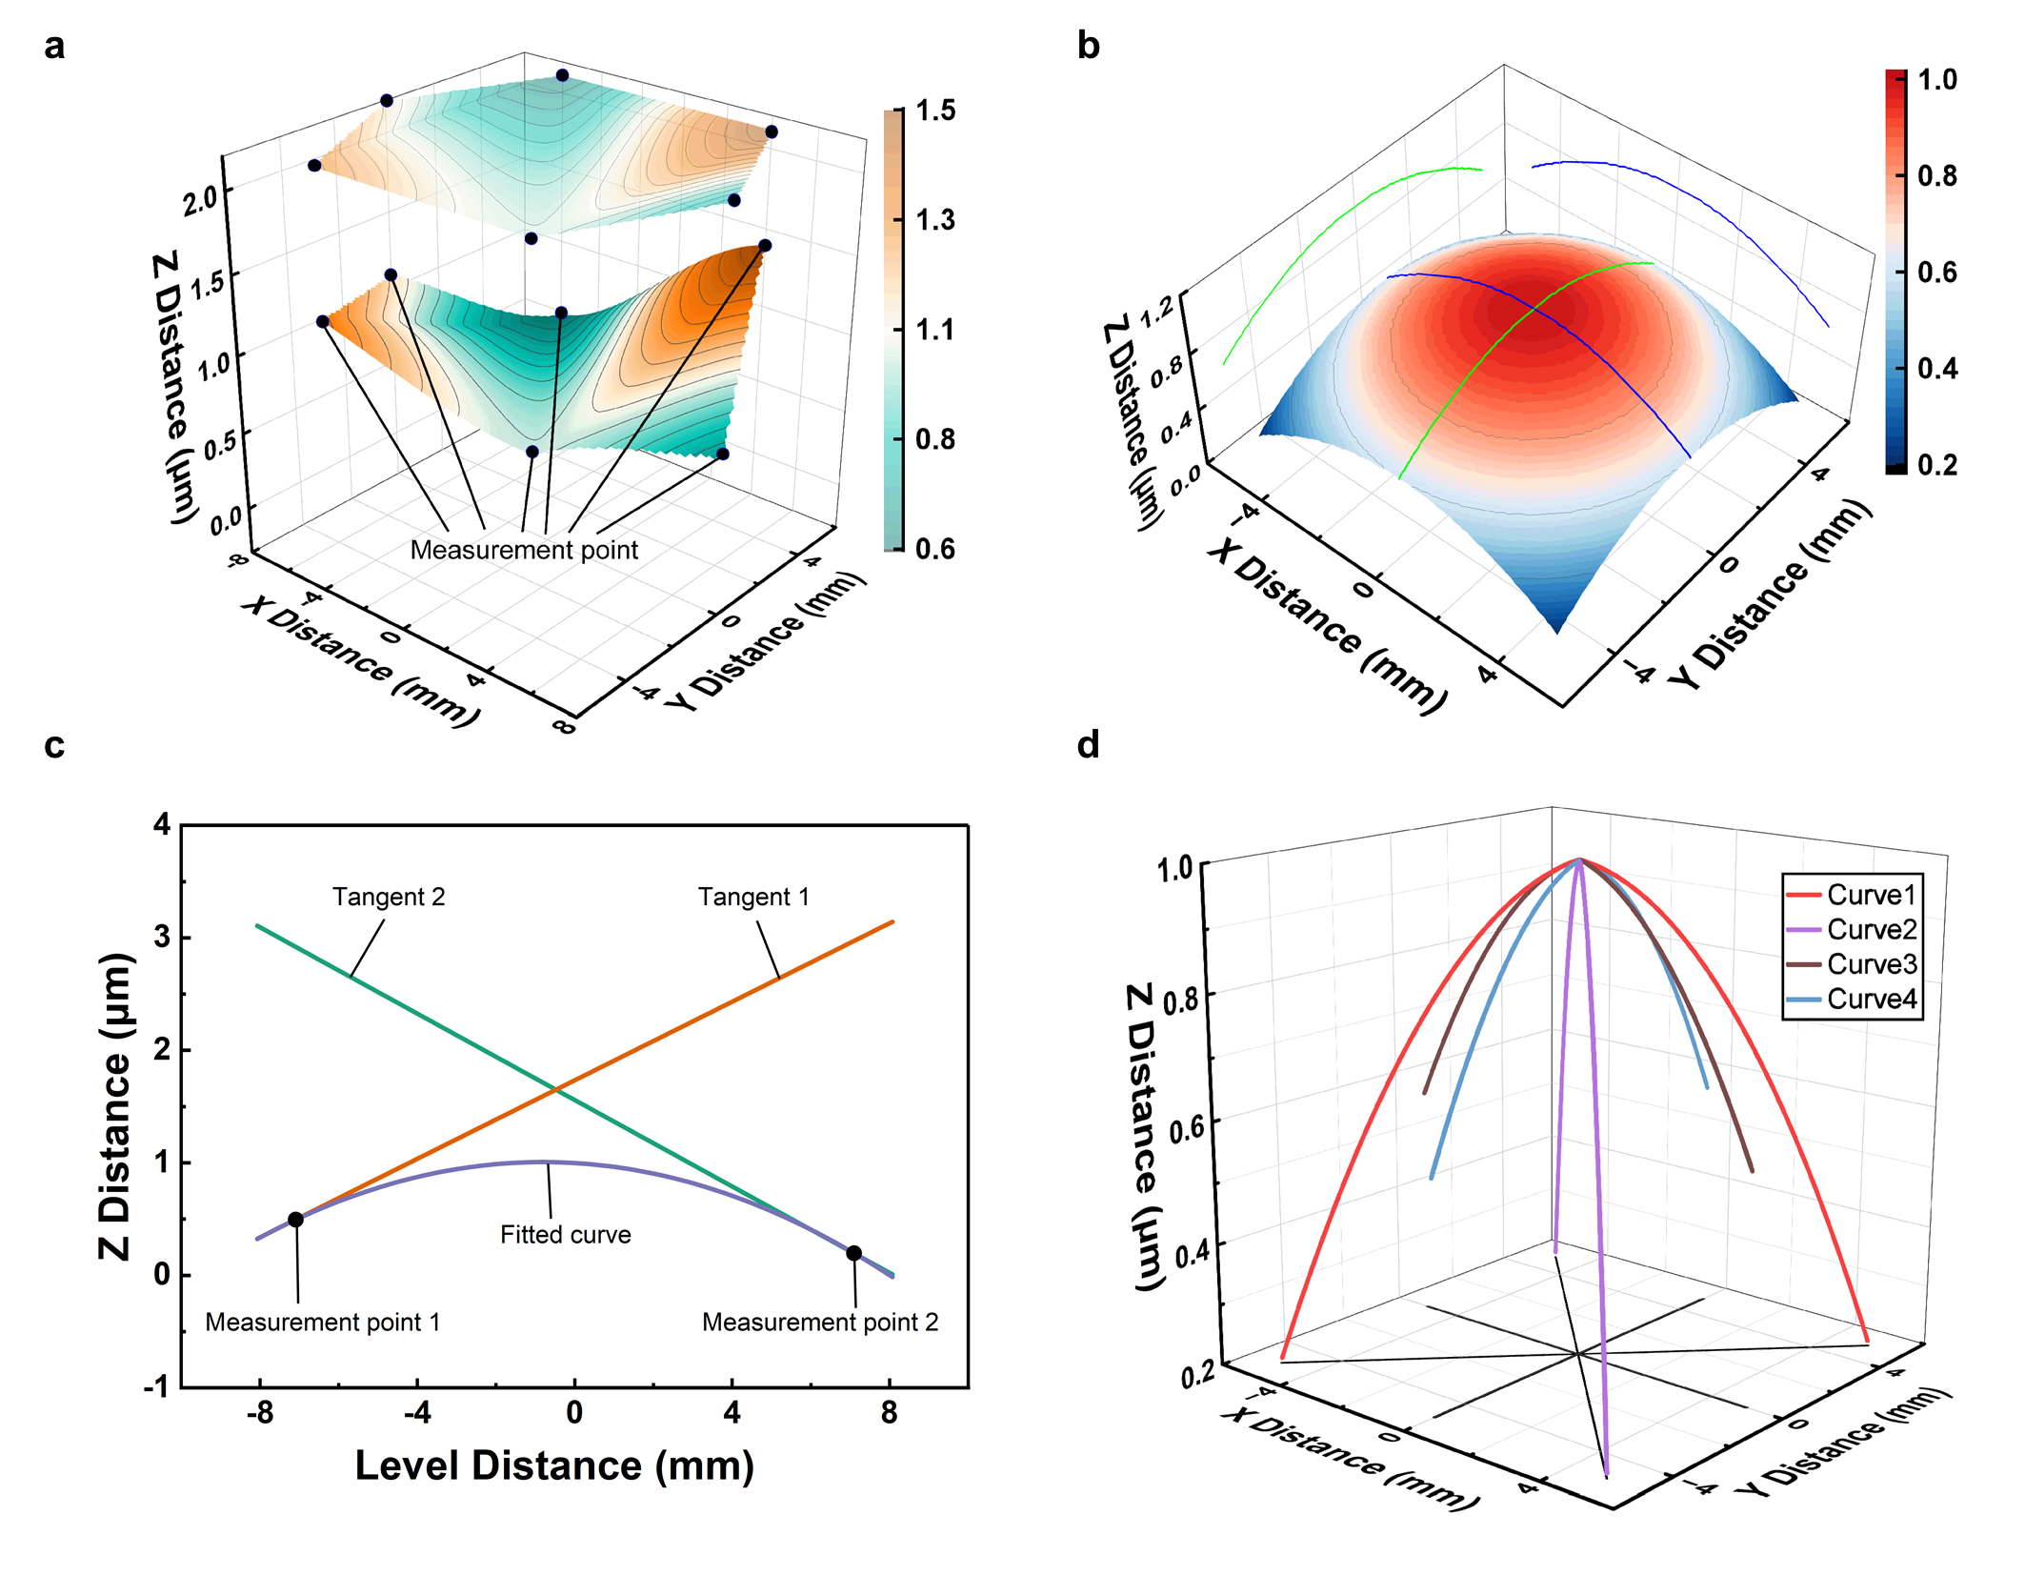 Figure 4. The measurement results of a 3D-stacked structure that has deformation in multiple layers. (a) The reconstructed deformation surfaces fitted by the measured elevation at the measurement points. (b) The reconstructed deformation surface fitted by the elevation and tilting angle at the measurement points. (c) The deformation curves fitted to data from two measurement points. "Measurement point 1" and "Measurement point 2" are symmetrical to the center of the chip. The "Fitted curve" is tangent to "Tangent1" and "Tangent2" at "Measurement point 1" and "Measurement point 2" respectively. (d) The assembly of all the fitted quadratic curves (i.e., "Curve1", "Curve2", "Curve3", and "Curve4").

To obtain the deformation distribution of each layer in a 3D-stacked structure, SIAS was employed to measure deformations at multiple points on each layer of the 3D-stacked structure. These points are chosen in a manner that they distribute uniformly around the center of the 3D-stacked structure. If the tilting angle of the measurement points is negligible, the cubic spline interpolation (CSI) method³⁰ is applied to fit the elevation of these measurement points to obtain the deformation distribution of the chip. CSI involves approximating the surface with a cubic polynomial near each point. This ensures smoothness of the interpolation results in the vicinity of the data points and adapts to the variations in the data by using local information. The resulting deformation distribution of a layer is depicted in Figure 4a, in which we are able to observe the overall deformation of the chip as well as the height and coordinate data of individual points on the layer surface (the geometrical center of the bottom layer of the 3D-stacked structure is defined as the origin of the Cartesian coordinate system). These data provide a comprehensive understanding of the deformation of the chip. The chip exhibits curvature variations that reveal possible bending in its structure. To be more specific, the chip has a maximum curvature of 1.837×10⁻⁴ μm⁻¹ at the point (0.62 mm, 4 mm). If the tilting angle of the measurement point is not negligible, the fitting of the deformation distribution of the chip involves several steps. Firstly, two measurement points symmetrical to the center of the chip are selected as a combination, such as "Measurement point 1" and "Measurement point 2" in Figure 4c. The elevation and tilting angles at the two measurement points can be formed into two straight lines as "Tangent1" and "Tangent2", respectively. A curve named "Fitted curve" is then fitted using the polynomial fitting method³¹. The "Fitted curve" is tangent to "Tangent1" and "Tangent2" at "Measurement point 1" and "Measurement point 2", respectively. Subsequently, the quadratic curves obtained from all combinations of measurement points are assembled into the same three-dimensional space, as depicted in Figure 4d. "Curve1", "Curve2", "Curve3", and "Curve4" represent different quadratic curves formed by various combinations of measurement points. Finally, the three-dimensional surface is fitted using the quadratic curve based on the method of cubic polynomial surface fitting ³¹; see Figure 4b. As shown in Figure 4b, we can observe the details of the curvature and bump deformation on each layer. The whole structure has a center convex deformation with a maximum height difference of 0.79 μm. Moreover, there is a maximum curvature of 4.98×10⁻³ μm⁻¹ at the origin.

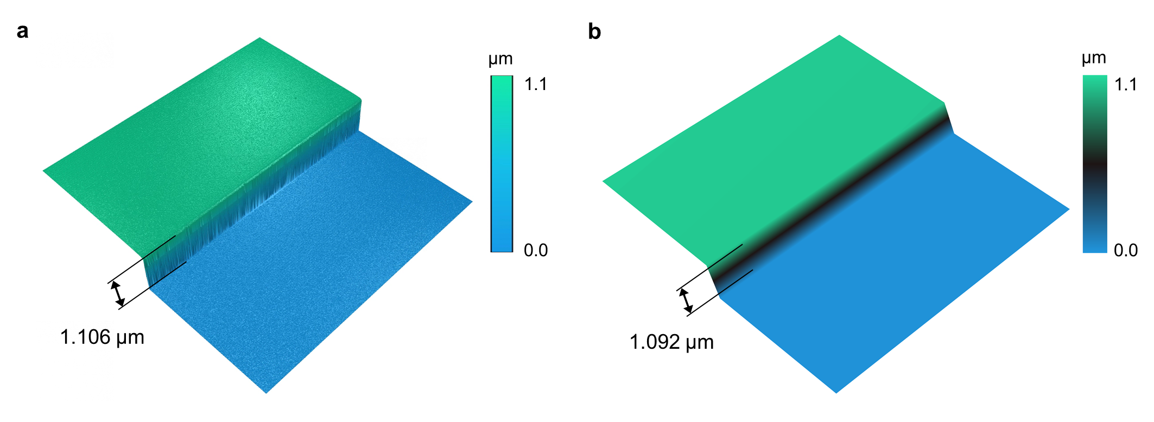
Figure 5. The measured deformation distribution of a step specimen. The measurement results of surface deformation using (a) the commercial WLI ER230 and (b) SIAS.

We evaluated the performance of the SIAS by measuring the surface deformation of an in-house fabricated step specimen, which is made by depositing a layer of aluminum film (1.1 μm-thick) on half of the surface of a silicon wafer using electron beam evaporation (EBE) technology. The surface deformation on the step specimen was firstly measured by a commercial WLI (model ER230; Atometrics, Inc.) with a 0.4-NA objective (Figure 5a). The deformation area that could be measured using the commercial WLI is about 400 μm wide by 400 μm long due to the limited field of view. We then compared the measured results from the commercial WLI to that from SIAS. We used the measurement results from ER230 with a 0.4-NA objective as the golden standard for the comparison. As shown in Figure 5a and Figure 5b, the step heights measured by ER230 and SIAS are 1.106 μm and 1.092 μm, respectively. The 14 nm difference demonstrates that SIAS is capable of achieving accurate measurements for surface profile and deformation.

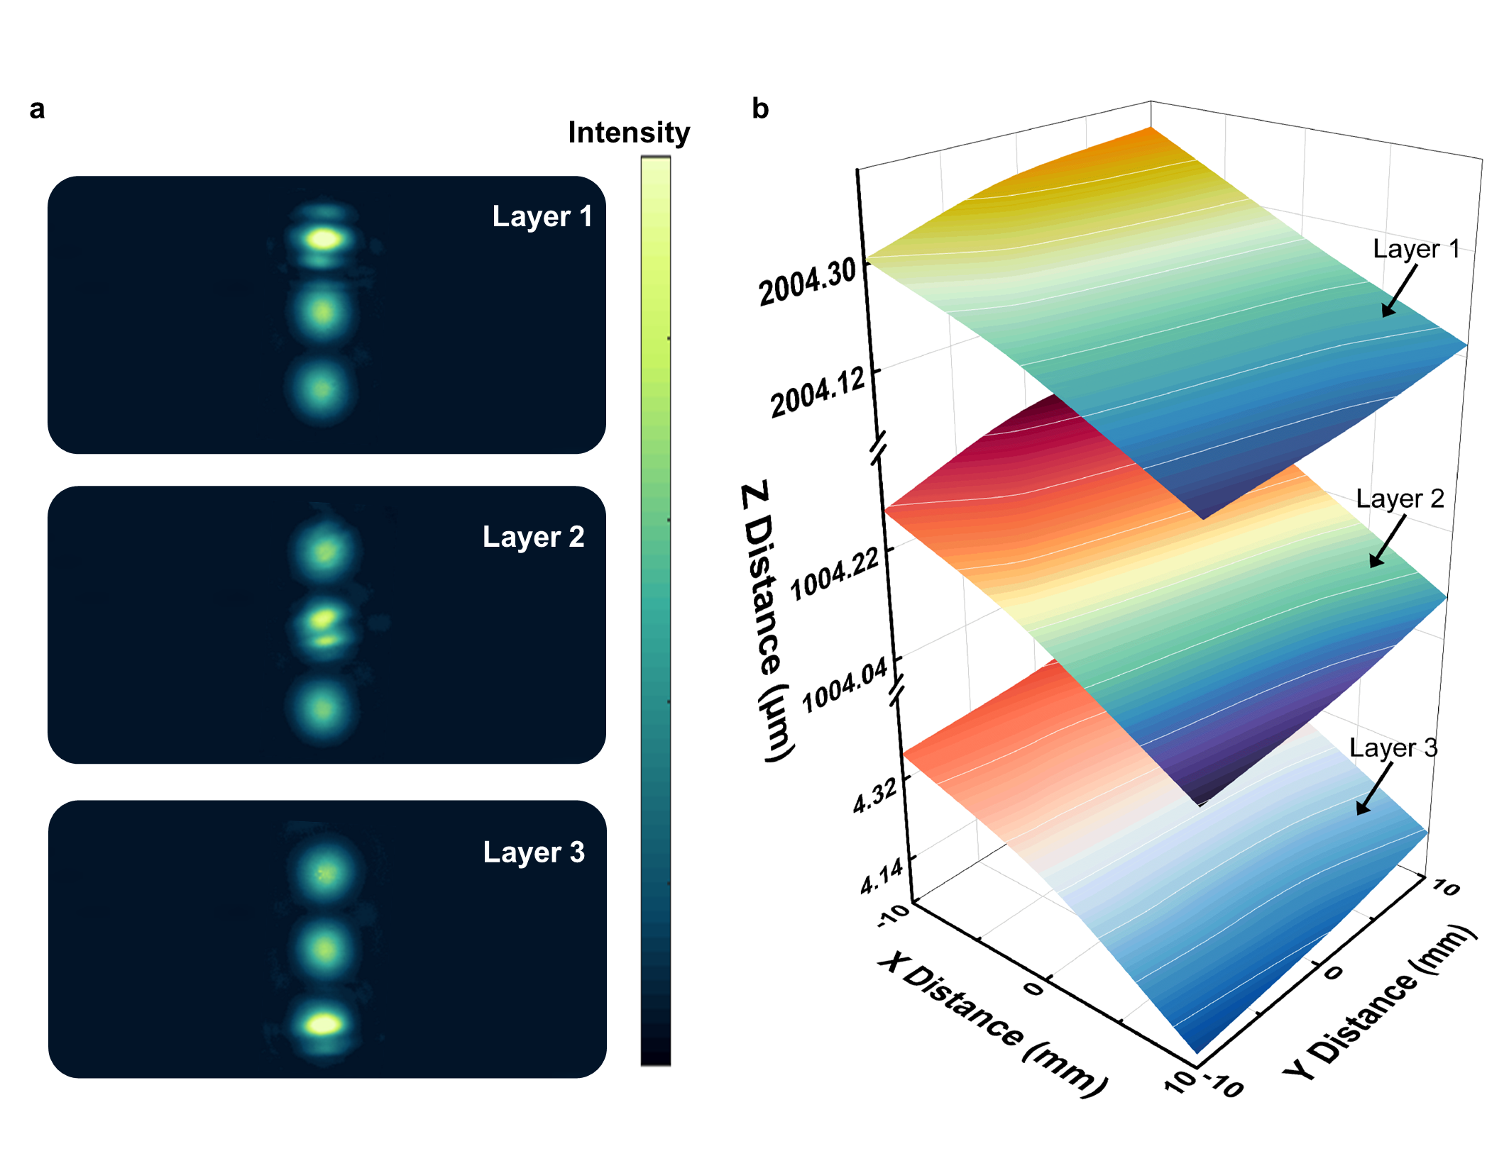Figure 6. The measured deformation distribution of a 3D-stacked structure. (a) The raw measurement signal. A partial interference pattern acquired by the CMOS camera during a single measurement by the measurement system, which represents the interference pattern for each layer separately. (b) The measurement results of three layers in the stacked structure.

The 3D-stacked structure under test consists of three layers, whose sizes are d₁ = 500 μm and d₂ = 500 μm; see the definition of d₁ and d₂ again in Figure 1a. To make the measurement of 3D-stacked structure feasible, the period of the mask's pinhole array should be the same as the period of the 3D-stacked structure and the pinhole diameter of the mask should be less than d₂. Therefore, the periodicity of the pinhole array mask was set at 1 mm with a pinhole diameter of 200 μm. The parameters of the micro-mirror array used in our measurement system were: 1 mm periodicity, h = 150 μm, w = 283 μm and l = 680 μm (see Figure 2c). Some interference patterns acquired by the CMOS camera during the measurement of the three-layer structure by SIAS are shown in Figure 6a, where each image contains the interference patterns of three layers of the 3D-stacked structure. The three CMOS camera images in Figure 6a show distinct interference fringes for each layer of the 3D-stacked structure. The measured deformation results for the three-layer structure are presented in Figure 6b, in which we are able to observe the details of the deformation distribution of each layer. The maximum differences in elevation of the layers from top to bottom are 0.3411 μm, 0.3347 μm, and 0.3972 μm, respectively. The maximum curvatures of all layers from top to bottom are 1.51×10⁻⁵ μm⁻¹ at position (0.36 mm, -0.28 mm), 1.6×10⁻⁵ μm⁻¹ at position (-0.08 mm, 0.38 mm), and 2.11×10⁻⁵ μm⁻¹ at position (-0.7 mm, 0.7 mm). These data demonstrate that our measurement system could measure the nanometer-scale deformation of multilayer structures simultaneously.

CONCLUSIONS
This study introduces an innovative method named stacked interferometry array system for the precise monitoring of the surface deformation of all layers in a 3D-stacked structure. We experimentally demonstrated that the measurement accuracy of our system could reach the nanometer scale and the measurement time for a single measurement point is less than 10 seconds after the measurement system was calibrated. The accuracy and speed of measurement can be further improved by using a high-precision and fast PZT stage alongside a careful calibration of the measuring system. Moreover, it is expected that the system can also be utilized to measure the nanoscale deformation of multiple layers in a 3D-stacked structure with even smaller spacing (e.g., <10 μm) by using a smaller micro-mirror array that can be fabricated through a standard semiconductor fabrication process. We hope this work could not only address current challenges in in-line or in-situ deformation monitoring of all layers in 3D-stacked chips in the fab but also may pave the way for many other fields where deformation or dimension measurement in micrometer scale spacing is impossible using conventional top-down measurement techniques.

Supporting Information
The Supporting Information is available free of charge at https://pubs.acs.org.
The experimental system for 3D-stacked structure measurement; design and fabrication of the micro-mirror array; extraction of interference patterns for each layer in a 3D-stacked structure; calculation of the elevation distribution.

Conflict of Interest
The authors claim a C.N. patent and a U.S. patent on the presented method in this work through Huazhong University of Science and Technology.

Funding Sources
This work was funded by the National Nature Science Foundation of China (Grant Nos. 52175509 and 52130504), the National Key Research and Development Program of China (2023YFF1500900), the Shenzhen Fundamental Research Program (JCYJ20220818100412027), the Guangdong-Hong Kong Technology Cooperation Funding Scheme Category C Platform (SGDX20230116093543005), the 2021 Postdoctoral Innovation Research Plan of Hubei Province (0106100226), and the Innovation Project of Optics Valley Laboratory (Grant No. OVL2023PY003).

ACKNOWLEDGMENTS
Thanks engineers Wei Xu and Pan Li in Optoelectronic Micro & Nano Fabrication and Characterizing Facility, Wuhan National Laboratory for Optoelectronics of Huazhong University of Science and Technology for the support in device fabrication (EBE and PECVD). This work was funded by the National Nature Science Foundation of China (Grant Nos. 52175509 and 52130504), the National Key Research and Development Program of China (2023YFF1500900), the Shenzhen Fundamental Research Program (JCYJ20220818100412027), the Guangdong-Hong Kong Technology Cooperation Funding Scheme Category C Platform (SGDX20230116093543005), the 2021 Postdoctoral Innovation Research Plan of Hubei Province (0106100226), and the Innovation Project of Optics Valley Laboratory (Grant No. OVL2023PY003).

REFERENCES
- Choi, C., Kim, H., Kang, J. H., et al. Reconfigureurable heterogeneous integration using stackable chips with embedded artificial intelligence. Nat. Electron. 2022, 5, 386–393.
- Liang, S. J. & Miao, F. Lego-like reconfigureurable AI chips. Nat. Electron. 2022, 5, 327–328.
- Iyer, S. S. & Kirihata, T. Three-dimensional integration: A tutorial for designers. IEEE Solid-State Circuits Mag. 2015, 7, 63–74.
- Tian, W., Li, Z., Wang, Y., et al. Height uniformity simulation and experimental study of electroplating gold bump for 2.5 D/3D integrated packaging. Micromachines 2022, 13, 1537.
- Black, B., Annavaram, M., Brekelbaum, N., et al. Die stacking (3D) microarchitecture. In 2006 39th Annual IEEE/ACM International Symposium on Microarchitecture (MICRO'06), 2006, 469–479.
- Lau, J. H. Evolution and outlook of TSV and 3D IC/Si integration. IEEE Trans. Compon. Packag. Manuf. Technol. 2010, 12, 560-570.
- Shen, L. C., Chien, C. W., Cheng, H. C., et al. Development of three-dimensional chip stacking technology using a clamped through-silicon via interconnection. Microelectron. Reliab. 2010, 50, 489-497.
- Ramm, P., Wolf, M. J., Klumpp, A., et al. Through silicon via technology—processes and reliability for wafer-level 3D system integration. In 2008 58th Electronic Components and Technology Conference, 2008, 841-846.
- Ding, B., Zhang, Z. H., Gong, L., et al. A novel thermal management scheme for 3D-IC chips with multi-cores and high power density. Appl. Therm. Eng. 2020, 168, 114832.
- Xiao, C., He, H., Li, J., et al. An effective and efficient numerical method for thermal management in 3D-stacked integrated circuits. Appl. Therm. Eng. 2017, 121, 200-209.
- De Groot, P. Principles of interference microscopy for the measurement of surface topography. Adv. Opt. Photon. 2015, 7, 1-65.
- Wang, S. H., Quan, C., Tay, C. J., et al. Deformation measurement of MEMS components using optical interferometry. Meas. Sci. Technol. 2003, 14, 909.
- Kumar, U. P., Bhaduri, B., Mohan, N. K., et al. Microscopic TV holography for MEMS deflection and 3-D surface profile characterization. Opt. Lasers Eng. 2008, 46, 687-694.
- Lu, X., Yuan, Y., Ma, C., et al. Self-calibrated absolute thickness measurement of opaque specimen based on differential white light interferometry. IEEE Trans. Instrum. Meas. 2008, 69, 2507-2514.
- Arieli, Y., Epshtein, S., Yakubov, I., et al. Surface measurements by white light spatial-phase-shift imaging interferometry. Opt. Express 2008, 22, 15632-15638.
- Liu, L., Wang, E., Zhang, X., et al. MEMS-based 3D confocal scanning microendoscope using MEMS scanners for both lateral and axial scan. Sens. Actuators A Phys. 2014, 215, 89-95.
- Fu, S., Cheng, F., Tjahjowidodo, T., et al. A non-contact measuring system for in-situ surface characterization based on laser confocal microscopy. Sensors 2018, 18, 2657.
- Jung, I. W., López, D., Qiu, Z., et al. 2-D MEMS scanner for handheld multispectral dual-axis confocal microscopes. J. Microelectromech. Syst. 2018, 27, 605-612.
- Sinclair, M. B., Haaland, D. M., Timlin, J. A., et al. Hyperspectral confocal microscope. Appl. Opt. 2006, 45, 6283-6291.
- Gelenbe, E., Koçak, T., Wang, R. Wafer surface reconstruction from top–down scanning electron microscope images. Microelectron. Eng. 2004, 75, 216-233.
- Nakamae, K. Electron microscopy in semiconductor inspection. Meas. Sci. Technol. 2021, 32, 052003.
- Tay, C. J., Wang, S. H., Quan, C., et al. Surface roughness investigation of semiconductor wafers. Opt. Laser Technol. 2004, 36, 535-539.
- Becker, C. R., Prokes, S. M., Love, C. T. Enhanced lithiation cycle stability of ALD-coated confined a-Si microstructures determined using in situ AFM. ACS Appl. Mater. Interfaces 2016, 8, 530-537.
- Ki, W. M., Kang, M. S., Yoo, S., et al. Fabrication and bonding process of fine pitch Cu pillar bump on thin Si chip for 3D stacking IC. In 2011 IEEE International 3D Systems Integration Conference (3DIC), 2012, 1-4.
- Roshanghias, A., Rodrigues, A., Schwarz, S., et al. Thermosonic direct Cu pillar bonding for 3D die stacking. SN Applied Sciences 2020, 2, 1-9.
- Kim, J., Zhu, L., Torun, H. M., et al. Micro-bumping, hybrid bonding, or monolithic? APPA study for heterogeneous 3D IC options. In 2021 58th ACM/IEEE Design Automation Conference (DAC), 2021, 1189-1194.
- Lau, J. H. Recent advances and trends in advanced packaging. IEEE Trans. Compon. Packag. Manuf. Technol. 2022, 12, 228-252.
- Mack, C. A. Fundamental Principles of Optical Lithography: The Science of Microfabrication. Wiley 2007. DOI:10.1002/9780470723876
- De Groot, P. Principles of interference microscopy for the measurement of surface topography. Adv. Opt. Photonics 2015, 7, 1-65.
- McKinley, S., Levine, M. Cubic spline interpolation. College of the Redwoods. 1998, 45, 1049-1060.
- Dey, T. K. Curve and surface reconstruction. In Handbook of Discrete and Computational Geometry, 2017, 915-936.

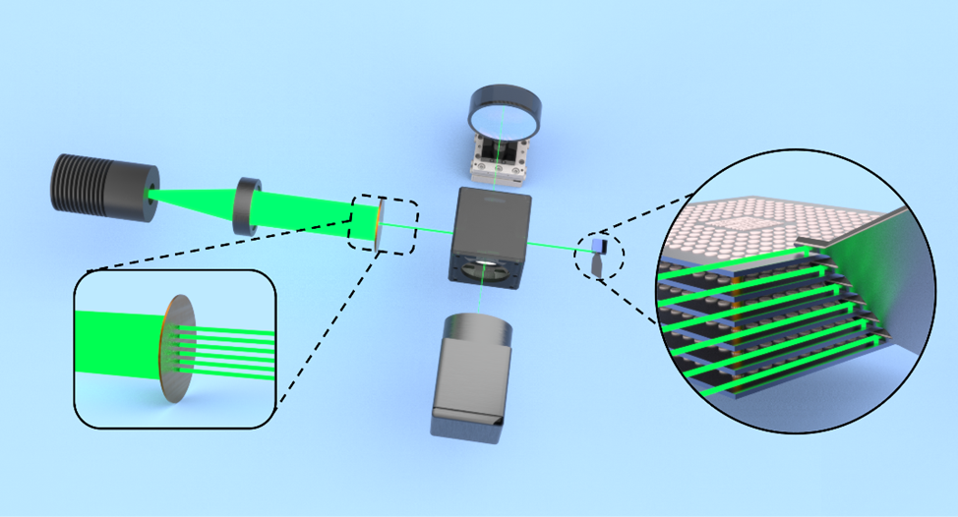
Abstract Graphic: For Table of Contents Use Only

