1-Chloronaphthalene-induced Donor/acceptor Vertical Distribution and Carrier Dynamics Changes in Nonfullerene Organic Solar Cells and the Governed Mechanism

Xinjun He¹, Christopher C. S. Chan², Jinwook Kim¹, Heng Liu³, Chun-Jen Su⁴, U-Ser Jeng⁴, Haibin Su⁵, Xinhui Lu³, Kam Sing Wong², Wallace C. H. Choy^{1,}*

¹Department of Electrical and Electronic Engineering, The University of Hong Kong, Pokfulam Road, Hong Kong, SAR, China
²Department of Physics and William Mong Institute of Nano Science and Technology, The Hong Kong University of Science and Technology, Clear Way Bay, Hong Kong, SAR, China
³Department of Physics, Chinese University of Hong Kong, New Territories, Hong Kong, SAR, China
⁴National Synchrotron Radiation Research Center, Hsinchu Science Park, Hsinchu 30076, Taiwan
⁵Department of Chemistry, The Hong Kong University of Science and Technology, Clear Way Bay, Hong Kong, SAR, China

E-mail: chchoy@eee.hku.hk (Wallace C. H. Choy)

Abstract
Electron donors and acceptors in organic solar cells (OSCs) shall strike a favorable vertical phase separation that acceptors and donors have sufficient contact and gradient accumulation near the cathodes and anodes, respectively. Random mixing of donors/acceptors at surface will result in charge accumulation and severe recombination for low carrier-mobility organic materials. However, it is challenging to tune the vertical distribution in bulk-heterojunction (BHJ) films as they are usually made from a well-mixed donor/acceptor solution. Here, for the first time, we present with solid evidence that the commonly used 1-chloronaphthalene (CN) additive can tune the donor/acceptor vertical distribution and establish the mechanism. Different from the previous understanding that ascribed the efficiency enhancement brought by CN to the improved molecular stacking/crystallization, we reveal that the induced vertical distribution is the dominant factor leading to the significantly increased performance. Importantly, the vertical distribution tunability is effective in various hot nonfullerene OSC systems and creates more channels for the collection of dissociated carriers at corresponding organic/electrode interfaces, which contributes the high efficiency of 18.29%. This study of the material vertical distribution and its correlation with molecular stacking offers methods for additives selection and provide insights for the understanding and construction of high-performance OSCs.

Keywords: organic solar cells, 1-chloronaphthalene, morphology control, vertical phase separation

1. Introduction
In today’s high-performance OSCs, additives have been widely employed to optimize the morphology and thus significantly improve the device photovoltaic performance. 1-Chloronaphthelene (CN) is one of the most commonly used additives in organic active layer to tune the aggregation behavior of donors and acceptors during film formation process¹⁻⁴. The improvement brought by CN has been ascribed to more ordered molecule stacking and higher crystallinity in organic films which leads to better charge dissociation and collection.⁵⁻⁸ However, it draws our attention that the molecular stacking in organic films has very slight change upon CN addition whereas the device efficiency has significant improvement. Particularly, the state-of-the-art donors/acceptors has very sophisticated chemical structures with delicately tailored backbone and side chain to balance crystallinity and molecular stacking.⁹⁻¹¹ For example, the typical π-π stacking distances that reflects on the inter-molecular interaction in organic active layer remains almost no change upon CN addition while the efficiency has a huge jump in the star nonfullerene PM6:Y6 systems.¹²⁻¹⁶ The change of corresponding crystal coherence length (CCL, in relation to molecule crystallinity) is generally within 0.3 nm. Correspondingly, it has been reported that ~20 nm domain size is favorable for exciton dissociation and charge transportation due to limited exciton diffusion length.¹⁷⁻¹⁸ These results indicate the current understanding about the function of CN additive in OSC is still inconclusive, which however is very important for the understanding and construction of high-performance OSCs.
It is generally believed that the electron donor and acceptor domain in active layer shall strike a balance between miscibility and phase separation to guarantee large donor/acceptor contact area and big domains gradiently enrich near anode/cathode, respectively. In this regard, the fabricated OSCs will simultaneously achieve efficient exciton dissociation at the donor/acceptor interface and fast charge transportation in the domain.^{17, 19} Contrarily, random mixing of donor and acceptor materials at the interface will result in counter-charge accumulation and severe charge recombination especially for low carrier mobility organic materials.²⁰
In this work, we reveal that the commonly used CN additive can effectively tune the donor/acceptor vertical distribution in bulk-heterojunction (BHJ) films, which was neglected and its contribution to device performance was covered up. We fundamentally explain that the large disparity of boiling points between the additive and main solvent in the blend solution, together with the different CN-donor/acceptor interaction, has led to the distribution discrepancy. Such structure creates more channels for the collection of the dissociated charges at the corresponding electrode interface. Different from previous understanding, we found the induced donor/acceptor vertical distribution is the main factor that leads to the efficiency enhancement while the slightly improved crystallization/aggregation brought by CN has very limited influence on the device performance. Meanwhile, the tunability of vertical distribution can be generally applied in various hot non-fullerene OSC systems including PM6:Y6, D18-Cl:Y6:PC₇₁BM and D18-Cl:N3:PC₆₁BM, confirming the mechanism is wide applicable and contributing to a high efficiency of 18.29%. In addition, we also confirm that the CN engaged device is very stable with little degradation in PCE after storage at glove box for over 2600 h. To the best of our knowledge, this is the first work presents solid evidence that CN can tune the donor/acceptor vertical distribution and clarifies its importance compared to the slightly better molecular stacking brought by CN. It contributes to better understanding about morphology control, and offers guidelines to the selection of new additives for constructing high-performance OSCs by simple one-step process of BHJ active layers.

2. Result and discussion
In this study, we firstly demonstrate that CN will induce favourable vertical distribution in BHJ film and then to clarify that it dominantly contributes to the better efficiency compared to the slightly better molecular packing/crystallization. To establish the mechanism for the distribution discrepancy, a benchmark nonfullerene OSC system is selected with PM6:Y6 as light absorbing layer, chloroform as main solvent and CN as additive. In this scenario, additive CN has much higher boiling point of 263 °C compared to the host solvent chloroform (61 °C), the majority of the chloroform will quickly volatilize and the increasing concentration of CN will magnify the solubility difference between donor and acceptor during the film drying process.²¹⁻²² The component (acceptor in this case) that has a stronger interaction with additive shall follow the volatilization of high boiling point CN to the top surface while the other component will enrich at the bottom. In order to estimate the interaction between additive CN and donor/acceptor, Hansen solubility parameters (δ) are calculated by group contribution method ²³⁻²⁵. For the case of PM6:Y6, δ_{PM6} = 19.12, δ_{Y6} = 19.88 and δ_{CN} = 20.65. Accordingly, the solvent-molecule interaction (χ_{s-m}) can be calculated by Flory-Huggins theory: χ_{PM6-CN} = 0.602 and χ_{Y6-CN} = 0.561. A lower χ value indicates a stronger interaction. Considering the stronger Y6-CN interaction and the high molecular weight of the PM6 (framework of the blend), Y6 is prone to follow the CN volatilization to the top surface while PM6 will gradiently enrich at layer bottom (Figure 1a). To verify the conjecture and visualize this process, we have conducted thin layer chromatography (TLC) measurement with cellulose as the stationary phase. As shown in Figure 1b, the blended donor and acceptor (right) remains in a mixed state after the pure CF elution. On the contrary, when CN is incorporated (CF:CN ratio of 1:1), an obvious colour stratification occurs with dark cyan on top and purple at bottom (the left photo of Figure 1c). Importantly, in Figure 1b where pure CF is employed, the thin layer (cellulose substrate) will quickly dry (several seconds) after taking out from the elution agent, but it keeps wet when CN is incorporated due to its high boiling point of 263 °C (the left photo of Figure 1c). The excess CN in the substrate will volatize and further extend (upward in particular) in the substrate. Following that, the acceptor (dark cyan) has reached the top of the substrate whereas the donor (purple) remains little change (the right photo of Figure 1c). We understand that the TLC results can not represent the real film-formation process as there is not cellulose in the fabrication process. However, it still serves as a strong evidence to support the proposed mechanism as it proves that CN has stronger interaction with Y6 and it will continue to influence the Y6 distribution even after spin coating due to the high boiling point.
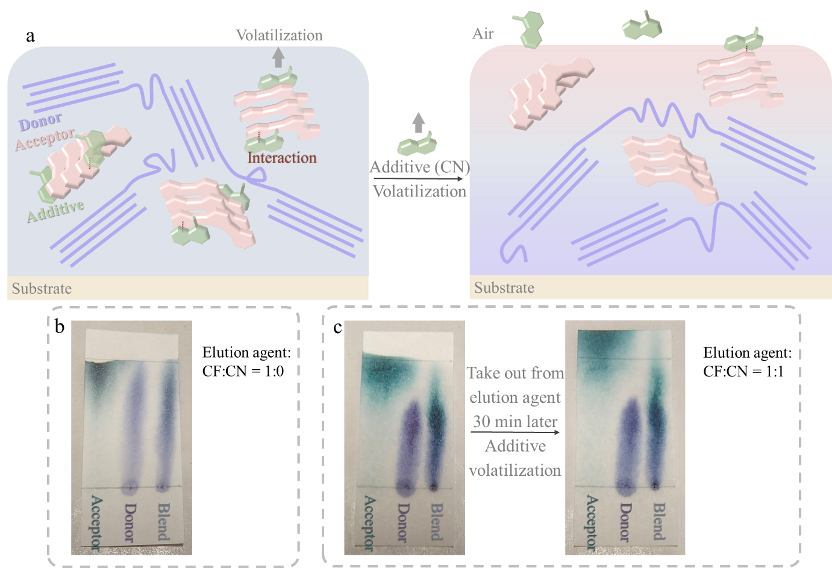
Figure 1. (a) The illustration of the additive induced vertical distribution. After additive volatilization, acceptor gradually enriches at layer top (pink) while donor enriches at bottom (purple). TLC results of neat donor, acceptor and blend materials with the elution agent (b) pure CF (CF:CN = 1:0) and (c) CF:CN = 1:1.

We then apply this mechanism in the real film-formation process to identify how the additive will influence the vertical distribution of donor/acceptor in BHJ film. We firstly investigate the morphological changes of the PM6:Y6 films with different CN additive ratios. As shown in Figure 2a, the atomic force microscopic (AFM) images shows that the film without any additive (0%) displays a smooth surface with a root-mean-square roughness (R_{RMS}) of 1 nm, indicating that the donor and acceptor materials are well mixed in the blend films (the corresponding phase image is shown in Figure S2). After incorporation of CN, there are many small protrusions at the top surface and they grow bigger when CN content increases. The corresponding R_{RMS} of the films slightly increase to 1.12 nm when the additive ratio increases to 0.75%, which improves the contact area to cathode and favours carrier collection. At higher CN content of 1% and 1.25%, the surface roughness increases vastly to 5 and 13 nm, with height fluctuation of 34.3 and 100.9 nm, respectively. The UV-Vis absorption spectra of the neat film and blend films with various additive ratios are provided in Figure 2b. Two main absorption peaks at around 610 nm and 810 nm can be assigned to donor and acceptor absorption peaks, respectively. It clearly shows that with the increase of additive ratio, the absorption peak at around 810 nm (Y6 absorption peak) has red shifted. At 1.25% CN content, its spectrum at long wavelength region is very close to neat Y6 film. These results suggest that Y6 in the blend film has aggregated²⁶ upon CN incorporation and the large bright domains in AFM images can be explained by Y6 aggregation or molecule packing. PL spectra of the blend films and PM6 neat films are provided in Figure 2c and Figure S3, respectively. The PL spectra are intensified with the increase of CN ratio, suggesting an increasing trend of phase separation in the film. For example, the PL signal is about 5-fold of the 1.25% sample compared to the 0.75% sample at about 670 nm, which means that donor and acceptor are more segregated in 1.25% sample. We have also conducted water contact angle test to shed light on the surface property evolution of the films (Figure S4). The extracted contact angle value is provided in Figure 2d, the contact angle encounters a decrease with the increase of additive ratio. The water contact angle of neat PM6 and Y6 films are given in Figure S5 with value of 109.2° and 98.1°, respectively. The fractional surface area of each component in the active blend can be estimated from Cassie’s equation (σ is the fractional surface area of each component):
$$cosθ_{blend}= σ_{PM6}cosθ_{PM6}+σ_{Y6}cosθ_{Y6}$$
The calculated factional surface of PM6 and Y6 is listed in Table S1. It suggests that the proportion of Y6 at the surface increases with the raise of CN ratio. To further uncover the elemental distribution of the films, we have implemented time-of-flight second ion mass spectroscopy (ToF-SIMS) measurement on the samples with a configuration of ITO/PEDOT:PSS/PM6:Y6. Figure 2e exhibits the elemental intensity evolution with sputtering time in the sample without CN incorporation. The stabilized signal of CN⁻, S⁻ and InO⁻ emerge in order, displaying a clear hierarchical structure of ITO/PEDOT:PSS/PM6:Y6. Since F⁻ signal is very sensitive to the changes and it exists in both PM6 and Y6 while CN⁻ exists in Y6, here we use CN⁻/F⁻ as the indicator to represent the dynamic ratio evolution of PM6/Y6. The CN⁻/F⁻ value shall be 0 for the neat PM6 film and a positive value for Y6 film. A lower CN⁻/F⁻ value suggests a higher PM6 ratio and lower Y6 ratio. Importantly, the CN⁻/F⁻ ratio shows low variation in the control film without additive (100-500 s, Figure 2f), indicating a relatively more homogeneous distribution of PM6 and Y6 over the active layer. Differently, the CN⁻/F⁻ ratio gradually decreases in the films with CN incorporation (0.75% and 1.25%), which means that Y6/PM6 ratio decreases in the vertical direction of the film and confirms that Y6 is enriched at the top region of the film (The separate CN⁻ and F⁻ ToF-SIMS profiles of different additive ratios are provided in Figure S6).
We have also conducted transient absorption (TA) characterization on the front and back sides of the samples with laser pumping at both side (800 nm). The corresponding spectra of samples with and without CN incorporation are displayed in Figure 2g and Figure S7, respectively, and the peak at around 840 nm is ascribed to ground state bleach (GSB) of the acceptor Y6. For the 0.75% CN sample, an intensified peak in the front-pumping spectrum is captured compared to its back counterpart. Meanwhile, there is little difference between the front- and back-pumping spectrum of the sample without CN. The results manifest that CN-incorporation can successfully tune the donor/acceptor vertical distribution in the BHJ film. In a conventional structured device, such a top Y6 enriched morphology with better phase separation is more beneficial to the charge transportation.
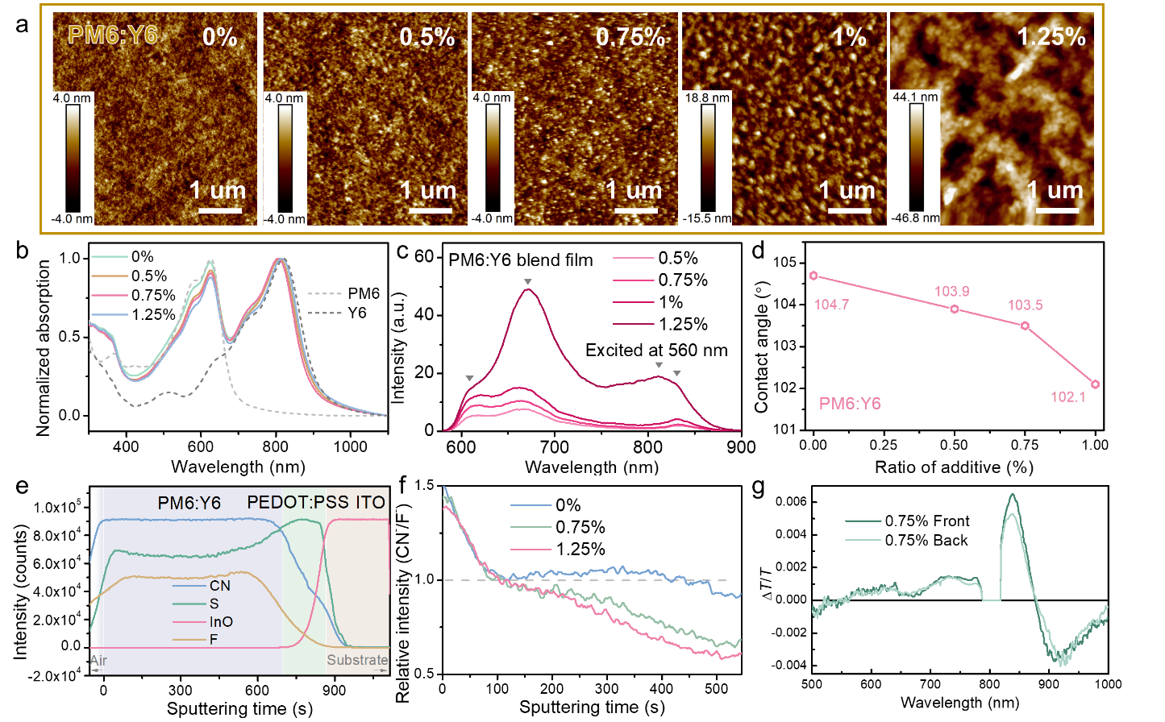
Figure 2. (a) AFM images, (b) UV-Vis spectra, (c) PL spectra and (d) contact angle (water) of PM6:Y6 films casted from solutions with different additive ratios. (e) ToF-SIMS measurement of the PM6:Y6 films without CN additive. (f) CN⁻/F⁻ ratio versus sputtering time of different active layers. (g) TA spectra of the PM6:Y6 film with 0.75% CN incorporation recorded from front (top) and back (bottom) pumping.

Next, we have fabricated OSCs with a conventional configuration of ITO/PEDOT: PSS/PM6:Y6/PDINO/Ag where the active layers are made from different additive ratio to reveal how the vertical distribution will affect the device optical and electrical properties. The device performances are summarized in Table S2. The PCE firstly increases and then decreases with increasing CN ratio. The OSC with 0.75% CN shows the highest PCE of 16.75% with open circuit voltage (Voc) of 0.849 V, short circuit current (Jsc) of 26.27 mA cm⁻² and fill factor (FF) of 0.75. To understand the improved device performances, we have conducted various measurements including J-V measurement under different light intensities, photocurrent versus effective voltage, space charge-limited current (SCLC) measurement on the devices to probe into the exciton and carrier dynamics. The detailed discussion is provided in the supporting information (Figure S8-S13). Briefly, the device with 0.75% CN incorporation presents suppressed bimolecular recombination at short-circuit condition, highest exciton dissociation probability (95.6%) and charge collection probability (85.1%), and the most balanced hole and electron mobility (µ_{h}/µ_{e} = 1.13), which accounts for the higher FF and better performance of the device. It shall be noted that since CN will concurrently increase the donor/acceptor crystallization and tune their vertical distribution, it is important to distinguish the contribution of performance enhancement brought by these two factors, which will be discussed in the final part.
To explore whether the CN-induced vertical distribution is generally applicable, we have also investigated the effect brought by CN in two top-efficiency OSC systems including D18-Cl:Y6:PC₇₁BM and D18-Cl:N3:PC₆₁BM.²⁷⁻²⁸ We have conducted TLC, UV-Vis absorption spectroscopy, contact angle, AFM and PL measurement on the films without and with CN incorporation (denoted as as-cast and additive film, respectively). These two systems present identical trend and very similar to aforementioned PM6:Y6 system. We select D18-Cl:Y6:PC₇₁BM to demonstrate the CN-induced vertical distribution and the corresponding influence on device performance comparing to simple improved donor/acceptor crystallization/stacking. Firstly, the TLC results are shown in Figure S14, a clear donor/acceptor stratification is captured after CN addition. Secondly, we have excited the samples from front or back side to record their photoluminescence behaviour and further to evaluate the vertical distribution of donor and acceptor materials in the blend film. Since the excitation wavelength is 510 nm and the acceptor has weak absorption at this wavelength, the excitation power shall be weak enough to ensure only the surficial materials are excited. The sampling process is illustrated in Figure 3a. Figure 3b shows the PL spectra of neat D18-Cl and Y6 films with a broad peak at 600-700 nm and 800-900 nm, respectively, which is consistent with other reports.²⁹⁻³⁰ Importantly, the neat donor and acceptor present distinct peak location and can be clearly distinguished from the PL results. In Figure 3c, the as-cast film shows two PL peaks can be well indexed to the donor and acceptor. Meanwhile, the back-excitation PL signal has similar shape to the front counterpart with weakened intensity. The identical shapes suggest a similar and homogeneous distribution of donor and acceptor on front or back side of the film. The weaker intensity of back excitation is explained by the substrate absorption and reflection. Interestingly, in the additive film (Figure 3d), the peak at around 850 nm is significantly intensified upon front excitation, indicating more Y6 is accumulated on top of the additive film. We have also measured the water contact angle of the D18-Cl:Y6:PC₇₁BM films (Figure S15), a lower contact angle is characterized for the additive film, which also implies more Y6 is enriched on top according to Cassie’s equation mentioned above. All these results manifest that CN can tune the vertical distribution of other two hot OSC systems, which confirms that the aforementioned mechanism is wide applicable.
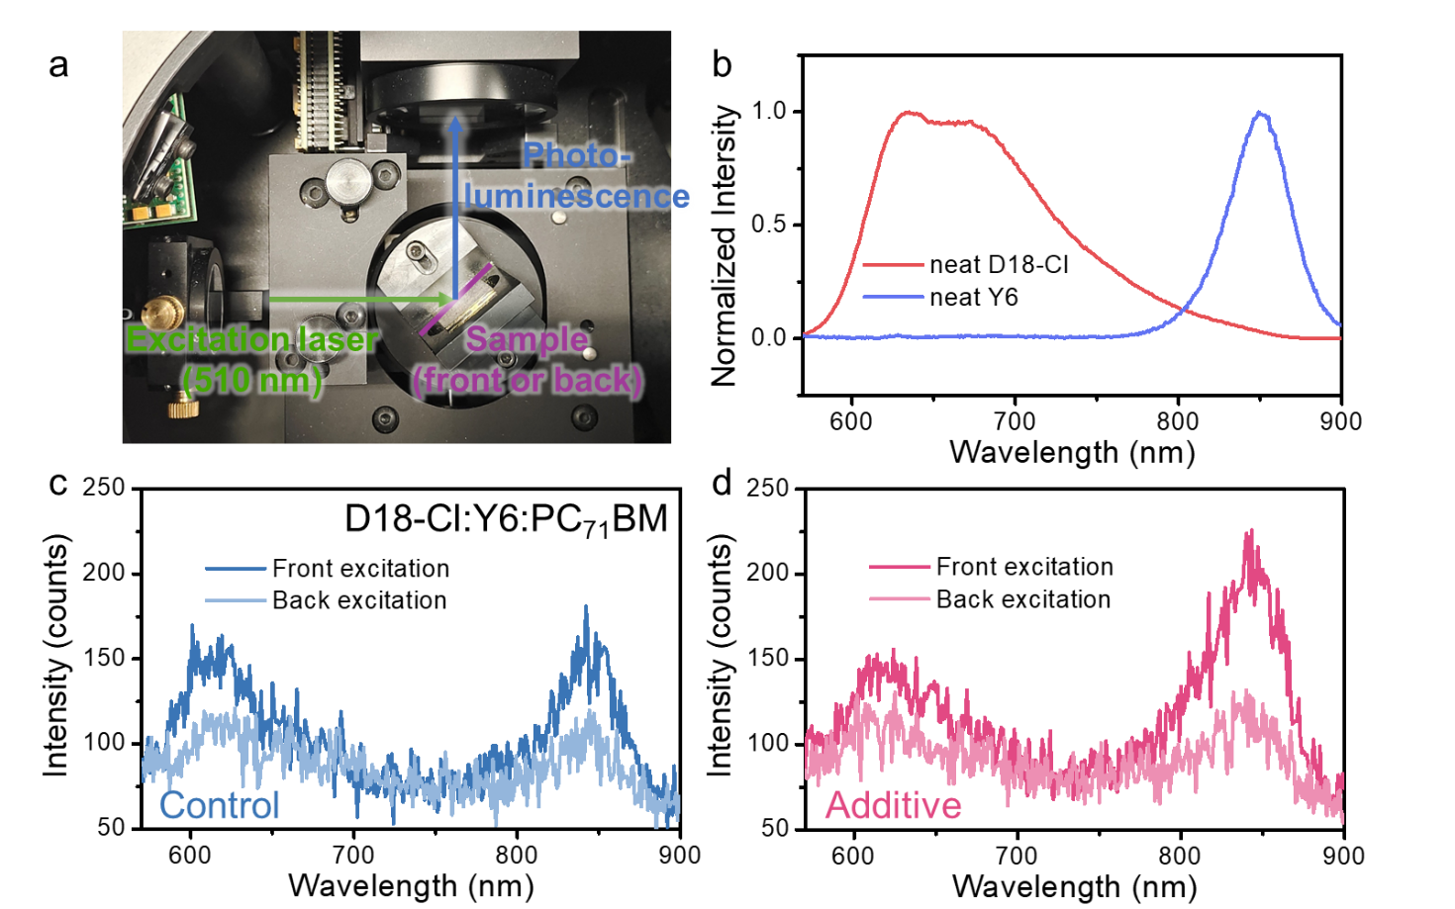
Figure 3. (a) Illustration of the PL sampling process. PL spectra of (b) D18-Cl and Y6 neat films and blend films (D18-Cl:Y6:PC₇₁BM) excited from front or back of the sample (c) as-cast and (d) with 0.25% CN incorporation.

Note that it is widely accepted that CN additive will increase the donor/acceptor crystallization and thus enhance device performance. In this work, we have successfully demonstrated that CN can tune the donor/acceptor vertical distribution. As mentioned in the introduction that CN addition has resulted in slightly better molecular stacking in state-of-the-art OSCs with fancy (donor/acceptor) chemical structure whereas the device efficiency has significant improvement.¹²⁻¹⁶ We believe it is the induced vertical distribution but not the slightly enhanced crystallization/stacking dominantly contributes to the performance improvement. To distinguish the contribution of these two factors, we have made the organic active layers with comparable molecular stacking/crystallization to the CN-ameliorated films but without detectable donor/acceptor vertical distribution (vertically uniform distribution).
The temperature dependent aggregation behaviour of acceptors including Y6 and N3 have been widely reported either in neat or in blend films.^{26, 31} The acceptors will aggregate and become more ordered upon thermal annealing. Here, we anneal the samples without CN additive at 100 °C for 10 min (denoted as annealed film) to make them more crystallized/aggregated. Then, it is compared with the CN optimized films (better crystallization together with favourable vertical distribution). The molecular stacking information in the annealed and additive film is probed by grazing incidence wide angle X-ray scattering (GIWAXS). As shown in Figure 4a-d, a sharp (010) peak is characterized for both films in the out-of-plane (OOP) direction, implying a dominant face-on orientation. The additive film shows a higher (010) peak position at 1.83 Å⁻¹, compared to annealed film (1.79 Å⁻¹), the π-π stacking distance is slightly shortened by 0.08 Å. In addition, both films exhibit lamellar stacking peaks (100) at 0.32 Å⁻¹, suggesting an identical stacking distance of 19.6 Å. Moreover, the comparable peak shape in terms of intensity and full width at half maximum (FWHM) indicates the similar crystallization pattern of the annealed and additive blend films. The UV-Vis absorption spectra of these films in Figure 4e also verify this point. After simple thermal annealing, the Y6 absorption peak has red shifted for ~10 nm due to the temperature dependent aggregation, which falls to the same situation as the additive film. Then we excite the annealed sample on front and back to record the PL signal and thus to confirm simple annealing will not lead to vertical distribution (glass substrate, Figure 4f). The front and back spectrum present similar shape with two broad peaks at 600-700 nm and 800-900 nm, indicating donor and acceptor are uniformly distributed in the top and bottom region of the film. AFM is implemented to further confirm it. If no additive involved, the surface roughness of annealed sample slightly increases from 0.88 nm to 0.97 nm (Figure 4g), but the film morphology is maintained. For the additive modified films, the small protrusion morphology come up, which is identical to Figure 2a and because of the accumulation of acceptor. Now, we can confirm that simple thermal annealing will lead to improved molecular packing/crystallization of blend film as the CN additive does, but it will not obviously change the vertical distribution of donor/acceptor.
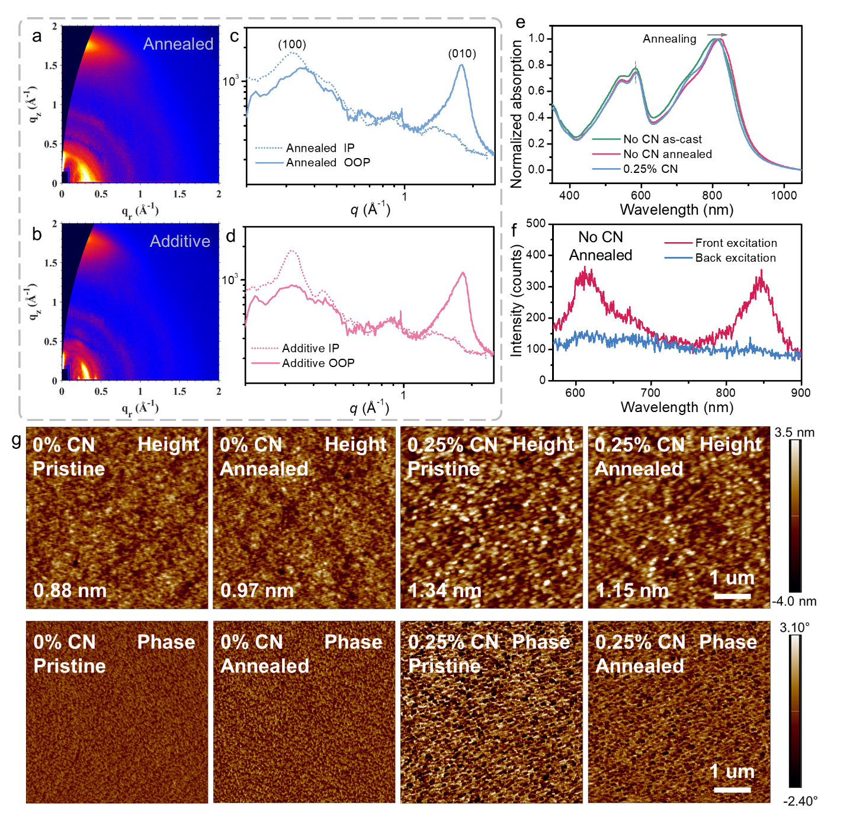
Figure 4. D18-Cl:PC₇₁BM:Y6 films. GIWAXS pattern of (a) (c) annealed and (b) (d) additive film. (e) The UV-Vis absorption spectra of as-cast, annealed and additive film. (f) The PL spectra of the annealed sample (no CN) excited from the front and back of the sample. (g) AFM images of as-cast, annealed and additive film.

Next, we have fabricated device to figure it out how they will influence the final device performance. Figure 5 presents the PCE histogram feature of as cast, annealed and additive devices. Histograms of other parameters and J-V characteristics for different devices are in Figure S16 and Table S5. The average efficiency of the devices upon thermal annealing slightly improves from 16.79% to 16.88%, which is much less than the additive modified devices (17.40%). We have also conducted other optical and electrical characterizations including external quantum efficiency (EQE), electrochemical impedance spectroscopy (EIS), transient photocurrent (TPC) measurement and stability test to investigate the device properties from these two factors (detailed discussion is provided in Figure S17). The additive devices with unique vertical distribution generally present better photovoltaic properties compared to simple annealed device with comparable molecular packing/crystallization. Based on these results, we draw a different conclusion from previous understanding that the biggest reason for device improvement after CN addition is the induced favourable donor/acceptor vertical distribution. The slightly improved molecular packing and crystallization has very small influence on device performance. Finally, the characterizations of another active layer, D18-Cl:N3:PC₆₁BM, are demonstrated in Figure S14, S19 and S20, which is consistent with other two systems in this work.
Figure 5. The histogram figure extracted from J-V curve of D18-Cl:Y6:PC₇₁BM-based as-cast, annealed and additive device.

3. Conclusion
In conclusion, we reveal CN as an additive can tune the donor/acceptor vertical distribution to gradually enrich near the anode/cathode, respectively. A clear and visualizing mechanism is provided. Different from the previous understanding that the performance improvement after CN addition is ascribed to the slightly better molecular packing and crystallization of donor/acceptor, we uncover that the vertical distribution is the main factor that leads to the significant improvement. By probing and studying the exciton and carrier dynamics via various photoelectrical characterizations, the active layers with the favourable vertical-distribution morphology display supressed charge recombination, enhanced and more balanced carrier mobility which contributes to better device performances. Equally important, our results show that such CN-induced vertical distribution exists in three state-of-the-art BHJ blends including PM6:Y6, D18-Cl:Y6:PC₇₁BM and D18-Cl:N3:PC₆₁BM, confirming the mechanism is wide applicable. This work elucidates the critical role of additives and also highlights the importance of vertical phase distribution in BHJ blends particularly comparing to the molecular stacking/crystallization. It also offers method/inspiration for the selection of new additive, which is essential for understanding and construction of high-performance non-fullerene OSCs.

Conflict of Interest
The authors declare no conflict of interest.
Acknowledgements
This research was supported by the University Grant Council of the University of Hong Kong for the funding (Grant 2019157209 and 202011159254), the General Research Fund (Grant 17200518, 17201819, 17211220, and 17200021), and the Collaboration Research Fund (CRF Project C7035-20G) from the Research Grants Council (RGC) of Hong Kong Special Administrative Region, China. The authors are grateful for the beam time and technical supports provided by 23A SWAXS beamline at NSRRC, Hsinchu. K.S. Wong would like to acknowledge the financial support from the Collaboration Research Fund (CRF-C6023-19G).

References
1. Jiang, K.; Zhang, J.; Peng, Z.; Lin, F.; Wu, S.; Li, Z.; Chen, Y.; Yan, H.; Ade, H.; Zhu, Z.; Jen, A. K. Y., Pseudo-bilayer architecture enables high-performance organic solar cells with enhanced exciton diffusion length. Nature Communications 2021, 12 (1), 468.
2. Zhan, L.; Li, S.; Lau, T.-K.; Cui, Y.; Lu, X.; Shi, M.; Li, C.-Z.; Li, H.; Hou, J.; Chen, H., Over 17% efficiency ternary organic solar cells enabled by two non-fullerene acceptors working in an alloy-like model. Energy & Environmental Science 2020, 13 (2), 635-645.
3. Wang, S.; Chen, J.; Li, L.; Zuo, L.; Qu, T.-Y.; Ren, H.; Li, Y.; Jen, A. K. Y.; Tang, J.-X., Narrow Bandpass and Efficient Semitransparent Organic Solar Cells Based on Bioinspired Spectrally Selective Electrodes. ACS Nano 2020, 14 (5), 5998-6006.
4. Guo, X.; Fan, Q.; Wu, J.; Li, G.; Peng, Z.; Su, W.; Lin, J.; Hou, L.; Qin, Y.; Ade, H.; Ye, L.; Zhang, M.; Li, Y., Optimized Active Layer Morphologies via Ternary Copolymerization of Polymer Donors for 17.6 % Efficiency Organic Solar Cells with Enhanced Fill Factor. Angewandte Chemie International Edition 2021, 60 (5), 2322-2329.
5. Zhang, G.; Chen, X.-K.; Xiao, J.; Chow, P. C. Y.; Ren, M.; Kupgan, G.; Jiao, X.; Chan, C. C. S.; Du, X.; Xia, R.; Chen, Z.; Yuan, J.; Zhang, Y.; Zhang, S.; Liu, Y.; Zou, Y.; Yan, H.; Wong, K. S.; Coropceanu, V.; Li, N.; Brabec, C. J.; Bredas, J.-L.; Yip, H.-L.; Cao, Y., Delocalization of exciton and electron wavefunction in non-fullerene acceptor molecules enables efficient organic solar cells. Nature Communications 2020, 11 (1), 3943.
6. Lin, F.; Jiang, K.; Kaminsky, W.; Zhu, Z.; Jen, A. K. Y., A Non-fullerene Acceptor with Enhanced Intermolecular π-Core Interaction for High-Performance Organic Solar Cells. Journal of the American Chemical Society 2020, 142 (36), 15246-15251.
7. Manley, E. F.; Strzalka, J.; Fauvell, T. J.; Jackson, N. E.; Leonardi, M. J.; Eastham, N. D.; Marks, T. J.; Chen, L. X., In Situ GIWAXS Analysis of Solvent and Additive Effects on PTB7 Thin Film Microstructure Evolution during Spin Coating. Advanced Materials 2017, 29 (43), 1703933.
8. Schmidt, K.; Tassone, C. J.; Niskala, J. R.; Yiu, A. T.; Lee, O. P.; Weiss, T. M.; Wang, C.; Fréchet, J. M. J.; Beaujuge, P. M.; Toney, M. F., A Mechanistic Understanding of Processing Additive-Induced Efficiency Enhancement in Bulk Heterojunction Organic Solar Cells. Advanced Materials 2014, 26 (2), 300-305.
9. Yuan, J.; Zhang, Y.; Zhou, L.; Zhang, G.; Yip, H.-L.; Lau, T.-K.; Lu, X.; Zhu, C.; Peng, H.; Johnson, P. A.; Leclerc, M.; Cao, Y.; Ulanski, J.; Li, Y.; Zou, Y., Single-Junction Organic Solar Cell with over 15% Efficiency Using Fused-Ring Acceptor with Electron-Deficient Core. Joule 2019, 3 (4), 1140-1151.
10. Lin, Y.; Wang, J.; Zhang, Z.-G.; Bai, H.; Li, Y.; Zhu, D.; Zhan, X., An Electron Acceptor Challenging Fullerenes for Efficient Polymer Solar Cells. Advanced Materials 2015, 27 (7), 1170-1174.
11. Liu, Q.; Jiang, Y.; Jin, K.; Qin, J.; Xu, J.; Li, W.; Xiong, J.; Liu, J.; Xiao, Z.; Sun, K.; Yang, S.; Zhang, X.; Ding, L., 18% Efficiency organic solar cells. Science Bulletin 2020, 65 (4), 272-275.
12. Ye, L.; Cai, Y.; Li, C.; Zhu, L.; Xu, J.; Weng, K.; Zhang, K.; Huang, M.; Zeng, M.; Li, T.; Zhou, E.; Tan, S.; Hao, X.; Yi, Y.; Liu, F.; Wang, Z.; Zhan, X.; Sun, Y., Ferrocene as a highly volatile solid additive in non-fullerene organic solar cells with enhanced photovoltaic performance. Energy & Environmental Science 2020, 13 (12), 5117-5125.
13. Bao, S.; Yang, H.; Fan, H.; Zhang, J.; Wei, Z.; Cui, C.; Li, Y., Volatilizable Solid Additive-Assisted Treatment Enables Organic Solar Cells with Efficiency over 18.8% and Fill Factor Exceeding 80%. Advanced Materials 2021, n/a (n/a), 2105301.
14. Lv, J.; Tang, H.; Huang, J.; Yan, C.; Liu, K.; Yang, Q.; Hu, D.; Singh, R.; Lee, J.; Lu, S.; Li, G.; Kan, Z., Additive-induced miscibility regulation and hierarchical morphology enable 17.5% binary organic solar cells. Energy & Environmental Science 2021, 14 (5), 3044-3052.
15. Liu, L.; Kan, Y.; Gao, K.; Wang, J.; Zhao, M.; Chen, H.; Zhao, C.; Jiu, T.; Jen, A.-K. Y.; Li, Y., Graphdiyne Derivative as Multifunctional Solid Additive in Binary Organic Solar Cells with 17.3% Efficiency and High Reproductivity. Advanced Materials 2020, 32 (11), 1907604.
16. Fan, H.; Yang, H.; Wu, Y.; Yildiz, O.; Zhu, X.; Marszalek, T.; Blom, P. W. M.; Cui, C.; Li, Y., Anthracene-Assisted Morphology Optimization in Photoactive Layer for High-Efficiency Polymer Solar Cells. Advanced Functional Materials 2021, 31 (37), 2103944.
17. Zhang, J.; Tan, H. S.; Guo, X.; Facchetti, A.; Yan, H., Material insights and challenges for non-fullerene organic solar cells based on small molecular acceptors. Nature Energy 2018, 3 (9), 720-731.
18. Zhao, F.; Dai, S.; Wu, Y.; Zhang, Q.; Wang, J.; Jiang, L.; Ling, Q.; Wei, Z.; Ma, W.; You, W.; Wang, C.; Zhan, X., Single-Junction Binary-Blend Nonfullerene Polymer Solar Cells with 12.1% Efficiency. Advanced Materials 2017, 29 (18), 1700144.
19. Zhao, F.; Wang, C.; Zhan, X., Morphology Control in Organic Solar Cells. Advanced Energy Materials 2018, 8 (28), 1703147.
20. Cheng, H.-W.; Raghunath, P.; Wang, K.-l.; Cheng, P.; Haung, T.; Wu, Q.; Yuan, J.; Lin, Y.-C.; Wang, H.-C.; Zou, Y.; Wang, Z.-K.; Lin, M. C.; Wei, K.-H.; Yang, Y., Potassium-Presenting Zinc Oxide Surfaces Induce Vertical Phase Separation in Fullerene-Free Organic Photovoltaics. Nano Letters 2020, 20 (1), 715-721.
21. Liu, X.; Huettner, S.; Rong, Z.; Sommer, M.; Friend, R. H., Solvent Additive Control of Morphology and Crystallization in Semiconducting Polymer Blends. Advanced Materials 2012, 24 (5), 669-674.
22. Bartelt, J. A.; Douglas, J. D.; Mateker, W. R.; Labban, A. E.; Tassone, C. J.; Toney, M. F.; Fréchet, J. M. J.; Beaujuge, P. M.; McGehee, M. D., Controlling Solution-Phase Polymer Aggregation with Molecular Weight and Solvent Additives to Optimize Polymer-Fullerene Bulk Heterojunction Solar Cells. Advanced Energy Materials 2014, 4 (9), 1301733.
23. Zhu, L.; Zhang, M.; Zhou, G.; Hao, T.; Xu, J.; Wang, J.; Qiu, C.; Prine, N.; Ali, J.; Feng, W.; Gu, X.; Ma, Z.; Tang, Z.; Zhu, H.; Ying, L.; Zhang, Y.; Liu, F., Efficient Organic Solar Cell with 16.88% Efficiency Enabled by Refined Acceptor Crystallization and Morphology with Improved Charge Transfer and Transport Properties. Advanced Energy Materials 2020, 10 (18), 1904234.
24. Leman, D.; Kelly, M. A.; Ness, S.; Engmann, S.; Herzing, A.; Snyder, C.; Ro, H. W.; Kline, R. J.; DeLongchamp, D. M.; Richter, L. J., In Situ Characterization of Polymer–Fullerene Bilayer Stability. Macromolecules 2015, 48 (2), 383-392.
25. Dong, S.; Jia, T.; Zhang, K.; Jing, J.; Huang, F., Single-Component Non-halogen Solvent-Processed High-Performance Organic Solar Cell Module with Efficiency over 14%. Joule 2020, 4 (9), 2004-2016.
26. Qin, Y.; Xu, Y.; Peng, Z.; Hou, J.; Ade, H., Low Temperature Aggregation Transitions in N3 and Y6 Acceptors Enable Double-Annealing Method That Yields Hierarchical Morphology and Superior Efficiency in Nonfullerene Organic Solar Cells. Advanced Functional Materials 2020, 30 (46), 2005011.
27. Qin, J.; Zhang, L.; Zuo, C.; Xiao, Z.; Yuan, Y.; Yang, S.; Hao, F.; Cheng, M.; Sun, K.; Bao, Q.; Bin, Z.; Jin, Z.; Ding, L., A chlorinated copolymer donor demonstrates a 18.13% power conversion efficiency. Journal of Semiconductors 2021, 42 (1), 010501.
28. Jin, K.; Xiao, Z.; Ding, L., 18.69% PCE from organic solar cells. Journal of Semiconductors 2021, 42 (6), 060502.
29. Wu, J.; Lee, J.; Chin, Y.-C.; Yao, H.; Cha, H.; Luke, J.; Hou, J.; Kim, J.-S.; Durrant, J. R., Exceptionally low charge trapping enables highly efficient organic bulk heterojunction solar cells. Energy & Environmental Science 2020, 13 (8), 2422-2430.
30. Xiao, L.; Wu, X.; Ren, G.; Kolaczkowski, M. A.; Huang, G.; Tan, W.; Ma, L.; Liu, Y.; Peng, X.; Min, Y.; Liu, Y., Highly Efficient Ternary Solar Cells with Efficient Förster Resonance Energy Transfer for Simultaneously Enhanced Photovoltaic Parameters. Advanced Functional Materials 2021, 31 (41), 2105304.
31. Zhao, H.; Naveed, H. B.; Lin, B.; Zhou, X.; Yuan, J.; Zhou, K.; Wu, H.; Guo, R.; Scheel, M. A.; Chumakov, A.; Roth, S. V.; Tang, Z.; Müller-Buschbaum, P.; Ma, W., Hot Hydrocarbon-Solvent Slot-Die Coating Enables High-Efficiency Organic Solar Cells with Temperature-Dependent Aggregation Behavior. Advanced Materials 2020, 32 (39), 2002302.

