Homologous Molecule Treatment in Perovskite Solar Cells: Synergistic Management of Holistic Defect and Charge Transfer

Ning Zhou¹, Yiheng Shen², Zixin Zeng¹, Lingyi Ke¹, Fancheng Kong³, Chen Cao⁴, Philip C. Y. Chow³, Sai-Wing Tsang^{1,5}, Alex K.-Y. Jen^{1,4,6}, Hin-Lap Yip^{1,5,6,7}*

1. Department of Materials Science and Engineering, City University of Hong Kong, Hong Kong, China
2. Department of Materials Science and Engineering, Shanghai University, Shanghai, China
3. Department of Mechanical Engineering, The University of Hong Kong, Hong Kong, China
4. Department of Chemistry, City University of Hong Kong, Hong Kong, China
5. Center of Super-Diamond and Advanced Films (COSDAF), City University of Hong Kong, Hong Kong, China
6. Hong Kong Institute for Clean Energy, City University of Hong Kong, Hong Kong, China
7. School of Energy & Environment, City University of Hong Kong, Hong Kong, China

Email: a.yip@cityu.edu.hk

Keywords: perovskite solar cells, crystallization regulation, defect passivation, synergistic effect

Accepted by
Advanced Functional Materials
11 December 2024

Perovskite solar cells (PSCs) are gaining significant attention as key players in the field of advanced photovoltaic technologies, attributed to their impressive efficiency metrics. Despite their advantages, achieving commercial viability for PSCs requires overcoming significant challenges, particularly in mitigating defects that trigger Shockley-Read-Hall recombination and mastering the crystallization process. Though multiple strategies tackle these issues, the complexity of molecular engineering, which often needs totally different molecules for different tasks, limits their commercial use. In this study, we introduce amidine thiourea (AT), a multifunctional compound with several strong coordination sites, which effectively passivates diverse defects within perovskite crystals and modulates the crystallization kinetics. Furthermore, we introduced a homologous molecule of AT, called 1-phenyl-3-guanylthiourea (PGT), which features an additional benzene ring, to treat surface defects and reduce interface non-radiative recombination. The integration of AT and PGT can synergistically regulate the perovskite crystallization kinetics and address holistic defects, including both bulk and surface of perovskite. The unique electronic properties of PGT also construct an effective charge transfer channel, which significantly suppresses the interface non-radiative combination. Based on this strategy, we fabricate planar PSCs, achieving a power conversion efficiency of 26.06%, with retention of 90% efficiency after 1400 hours under continuous illumination.

- Introduction
Organic and inorganic hybrid halide perovskites are renowned for their exceptional optoelectronic properties and cost-effectiveness, coupled with scalable fabrication processes, positioning them at the forefront of next-generation photovoltaic (PV) technology.^{[1-3]} Remarkably, the PCEs of low-temperature, solution-processed perovskite solar cells (PSCs) have already reached over 26%, closely rivalling those of advanced crystalline silicon solar cells.^{[4]} This achievement underscores the potential of PSCs to transform the solar industry. Recently, significant effort has been dedicated to developing p-i-n type PSCs, which offer improved operational stability due to the use of non-doped hole-transporting materials, exhibit minimal hysteresis effects, and better compatibility with both flexible and tandem devices.^{[5-7]} However, the performance of these PSCs is primarily hindered by nonradiative recombination losses and suboptimal charge extraction capabilities, which are exacerbated by a high density of defects within the perovskite bulk and at the device interfaces. In addition, achieving efficient charge transfer at the perovskite/charge transport layer interfaces is also critical to device performance, necessitating innovative solutions to these complex challenges.

The low-temperature, solution-based processing of perovskites often results in the formation of various defects^{[8]}, such as atomic vacancies, interstitials, unreacted precipitates, and the formation of non-desired crystalline phases.^{[9]} To mitigate these defeats, Lewis base additives, such as urea, thiophene, pyridine, and several other compounds^{[10-14]}, were employed as electron-pair donors to neutralize positively charged defects through specific coordination interactions with both under-coordinated and interstitial Pb²⁺ ions. Conversely, Lewis acids accept electron pairs, forming complexes with negatively charged defects like Pb−I anti-sites and under-coordinated I¯ ions ^{[15-18]}. Furthermore, zwitterions, capable of passivating both negatively and positively charged defects simultaneously, offer a dual-functional approach to defect management^{[19-22]}, leading to significant improvement in the efficiency and stability of PSCs.^{[23]}
Beyond mere passivation of defects, the regulation of the crystallization process is crucial for reducing the inherent defects in perovskite materials.^{[24]} Optimizing the perovskite precursor solution through interactions between Lewis acids and bases is an effective approach for achieving high-quality perovskite films. As most p-i-n PSCs employ C₆₀ as the electron transport layer (ETL), it is also crucial to address the energy-level mismatch between the conduction band minimum of the perovskite and the lowest unoccupied molecular orbital (LUMO) level of C₆₀. This mismatch can impede efficient charge extraction, as the presence of near-interface minority carriers can lead to direct recombination at the interface with majority carriers, thereby affecting the overall performance of the solar cell. To address this, intermediate layers are essential in tailoring the energy levels that bridge the gap optimally, thereby smoothing the path for efficient charge extraction. ^{[25-26]} However, different issues generally require different kinds of molecules to modulate, which can complicate the overall approach and potentially increase the complexity of the system.^{[27]}

In our study, we incorporated amidine thiourea (AT), a molecule distinguished by the presence of an additional amidine group relative to thiourea (TU), into the perovskite precursor solution. This enhancement equips AT with functional groups that can function as both Lewis acids and bases, enabling a dual role in modulating the perovskite's crystallization process and suppressing defects. Traditionally used for the selective absorption of heavy metals, AT has been relatively unexplored in perovskite precursor chemistry.^{[28-29]} We focused on the cooperative crystallization modulation and defect mitigation effects of AT, examining its interactions with charged defects within the perovskite film. Notably, the −C=S and −C=N groups form strong bidentate coordination with undercoordinated Pb²⁺ ions, while the multiple −NH₂ groups interact with I¯ ions, effectively passivating the associated defects. Additionally, using in-situ techniques like grazing incidence wide-angle X-ray scattering (GIWAXS) and photoluminescence (PL), we monitored perovskite nucleation and crystal growth during spin-coating and annealing to gain insights into crystallization dynamics. We further explored the homologous series molecule, 1-phenyl-3-guanylthiourea (PGT), for perovskite surface modification. Besides surface defect passivation, the benzene ring in PGT can modulate the energy levels at the interface between C₆₀ and the perovskite, potentially enhancing the overall performance of the solar cell by optimizing charge transfer and reducing non-radiative recombination losses. The synergistic effects of AT and PGT were investigated through a combination of experimental measurements and theoretical calculations to elucidate the mechanisms of defect mitigation as well as Voc enhancement. By controlling the crystallization process, improving the quality of the crystal lattice, and enhancing charge transport at the interfaces, we have successfully led to significant improvements in the PCE and the operational stability of PSCs. Our findings indicate that an overall optimization approach utilizing homologous series molecules are effective in developing high-performance perovskite solar cells. This strategy harnesses the systematic variation inherent in homologous molecules to fine-tune the properties of perovskite materials, leading to enhancements in solar cell efficiency and stability.

- Results and discussion

  - Interaction between perovskite and AT molecule
Taking inspiration from the widely utilized thiourea (TU) molecules, which possess −C=S and −NH₂ functional groups capable of coordinating with undercoordinated Pb²⁺ ions^{[30-32]}, our research aims to enhance the coordination effects and hydrogen bonding in perovskite films. To achieve this, we introduce amidine thiourea (AT) into the perovskite structure, as depicted in Figure 1a. AT presents superior advantages over TU, owing to the presence of both sulfur and nitrogen atoms in its molecular structure, which endow it with a broader spectrum of functional capabilities beyond the sulfur-based interactions found in TU. This dual atomic composition endows AT with enhanced reactivity and coordination chemistry. The sulfur atoms in AT can form sulfur-metal bonds with Pb²⁺ ions, while the nitrogen atoms, known for their nucleophilic properties, are well-suited to engage in coordination bonds with Pb²⁺ ions. The nitrogen atoms in −C=N of AT possess partial negative charges, actively attracting and coordinating with Pb²⁺ ions. As a result, the coordination interactions facilitated by AT result in more stable bidentate coordination structures with perovskite whereas TU forms less stable monodentate coordination structures with the perovskite. To confirm the chemical interaction between the perovskite and TU or AT molecules, we performed X-ray photoelectron spectroscopy (XPS) and Fourier-transform infrared spectroscopy (FTIR) analyses, as depicted in Figure 1b-f and Figure S1. The XPS measurements in Figure 1b indicated a notable decrease in the binding energy of Pb atoms, with the Pb 4f^{5/2} and Pb 4f^{7/2} peaks shifted from 143.17 eV and 138.28 eV to lower binding energy regions of 143.00 eV and 138.14 eV, respectively after the introduction of TU. However, the Pb 4f^{5/2} and Pb 4f^{7/2} further shift to 142.69 eV and 137.82 eV, respectively after the introduction of AT. This shift indicates much stronger interaction between AT and uncoordinated Pb ions compared with TU and Pb ions.^{[33]} The presence of sulfur and nitrogen atoms in AT, with their lone pair electrons, engages with the empty orbitals of undercoordinated Pb²⁺, indicating the formation of S┉Pb┉N bidentate chelation bonds in the AT-doped perovskite.^{[34-35]} These bonds are also anticipated to regulate the growth of perovskite crystals and enhance the film crystallinity with a favored orientation. Similarly, the I 3d_{3/2} and I 3d_{5/2} peaks of the perovskite with AT shifted towards lower binding energies compared to those of the perovskite treated with TU (Figure 1c). This shift indicates the formation of stronger hydrogen bonds between the amino groups of AT and the iodide ions in the perovskite. The hydrogen bonds increase the electron density around the iodide ion due to the partial positive charge on the hydrogen atom attracting electron density. These multiple amino groups in AT molecules play a critical role in restraining the migration of I¯, effectively decelerating the perovskite film degradation, contributing to the stability of the perovskite film.^{[36]} In Figure 1d, The N 1s spectrum of the AT molecule exhibits three distinct peaks: =NH at 398.8 eV, N=C–N at 399.3 eV, and –NH₂ at 400.0 eV, respectively. Upon interacting with perovskite, the individual peaks of =NH, N=C–N, and –NH₂ in the AT molecule are noted to shift to higher binding energies of 399.1 eV, 399.7 eV, and 400.4 eV, respectively. These shifts indicate a change in the electronic environment around the nitrogen atom, consistent with the perovskite gaining electrons from the N atoms in the AT molecule.

In our FTIR spectroscopy analysis, as depicted in Figure 1e-f and Figure S1, the characteristic stretching vibration peak for the −C=S group of AT was detected at 746 cm⁻¹ (Figure 1e), while that of TU was observed at 731 cm⁻¹ (Figure S1a). After integration with PbI₂, these peaks experienced a notable redshift, shifting to 726 cm⁻¹ for AT and 723 cm⁻¹ for TU, respectively. The more pronounced shift observed for the AT-treated film suggests a stronger coordination interaction between the −C=S group and the uncoordinated Pb atoms, resulting in the formation of an S┉Pb bond. This enhanced coordination weakens the bond strength of the −C=S group, which in turn leads to a reduced stretching vibration frequency, indicating a more effective passivation at the molecular level.^{[37-39]} Additionally, the emergence of a peak at 421 cm⁻¹ suggests the formation of Pb–N bonds in AT treated perovskite film system.^{[40]} The −C−N and −C=N stretching vibration, initially observed at 1194 cm⁻¹ and 1644 cm⁻¹, respectively, experienced a shift to lower wavenumber of 1180 cm⁻¹ and 1635 cm⁻¹ due to their coordination with Pb²⁺ (Figure 1f). This shift indicates the weakening of the −C−N and −C=N bonds through coordination with Pb²⁺ ions.^{[41]} The appearance of a new peak at 2206 cm⁻¹ is attributed to the resonance of Pb–N–C, further confirming the establishment of a coordination bond between AT and Pb²⁺ ions.^{[40]} These findings confirm the coordinative interaction between the lone pair electrons on N and S atoms of AT and the empty 5d orbitals of Pb. Moreover, the symmetric and asymmetric stretching vibration peaks of the −NH₂ group, observed at approximately 3300 cm⁻¹ and 3416 cm⁻¹, respectively, shifted towards lower wavenumbers in Figure 1f. However, when reacted with perovskite, the shift in the stretching vibration peaks of the −NH₂ group of TU is not as significant as that of AT (Figure S1b). This more notable shift is attributed to the formation of stronger −NH₂┉I hydrogen bonds for perovskite@AT system, which align well with the XPS findings.^{[41-42]} To delve deeper into the structural analysis of AT and PbI₂@AT complex, ¹H NMR and ¹³C NMR spectroscopy were adopted, as shown in Figure S2. The 1H NMR comparison between AT and PbI2@AT revealed a low-field shift in PbI₂@AT, attributable to the electron-withdrawing effect of the Lewis acidic Pb²⁺. In ¹³C NMR spectra, the chemical shifts of the −C=S and −C=N groups in PbI₂@AT from 188.04 ppm and 162.12 ppm to 186.36 ppm and 160.83 ppm, respectively, provide substantial evidence of the coordination interaction between these groups and Pb²⁺.^{[40, 43]} The coordination chemistry investigation indicates an effective interaction between AT and the perovskite defect sites.

Furthermore, to evaluate the ion migration dynamics within the perovskite film, we quantified the activation energy (E_{a}) associated with ionic movement. As shown in Figure 1g, we measured the temperature-dependent conductivity of the perovskite films, which revealed a significant increase in the activation energy (Ea) for the films containing TU or AT. Upon exposure to light, the Ea values increased to 0.218 eV for the TU-containing film and 0.285 eV for the AT-containing film, representing a notable elevation from the 0.197 eV observed in the pristine film. This significant elevation in E_{a} suggests that incorporating AT effectively inhibits ion migration, which may notably extend the operational lifespan of the PSCs by suppressing the detrimental effects of ion migration.

The schematic diagram in Figure 1h provides a visual summary of the proposed interaction mechanism between perovskite and AT. This visual representation highlights the bidentate coordination effect of AT with the perovskite lattice, along with the establishment of multiple hydrogen bonds. These interactions collectively enhance the chemical bonding at the perovskite-AT system, surpassing the interactions observed with TU-containing perovskites. Based on the above analysis, we chose AT as the additive for the perovskite film in this manuscript.

To gain further insights into the structural and morphological changes induced by AT, we conducted X-ray diffraction (XRD) analysis on both pristine and AT-doped films as shown in Figure S3. The results revealed that incorporating AT enhanced the crystallinity of the film, indicating improved film quality. Furthermore, we have presented direct evidence that AT does not integrate into the perovskite lattice, as evidenced by the lack of a significant shift in the diffraction angle. To investigate the changes in the crystal structure during the annealing process, we conducted XRD measurements at specific time intervals: 0 s, 10 s, 20 s, and 120 s. Our findings highlighted a more advantageous transition from the δ-phase to the α-phase in the AT-doped perovskite film compared to the pristine FA_{0.92}Cs_{0.08}PbI₃ film, as shown in Figure S4. Specifically, under 100 °C annealing, the δ-phase, identifiable by a peak centred at 11.6°, disappeared more rapidly in AT-doped film than in the pristine film. The presence of AT appears to expedite the phase transition of the perovskite film during annealing, leading to the formation of a more stable and preferable α-phase structure. This enhanced crystallinity and phase stability contribute to the improved performance and longevity of the perovskite film.
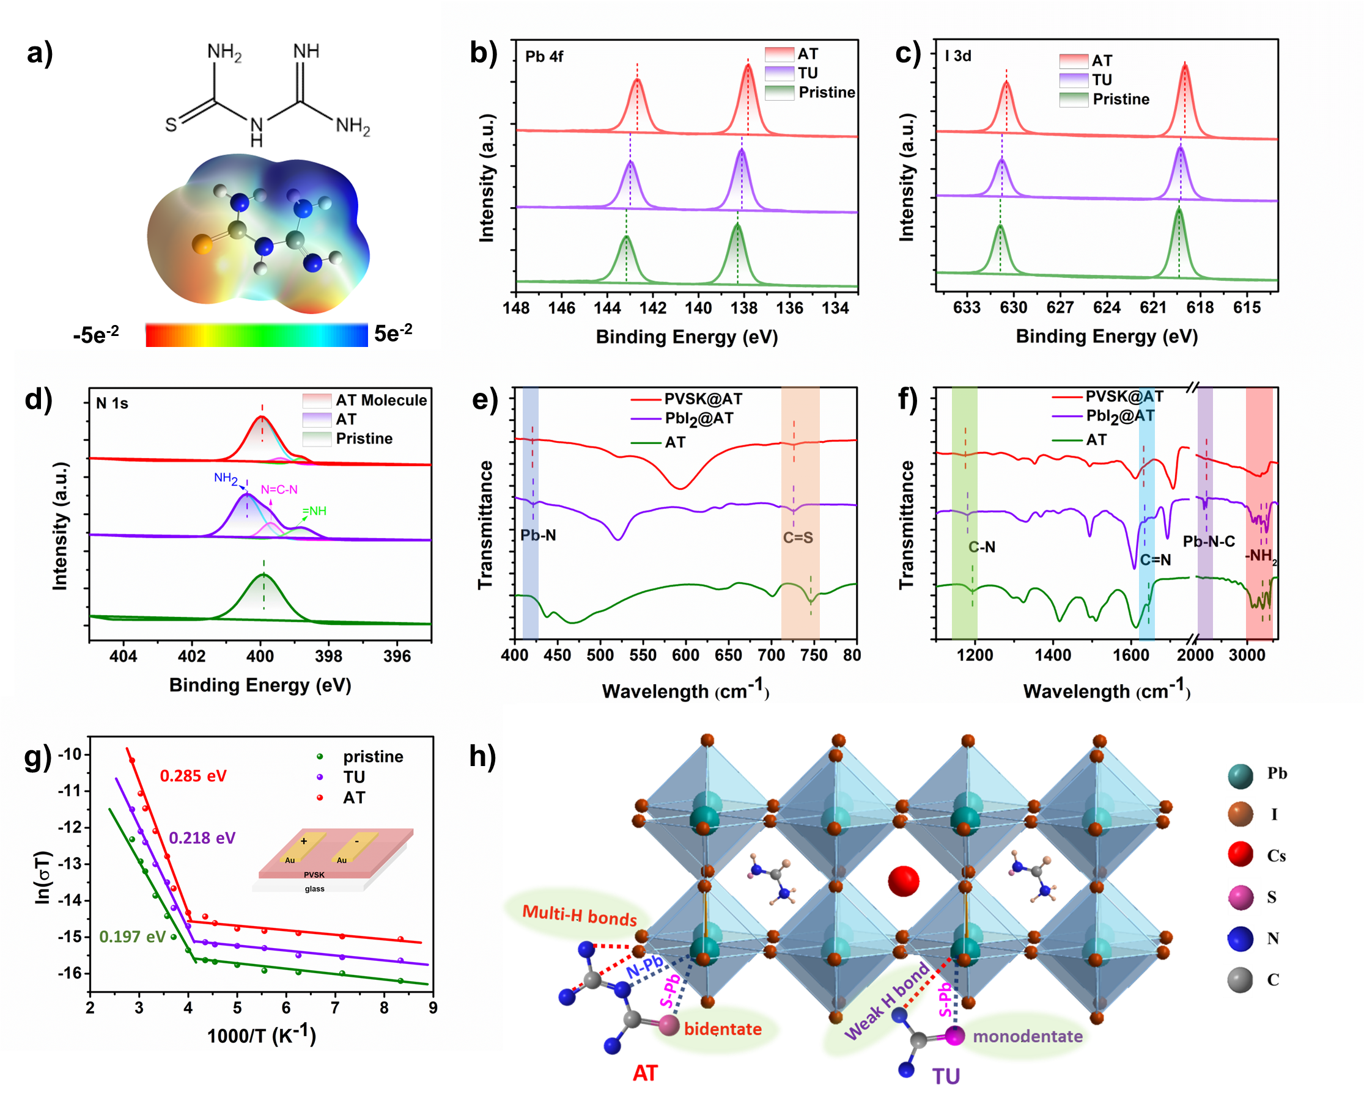
Figure 1. a) The molecular structure and electrostatic potential (ESP) profile of AT. The XPS spectra for b) Pb 4f; c) N 1s; and d) I 3d peaks of the pristine perovskite and AT-doped perovskite films. e) and f) The FTIR spectra of the AT, PbI₂@AT and PVSK@AT films. g) Temperature-dependent conductivity of perovskite films under illumination with a light intensity of 0.3 mW/cm². h) Schematic of the proposed bonding mechanism of perovskite with TU or AT.

2.2 Crystallization kinetics of perovskite films
We incorporated AT into the FA_{0.92}Cs_{0.08}PbI₃ film through a one-step deposition process. Scanning electron microscopy (SEM) was utilized to examine the morphology and grain size of the resulting perovskite films, as shown in Figure 2a, b, and the corresponding grain size distributions are presented in Figure 2c, d. The SEM analysis revealed that the incorporation of AT yielded films with more uniform and significantly larger grain sizes. This enlargement in grain size is predominantly attributed to the Ostwald ripening effect. The presence of AT introduces chemical heterogeneity, elevating the Gibbs energy barrier and slowing the nucleation rate, which favors the growth of larger grains^{[36, 44]}. The surface characteristics were further probed using atomic force microscopy (AFM), with Figure S5 showcasing the improved surface smoothness in the AT-doped film, reflected in the reduced root mean square (RMS) roughness from 18.4 nm in the pristine film to 14.5 nm in the AT-doped film. Moreover, Raman mapping, displayed in Figure S6a, b, was employed to assess the uniformity of the perovskite film over a 20×20 mm² area. The AT-doped film demonstrated superior uniformity and higher laser-induced emission intensity, indicating a reduced non-radiative defect density. The Raman full-width-at-half-maximum (FWHM) mappings in Figure S6c, d, along with their corresponding line profiles, indicated a slightly narrower FWHM for the AT-doped film, suggesting a lower structural defect density compared to the pristine film.
To gain a comprehensive understanding of the enhanced perovskite crystallization kinetics, we conducted in-situ GIWAXS measurements to monitor the entire film formation process. As shown in Figure 2e, f, the GIWAXS patterns obtained during the experiment revealed distinct stages. During the initial stage (t1, first 18 s), there was no significant scattering halo observed in the GIWAXS patterns. This lack of halo is attributed to the low diffraction intensity of the solvated colloidal sol precursor. At the t3 stage (78 s), the introduction of the antisolvent initiated the formation of a supersaturated solvate intermediate, marked by scattering features between q values of 7.5 to 8 nm⁻¹. Subsequently, after 15 s at the end of the antisolvent dripping, the annealing stage began. The stages t5 to t7 represented the perovskite evolution process, with t7 indicating the end of crystal growth. Comparing the GIWAXS patterns in Figure 2e and 2f,
a scattering signature centered at q ≈ 9.2 nm⁻¹ along the (001) crystallographic plane in the as-cast film indicated the transformation of the colloidal solution into the black perovskite phase. This phase emerged earlier in the AT-doped film than in the control film (t5 - t3 > t6 - t4), suggesting AT promotes phase conversion from the intermediate phase to the perovskite black phase. This acceleration of phase transitions is likely due to AT lowering the formation energy, enabling rapid aggregation of PbI₂ and organic salts during the evaporation of solvent.^{[45-47]} Furthermore, the AT-doped perovskite film ceased crystal growth earlier at 237 s, while the control continued until 288 s. Upon completion of crystallization (stage t7&t8), the AT-doped film showed a more intense signal than pristine one (Figure 2g), consistent with the XRD results. AT is found to modulate the kinetics of perovskite crystallization by reducing the energy required for formation, facilitating phase transition, and resulting in a more organized crystal lattice structure.
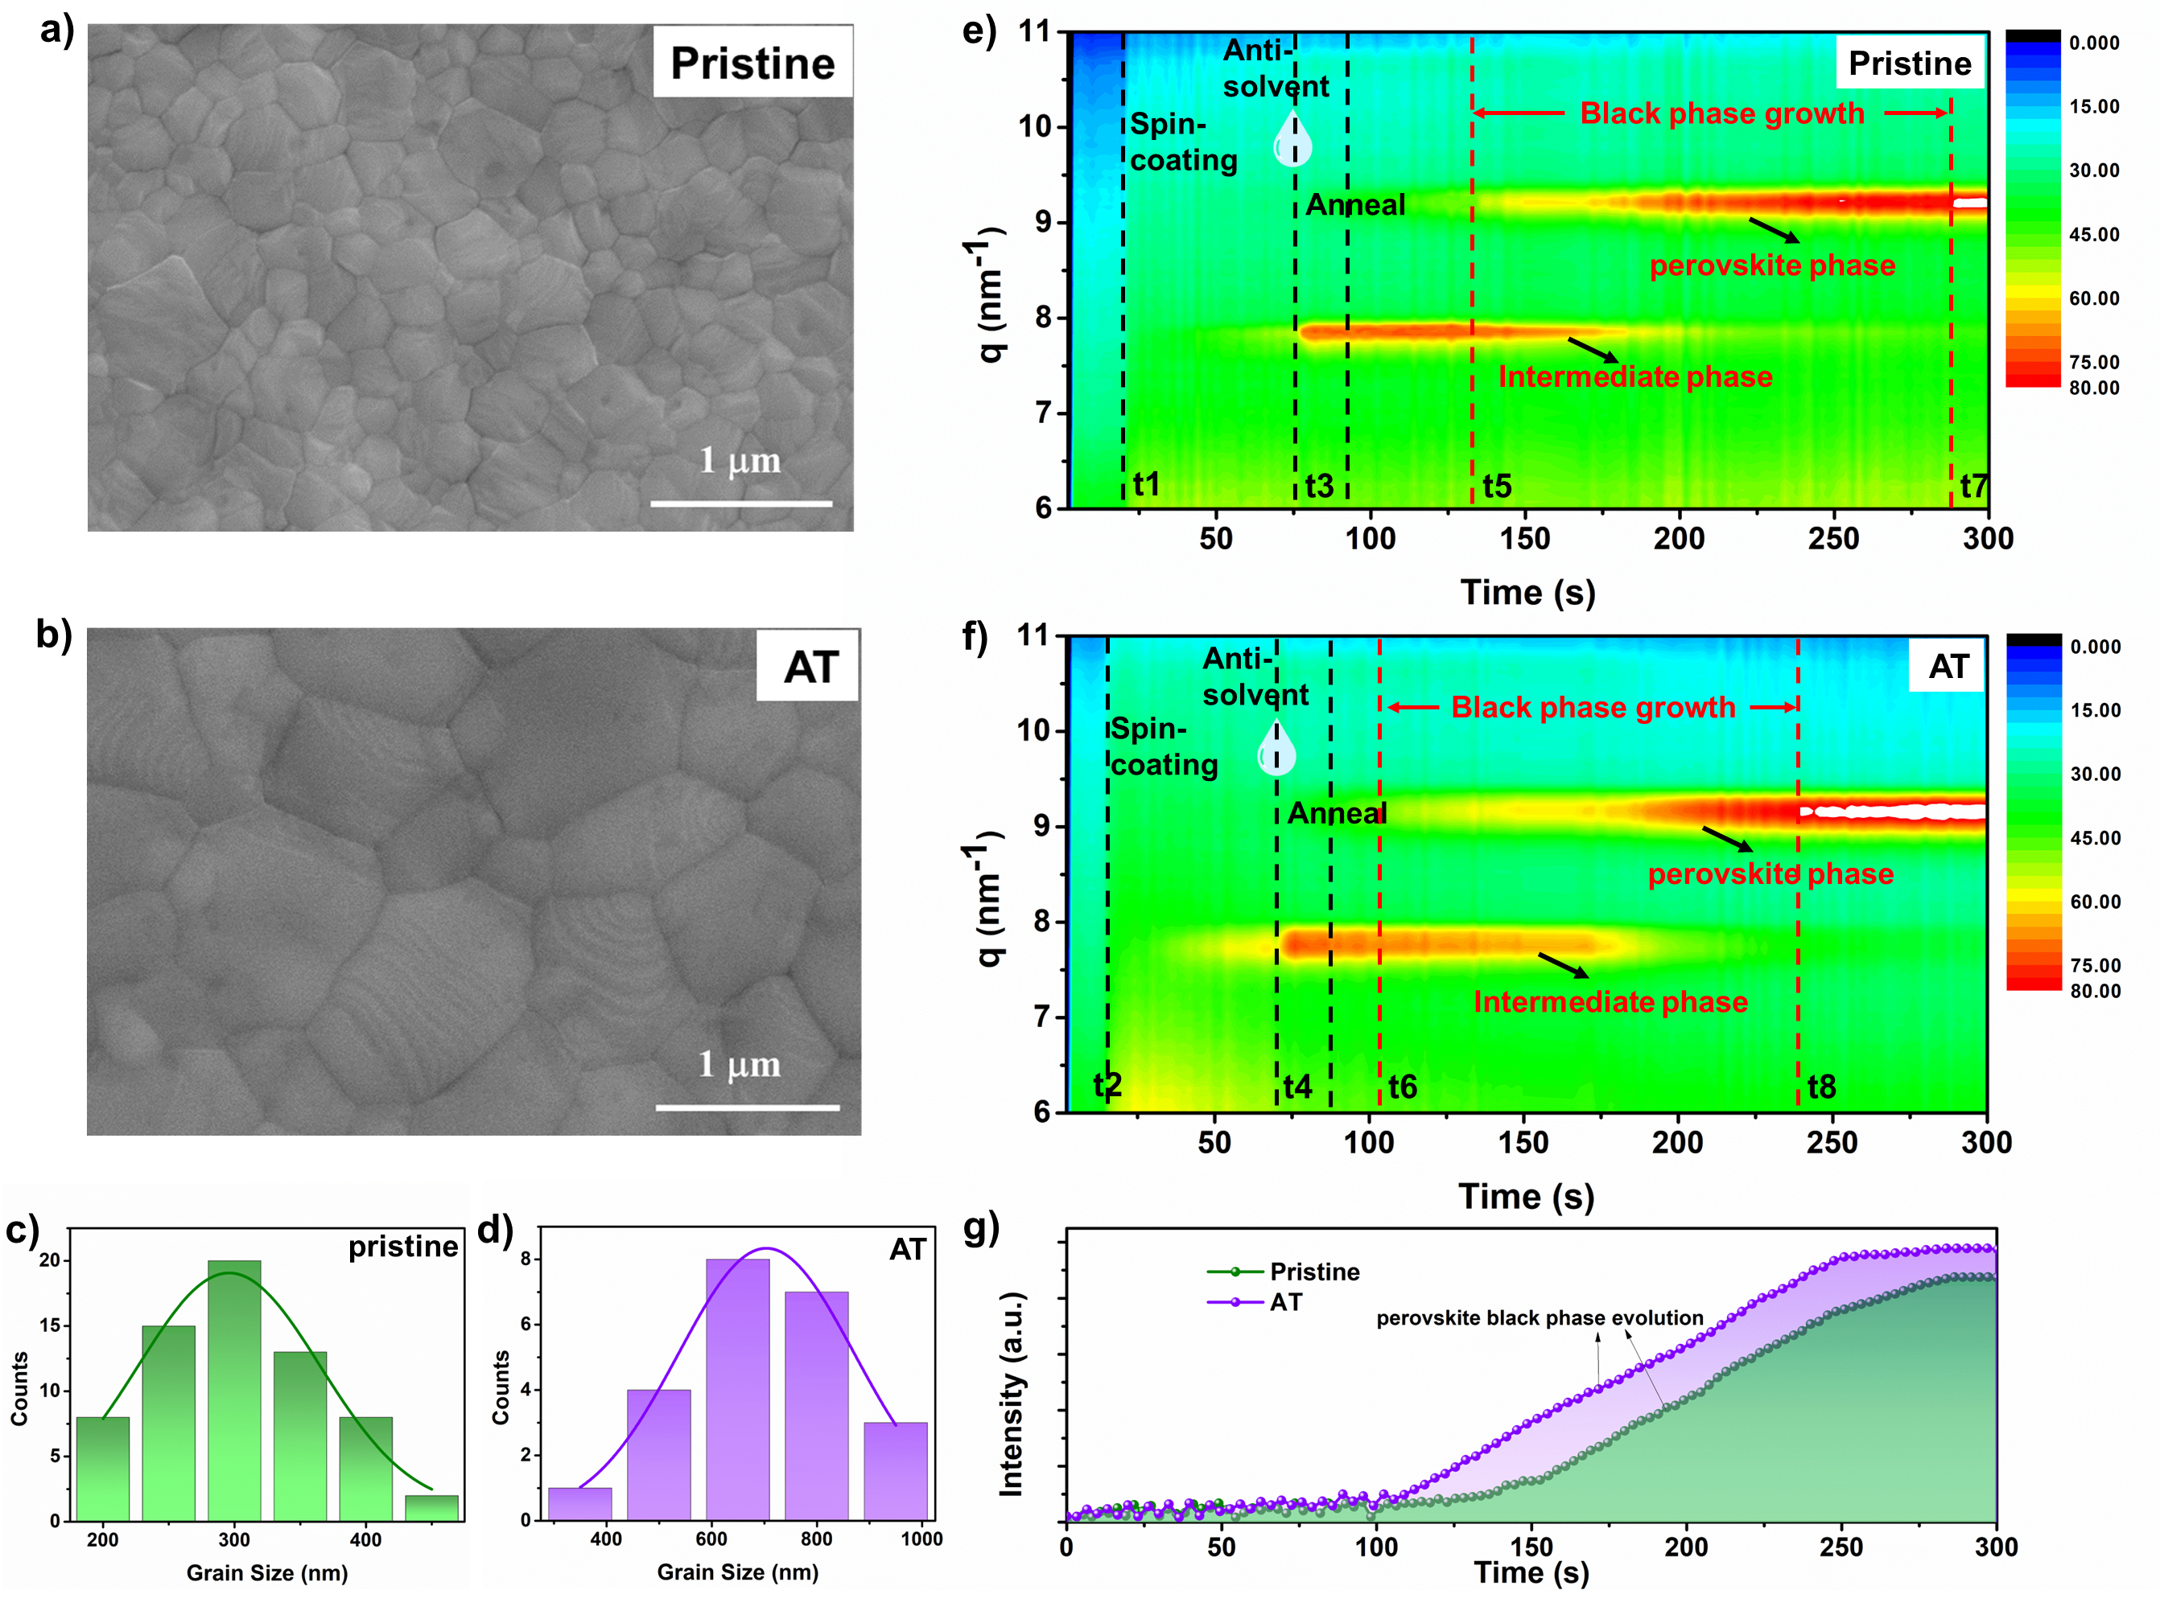
Figure 2. a) and b) The SEM top-view images for the pristine film and film with AT. c) and d) The grain distribution for the pristine film and film with AT. c) and d) In-situ GIWAXS spectra during the formation of pristine film and films with AT. e) Time-resolved integrated peak area intensity for black perovskite phases evolution of pristine film and film with AT.

Understanding the nucleation and crystal growth process of perovskite films with and without AT is crucial for elucidating the film growth mechanism and its effects on the final morphology. To explore this process, we conducted in-situ PL measurements during both the spin-coating process with anti-solvent and the subsequent annealing process.^{[45]} Figure 3a and Figure 3b illustrate the PL intensity changes of the perovskite films throughout the spin-coating process. The addition of the anti-solvent triggers an increase in PL intensity, suggesting it accelerates the extraction of solvents. This rapid extraction leads to fast supersaturation of the perovskite precursor, which in turn prompts rapid nucleation and crystal growth. For the precursor without AT, the PL intensity reaches the orange color range at 14.3 s, suggesting a substantial number of crystal nuclei have formed. In contrast, for the precursor with AT, this occurs at 16.6 s, indicating slower nucleation due to the presence of a stable FAI·PbI₂·AT·DMSO adduct phase that delays the perovskite phase transformation. The effective modulation of the nucleation stage, dominated by intermediate phases, has been demonstrated to be responsible for the suppressed nucleation kinetics.^{[37]} Lewis base groups such as −C=S, −C=N, and −NH₂ are known to reduce the nucleation rate, aiding in controlling crystal size and improving perovskite film uniformity and compactness.^{[37, 48]} Following deposition, the films were subjected to a rapid crystal growth process on a hotplate, monitored using in-situ PL (Figure 3c and Figure 3d). During annealing, the formation of a solid perovskite film involves transitioning from a solution state to a solid state through solvent evaporation. This process highlights the importance of drying kinetics and the rate of solvent removal. Notably, the film with AT exhibited faster crystallization than the control film during the early annealing stage, indicating an expedited solution-to-solid phase transition that influences perovskite crystal growth. In accordance with the von Weimarn rules^{[45, 49]}, the interplay between nucleation and crystal growth is pivotal in determining the size of crystalline grains within a material. Crystal size is influenced by the nucleation rate (N) and the growth rate (G), which can be articulated by the following relationship:
Z_{S}=1.1(N/G) ^{1/2},
where Z_{S} represents the quantity of grains per unit area, while N and G represent the nucleation and growth rates, respectively.^{[50-51]} The interplay between a diminished nucleation rate and an accelerated crystallization rate during annealing in the presence of AT facilitates the development of a perovskite film with larger grain sizes compared to the control film.

Enlarged grain size in perovskite films is beneficial in reducing film defects. The influence of grain size on defect trapping in the perovskite film with AT is confirmed through ultrafast transient absorption (TA) measurements. Figures 3e-f display the TA spectra in pseudo-colour, while Figure S7 presents the TA spectra as a function of probe wavelength and pump-probe delay time for both pristine and AT-modified films. Several features are observed when analysing the TA spectra across wavelengths. At shorter wavelengths (680-730 nm), a long-lived photo-induced absorption (PA1) appears, resulting from excited state absorption. A pronounced ground-state bleaching (GB) phenomenon, with peaks centered at 760-790 nm, is observed. This is attributed to the depletion of the valence band and the concurrent occupation of conduction band-edge states by photoexcited carriers. Notably, the significant redshift observed in the GB peak position is due to the competition between the redshift effect from band-gap renormalization and the blueshift effect from the Burstein-Moss effect^{[52]}. At longer wavelengths (810-840 nm), a broad but weaker photo-induced absorption (PA2) bleaching feature is observed, associated with the filling of below-gap trap states.^{[53-55]} The decay profiles measured at 810 nm reflect the lifetime of carriers trapped in sub-bandgap defect states, as depicted in Figure S8. These decay profiles can be well-fitted by a bi-exponential decay function:
I(t) = A₁exp(−t/τ₁) + A₂exp(−t/τ₂),
where τ1 and τ2 are short and long decay time constants, respectively. The longer decay time constant observed in the AT-modified film indicates a lower density of defect states compared to the pristine film. In summary, adding AT to the perovskite film improves morphology, increases grain size, improves surface smoothness, and reduces structural defects, thereby improving overall film quality and performance.
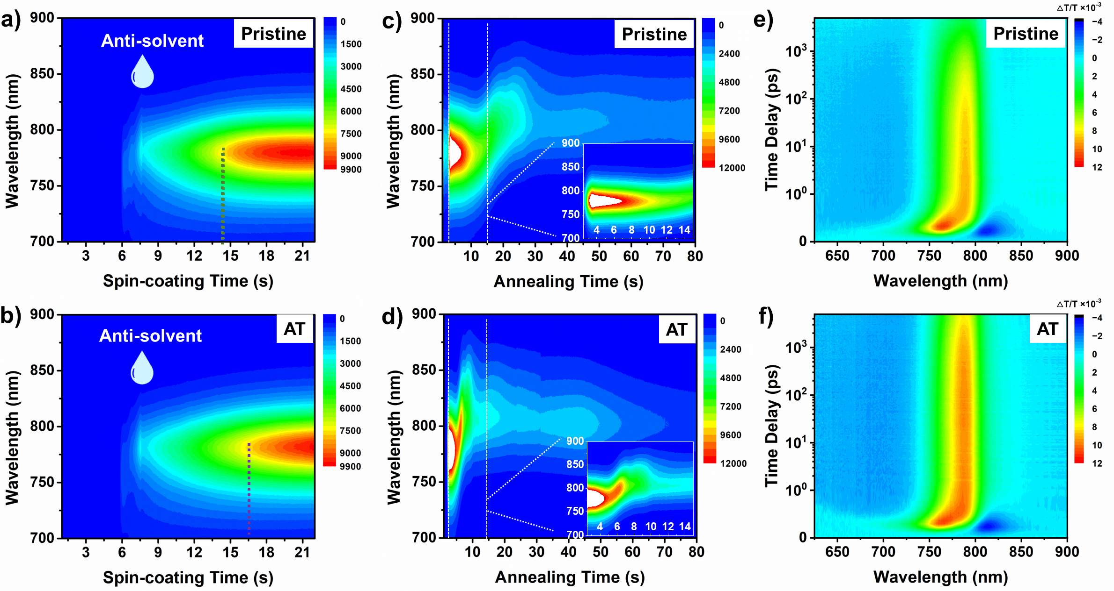
Figure 3. a) and b) The in-situ PL during spinning-coating process for the pristine perovskite film and perovskite with AT film. c) and d) The in-situ PL during early annealing process for the pristine perovskite film and perovskite with AT film. e) and f) 2D pseudo-colour TA spectra as a function of probe wavelength and pump-probe delay time for pristine perovskite and perovskite with AT.

2.3 Surface treatment of the perovskite and perovskite/C₆₀ interfacial recombination
In p-i-n type solar cells, one of the key factors influencing the voltage loss is the top ETL, such as C₆₀ or PCBM. Non-radiative recombination at the perovskite-ETL interface and the related defect states can significantly reduce device efficiency.^{[26]} To suppress interface non-radiative recombination and reduce the further surface trap density, the homologous molecule, named PGT (Figure 4a), is utilized to modify the perovskite surface and enhance interface electron extraction. The introduction of a benzene ring can tune the electronic properties of AT. The SEM image of the perovskite film treated with PGT (Figure S9) reveals no significant change in grain size. XRD analysis indicates no significant difference in crystallinity between the PGT-treated and AT additive-treated films. (Figure S10). Additionally, the PL emission properties of the corresponding perovskite films were examined. Figure 4b shows the steady-state PL spectra, revealing that AT enhances PL emission over the untreated film, and PGT further amplifies this effect. To further investigate the presence of surface traps, time-resolved PL (TRPL) decay kinetics are analysed. The TRPL decay kinetics, depicted in Figure 4c, exhibits a bi-exponential decay process with a fast decay (τ1) and a slow decay (τ2), the latter typically indicative of bulk perovskite radiative recombination. As summarized in Table S2, the AT-treated film and the AT & PGT-treated film exhibit longer charge carrier lifetimes, with values of 657.8 ns and 1031.3 ns, respectively, compared to the pristine film (411.6 ns). This demonstrates a decrease in film defect density due to improved film quality and surface trap passivation after the AT and PGT synergistic treatments in the treated films. The suppression of defects in both the bulk and surface regions of the perovskite helps mitigate carrier losses, potentially enhancing short-circuit current (J_{SC}), open-circuit voltage (V_{OC}), and solar cell performance.

PLQY characterization allows for the analysis of non-radiative recombination loss behaviour in each layer and interface.^{[26]} To understand the improvement in non-radiative recombination loss with AT and PGT treatment, PLQY measurements were conducted to analyse the non-radiative recombination in perovskite films, perovskite/C₆₀ films, and the corresponding solar cells (Figure 4d). The PLQY of the bare perovskite film on glass improved from 1.8% to 2.6% and further to 3.8% after treatment with AT and AT & PGT, respectively, suggesting effective trap passivation. However, when the perovskite film was combined with C₆₀, the PLQY decreased to 0.97% for the pristine film, 1.6% for the AT-treated film, and 2.2% for the AT & PGT-treated film, likely due to the effective charge transfer from the perovskite to the C₆₀ layer. Nevertheless, the film treated with AT & PGT still show a much-improved PLQY, showing the synergistic effect of AT & PGT.

Further analysis using UV-vis absorption and UV photoelectron spectroscopy (UPS) determined the energy levels of the films (Figure 4e, f). The UPS spectra provided information about the photoemission parameters, which are listed in Table S3. The valence band maximum (VBM) values were consistent across the pristine and AT-treated films of -5.58 eV, but shifted significantly with PGT treatment of -6.74 eV. We then confirmed the work function results through kelvin probe force microscopy (KPFM), as depicted in Figure S11. The surface potential difference between pristine film and AT & PGT treated film is measured to be 0.8 eV, which is consistent with the UPS results. (Figure 4g) UV-vis absorption spectroscopy (Figure S12) indicated similar band gaps of approximately 1.54 eV for all the films (pristine, perovskite with AT, perovskite treated by both AT & PGT) (Figure S13), suggesting similar energy levels for those films. The reflection electron energy loss spectroscopy (REELS) spectrum reveals that the surface bandgap of the PGT is 2.7 eV (Figure 4h). Surprisingly, based on the data, we can determine the surface LUMO of the PGT layer to be -4.04 eV, which is nearly the same as the perovskite CBM. The energy levels of the perovskite and the electron and hole transport materials were characterized using UPS data, complemented by references from pertinent literature. An energy level diagram for the perovskite/PGT/C₆₀ system was constructed (Figure 4i).^{[56-57]} It can be inferred that PGT may enhance its hole-blocking capability within the system, potentially benefitting solar cell performance. At the same time, the suitable LUMO does not hinder electron transfer, which behaves as a wonder hole-blocking layer for the perovskite/C₆₀ interface. The unique energy band alignment, coupled with the coordination chemistry that PGT exhibits with perovskite, positions PGT as a promising candidate for perovskite performance enhancement. Integrating a benzene ring into a π-conjugated system significantly amplifies the availability of π electrons, thereby facilitating ultrafast charge separation. Concurrently, the additional benzene ring can modulate the molecular band structure to align optimally with the perovskite interface. The properties that enhance charge transport efficiency and passivate surface defects are pivotal for boosting the efficiency and stability of perovskite-based solar cells.
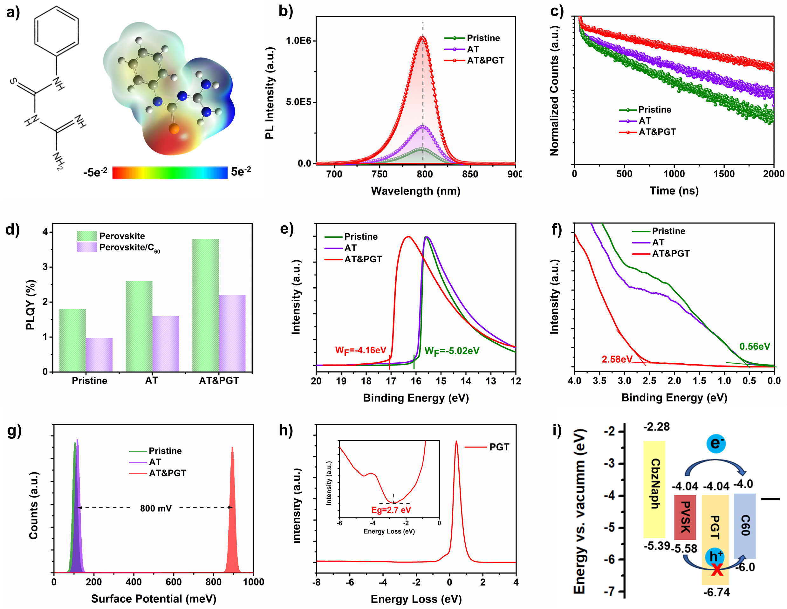
Figure 4. a) The molecule structure and ESP profile of PGT. b) The PL emission spectra for pristine film, film with AT additive, and film with AT & PGT co-treatment, respectively. c) The TRPL decay for pristine film, film with AT additive, and film with AT & PGT co-treatment, respectively. d) The perovskite film, perovskite/C₆₀ half stack PLQY diagram for pristine film, film with AT additive, and film with AT & PGT co-treatment, respectively. e) UPS spectra close to the onset region for pristine film, film with AT additive, and film with AT & PGT co-treatment. f) Valence band spectra of pristine film, film with AT additive, and film with AT & PGT co-treatment. g) The CPD of KPFM results. h) REELS spectrum of PGT. The inset illustrates the method for determining the band gap. i) The energy-level alignment diagram of the device component of the device.

Moreover, XPS analysis revealed the presence of sulfur (S) on both the upper surface of the AT-doped and AT & PGT-treated perovskite films (Figure S14). Despite this, PGT remains essential for enhancing the device performance. To understand the interactions between perovskite with AT and PGT, static density functional theory (DFT) calculations were performed based on the FA_{7/8}Cs_{1/8}PbI₃ system. The main objective of these calculations was to understand their passivation mechanism on the perovskite surfaces. The AT and PGT molecules were introduced onto the perovskite surface. The optimized adsorption models for AT and PGT on the perovskite surface are illustrated in Figure S15, with key bond lengths and interatomic distances detailed in Table S4. These data confirm the establishment of Pb−S and Pb−N coordination bonds, as well as N−H┉I hydrogen bonds. The adsorption energy of all molecules on the perovskite surface was calculated using the formula:
E_{ads} = E(perovskite@m) − E(perovskite) – E(m) + E(I),
where E(perovskite@m), E(perovskite), E(m), and E(I) represent the energy of the perovskite with the absorbed molecule, the pristine perovskite, the isolated adsorbent molecule in its ground state configuration, and the crystalline iodine, respectively. As presented in Figure 5d, both AT and PGT exhibited strong adsorption on the perovskite surface, with E_{ads} values lower than -1 eV, indicating a strong passivation effect. However, PGT exhibited stronger adsorption than AT, suggesting a more robust passivation effect because of the introduction of benzene ring. Further charge density difference calculation, depicted in Figure 5a-c, support these findings. They reveal charge depletion around the carbon atom and accumulation on the S-side of the Pb−S bond in the S-site adsorption configurations, indicative of typical coordination bonds. The N-site adsorption configurations exhibit more pronounced and complex charge transfer due to the large electronegativity difference between N and Pb, consistent with their stronger adsorption.

Quantitative analysis of the most stable adsorption processes was conducted by calculating integrated charge density difference values on planes parallel to the surface (Figure 5e). It was found that more electrons were transferred from PGT to the perovskite, partly due to the additional electron depletion from the benzene ring in PGT (31.62 Å ≤ z ≤ 34.92 Å), leading to stronger electron redistribution on the perovskite surface. Additionally, the charge density around iodine atoms was observed to shift towards hydrogen atoms in the −NH₂ and −NH− groups, consistent with the presence of N−H┉I hydrogen bonds observed in the system. The electronic density of states (DOS) for perovskite@AT and perovskite@PGT systems, calculated at the Perdew-Burke-Ernzerhof (PBE) level, is shown in Figure 5f. The adsorption of AT and PGT increased the electronic band gap of the perovskite, especially for the perovskite@PGT system, which is consistent with the observed increase in V_{OC} in the PGT-modified devices. It is important to note that although the PBE level typically underestimates band gap values, the difference in calculated band gaps among similar systems remains valid.

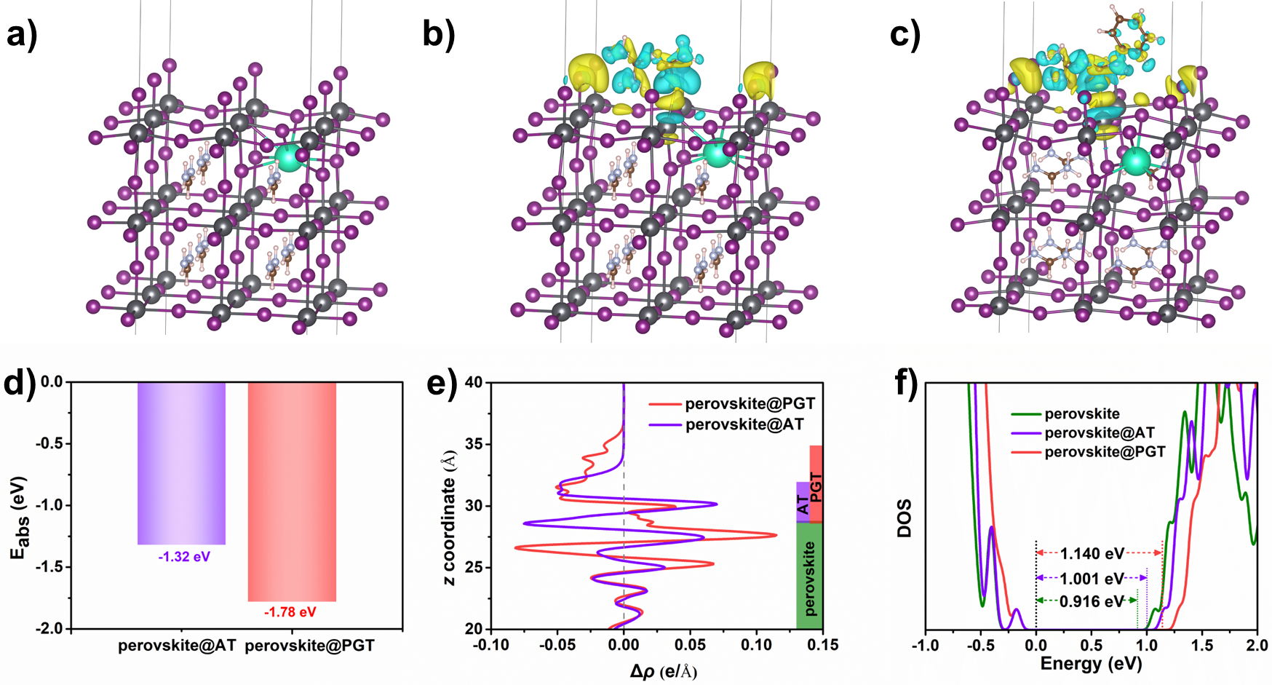
Figure 5. Spatial distribution of charge density difference in the a) perovskite; b) perovskite@AT and c) perovskite@PGT models. d) The absorption energy E_{ads} for perovskite@AT and perovskite@PGT. e) Charge density differences integrated in planes parallel to the surface (Δρ) as a function of height (z). f) DOS of the pristine and adsorption models.

2.4 The performance and operational stabilities of PSCs
Figure 6a outlines a standard p-i-n planar architecture of the PSCs. Figure 6b displays the current-voltage (J-V) curves of the PSCs. The performance of the devices with varying amounts of AT and PGT is illustrated in Figure S16. Table 1 summarizes the best photovoltaic performance parameters, while Table S5 and Table S6 detail the typical performance of devices with different amounts of AT and PGT added. Optimizing AT concentration is key to device performance, as it affects passivation efficiency and film formation. Too little AT may fail to adequately passivate perovskite defects, increasing recombination and reducing efficiency. Conversely, excess AT could cause side reactions or disrupt crystal growth, harming perovskite structure and efficiency. The control device exhibits a PCE of 22.18%. It achieves a V_{OC} of 1.109 V, a J_{SC} of 24.39 mA/cm^{2,} and a FF of 82.0%. Upon the incorporation of 1%mmol of thiourea, which acts as a reference additive, into the perovskite, the device exhibits comparable performance to the pristine film-based device, with a PCE of 22.34%, V_{OC} of 1.116 V, J_{SC} of 24.87 mA/cm², and FF of 80.5%. However, when 1%mmol AT is introduced into the perovskite, there is a marked improvement in PCE to 23.78%, with V_{OC} = 1.126 V, J_{SC} = 25.41 mA/cm², and FF = 83.1%. The highest PCE of 26.06% is obtained when the perovskite is treated with 1%mmol AT and 1%mmol PGT with little hysteresis (Figure S17) (V_{OC} = 1.194 V, J_{SC} = 25.77 mA/cm², FF = 84.7%). This efficiency is among the highest reported for PSCs based on FA_{0.92}Cs_{0.08}PbI₃. Figure S18 summarizes the V_{OC}, J_{SC}, FF, and PCE for all the three types of devices. It is worth noting that the presence of the AT molecule enhances the J_{SC} by improving film quality and reducing bulk defects. PGT notably increases V_{OC} by suppressing surface recombination and serving as a hole-blocking layer due to its suitable HOMO/LUMO levels (Figure 3g). However, when the thickness of PGT becomes too large, the J_{SC} decreases substantially due to the insulation effect of PGT (Figure S16b). The EQE spectra in Figure 6c confirm that AT and AT & PGT treatments lead to increased current density compared to pristine cells.

To determine the trap density within the perovskite film, we performed space charge limited current (SCLC) measurements using the structure ITO/SAM/perovskite/MoO₃/Ag, as depicted in Figure 6d. The trap density, denoted as $n_{t}$​, was derived from the following formula:
$n_{t}=\frac{2V_{TFL}εε_{0}}{eL^{2}}$ ^{[58]},
where V_{TFL} is the trap-filled limit voltage, L is the film thickness (measured from Figure S19, indicating a perovskite film thickness of approximately 800 nm), ε₀ is the vacuum permittivity (ε₀ = 8.8 × 10⁻¹² F/m), and e is the elementary charge. With ε value of 46.9^{[51]}, the calculated trap densities for the pristine, AT treated, and AT & PGT-treated films were 2.10 × 10¹⁵ cm⁻³, 1.69 × 10¹⁵ cm⁻³, and 1.45 × 10¹⁵ cm⁻³, respectively, showing a decrease with different treatment, indicative of fewer defect states. The recombination losses in the devices were evaluated by measuring J-V characteristics under varying light intensities from 20 to 100 mW/cm². In addition, we investigated the carrier recombination mechanisms by examining the ideality factors derived from the intensity-dependent V_{OC}, as depicted in the equation:
$Voc=\frac{E_{g}}{q}-\frac{Ak_{B}T}{q}\ln{\frac{J_{0}}{J_{L}}}$,
In Figure 6e, it is evident that V_{OC} exhibits a monotonic increase with the intensity of light, and the ideality factor exceeds 1. This indicates that recombination is not solely governed by the concentration of minority carriers but is also influenced by trap-assisted SRH recombination mechanisms. Moreover, the ideality factor decreases from 1.27 to 1.15 and further from 1.15 to 1.08 with the AT and AT & PGT treatments, respectively. This indicates that trap-assisted SRH recombination is suppressed in the treated devices. Figure 6f presents the relationship between J_{SC} and light intensity, showing slopes of 0.962, 0.987, and 0.992 for the pristine, AT-treated, and AT & PGT-treated devices, respectively. This suggests that monomolecular recombination is predominant in the optimized devices, and the treated devices exhibit an ideal relationship between J_{SC} and illumination intensity, indicating a reduced trap density compared to the pristine cell.

To access device stability, maximum power point (MPP) tracking was conducted under white LED illumination without UV in a glovebox at 35°C, and the AT & PGT-treated devices showed superior performance, retaining over 90% of their initial PCE for 1400 hours of continuous illumination, which is much better than the pristine cell retained only 82% (Figure 6g). The improved operational stability is likely due to effective passivation that diminishes surface reactivity and decelerates the rate of degradation. We also evaluated the thermal stability by storing the devices on an 85°C hot plate inside the glovebox. As shown in Figure 6h, the treated devices exhibited improved thermal stability compared to the pristine device, indicating the AT & PGT treatment helps devices better tolerate high temperatures. Regarding humidity stability, we conducted XRD analysis on two types of films stored in an atmosphere with a relative humidity close to 80 % (Figure S20). The AT & PGT-treated films showed better resistance to degradation compared to the pristine film, which exhibited PbI₂ and δ-phase formation within days. The treated film also showed increased hydrophobicity, indicated by a larger contact angle, offering enhanced resistance to moisture, as shown in Figures S20c-e. Overall, the AT & PGT treatment not only enhances the operational stability of the devices under MPP conditions and 1-sun illumination but also improves their thermal and humidity stability.
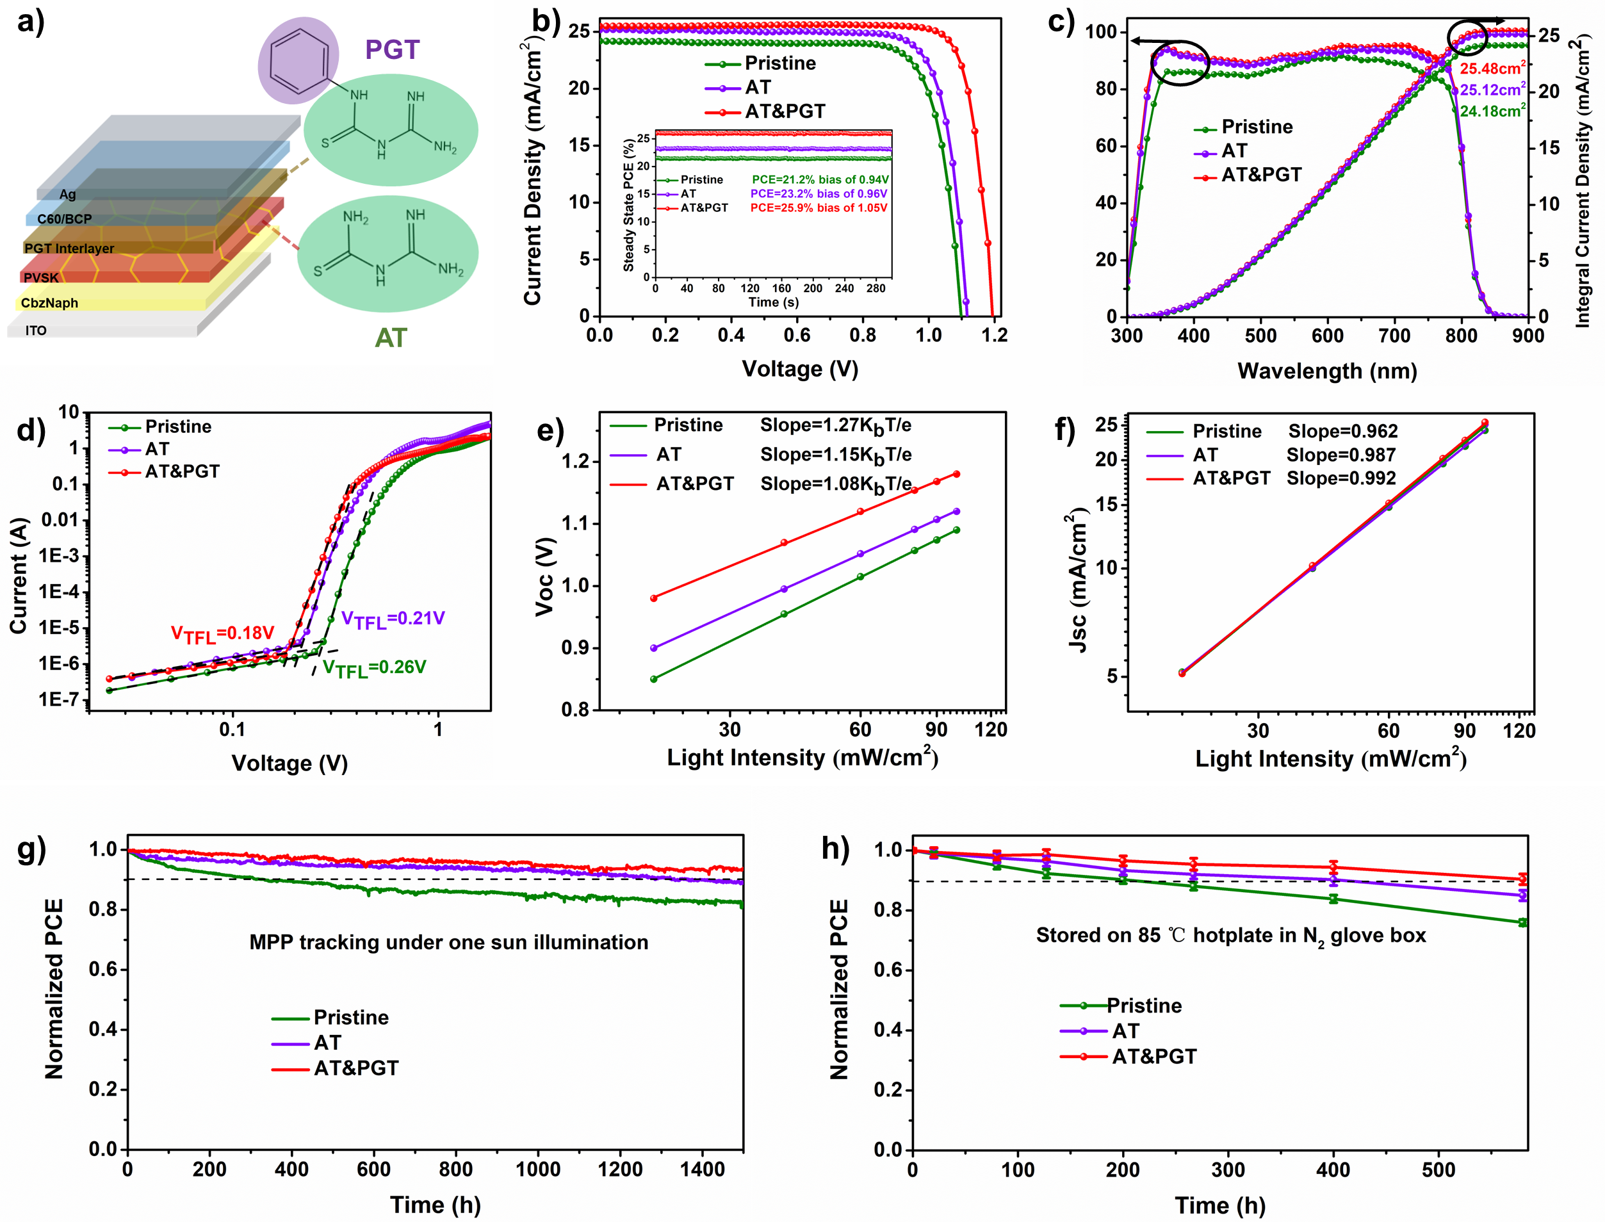
Figure 6. a) Schematic architecture of planar p-i-n type PSCs. b) The J-V curve for the best-performing perovskite solar cell of the corresponding perovskite film. c) EQE spectra of pristine, AT and AT & PGT treatment-based perovskite solar cell. d) Dark current-voltage measurements of the hole-only devices for pristine, AT and AT & PGT treatment-based perovskite solar cell. Light intensity dependence of pristine, AT and AT & PGT treatment-based perovskite solar cell e) J_{SC} versus light intensity and f) V_{OC} versus light intensity. g) MPP tracking for pristine, AT and AT & PGT treatment-based perovskite solar cell. h) Stability of pristine, AT and AT & PGT treatment-based perovskite solar cell stored on 85℃ hotplates in glove box.

Table 1. Device parameters (V_{OC}, J_{SC}, FF, and PCE) of pristine film, with AT, and film with AT & PGT co-treatment.
Device | V_{OC} (V) | J_{SC} (mA/cm2) | FF (%) | PCE (%)
Pristine | 1.109 | 24.39 | 82.0 | 22.18
Pristine | 1.103±0.06 | 24.18±0.21 | 81.5±0.5 | 21.73±0.45
AT | 1.126 | 25.41 | 83.1 | 23.78
AT | 1.122±0.04 | 25.17±0.24 | 82.8±0.3 | 23.38±0.40
AT & PGT | 1.194 | 25.77 | 84.7 | 26.06
AT & PGT | 1.190±0.04 | 25.52±0.25 | 84.4±0.3 | 25.63±0.43

- Conclusion
In summary, our study focused on the chemical interactions between AT and perovskite, highlighting its dual ability to simultaneously passivate both negatively and positively charged defects. Using in-situ GIWAXS and PL monitoring, we demonstrated control over perovskite crystallization kinetics, where AT induced larger grain sizes by accelerating the transformation from intermediates to crystalline perovskite. This resulted in a highly crystalline film with reduced trap states and enhanced carrier dynamics. Furthermore, we integrated PGT, a homologous molecule of AT, to address surface defects and mitigate interface non-radiative recombination by blocking the hole transfer. This strategic application of PGT leverages its structural similarities to AT while introducing variations that are beneficial for reducing surface and interface energy loss, thereby enhancing the overall performance of the perovskite solar cells. The hydrophobic nature of the PGT molecule improved the water resistance of the film. The synergistic effect of crystallization modulation by AT and the interface charge transfer enhancement by PGT has culminated in achieving a PCE of 26.06%. The devices also showed excellent operational stability, maintaining over 90% of their initial efficiency after continuous one-sun illumination for over 1000 hours. Our work provides significant insights into molecule-designing strategies for modulating overall defect passivation and constructing charge transfer channels through homologous series molecules.

- Experimental Section
Materials
All the materials used were utilized without further purification, including N,N-Dimethylformamide (DMF, 99.99%, J&K), dimethyl sulfoxide (DMSO, 99.70%, J&K), isopropanol (IPA, 99.50%, J&K), and chlorobenzene (CB, 99.5%, J&K). Cesium iodide (CsI), Formamidinium iodide (FAI), MACl, bathocuproine (BCP, 99.9%), and C₆₀ were purchased from Xi’an Polymer Light Technology. PbI₂ (99.99%) was purchased from TCI. Thiourea (TU), amidine thiourea (AT), and 1-Phenyl-3-guanylthiourea (PGT) were purchased from Aladdin.
Device fabrication
The cleaned ITO substrates were treated with ultraviolet-ozone for 30 minutes before being transferred to a glovebox filled with nitrogen for film deposition. A solution of CbzNaph at a concentration of 0.5 mg/mL in IPA was spin-coated onto the ITO at a speed of 5,000 rpm for 30 seconds, followed by annealing at 100°C for 15 minutes. The perovskite precursor solution, with a molarity of 1.7 M, was prepared by mixing FAI, CsI, and PbI₂ in a mixed solvent of DMF and DMSO (in a volume ratio of 4:1), resulting in the chemical composition FA_{0.92}Cs_{0.08}PbI₃. To this solution, an excess of 5% PbI₂ and 10 mol% MACl were added. An appropriate amount of AT molecule was incorporated into the precursor solution to achieve the desired perovskite. The prepared precursor solution, 50 μL, was spin-coated onto the CbzNaph-coated ITO substrate at 1,000 rpm for 10 seconds and 5,000 rpm for 40 seconds; 180 μL of CB, serving as an antisolvent, was added to the film 10 seconds before the completion of the final spin-coating step, followed by annealing at 110°C for 20 minutes. Once the perovskite active layer was deposited, a solution of PGT molecules (1 mmol/mL in IPA), 50 μL, was spin-coated onto the film at 5,000 rpm for 30 seconds and then annealed at 100°C for 5 minutes. The films were allowed to cool to room temperature before proceeding to thermal evaporation. Finally, 25 nm of C₆₀, 8 nm of BCP, and 100 nm of Ag electrodes were sequentially evaporated under high vacuum conditions (less than 4 × 10⁻⁶ torr).
Characterizations
The surface morphology of the samples was examined using a scanning electron microscopy (SEM) instrument, specifically the Philips XL30 FEG model. For photoluminescence analysis, both steady-state and time-resolved PL spectra were captured with an FLS1000 spectrofluorometer from Edinburgh, utilizing a 450 nm pulsed excitation laser. The XPS and UPS characterizations were performed using a VG ESCALAB 220i XL surface analysis system. XRD measurements were carried out on a D2 Phaser instrument, employing Cu Kα radiation with a wavelength of 1.5418 Å. The in-situ grazing-incidence wide-angle X-ray scattering (GIWAXS) experiments were conducted at the BL14B1 beamline of the Shanghai Synchrotron Radiation Facility (SSRF), with an X-ray beam wavelength of 1.24 Å incident at an angle of 0.3° and an energy of 10 keV. Raman mapping data was gathered with a WITec alpha300 R Raman System. The J–V characteristics were determined using a Keithley 2400 source meter under AM 1.5G (100 mW cm⁻²) illumination with an Enlitech SS-F5 solar simulator. EQE measurements were taken using an Enlitech EQE measurement system. For thermal stability assessment, the devices were aged on a hotplate at 85°C in a nitrogen-filled glovebox, then cooled to room temperature before J–V testing. Maximum power point tracking (MPP) was conducted using the high-throughput solar-cell lifetime test system from CRYSCO, which employed an LED-simulated AM 1.5G spectrum for maximum power point tracking.

Acknowledgements
This research was financially supported by the Research Grants Council (RGC) of Hong Kong (GRF No. 11307323), the Innovation and Technology Fund (No. MRP/040/21X), the Green Technology Fund (No. GTF202020164), and the Seed Collaborative Research Fund (No. SCRF/0069) provided by the State Key Laboratory of Marine Pollution at City University of Hong Kong. The authors express their gratitude to the BL14B1 beamline at the Shanghai Synchrotron Radiation Facility (SSRF) for the facilities used for grazing-incidence wide-angle X-ray scattering (GIWAXS) measurements.

Data availability
All data supporting the findings of this study are available within the main text and the ESI. All relevant data are available from the corresponding authors upon reasonable request.

Conﬂict of Interest
The authors declare no conﬂict of interest.

References
[1] J. Huang, Y. Yuan, Y. Shao, Y. Yan, Nat. Rev. Mater. 2017, 2, 1.
[2] S. Wu, Z. Chen, H.-L. Yip, A. K.-Y. Jen, Matter 2021, 4, 3814.
[3] Q. Chen, N. De Marco, Y. Yang, T.-B. Song, C.-C. Chen, H. Zhao, Z. Hong, H. Zhou, Y. Yang, Nano Today 2015, 10, 355.
[4] Research-Cell Efficiency Chart. National Renewable Energy Laboratory (2024) https://www.nrel.gov/pv/cell-efficiency.html.
[5] Q. Jiang, J. Tong, Y. Xian, R. A. Kerner, S. P. Dunfield, C. Xiao, R. A. Scheidt, D. Kuciauskas, X. Wang, M. P. Hautzinger, Nature 2022, 611, 278.
[6] X. Zheng, Y. Hou, C. Bao, J. Yin, F. Yuan, Z. Huang, K. Song, J. Liu, J. Troughton, N. Gasparini, Nat. Energy 2020, 5, 131.
[7] D. Luo, W. Yang, Z. Wang, A. Sadhanala, Q. Hu, R. Su, R. Shivanna, G. F. Trindade, J. F. Watts, Z. Xu, Science 2018, 360, 1442.
[8] E. M. Tennyson, T. A. Doherty, S. D. Stranks, Nat. Rev. Mater. 2019, 4, 573.
[9] S. Kosar, A. J. Winchester, T. A. Doherty, S. Macpherson, C. E. Petoukhoff, K. Frohna, M. Anaya, N. S. Chan, J. Madéo, M. K. Man, Energy Environ. Sci. 2021, 14, 6320.
[10] L. Zhang, F. Yu, L. Chen, J. Li, Appl. Surf. Sci. 2018, 443, 176.
[11] N. K. Noel, A. Abate, S. D. Stranks, E. S. Parrott, V. M. Burlakov, A. Goriely, H. J. Snaith, ACS Nano 2014, 8, 9815.
[12] W. Cai, Y. Wang, W. Shang, J. Liu, M. Wang, Q. Dong, Y. Han, W. Li, H. Ma, P. Wang, Chem. Eng. J. 2022, 446, 137033.
[13] C. Fei, B. Li, R. Zhang, H. Fu, J. Tian, G. Cao, Adv. Energy Mater. 2017, 7, 1602017.
[14] J.-W. Lee, S.-H. Bae, Y.-T. Hsieh, N. De Marco, M. Wang, P. Sun, Y. Yang, Chem 2017, 3, 290.
[15] S. Wang, A. Wang, X. Deng, L. Xie, A. Xiao, C. Li, Y. Xiang, T. Li, L. Ding, F. Hao, J. Mater. Chem. A 2020, 8, 12201.
[16] Z. Yang, J. Dou, S. Kou, J. Dang, Y. Ji, G. Yang, W. Q. Wu, D. B. Kuang, M. Wang, Adv. Funct. Mater. 2020, 30, 1910710.
[17] J. Luo, J. Xia, H. Yang, H. A. Malik, F. Han, H. Shu, X. Yao, Z. Wan, C. Jia, Nano Energy 2020, 70, 104509.
[18] Y. Hu, Z. He, X. Jia, W. Zhao, S. Zhang, M. Jiao, Q. Xu, D. Wang, C. Yang, G. Yuan, Sol. RRL 2022, 6, 2100942.
[19] A. Abate, M. Saliba, D. J. Hollman, S. D. Stranks, K. Wojciechowski, R. Avolio, G. Grancini, A. Petrozza, H. J. Snaith, Nano Lett. 2014, 14, 3247.
[20] C. Li, A. Wang, L. Xie, X. Deng, K. Liao, J.-a. Yang, T. Li, F. Hao, J. Mater. Chem. A 2019, 7, 24150.
[21] Y. Shao, Z. Xiao, C. Bi, Y. Yuan, J. Huang, Nat. Commun. 2014, 5, 5784.
[22] Y. Wu, X. Yang, W. Chen, Y. Yue, M. Cai, F. Xie, E. Bi, A. Islam, L. Han, Nat. Energy 2016, 1, 1.
[23] Y. Cai, J. Cui, M. Chen, M. Zhang, Y. Han, F. Qian, H. Zhao, S. Yang, Z. Yang, H. Bian, Adv. Funct. Mater. 2021, 31, 2005776.
[24] A. R. bin Mohd Yusoff, M. Vasilopoulou, D. G. Georgiadou, L. C. Palilis, A. Abate, M. K. Nazeeruddin, Energy Environ. Sci. 2021, 14, 2906.
[25] Y. Niu, Y. Peng, X. Zhang, Y. Ren, R. Ghadari, J. Zhu, G. Tulloch, H. Zhang, P. Falaras, L. Hu, ACS Energy Lett. 2022, 7, 3104.
[26] F. Ye, S. Zhang, J. Warby, J. Wu, E. Gutierrez-Partida, F. Lang, S. Shah, E. Saglamkaya, B. Sun, F. Zu, Nat. Commun. 2022, 13, 7454.
[27] C. Liu, Y. Yang, H. Chen, J. Xu, A. Liu, A. S. Bati, H. Zhu, L. Grater, S. S. Hadke, C. Huang, Science 2023, 382, 810.
[28] M. Deng, Y. Huang, X. Zhang, Z. Feng, J. Gou, B. Sun, Sep. Sci. Technol. 2016, 1.
[29] Q. Wang, Q. Dang, C. Liu, X. Wang, B. Li, Q. Xu, H. Liu, X. Ji, B. Zhang, D. Cha, Carbohydr. Polym. 2021, 269, 118273.
[30] Q. Sun, B. Tuo, Z. Ren, T. Xue, Y. Zhang, J. Ma, P. Li, Y. Song, Adv. Funct. Mater. 2022, 32, 2208885.
[31] L. Zhu, Y. Xu, P. Zhang, J. Shi, Y. Zhao, H. Zhang, J. Wu, Y. Luo, D. Li, Q. Meng, J. Mater. Chem. A 2017, 5, 20874.
[32] H. Zheng, X. Dong, C. Wang, F. Chen, G. Liu, J. Mater. Chem. C 2024, 12, 974.
[33] M.-H. Li, T.-G. Sun, J.-Y. Shao, Y.-D. Wang, J.-S. Hu, Y.-W. Zhong, Nano Energy 2021, 79, 105462.
[34] K. Chen, X. Xiao, J. Liu, J. Qi, Q. Gao, Y. Ma, Y. Cheng, A. Mei, H. Han, Adv. Mater. 2024, 2401319.
[35] Q. Wang, Q. Dang, C. Liu, X. Wang, B. Li, Q. Xu, H. Liu, X. Ji, B. Zhang, D. Cha, Carbohydr. Polym. 2021, 269, 118273.
[36] Y. Xu, X. Guo, Z. Lin, Q. Wang, J. Su, J. Zhang, Y. Hao, K. Yang, J. Chang, Angew. Chem. Int. Ed. 2023, e202306229.
[37] C. Xu, Z. Zhang, S. Zhang, H. Si, S. Ma, W. Fan, Z. Xiong, Q. Liao, A. Sattar, Z. Kang, Adv. Funct. Mater. 2021, 31, 2009425.
[38] J.-W. Lee, Z. Dai, C. Lee, H. M. Lee, T.-H. Han, N. De Marco, O. Lin, C. S. Choi, B. Dunn, J. Koh, J. Am. Chem. Soc. 2018, 140, 6317.
[39] T.-H. Han, J.-W. Lee, C. Choi, S. Tan, C. Lee, Y. Zhao, Z. Dai, N. De Marco, S.-J. Lee, S.-H. Bae, Nat. Commun. 2019, 10, 520.
[40] C. Yang, Y. Chen, P. Xu, L. Yang, J. Zhang, J. Sun, Mol. Catal. 2020, 480, 110637.
[41] M. Yang, R. Hu, J. Kang, Y. Xiao, G. Han, W. Hou, Org. Electron. 2022, 111, 106656.
[42] Z. Xiong, X. Chen, B. Zhang, G. O. Odunmbaku, Z. Ou, B. Guo, K. Yang, Z. Kan, S. Lu, S. Chen, Adv. Mater. 2022, 34, 2106118.
[43] L. Bai, F. Yao, R. Wang, B. Liu, D. He, Q. Zhou, W. Wang, C. Xu, X. Hu, S. Chen, Sci. China Mater. 2022, 65, 3368.
[44] C. Ran, W. Gao, J. Li, J. Xi, L. Li, J. Dai, Y. Yang, X. Gao, H. Dong, B. Jiao, Joule 2019, 3, 3072.
[45] H. Hu, M. Singh, X. Wan, J. Tang, C.-W. Chu, G. Li, J. Mater. Chem. A 2020, 8, 1578.
[46] G. Li, Z. Su, L. Canil, D. Hughes, M. H. Aldamasy, J. Dagar, S. Trofimov, L. Wang, W. Zuo, J. J. Jerónimo-Rendon, Science 2023, 379, 399.
[47] M. Qin, H. Xue, H. Zhang, H. Hu, K. Liu, Y. Li, Z. Qin, J. Ma, H. Zhu, K. Yan, Adv. Mater. 2020, 32, 2004630.
[48] X. Meng, J. Lin, X. Liu, X. He, Y. Wang, T. Noda, T. Wu, X. Yang, L. Han, Adv. Mater. 2019, 31, 1903721.
[49] P. Von Weimarn, Chem. Rev. 1925, 2, 217.
[50] L. Li, Y. Chen, Z. Liu, Q. Chen, X. Wang, H. Zhou, Adv. Mater. 2016, 28, 9862.
[51] N. Zhou, Y. Shen, Y. Zhang, Z. Xu, G. Zheng, L. Li, Q. Chen, H. Zhou, Small 2017, 13, 1700484.
[52] J. Fu, Q. Xu, G. Han, B. Wu, C. H. A. Huan, M. L. Leek, T. C. Sum, Nat. Commun. 2017, 8, 1300.
[53] X. Wu, M. T. Trinh, D. Niesner, H. Zhu, Z. Norman, J. S. Owen, O. Yaffe, B. J. Kudisch, X.-Y. Zhu, J. Am. Chem. Soc. 2015, 137, 2089.
[54] Z. Liu, C. Wang, Z. Hu, J. Du, J. Yang, Z. Zhang, T. Shi, W. Liu, X. Tang, Y. Leng, Photonics Res. 2020, 8, A31.
[55] F. Zheng, W. Chen, T. Bu, K. P. Ghiggino, F. Huang, Y. Cheng, P. Tapping, T. W. Kee, B. Jia, X. Wen, Adv. Energy Mater. 2019, 9, 1901016.
[56] W. Jiang, F. Li, M. Li, F. Qi, F. R. Lin, A. K. Y. Jen, Angew. Chem. In. Ed. 2022, 61, e202213560.
[57] K. Akaike, K. Kanai, H. Yoshida, J. y. Tsutsumi, T. Nishi, N. Sato, Y. Ouchi, K. Seki, J. Appl. Phys. 2008, 104, 023710.
[58] M. A. Lampert, Phys. Rev. 1956, 103, 1648.

