Engineering ultrafast exciton dynamics to boost organic photovoltaic performance
Yu Guo,^{1,#} Guangchao Han,^{2,#} Jing Guo,³ Haotian Guo,³ Yuang Fu,⁴ Xiaodan Miao, ² Zhen Wang,¹ Dongsheng Li,¹ Shuixing Li,⁵ Xiaomin Xu,³ Xinhui Lu,⁴ Hongzheng Chen,⁵ Yuanping Yi,^{2,*} Philip C. Y. Chow^{1,*}

1. Department of Mechanical Engineering, The University of Hong Kong, Pokfulam, Hong Kong, China
2. CAS Key Laboratory of Organic Solids, Institute of Chemistry, Chinese Academy of Sciences, Haidian, Beijing, China
3. Institute of Materials Research, Shenzhen International Graduate School, Tsinghua University, Shenzhen, China
4. Department of Physics, The Chinese University of Hong Kong, Shatin, Hong Kong, China
5. State Key Laboratory of Silicon and Advanced Semiconductor Materials, International Research Center for X Polymers, Department of Polymer Science and Engineering, Zhejiang University, Hangzhou, China
# These authors contributed equally
*﻿Correspondence to P. C. Y. Chow <pcyc@hku.hk>, Y. Yi <ypyi@iccas.ac.cn>

Accepted by:
Energy & Environmental Science
October 14, 2024

Abstract
State-of-the-art organic photovoltaic (OPV) devices are based on Y-type acceptors, with power conversion efficiencies now exceeding 20%. However, the basic structure-photophysics-performance relationship of these materials remains unclear, hindering rational material development and engineering. Here we investigate a broad range of Y-type acceptors using a combination of experimental and theoretical studies. We first show that a transient electroabsorption (TEA) signal is universal in neat Y-type acceptor films upon photoexcitation, which is caused by the formation of intermolecular charge-transfer (ICT) states in tightly packed molecular aggregates (i.e. ordered regions of the film). Tracking the TEA signal growth dynamics can monitor the migration of excitons from disordered to ordered regions in various Y-type acceptor films on the sub-picosecond timescale. Importantly, our results reveal that Y-type acceptors with moderately reduced intermolecular interaction strength can generally achieve faster exciton migration, better structural uniformity and higher device performance, thereby providing insights for future OPV material development and engineering.

Introduction
Carbon-based π-conjugated molecules and polymers are promising semiconducting materials for low-cost, printed, flexible and environmental-friendly optoelectronic devices including organic photovoltaics (OPV), organic light-emitting diodes (OLED) and organic electrochemical transistors (OECT)^{1,2}. New material developments over the past 5 years have led to a great improvement in the solar power conversion efficiency (PCE) of OPV blends, now reaching over 20% in single-junction devices³⁻⁹. This is largely driven by the development of a new class of electron-accepting molecules known as Y-type acceptors (named after the first of its kind, Y6 or BTP-4F). Efficient OPV devices are achieved by blending near-infrared-absorbing Y-type acceptors with visible-light-absorbing, electron-donating (donor) polymers with high crystallinity (such as PM6 or PBDB-T-2F). Upon solution processing, a self-assembled and intermixed donor-acceptor (D-A) blended film with nanoscale domain sizes (bulk heterojunction structure) is used to enable the separation of coulombically bound electron-hole pairs (excitons).

Since the first report of Y6 in 2019, many Y6 derivatives have been developed to further improve the PCEs of OPVs³⁻⁷. Various molecular engineering strategies have been explored, including modification of the side chains^{5,6}, end groups^{10,11} as well as the core unit^{12,13}. In addition to binary D-A blends, OPVs adopting a multi-component blend (e.g. ternary/quaternary D-A blends) are commonly used to optimize the device PCE^{7,14}. Previous studies have investigated the structural and photophysical properties of Y-type acceptors. It is well-known that Y-type acceptors, due to their A-DA'D-A structure with a curved geometry, have a strong tendency to aggregate and form a three-dimensional intermolecular packing structure in both pure films and in polymer-blended films^{10,15-17}. This aggregation property is generally considered to enable Y-type acceptor-based OPV blends to achieve large domain crystallinity and structural order, leading to efficient charge transport and reduced recombination losses^{7,18}. The tight and ordered packing also gives rise to the formation of intermolecular charge-transfer (ICT) states that are delocalized over neighboring Y-type acceptor molecules^{15,19}, which play a key role in promoting exciton lifetime²⁰, facilitating energy-efficient endothermic charge separation²¹ and reducing spin-triplet recombination at donor-acceptor interfaces²². Also, electrostatic dipole/quadrupole moments in Y-type acceptor molecules are considered to promote exciton separation at donor-acceptor interface with small energy (voltage) loss²³⁻²⁶.

It is clear that Y-type acceptors possess intriguing structural and photophysical properties that set them apart from earlier generations of OPV materials, leading to record device performance. However, it is also true that certain Y-type acceptors exhibit much superior performances in blend devices than other derivatives ^{3-6,10,11,13,27}, and the relationship that connects basic molecular design with device performance remains unclear. Understanding the fundamental structure-photophysics-performance relationship of Y-type acceptors is needed to facilitate rational design and development of OPV materials and devices with high efficiency and stability.

Results
Ultrafast spectroscopy and quantum chemical theory
Here we present a detailed investigation of the basic structure-photophysics-performance relationship of Y-type acceptors. We begin by studying the pump-probe transient absorption (TA) spectra of a range of model Y-type acceptors (data for Y6, BO-4Cl and BTP-eC9 are shown in Fig. 1; see Supplementary Fig. 1 for other Y-type acceptor films). The early-time (0.2 ps) TA spectral response near the absorption edge (~750 to 880 nm) for neat (pristine) films of these molecules are shown in Figs. 1b-d (top panels), overlaid by their steady-state ground-state absorption (GSA) and photoluminescence (PL) spectra (see Materials and Methods for experimental details and find steady-state GSA spectra of Y-type acceptor films in Supplementary Fig. 2). The early-time TA spectral profiles of all three selected molecules are different from their GSA spectra. This indicates that, in addition to bleaching of the ground state upon photoexcitation, the measured TA spectra in this region are affected by another underlying spectral feature. The difference between the normalized TA and GSA spectra are shown in the bottom panels (TA − GSA). Interestingly, we find a good match between this spectral difference and the steady-state device electroabsorption response (Device EA) measured in diode devices of these Y-type acceptors under an applied electric field (see Supplementary Fig. 3). This finding suggests that a transient electroabsorption (TEA) spectral signal is present in the TA data on the ultrafast timescale in neat films of a range of Y-type acceptors, with no external electric field applied.

To understand the origin of the TEA response in Y-type acceptor films, we first turn to TA results of Y-type acceptors dispersed by insulating polymers in films and in dilute solutions, where intermolecular electronic couplings are weak (see Supplementary Fig. 4). In the dispersed samples, we find a good matching between the early-time TA and the steady-state GSA spectra above the optical gap, which indicates that ground-state bleaching is the dominant signal in the early-time TA spectra and negligible TEA response is created. This result shows that TEA response is created in the presence of strong intermolecular interactions (tightly packed aggregates). It is well-established that an electric field can cause a Stark shift in the energy levels of an organic semiconductor, leading to an electroabsorption (EA) spectral signal given by²⁸⁻³²:
$\frac{\text{∆}\text{T}}{\text{T}}\text{(}\text{E}\text{) }∝ \text{∆}\text{p}\frac{\text{d}\text{A}\left(\text{E}\right)}{\text{d}\text{E}}\text{+}{\left(\text{∆}\text{μ}\right)}^{\text{2}}\frac{{\text{d}}^{\text{2}}\text{A}\left(\text{E}\right)}{\text{d}{\text{E}}^{\text{2}}}$ (Equation 1)
where $\frac{\text{∆}\text{T}}{\text{T}}\text{(}\text{E}\text{)}$ is the relative change in transmitted light intensity at photon energy E, A(E) is the spectral absorbance, Δp and Δµ are the changes in polarizability and dipole moment during the transition from electronic ground to excited states, respectively. In a steady-state EA experiment, an external electric field is applied across an organic thin-film diode to induce the Stark shift, while in the all-optical time-resolved TA experiment the Stark shift originates from the local electric field created between photogenerated electron-hole pairs. We note that although Stark-induced TEA response is often observed in OPV blended films as a signature for exciton separation into free charges at the D-A interface^{33,34}, TEA response has also been observed in neat molecular films in the past, e.g., PCBM³⁵ and VOPc³⁶ films, where delocalized excited states can be formed (see Supplementary Note 1 for extended discussion).

We perform molecular dynamics (MD) simulations to study intermolecular packing of Y6 molecules and aggregates in neat film structure. As opposed to single crystal structure, where all Y6 molecules can form tightly packed aggregates with high degree of structural order^{37,38}, both tight (ordered) and loose (disordered) intermolecular packings exist simultaneously in the solution-processed films (Supplementary Fig. 5). We then carry out density functional theory (DFT) calculations to determine excited state properties of Y6 dimers in both ordered and disordered phases. The excited state property depends strongly on the intermolecular packing (see Supplementary Fig. 5b). In ordered regions, the dimers have small intermolecular spacings and the excited states show significant charge-transfer character across the neighboring molecules, leading to the formation of intermolecular charge-transfer (ICT) states that can be formed upon photoexcitation near the film's absorption edge (E_{ICT} ~1.45 eV). In the disordered regions, the dimers have larger intermolecular spacings and the excited states are mostly localized within individual molecules and show weak charge-transfer character. For clarity of discussion, here we refer to these localized excited states with weak charge-transfer character simply as local exciton (LE) states. These LE states available in the loosely packed regions of the film have higher energy than the ICT states (E_{LE} ~1.70 eV; accessible with above-gap excitation), which is similar to excitons found in non-interacting monomers. We also compare the Δµ and Δp values of LE and ICT states to study their relative EA signal strengths (see full details in Supplementary Fig. 5b). Overall, we find that ICT states exhibit significantly greater Δµ and Δp compared to the LE states (Δµ of ~17 Debye and ~4 Debye for ICT and LE states, respectively; Δp of ~1100 Å³ and ~700 Å³ for ICT and LE states, respectively), and thus can give rise to a Stark-induced TEA spectral response in the presence of local electric fields between the delocalized electron-hole pairs (see schematic illustration in Fig. 1f). We also observe similar results for BTP-eC9 (see Supplementary Fig. 6).

We then study the evolution of the TEA response with increasing pump-probe time delay. As shown in Fig. 2a, when photoexciting Y6 film at the absorption edge (910 nm, ~1.36 eV), we observe no shift in the measured TA spectra with increasing time delay. This indicates that all photoexcitation events populate the lowest energy states (i.e. the ICT states in tightly packed molecular aggregates)³⁹, from which they gradually relax to the ground state on the 100 ps-timescale (concomitant drop in ground-state bleaching and TEA signals). In contrast, a clear (red) shifting of the TA spectra is observed up to the picosecond timescale when photoexciting Y6 film above the optical gap (700 nm, ~1.77 eV). Since the higher-energy photoexcitation can populate LE states in loosely packed molecules, we consider that the TA spectral red shift represents a migration of excited states from LE to ICT states down the energy gradient. This is supported by the TA results under a range of intermediate excitation energies between 700 nm and 910 nm, showing less spectral shifting as excitation energy is reduced (see Supplementary Fig. 7). To further verify this hypothesis, we analyze the TA results using a spectral decomposition tool based on genetic algorithm (GA) (see Supplementary Fig. 8 for details), a computation method that has been successfully applied to extract kinetics of overlapping TA features for a variety of organic systems^{29,34,40-43}. Fig. 2b shows the GA-extracted spectral signals underlying the overall TA data for Y6, BO-4Cl and BTP-eC9 films pumped at 700 nm (Fig. 2a), showing a good agreement with the steady-state EA spectra of the corresponding materials measured in a diode structure (see Supplementary Fig. 9 for other Y-type acceptors). This result confirms that the aforementioned TEA signal originated from delocalized ICT states in tightly packed molecular aggregates is also responsible for the picosecond TA spectral evolution of neat Y-type acceptor films following above-gap photoexcitation. Comparison of the TEA spectrum with the first and second derivatives of the absorption spectrum shows that it is composed of both the first and second terms in Equation 1, which can be assigned to the relatively large Δµ and Δp between electronic ground and excited states from DFT calculations discussed above (see Supplementary Fig. 10). The change in TEA (ΔTEA) signal intensity in time with respect to its initial intensity at 0.2 ps (instrument response) is shown in Fig. 2c (top panels). It is clearly seen that, for all three Y-type acceptors, a growth in the TEA signal intensity (positive ΔTEA) causes a small but measurable TA spectral shift on the picosecond timescale following above-gap photoexcitation (Fig. 2a). We define τ as the time taken for the ΔTEA signal to reach its maximum intensity (see Supplementary Note 2 and Fig. 11 for details of determining τ of Y-type acceptors), which represents the time taken for all LE states created in the disordered regions to migrate and transfer into ICT states in the ordered regions. We find longer τ for Y6 (~2.9 ps) compared to BO-4Cl and BTP-eC9 films (both ~1.6 ps), and its implications are discussed below. We further investigate the effect of temperature on the ΔTEA growth dynamics (see Fig. 2c and Supplementary Fig. 12). For Y6, we measure a much delayed overall ΔTEA growth time at 100 K (τ ~ 30 ps). The strong temperature effect indicates that much of the LE-ICT migration in Y6 film is driven by thermally activated hopping between discrete energetic levels. While hopping-mediated LE-ICT migration is also observed in BO-4Cl and BTP-eC9 at 100 K, however, we find that a larger portion (~75%) of the maximum ΔTEA signal in these samples can already be created within the first 0.5 ps (compared to ~45% in Y6). We will return to this point below.

The ΔTEA signal growth dynamics and τ values thus contain valuable information about the structure-energy landscape in various Y-type acceptor aggregates. We are aware that high photoexcitation densities in TA experiments can cause annihilations between excited states that may affect the measured excited-state dynamics. Indeed we observe faster excited-state population decay as the excitation fluence per pulse increases from ~2 to 5 µJ cm⁻², reducing the overall excited-state lifetime from ~500 ps to ~300 ps (see Supplementary Fig. 13a). Interestingly, however, we observe a linear relationship between excitation density and the early-time TA spectral intensity at 0.2 ps across the same fluence range (Supplementary Fig. 13b), which indicates that annihilation events do not affect TA dynamics at early times. We also observe almost no clear difference in the ΔTEA growth dynamics for the various Y-type acceptor films across the same fluence range (Supplementary Fig. 13a). Therefore, the τ values extracted from TA data with pump at 700 nm in Fig. 2 (excitation fluence ~4.5 µJ cm⁻² per pulse) are representative of the averaged time taken for LE states formed in disordered regions to migrate to ICT states in ordered regions in various Y-type acceptor films. We emphasize that the LE-ICT migration dynamics (τ) provides a measure of the structural uniformity of these Y-type acceptor films that involves a mixture of ordered and disordered phases, which is different to the intrinsic energetic disorder of the lowest photoexcited state in a semiconductor typically extracted by fitting of the absorption tail (e.g. Urbach energy^{44,45}).

Structure-photophysics-performance relationship
We then extend our study to the ΔTEA growth dynamics for five other Y-type acceptor neat films, namely BTP-S1, Y7, Y6-BO, BTP-S9 and L8-BO (see Figs. 3a,b). Together with the data discussed above (Y6, BO-4Cl and BTP-eC9), we measure a range of τ values for these Y-type acceptors from ~1.0 ps to ~3.5 ps (see Supplementary Table 1; the blue dashed line in Fig. 3b provides a guide to the eye). Since the ΔTEA growth time (τ) provides a measure of the structure-energy landscape of various Y-type acceptor molecules, we investigate the relationship between τ measured for various Y-type acceptors in neat films and their solar cell performance in OPV blend devices. We summarize the OPV blend device performances of various Y-type acceptors reported in literature^{6,10,11,17,27,46}, with PCEs ranging from ~14.6% to 18.0% (see Supplementary Table 2). We note that variations in PCE values for the same material system can result from different material batches, differences in device dimension and architecture and also variations in film processing conditions. Thus, to ensure a fair comparison between different material systems, we select and compare OPV blend device data with the following considerations: (1) the active layers were made of binary D-A blends between the Y-type acceptors and the most commonly used donor polymer, PM6 (PBDB-T-2F; see Supplementary Fig. 14a for chemical structure); (2) the devices were prepared with the same device architecture, typical charge extraction layer materials and additives (see Supplementary Table 3); (3) all selected devices were fabricated and tested using similar procedures; (4) the averaged device performance were reported to accounted for statistical variations.

Interestingly, we find a strong correlation between τ of Y-type acceptors and their device PCEs in D-A blends (Fig. 3c). Material systems with shorter τ (such as L8-BO and BTP-eC9; τ ~1.0 ps and 1.6 ps, respectively) can generally achieve higher PCEs in blend devices compared to systems with longer τ (such as Y6 and BTP-S1; τ ~2.9 ps and 3.5 ps, respectively). This result reveals a direct correlation between the ultrafast exciton dynamics in neat films of Y-type acceptors and their photovoltaic performance in blend devices, which we believe is consistent with previous studies showing that Y-type acceptors can form similar molecular aggregation configurations in both neat films and D-A blended films due to their large phase separation with standard donor polymers such as PM6^{10,15-17}. We attempted to extract LE-ICT migration dynamics (τ) in D-A blended films, however, obtaining an accurate measure is challenging since the generation of free charges across the D-A interface also creates a substantial TEA signal (see Supplementary Note 1 and Fig. 15 for additional discussion). We further investigate the relationships between τ and specific photovoltaic parameters, namely fill factor (FF; Fig. 3d), short-circuit current density (J_{SC}; Fig. 3e) and open-circuit voltage (V_{OC}; Fig. 3f). Note that the overall device PCE corresponds to the product of these three parameters divided by the total incident solar power. The device FF, which provides a measure of the energy loss due to charge recombination during solar PV operation, is found to have the strongest correlation with τ (Fig. 3d). We rationalize this finding as follows: Since Y-type acceptor systems with longer τ have more loosely packed molecules and therefore larger structural disorder, the same loosely packed molecules are also likely to act as barriers for charge transport, leading to charge trapping and thus increased recombination losses. This is indeed consistent with electron mobility data reported for the various Y-type acceptors based on space-charge limited current (SCLC) measurements in D-A blend devices (Supplementary Fig. 16)^{6,10,11,17,47}. We rule out differences in exciton separation dynamics at D-A interface as a key reason for the change in device FF, given that all D-A blends show similar free charge generation timescale (~100 ps at room temperature^{30,33}; see Supplementary Fig. 15). Y-type acceptors with shorter τ also tend to achieve higher J_{SC} and EQE_{max} in blend devices (Fig. 3e and Supplementary Fig. 17), although the correlation is not as strong as for FF. We believe this is because J_{SC} and EQE_{max} depend not only on charge transport and recombination, but is also affected by small differences in sunlight absorbance by the various Y-type acceptors and their resulted blended films (Supplementary Fig. 2). The differences in optical gaps between these Y-type acceptors can also explain the lack of correlation between V_{OC} and τ (Fig. 3f), which depends greatly on the charge energetic levels in addition to recombination losses. Besides finding a direct correlation between ΔTEA growth dynamics (τ) and blend device performance (FF and J_{SC}), we also observe a good correlation between the ΔTEA signal intensity (i.e. normalized to total number of photoexcitations created by pump pulse) and the device FF. Since the ΔTEA signal arises from the migration of LE states in disordered regions to ICT states in ordered regions, we expect larger ΔTEA signals for Y-type acceptor systems with greater degree of structural disorder. Indeed, we find that Y-type acceptor systems with lower ΔTEA intensities can generally achieve higher blend device FF (see Supplementary Fig. 18), thus further supporting the fact that ΔTEA signal provides a direct measure of the structure-energy landscape. Besides PM6 donor, we also find a good correlation between ΔTEA dynamics (τ) and device FF for blends based on other donor polymers (see Supplementary Fig. 14 and Table 4)^{7,48-53}. Furthermore, OPV blend devices prepared via layer-by-layer approach also exhibit a consistent trend of higher fill factor for Y-type acceptors with shorter τ (see Supplementary Fig. 19 and Table 5)⁵⁴⁻⁵⁷.

We employ grazing-incidence wide-angle X-ray scattering (GIWAXS) to further study the relationship between ΔTEA dynamics and structural properties of the Y-type acceptors. We focus our study on comparing lower-performance systems (BTP-S1 and Y6; τ ~2.9 to 3.5 ps) with higher-performance systems (BTP-eC9 and L8-BO; τ ~1.0 to 1.6 ps). Fig. 4a shows the two-dimensional (2D) GIWAXS diffraction data for neat films of these systems (see Supplementary Fig. 20a for line-cut profiles in in-plane and out-of-plane directions). All of the studied Y-type acceptors are preferentially face-on oriented according to the intense π-π diffraction peaks in the out-of-plane direction at q_{z} ~1.75 Å⁻¹. In addition, we observe wide diffuse GIWAXS halos at q ~1.4 Å⁻¹, which can be attributed to scattering of loosely packed molecules in disordered regions of the films^{58,59}. Fig. 4b shows the semi-logarithmic azimuthally integrated GIWAXS profiles of the π-π stacking region, which capture more complete scattering signals than the line-cut profiles in the out-of-plane direction. The data can be fitted with two Gaussian features. The dominating feature peaking at ~1.75 Å⁻¹ corresponds to closely packed molecular aggregates in the ordered film regions (integrated area A₁) with d spacing of ~3.6 Å, while the much weaker feature peaking at ~1.4 Å⁻¹ corresponds to loosely packed molecules in disordered film regions (integrated area A₂) with d spacing of ~4.4 Å (see Supplementary Table 6 for GIWAXS fitting results)^{6,16,60}. We take the ratio between the integrated areas of these two scattering features as a quantitative estimate of the ratio between disordered/ordered structures in these Y-type acceptor films, with smaller A₂/A₁ representing less disordered structures. Furthermore, we determine the polar angle distribution of the π-π stacking peak by taking the full width at half maximum (FWHM) of the Gaussian fitting (see Supplementary Fig. 20b), where narrower polar angle distributions (smaller FWHM) indicate more oriented molecules and thus less structural disorder^{58,61}. Fig. 4c compares τ, A₂/A₁ and FWHM of polar angle distributions for the four Y-type acceptors, showing that systems with shorter τ generally have lower A₂/A₁ and smaller polar angle FWHM, i.e. less loosely packed molecules and better structural uniformity.

Discussion
Our results therefore shed lights on the structure-photophysics-performance relationship of Y-type acceptors in high-performance OPV devices. By monitoring the ΔTEA growth time (τ) in the TA data of various Y-type acceptors, it is possible to achieve an accurate mapping of the structural order and uniformity of Y-type acceptor molecular aggregates formed in films and correlate with their performance in OPV blend devices. Our results also provide insights on how to design Y-type acceptor molecules with high OPV performance. As mentioned above, it is often considered that systems with stronger intermolecular interactions (i.e. more planar molecular structure^{18,60}, larger molecular dipole moment^{10,62}) will tend to enable better charge transport and thus device PCE thanks to the smaller π-π stacking spacing (d spacing) in aggregates. However, our results show the opposite trend. Instead, we find that BTP-S1, which has the strongest intermolecular interaction strength due to the asymmetric and planar structure with large dipole moment (d spacing ~3.43-3.51 Å; ref: ^{11,62}), also shows the highest density of loosely packed molecules in films (longest τ, most structural disorder and lowest device PCE). We consider this is because these molecules tend to interact too strongly with their neighbors, such that although certain regions of the solution processed film have very tight π-π stacking, other parts of the film are actually more disordered. By reducing the dipole moment and increasing steric hindrance via increasing length of branched inner alkyl side chains at the pyrrole groups, the other asymmetric system studied herein can achieve much faster τ and higher device PCE despite their reduced intermolecular interaction strength (BTP-S9, d spacing ~3.59-3.65 Å; ref: ^{17,27,62}). Among the symmetric molecules studied herein, Y6 (d spacing ~3.53-3.57 Å; ref: 3,6) has the strongest intermolecular interaction strength due to the relatively planar structure (short inner side chains) and large dipole moment due to the fluorinated end groups. In comparison, both BTP-eC9 (longer inner side chains and chlorinated end groups, d spacing ~3.58-3.63 Å; ref: 5,17) and L8-BO (branched outer side chains at the thiophene groups, d spacing ~3.58-3.63 Å; ref: ^{6,8,63}) have reduced intermolecular interaction strengths but better overall film structural order and superior device PCEs compared to Y6 (Fig. 4d).

While the maximum ΔTEA growth time (τ) probes the migration of LE states created in disordered film regions towards ICT states in ordered regions (via thermal activated hopping), we note that LE states could also be created in ordered regions of Y-type acceptor aggregates upon above-gap photoexcitation (Fig. 1f). Since they are created within the ordered regions, these LE states can rapidly delocalize into ICT states (within ~0.5 ps) even at low temperatures¹⁹. As shown in Fig. 2c, a larger portion (~75%) of the maximum ΔTEA signal in BTP-eC9 film is created within ~0.5 ps at 100 K compared to only ~45% in Y6. This is likely due to the improved structural order of BTP-eC9 compared to Y6, as shown in the GIWAXS results (Fig. 4), such that the majority of LE states are created within the ordered regions upon photoexcitation and can rapidly delocalize into ICT states within a picosecond. We also note that direct generation of free charges in neat Y-type acceptor systems, most likely driven by reduced exciton binding energies as well as energetic offsets between domains with different molecular orientations^{37,42,61}, may also contribute to the ΔTEA signals. However, we believe their contribution is small, because: 1) we generally find lower device efficiencies for Y-type acceptor systems with higher ΔTEA signal intensities (Supplementary Fig. 18), 2) we measure similar ΔTEA signals in Y-type acceptor films with varying distribution of molecular orientations⁶¹ (Supplementary Fig. 21), and 3) the yield of free charge generation is expected to be low (i.e. neat-film-based devices show external quantum efficiencies of no more than a few percents^{37,39}. Finally, based on both ΔTEA dynamics (Figs. 2c and 3b) and GIWAXS analysis (Fig. 4) of efficient materials such as BTP-eC9 and L8-BO, there appears to be room for further suppressing the formation of loosely packed aggregates in these systems and thus further improving charge transport and device PCE. This is a likely reason why current state-of-the-art OPV devices are still limited to device FF of ~80%. While further suppressing structure disorder may help promote this number, we believe there is also a need to significantly improve the overall charge transport mobilities in both OPV donor and acceptor materials (currently ~10⁻³ cm² V⁻¹ s⁻¹, which is a few magnitudes lower than inorganic and hybrid materials). Overcoming these remaining challenges will enable the development of truly high-performance OPV devices.

In summary, we reveal that a large TEA response due to Stark effect is universal in the early-time TA spectral data of Y-type acceptor films. The TEA response is caused by delocalized ICT states buried in the ordered regions of the molecular aggregates, as explained by quantum chemical theory. Since LE states have much weaker Δp and Δµ values than ICT states, monitoring of the ΔTEA intensity growth kinetics on the picosecond timescale provides a direct measurement of the LE-ICT energy transfer process in various Y-type acceptors. Since LE states are formed in loosely packed molecules (disordered regions), the time taken for LE-ICT transfer to complete reflects the degree of structural order and uniformity in various Y-type acceptor systems. This explains the strong correlation between the ΔTEA growth dynamics of a wide range of Y-type acceptors and their optimized photovoltaic performance in donor-acceptor blends, especially the device fill factor. Our results indicate that moderately reducing the intermolecular interaction strength of Y-type acceptors can generally achieve faster LE-ICT migration, better film structural uniformity and higher device PCE. Therefore, our results demonstrate a new method to probe ultrafast transport dynamics of buried charge-transfer states in molecular aggregates and provide insights for future development of organic optoelectronic materials and devices.

References
1 Chow, P. C. Y. & Someya, T. Organic Photodetectors for Next-Generation Wearable Electronics. Adv. Mater. 32, 1902045 (2020).
2 Zhang, G. et al. Renewed Prospects for Organic Photovoltaics. Chem. Rev. 122, 14180-14274 (2022).
3 Yuan, J. et al. Single-Junction Organic Solar Cell with over 15% Efficiency Using Fused-Ring Acceptor with Electron-Deficient Core. Joule 3, 1140-1151 (2019).
4 Cui, Y. et al. Over 16% efficiency organic photovoltaic cells enabled by a chlorinated acceptor with increased open-circuit voltages. Nat. Commun. 10, 2515 (2019).
5 Cui, Y. et al. Single-Junction Organic Photovoltaic Cells with Approaching 18% Efficiency. Adv. Mater. 32, 1908205 (2020).
6 Li, C. et al. Non-fullerene acceptors with branched side chains and improved molecular packing to exceed 18% efficiency in organic solar cells. Nat. Energy 6, 605-613 (2021).
7 Zhu, L. et al. Single-junction organic solar cells with over 19% efficiency enabled by a refined double-fibril network morphology. Nat. Mater. 21, 656-663 (2022).
8 Sun, Y. et al. π-Extended Nonfullerene Acceptor for Compressed Molecular Packing in Organic Solar Cells To Achieve over 20% Efficiency. J. Am. Chem. Soc. 146, 12011–12019 (2024).
9 Jiang, Y. et al. Non-fullerene acceptor with asymmetric structure and phenyl-substituted alkyl side chain for 20.2% efficiency organic solar cells. Nat. Energy (2024).
10 He, C. et al. Asymmetric electron acceptor enables highly luminescent organic solar cells with certified efficiency over 18%. Nat. Commun. 13, 2598 (2022).
11 Li, S. et al. Asymmetric Electron Acceptors for High-Efficiency and Low-Energy-Loss Organic Photovoltaics. Adv. Mater. 32, 2001160 (2020).
12 Chen, H. et al. Lowing the energy loss of organic solar cells by molecular packing engineering via multiple molecular conjugation extension. Science China Chemistry 65, 1362-1373 (2022).
13 Chen, H. et al. Central Unit Fluorination of Non-Fullerene Acceptors Enables Highly Efficient Organic Solar Cells with Over 18 % Efficiency. Angew. Chem., Int. Ed. 61, e202209580 (2022).
14 Zuo, L. et al. Dilution effect for highly efficient multiple-component organic solar cells. Nature Nanotechnology 17, 53-60 (2022).
15 Zhang, G. et al. Delocalization of exciton and electron wavefunction in non-fullerene acceptor molecules enables efficient organic solar cells. Nat. Commun. 11, 3943 (2020).
16 Zhu, L. et al. Efficient Organic Solar Cell with 16.88% Efficiency Enabled by Refined Acceptor Crystallization and Morphology with Improved Charge Transfer and Transport Properties. Adv. Energy Mater. 10, 1904234 (2020).
17 Zhan, L. et al. Desired open-circuit voltage increase enables efficiencies approaching 19% in symmetric-asymmetric molecule ternary organic photovoltaics. Joule 6, 662-675 (2022).
18 Wang, J. et al. Physical insights into non-fullerene organic photovoltaics. Nature Reviews Physics 6, 365–381 (2024).
19 Wang, R. et al. Charge Separation from an Intra-Moiety Intermediate State in the High-Performance PM6:Y6 Organic Photovoltaic Blend. J. Am. Chem. Soc. 142, 12751-12759 (2020).
20 Chen, X.-K. et al. Intermolecular CT excitons enable nanosecond excited-state lifetimes in NIR-absorbing non-fullerene acceptors for efficient organic solar cells. arXiv (2023).
21 Classen, A. et al. The role of exciton lifetime for charge generation in organic solar cells at negligible energy-level offsets. Nat. Energy 5, 711-719 (2020).
22 Gillett, A. J. et al. The role of charge recombination to triplet excitons in organic solar cells. Nature 597, 666-671 (2021).
23 Perdigón-Toro, L. et al. Barrierless Free Charge Generation in the High-Performance PM6:Y6 Bulk Heterojunction Non-Fullerene Solar Cell. Adv. Mater. 32, 1906763 (2020).
24 Xu, Y. et al. Tuning the Hybridization of Local Exciton and Charge-Transfer States in Highly Efficient Organic Photovoltaic Cells. Angew. Chem., Int. Ed. 59, 9004-9010 (2020).
25 Karuthedath, S. et al. Intrinsic efficiency limits in low-bandgap non-fullerene acceptor organic solar cells. Nat. Mater. 20, 378-384 (2021).
26 Li, X. e. et al. Mapping the energy level alignment at donor/acceptor interfaces in non-fullerene organic solar cells. Nat. Commun. 13, 2046 (2022).
27 Li, S. et al. Unveiling structure-performance relationships from multi-scales in non-fullerene organic photovoltaics. Nat. Commun. 12, 4627 (2021).
28 Liu, T., Foo, Y., Zapien, J. A., Li, M. & Tsang, S.-W. A generalized Stark effect electromodulation model for extracting excitonic properties in organic semiconductors. Nat. Commun. 10, 5089 (2019).
29 Schwarz, K. N. et al. Reduced Recombination and Capacitor-like Charge Buildup in an Organic Heterojunction. J. Am. Chem. Soc. 142, 2562-2571 (2020).
30 Chan, C. C. S. et al. Quantification of Temperature-Dependent Charge Separation and Recombination Dynamics in Non-Fullerene Organic Photovoltaics. Adv. Funct. Mater. 31, 2107157 (2021).
31 Xing, Z. et al. Improved Structural Order and Exciton Delocalization in High-Member Quasi-Two-Dimensional Tin Halide Perovskite Revealed by Electroabsorption Spectroscopy. J. Phys. Chem. Lett. 14, 4349-4356 (2023).
32 Bublitz, G. U. & Boxer, S. G. Stark spectroscopy: Applications in chemistry, biology, and materials science. Annual Review of Physical Chemistry 48, 213-242 (1997).
33 Hinrichsen, T. F. et al. Long-lived and disorder-free charge transfer states enable endothermic charge separation in efficient non-fullerene organic solar cells. Nat. Commun. 11, 5617 (2020).
34 Gélinas, S. et al. Ultrafast Long-Range Charge Separation in Organic Semiconductor Photovoltaic Diodes. Science 343, 512-516 (2014).
35 Cabanillas-Gonzalez, J. et al. Photoinduced Transient Stark Spectroscopy in Organic Semiconductors: A Method for Charge Mobility Determination in the Picosecond Regime. Physical Review Letters 96, 106601 (2006).
36 Wang, Z. et al. Long-Range Hot Charge Transfer Exciton Dissociation in an Organic/2D Semiconductor Hybrid Excitonic Heterostructure. J. Am. Chem. Soc. 145, 11227-11235 (2023).
37 Zhu, L. et al. Small Exciton Binding Energies Enabling Direct Charge Photogeneration Towards Low-Driving-Force Organic Solar Cells. Angew Chem Int Ed Engl 60, 15348-15353 (2021).
38 Mahadevan, S. et al. Assessing intra- and inter-molecular charge transfer excitations in non-fullerene acceptors using electroabsorption spectroscopy. Nat. Commun. 15, 2393 (2024).
39 Giannini, S. et al. On the Role of Charge Transfer Excitations in Non-Fullerene Acceptors for Organic Photovoltaics. arXiv (2023).
40 Rao, A. et al. The role of spin in the kinetic control of recombination in organic photovoltaics. Nature 500, 435-439 (2013).
41 Chow, P. C. Y., Gélinas, S., Rao, A. & Friend, R. H. Quantitative Bimolecular Recombination in Organic Photovoltaics through Triplet Exciton Formation. J. Am. Chem. Soc. 136, 3424-3429 (2014).
42 Price, M. B. et al. Free charge photogeneration in a single component high photovoltaic efficiency organic semiconductor. Nat. Commun. 13, 2827 (2022).
43 Tamai, Y. et al. Ultrafast Long-Range Charge Separation in Nonfullerene Organic Solar Cells. ACS Nano 11, 12473-12481 (2017).
44 Kaiser, C. et al. A universal Urbach rule for disordered organic semiconductors. Nat. Commun. 12, 3988 (2021).
45 Chiu, K. L. et al. Heat transfer in photovoltaic polymers and bulk-heterojunctions investigated by scanning photothermal deflection technique. Nano Sel. 2, 768-778 (2021).
46 Cui, Y. et al. Organic photovoltaic cell with 17% efficiency and superior processability. Natl. Sci. Rev. 7, 1239-1246 (2019).
47 Zhang, K. et al. Triggering favorable energy landscape: a general approach towards highly efficient and photostable organic solar cells. Energy Environ. Sci. 15, 5261-5273 (2022).
48 Liu, S. et al. Efficient Dual Mechanisms Boost the Efficiency of Ternary Solar Cells with Two Compatible Polymer Donors to Exceed 19%. Adv. Mater. 36, 2312959 (2024).
49 Liu, Q. et al. 18% Efficiency organic solar cells. Sci. Bull. 65, 272-275 (2020).
50 Huang, T. et al. Dual-donor organic solar cells with 19.13% efficiency through optimized active layer crystallization behavior. Nano Energy 121, 109226 (2024).
51 Li, D. et al. Co-crystallization of Fibrillar Polymer Donors for Efficient Ternary Organic Solar Cells. ACS Mater. Lett. 5, 2065-2073 (2023).
52 Tang, J. et al. Wide Band-Gap Polymer Donors Functionalized with Unconventional Carbamate Side Chains for Polymer Solar Cells. Angew. Chem., Int. Ed. 61, e202213252 (2022).
53 Ma, X. et al. Approaching 18% efficiency of ternary organic photovoltaics with wide bandgap polymer donor and well compatible Y6 : Y6-1O as acceptor. Natl. Sci. Rev. 8, nwaa305 (2021).
54 Liu, S. et al. High-Performance Pseudo-Bilayer Organic Solar Cells Enabled by Sequential Deposition of D18/Y6 Chloroform Solution. ACS Applied Energy Materials 6, 5047-5057 (2023).
55 He, C. et al. Versatile Sequential Casting Processing for Highly Efficient and Stable Binary Organic Photovoltaics. Adv. Mater. 34, 2203379 (2022).
56 Zhang, Y. et al. Graded bulk-heterojunction enables 17% binary organic solar cells via nonhalogenated open air coating. Nat. Commun. 12, 4815 (2021).
57 Fu, H. et al. A Generally Applicable Approach Using Sequential Deposition to Enable Highly Efficient Organic Solar Cells. Small Methods 4, 2000687 (2020).
58 Peng, Z., Ye, L. & Ade, H. Understanding, quantifying, and controlling the molecular ordering of semiconducting polymers: from novices to experts and amorphous to perfect crystals. Mater. Horiz. 9, 577-606 (2022).
59 Mahmood, A. & Wang, J.-L. A Review of Grazing Incidence Small- and Wide-Angle X-Ray Scattering Techniques for Exploring the Film Morphology of Organic Solar Cells. Sol. RRL 4, 2000337 (2020).
60 Liu, K. et al. 19.7% efficiency binary organic solar cells achieved by selective core fluorination of nonfullerene electron acceptors. Joule (2024).
61 Fu, Y. et al. Molecular orientation-dependent energetic shifts in solution-processed non-fullerene acceptors and their impact on organic photovoltaic performance. Nat. Commun. 14, 1870 (2023).
62 Xia, X. et al. Uncovering the Crystalline Packing Advantages of Asymmetric Y-Series Acceptors for Efficient Additive-Insensitive and Intrinsically Stable Organic Solar Cells. Adv. Energy Mater. 14, 2303785 (2024).
63 Gao, J. et al. Over 19.2% Efficiency of Organic Solar Cells Enabled by Precisely Tuning the Charge Transfer State Via Donor Alloy Strategy. Adv. Sci. 9, 2203606 (2022).

Methods
Sample preparation
Materials. PM6 and Y6 were purchased from eFlexPV Limited. Y6-BO, Y7, BO-4Cl, BTP-eC9 and L8-BO were purchased from Hyper Chemicals Limited. BTP-S1 and BTP-S9 were designed and synthesized by Hongzheng Chen’s group. The other reagents and chemicals were purchased from commercial sources and used as received.
Preparation of Y-type acceptor neat films. Y-type acceptor materials were dissolved in chloroform with concentration of 10 mg/mL. Y-type acceptor neat films were spin-coated (2500 rpm) onto precleaned glass substrates from chloroform solutions inside a glovebox with nitrogen atmosphere. All film samples were encapsulated inside the glovebox.
Preparation of dispersed Y6 films. The preparation of dispersed Y6 films followed the same procedure of preparing Y6 neat films except that a controlled amount of insulating polymer was added to the Y6 solutions before spin-coating to achieve the desired dilution effect.
Preparation of PM6:Y-type acceptor blend films. The preparation of PM6:Y-type acceptor blend films followed the same procedure of preparing Y-type acceptor neat films described above except that the total concentration of the PM6:Y-type acceptor blends (1:1.2 w/w) in chloroform was 15 mg/mL.
Steady-state absorption and photoluminescence spectroscopy
The steady-state ground-state absorption spectra of Y-type acceptor neat films were measured with a PerkinElmer Lambda 365 spectrophotometer. The photoluminescence spectra of Y-type acceptor neat films were measured with a Princeton Instrument (HRS-300) monochromator integrated with a PIXIS CCD camera, both spectrally calibrated using a standard light source.
Transient absorption spectroscopy
Transient absorption spectroscopy was conducted with a femtosecond transient absorption spectrometer (Ultrafast Systems, HELIOS). A femtosecond laser amplifier (Light Conversion) operating at a repetition rate of 1 kHz was used to generate 1030 nm pulses, which were split into two beams. One of the split beams was used to generate the pump beam at various wavelengths via an optical parametric amplifier. The other split beam was focused onto a sapphire crystal to generate a white light continuum probe pulse. The pump and probe beams were spatially overlapped in the encapsulated film samples. The time delay between the pump and probe pulses was controlled by a mechanical delay stage. Calibrated laser beam profiler and power meter were used to determine the pulse fluences (ranging from ~2-5 µJ cm⁻²). Note that a linear relationship between the excitation density and the early-time TA spectral intensity at 0.2 ps exists across the studied fluence range (Supplementary Fig. 13b). Transient absorption measurement at low temperature was conducted using a liquid nitrogen-cooled optical cryostat (Instec). A spectral decomposition tool based on genetic algorithm (GA) was used for data analysis based on the same procedure reported in previous works^{29,34,40-43}.
Device electroabsorption (EA) measurement
The device structure for the EA measurement was ITO/Al₂O₃/organic layer/Ag. The Al₂O₃ layer with thickness of ~25 nm was deposited on the precleaned ITO substrate by sputtering. Then, the organic layer, i.e. Y-type acceptor neat film, was spin-coated on the top of the Al₂O₃ layer with thickness of ~50 nm. Finally, semi-transparent Ag top electrode with thickness of ~15 nm was thermally evaporated in a vacuum chamber. The devices were encapsulated inside glovebox to avoid degradation during measurement in air. The insulating Al₂O₃ layer was used to prevent charge injection under the application of external electric field. The EA spectrum was measured with a home-built setup similar to that in previous work³¹. The excitation laser at various wavelengths was generated by a SC-PRO supercontinuum source and an AOTF system from Wuhan Yangtze Soton Laser Co., Ltd. The excitation light was focused onto the device and the transmitted light intensity (T) was measured by a photodetector connected to the source meter (Keithley 2400). An alternating current electric field with frequency of 1 kHz from a signal generator (Keysight) was applied to the electrodes of device. The electric-field-induced change in transmitted light intensity (ΔT) was detected by a photodetector connected to a lock-in amplifier (Stanford Research Systems, SR 860). The ΔT signal at the second harmonic of the applied alternating current frequency, i.e. 2 kHz, was recorded. The EA spectral signal was calculated by taking the ratio of ΔT/T.
Grazing-incidence wide-angle X-ray scattering (GIWAXS) measurement
The GIWAXS measurements were conducted with a Xeuss 2.0 SAXS/WAXS laboratory beamline using a Cu X-ray source (8.05 keV, 1.54 Å) and a Pilatus3R 300K detector with an incident angle of 0.20°. The film samples were prepared by spin-coating onto pre-cleaned silicon wafer substrates.
Quantum chemical theory modelling
All atomistic molecular dynamics simulations were based on the general amber force field with the RESP charges and carried out using the GROMACS2019 software package. A spherical cut-off of 1.2 nm for the summation of van der Waals interactions and short-range electrostatic interactions and the particle-mesh Ewald solver for long-range electrostatic interactions were employed throughout. The simulations were carried out with 3D periodic boundary conditions using the leap-frog integrator with a time step of 1.0 fs. The molecular packing morphologies for Y6 and BTP-eC9 were imitated by the following procedure: (1) Randomly placing 400 molecules in a large box (25×25×25 nm³) to generate an initial geometry; (2) 5 ns of simulation at 300 K and 100 bar to make molecules close together quickly; (3) thermal annealing at 1 bar: heating up to 800 K in 5 ns, 5 ns of simulation at 800 K, cooling down to 300 K in 5 ns and 5 ns of simulation at 300 K (repeat 3 times); (4) 20 ns of simulation at 300 K and 1 bar for equilibration. The Berendsen barostat and velocity rescaling thermostat under the NPT ensemble were applied to control the pressure and temperature, respectively. Representative dimers were extracted from the last snapshot for further time-dependent density functional theory (TDDFT) calculations at the ωB97XD/6-31G** level. The polarizable continuum model (PCM) with the static dielectric constants set to 3.5 was applied to implicitly consider the dielectric environments in the films. The range-separated parameter (ω) of the functional ωB97XD was optimally tuned with the PCM. All the TDDFT calculations were performed by the Gaussian 16 program. The excited-state electron-hole density distributions were obtained by combining with the Multiwfn program.

Acknowledgements
P.C.Y.C. acknowledges support from the Hong Kong Research Grant Council (27200822, 16300023), National Natural Science Foundation of China (22222905), and the University Research Council of the University of Hong Kong. G.H. and Y.Y. acknowledge support from the Youth Innovation Promotion Association (Grant No. 2023037) and the Strategic Priority Research Program (grant no. XDB0520102) of the Chinese Academy of Sciences. Y.F. and X.L. thank the financial support from the National Natural Science Foundation of China (No. 52122004). The authors acknowledge Dr Christopher C.S. Chan and Dr Zengshan Xing for their support with EA measurements, and Dr Alex Gillett from the University of Cambridge for helpful discussions.

Author Contributions
Y.G. performed sample preparation, optical experiments and data analysis of this study. G.H., X.M. and Y.Y. performed computational simulations and analysis. J.G., H.G. and X.X. provided support on device sample fabrication. G.H. and Y.Y. acknowledge support from the Youth Innovation Promotion Association (Grant No. 2023037) and the Strategic Priority Research Program (grant no. XDB0520102) of the Chinese Academy of Sciences. Y.F. and X.L. provided support on X-ray scattering measurements and analysis. Z.W. and D.L. assisted in data analysis and experiments. S.L. and H.C. provided support on material samples. P.C.Y.C. conceived and supervised the project. P.C.Y.C. and Y.G. wrote the manuscript. All authors reviewed the manuscript.

Data Availability
The data that support the findings of this study are available from the corresponding author upon reasonable request.

Competing Interests
The authors declare no competing interests.
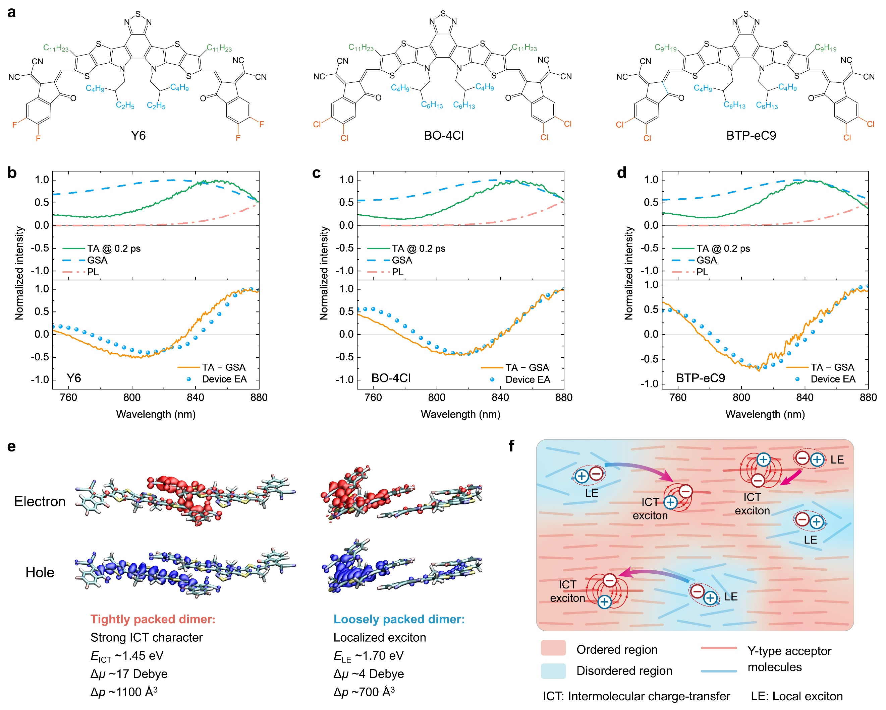
Fig. 1 Chemical structures and basic properties of Y-type acceptors. (a) Chemical structures of Y6, BO-4Cl and BTP-eC9. (b-d) Transient absorption (TA) spectra (ΔT/T) at 0.2 ps, steady-state ground-state absorption (GSA) and photoluminescence (PL) spectra (top panels), difference between TA and GSA spectra (TA−GSA), and electroabsorption (EA) spectra (bottom panels) of Y6 (b), BO-4Cl (c) and BTP-eC9 (d) neat films. (e) Electron and hole wavefunction distributions of the first singlet excited states in tightly and loosely packed Y6 dimers. As described in the main text, intermolecular charge-transfer (ICT) states are formed in tightly packed dimers, while localized excitons (LE) are formed in loosely packed dimers. The energies, changes in dipole moment (Δµ) and polarizability (Δp) of these states relative to the ground state are shown (see Supplementary Fig. 5 for details). (f) Schematic diagram illustrating the formation and dynamics of LE and ICT states in solution processed Y-type acceptor neat films.
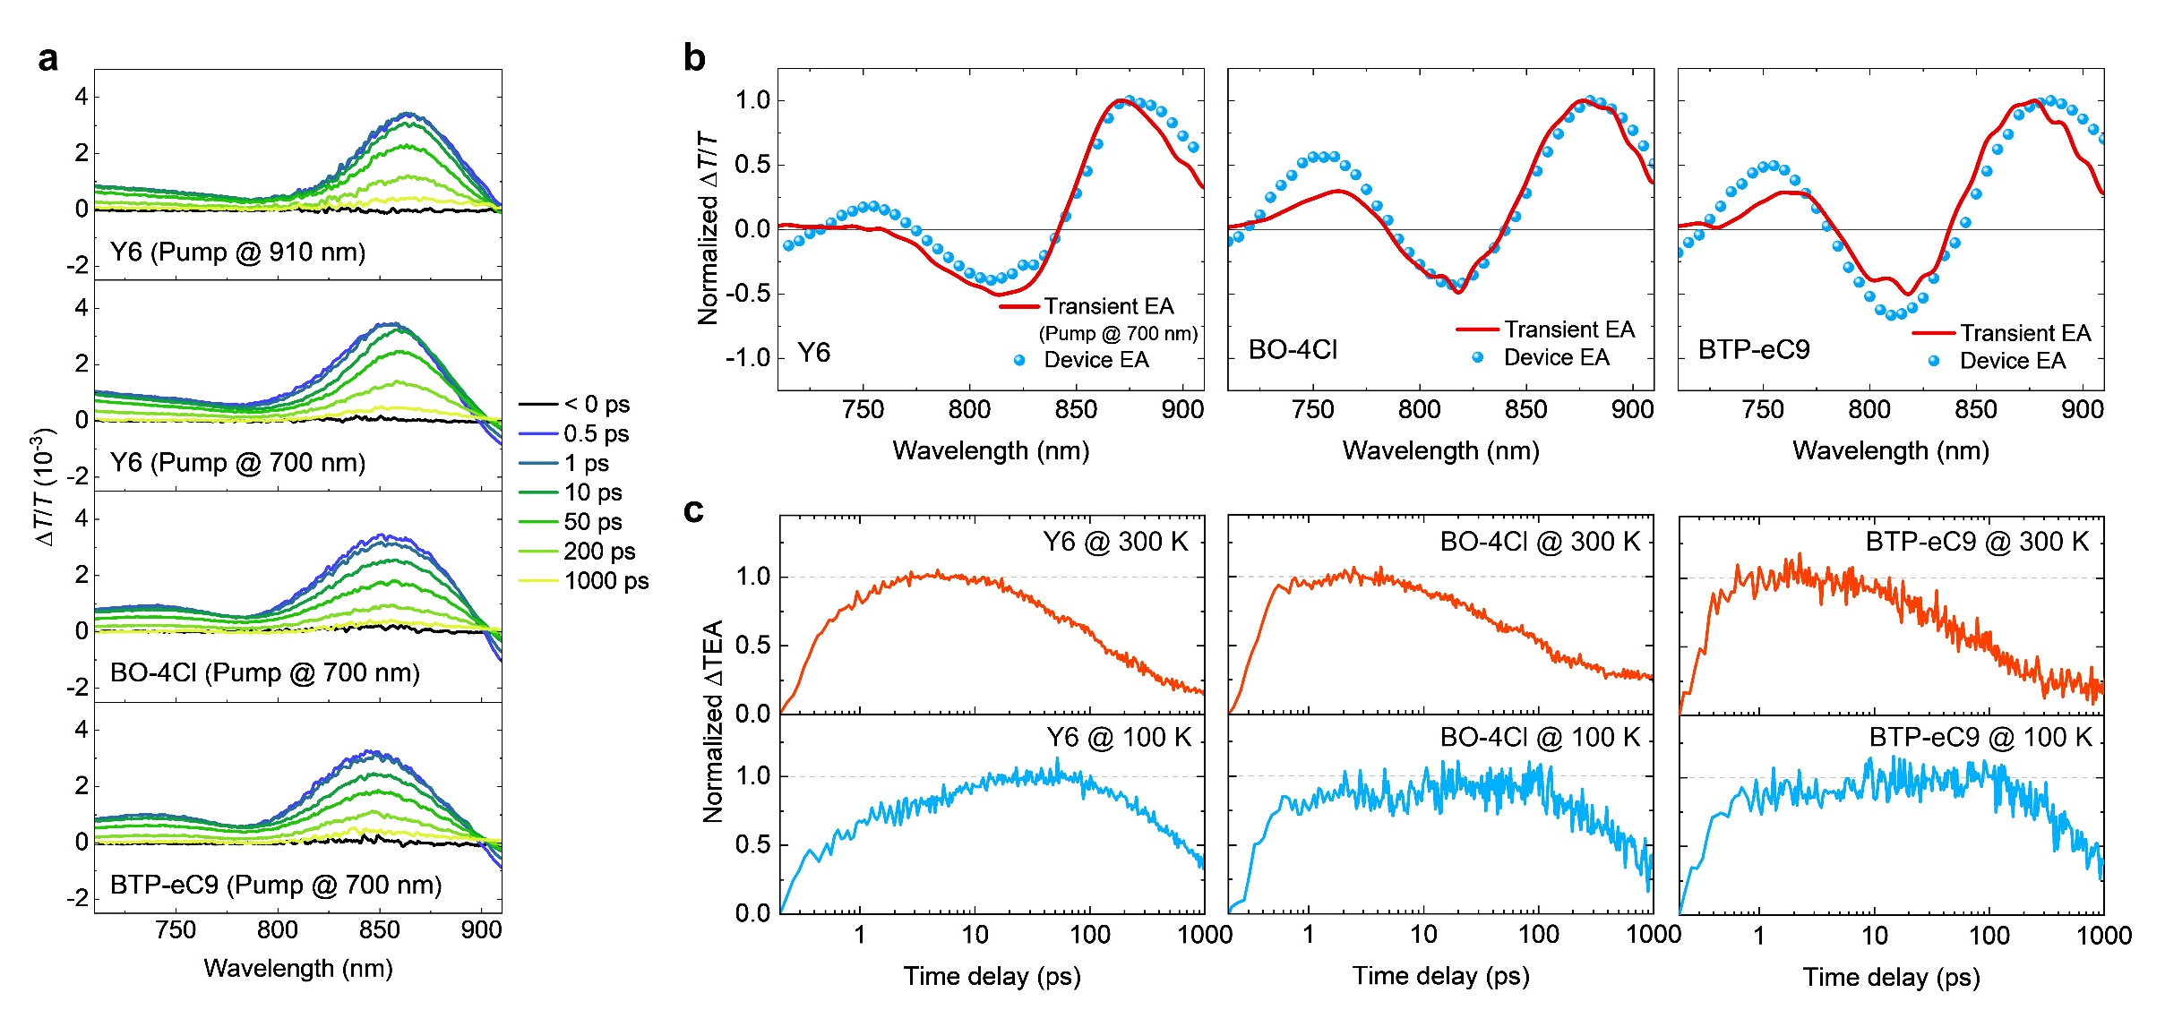
Fig. 2 Transient absorption spectroscopy results and analysis. (a) Transient absorption (TA) spectra of Y6 neat film with pump wavelengths at 910 nm and 700 nm, and TA spectra of BO-4Cl and BTP-eC9 neat films pumped at 700 nm (pump fluence of ~4.5 µJ cm⁻²; see Supplementary Fig. 13 for pump-fluence-dependent TA data). (b) Transient electroabsorption (TEA) signals extracted from the TA data (pumped at 700 nm) using a spectral decomposition tool based on genetic algorithm and steady-state device EA spectra of Y6, BO-4Cl, and BTP-eC9 neat films. (c) Kinetics of change in TEA (ΔTEA) signal intensity with respect to its initial intensity at 0.2 ps (instrument response) of Y6, BO-4Cl and BTP-eC9 films measured at temperatures of 300 K and 100 K.

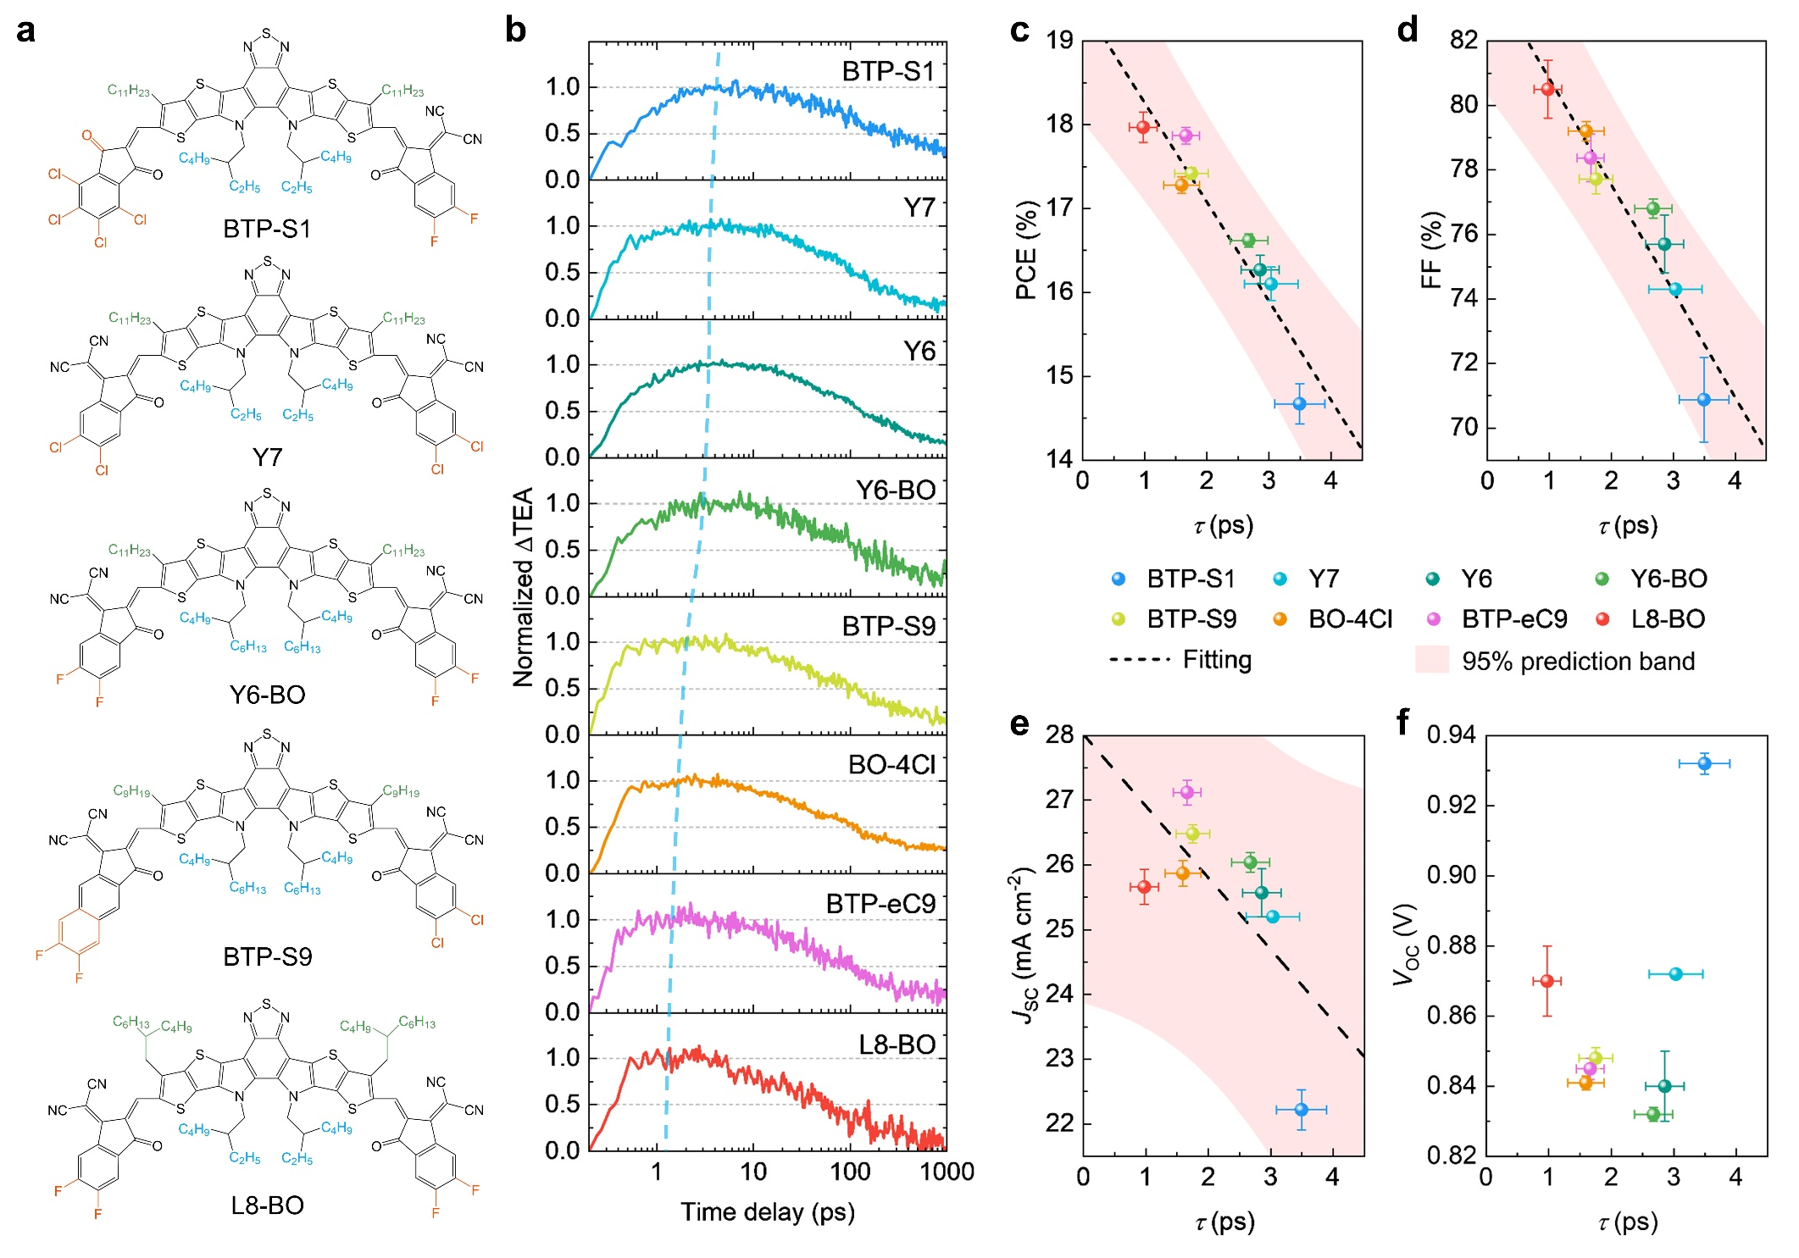
Fig. 3 Correlation between ultrafast exciton dynamics and device performance. (a) Chemical structures of BTP-S1, Y7, Y6-BO, BTP-S9 and L8-BO. (b) Kinetics of transient electroabsorption growth (ΔTEA) dynamics of various Y-type acceptor neat films. We define τ as the time for the ΔTEA signal to reach its maximum intensity, and the blue dotted line provides a guide for the eye. (c-f) Plots showing the relationship between device power conversion efficiency (PCE) (c), fill factor (FF) (d), short-circuit current density (J_{SC}) (e), and open-circuit voltage (V_{OC}) (f) against τ for various Y-type acceptors. Note that the device performance are based on binary OPV devices comprising a blend of the various Y-type acceptors with a common donor polymer PM6 collected from previous reports according to the selection criteria described in the main text^{6,10,11,17,27,46}. The black dashed lines and the shaded areas represent the best fit lines and 95% prediction bands, respectively. Most OPV performance parameters are average values with error bars from literature except that V_{OC}, J_{SC}, and FF values of PM6:Y7-based devices do not have error bars, as reported by reference⁴⁶.

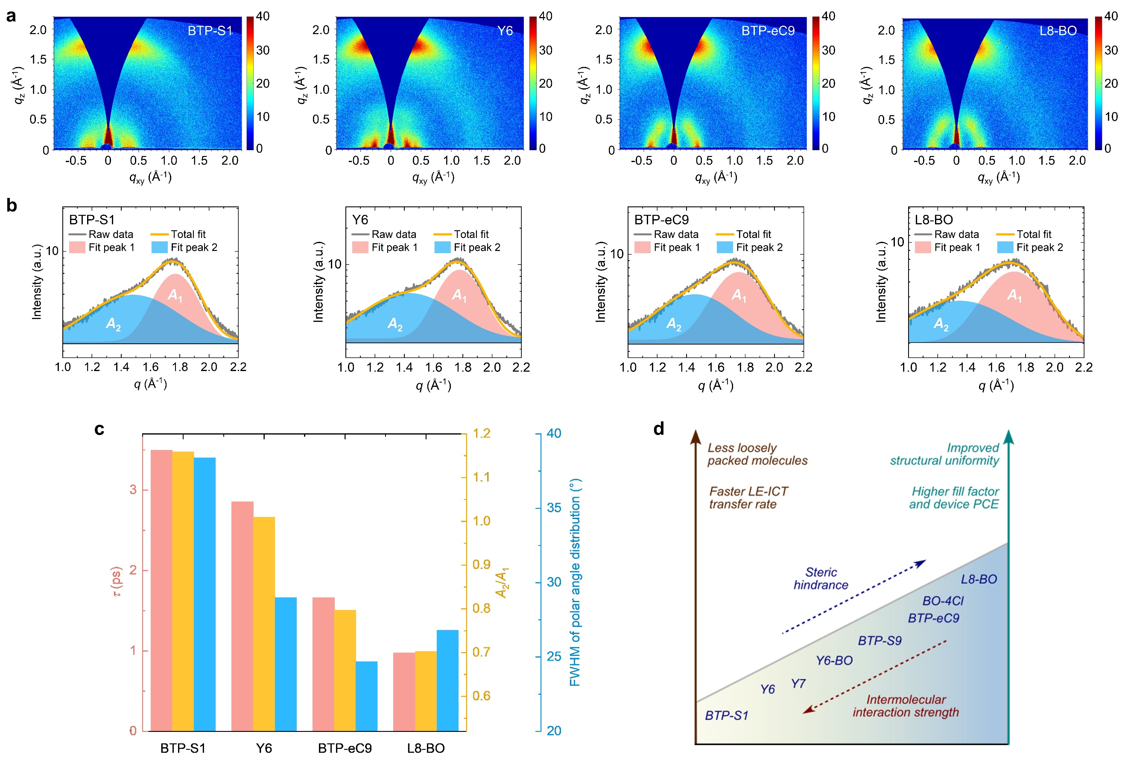
Fig. 4 Structure-photophysics-performance relationship of Y-type acceptors. (a) Two-dimensional (2D) grazing-incidence wide-angle X-ray scattering (GIWAXS) diffraction patterns of BTP-S1, Y6, BTP-eC9 and L8-BO neat films. (b) Peak fitting of azimuthally integrated GIWAXS profiles of the π-π stacking region of four Y-type acceptor neat films. The gray lines are the raw data of azimuthally integrated GIWAXS profiles. Fit peak 1 with an integrated area of A₁ corresponds to ordered structures. Fit peak 2 with an integrated area of A₂ corresponds to disordered structures. The orange lines are the sum of fit peaks 1 and 2. (c) The time for the ΔTEA signal to reach the maximum intensity (τ), the integrated area ratio (A₂/A₁) of fit peak 2 (A_{2,} disordered structures) to fit peak 1 (A₁, ordered structures) from Fig. 4b, and full width at half maximum (FWHM) of polar angle distributions of BTP-S1, Y6, BTP-eC9 and L8-BO neat films. Lower A₂/A₁ indicates lower fraction of disordered structures. Smaller FWHM of polar angle distribution of Y-type acceptors indicates that molecules are more oriented. (d) Schematic illustrating the structure-photophysics-performance relationship of Y-type acceptors based on the results presented herein.

