Jing, J., Sun, F., Wang, Z., Ma, L., Luo, Y., Du, Z., ... & Chu, Z. (2024). Scalable production of ultraflat and ultraflexible diamond membrane. Nature, 636(8043), 627-6
https://doi.org/10.1038/s41586-024-08218-x34.

Scalable production of ultraflat and ultraflexible diamond membrane
Jixiang Jing
Fuqiang Sun
Zhongqiang Wang
Linjie Ma
Yumeng Luo
Zhiyuan Du
Tianyu Zhang
Yicheng Wang
Feng Xu
Tongtong Zhang
Changsheng Chen
Xuhang Ma
Yang He
Ye Zhu
Huarui Sun
Xinqiang Wang
Yan Zhou
James Kit Hon TSOI
Jörg Wrachtrup
Ngai Wong
Can Li
Dong-Keun Ki
Qi Wang
Kwai Hei Li
Yuan Lin
Zhiqin Chu

Department of Electrical and Electronic Engineering
Faculty of Engineering
The University of Hong Kong

Corresponding author: Zhiqin Chu, Department of Electrical and Electronic Engineering, The University of Hong Kong, Pokfulam Road, Hong Kong.
Email: zqchu@eee.hku.hk

Submitted to Nature Feb 1, 2024
Accepted Oct 15, 2024

Scalable production of ultraflat and ultraflexible diamond membrane

Abstract:
Diamond is an exceptional material with tremendous potential across various fields due to its remarkable properties. However, despite extensive efforts over the past decades, producing large quantities of desired ultrathin diamond membranes for widespread use remains challenging. Herein, we demonstrate that edge-exposed exfoliation using sticky tape is a simple, scalable, and reliable method for producing ultrathin and transferable polycrystalline diamond membranes. Our approach enables the mass production of large-area (2-inch wafer), ultrathin (sub-micron thickness), ultraflat (sub-nano surface roughness), and ultraflexible (360-degree bendable) diamond membranes. These high-quality membranes, possessing a flat workable surface, support standard micromanufacturing techniques, and their ultraflexible nature allows for direct elastic strain engineering and deformation sensing applications, which is not possible with their bulky counterpart. Systematic experimental and theoretical studies reveal that the quality of the exfoliated membranes depends on the peeling angle and membrane thickness, where largely intact diamond membranes can be robustly produced within an optimal operation window. This single-step method, which opens up new avenues for the mass production of high-figure-of-merit diamond membranes, is expected to accelerate the commercialization and arrival of the diamond era in electronics, photonics, and other related fields.

Main:
Diamond is an excellent material for electronic and photonic applications ¹⁻³, owing to its exceptional carrier mobility ⁴, thermal conductivity ⁵, dielectric breakdown strength ², and ultrawide bandgap and optical transparency that spans from the infrared to the deep-ultraviolet ^{6,7}. To replace pricey natural diamonds, synthetic ones (both single- and poly-crystal types) massively produced through high pressure high temperature (HPHT) ⁸ and chemical vapor deposition (CVD) ⁹ techniques have been extensively explored in diverse electrical, optical, mechanical, thermal and acoustic applications (summarized in Extended Data Fig. 1 and Supplementary Note 1). Although diamonds hold significant promise, their widespread adoption is still hindered by the unavailability of large-area, layered forms of such material that are fully compatible with well-developed silicon-based semiconductor technologies ¹⁰⁻¹³. Therefore, the development of high-quality wafer-scale ultrathin diamond membranes, featuring excellent controllability and heterogeneous integration potential, is set to unveil a myriad of new opportunities for next-generation electronic and photonic devices ¹⁴⁻¹⁶.

Currently, ultrathin diamonds are obtained by either slicing bulk diamond ¹⁷ or through CVD growth on a heterogenous substrate ¹⁸. Slicing generates high-quality single-crystal diamond (SCD) but the method is not scalable for industrial applications because the dimension and surface roughness of obtained membranes are constrained by the laser ¹⁷ and focus-ion beam treatment ^{19,20}. Heterogenous growth produces wafer-scale membranes with well-controlled thicknesses. However, the lattice mismatch between the diamond and the silicon (Si) growth substrate tends to form a polycrystalline diamond (PCD) that roughens the membrane surfaces ²¹, rendering them incompatible with micro-/nano-fabrication, heterogenous integration and heat dissipation management. Although mechanical and chemical polishing can effectively flatten thick and rough membranes ^{22,23}, separating the membrane from the growth substrate still requires sophisticated procedures such as plasma etching and chemical erosion of the Si substrate ²⁴. In addition, the etching strategies suffer from long fabrication time and limited membrane size (usually in millimeters at most ²⁵, making large-scale production challenging. Thus, to facilitate the widespread use of ultrathin diamond membranes, a simpler and scalable method to obtain and transfer ultrathin and ultraflat diamond membranes is urgently needed.

Inspired by the great success of monolayer materials ²⁶⁻³² such as graphene ³³⁻³⁵, here, we show that the single-step edge-exposed exfoliation is a feasible way to obtain and transfer ultraflat and ultraflexible diamond membranes at a wafer scale. Using sticky 3M scotch tape and a homemade machine that can peel at precise speeds and lift angles, we successfully separated a 2-inch diamond membrane from its Si growth substrate. Scanning electron microscope (SEM) and atomic force microscopy (AFM) images show that the bottom surface of the exfoliated membranes is sufficiently smooth (Ra < 1 nm), overcoming the bottleneck for precise micro-/nano-fabrication. We further transferred the membrane to a flexible polydimethylsiloxane (PDMS) substrate and demonstrated it as a prototype of a flexible diamond strain sensor that could withstand > 10000 deformation cycles at 2 % strain.

Fabrication of large-area intact diamond membranes via single-step exfoliation
We used microwave plasma CVD to grow thin diamond membranes on Si substrates (see Methods). By controlling the growth time, membranes of varying thickness were obtained. To ease the detachment of the membrane from the substrate, we first cropped the wafer edge with a scribing pen at the backside of the silicon wafer to expose the diamond-substrate interface (Fig. 1a, b and Supplementary Fig. 1). This newly formed edge is crucial for the following exfoliation of an intact large-sized diamond membrane. Details of the cropping process and mechanism analysis are available in the Methods section and Supplementary Note 2. By attaching a transparent tape on top of the membrane surface and stretching the tape along the cropped edge, we successfully exfoliated an intact 1-μm-thick, 2-inch-wide diamond membrane from the growth substrate (Fig. 1b and Movie 1). The exfoliated 2-inch membrane exhibits excellent optical transparency (Fig. 1c, left) and structural integrity as seen from the 5× and 50× magnification optical images (Fig. 1c, right and Supplementary Fig. 2). To demonstrate the feasibility of our method, we also exfoliated 2-inch ultrathin diamond membranes with varying thicknesses (200 nm to 800 nm) by hand and characterized their micro-crack density and exfoliation yield (Extended Data Fig. 2 and Methods). Compared with reported works in the last 30 years, the present study is the first to achieve mass production of wafer-scale transferable diamond membranes (Fig. 1d and Supplementary Table. 1). In principle, our approach can be extended to the largest sizes of commercially available diamond membranes grown on Si substrate (i.e., the 12-inch diamond wafer ³⁶).

Besides lab-grown samples, commercially available diamond membranes grown on Si and molybdenum (Mo) substrates can also be exfoliated using our method (Supplementary Fig. 3). Upon dissolving the sticky tape in piranha solution, the free-standing diamond membrane can subsequently be integrated with a variety of substrates, including gallium nitride (GaN), molybdenum disulfide (MoS₂) and soft PDMS (Supplementary Fig. 4), demonstrating its great potential for different heterogeneous integration applications.

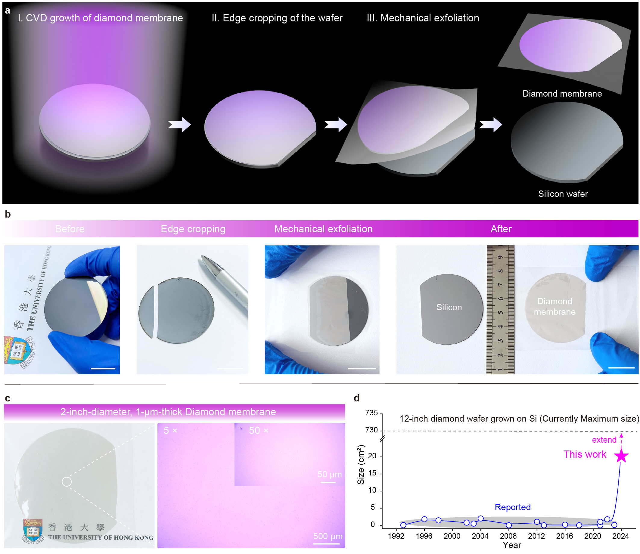

Fig. 1 Exfoliating wafer-scale diamond membranes.
a, Schematic diagram depicting the edge-exposed exfoliation of a diamond membrane from a Si growth substrate using sticky 3M tape. The wafer edge is cropped to facilitate exfoliation. b, Photographs showing a ~ 1-μm-thick, 2-inch-wide diamond membrane grown on a Si substrate (i) is cropped by a scribing pen (ii) and then readily and cleanly exfoliated by hand using transparent sticky tape (iii). The resulting Si substrate is free of residues and can be reused (iv). c, Photographs of an exfoliated 2-inch-sized, 1-μm-thick diamond membrane and corresponding 5× and 50× magnification optical images. d, Statistics in reported size of transferable diamond membranes in the past three decades. Notice that our approach can be, in principle, extended to 12 inch samples (the maximum size of diamond grown on silicon wafers in the market reported in 2021 ³⁶).

Outstanding quality of the exfoliated wafer-scale diamond membrane
For the exfoliated diamond membrane, we next performed a comprehensive characterization to examine its quality. The typical Raman peak at ~ 1332 cm⁻¹, representing the nature of diamond as shown in measurement of single-crystal diamond (Supplementary Fig. 5), was observed for measurements on both top (as-grown) and bottom (buried) surfaces (Fig. 2a and Supplementary Fig. 6). The low peak ranging from 1500 cm⁻¹ to 1600 cm⁻¹ for the as-grown surface, suggested the existence of partial sp² carbon content (non-diamond) that was also monitored in the X-ray photoelectron spectroscopy (XPS) result (Fig. 2b). Additionally, the X-ray diffraction (XRD) measurement showed the polycrystalline diamond membrane was (111)-crystal face dominated. Furthermore, the high optical refractive index (2.36 at 450 nm, Fig. 2d), low extinction coefficient in the visible range (Fig. 2e), large electrical resistance (~ 10¹⁰ Ω, see more results in Supplementary Fig. 7) and high thermal conductivity (~ 1300 W/(m·K), also see more results in Supplementary Fig. 8) have been measured for buried surface, all of which being comparable to those of a standard SCD sample (summarized in Fig. 2f). In contrast, our diamond membrane exhibits lower mechanical hardness and apparent Young’s Modulus than bulk SCD, which is primarily attributed to the thickness thinning ^{37,38}.

It is well known that the resistance of diamond membrane is determined by its intactness and quality, and the initial value for the as-grown surface was measured at ~ 10⁴ Ω (mainly contributed to the hydrogen termination during CVD growth that induces a thin layer resembling p-type doping ^{39,40}). To assess the potential influence of exfoliation process on the quality of our membrane, we mapped the surface resistance by fabricating isolated die arrays (each contains a pair of gold electrodes, as shown in Fig. 2g inset and Extended Data Fig. 3) on top of a 2-inch-sized diamond wafer before (Fig. 2g) and after exfoliation (Fig. 2i), and detailed fabrication process are available in Methods. The relatively uniform distribution of resistance (Fig. 2h) indicates the consistency of our membrane across the entire 2-inch wafer, and this remained almost identical after exfoliation (there was an overall decrease in resistance that may be related to detachment from Si substrate). As a material with a typical ultrawide bandgap (5.47 eV ²), we further showcased the photodetection of ultraviolet (UV) light using our diamond membrane (Extended Data Fig. 3). Specifically, by utilizing an UV light source (central wavelength at 275 nm) to illuminate the diamond membrane, an obvious change in photocurrent was observed (Extended Data Fig. 3). This outstanding photovoltaic conversion based on the diamond membrane further indicates the intactness and high-quality of our diamond membranes. Consequently, we characterized the performance of specific units within the die arrays under UV on/off cycles (Extended Data Fig. 3). Under different period cycles, the unit both displayed stable variation that also reveal the robustness of our diamond membrane.

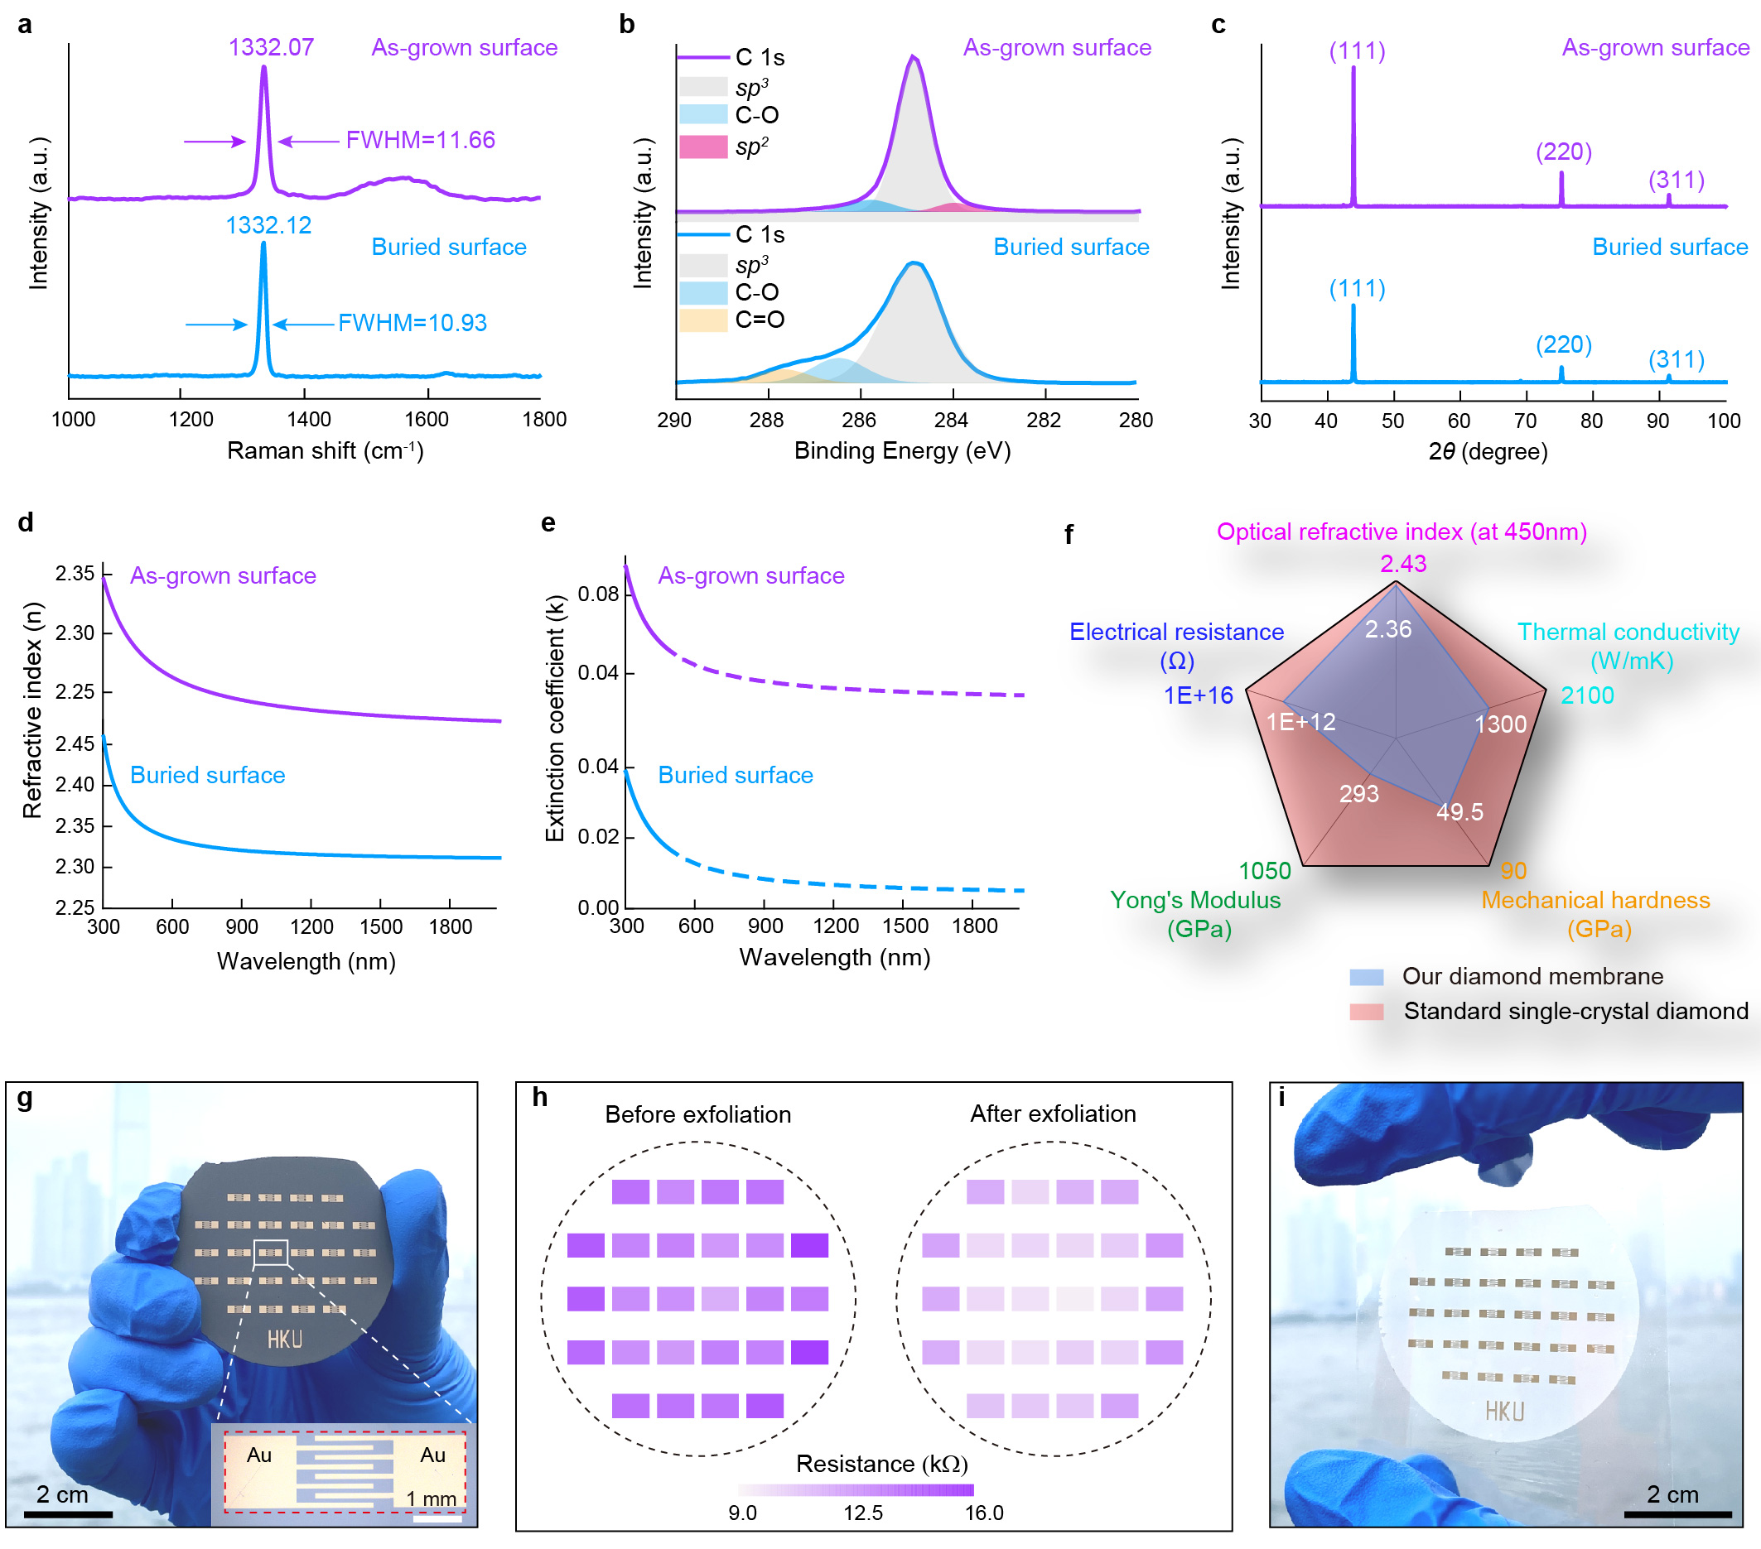

Fig. 2 Detailed characterization of exfoliated diamond membrane.
a, Raman, b, XPS and c, XRD spectrum for as-grown surface (top) and buried surface (bottom) of exfoliated 1-μm-thick diamond membrane. d, e, Optical refractive index (d) and extinction coefficient (e) of exfoliated 1-μm-thick diamond membrane. f, Comparison of our diamond membrane (2-inch-size, 1-μm-thick membrane) and standard single-crystal bulk diamond (0.5×0.5×0.3 mm, commercially available from Element sixTM) in different aspects. Notice that all characterizations here were conducted on the buried surface of diamond membrane. g, Photograph of fabricated die arrays on a 2-inch diamond membrane grown on Si substrate. The inset showing the enlarged optical image of single die pattern (the red dashed box indicates the region with hydrogen-terminated surface). h, Resistance change for these die arrays on as-grown surface before and after exfoliation. i, Photograph of the die arrays on a 2-inch diamond membrane after exfoliation from Si substrate.

Ultraflatness of diamond membranes: a key requirement for micromanufacturing
After understanding the overall performance of the diamond membrane in different aspects, the mysterious buried surface triggered us to characterize its surface morphology something that has seldom been investigated by others. The high-magnification SEM images (Fig. 3a) of a ~ 1-μm-thick membrane show that the as-grown surface contained stacked grains (100 s nm in size) as reported before, but to our surprise, the buried surface was completely smooth. The cross-sectional image further revealed that the grain size increased along the direction of growth (More details of the diamond-silicon interface are available in Extended Data Fig. 4). This astonishing difference was also seen on other thickness membranes (Supplementary Fig. 9). We further conducted AFM measurements to precisely compare the roughness difference, which confirmed that the as-grown surface of the 1-μm-thick membrane is rougher (Ra=36.203 nm) than the buried surface (Ra=0.952 nm) (Fig. 3b). To investigate whether the ultraflat buried surface was due to the surface morphology of the substrate, we employed smoother Si wafer as growth substrate. Interestingly, a yet flatter buried surface (Ra=0.612 nm) can be further obtained. Unlike as-grown surface whose roughness increases with membrane thickness, the roughness of the buried surface decreases with membrane thickness initially until reaching a constant level when the thickness is above ~600 nm (Fig. 3c).

To clearly understand the formation of the ultraflat buried surface, we conducted a detailed computational analysis on the growth mechanism of the diamond membrane (Supplementary Fig. 10). The result reveals that seed diamond nanoparticles deposited on the Si substrate grow along various crystal faces during CVD. Horizontal and upward growth linked separated particles together and increased the membrane thickness. However, due to varying growth rates of the crystal faces, the as-grown surface is uneven. The buried surface, on the other hand, is shaped by the smooth surface of the Si substrate that prevents any downward growth of the diamond seeds.

An alternative strategy to access the interface between the diamond membrane and Si substrate, is grinding, plasma etching and chemical erosion on the Si substrate (Supplementary Fig. 11). The results show that the obtained membranes are inevitably damaged mainly due to the complex and harsh manipulations. Therefore, compared with all reported strategies for flatting diamond membranes (Fig. 3d and Supplementary Table. 2), our edge-exposed exfoliation method achieved the flattest surface (roughness of < 1 nm) and was the only one that could peel membranes ranging from hundreds of nanometers to tens of micrometers thick (Supplementary Fig. 12).

The ultraflat buried surface of the exfoliated membrane makes it accessible to precise nanofabrication using standard e-beam lithography and subsequent plasma etching (see Methods). As a proof-of-concept demonstration, we fabricated diamond nanopillars and resonators, with a typical feature size of 300 nm, on the smooth buried surface (Fig. 3e). The well-controlled structure morphology (surfaces and sidewalls) was inaccessible to the rough as-grown surface (Supplementary Fig. 13), which indicates the great potential of our membrane in diamond nanophotonics (metasurfaces, metalens, waveguide resonators). Additionally, by exposing the diamond membrane to nitrogen gas during CVD growth, we obtained membranes with nitrogen-vacancy (NV) centers-atomic defects that are promising for quantum technologies (Supplementary Fig. 14).

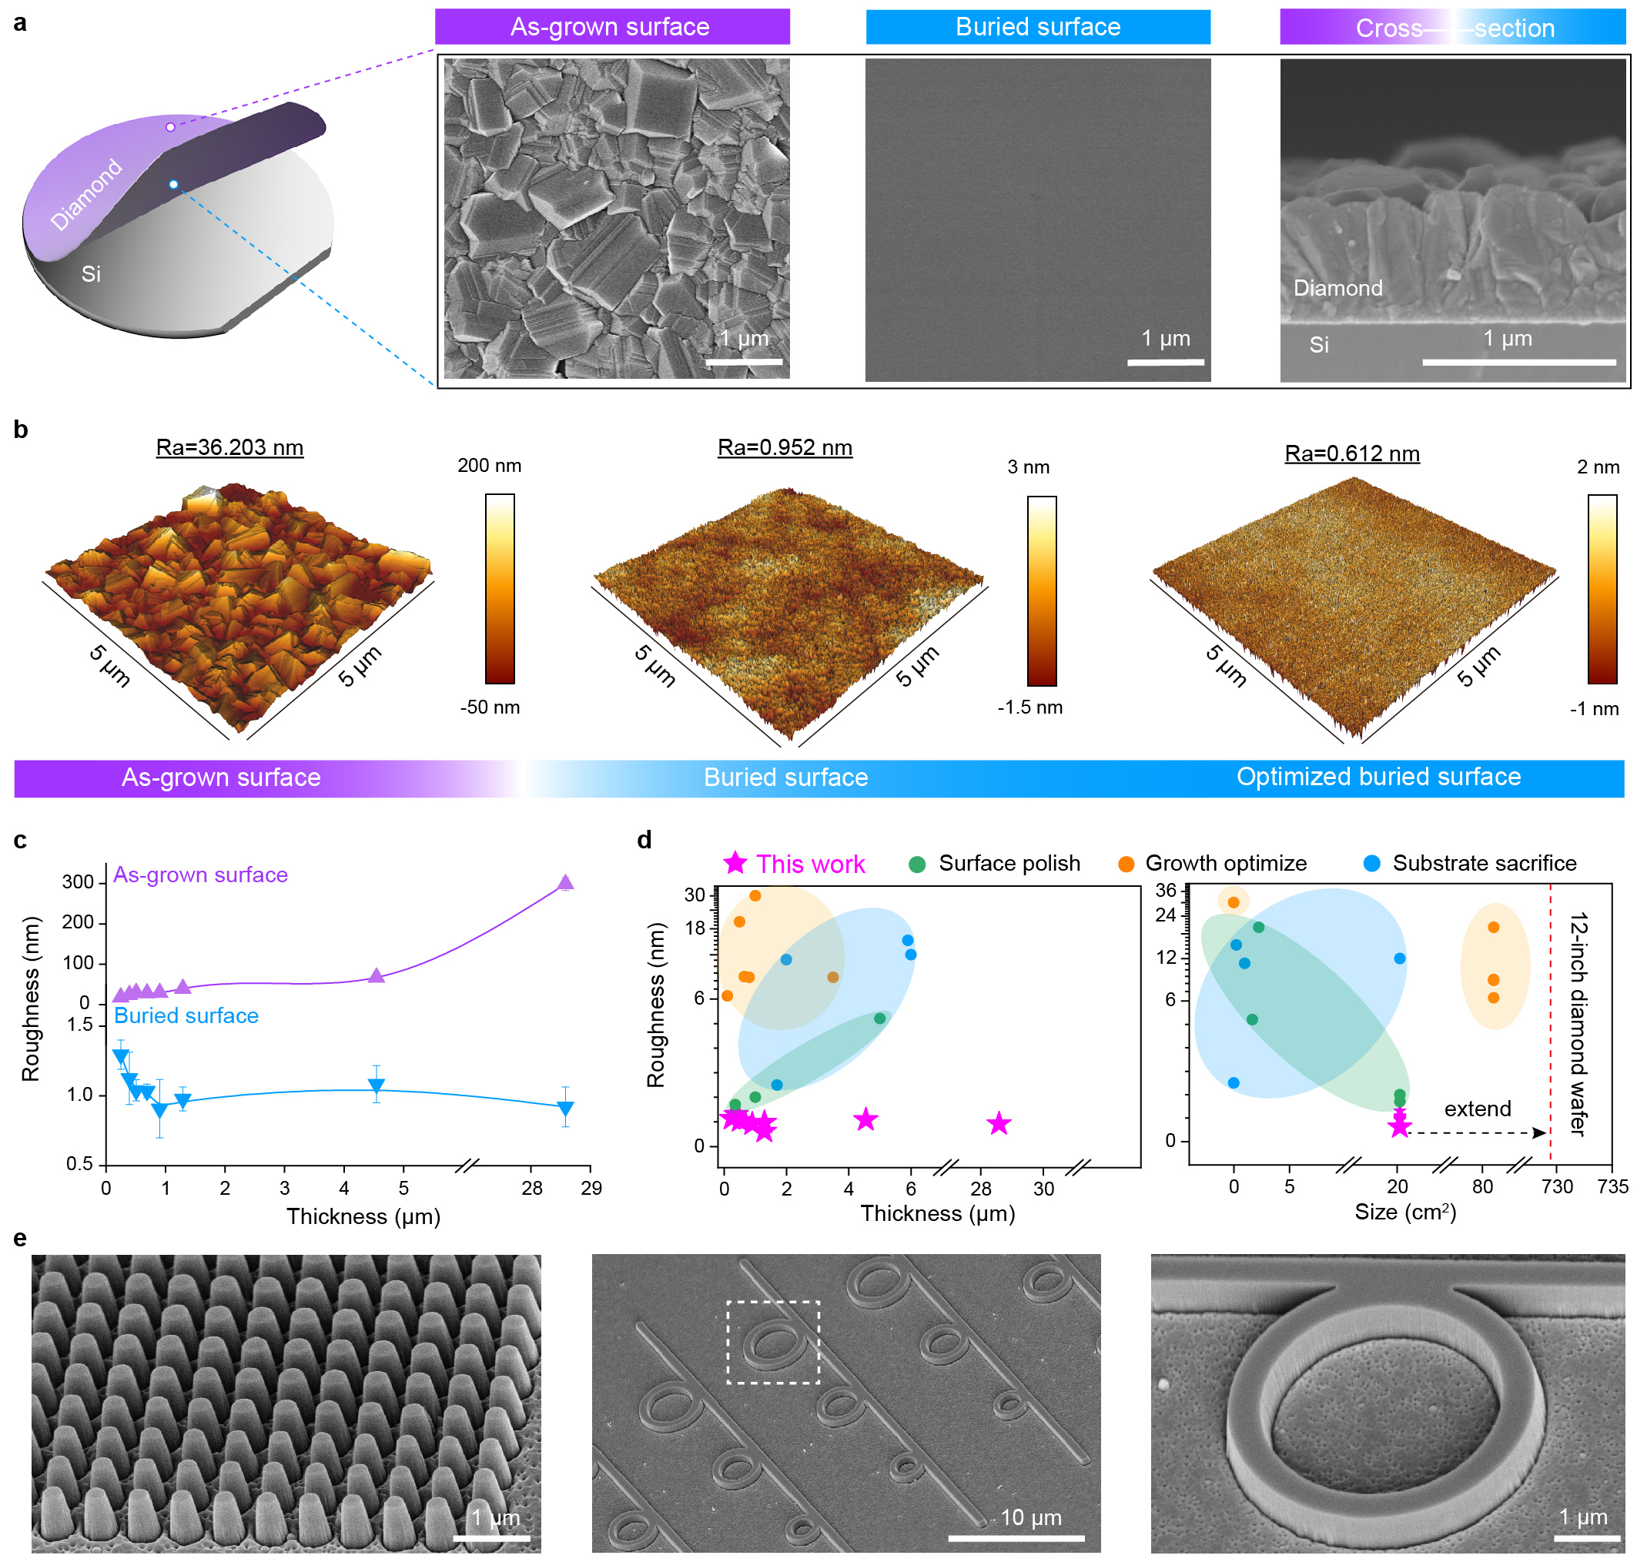

Fig. 3 Ultraflatness of mechanically exfoliated diamond membranes.
a, SEM images of the as-grown surface, buried surface and cross-sectional view of an ~ 1-µm-thick diamond membrane. b, AFM roughness profile of an as-grown surface, buried surface, and an optimized buried surface grown on a smoother Si substrate. c, Average roughness of as-grown and buried surface for membranes (20 µm × 20 µm area) of different thicknesses. d, Comparison of various strategies used to obtain smooth diamond membranes. Our edge-exposed exfoliation method produced the smoothest surface across all membrane thicknesses (left) and areas (right). e, SEM image of nanoscale patterns fabricated on the buried surface of an exfoliated 1-µm-thick diamond membrane.

Ultraflexibility of diamond membranes: a prerequisite for direct strain-modulated electronics
Despite diamond being the hardest material in nature, the decrease in thickness provides possibility for accessing flexible diamond due to the reduction of apparent Young’s Modulus (Fig. 2f). Moreover, the multiple grain boundaries and dislocations inside polycrystalline diamond membrane might help accommodate more strains by grain boundary and dislocation sliding under deformations (Supplementary Fig. 15). In particular, our exfoliated diamond membranes exhibit surprising flexibility: a 4-μm-thick sample can be bent 360° (Fig. 4a, b) and wrapped around different size cylinders with radii varying from 10 mm to 2 mm (Fig. 4c). To demonstrate the bandgap of our diamond membrane can be modulated by elastic strain engineering in the same way as SCD nanopillars ⁴¹, we attached a 1-μm-thick membrane onto a flexible PDMS substrate and characterized the electrical conductivity of the membrane under alternating compressive and tensile strains (Fig. 4d, Extended Data Fig. 5 and Supplementary Fig. 16). The experiment began with a low (3.42%) compressive strain to avoid fracture, followed by a large range of tensile strain.

The increasing and unstable resistance in the crack region indicates the formation and propagation of micro-cracks (Fig. 4d). Based on the calculated deformation of PDMS, the maximum tensile strain that our sample can support is ~ 4.08% (Extended Data Fig. 5). Tests from other 5 samples showed that the maximum strain occurred at 3% ~ 5% (Extended Data Fig. 5), which is lower than the 9% ⁴² and 9.7% ⁴³ achieved with SCD nano-pillars and micro-bridge samples, respectively (Fig. 4e). This difference is likely due to the larger area and polycrystalline nature of our sample. Additionally, the rough sidewall edges created during sample cropping could also accelerate the rupture. However, the observed strain is the highest when compared to other reported polycrystalline diamond membranes (Fig. 4e).

To illustrate the repeatability of this piezo-resistance effect, we implemented several load-unload cycles on the membrane using a three-point bending setup (Extended Data Fig. 5). The response was consistent over time. Notably, our membrane could also withstand > 10000 deformation cycles at 2% strain without any damage (Supplementary Fig. 17).

As a proof-of-concept, we built a flexible 5 × 3 array of strain sensors on a 1-μm-thick diamond membrane grown on a 2-inch Si wafer. Gold electrodes were deposited on the membrane and the sensor units were electrically isolated by removing unprotected hydrogen-terminated areas (Fig. 4f and Supplementary Fig. 18). We exfoliated the membrane containing the sensor array from the Si substrate using transparent tape (Fig. 4g). When attached to an arm, the sensor array detected the change in muscle deformation in response to stretching and bending of the arm (Fig. 4h, i). This shows that the exfoliated membrane is functional and can be used for downstream applications.

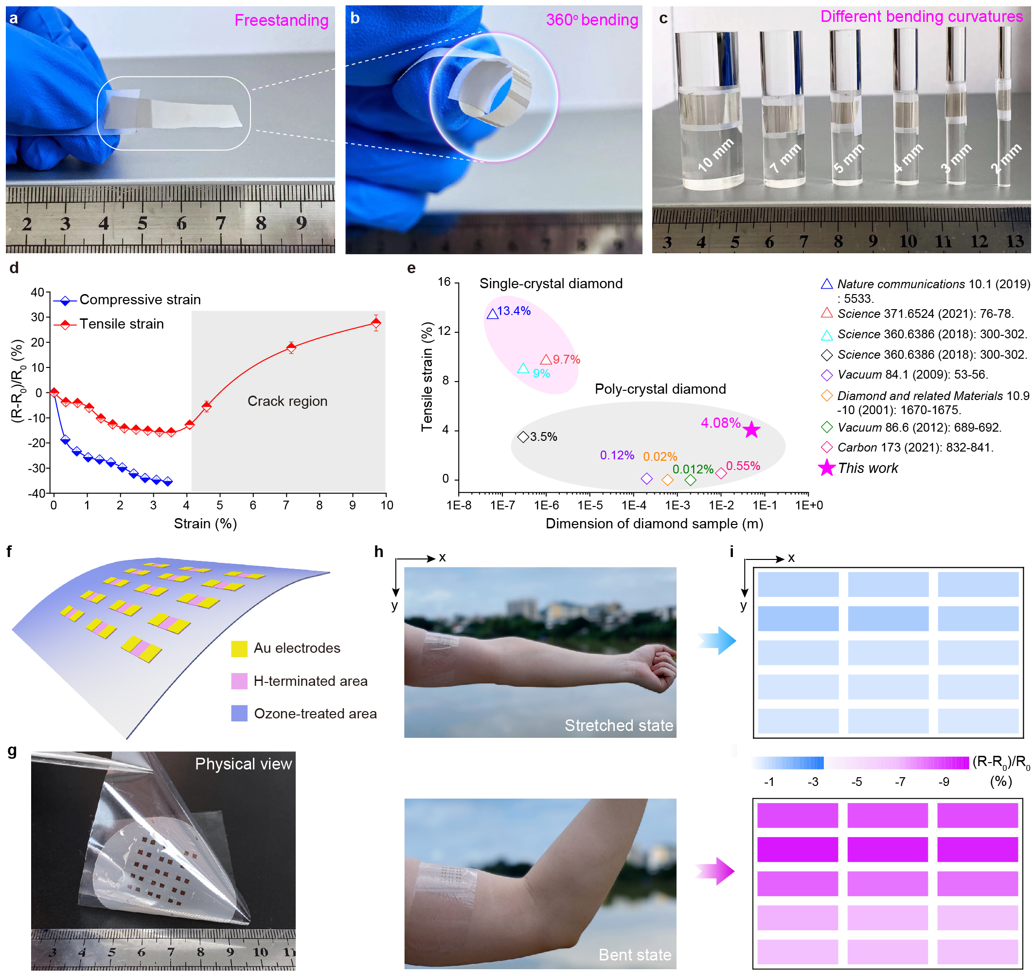

Fig. 4 Flexible diamond membranes for wearable electronics applications.
a, b, c, Photograph of a ~ 4-μm-thick diamond membrane being freestanding (a), bent 360 degrees (b) and wrapped around cylinders of different radii (c). d, Change in resistance of diamond membranes subjected to different tensile (red) and compressive (blue) strains. The gray region indicates the occurrence of micro-cracks under deformation. e, Comparison of supported maximum tensile strain for SCD nanoscale samples and polycrystalline diamond membranes. f, g, Schematic (f) and photograph (g) of a 5 × 3 diamond strain sensor array fabricated on a 2-inch membrane and exfoliated using transparent tape. h, Photographs showing a strain sensor array on a stretched (top) and bent (bottom) arm. i, Change in resistance for each unit of the strain sensor array corresponding to the stretched and bent arm shown in h.

Reliability of our proposed edge-exposed exfoliation approach
To understand the relationship between the exfoliating parameters and the quality of exfoliated diamond membranes, we built a homemade setup that can peel and produce intact and crack-free membranes in a consistent and reproducible way. Specifically, a universal-testing machine (ElectroPlusTM E3000) was used to control the peeling speed and an angle-adjustable stage was used to obtain accurate peeling angles (Fig. 5a and Supplementary Fig. 19). To determine the optimum peeling parameters, we peeled membranes of different thicknesses at a constant speed (10 mm/min) and varying peeling angles (20° to 90°) (Movie 2). Calculating the density of cracks on the exfoliated membranes, we find that exfoliating performance depends on peeling angle and membrane thickness (Fig. 5b). For thicker membranes (800 nm and 1000 nm), a wide range of peeling angles (20° to 90°) can be used to obtain crack-free membranes (Fig. 5b). When the membrane reaches 600 nm thick, the working range of peeling angles that induces the fewest cracks narrows to 40° - 70°, and this operating window continues to narrow for thinner membranes.

Theoretically, a crack with initial length l is expected to grow under tensile stress $σ$ once the value of $σ^{2}l$ reaches a critical level ⁴⁴. Here, the small ditches on the membrane surface effectively serve as initial cracks/defects whose propagation could be triggered by peeling-induced stress in the membrane. Interestingly, the size distributions of these pre-existing cracks on both the top and bottom surfaces of the membrane are all half-normal like, irrespective of membrane thickness (Supplementary Fig. 20). We proceeded by using the finite element method (Comsol Multiphysics) to calculate the stress field (see Methods) induced in the diamond membrane where a cohesive law ^{45,46} was introduced to simulate its adhesion and mixed-mode decohesion ^{47,48} with the Si substrate. On the other hand, possible crack propagation was simulated by the phase field method ^{49,50}.

By using a 600-nm-thick membrane as an example, its response under three different peeling angles (30°, 60° and 90°) was simulated. At a small peeling angle of 30°, the detached membrane undergoes mild bending deformations. Consequently, both the bottom and top sides of the membrane are under tensile stress, eventually leading to the propagation of large cracks from the top (Fig. 5d and Movie 3). In comparison, the top (concave) side of the membrane is under compression when the peeling angle is large (90°), which prevents possible crack growth. However, the elevated tensile stress on the bottom (convex) side of the highly deformed membrane is strong enough to trigger the propagation of small initial cracks there (Fig. 5d and Movie 4). As a result, no crack propagation will take place inside the 600 nm thick membrane only when exfoliation is conducted at an intermediate peeling angle (60°). Since a smaller crack requires a higher tensile stress to initiate its growth, the probability of crack propagation can be estimated by calculating the percentage of cracks with sizes (that follow a half-normal distribution) above the threshold value under a given peeling angle and membrane thickness (see Methods and Supplementary Figs. 20-23). For thicker membranes (700 nm to 1000 nm), our simulations indicate a peeling angle between ~ 30° to 90° can avoid crack propagation. When the thickness reaches 600 nm, the range of peeling angle that induces the smallest probability of crack propagation narrows to 45° - 65° (Fig. 5c). These results are in good agreement with the observed crack density in different exfoliated membranes (Fig. 5b), and therefore can be used to guide the mass production of crack-free membranes. More analysis of underlying mechanism for holistic exfoliation is available in Supplementary Note 9, where a dimensionless peeling number $M$ and related critical conditions are suggested to guide the design and evaluation of other material systems for intact peeling (Supplementary Fig. 24).

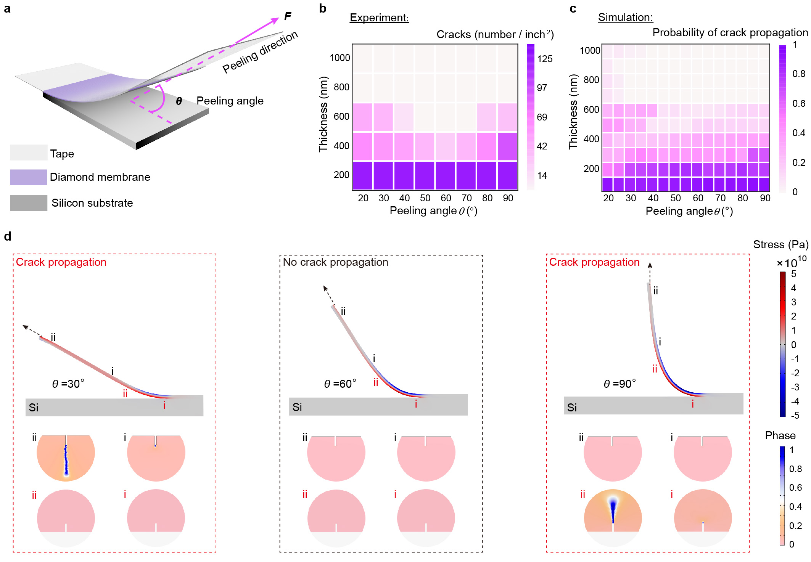

Fig. 5 Factors affecting the quality of mechanically exfoliated diamond membranes.
a, Schematic showing the exfoliation of a diamond membrane from the substrate under a peeling force F and peeling angle θ. b, Experimental statistics for the density of micro-cracks on membranes of different thicknesses that were exfoliated from 1 cm × 1 cm wafers under different peeling angles. Peeling speed was set at 10 mm/min. c, Calculated probability of crack propagation on membranes of different thicknesses exfoliated at varying peeling angles. d, Distribution of the bending stress (from FEM simulations) in a 600-nm-thick membrane peeled at 30° (left), 60° (middle) and 90° (right). Lower panels show the phase states of the cracks located at different places on the top (black numerals) and bottom (red numerals) of the diamond membrane under enforced peeling. Here, a crack starts to propagate when the stress near its tip reaches a critical level (see Methods), effectively transforming the material from the unbroken state (phase value 0) to the fully broken state (phase value 1). The initial sizes of the cracks set in phase-field simulations are 56 nm (on the top side) and 1.2 nm (on the bottom side), where 95% of cracks are smaller than these sizes on the corresponding surfaces (Supplementary Fig. 22).

Conclusion
We showed that the edge-exposed exfoliation method is a simple and fast way to commercially produce transferable, wafer-scale, ultrathin and ultraflat diamond membranes. The optimal operation window determined by experimental demonstration and computational analysis provides guidance for realizing standard industrial production. Additionally, the method is scalable and amenable to any membrane thickness and size. Compared to standard single-crystal bulk diamond, our membrane shows comparable optical properties (RI: ~ 2.36 at 450 nm wavelength), thermal conductivity (~ 1300 W/(m·K)) and electrical resistivity (~ 10¹⁰ Ω). Unlike other methods, membranes produced using our approach are sufficiently flat (roughness < 1 nm) for precise micro- and nano-fabrication. The supported deformation (~ 4% strain) for a centimeter-scale sample achieved elastic strain engineering on the macroscopic dimension, opening possibilities in next-generation diamond-based electronics (e.g., field-effect transistors, p-n junction diodes), photonics (e.g., Raman lasers, ultraviolet detectors, planar photonic devices including metalenses and metasurfaces, photonic structures including ring- and cavity-resonators, waveguides, nanopillars), mechanics (e.g., mechanical cantilevers, MEMS devices), thermics (e.g., on-chip heat spreader), acoustics (e.g., surface acoustic wave (SAW) filters, planar acoustic metamaterials) and quantum technologies (e.g., scalable and customizable devices).

Methods
CVD growth of diamond membranes
The heteroepitaxial growth of diamond on Si substrate involves three steps: pretreatment of the substrate, deposition of diamond seeds, and CVD growth of the diamond membranes. The Si surface was pretreated with hydrogen plasma, and a 2-inch silicon wafer was placed into the microwave plasma-assisted chemical vapor deposition (MPCVD) device for 10 minutes under conditions of 1300-W power, 35-Torr cavity pressure, and 300-sccm H₂ gas flow. The preparation of diamond seeds includes mixing, dispersing, and centrifuging steps. The diamond seeds (Tokyo Chemical Industry Company Limited) with a size of less than 10 nm were mixed with dimethyl sulfoxide (DMSO), anhydrous ethanol, and acetone at a mass ratio of 1:5000:250:250. The mixture was sonicated for 12 hours to disperse, and then centrifuged at a rotating speed of 1000 r/min for 20 minutes to separate impurities. Next, the suspension was spin-coated on the Si wafer (depositing parameters: 500 r/min, 3 drops were added within 15 s, and then increased the rotating speed to 4500 r/min for 110 s) and repeated three times. The deposited diamond seeds were placed into the MPCVD setup (Seki 6350) to grow a diamond membrane. The main growth parameters for a 1-μm-thick membrane include 3400-W microwave power, 900-℃ temperature, 15-sccm methane flow rate, and 40-minute growth time.

The wafer edge cropping
To create a new edge on the diamond-Si wafer, we attempted two different strategies: i) utilizing a scribing pen to manually crop a notch on the edge of diamond-Si wafer, and manipulating it on the Si side to avoid damage to the diamond membrane. Next, we press the created notch by hand, and the Si wafer can break along the grain direction (100) starting from the created notch. ii) utilizing the commercial wafer dicing machine to crop the backside of the diamond-Si wafer automatically.

Statistics of exfoliation yield and crack density
To evaluate the exfoliation performance of diamond membrane achieved by our method, we took three pieces of 2-inch-sized sample to conduct statistics for each thickness in turn. By calculating the ratio of the exfoliated area to the original area (before exfoliation) under the optical microscope, we determined the exfoliation intactness for membranes of different thicknesses. Additionally, with the assistance of an optical microscope, the number of micro-cracks was counted in the full range of a 2-inch diamond wafer. Notably, the cracks generated during exfoliation were almost micro-size, which were visible by a normal optical microscope. Thereafter, by dividing by the exfoliated area of diamond membrane, the crack density was determined.

Fabrication of die arrays on 2-inch-sized diamond membrane
Herein, a 1-μm-thick diamond membrane grown on a 2-inch Si wafer was used as an example. Specifically, a layer of photoresist (OIR-906-12) was coated on the membrane at a spinning rate of 4000 r/min for 60 s and then heated to 110 ℃ for 90 s. Next, the pattern definition of electrodes was created by photolithography at a UV dose of 300 mJ/cm², followed by Au deposition to a thickness of 100 nm. Another resist (AR-N 4200) was also coated on the membrane at a spinning rate of 4000 r/min for 60 s and then heated to 90 ℃ for 60 s. The pattern definition for each device unit was introduced by photolithography at a UV dose of 340 mJ/cm². To electrically isolate each unit in the device array, we etched the hydrogen-terminated layer by UV ozone treatment for 20 minutes. The achieved diamond device was then exfoliated with sticky tape from the Si substrate after exposing Au electrodes by laser cutting.

Methods for modeling the peeling and fracturing of diamond membranes
To model the initiation and propagation of microcracks inside the diamond membrane during enforced peeling (Supplementary Fig. 21), we started with the constitutive law of homogeneous linear elastic materials (such as the diamond membrane and Si substrate):

$σ=\frac{Eν}{（1+ν）\left(1-2ν\right)}tr\left(ε\right)I+\frac{E}{(1+ν)}ε$ , (1)

where $σ$ is the Cauchy stress tensor, $I$ is the unit tensor, $E$ and $ν$ are Young’s modulus and Poisson’s ratio, of the material, respectively. $ε=\frac{1}{2}\left[\left(F-I\right)+{(F-I)}^{T}\right]$ is the strain tensor with $F=\frac{∂x}{∂X}$ being the deformation gradient between the current configuration $x$ and the reference configuration $X$.

The quasi-static peeling process was then modeled under the plane strain condition. Specifically, a cohesive law ^{46,51} was introduced to describe the cohesion of the diamond membrane with the Si substrate, where the interface cohesion strength is described by the normal strength $S_{n}$ and shear strength $S_{t}$. On the other hand, resistance of the interface to breakage is characterized by the critical tensile fracture energy $G_{IC}$ and critical shear fracture energy $G_{IIC}$. A bi-linear separation law was adopted to describe the gradual detachment of the cohesive zone ⁵² while the mixed mode propagation criterion

$\frac{G_{I}}{G_{IC}}+\frac{G_{II}}{G_{IIC}}=1$ (2)

was used to predict the onset of interface fracture where $G_{I}$ and $G_{II}$ are the so-called mode I (tensile) and mode II energy release rate, which can be derived from the relative normal and shear displacement during the decohesion process ⁴⁵.

A phase field model was employed to describe the tension-induced propagation of microcracks on both sides of the diamond membrane ⁴⁹. Taking the degradation of energy due to fracture phase $d$ (damage state) into consideration, global energy storage $ψ$ is expressed as

$ψ(ε,d)=\int{\left[{\left(1-d\right)}^{2}φ_{t}(ε)+φ_{c}(ε)\right]dV}$, (3)

where $φ_{t}$ and $φ_{c}$ are respectively the tensile and compressive strain energy density, and $V$ is the volume. In the simulation, we first set a fixed boundary on the bottom side of the Si substrate. Initial microcracks were assigned on the top and bottom surfaces of the diamond membrane. An initial interface decohesion region (with length $L$) was also introduced to diamond-Si interface. After that, a peeling force was applied on one end (acting on the top surface) of the diamond membrane to drive its delamination (Fig. 5d and Supplementary Fig. 21). We used the $XX$-component ($S_{XX}$) of the second Piola-Kirchhoff stress $S=det⁡(F)F^{-1}σF^{-T}$, i.e., the normal stress in the horizontal/interface direction, to show the stress state (Fig. 5d) of the diamond membrane. Interestingly, our results showed that, under relatively large peeling angle, the maximum tensile stress $S_{max}$ occured exclusively on the bottom surface of the highly curved diamond membrane (Fig. 5d). On the other hand, large tensile stress was also observed on the top side of the membrane when the peeling angle is relatively small. By assuming that the microcrack size (~ $nm$) is much smaller than the size of the membrane (~ $μm-cm$), the surface microcracks can be modeled as edge cracks in a semi-infinite plate subject to a remote tensile stress (Supplementary Fig. 21). Under such circumstance, the critical condition of crack propagation can be expressed as ⁵³

$G=\frac{1.26π\left(1-ν^{2}\right)S_{XX}^{2}l}{E}≥G_{cr}$, (4)

where $G$ is the energy release rate of a crack (with length $l$) under the tensile stress $S_{XX}$ and $G_{cr}$ is the critical fracture energy of diamond. The above formulation provides a framework for us to simulate the interface decohesion and surface crack propagation in the diamond membrane during enforced peeling. The values of different parameters adopted in this study, along with their sources, are summarized in Supplementary Table. 3.

Fracture probability
As shown in Supplementary Fig. 19, the size distribution of microcracks in the diamond membrane is not uniform. The variation in the size of microcracks enables us to estimate the probability of individual cracks to propagate. Specifically, since the length distribution of cracks at both the top and bottom surfaces was found to be half-Gaussian like, we can use one side of the normal distribution $P=g(l,ξ)$ to approximate it (Supplementary Fig. 22a, b), where $l$ is the crack size and $ξ$ is the standard deviation. Then the fracture probability is simply

$P_{f}=P(l≥l_{cr})$, (5)

where $l_{cr}$ is the critical length (determined by setting ${G=G}_{cr}$ in Eq. (4)) for a crack to propagate under the maximum tensile stress $S_{XX}$. Since cracks on both top (with propagation probability $P_{f}^{top}$, Supplementary Fig. 22c) and bottom surfaces (with propagation probability $P_{f}^{bot}$, Supplementary Fig. 21d) can propagate, the total probability of crack propagation ($P_{f}^{tol}$, Fig. 5c) is given by

$P_{f}^{tol}=1-(1-P_{f}^{top})(1-P_{f}^{bot})$. (6)

Nano-patterning on diamond membranes
Free-standing diamond membranes were adhered on indium tin oxide (ITO) glass by an interface layer of polymethyl methacrylate (PMMA) resist, followed by 90 ℃ curing for 2 minutes. Then, a layer of hydrogen silsesquioxane (HSQ) resist is deposited on the diamond membrane with 3000 r/min spin coating for 50 s and 90 ℃ curing for 90 s, respectively. Next, e-beam exposing of nano-pattern on HSQ resist with a dose of 700 µC/cm², followed by 90 s development in 25 % tetramethylammonium hydroxide (TMAH) and nitrogen gas drying. After the fabrication of pattern mask on diamond membranes, oxygen gas with a flow rate of 80-sccm was adopted to etch diamond material. The RF voltage, bias voltage, and cavity pressure were set to 200 W, 60 W, and 10 mTorr, respectively. The etching time was 10 minutes and the etch rate was about 1.2 nm/s.

Acknowledgement
We thank Dr. Ai Lin Chun of Science Storylab for critically reading and editing the manuscript; Prof. Fangfei Ming of Sun Yat-sen University (Guangzhou) for assistance in sample characterization; Dr. Hao Ding and Dr. Alan Wong of Faculty of Dentistry, The University of Hong Kong for assistance in peeling test; Mr. Yau Chuen Yiu of Department of Electrical and Electronic Engineering, The University of Hong Kong for help in Raman measurement.
Funding:
Q.W. acknowledges support from Guangdong Major Project of Basic and Applied Basic Research (Project No. 2023B0303000012). Z.C. acknowledges the financial support from the HKSAR Research Grants Council (RGC) Research Matching Grant Scheme (RMGS, Project No. 207300313); RGC Theme-based Research Scheme (TRS, Project No. T45-701/22-R); HKU Seed Fund; the Health@InnoHK program of the Innovation and Technology Commission of the Hong Kong SAR Government; and the Guangdong Special Support Project (Project No. 2019BT02X030). Y.L. thanks the financial support from the RGC General Research Fund (GRF, Project No. 17210520), the Health@InnoHK program of the Innovation and Technology Commission of the Hong Kong SAR Government, and the National Natural Science Foundation of China (Project No. 12272332). Y.Z. acknowledges support from the Guangdong Special Support Project (Project No. 2019BT02X030). D.K.K. acknowledges support from the HKSAR Research Grants Council (RGC) under schemes of Area of Excellence (AoE/P-701/20) and GRF (17300020). J.W. acknowledges the BMBF via project Spinning (13N16219), QHMI (03ZU1110/B), QMED (03ZU1110FE) as well as DiaQnos (13N16455) and the EU via project AMADEUS (101080136).
Author contributions:
Z.C. and J.J. conceived the idea. Z.C., Y.L., K.H.L., and Q.W. supervised the project. J.J. led the experimental investigation with assistance from L.M., Y.L., Z.D., T.Z., Y.W., F.X., T.Z., C.C., X.M., Y.H., Y.Z., H.S.. F.S. established the theoretical model under the supervision of Y.L.. Z.W. performed diamond material growth under the supervision of Q.W.. J.J., F.S., K.H.L., Y.L., Z.C. co-wrote the manuscript with input from all authors. Q.W., Y.Z., J.K.H.T., J.W., N.W., C.L., D.K.K. and X.W. discussed the results and commented on the manuscript.
Competing interests:
Z.C., J.J., Q.W., Z.W., and K.H.L. are inventors on a Chinese Invention Patent related to this work (No. 202310540694.7) entitled “Scalable fabrication of large-scale, ultraflat and transferable polycrystalline diamond membranes”. Z.C., J.J., Y.L., Q.W., Z.W., and K.H.L. are inventors on a Chinese Invention Patent related to this work (No. 202310990328.1) entitled “A method for fabricating in large-scale ultraflat polycrystalline diamond membranes”. The authors declare that they have no competing interests.
Data and materials availability:
All data are in the main text or the supplementary materials.

References and Notes
1 May, P. W. The new diamond age? Science 319, 1490-1491 (2008).
2 Wort, C. J. & Balmer, R. S. Diamond as an electronic material. Mater Today 11, 22-28 (2008).
3 Aharonovich, I., Greentree, A. D. & Prawer, S. Diamond photonics. Nat Photonics 5, 397-405 (2011).
4 Isberg, J. et al. High carrier mobility in single-crystal plasma-deposited diamond. Science 297, 1670-1672 (2002).
5 Field, J. E. The properties of natural and synthetic diamond. (Academic, 1992).
6 Watanabe, H., Nebel, C. & Shikata, S. Isotopic homojunction band engineering from diamond. Science 324, 1425-1428 (2009).
7 Tsao, J. et al. Ultrawide‐bandgap semiconductors: research opportunities and challenges. Advanced Electronic Materials 4, 1600501 (2018).
8 Bundy, F., Hall, H. T., Strong, H. & Wentorfjun, R. Man-made diamonds. Nature 176, 51-55 (1955).
9 Angus, J. C., Will, H. A. & Stanko, W. S. Growth of diamond seed crystals by vapor deposition. Journal of Applied Physics 39, 2915-2922 (1968).
10 Zhu, T. & Li, J. Ultra-strength materials. Progress in Materials Science 55, 710-757 (2010).
11 Li, J., Shan, Z. & Ma, E. Elastic strain engineering for unprecedented materials properties. Mrs Bull 39, 108-114 (2014).
12 Meng, Y. et al. Photonic van der Waals integration from 2D materials to 3D nanomembranes. Nature Reviews Materials, 1-20 (2023).
13 Montblanch, A. R.-P., Barbone, M., Aharonovich, I., Atatüre, M. & Ferrari, A. C. Layered materials as a platform for quantum technologies. Nat Nanotechnol, 1-17 (2023).
14 Piracha, A. H. et al. Scalable fabrication of integrated nanophotonic circuits on arrays of thin single crystal diamond membrane windows. Nano Lett 16, 3341-3347 (2016).
15 Aharonovich, I. & Neu, E. Diamond nanophotonics. Adv Opt Mater 2, 911-928 (2014).
16 Rath, P., Khasminskaya, S., Nebel, C., Wild, C. & Pernice, W. H. Diamond-integrated optomechanical circuits. Nat Commun 4, 1690 (2013).
17 Sakamoto, K. et al. Laser slicing of a diamond at the {100} plane using an irradiation sequence that restricts crack propagation along the {111} plane. Diam Relat Mater 136, 110045 (2023).
18 Williams, O. A. Nanocrystalline diamond. Diam Relat Mater 20, 621-640 (2011).
19 Fairchild, B. A. et al. Fabrication of ultrathin single‐crystal diamond membranes. Adv Mater 20, 4793-4798 (2008).
20 Guo, X. et al. Tunable and transferable diamond membranes for integrated quantum technologies. Nano Lett 21, 10392-10399 (2021).
21 Kaboli, S. & Burnley, P. C. Direct observations of crystal defects in polycrystalline diamond. Materials Characterization 142, 154-161 (2018).
22 Schuelke, T. & Grotjohn, T. A. Diamond polishing. Diam Relat Mater 32, 17-26 (2013).
23 Luo, H., Ajmal, K. M., Liu, W., Yamamura, K. & Deng, H. Polishing and planarization of single crystal diamonds: state-of-the-art and perspectives. International Journal of Extreme Manufacturing 3, 022003 (2021).
24 Sumant, A. V. et al. Toward the ultimate tribological interface: Surface chemistry and nanotribology of ultrananocrystalline diamond. Adv Mater 17, 1039-1045 (2005).
25 https://www.fraunhofer.de/en/press/research-news/2024/march-2024/faster-charging-with-diamonds.html#:~:text=Diamond%20is%20known%20for%20its,semiconductor%20lasers%20or%20electric%20vehicles.
26 Tan, C. et al. Recent advances in ultrathin two-dimensional nanomaterials. Chemical reviews 117, 6225-6331 (2017).
27 Zhang, H. Ultrathin two-dimensional nanomaterials. Acs Nano 9, 9451-9469 (2015).
28 Huang, Y. et al. Universal mechanical exfoliation of large-area 2D crystals. Nat Commun 11, 2453 (2020).
29 Kang, J.-H. et al. Monolithic 3D integration of 2D materials-based electronics towards ultimate edge computing solutions. Nature Materials, 1-8 (2023).
30 Liu, F. et al. Lattice Polarity Manipulation of Quasi‐vdW Epitaxial GaN Films on Graphene Through Interface Atomic Configuration. Adv Mater 34, 2106814 (2022).
31 Liu, F. et al. Determination of the preferred epitaxy for III-nitride semiconductors on wet-transferred graphene. Science Advances 9, eadf8484 (2023).
32 Yang, X. et al. Buried interfaces in halide perovskite photovoltaics. Adv Mater 33, 2006435 (2021).
33 Novoselov, K. S. et al. Electric field effect in atomically thin carbon films. Science 306, 666-669 (2004).
34 Akinwande, D. et al. Graphene and two-dimensional materials for silicon technology. Nature 573, 507-518 (2019).
35 Yi, M. & Shen, Z. A review on mechanical exfoliation for the scalable production of graphene. Journal of Materials Chemistry A 3, 11700-11715 (2015).
36 https://www.businesswire.com/news/home/20210727005604/en/AKHAN-Semiconductor-Fabricates-First-of-its-Kind-300MM-Diamond-Wafer
37 Kim, H. et al. Remote epitaxy. Nature Reviews Methods Primers 2, 40 (2022).
38 Seal, M. Graphitization and plastic deformation of diamond. Nature 182, 1264-1267 (1958).
39 Strobel, P., Riedel, M., Ristein, J. & Ley, L. Surface transfer doping of diamond. Nature 430, 439-441 (2004).
40 Chakrapani, V. et al. Charge transfer equilibria between diamond and an aqueous oxygen electrochemical redox couple. Science 318, 1424-1430 (2007).
41 Shi, Z. et al. Metallization of diamond. Proceedings of the National Academy of Sciences 117, 24634-24639 (2020).
42 Banerjee, A. et al. Ultralarge elastic deformation of nanoscale diamond. Science 360, 300-302 (2018).
43 Dang, C. et al. Achieving large uniform tensile elasticity in microfabricated diamond. Science 371, 76-78 (2021).
44 Freund, L. B. Dynamic fracture mechanics. (Cambridge university press, 1998).
45 Camanho, P. P., Davila, C. G. & De Moura, M. Numerical simulation of mixed-mode progressive delamination in composite materials. Journal of composite materials 37, 1415-1438 (2003).
46 Barenblatt, G. I. The mathematical theory of equilibrium cracks in brittle fracture. Advances in applied mechanics 7, 55-129 (1962).
47 Needleman, A. An analysis of tensile decohesion along an interface. Journal of the Mechanics and Physics of Solids 38, 289-324 (1990).
48 Zhao, H.-P., Wang, Y., Li, B.-W. & Feng, X.-Q. Improvement of the peeling strength of thin films by a bioinspired hierarchical interface. International Journal of Applied Mechanics 5, 1350012 (2013).
49 Miehe, C., Hofacker, M. & Welschinger, F. A phase field model for rate-independent crack propagation: Robust algorithmic implementation based on operator splits. Computer Methods in Applied Mechanics and Engineering 199, 2765-2778 (2010).
50 Spatschek, R., Brener, E. & Karma, A. Phase field modeling of crack propagation. Philosophical Magazine 91, 75-95 (2011).
51 Dugdale, D. S. Yielding of steel sheets containing slits. Journal of the Mechanics and Physics of Solids 8, 100-104 (1960).
52 de Oliveira, L. A. & Donadon, M. V. Delamination analysis using cohesive zone model: A discussion on traction-separation law and mixed-mode criteria. Engineering Fracture Mechanics 228, 106922 (2020).
53 Anderson, T. L. Fracture mechanics: fundamentals and applications. (CRC press, 2017).

