Low Voltage-Enhanced Mechano-Bactericidal Biopatch
Yaozhen Yi, Haixu Dou, Jie Zhao*, Ziting Liu, Shuilin Wu*, Yuxiang Chen, Lizhi Xu, Changchao Zhang, Chaozong Liu, Shichao Niu*, Zhiwu Han, and Luquan Ren
Corresponding Authors
Jie Zhao − The National Key Laboratory of Automotive Chassis Integration and Bionics (ACIB), College of Biological and Agricultural Engineering, Jilin University, Changchun 130022, China; orcid.org/0000-0003-0518-4155; Email: jiezhao@jlu.edu.cn
Shuilin Wu − School of Materials Science and Engineering,Peking University, Beijing 100871, China; orcid.org/0000-0002-1270-1870; Email: slwu@pku.edu.cn
Shichao Niu − The National Key Laboratory of Automotive Chassis Integration and Bionics (ACIB), College of Biological and Agricultural Engineering, Jilin University, Changchun 130022, China; Institute of Structured and Architected Materials, Liaoning Academy of Materials, Shenyang 110167, China; orcid.org/0000-0003-0208-9996; Email: niushichao@jlu.edu.cn
Authors
Yaozhen Yi − The National Key Laboratory of Automotive Chassis Integration and Bionics (ACIB), College of Biological and Agricultural Engineering, Jilin University, Changchun 130022, China
Haixu Dou − The National Key Laboratory of Automotive Chassis Integration and Bionics (ACIB), College of Biological and Agricultural Engineering, Jilin University, Changchun 130022, China
Ziting Liu − School of Materials Science and Engineering, Peking University, Beijing 100871, China
Yuxiang Chen − Department of Mechanical Engineering, The University of Hong Kong, Hong Kong, SAR, China
Lizhi Xu − Department of Mechanical Engineering, The University of Hong Kong, Hong Kong, SAR, China; orcid.org/0000-0001-6888-0524
Changchao Zhang − Institute of Orthopaedic and Musculoskeletal Science Royal National Orthopaedic Hospital, University College London, HA74LP London, U.K.
Chaozong Liu − Institute of Orthopaedic and Musculoskeletal Science Royal National Orthopaedic Hospital, University College London, HA74LP London, U.K.
Zhiwu Han − The National Key Laboratory of Automotive Chassis Integration and Bionics (ACIB), College of Biological and Agricultural Engineering, Jilin University, Changchun 130022, China; orcid.org/0000-0003-1069-7035
Luquan Ren − The National Key Laboratory of Automotive Chassis Integration and Bionics (ACIB), College of Biological and Agricultural Engineering, Jilin University, Changchun 130022, China; Institute of Structured and Architected Materials, Liaoning Academy of Materials, Shenyang 110167, China

Abstract
Mechano-bactericidal strategies represent a safe and sustainable method for preventing microbial contamination in the postantibiotic era. However, their effectiveness against Gram-positive bacteria (≤55%) is still limited due to the thick peptidoglycan layer in their cell walls. Herein, an intelligent biomimetic nanopillared biopatch is developed. It is assisted by low-voltage (8 V) electrical stimulation from TENG and significantly enhances antibacterial efficacy (>99%) against three types of stubborn Gram-positive bacteria. These collaborative antibacterial behaviors are solely based on purely physical actions, thus avoiding the risk of triggering bacterial resistance. Moreover, the slight mechanical energy generated by human physiological activities is converted into a power source, exhibiting energy-efficient, eco-friendly, and sustainable features. The
conductive hydrogel in the biopatch can also act as an intelligent temperature sensor, monitoring, and real-time assessment of wound conditions. This intelligent biopatch holds immense potential for efficient healing and safe management of both acute and chronic wound infections.
KEYWORDS: Nanopillar, Mechano-bactericidal, Triboelectric, Electrical stimulation, Antimicrobial resistance
During the wound healing process, wounds are prone to infection by pathogenic bacteria.1,2 This can lead to chronic or even nonhealing status.3 Antibiotics and anti- bacterial agents remain the primary treatments for these bacterial infections.4,5 However, their extensive use and abuse remarkably reduce the susceptibility of bacterial strains, ultimately resulting in the emergence of antimicrobial resistance (AMR).6,7 Recently, some insect-wing-inspired surfaces, featuring densely packed nanopillars, have demon- strated rapid (<5 min) and efficient antibacterial activities by mechanical stretching or puncturing of bacterial mem- branes.8−11 This mechano-bactericidal process does not involve any biochemical biocides, thereby avoiding the potential to induce AMR.12−14 It is also demonstrated that these biomimetic nanopillars can kill antibiotic-resistant bacteria (e.g methicillin-resistant Staphylococcus aureus, MRSA).15 Additionally, these nanopillars exhibit “selective biocidal activity”, specifically killing bacteria while maintaining biocompatibility with mammalian cells.16 Despite these merits, the mechano-bactericidal efficiency of these nanopillars may be unsatisfactory, particularly against Gram-positive bacteria.10,17 This is due to their thicker peptidoglycan layers (20−80 nm), which make them more resistant to physical stress compared to the thinner layers (2−3 nm) of Gram-negative bacteria.18,19 Typically, the mechano-bactericidal rate for Gram-negative bacteria exceeds 80%. For Gram-positive bacteria, it often falls below 55%.20,21
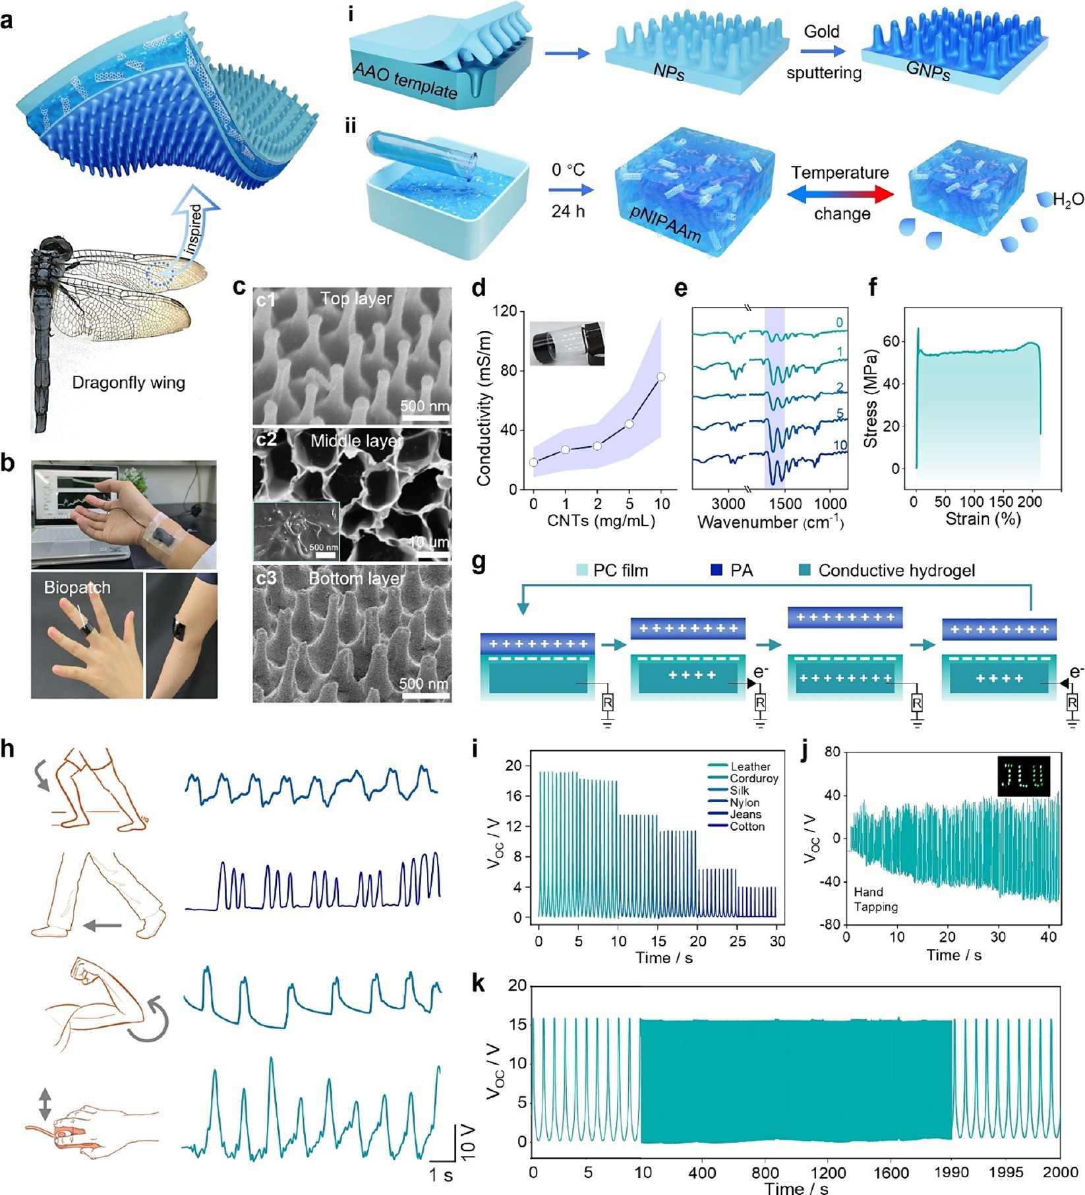
Figure 1. Design and characterization of the intelligent biomimetic nanopillared biopatch. a) Schematic of the preparation of intelligent biomimetic nanopillared biopatch. b) Digital photo of the intelligent biopatch worn on the human joints. c) SEM images of c1) nanopillars (NPs), c2) pNIPAAm hydrogel, and c3) gold-coated nanopillars (GNPs). The interior image of c2 is a typical SEM image of pNIPAAm hydrogel doped with CNTs. d) Conductivity of pNIPAAm hydrogels mixed with CNTs at different concentrations. e) FTIR-ATR spectra of pNIPAAm hydrogels. f) Stress−strain curves of the biopatch. g) A cycle of electricity generation process of the biopatch. h) The VOC of the biopatch applied to knee, ankle, elbow, and wrist of the human body under normal human activities (lifting the leg, walking, raising the arm, and moving the mouse). (i) The VOC of the six cloths in periodical contact and separation from the biopatch. Unless otherwise indicated, all triboelectric output tests are performed at a frequency of 2 Hz with a biopatch area of 2 × 4 cm2. j) VOC of the biopatch when the hand taps a 16 cm2-sized biopatch, and the inserted photograph is 28 colorful LEDs lightened by the biopatch. k) VOC output stability of the biopatch within 2000 s. The inserted left and right images showed zoom-in views of VOC within 10 s.
Meanwhile, electrical stimulation (ES) has also been recognized as another effective physical antimicrobial strategy to inhibit microbial growth. Sufficiently high electric fields (>107 V m−1) can cause irreversible damage to bacteria.22,23 However, applying such high electric fields typically requires external power equipment and carries significant safety risks.24−26 The triboelectric nanogenerator (TENG) represents a novel energy supply device capable of collecting tiny amounts of mechanical energy and converting it into periodic electrical pulses, featuring controllable parameters, portable design, and high electrical safety.27−29 While ES from TENG-based devices has been employed for antibacterial treatments, its low-voltage largely limits its antibacterial effect.30,31 Thus, it is often combined with other therapeutic strategies for enhancing its antibacterial efficacy.32,33 Combining a TENG device with the controlled release of the antibiotic minocycline has produced notable antibacterial performances, effectively sidestepping the hazards linked to high-voltage fields.34 However, this approach still carries the risk of AMR inherent to the use of antibiotics.
Herein, we ingeniously combine mechano-bactericidal nanopillar with self-powered low-voltage ES to realize a purely physical antibacterial strategy. It offers enhanced antibacterial efficiency, electrical safety, and the avoidance of AMR, which is highly significant, and remains unreported to date. First, an intelligent biomimetic nanopillared biopatch is developed, which is assisted by a TENG unit. Owing to the synergy between the low-voltage (8 V) ES from the TENG and biomimetic nanopillars, the biopatch demonstrates antibacte- rial efficiencies of up to 99.95%, 99.87%, 99.82%, and 99.77% against E. coli, S. aureus, S. epidermidis, and MRSA, respectively. This is a significant improvement over the antibacterial rates of 87.86%, 53.29%, 50.92% and 48.54%, respectively, which is observed on nanopillared surfaces without ES assistance. Additionally, this intelligent biopatch displays excellent capabilities in promoting mammalian cell proliferation and wound repair, rapidly healing S. aureus-infected wounds in mice. Furthermore, the conductive poly- (Nisopropylacrylamide) (pNIPAAm) hydrogel incorporated into the biopatch acts as a sensitive thermal sensing module, facilitating smart monitoring of the temperature around the wound site. Our work successfully provides a proof-of-concept for a highly efficient, purely physical, and safe therapeutic strategy to repair infected wounds.
The intelligent biopatch was prepared by encapsulating a conductive pNIPAAm hydrogel into polycarbonate (PC) films (Figure 1a, b). The PC surface features delicate biomimetic nanopillars, which were fabricated using a nanoimprint technique with anodic aluminum oxide nanowells as a template (Figure S1), closely resembling the nanopillars found on dragonfly wings (Figure S2−S3). To improve surface conductivity, a gold layer was sputtered onto the nanopillared PC surface (GNPs, Figure 1c3) which contact with the wound bed. The other side of the biopatch is also a nanopillared PC film without gold layer (NPs, Figure 1c1), serving as the negative friction layer separated from the fabric. Afterward, pNIPAAm hydrogels mixed with various concentrations of carbon nanotubes (CNTs) were prepared as the embedded intermediate layer in the biopatch (Figure 1c2 and Figure S4− S5). As the concentration of CNTs increased from 0 mg/mL to 10 mg/mL, the conductivity of the pNIPAAm hydrogel gradually increased from 22.8 mS/m to 94 mS/m (Figure 1d). FT-IR spectroscopy displayed that pNIPAAm exhibited characteristic absorption peaks corresponding to typical amide I C=O stretching band (∼1650 cm−1) and amide II N-H vibration band (∼1550 cm−1).35,36 The FT-IR spectra of the pNIPAAm hydrogels with incorporated CNTs exhibited similar absorptions to the pure pNIPAAm spectra, confirming that the CNTs did not affect hydrogel formation (Figure 1e). The mechanical properties of the biopatch were assessed using stress−strain curves. The biopatch exhibited a tensile strength of ∼55 MPa and a strain at the point of breakage of ∼214% (Figure 1f). During normal daily use of the electronic skin patch, the tensile strain usually does not exceed 150%, demonstrating that the biopatch possesses robust mechanical tensile capabilities sufficient to withstand high-strength demands.37
Subsequently, the electrical output performance of the biopatch was evaluated. The top PC layer of the biopatch and a cloth fabric (Polyamide, PA) were combined to form a frictional electric pair, with the conductive hydrogel (contain- ing 10 mg/mL CNTs) acting as a single electrode in this TENG system. During human movement, the fabric contacts and separates from the biopatch, generating an electrical output signal (Figure 1g). The electrical output capability of TENGs is commonly characterized by the open-circuit voltage (V_{OC}), short-circuit current (I_{SC}), and charge transfer (Q_{SC}). Obviously, the TENG composed of nanopillared PC films exhibits better output performance compared to the TENG composed of flat PC films. The V_{OC}, I_{SC}, and Q_{SC} of the biopatch with NPs are about 12.5 V, 90 nA, and 4 nC, respectively. In contrast, the biopatch without NPs exhibits the related values of about 8 V, 50 nA, and 2.8 nC, respectively (Figure S6). The nanopillared biopatch (2 × 4 cm2) was attached to four representative human joints (knee, ankle, elbow, and wrist), and the measured V_{OC} during movement exceeded 8 V in all cases (Figure 1h). This result demonstrates that the TENG-based biopatch can effectively convert mechanical energy from human movement into electrical energy (Videos S1−S4). Figure 1i displays that the biopatch generated a good output voltage when in contact with various clothing materials, including leather, corduroy, silk, nylon, jeans, and cotton, indicating its excellent applicability. To further demonstrate the output performance, a biopatch with an area of 16 cm2 was fabricated, capable of illuminating 28 LED lights with a simple hand tap (Figure 1j and Video S5). The biopatch demonstrated excellent fatigue resistance, showing virtually no fluctuations in the output electrical signal even after more than 2000 cycles of contact and separation (Figure 1k). Additionally, the electrical output remained virtually unchanged even after 21 days of storage (Figure S7), indicating its excellent stability and prolonged lifespan.
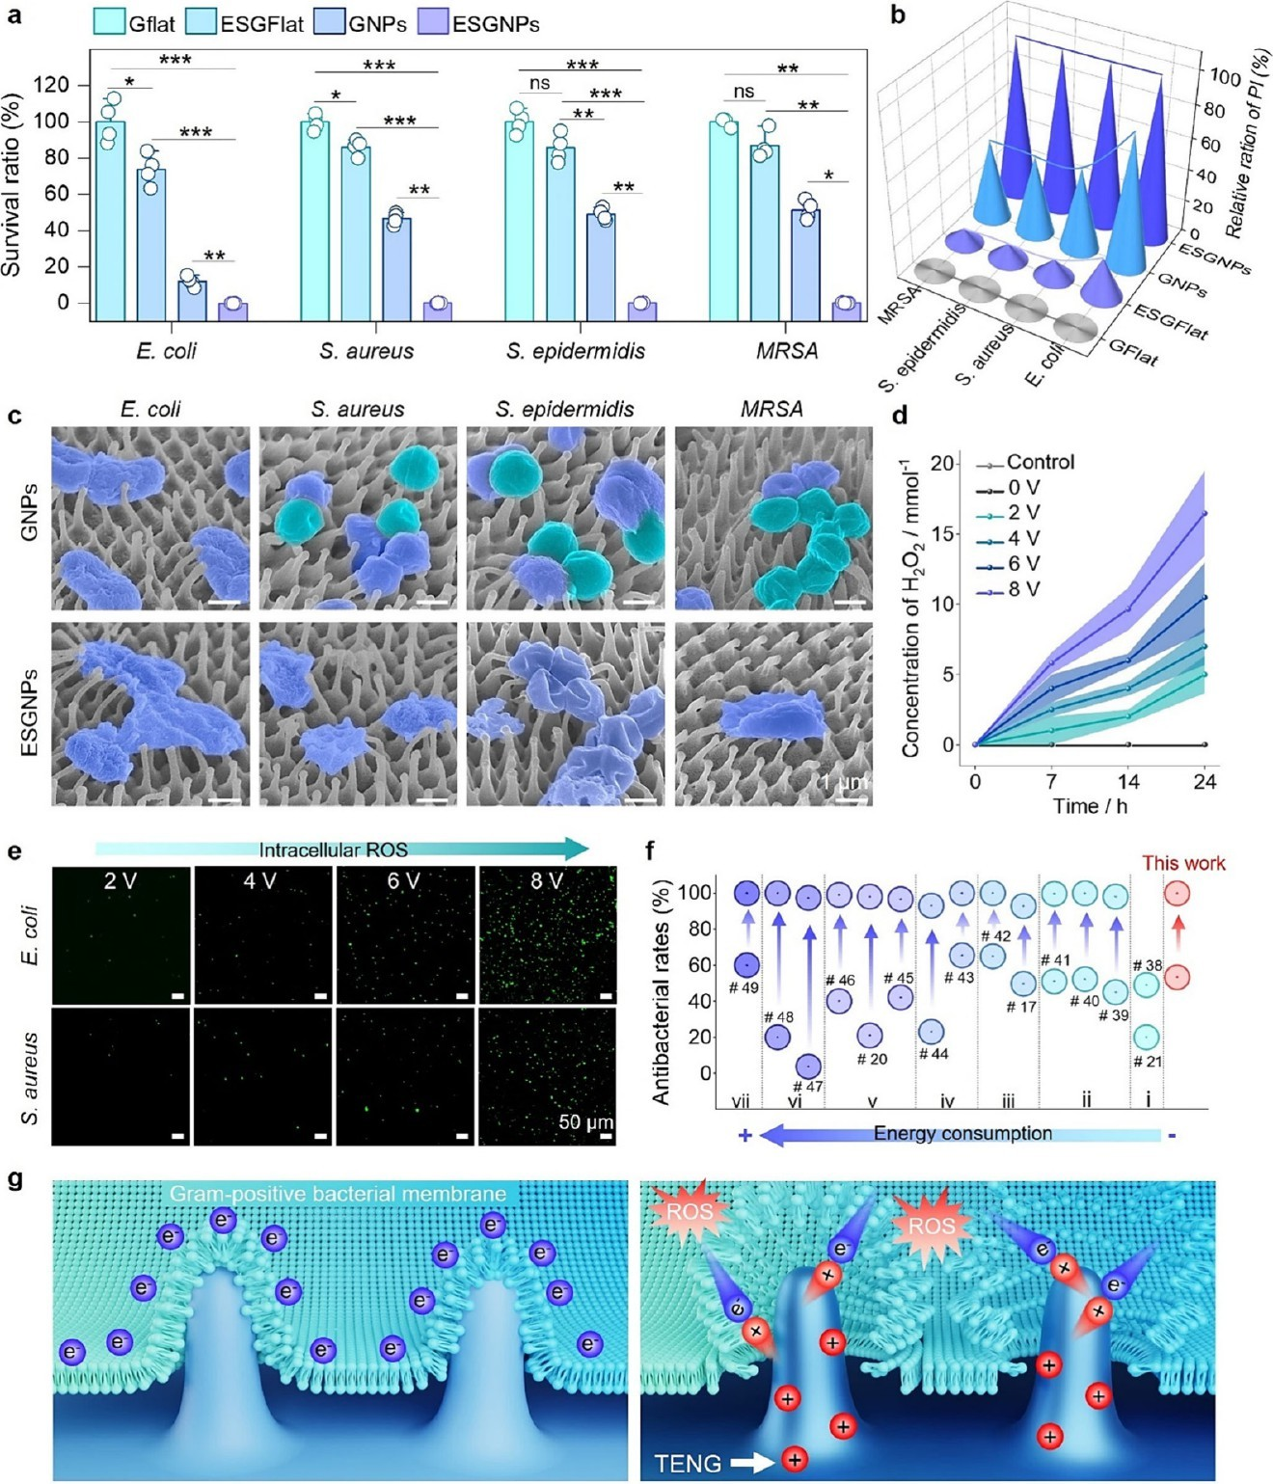
Figure 2. Synergistic antibacterial properties of nanopillars and ES from the biopatch. a) Survival ratio of various samples (GFlat: gold-coated flat surface; ESGFlat: gold-coated flat surface under 8 V TENG-based ES; GNPs: gold-coated nanopillars; ESGNPs: gold-coated nanopillars under 8 V TENG-based ES) against E. coli, S. aureus, S. epidermidis, and MRSA. b) Quantitative analysis of live/dead staining images of samples against E. coli, S. aureus, S. epidermidis, and MRSA. c) Representative SEM images of bacterial cells adhered to the samples. These images are processed with false colors, where green represents live bacteria and purple represents dead bacteria. d) Concentration of H2O2 generated by the TENG-induced ES under different voltages within 24 h. e) Fluorescent staining images showing intracellular reactive oxygen species (ROS) levels in the bacteria on different samples. f) Compared to various strategies that enhance the antibacterial performance of nanopillars, the low-voltage ES approach demonstrates a unique combination of high antibacterial efficiency and low energy consumption. These strategies include: i, Pure mechano- bactericidal,21,38 ii, Cation-enhanced mechano-bactericidal,39−41 iii: Antibiotics or biocides-assisted mechano-bactericidal,17,42 iv: Photodynamic- enhanced mechano-bactericidal,43,44 v: Photothermally enhanced mechano-bactericidal,45,20,46 vi: Photothermally and photodynamic synergies- enhanced mechano-bactericidal,47,48 vii: Capacitor charging-enhanced mechano-bactericidal.49 g) Schematic illustrating the impact of nanopillars and ES on bacteria. The left image depicts the Gram-positive bacterial membrane on the GNPs surface. The right image shows the damage to bacteria on a ESGNPs surface.
Exposed wounds are susceptible to bacterial infections, heavily hindering the wound healing process. Hence, it is essential for wound patches to possess antibacterial properties. Initially, Gram-negative Escherichia coli (E. coli) and three typical Gram-positive bacteria: Staphylococcus aureus (S. aureus), Staphylococcus epidermidis (S. epidermidis), and MRSA were used to investigate the antimicrobial properties of GNPs under TENG-based ES (ESGNPs). Considering the biopatch’s output voltage ranges from 8 to 20 V under normal human physiological activities (Figure 1h), we conducted antibacterial experiments at a lower limit (output voltage = 8 V) (Figure S8). The individual GNPs exhibit bactericidal rates of 87.86% against E. coli, 53.29% against S. aureus, 50.92% against S. epidermidis, and 48.54% against MRSA. In contrast, the ESGNPs surfaces show significantly higher bactericidal rates: 99.95% against E. coli, 99.87% against S. aureus, 99.82% against S. epidermidis, and 99.77% against MRSA, respectively (Figure 2a and Figure S9). Obviously, ES substantially improves the antibacterial effectiveness of the nanopillars, particularly against the three resistant Gram-positive bacteria. Interestingly, the ES effect on GFlat surfaces is comparatively poor, with bactericidal rates of ∼26.31% against E. coli, ∼13.89% against S. aureus, ∼14.40% against S. epidermidis, and ∼13.11% against MRSA. Confocal laser scanning microscopy (CLSM) images show that a substantial number of active Gram-positive bacteria, stained green, remained visible on the GNPs surfaces (Figure S10). However, virtually no viable bacterial cells were observed on the ESGNPs surfaces. The antimicrobial trends observed through live/dead staining aligned with the colony-counting method results (Figure 2b). The ES-enhanced antibacterial action was further investigated through morphological characterization of the adherent bacteria. As shown in Figure S11, both the GFlat and ESGFlat surfaces are covered with typical rod-shaped E. coli. In contrast, most E. coli on the GNPs surfaces show a collapsed state (Figure 2c). Upon the introduction of ES, the ESGNPs surfaces cause even more severe bacterial membrane damage and distinct nanopillar tips are exposed. Similarly, the three Gram-positive bacteria display a similar morphological change trend. They are smooth spherical shapes on the GFlat and ESGFlat surfaces, a few collapsed membranes on the GNPs surfaces, and more pronounced bacterial morphological damage of atrophy and disruption on the ESGNPs surfaces.
Unlike existing TENGs that use pulsed high electric fields (>100 V) to induce electroporation, the lower voltage is less likely to cause bacterial membrane perforation. To clarify the enhanced antibacterial mechanism, we analyzed the H2O2 concentrations and pH values at intervals during the ES treatments. Obviously, even after 24 h of ES, the H2O2 concentrations reach only 16.5 mM (Figure 2d), lower than the minimum bactericidal concentration of H2O2 (22.98 mM). Additionally, no significant pH changes were observed in the bacterial medium (Figure S12). Thus, we are ruling out the antimicrobial mechanism of ES-induced changes in H2O2 or pH levels. The potential difference generated by the TENG may disrupt the electron balance in the bacterial cellular respiratory chain, leading to increased intracellular reactive oxygen species (ROS) levels. The intracellular ROS were detected using the green fluorescent probe DCFH-DA. Fluorescence microscopy images reveal no emissions from bacterial cells on both GFlat and GNPs surfaces, indicating that neither the gold layer nor the nanopillars significantly induce intracellular ROS (Figure S13). However, as the voltage increases from 2 to 8 V, the intensity of green fluorescence on the nanopillars also increases, suggesting enhanced generation of ROS and promoting the oxidation process of nonfluorescent DCFH to fluorescent DCF (Figure 2e).30 In short, electrons from the bacterial electron transport chain (ETC) are captured by the GNPs under the TENG-based ES. As electron donors, the bacterial internal components are oxidized when electrons are depleted by the charged nanopillared surface, leading to increased intracellular ROS levels through energy-consuming biochemical reactions. This weakens the bacteria, making even stubborn Gram-positive bacteria more vulnerable and their cell membranes more easily penetrable (Figure 2g).
Incorporating strategies such as antibiotics, biocides, photo- dynamic therapy (PDT), and photothermal therapy (PTT) can significantly enhance the antibacterial efficiency of nanopillared surfaces, achieving over 99% eradication of Gram-positive bacteria (Figure 2f). However, the use of biochemical agents may lead to AMR and environmental pollution. Additionally, light-excited strategies are constrained by factors such as light penetration depth, portability, and the need for external equipment. This TENG-based, low-voltage ES-enhanced nanopillared antibacterial strategy does not require any biochemical reagents or external power sources, thereby reducing the risk of AMR and promoting environment sustainability.
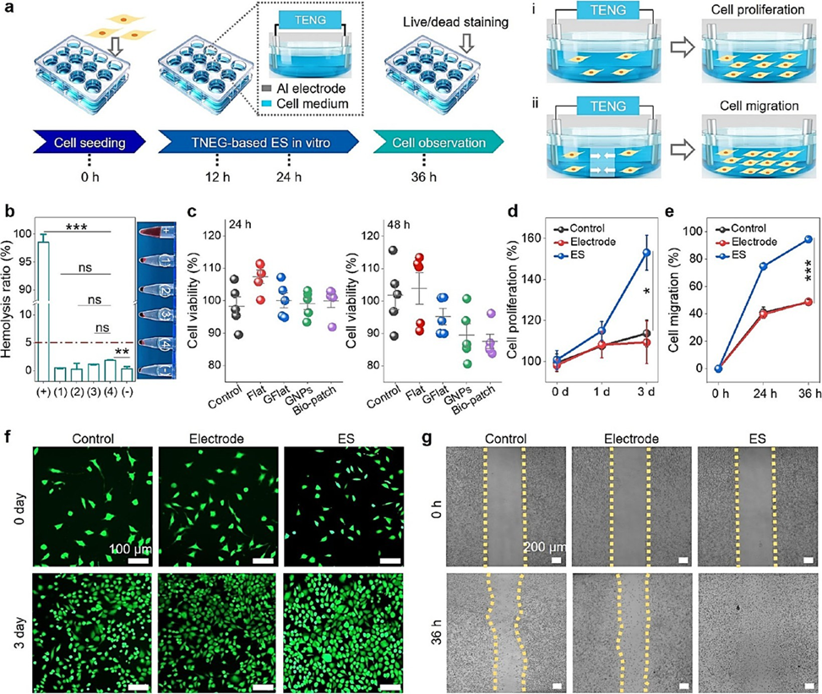
Figure 3. Evaluation of biocompatibility of the biopatch and effect of TENG-induced ES on cellular behavior. a) Schematic showing the effects of ES from the TENG-based biopatch on cell proliferation and migration. b) Hemolysis ratio of (1) Flat, (2) GFlat, (3) GNPs, and (4) Biopatch. c) Cell viability of L929 normal fibroblasts about the samples after 24 and 48 h of coculture. d) Cell proliferation of fibroblasts after 3 days of ES. e) Corresponding cell migration ratio of fibroblasts under ES compared to the control groups. f) Fluorescence images of fibroblasts after ES recorded on days 0 and 3. g) Cell migration images of fibroblasts after 36 h of ES.
The biocompatibility of the samples was assessed using hemolysis and cytotoxicity assays in vitro. As shown in Figure 3b, no significant hemolysis is observed in all experimental samples compared to the positive controls. The CCK-8 assay shows that the relative cell viability of all samples exceeded 85%, and only a few dead cells (stained red) are observed in the live/dead staining assay after 24 and 48 h of coculture, demonstrating good cytocompatibility (Figure 3c and Figure S14). Subsequently, the effect of ES on fibroblasts in vitro was evaluated by observing cell proliferation and migration (Figure 3a). The results show a 30% increase in fibroblast growth after 3 days of coculture in the ES group compared to the control and electrode groups (Figure 3d). Furthermore, cell morphol- ogy remains normal in all groups, indicating the safety of an 8 V alternating current low-intensity electric field for fibroblast cells (Figure 3f). Additionally, ES from the biopatch facilitates the directional migration of fibroblast cells within 36 h, displaying a 2-fold increase compared to the control and electrode groups (Figure 3e and 3g). The biopatch’s ability to enhance fibroblast activity demonstrates its potential to promote wound healing.
A full-thickness wound with a diameter of 8 mm was created on the backs of BALB/c mice and subsequently infected with S. aureus (1 × 108 CFUs/mL) to evaluate the synergistic therapeutic effects of ES and mechano-bactericidal behavior (Figure 4a and Figure S15). It is observed that the wound area in the ESGNPs group closes fastest and recovers best in all tested groups (Figure 4b, c and Figure S16). On day 9, the average relative wound area decreases to ∼1.18% in the ESGNPs group, ∼7.56% in the GNPs group, 15.14% in the ES group, and ∼23.08% in the Control group (without any therapy) (Figure 4e and f). Throughout the treatment duration, a reduction in body weight was observed in all groups on the first day postsurgery, which can be attributed to the recovery from anesthesia. Subsequently, the weight of the mice in the treatment groups gradually increased, with the mice in the ESGNPs group experiencing the fastest weight gain (Figure 4d). Representative plate photographs show that the inhibition rate of S. aureus by the ESGNPs group is ∼97.04% on day 9, while for the GNPs, ES, and Control groups are ∼81.06%, ∼62.72%, and ∼45.43%, respectively (Figure 4g and Figure S17). In short, the mechano-bactericidal strategy and ES can work synergistically to inhibit bacterial growth and promote wound healing.
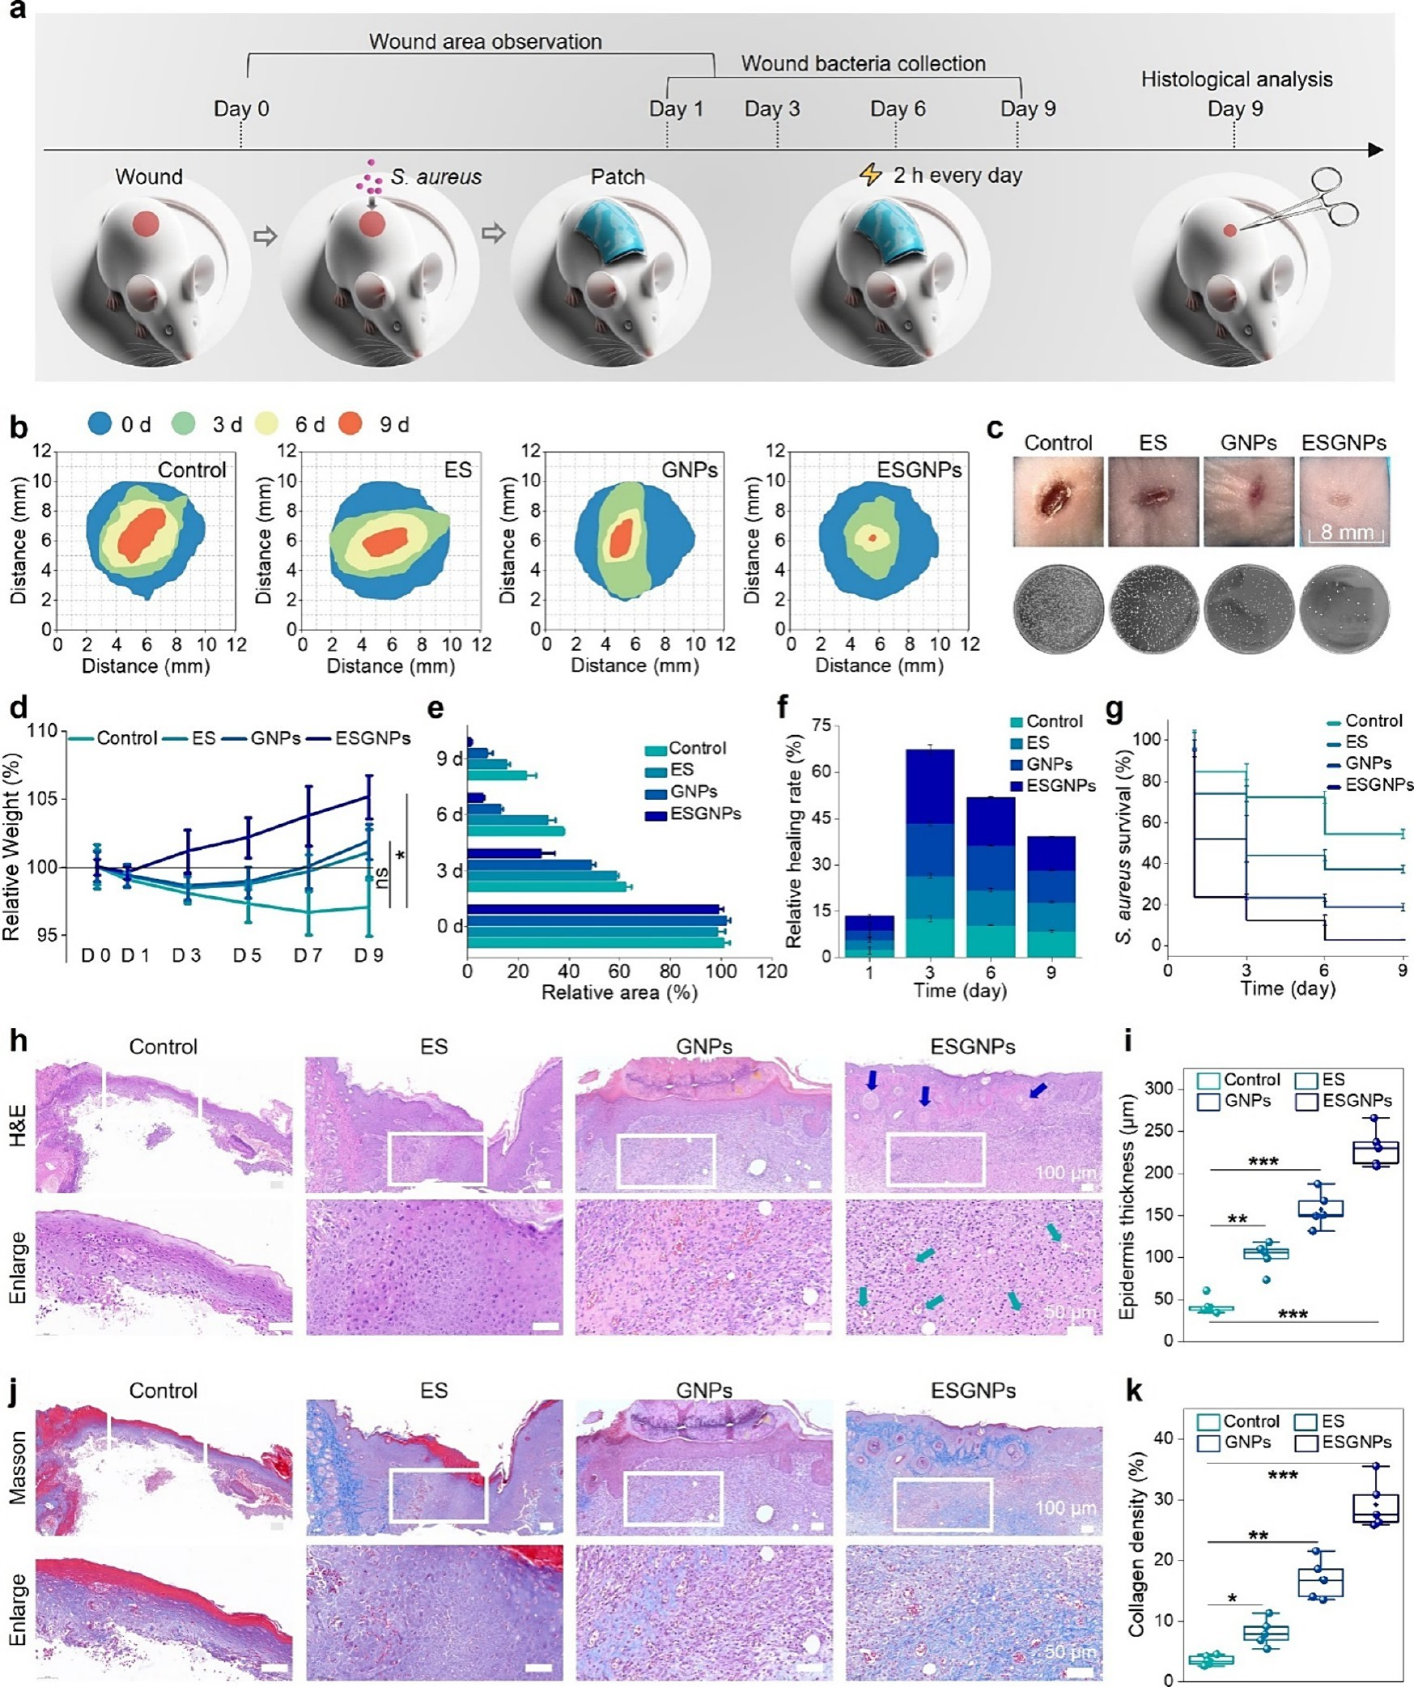
Figure 4. In vivo anti-infection and wound healing evaluation of the biopatch. a) Schematic diagram of the wound healing experiment. b) Schematic of wound area changes on days 0, 3, 6, and 9 in Control, ES, GNPs, ESGNPs groups. c) Digital photos of wounds and representative plate photographs of S. aureus collected from the wounds for different treatment groups taken on day 9. d) Weight changes of each group on days 0, 1, 3, 5, 7, and 9. e) Quantitative data of wound contraction area at different time points. f) Relative wound healing rate for different treatment groups at various time points. g) Survival ratios of bacterial cells collected from the wound area for different treatment groups on days 1, 3, 6, and 9. h) H&E staining images of wounds in different groups after 9 days. (i) Statistical analysis of epithelium thickness based on H&E staining images (n= 5). j) MT staining images of wounds in different groups at 9 days. k) Statistical analysis of collagen density based on MT staining images (n = 5).
Hematoxylin and eosin (H&E) and Masson trichrome (MT) staining were further conducted on day 9 to evaluate the refilling of the wound beds. The epidermal thickness in the wound treated with ESGNPs is significantly higher (230.71 μm) compared to the Control (42.13 μm), ES (101.34 μm), and GNPs (157.19 μm) groups (Figure 4i). Notably, clear cutaneous appendages, such as hair follicles (blue arrows) and neovascularization (green arrows), are visible in the new epithelium of the ESGNPs group (Figure 4h). It indicates that the wound has undergone a stage of wound remodeling, and the new tissue appear to be more mature and closer to normal tissue. Additionally, the ESGNPs group show large amounts of regularly and tightly arranged collagen fibers in the MT staining (Figure 4j). The collagen volume fractions are approximately 3.53%, 8.11%, 16.89%, and 29.22% for the Control, ES, GNPs, and ESGNPs groups, respectively (Figure 4k). These results confirm that the biopatch can effectively repair infected wounds by inhibiting bacterial growth, followed by treatment with ES on demand to promote wound regeneration, thus achieving a better healing effect.
In this system, the conductive pNIPAAm hydrogel not only serves as an electrode but also functions as a temperature sensor for real-time wound status monitoring. This is because a phase separation phenomenon occurs when the pNIPAAm hydrogel is heated above its lower critical solution temperature (LCST, ∼ 32 °C). During this process, the pNIPAAm undergoes volume shrinkage, and the CNTs aggregate, leading to a decrease in the hydrogel’s resistance (Figure 5a). Figure 5b illustrates the negative thermosensitive property of this hydrogel-based temperature sensor, showing a linear thermal response signal during the heating process, with a calculated a temperature coefficient of resistance (TCR) value of -0.92%°C⁻¹ (R² = 0.988). The temperature discrimination capability of the hydrogel sensor is shown in Figure 5c. It displays significant differences in relative resistance changes at hot (70 °C) and cold (30 °C) temperatures. The deviation of the output signal at each temperature is negligible, indicating strong repeatability and stability. Additionally, the sensor exhibits good transient thermosensitive ability. When exposed to a heat source (70 °C), the resistance rapidly decreases due to its negative temperature coefficient. Conversely, when exposed to a cold source (30 °C), the resistance increases (Figure 5d).
The biopatch is further employed as an inflammation indicator by quantitatively monitoring temperature changes of S. aureus-infected wounds in mice. An increase in temperature signifies undergoing inflammation, whereas a decrease indicates reducing inflammation. Initially, the wound, newly infected with S. aureus but not yet inflamed, exhibits a normal temperature of 33.7 °C, with the hydrogel sensor’s resistance measuring around 45.7 kΩ (Figure 5e1). As inflammation begins, the wound temperature increases to 37.5 °C, with a sharp decrease in sensor resistance to about 44.1 kΩ. After treatment with the intelligent biopatch, inflammation reduces, normalizing the temperature to 34 °C and the resistance to approximately 45.5 kΩ (Figure 5e2). The reliable thermo- sensitive response of the biopatch is further confirmed by infrared thermal imaging, which distinctly captures significant temperature change during the wound’s inflammatory and healing stages. Additionally, the hydrogel-based temperature sensor was utilized to monitor simulated human fever. At a normal forehead temperature of 36.5 °C, the sensor’ resistance measures about 44.6 kΩ. When the temperature increases to 39.2 °C (fever state), the resistance decreases sharply to around 31.5 kΩ (Figure 5f1). As the temperature decreases from 39 to 37.3 °C (recover state), the resistance increases from 32 kΩ to 44.3 kΩ (Figure 5f2). The sensor’s high- temperature resolution makes it suitable as a “fever indicator”.
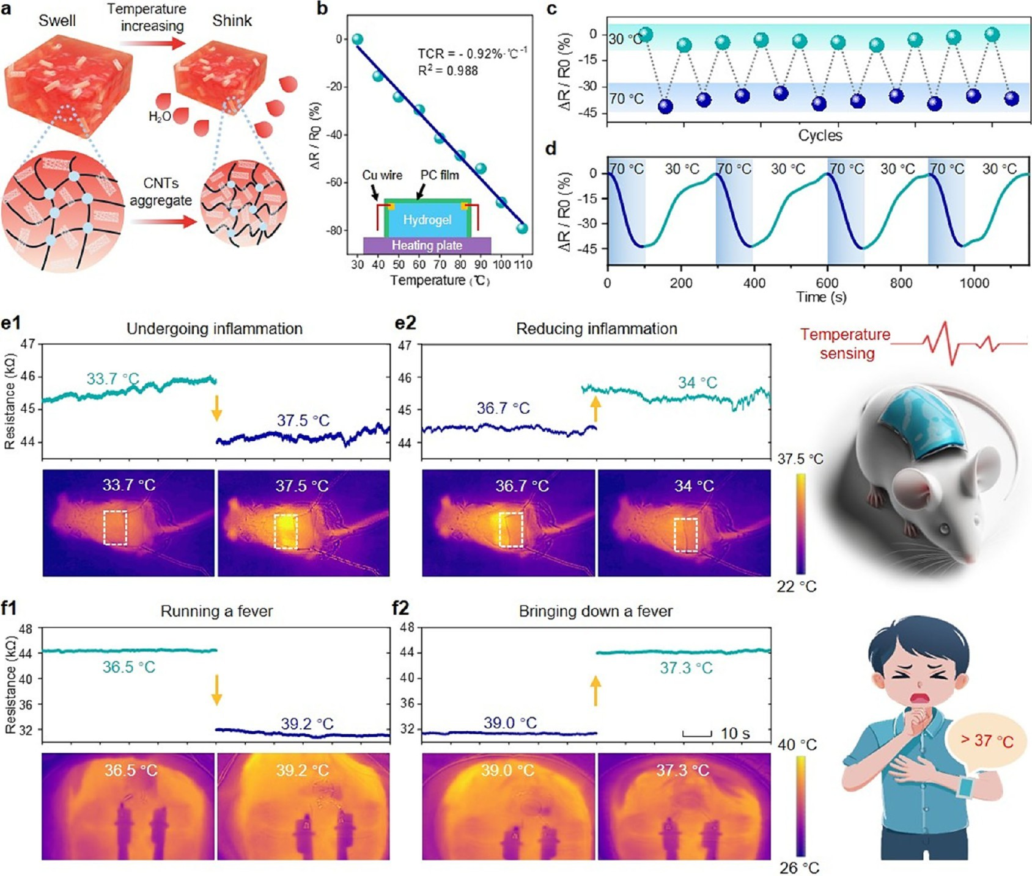

Figure 5. Temperature-sensing properties of intelligent biomimetic nanopillared biopatch. a) Schematic illustrating the working principle of temperature monitoring using the hydrogel-based sensor. b) Normalized relative resistance variation of the conductive pNIPAAm hydrogel sensor across a temperature range of 30 to 110 °C. Temperature coefficient of resistance TCR = [(RT − R0)/R0]/δT, where RT is the instantaneous resistance at the measured temperature, and R0 is the original resistance. c) Repetitive temperature discrimination ability of the hydrogel sensor during cycles of cooling and heating between 30 and 70 °C. d) Instantaneous resistance change signal of the hydrogel sensor in response to stimuli at 30 and 70 °C. e1) Real-time resistance changes of the hydrogel sensor during inflammation and e2) healing processes of S. aureus-infected wounds, along with corresponding infrared thermal images before and after inflammation. f1) Real-time resistance changes and infrared thermal images of the human forehead before and f2) after inducing “artificial fever.”
In conclusion, an intelligent biomimetic nanopillared biopatch with low voltage-enhanced mechano-bactericidal action and temperature sensing capabilities was developed. With the assistance of TENG-based low-voltage ES (8 V), the biopatch significantly enhances the bactericidal effect of nanopillars, especially against stubborn Gram-positive bacteria. The efficacy against E. coli increases from 87.86% to 99.95%, S. aureus from 53.29% to 99.87%, S. epidermidis from 50.92% to 99.82%, and MRSA from 48.54% to 99.77%. Both the mechano-bactericidal action and ES are physically antimicro-bial mechanisms, with no risk of inducing AMR. Moreover, the TENG-based ES stimulates rapid fibroblast proliferation and migration. Owing to its excellent antibacterial properties and ability to promote fibroblast activity, the biopatch successfully healed the S. aureus-infected wound by day 9. The pNIPAAm hydrogel functions both as an electrode and a temperature sensor, providing safe, intelligent wound management. This highly integrated biopatch is user-friendly, noninvasive, and effective for chronic wound healing.

ASSOCIATED CONTENT
Materials and methods, SEM image of AAO templates (Figure S1), SEM images of the dragonfly wing prototype (Figure S2), statistical diagram of nanopillar morphological dimensions (Figure S3), SEM images of CNTs (Figure S4), SEM images of conductive pNIPAAm hydrogel (Figure S5), VOC, ISC and Qsc of the biopatch (Figure S6), output voltage of the biopatch at 0, 7, 14, and 21 d (Figure S7), schematic diagram of the antibacterial experiment design (Figure S8), representative plate photographs for bacteria (Figure S9), real-time bacterial viability obtained via live/dead staining (Figure S10), representative SEM images of bacterial cells (Figure S11), pH variation in PBS medium (Figure S12), fluorescent staining images of intracellular ROS in bacteria (Figure S13), live/dead staining images of L929 cells (Figure S14), photographs of the biopatch treating mouse wounds (Figure S15), representative wound images (Figure S16), and representative wound images (Figure S17)
(Video S1) Electrical output performance of the patch applied to the knee under normal human activity (lifting the leg) (MP4)
(Video S2) Electrical output performance of the patch applied to the ankle under normal human activity (simulating walking) (MP4)
(Video S3) Electrical output performance of the patch applied to the elbow under normal human activity (raising the arm) (MP4)
(Video S4) Electrical output performance of the patch applied to the wrist under normal human activity (moving the mouse) (MP4)
(Video S5) Tap the wound patch to light the LED (MP4)
Author Contributions
J.Z., S.W., and S.N. conceived the study; Y.Y. designed the experiments and wrote the manuscript with help from all the authors; Y.Y., H.D., Z.L., Y. C., L.X., C.Z., C.L., Z.H., and L.R. performed the experiments or provided essential experimental resources; H.D. drew the figures and assisted in optimizing the experiments. All authors discussed the experimental data and results.
Notes: The authors declare no competing financial interest.
ACKNOWLEDGMENTS
The authors gratefully acknowledge the financial support through the National Science Foundation of China (No. 52375290, 52075218), Foundation for Innovative Research Groups of the National Natural Science Foundation of China (No. 52021003), National Natural Science Foundation of China Excellent Youth Fund (No. 52222509), Science and Technology Development Program of Jilin Province (No. SKL202402005), “Fundamental Research Funds for the Central Universities”, Young and Middle-aged Technology Innovation Leading Talents and the Team Projects of Science and Technology Development Plan of Jilin Province (20230508041RC).
References
(1) Jiang, Y.; Trotsyuk, A. A.; Niu, S.; Henn, D.; Chen, K.; Shih, C. C.; Larson, M. R.; Mermin-Bunnell, A. M.; Mittal, S.; Lai, J.-C.; Saberi, A.; Beard, E.; Jing, S.; Zhong, D.; Steele, S. R.; Sun, K.; Jain, T.; Zhao, E.; Neimeth, C. R.; Viana, W. G.; Tang, J.; Sivaraj, D.; Padmanabhan, J.; Rodrigues, M.; Perrault, D. P.; Chattopadhyay, A.; Maan, Z. N.; Leeolou, M. C.; Bonham, C. A.; Kwon, S. H.; Kussie, H. C.; Fischer, K. S.; Gurusankar, G.; Liang, K.; Zhang, K.; Nag, R.; Snyder, M. P.; Januszyk, M.; Gurtner, G. C.; Bao, Z. Wireless, Closed- Loop, Smart Bandage with Integrated Sensors and Stimulators for Advanced Wound Care and Accelerated Healing. Nat. Biotechnol. 2023, 41 (5), 652−662.
(2) Lokwani, R.; Josyula, A.; Ngo, T. B.; DeStefano, S.; Fertil, D.; Faust, M.; Adusei, K. M.; Bhuiyan, M.; Lin, A.; Karkanitsa, M.; Maclean, E.; Fathi, P.; Su, Y.; Liu, J.; Vishwasrao, H. D.; Sadtler, K. Pro-Regenerative Biomaterials Recruit Immunoregulatory Dendritic Cells after Traumatic Injury. Nat. Mater. 2024, 23 (1), 147−157.
(3) Chen, Y.; Wei, S.; Li, R.; Xie, W.; Yang, H. Bioclay Enzyme with Bimetal Synergistic Sterilization and Infectious Wound Regeneration. Nano Lett. 2024, 24 (26), 8046−8054.
(4) Gugger, M. K.; Hergenrother, P. J. A New Type of Antibiotic Targets a Drug-Resistant Bacterium. Nature 2024, 625 (7995), 451−452.
(5) Li, J.; Wang, C.; Wu, S.; Cui, Z.; Zheng, Y.; Li, Z.; Jiang, H.; Zhu, S.; Liu, X. Superlattice Nanofilm on a Touchscreen for Photoexcited Bacteria and Virus Killing by Tuning Electronic Defects in the Heterointerface. Adv. Mater. 2023, 35 (22), 2300380.
(6) Linklater, D. P.; Ivanova, E. P. Nanostructured Antibacterial Surfaces - What Can Be Achieved? Nano Today 2022, 43, 101404.
(7) Zhang, F.; Zhuang, J.; Li, Z.; Gong, H.; de Ávila, B. E.-F.; Duan, Y.; Zhang, Q.; Zhou, J.; Yin, L.; Karshalev, E.; Gao, W.; Nizet, V.; Fang, R. H.; Zhang, L.; Wang, J. Nanoparticle-Modified Microrobots for in Vivo Antibiotic Delivery to Treat Acute Bacterial Pneumonia. Nat. Mater. 2022, 21 (11), 1324−1332.
(8) Ivanova, E. P.; Hasan, J.; Webb, H. K.; Truong, V. K.; Watson, G. S.; Watson, J. A.; Baulin, V. A.; Pogodin, S.; Wang, J. Y.; Tobin, M. J.; Löbbe, C.; Crawford, R. J. Natural Bactericidal Surfaces: Mechanical Rupture of Pseudomonas Aeruginosa Cells by Cicada Wings. Small 2012, 8 (16), 2489−2494.
(9) Linklater, D. P.; Baulin, V. A.; Juodkazis, S.; Crawford, R. J.; Stoodley, P.; Ivanova, E. P. Mechano-Bactericidal Actions of Nanostructured Surfaces. Nat. Rev. Microbiol. 2021, 19 (1), 8−22.
(10) Chu, G.; Guan, M.; Jin, J.; Luo, Y.; Luo, Z.; Shi, T.; Liu, T.; Zhang, C.; Wang, Y. Mechanochemically Reprogrammed Interface Orchestrates Neutrophil Bactericidal Activity and Apoptosis for Preventing Implant-Associated Infection. Adv. Mater. 2024, 36 (16), 2311855.
(11) Zhao, S.; Li, Z.; Linklater, D. P.; Han, L.; Jin, P.; Wen, L.; Chen, C.; Xing, D.; Ren, N.; Sun, K.; Juodkazis, S.; Ivanova, E. P.; Jiang, L. Programmed Death of Injured Pseudomonas Aeruginosa on Mechano-Bactericidal Surfaces. Nano Lett. 2022, 22 (3), 1129−1137.
(12) Wang, Y.; Yang, Y.; Shi, Y.; Song, H.; Yu, C. Antibiotic-Free Antibacterial Strategies Enabled by Nanomaterials: Progress and Perspectives. Adv. Mater. 2020, 32 (18), 1904106.
(13) Yang, R.; Zhao, P.; Wang, L.; Feng, C.; Peng, C.; Wang, Z.; Zhang, Y.; Shen, M.; Shi, K.; Weng, S.; Dong, C.; Zeng, F.; Zhang, T.; Chen, X.; Wang, S.; Wang, Y.; Luo, Y.; Chen, Q.; Chen, Y.; Jiang, C.; Jia, S.; Yu, Z.; Liu, J.; Wang, F.; Jiang, S.; Xu, W.; Li, L.; Wang, G.; Mo, X.; Zheng, G.; Chen, A.; Zhou, X.; Jiang, C.; Yuan, Y.; Yan, B.; Zhang, J. Assessment of Visual Function in Blind Mice and Monkeys with Subretinally Implanted Nanowire Arrays as Artificial Photo- receptors. Nat. Biomed. Eng. 2024, 8 (8), 1018−1039.
(14) Chen, J. C.; Bhave, G.; Alrashdan, F.; Dhuliyawalla, A.; Hogan, K. J.; Mikos, A. G.; Robinson, J. T. Self-Rectifying Magnetoelectric Metamaterials for Remote Neural Stimulation and Motor Function Restoration. Nat. Mater. 2024, 23 (1), 139−146.
(15) Wandiyanto, J. V.; Cheeseman, S.; Truong, V. K.; Kobaisi, M. A.; Bizet, C.; Juodkazis, S.; Thissen, H.; Crawford, R. J.; Ivanova, E. P. Outsmarting Superbugs: Bactericidal Activity of Nanostructured Titanium Surfaces against Methicillin- and Gentamicin-Resistant Staphylococcus Aureus ATCC 33592. J. Mater. Chem. B 2019, 7 (28), 4424−4431.
(16) Pham, V. T. H.; Truong, V. K.; Orlowska, A.; Ghanaati, S.; Barbeck, M.; Booms, P.; Fulcher, A. J.; Bhadra, C. M.; Buividas, R.; Baulin, V.; Kirkpatrick, C. J.; Doran, P.; Mainwaring, D. E.; Juodkazis, S.; Crawford, R. J.; Ivanova, E. P. Race for the Surface”: Eukaryotic Cells Can Win. ACS Appl. Mater. Interfaces 2016, 8 (34), 22025− 22031.
(17) Liu, Z.; Yi, Y.; Wang, S.; Dou, H.; Fan, Y.; Tian, L.; Zhao, J.; Ren, L. Bio-Inspired Self-Adaptive Nanocomposite Array: From Non- Antibiotic Antibacterial Actions to Cell Proliferation. ACS Nano 2022, 16 (10), 16549−16562.
(18) Fujimoto, K.; Saito, A.; Kotsuchibashi, Y. Cicada-Wing-Inspired Nanopillar Hydrogels Consisting of Poly(Vinyl Alcohol) and Poly(Methacrylic Acid) for Capturing Bacteria through Their Flexibility and Wide Range of Motion. ACS Macro Lett. 2022, 11 (6), 727−732.
(19) Linklater, D. P.; Baulin, V. A.; Juodkazis, S.; Crawford, R. J.; Stoodley, P.; Ivanova, E. P. Mechano-Bactericidal Actions of Nanostructured Surfaces. Nat. Rev. Microbiol. 2021, 19 (1), 8−22.
(20) Zhao, X.; Xu, Z.; Wei, Z.; Sun, Y.; Zhou, Q. Nature-Inspired Mechano-Bactericidal Nanostructured Surfaces with Photothermally Enhanced Antibacterial Performances. Prog. Org. Coat. 2023, 182, 107599.
(21) Bhadra, C. M.; Khanh Truong, V.; Pham, V. T. H.; Al Kobaisi, M.; Seniutinas, G.; Wang, J. Y.; Juodkazis, S.; Crawford, R. J.; Ivanova, E. P. Antibacterial Titanium Nano-Patterned Arrays Inspired by Dragonfly Wings. Sci. Rep. 2015, 5 (1), 16817.
(22) Huo, Z.; Lee, D.; Jeong, J.; Kim, Y.; Kim, J.; Suh, I.; Xiong, P.; Kim, S. Microbial Disinfection with Supercoiling Capacitive Tribo- electric Nanogenerator. Adv. Energy Mater. 2022, 12 (15), 2103680.
(23) Liu, Y.; Wang, P.; Wang, C.; Yao, S.; Zhang, D. Self-Powered Electroporation Technologies Based on Triboelectric Nanogener- ators. Nano Energy 2024, 123, 109354.
(24) Conta, G.; Libanori, A.; Tat, T.; Chen, G.; Chen, J. Triboelectric Nanogenerators for Therapeutic Electrical Stimulation. Adv. Mater. 2021, 33 (26), 2007502.
(25) Tan, J.; Fan, Z.; Zhou, M.; Liu, T.; Sun, S.; Chen, G.; Song, Y.; Wang, Z.; Jiang, D.; Zhu, X.; Wang, F.; Zhao, Q.; Du, X. Adaptive Interfacial Materials and Implants for Visual Restoration. Adv. Funct. Mater. 2024, 34 (32), 2314575.
(26) Wang, F.; Liu, M.; Liu, C.; Huang, C.; Zhang, L.; Cui, A.; Hu, Z.; Du, X. Light Control of Droplets on Photo-Induced Charged Surfaces. Natl. Sci. Rev. 2023, 10 (1), nwac164.
(27) Shan, C.; Li, K.; Cheng, Y.; Hu, C. Harvesting Environment Mechanical Energy by Direct Current Triboelectric Nanogenerators. Nano-Micro Lett. 2023, 15 (1), 127.

(28) Li, G.; Wang, J.; He, Y.; Xu, S.; Fu, S.; Shan, C.; Wu, H.; An, S.; Li, K.; Li, W.; Wang, P.; Hu, C. Ultra-Stability and High Output Performance of a Sliding Mode Triboelectric Nanogenerator Achieved by an Asymmetric Electrode Structure Design. Energy Environ. Sci. 2024, 17 (7), 2651−2661.
(29) Wang, T.; Ouyang, H.; Luo, Y.; Xue, J.; Wang, E.; Zhang, L.; Zhou, Z.; Liu, Z.; Li, X.; Tan, S.; Chen, Y.; Nan, L.; Cao, W.; Li, Z.; Chen, F.; Zheng, L. Rehabilitation Exercise-Driven Symbiotic Electrical Stimulation System Accelerating Bone Regeneration. Sci. Adv. 2024, 10 (1), No. eadi6799.
(30) Jannesari, M.; Asadian, E.; Ejehi, F.; English, N. J.; Mohammadpour, R.; Sasanpour, P. Boosting On-Demand Anti- bacterial Activity Using Electrical Stimulations from Polypyrrole- Graphene Oxide Triboelectric Nanogenerator. Nano Energy 2023, 112, 108463.
(31) Tang, Q.; Ke, Q.; Chen, Q.; Zhang, X.; Su, J.; Ning, C.; Fang, L. Flexible, Breathable, and Self-Powered Patch Assembled of Electro- spun Polymer Triboelectric Layers and Polypyrrole-Coated Electrode for Infected Chronic Wound Healing. ACS Appl. Mater. Interfaces 2023, 15 (14), 17641−17652.
(32) Jannesari, M.; Ejehi, F.; English, N. J.; Mohammadpour, R.; Akhavan, O.; Shams, S. Triggering Triboelectric Nanogenerator Antibacterial Activities: Effect of Charge Polarity and Host Material Correlation. Chem. Eng. J. 2024, 486, 150036.
(33) Shi, S.; Si, Y.; Li, Z.; Meng, S.; Zhang, S.; Wu, H.; Zhi, C.; Io, W.-F.; Ming, Y.; Wang, D.; Fei, B.; Huang, H.; Hao, J.; Hu, J. An Intelligent Wearable Filtration System for Health Management. ACS Nano 2023, 17 (7), 7035−7046.
(34) Du, S.; Zhou, N.; Xie, G.; Chen, Y.; Suo, H.; Xu, J.; Tao, J.; Zhang, L.; Zhu, J. Surface-Engineered Triboelectric Nanogenerator Patches with Drug Loading and Electrical Stimulation Capabilities: Toward Promoting Infected Wounds Healing. Nano Energy 2021, 85, 106004.
(35) Deng, Z.; Hu, T.; Lei, Q.; He, J.; Ma, P. X.; Guo, B. Stimuli- Responsive Conductive Nanocomposite Hydrogels with High Stretchability, Self-Healing, Adhesiveness, and 3D Printability for Human Motion Sensing. ACS Appl. Mater. Interfaces 2019, 11 (7), 6796−6808.
(36) Tan, J.; Fan, Z.; Zhou, M.; Liu, T.; Sun, S.; Chen, G.; Song, Y.; Wang, Z.; Jiang, D. Orbital Electrowetting-on-Dielectric for Droplet Manipulation on Superhydrophobic Surfaces. Adv. Mater. 2024, 36 (24), 2314346.
(37) Du, S.; Suo, H.; Xie, G.; Lyu, Q.; Mo, M.; Xie, Z.; Zhou, N.; Zhang, L.; Tao, J.; Zhu, J. Self-Powered and Photothermal Electronic Skin Patches for Accelerating Wound Healing. Nano Energy 2022, 93, 106906.
(38) Wang, G.; Jiang, W.; Mo, S.; Xie, L.; Liao, Q.; Hu, L.; Ruan, Q.; Tang, K.; Mehrjou, B.; Liu, M.; Tong, L.; Wang, H.; Zhuang, J.; Wu, G.; Chu, P. K. Nonleaching Antibacterial Concept Demonstrated by In Situ Construction of 2D Nanoflakes on Magnesium. Adv. Sci. 2020, 7 (1), 1902089.
(39) Zhou, Y.; Wang, X.; Li, Y.; Wang, W.; Gilchrist, M. D.; Zhang, N. Toward the Scalable Fabrication of Fully Bio-Based Antimicrobial and UVB-Blocking Transparent Polylactic Acid Films That Incorpo- rate Natural Coatings and Nanopatterns. ACS Appl. Mater. Interfaces 2022, 14 (48), 54338−54348.
(40) Gao, Q.; Feng, T.; Huang, D.; Liu, P.; Lin, P.; Wu, Y.; Ye, Z.; Ji, J.; Li, P.; Huang, W. Antibacterial and Hydroxyapatite-Forming Coating for Biomedical Implants Based on Polypeptide-Function- alized Titania Nanospikes. Biomater. Sci. 2020, 8 (1), 278−289.
(41) Choi, G.; Song, Y.; Lim, H.; Lee, S. H.; Lee, H. K.; Lee, E.; Choi, B. G.; Lee, J. J.; Im, S. G.; Lee, K. G. Antibacterial Nanopillar Array for an Implantable Intraocular Lens. Adv. Healthc. Mater. 2020, 9 (18), 2000447.
(42) Bright, R.; Hayles, A.; Wood, J.; Palms, D.; Brown, T.; Barker, D.; Vasilev, K. Surfaces Containing Sharp Nanostructures Enhance Antibiotic Efficacy. Nano Lett. 2022, 22 (16), 6724−6731.
(43) Tang, Y.; Sun, H.; Qin, Z.; Yin, S.; Tian, L.; Liu, Z. Bioinspired Photocatalytic ZnO/Au Nanopillar-Modified Surface for Enhanced Antibacterial and Antiadhesive Property. Chem. Eng. J. 2020, 398, 125575.
(44) Wang, S.; Liu, Z.; Wang, L.; Xu, J.; Mo, R.; Jiang, Y.; Wen, C.; Zhang, Z.; Ren, L. Superhydrophobic Mechano-Bactericidal Surface with Photodynamic Antibacterial Capability. ACS Appl. Mater. Interfaces 2023, 15 (1), 723−735.
(45) Yuan, Z.; Tao, B.; He, Y.; Liu, J.; Lin, C.; Shen, X.; Ding, Y.; Yu, Y.; Mu, C.; Liu, P.; Cai, K. Biocompatible MoS2/PDA-RGD Coating on Titanium Implant with Antibacterial Property via Intrinsic ROS- Independent Oxidative Stress and NIR Irradiation. Biomaterials 2019, 217, 119290.
(46) Zhang, X.; Zhang, J.; Han, X.; Wang, S.; Hao, L.; Zhang, C.; Fan, Y.; Zhao, J.; Jiang, R.; Ren, L. A Photothermal Therapy Enhanced Mechano-Bactericidal Hybrid Nanostructured Surface. J. Colloid Interface Sci. 2023, 645, 380−390.
(47) Zhang, G.; Yang, Y.; Shi, J.; Yao, X.; Chen, W.; Wei, X.; Zhang, X.; Chu, P. K. Near-Infrared Light II - Assisted Rapid Biofilm Elimination Platform for Bone Implants at Mild Temperature. Biomaterials 2021, 269, 120634.
(48) Zhang, X.; Zhang, G.; Chai, M.; Yao, X.; Chen, W.; Chu, P. K. Synergistic Antibacterial Activity of Physical-Chemical Multi-Mech- anism by TiO2 Nanorod Arrays for Safe Biofilm Eradication on Implant. Bioact. Mater. 2021, 6 (1), 12−25.
(49) Wang, G.; Tang, K.; Jiang, W.; Liao, Q.; Li, Y.; Liu, P.; Wu, Y.; Liu, M.; Wang, H.; Li, B.; Du, J.; Chu, P. K. Quantifiable Relationship Between Antibacterial Efficacy and Electro-Mechanical Intervention on Nanowire Arrays. Adv. Mater. 2023, 35 (19), 2212315.

