A Systematic Review of the Integration of Building Information Modeling into Life Cycle Assessment
Yue TENG ¹, Jiayi XU ¹, Wei PAN ^{1*}, Yang ZHANG ¹

¹ Department of Civil Engineering, The University of Hong Kong, Hong Kong, China
* Corresponding Author, Department of Civil Engineering, The University of Hong Kong, Pokfulam, Hong Kong, China.
Tel: (852) 2859 2671; Fax: (852) 2559 5337; Email: wpan@hku.hk

Abstract
Building information modeling (BIM) is helpful for simplifying data acquisition and reducing labor-intensive processes in the life cycle assessment (LCA) of buildings. However, there is a lack of systematic understanding of how to integrate BIM into LCA to make the process more efficient. This paper aims to develop a framework for systematically reviewing the body of knowledge on BIM-integrated LCA in the dimensions of concept, methodology, and value while drawing on the dialectical systems theory. This study analyzed cases of 82 buildings from selected publications between 2011 and 2021 and found that a majority of them studied residential, low-rise, and concrete buildings using Autodesk Revit as the BIM tool. It also highlighted the importance of a clear and unified definition of the level of development (LoD) in the BIM model for LCA applications. Three types of methods for BIM-integrated LCA were identified: integrating different data into a third party application or tool (I), importing a bill of quantities report generated from the BIM model into a dedicated LCA tool (II), and using plug-ins with LCA data for BIM software (III). However, interoperability between BIM and LCA remains a serious challenge owing to different terminologies and data structures. Hence, two means have been suggested: adapting the BIM model to the LCA data structure and developing a simpler BIM tool. This paper provides a theoretical foundation for a simplified but improved explanation for a BIM-integrated LCA that identifies the research trends and critical challenges that need to be addressed. It also serves as information base for building researchers, users, and software developers for future improvements.
Keywords: Building information modeling; Life cycle assessment; Building life cycle; Environmental impact assessment

- Introduction
Life cycle assessment (LCA) is recognized as a powerful tool for evaluating the inputs, outputs, and potential environmental impacts of a product system that is widely used in the building sector [1]. However, applying conventional LCA to assess the environmental impacts of buildings is a time-consuming and complex process owing to the effort required to collect the bill of quantities (BoQ) of building materials from contractors and to identify suitable datasets from the LCA database. Hence, simplified data acquisition from LCA has been underlined by several studies [2, 3].
Recent research suggests that the integration of building information modeling (BIM) with LCA would help address such limitations of conventional LCA [4]. The term ‘BIM’ was conceived in 1992 and became popular in 2002 with the publication of a white paper entitled ‘Building Information Modeling’ by Autodesk [5]. Several methods that integrate BIM with LCA have been developed since then. As an example, Tally is a plug-in of Autodesk Revit that quantifies the environmental impacts of building materials based on the LCA method [6]. The coalescence of BIM enables changes to the antiquated LCA, whereas their integration research is still at a nascent stage. There is a need to explore contemporary research trends and knowledge gaps in BIM-integrated LCA in the building sector. However, no research has explicitly framed a systematic approach to understand how BIM helps improve the LCA application by clearly answering questions such as ‘what BIM-integrated LCA is’, ‘how to integrate BIM with LCA to simplify and automate data input’, and ‘what applications of BIM-integrated LCA are’.

Therefore, this paper aims to contribute to a systematic understanding of BIM-integrated LCA by clearly addressing the three dimensions of concept, methodology, and value by applying dialectical system theory (DST). A range of case buildings collected from peer-reviewed journal papers covering BIM and LCA within the construction domain was systematically reviewed utilizing scientometric and detailed content analysis techniques. Scientometric analysis was conducted using the VOSviewer tool and the content analysis of the cases was carried out from the concept, methodology, and value dimensions. Following this introduction, Section 2 presents a review of previous studies on BIM-integrated LCA to identify knowledge gaps. Section 3 develops a philosophical framework and explains the research methods. Section 4 reports the reviewed results, and Section 5 discusses the main recommendations. Finally, Section 6 concludes the paper.

- Previous papers on reviewing BIM-integrated LCA
The great potential of BIM tools to support decision-making during LCA applications of buildings in selecting building materials, dimensioning choices, construction methods, and building service systems have been acknowledged and summarized in several review papers [7, 8]. For example, Soust-Verdaguer et al. [9] reviewed studies centered on BIM and LCA by focusing on how BIM could simplify data input and optimize the data output of LCA tools. The study also proposed viable methods for integrating BIM software and LCA tools, such as developing templates and plug-ins for BIM software. Eleftheriadis et al. [10] explored the development of BIM and LCA in terms of energy efficiency (e.g., embodied and operational energy) and engineering performance (e.g., cost, safety, and buildability) of structural systems through a review study. This highlights the need to integrate BIM for future innovation in the decision-making process related to building structures. Llatas et al. [11] conducted a systematic literature review (SLR) to search for opportunities to integrate the LCA in BIM during the building design stage and proposed an approach to help in the implementation of LCA in BIM. However, only 36 cases published in two journals were analyzed in this study. Dalla Mora et al. [12] reviewed BIM-integrated LCA studies published between 2007 and 2019 to demonstrate how BIM could enhance data management in LCA applications and examined the influence of different parameters. This study further highlighted that lack of available LCA databases integrated into BIM tools is one of the major problems. Obrecht et al. [13] conducted a review of 60 relevant BIM and LCA integration case studies to determine the advantages and disadvantages of current integration approaches from the technical, informational, organizational, and functional standpoints. Similarly, Seyis [14] identified 21 advantages and seven disadvantages associated with BIM-based LCAs through a comprehensive review, a range of semi-structured interviews, and the Delphi method. The results suggested that the main challenges associated with BIM-integrated LCA were the laborious data input process. Panteli et al. [15] focused on previous studies on the use of BIM for the environmental assessment of buildings during the design stage and proposed that the interoperability of data sharing between BIM and LCA tools was crucial. Lu et al. [16] conducted a review of 36 peer-reviewed papers on BIM and LCA based on a four-step methodology framework for conducting LCA, viz., defining the system boundary, conducting inventory analysis, obtaining the environmental impacts, and analyzing the results. This study also examined how the integration of BIM could help to improve LCA applications during different life cycle stages.

In summary, these published review papers have addressed the integrated use of BIM and LCA by investigating the research trends and challenges, the improvement of LCA applications with BIM, and the advantages and disadvantages of different approaches to integrating BIM with LCA. However, there exists a clear lack of systematic review and research works that seek answers to the three questions that being raised in the introduction section.

- Methodology

3.1 A three-dimension framework for analyzing BIM-integrated LCA
To guide the theoretical examination of BIM-integrated LCA studies, the dialectical system approach was adopted in the present review paper. A dialectical system is defined as “a network/system of essential interdependent viewpoints of consideration” by Mulej et al. [17], which describes such a system with its components and interrelationships. This approach explains a system based on the following four aspects, viz., ontology, epistemology, methodology, and axiology, which have been used by other researchers to address studies on zero-carbon buildings [18], sustainable buildings [19], and buildings’ life cycle carbon assessment [20]. Accordingly, ontology indicates what BIM-integrated LCA is; epistemology explains how to know what BIM-integrated LCA is; methodology denotes how to integrate BIM with LCA to simplify and automate data input, and axiology refers to the values and applications of BIM-integrated LCA. Guided by this theoretical explanation and a previous study conducted by Pan and Ning [19], the indicators for analyzing the BIM-integrated LCA are examined from the standpoint of concept, methodology, and value, as shown in Figure 1.
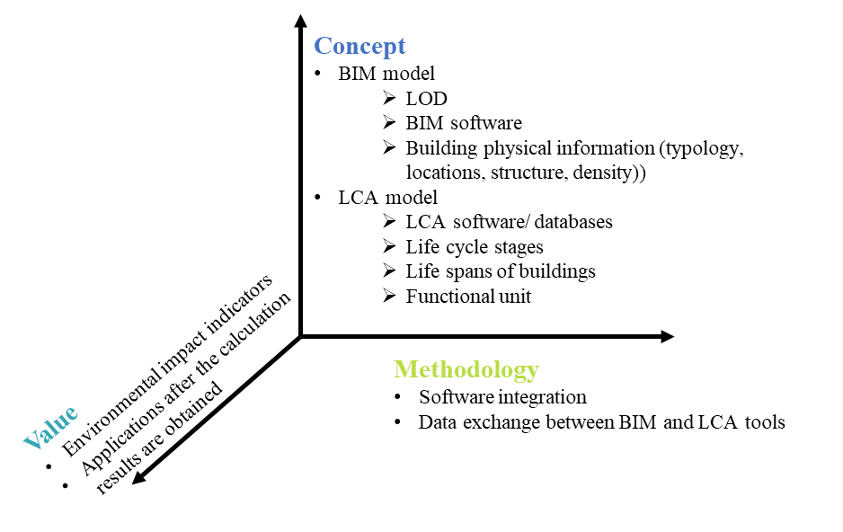
Figure 1 Three-dimension framework of indicators for analyzing BIM-integrated LCA (adapted from Pan and Ning [19])

3.1.1 The dimension of concept
The concept dimension identifies “what BIM-integrated LCA is”, which can be explained as the data input process. It includes the definition of study scopes and assumptions, as well as the selection of BIM software and LCA tools for conducting the life cycle inventory analysis of a building.

The data involved in a BIM model include the physical and graphical information of a building by establishing a virtual model using BIM software such as Autodesk Revit and ArchiCAD. The physical information of a building includes the adopted structure, density, typology, and geographical location, which is determined during the BIM input process. To describe the information richness of a BIM model, the level of development (LOD) is usually used, which is defined as “the minimum dimensional, spatial, quantitative, qualitative, and other data included in a model element” according to the American Institute of Architecture (AIA). The LOD is divided into five levels, viz., LOD 100, 200, 300, 400, and 500, according to the level of details being developed for the LCA application. Therefore, the LOD is used as the criterion for analyzing the extent of BIM input. The data involved in LCA tools comprise the graphic and environmental information of a building. The selected life cycle stages, assumed life spans, and functional units of conducting an LCA are defined, and the environmental characteristics of the building materials are identified during the LCA input process.

3.1.2 The dimension of methodology
The methodology dimension examines “how to integrate BIM with LCA to simplify and automate data input”, which can be explained as the data analysis process. This dimension consists of software integration and data exchange between the BIM and LCA tools. For example, a common application of BIM-integrated LCA is to automatically obtain the BoQ from the BIM model for simplifying the data acquisition process of LCA [9]. The material quantities are exported to a third party (e.g., Excel and author-developed applications) so that they can be organized before being imported into LCA tools.

3.1.3 The dimension of value
The value dimension explores “what applications of BIM-integrated LCA are” which reflects the data output process. This dimension includes the examination of the calculated environmental impact indicators, such as, carbon emissions, energy consumption, global warming potential (GWP), and the prevalent applications after the calculation results are obtained (e.g., improvement after integrating BIM, sensitivity analysis, uncertainty analysis or scenario analysis).

3.2 Reviewing papers on BIM-integrated LCA
A three-step process that included case selection, science mapping analysis, and in-depth content analysis was adopted for reviewing the BIM-integrated LCA papers. The case buildings for the review were selected from peer-reviewed journal papers. Further, science mapping analysis to explore the main contributors to existing research and their inter-relationships was conducted using a text mining tool named VOSviewer, which is a useful tool that can visualize bibliometric networks and assists researchers in conducting literature review analysis [21]. Finally, the in-depth content analysis of the case studies was conducted by drawing on the three-dimensional framework of concept, methodology, and value, representing the information flow of data input, analysis, and output.

3.2.1 Step 1: Case selection
A literature search was conducted based on a current list of high-quality journal articles that integrate BIM and LCA to calculate the environmental impacts, energy consumption, and carbon emissions of a building. To provide a comprehensive understanding of the current applications of BIM in LCA, this study conducted a rigorous retrieval process based on the most renowned indexed databases: Web of Science (WoS) and Scopus. The process for retrieving related cases from peer-reviewed papers is summarized as follows (Figure 2):
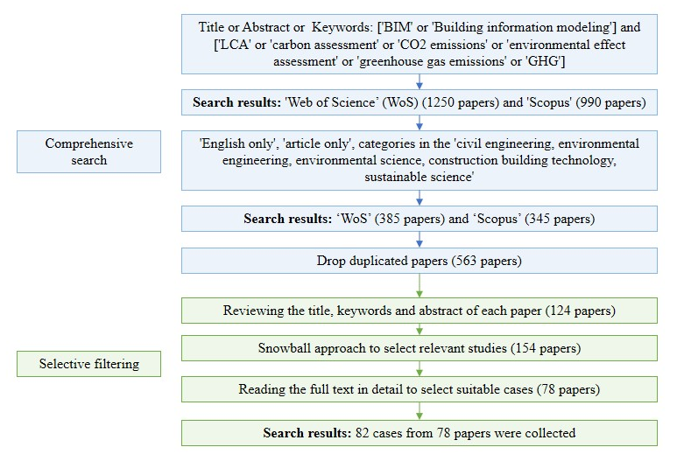
Figure 2 Process for retrieving related cases from peer-reviewed papers

The first step was to input the following relevant “title, abstract, and keywords” in the search engines: ‘BIM’ or ‘building information modeling’ and ‘LCA’ or ‘carbon assessment’ or ‘CO₂ emissions’ or ‘environmental effect assessment’ or ‘greenhouse gas emissions’ or ‘GHG’. No time limitation was set for the search criteria to ensure that comprehensive coverage of the existing literature was obtained. Only peer-reviewed English journal articles were selected for analysis to ensure the quality of the study and completeness of the collected data. The categories of these articles were limited to the fields of civil engineering, environmental engineering, environmental science, construction building technology, environmental studies and sustainable science. Duplications from different search engines were eliminated.

A filtering process was conducted on the completion of search for related papers to exclude irrelevant papers by scanning the titles, keywords, and abstracts of each paper. Given that this study is restricted to case studies related to the integration of BIM with LCA, papers that failed to provide specific information on such cases were excluded and 124 papers remained for analysis after filtration. A snowball approach was then followed by reading the text of each paper quickly to select other relevant studies. Finally, suitable cases were selected by reading the full text of each paper in detail. The search results provided 82 cases of buildings from 78 papers related to BIM for use in LCA.

3.2.2 Step 2: Science mapping analysis
The bibliometric network relationship of research on applying BIM to LCA was visualized, computed, and analyzed through VOSviewer software. The indicators of “co-occurrence keywords” and “countries’ activeness” were used to examine the research focus and contribution of countries or regions to the global research community in this discipline.

3.2.3 Step 3:In-depth content analysis
In-depth content analysis entailed comparing the concepts, methodologies, and values outlined in the content of the selected studies. Particular attention was paid to prevailing gaps in knowledge, limitations of the selected studies, and formulating future recommended research work across these studies.

- Results and analyses
A large number of BIM-integrated LCA papers has been published in recent years. In particular, this research field has received considerable attention from researchers during the last four years. The 82 selected cases of buildings from the 78 papers were analyzed further through science mapping and in-depth content analyses in the following sections to illustrate the research trends and knowledge gaps.

Figure 3 Number of BIM-integrated LCA case study papers published during 2011 to 2021

4.1 Science mapping analysis of BIM-integrated LCA

4.1.1 Analysis of co-occurrence of keywords
Keywords represent the research focus and direction in the BIM-integrated LCA research domain: minimum keyword frequency was set to three for VOSviewer. Subsequently, a filtering process was carried out by merging synonyms (e.g., ‘carbon footprint’ and ‘carbon emissions’), transforming abbreviated terms with full terms (e.g., ‘LCA’ and ‘life cycle assessment’), and ignoring general terms (e.g., ‘conclusion’, ‘method’, etc.) and 32 keywords were selected to meet the requirement (as shown in Table 1 and Figure 4). A large node size indicates a high occurrence of the items, a thick connection line indicates a close relationship between the two items, and different colors divide nodes into different clusters. The results indicate that the five most popular keywords in this domain are life cycle assessment, building information modeling, environmental impacts, carbon emissions, and sustainability. These keywords were also strongly connected to different clusters.
Table 1 Details of the keywords of the selected 78 BIM-integrated LCA papers
Keywords | Occurrences | Total link strength
Life Cycle Assessment | 64 | 377
Building Information Modeling | 61 | 349
Environmental Impacts | 33 | 237
Carbon Emissions | 32 | 201
Sustainability | 30 | 203
Design | 28 | 189
Energy Consumption | 28 | 187
Construction | 24 | 165
Buildings | 19 | 132
Embodied Energy | 19 | 130
Performance | 14 | 99
Embodied Carbon | 13 | 77
Greenhouse Gas Emissions | 12 | 83
Cost | 11 | 77
Optimization | 11 | 86
Integration | 8 | 56
Simulation | 8 | 61
China | 7 | 51
Residential Buildings | 7 | 44
Operational Energy | 6 | 40
Demolition Waste | 5 | 32
Green Buildings | 5 | 31
Climate Change | 4 | 22
Database | 4 | 23
Early Stage | 4 | 36
Challenges | 3 | 28
Components | 3 | 15
Concrete | 3 | 18
Global Warming Potential | 3 | 16
Hong Kong | 3 | 18
LEED | 3 | 13
Prefabrication | 3 | 24
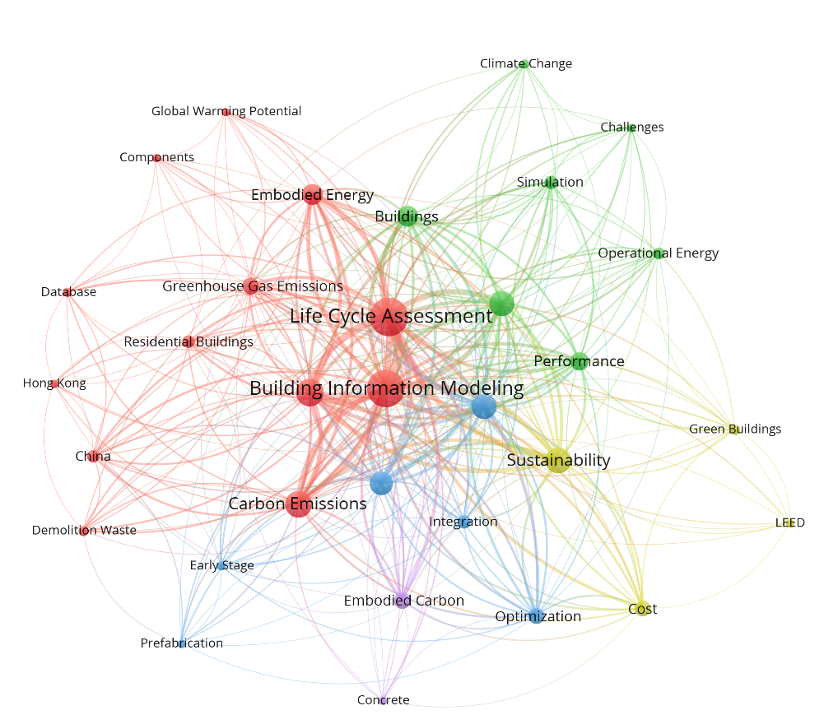
Figure 4 Co-occurrence of keywords analysis of the selected 78 BIM-integrated LCA papers

4.1.2 Analysis of activeness of countries or regions
The contribution of countries or regions to the global research community was analyzed. With the minimum number of publications from a country set at 2, 23 out of 34 countries were listed: Table 2 and Figure 5 present the detailed information of countries or regions that have been active in the research field of BIM-integrated LCA. The results show that China has made a significant contribution in this field when compared to other countries and regions. The connection line illustrates a strong connection between China and Australia.

Table 2 Details of countries or regions of the selected 78 BIM-integrated LCA papers
Country or region | Documents | Citations | Total link strength
China | 17 | 368 | 2381
Australia | 10 | 241 | 1664
Brazil | 7 | 173 | 1281
Switzerland | 5 | 180 | 1261
Portugal | 6 | 96 | 1104
Sweden | 6 | 209 | 1063
Spain | 3 | 32 | 631
USA | 5 | 684 | 626
Italy | 2 | 40 | 586
Singapore | 4 | 106 | 513
Germany | 3 | 14 | 483
Belgium | 2 | 80 | 481
Canada | 5 | 162 | 415
Hong Kong | 5 | 148 | 410
UK | 6 | 124 | 380
Malaysia | 2 | 7 | 354
Pakistan | 2 | 7 | 354
Saudi Arabia | 2 | 35 | 305
Iran | 2 | 32 | 168
Egypt | 2 | 36 | 167
South Korea | 5 | 106 | 146
India | 2 | 1 | 101
Norway | 2 | 49 | 85
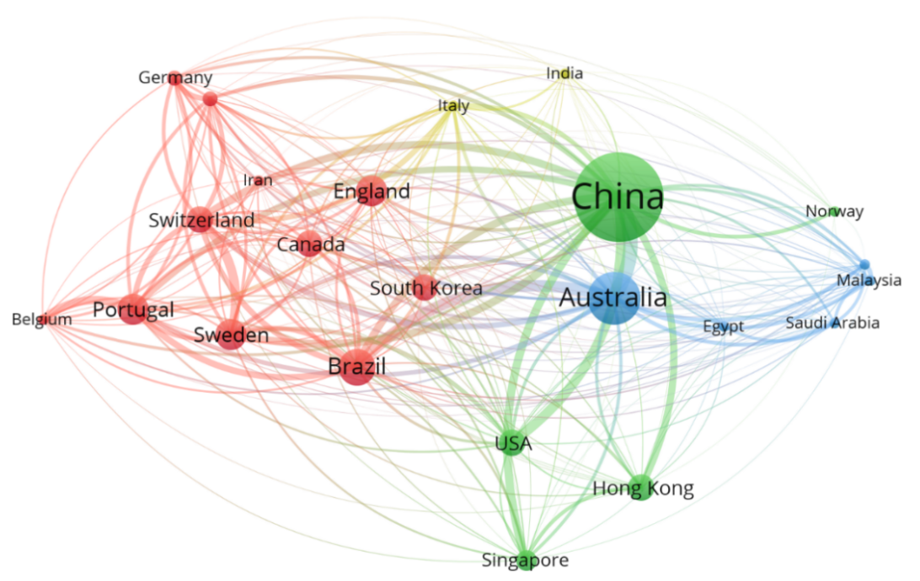
Figure 5 Activeness of the countries or regions of the selected 78 BIM-integrated LCA papers

4.2 In-depth content analysis of BIM-integrated LCA

4.2.1 In the concept dimension: data input of BIM and LCA model
Traditionally, data input used to be the most time-consuming task while carrying out LCA of buildings. Previous studies have proposed that the use of BIM could support energy simulations and carbon modeling over a building's life cycle by enabling the automatic extraction of material and component quantities [9, 10, 22]. It provides an effective method to identify scenarios of mitigating emissions related to material processing and construction methods in both the early and late design stages [23, 24]. Figure 6 illustrates the distributions of the reported results of the 82 case buildings in terms of the BIM model input and LCA model input.
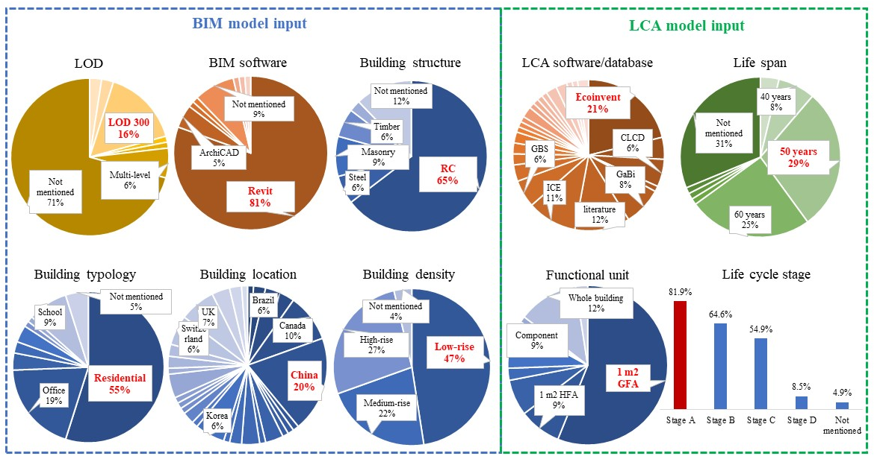
Figure 6 Distributions of reported results of the 82 buildings in terms of BIM model and LCA model input

- BIM model input
BIM is oriented to the modeling and communication of both graphic and non-graphic information, which enables automatic extraction of material quantities for further energy simulations and carbon calculations in a third-party application. The definition of the physical model is crucial during LCA application. However, only less than 30% of the cases specified the LOD of the model and a majority of them were based on the LOD 300 model to obtain the approximate quantities, size, shape, location, or orientation required for further analysis of energy or emission [25–27]. Among the 82 cases, 66 selected Autodesk Revit as the BIM tool while four used ArchiCAD. A study conducted by Hao et al. [28] adopted GGJ2013 and GCL 2013, two BIM software tools developed within China that have advantages for establishing models for the design of prefabricated buildings, as an alternative to Revit or other common BIM software. In terms of building typology, 54.9% of the cases were centered on residential buildings, 47.6% of the cases were low-rise buildings, and 64.6% of the case buildings adopted concrete structures. Concerning the building locations, the results indicated that these case buildings were across different countries and regions while only 19.5% were from Mainland China.

- LCA model input
A majority of the papers that were reviewed have selected a complete building as the functional unit to develop the LCA although a few considered a portion only [29–31]. In terms of the specific functional unit, 56.1% of the 82 buildings selected a 1 m² gross floor area (GFA). Approximately 70% of the case buildings have specified their lifespans to develop the LCA: 23 buildings selected 50-year period. Although the typical four life cycle stages for conducting LCA of buildings have been developed by the European standard BS EN 15978:2011 (BSI, 2012), which categorizes building life cycle stages into four main stages viz., product and construction (A1–A5), use (B1–B5), end-of-life (C1–C4) and recycling (D), the selected stages are still highly related to the goal and scope of the study. Several of the case buildings have focused on the production and construction phase (A, 82.9%): details for other phases are–use (B) (64.6%), end-of-life (C) (54.9%), and few examined recycling (D) phase. The 82 buildings developed the life cycle inventory (LCI) based on the application of more than 20 different databases or software, and a majority selected general ones. For example, databases such as the ICE [31, 32], GaBi [33], and Ecoinvent [25, 26, 34] were widely utilized for carbon modeling and EnergyPlus [35] or DesignBuilder [36] software was commonly utilized for energy simulation. Particularly, Ecoinvent being the world’s leading database, approximately 21.2% of the cases of buildings have used this database for environmental impact assessment. In addition to these general databases, some cases also adopted national databases such as the Swiss Buildings Database [37] and KBOB [38, 39] in Switzerland, CLCD in China [40, 41], Oekobaudat.de in Germany [42, 43], and Korea LCI database in Korea [44, 45]. Furthermore, in some cases the environmental data were determined directly from other literature [46–48]; although this reduced the overall time, it could lead to unreliable results when such case buildings are located in a different place [49].

4.2.2 In the methodology dimension: software integration and data exchange of BIM and LCA
The critical task in this dimension is to define how to achieve software integration and data exchange between BIM software and LCA tools. Traditional LCA of buildings is usually conducted at the end of the design stage when accurate data are available, but it could be too late to influence key decisions. Several methodological approaches have been proposed to address this issue by integrating BIM software and LCA tools. For example, Basbagill et al. [7] proposed a method combining BIM software (Dprofiler), carbon assessment tools (SimaPro and Athena EcoCalculator), and sensitivity analysis software (ModelCenter) to quickly evaluate and compare the embodied carbon of different building component materials and dimensioning choices in the early design stage. Jrade and Jalaei [50] used a method that linked a material database stored in a BIM module to an LCA module to simplify the environmental impact assessment process of buildings in the conceptual stage. Shin and Cho [51] developed a framework to select appropriate design alternatives in the early stage of a construction project by manually entering data into LCA tools after being extracted from ArchiCAD. Shafiq et al. [52] combined Autodesk Revit and Excel to assess embodied carbon in a two-story building. Najjar et al. [24] employed Autodesk Revit, Green Building Studio, and Tally to estimate the impact of a case study building. Similarly, Bueno et al. [53] integrated LCA in Autodesk Revit using a BIM plug-in (Tally) to automatically obtain the environmental impacts of various building components in the initial design stages. Cavalliere et al. [37] developed a BIM-based method for a continuous embodied environmental impact assessment in the detailed design phase. The corresponding emission factors were collected from different databases according to the LOD at different stages to support accurate decision-making. Feng et al. [54] calculated the embodied carbon of materials by multiplying their emission factors collected from the Ecoinvent database and material quantities exported from Revit for evaluating different renovation and reconstruction scenarios in British Columbia. Abbasi and Noorzai [30] proposed a BIM-based multi-optimization approach to determine the trade-off between embodied and operational energy and provided ways to select optimal solutions in the early design stage. Tushar et al. [29] integrated BIM software (Autodesk Revit), an energy rating tool (FirstRate5), and a BIM plug-in (Tally) to quantify and compare different building designs of a residential building.

Data exchange between BIM and LCA is another critical challenge when using different data formats in BIM software and professional LCA tools. The most relevant purposes of coupling BIM and LCA tools are the export of BoQ and the determination of building datasets, which represent the most time-consuming processes. Three different approaches have been proposed in previous studies to achieve data exchange between BIM and LCA tools. They are integrating process combining different data into a third party application or tool (Type I), importing a BoQ report generated from the BIM model into a dedicated LCA tool (Type II), and using plug-ins with LCA data for BIM software (Type III) (Figure 7): comparisons of these three types of approaches are presented in Table 3.

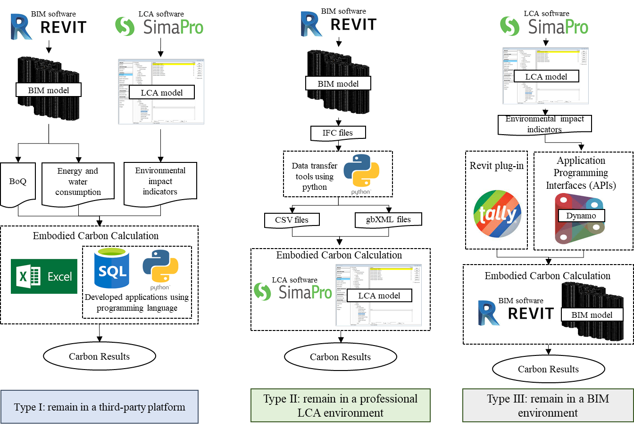
Figure 7 Three approaches for data exchange between BIM software and LCA tools
(Notes: take Revit for BIM modeling and SimaPro for embodied carbon assessment as an example)

Table 3 Comparisons of three types of data exchange approaches between BIM and LCA tools
Type | Data exchange approach | Calculation platform | Description | Advantage | Disadvantage | Proportion of the case building
I | From BIM and LCA to a third party | Excel | Importing a BoQ report generated from the BIM model and corresponding emission factors provided by LCA tools into Excel | Simple and time-saving | Inefficient to handle a more complex calculation | 34.1%
I | From BIM and LCA to a third party | Self-developed application | Using programming language to achieve automatic data extraction and calculation between BIM and LCA tools | Automatic and clear calculation | Only numerical results can be obtained | 9.8%
II | From BIM to LCA | Professional LCA tools | Importing a BoQ report generated from the BIM model or BIM model into dedicated LCA tools | Professional, detailed and visualized analysis | Inconsistent data formats of material databases;  Manually data mapping is needed | 25.6%
III | From LCA to BIM | BIM platform | Using a Revit plug-in to conduct LCA | Flexible data modification, integrated data storage, quick feedback, and intuitive visualization | Inaccuracy of the results | 9.8%
III | From LCA to BIM | BIM platform | Importing LCA data into BIM objects or an in-built database through application programming interfaces (APIs) |  | Manual data mapping is needed | 20.7%

Microsoft Excel is the most commonly used third-party tool where the integration process is conducted by multiplying the quantities of materials and building components from BIM software, such as Revit [55] and ArchiCAD [56], and the corresponding emission factors provided by LCA tools, such as Ecoinvent [25, 57] and ICE [31, 58] databases. The Excel-based method is relatively simple and can achieve quick feedback; therefore, it has been adopted by 34.1% of 82 case buildings. However, this method is inefficient in handling complex calculations when there are numerous parameters related to building materials and fuel types and the corresponding emission factors must be handled manually [51]. Therefore, some scholars have developed their own applications using programming language to achieve automatic data extraction and calculation. For example, Marzouk et al. [59] developed a window application written in C#.net to evaluate and compare the emissions of building elements wherein the building information stored in the BIM model was transferred to MS Access through the Revit DB link and the emission factors were extracted from the Athena Impact Estimator. Finally, the SQL was used to import the data to the aforementioned application for automated carbon emission estimation. Xu et al. [60] integrated engineering quantities and environment-related data into a database and adopted a Python program to assist in automatic calculation.

Although the automatic calculation is achievable, the self-developed applications provide only numerical results with no scope for conducting further analysis. Therefore, a few studies relied on professional and dedicated LCA tools for assessing carbon emissions and energy consumption by importing material quantities generated from BIM software. For example, Yang et al. [40] developed a BIM-enabled carbon assessment tool named eBalance for carrying out LCA within China. Glondon BIM5D programs were used to extract the material quantities and energy consumption of the equipment. Rezaei et al. [26] performed a conception-to-demolition carbon assessment of a four-story multi-residential building in Québec, Canada, by combining BIM Revit, Ecoinvent database, and openLCA software. The material lists from Revit were initially matched with a dataset in Ecoinvent based on expert judgment, Canadian construction codes and standards, and material properties, and finally processed with the openLCA software. In the study by Abbasi and Noorzai [30], the geometric data and bill of materials of the building were extracted from the BIM Revit and subsequently input into the Athena Impact Estimator to calculate the embodied energy of an eight-story residential building. Compared with the type I method, using professional LCA tools can provide a more detailed analysis of the results. However, one of the most important challenges of this method is the difficulty in unifying the data formats of material databases in BIM software with LCA tools such as the functional units, types, and names. Moreover, manual data mapping consumes plenty of time as information in the BIM software is usually not as detailed as that in LCA tools.

Compared with the first two methods where the BIM is conducted merely as a quantity take-off tool, the type III approach conducts the assessment within a native BIM environment where data update can be easily achieved. For example, some scholars proposed a Revit plug-in named Tally to evaluate the carbon emissions and energy of buildings [6, 61]. The BIM model was established in Revit and the required building information could be directly extracted into Tally for the calculation. However, some studies have challenged the accuracy of the results provided by Tally due to its inflexible and insufficient databases in comparison with the professional LCA tools [62, 63]. Therefore, a more flexible method has been used in some studies where data from professional LCA tools were imported into BIM objects using Revit application programming interface (API). Recent studies on LCA have encouraged the use of visual scripting interfaces such as Dynamo, an existing API of Revit. For example, Röck et al. [64] calculated the embodied carbon of buildings directly using Dynamo by multiplying the building elements, such as volume, quantity, location, and orientation, obtained from BIM Revit and the respective environmental impact indicators from the Ecoinvent database. This study also defined a common name convention so that automatic data mapping could be achieved. In the study by Hollberg et al. [38], each building material in the native material library of Revit was linked by emission factors collected from the KBOB database using an individual ID, which means that the material quantities obtained by Dynamo have specific KBOB IDs. However, Dynamo has the limitation of accessing the volumetric information of technical routing elements such as pipes or ducts. Meanwhile, certain scholars have developed their own Revit APIs. For example, Nizam et al. [65] developed a tool that includes four modules, viz., material, transportation, construction, and embodied energy tab, as an add-in for Revit wherein data are directly extracted from Revit, ICE database, Chinese handbook, project documents, and interviews prior to being imported into the tool. Santos et al. [66] developed an innovative BIM-based LCA/LCC tool named BIMEELCA through the Revit API to assess the environmental and economic impacts of buildings. Compared with the other two types of BIM-LCA methods, type III offers improved data modification flexibility, integrated data storage, quick feedback, and visualization. However, because manual handling is still required, the data mapping process from LCA tools to BIM objects remains to be inefficient.

4.2.3 In the value dimension: data output and applications of BIM-integrated LCA results
To perform LCA, diverse environmental impact indicators such as GHGs, carbon dioxide (CO₂), consumed energy, and a more aggregated concept called carbon equivalent (CO_{2e}) have been used to measure the impact of construction activities. To reflect the impact of different gases on climate change, such as the rising atmospheric temperature, it is a common practice to use an indicator named Global Warming Potential (GWP) to measure the GHG emission of buildings. The use of GWP allows policymakers to compare the carbon reduction opportunities among different sectors and gases. Among these 82 case buildings, 67 were assessed for carbon-related indicators (also called carbon emissions, GWP, GHGs, and carbon footprint), and 23 of them calculated the consumed energy. Additional data for these case buildings were collected by normalizing the embodied carbon (kg CO_{2e}/m²), energy (kWh/m²), operational carbon (kg CO_{2e}/m²/yr), and energy (kWh/m²/yr) based on the floor area and life span: those that did not present specific results were excluded. The results are shown in Figures 8 and 9.

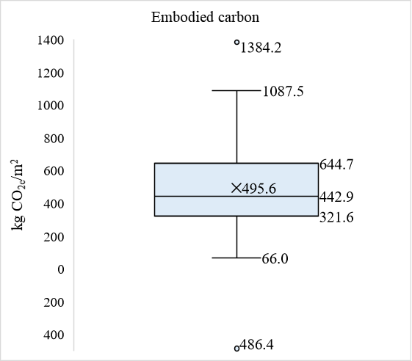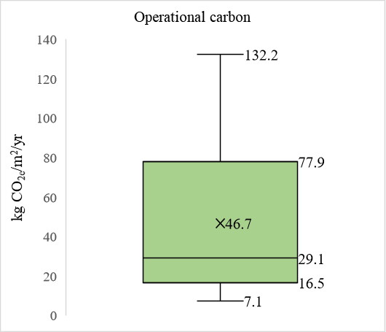

Figure 8 Normalized embodied and operational carbon of the case buildings
(Notes: 31 and 52 cases without showing the embodied and operational carbon values respectively were not presented)

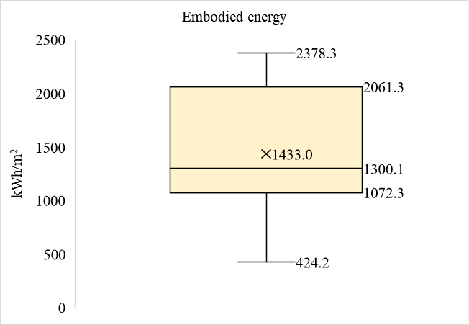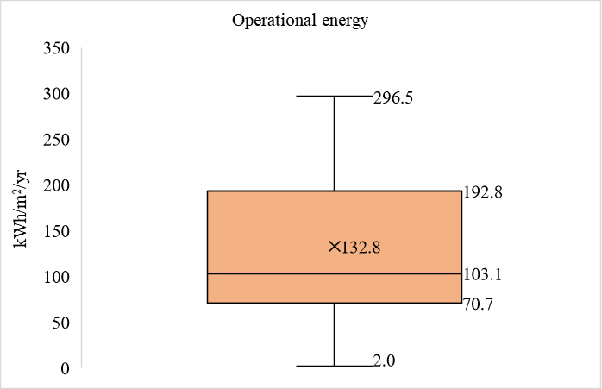
Figure 9 Normalized embodied and operational energy of the case buildings
(Notes: 69 and 68 cases without showing the embodied and operational energy values respectively were not presented)

It can be seen from Figure 8 that 50 case buildings have specified the embodied carbon ranging from 66 to 1384.2 kg CO_{2e}/m² and the average is 495.6 kg CO_{2e}/m², except for a minus figure from one building that focused only on the end-of-life and recycling stages. In this case, demolition waste treatment did not incur additional emissions and recyclable waste was generated. The average operational carbon for the 28 cases is 46.7 kg CO_{2e}/m²/yr, with the highest and lowest figure of 132.2 and 7.1 kg CO_{2e}/m²/yr, respectively. Only 16 of the case buildings specified the energy in the papers (Figure 9) and those with other functional units viz., MBtu, GJ, and MJ were adjusted to kWh/m² according to the information provided in the papers so that they could be uniformly compared. The results show that case 1 consumed extremely low energy (2 kWh/m²/yr) during the operational stage each year because this building earned LEED® Gold certification owing to the less energy-intensive designs that have been incorporated. The embodied energy ranges from 424.2 to 2378.3 kWh/m² and the average is 1433 kWh/m2. The operational energy of the other six cases ranges from 54.1 to 296.5 kWh/m²/yr.

Apart from the explanation of the data output, exploring further applications, such as the comparability and optimization of the results (e.g., scenario analysis and sensitive analysis), of BIM-integrated LCA results is another important task. However, only a few studies have checked the consistency of the results by comparing BIM-based LCA tools with professional LCA software or traditional manual calculations. For example, Bueno et al. [53] compared the results calculated by the BIM-LCA plug-in with a full LCA using Gabi 6 software. The results were not consistent, despite the research efforts towards equalizing the scope of the studies to provide a fair comparison. Another study conducted by Nizam et al. [65] performed a detailed manual calculation to validate the BIM-integrated LCA results. However, no studies have quantitatively analyzed the efficiency of combining BIM with LCA applications.

About 42.7% of the case buildings have adopted scenario analysis after calculating the environmental impact of buildings to improve decision-making support. For example, Marzouk et al. [59] investigated the emissions associated with 98 alternatives for different project assemblies, viz., the columns, beams, walls, cladding, and slabs, and examined the best alternative. Shadram et al. [67] evaluated 19 scenarios to demonstrate how different types of insulating materials from different suppliers could achieve embodied energy reduction. Feng et al. [54] examined the carbon emissions of the following six different renovation and reconstruction scenarios: base case, basic renovation, moderate renovation, deep renovation, newly built house, and passive house. The results indicated that the newly built houses had lower lifecycle emissions per square meter than the renovated existing houses. Ansah et al. [31] conducted scenario analyses to evaluate the variation induced in life cycle energy demands and emissions, such as adopting locally manufactured steel, varying the facade design, and modifying the sources of paint. Tushar et al. [29] compared building scenarios with different design options, including insulation and accessory materials, and the results revealed that plywood walls had a lower impact on the environment than the other type of walls. Sensitivity analysis was also developed by some scholars to identify parameters that had a greater impact on the evaluated performance. For example, Basbagill et al. [7] searched for the minimum and maximum possible embodied impact of each building component using a predefined range of building shapes and design parameters. Peng [48] conducted a sensitivity analysis to identify the parameters that had the greatest impact on a building’s performance. Abbasi and Noorzai [30] combined a multi-objective optimization algorithm with BIM and LCA to determine the trade-off between embodied and operational energy using Pareto front sensitivity analysis. The results indicated that there was an optimal range for maximizing the embodied energy to reduce the operation energy.

Discussion
Traditional LCA is mostly conducted either in the latter design phase or construction phase when detailed information about materials and components becomes available by when it is usually too late to support decision-making. The utilization of BIM can optimize data acquisition for LCA thereby improving the efficiency of LCA applications [14]. This paper conducted a systematic literature review and examined the knowledge gaps that existed in integrating BIM with LCA through a detailed analysis of 82 case buildings. The knowledge gaps that were identified in the dimensions of the concept, methodology, and value are identified in Figure 10 and discussed in the following paragraphs.
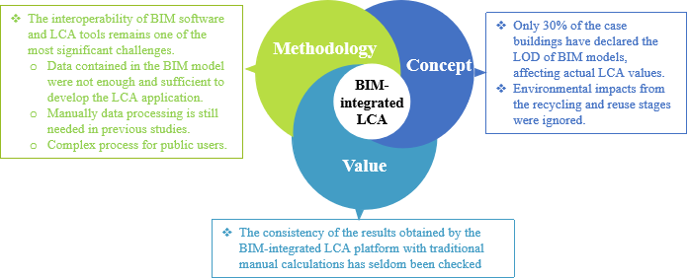
Figure 10 Knowledge gaps of BIM-integrated LCA in the dimensions of concept, methodology and value

First, even though it is considered important to declare the LOD of BIM models during the application of LCA in the early design stage as the LOD allows quick modeling and accurate environmental impact calculation, only less than 30% of the case buildings have declared the LOD of BIM models. For example, a study conducted by Naneva et al. [68] proposed that the variability between the LODs of different components could affect the actual LCA values. Hence, there is a need to clarify the LOD of BIM models before conducting an LCA.

Second, previous case studies have seldom considered the environmental impact from the recycling and reuse stages and only focused on partly life cycle stages that could be easily modeled. This is due to the fact that the developed BIM-based LCA method is still limited by time and assumptions related to the collected information, as proposed by Peng [48] and Bueno et al. [53]. However, the environmental impact reduction potential of reusing or recycling materials, particularly for buildings with steel and timber structures, has been acknowledged in certain other studies [69, 70].

Third, the interoperability of BIM software and LCA tools remains one of the most significant challenges because LCA is a generic method that has been developed to be applicable to any sector, whereas BIM is mainly used in the construction sector [48]. Therefore, the two fields remain separate worlds in terms of tools, terminology, and data structure, and buildings must be separately modeled in both BIM and LCA software because direct information exchange does not exist. Besides, data contained in the BIM model are not sufficient for the LCA application because information related to HVAC elements, transportation modes, distances, construction equipment, electricity consumption, etc., is not included in the BIM database. These limitations lead to a BIM model that is deficient in many aspects, an incomplete BoQ, and imprecise LCA results. This issue has occurred in many studies [7, 39, 65], because users must manually add the information to the BIM database in advance. Therefore, more information on material properties should be included to adapt databases of the BIM models to LCA data structure. Automatic data collection and integration using sensors or smart meters are also encouraged to further reduce manual work. Although several additional strategies were proposed, such as a common naming convention [64], an individual ID [38], and a more professional extract, transform, and load (ETL) technology [67], manual data processing was still necessary for these completed studies. Because BIM and LCA integration still remains a specialized field for academics and consultants, developing a simpler BIM-based tool to be applied during the early design stage is necessary for LCA practitioners.

Finally, the consistency of the results obtained by the BIM-integrated LCA platform with traditional manual calculations has seldom been checked. Previous studies have demonstrated that integration of BIM and LCA can simplify and help conduct quick calculations [71, 72], while only a few of them have made actual comparisons with the traditional LCA methods. Nevertheless, the use of results as aided decision support tools during the early design stages through a scenario or sensitivity analysis has been conducted in various studies. This can help examine the low environmental impact alternatives.

Conclusion
This study examined 82 case buildings collected from 78 papers on BIM-integrated LCA published in the past decade. The examination utilized scientometric and detailed content analysis techniques to conduct content analyses in the philosophical dimensions of the concept, methodology, and value while drawing on the dialectical system theory (DST). The conclusions of this study are as follows.

First, the proposed three-dimension framework achieves a clear understanding of the BIM-integrated LCA by explaining ‘what BIM-integrated LCA is’, ‘how to integrate BIM with LCA to simplify and automate data input’, and ‘what applications of BIM-integrated LCA are’, whereas previous studies failed to seek answers to the three questions systematically. It provides an innovative theoretical foundation for researchers to improve the BIM-integration LCA of buildings. Future case studies can be conducted following this framework to ensure the completeness of the research.

Second, the knowledge gaps were identified in the concept, methodology, and value dimensions by analyzing 82 case buildings, viz., the lack of a clear and unified definition of LoD for BIM-integrated LCA applications, the use of different data formats in BIM and LCA tools, and a short of consistent checking and verification of the results obtained from BIM-integrated LCA and conventional LCA applications. It emphasizes that these challenges should be carefully addressed, which identifies the directions of future BIM-integrated LCA research.

Third, three types of methods for BIM-integrated LCA were identified: integrating different data into a third party application or tool (Ⅰ), importing a bill of quantities report generated from the BIM model into a dedicated LCA tool (Ⅱ), and using plug-ins with LCA data for BIM software (III). By clearly identifying their advantages and disadvantages, this paper proposes that significant challenges in software interoperability still exist because of insufficient information in BIM for conducting LCA and the different data structures used by the two tools. The paper, therefore, concludes that further research is needed to standardize the data structures contained in the BIM model for LCA applications for a more automated and efficient BIM-integrated LCA tool that reduces the time required for manual data mapping and processing. Moreover, BIM-integrated LCA remains a specialized field for academics and consultants because the substantial effort is needed for data collection, data exchange, and data analysis. Hence, it is necessary to develop a quicker and simpler tool for LCA practitioners. Automatic data collection and integration using sensors or smart meters are also encouraged to further reduce manual work.

Acknowledgments
This work was supported by grants from the General Research Fund of the Hong Kong Research Grants Council [Project No.: 17203219 and Project No.:17201120].

References
[1] M. Buyle, J. Braet, A. Audenaert, LCA in the construction industry: a review, Int. J. Energy Environ. Eng. 6(4) (2012) 397-405.
[2] B. Soust-Verdaguer, C. Llatas, A. García-Martínez, Simplification in life cycle assessment of single-family houses: A review of recent developments, Build. Environ. 103 (2016) 215-227.
[3] T. Malmqvist, M. Glaumann, S. Scarpellini, I. Zabalza, A. Aranda, E. Llera, S. Díaz, Life cycle assessment in buildings: The ENSLIC simplified method and guidelines, Energy 36(4) (2011) 1900-1907.
[4] Y. Arayici, T. Fernando, V. Munoz, M. Bassanino, Interoperability specification development for integrated BIM use in performance based design, Autom. Constr. 85 (2018) 167-181.
[5] G. Van Nederveen, F. Tolman, Modelling multiple views on buildings, Autom. Constr. 1(3) (1992) 215-224.
[6] C. Raposo, F. Rodrigues, H. Rodrigues, BIM-based LCA assessment of seismic strengthening solutions for reinforced concrete precast industrial buildings, Innov. Infrastruct. Solut. 4(1) (2019) 1-10.
[7] J. Basbagill, F. Flager, M. Lepech, M. Fischer, Application of life-cycle assessment to early stage building design for reduced embodied environmental impacts, Build. Environ. 60 (2013) 81-92.
[8] S. Eleftheriadis, P. Duffour, D. Mumovic, BIM-embedded life cycle carbon assessment of RC buildings using optimised structural design alternatives, Energy Build.173 (2018) 587-600.
[9] B. Soust-Verdaguer, C. Llatas, A. García-Martínez, Critical review of bim-based LCA method to buildings, Energy Build. 136 (2017) 110-120.
[10] S. Eleftheriadis, D. Mumovic, P. Greening, Life cycle energy efficiency in building structures: A review of current developments and future outlooks based on BIM capabilities, Renew. Sust. Energ. Rev. 67 (2017) 811-825.
[11] C. Llatas, B. Soust-Verdaguer, A.J.B. Passer, Environment, Implementing Life Cycle Sustainability Assessment during design stages in Building Information Modelling: From systematic literature review to a methodological approach, Build. Environ. (2020) 107164.
[12] T. Dalla Mora, E. Bolzonello, C. Cavalliere, F.J.S. Peron, Key Parameters Featuring BIM-LCA Integration in Buildings: A Practical Review of the Current Trends, Sustainability. 12(17) (2020) 7182.
[13] T. Potrč Obrecht, M. Röck, E. Hoxha, A.J.S. Passer, BIM and LCA integration: A systematic literature review, Sustainability. 12(14) (2020) 5534.
[14] S. Seyis, Mixed method review for integrating building information modeling and life-cycle assessments, Build. Environ. 173 (2020) 106703.
[15] C. Panteli, A. Kylili, P.A.J.J.o.C.P. Fokaides, Building information modelling applications in smart buildings: From design to commissioning and beyond A critical review, J. Clean Prod. (2020) 121766.
[16] K. Lu, X. Jiang, J. Yu, V.W. Tam, M.J.J.o.C.P. Skitmore, Integration of Life Cycle Assessment and Life Cycle Cost using Building Information Modeling: A Critical Review, J. Clean Prod. (2020) 125438.
[17] M. Mulej, B. Rosi, M. Mulej, The dialectical network thinking–a new systems theory concerned with management, Kybernetes (2006).
[18] W. Pan, System boundaries of zero carbon buildings, Renew. Sust. Energ. Rev. 37 (2014) 424-434.
[19] W. Pan, Y. Ning, Dialectics of sustainable building: Evidence from empirical studies 1987–2013, Build. Environ. 82 (2014) 666-674.
[20] Y. Teng, K. Li, W. Pan, T. Ng, Reducing building life cycle carbon emissions through prefabrication: Evidence from and gaps in empirical studies, Build. Environ. 132 (2018) 125-136.
[21] R. Jin, J. Zuo, J.J.J.o.C.E. Hong, Management, Scientometric review of articles published in ASCE’s journal of construction engineering and management from 2000 to 2018, J. Constr. Eng. Manage.145(8) (2019) 06019001.
[22] H.-Y. Chong, C.-Y. Lee, X. Wang, A mixed review of the adoption of Building Information Modelling (BIM) for sustainability, J. Clean Prod. 142 (2017) 4114-4126.
[23] M. Röck, A. Hollberg, G. Habert, A. Passer, LCA and BIM: Integrated Assessment and Visualization of Building Elements’ Embodied Impacts for Design Guidance in Early Stages, Procedia CIRP 69 (2018) 218-223.
[24] M. Najjar, K. Figueiredo, M. Palumbo, A. Haddad, Integration of BIM and LCA: Evaluating the environmental impacts of building materials at an early stage of designing a typical office building, J. Build. Eng. 14 (2017) 115-126.
[25] B. Soust-Verdaguer, C. Llatas, L. Moya, Comparative BIM-based Life Cycle Assessment of Uruguayan timber and concrete-masonry single-family houses in design stage, J. Clean Prod. 277 (2020) 121958.
[26] F. Rezaei, C. Bulle, P. Lesage, Integrating building information modeling and life cycle assessment in the early and detailed building design stages, Build. Environ. 153 (2019) 158-167.
[27] K. Lu, H. Wang, Estimation of building’s life cycle carbon emissions based on life cycle assessment and building information modeling: a case study of a hospital building in China, J. Geoscience. Environ. Prot. 7(06) (2019) 147.
[28] J.L. Hao, B. Cheng, W. Lu, J. Xu, J. Wang, W. Bu, Z. Guo, Carbon emission reduction in prefabrication construction during materialization stage: a BIM-based life-cycle assessment approach, Sci. Total Environ. 723 (2020) 137870.
[29] Q. Tushar, M.A. Bhuiyan, G. Zhang, T. Maqsood, An integrated approach of BIM-enabled LCA and energy simulation: The optimized solution towards sustainable development, J. Clean Prod. 289 (2021) 125622.
[30] S. Abbasi, E. Noorzai, The BIM-Based multi-optimization approach in order to determine the trade-off between embodied and operation energy focused on renewable energy use, J. Clean Prod. 281 (2021) 125359.
[31] M.K. Ansah, X. Chen, H. Yang, L. Lu, P.T. Lam, An integrated life cycle assessment of different façade systems for a typical residential building in Ghana, Sust. Cities Soc. 53 (2020) 101974.
[32] F. Abanda, A. Oti, J. Tah, Integrating BIM and new rules of measurement for embodied energy and CO2 assessment, J. Build. Eng. 12 (2017) 288-305.
[33] J.P. Carvalho, I. Alecrim, L. Bragança, R. Mateus, Integrating BIM-Based LCA and Building Sustainability Assessment, Sustainability 12(18) (2020) 7468.
[34] Y. Lu, X. Song, Beyond boundaries: A global use of life cycle inventories for construction materials, J. Clean Prod. 156 (2017) 876-887.
[35] F. Jalaei, G. Guest, A. Gaur, J. Zhang, Exploring the effects that a non-stationary climate and dynamic electricity grid mix has on whole building life cycle assessment: A multi-city comparison, Sust. Cities Soc. 61 (2020) 102294.
[36] B. Cheng, J. Li, V.W. Tam, M. Yang, D. Chen, A BIM-LCA approach for estimating the greenhouse gas emissions of large-scale public buildings: a case study, Sustainability 12(2) (2020) 685.
[37] C. Cavalliere, G. Habert, G.R. Dell'Osso, A. Hollberg, Continuous BIM-based assessment of embodied environmental impacts throughout the design process, J. Clean Prod. 211 (2019) 941-952.
[38] A. Hollberg, G. Genova, G. Habert, Evaluation of BIM-based LCA results for building design, Autom. Constr. 109 (2020) 102972.
[39] C. Kiamili, A. Hollberg, G. Habert, Detailed Assessment of Embodied Carbon of HVAC Systems for a New Office Building Based on BIM, Sustainability 12(8) (2020) 3372.
[40] X. Yang, M. Hu, J. Wu, B. Zhao, Building-information-modeling enabled life cycle assessment, a case study on carbon footprint accounting for a residential building in China, J. Clean Prod. 183 (2018) 729-743.
[41] S. Su, Q. Wang, L. Han, J. Hong, Z. Liu, BIM-DLCA: an integrated dynamic environmental impact assessment model for buildings, Build. Environ. 183 (2020) 107218.
[42] P. Schneider-Marin, H. Harter, K. Tkachuk, W. Lang, Uncertainty analysis of embedded energy and greenhouse gas emissions using BIM in early design stages, Sustainability 12(7) (2020) 2633.
[43] S. Theißen, J. Höper, J. Drzymalla, R. Wimmer, S. Markova, A. Meins-Becker, M. Lambertz, Using Open BIM and IFC to Enable a Comprehensive Consideration of Building Services within a Whole-Building LCA, Sustainability 12(14) (2020) 5644.
[44] H. Jun, N. Lim, M. Kim, BIM-based carbon dioxide emission quantity assessment method in Korea, J. Asian Archit. Build. Eng.14(3) (2015) 569-576.
[45] S. Lee, S. Tae, S. Roh, T. Kim, Green template for life cycle assessment of buildings based on building information modeling: Focus on embodied environmental impact, Sustainability 7(12) (2015) 16498-16512.
[46] K. Lu, X. Jiang, V.W. Tam, M. Li, H. Wang, B. Xia, Q. Chen, Development of a carbon emissions analysis framework using building information modeling and life cycle assessment for the construction of hospital projects, Sustainability 11(22) (2019) 6274.
[47] J. Xu, Y. Shi, Y. Xie, S. Zhao, A BIM-Based construction and demolition waste information management system for greenhouse gas quantification and reduction, J. Clean Prod. 229 (2019) 308-324.
[48] C. Peng, Calculation of a building's life cycle carbon emissions based on Ecotect and building information modeling, J. Clean Prod. 112 (2016) 453-465.
[49] W. Pan, Y. Teng, A systematic investigation into the methodological variables of embodied carbon assessment of buildings, Renew. Sust. Energ. Rev. 141 (2021) 110840.
[50] A. Jrade, F. Jalaei, Integrating building information modelling with sustainability to design building projects at the conceptual stage, Build. Simul. 2013, pp. 429-444.
[51] Y. S. Shin, K. Cho, BIM Application to Select Appropriate Design Alternative with Consideration of LCA and LCCA, Math. Probl. Eng.2015 (2015) 1-14.
[52] N. Shafiq, M.F. Nurrudin, S.S.S. Gardezi, A.B. Kamaruzzaman, Carbon footprint assessment of a typical low rise office building in Malaysia using building information modelling (BIM), Int. J. Sustain. Build. Technology. Urban. Development. 6(3) (2015) 157-172.
[53] C. Bueno, L.M. Pereira, M.M. Fabricio, Life cycle assessment and environmental-based choices at the early design stages: an application using building information modelling, Archit. Eng. Des. Manag.14(5) (2018) 332-346.
[54] H. Feng, D.R. Liyanage, H. Karunathilake, R. Sadiq, K. Hewage, BIM-based life cycle environmental performance assessment of single-family houses: Renovation and reconstruction strategies for aging building stock in British Columbia, J. Clean Prod. 250 (2020) 119543.
[55] Y. Cang, Z. Luo, L. Yang, B. Han, A new method for calculating the embodied carbon emissions from buildings in schematic design: Taking “building element” as basic unit, Build. Environ. 185 (2020) 107306.
[56] Y.S. Shin, K. Cho, BIM application to select appropriate design alternative with consideration of LCA and LCCA, Math. Probl. Eng. (2015).
[57] L. Georges, M. Haase, A. Houlihan Wiberg, T. Kristjansdottir, B. Risholt, Life cycle emissions analysis of two nZEB concepts, Build. Res. Informat.43(1) (2015) 82-93.
[58] C.R. Iddon, S.K. Firth, Embodied and operational energy for new-build housing: A case study of construction methods in the UK, Energy Build. 67 (2013) 479-488.
[59] M. Marzouk, E.M. Abdelkader, K. Al-Gahtani, Building information modeling-based model for calculating direct and indirect emissions in construction projects, J. Clean Prod. 152 (2017) 351-363.
[60] Z. Xu, S. Wang, E. Wang, Integration of BIM and Energy Consumption Modelling for Manufacturing Prefabricated Components: A Case Study in China, Adv. Civ. Eng.2019 (2019) 1609523.
[61] M. Najjar, K. Figueiredo, A.W.A. Hammad, A. Haddad, Integrated optimization with building information modeling and life cycle assessment for generating energy efficient buildings, Appl. Energy. 250 (2019) 1366-1382.
[62] C. Bueno, M.M. Fabricio, Comparative analysis between a complete LCA study and results from a BIM-LCA plug-in, Autom. Constr. 90 (2018) 188-200.
[63] R. Santos, A.A. Costa, J.D. Silvestre, L. Pyl, A validation study of a semi-automatic BIM-LCA tool, In 2º Congresso Português de Building Information Modelling, Instituto Superior Técnico Universidade de Lisboa. (2018).
[64] M. Röck, A. Hollberg, G. Habert, A. Passer, LCA and BIM: Visualization of environmental potentials in building construction at early design stages, Build. Environ. 140 (2018) 153-161.
[65] R.S. Nizam, C. Zhang, L. Tian, A BIM based tool for assessing embodied energy for buildings, Energy Build. 170 (2018) 1-14.
[66] R. Santos, A.A. Costa, J.D. Silvestre, T. Vandenbergh, L. Pyl, BIM-based life cycle assessment and life cycle costing of an office building in Western Europe, Build. Environ. 169 (2020) 106568.
[67] F. Shadram, T.D. Johansson, W. Lu, J. Schade, T. Olofsson, An integrated BIM-based framework for minimizing embodied energy during building design, Energy Build. 128 (2016) 592-604.
[68] A. Naneva, M. Bonanomi, A. Hollberg, G. Habert, D. Hall, Integrated BIM-based LCA for the entire building process using an existing structure for cost estimation in the Swiss context, Sustainability 12(9) (2020) 3748.
[69] A. Shirazi, B.J.B. Ashuri, Environment, Embodied life cycle assessment comparison of single family residential houses considering the 1970s transition in construction industry: Atlanta case study, Build. Environ.140 (2018) 55-67.
[70] P. Wu, B. Xia, X.J.R. Zhao, S.E. Reviews, The importance of use and end-of-life phases to the life cycle greenhouse gas (GHG) emissions of concrete–a review, Renew. Sust. Energ. Rev. 37 (2014) 360-369.
[71] M. Abouhamad, M. Abu-Hamd, Life Cycle Assessment Framework for Embodied Environmental Impacts of Building Construction Systems, Sustainability 13(2) (2021) 461.
[72] F. Jalaei, A. Jrade, An automated BIM model to conceptually design, analyze, simulate, and assess sustainable building projects, J. Constr. Eng. Manage. 2014 (2014) 1-21.

