BIM-integrated LCA to automate embodied carbon assessment of prefabricated buildings
Jiayi XU ¹, Yue TENG ², Wei PAN ^{1*}, Yang ZHANG ¹

¹ Department of Civil Engineering, The University of Hong Kong, Hong Kong, China
² Department of Building and Real Estate, The Hong Kong Polytechnic University, Hong Kong, China
* Corresponding Author, Department of Civil Engineering, The University of Hong Kong, Pokfulam, Hong Kong, China.
Tel: (852) 2859 2671; Fax: (852) 2559 5337; Email: wpan@hku.hk

Abstract:
Building information modeling (BIM) has been leveraged to reduce manual efforts in the life cycle assessment (LCA) of buildings. However, data interoperability between BIM and LCA tools remains a significant challenge because of disparate data structures, leading to a deficiency in automatic data mapping methods. Few studies have adopted professional BIM and LCA tools to evaluate the embodied carbon of prefabricated buildings at multiple spatial levels. Thus, this paper developed a BIM-integrated LCA solution to automate the embodied carbon assessment of prefabricated buildings based on a five-level framework: material, component, assembly, flat, and building. The solution framework involved three modules: (1) BIM data preparation, (2) data extraction and integration, and (3) embodied carbon assessment. An Industry Foundation Classes (IFC)-enabled data transfer tool was developed to adapt BIM data to the LCA data structure automatically. A real-life prefabricated building in Hong Kong was used to validate the feasibility of the developed solution by comparing it with the traditional LCA method. Embodied carbon was reported in five levels. The cradle-to-end-of-construction embodied carbon of the case building was calculated as 561 kg CO₂/m², showing an acceptable 1% discrepancy with traditional LCA results owing to inevitable quantity differences between design and construction. The results also indicate a dramatical time reduction in the LCA modeling process from 729 min to 62 min, achieving a 91.5% efficiency improvement. It can thus practically increase practitioners’ willingness to conduct LCA at an early design stage with quick feedback. The developed solution also extends the knowledge on automatic BIM-integrated LCA methodologically by addressing data interoperability using the IFC standard. Further, it provides systematic insights into the embodied carbon emissions of prefabricated buildings based on the five-level theoretical framework, guiding low-carbon designs for prefabricated buildings.

Keywords: Embodied carbon assessment; Building information modeling; Prefabrication; Data interoperability; Industry Foundation Classes

Introduction
Global warming has become a severe climate problem over the past few decades, owing to the significant influence of human activities on the climate system (IPCC, 2014). Surging anthropogenic carbon emissions, as a critical type of greenhouse gases (GHGs), contribute to a large portion of the cause of climate change. The building sector accounts for 39% of the global carbon emissions, making it the largest GHG contributor among various industries (WorldGBC, 2020). During a building’s full life cycle, operational carbon plays a vital role in total carbon emissions because of the long period of the use stage, whereas embodied carbon generated from construction has been increasingly emphasized owing to the promotion of low/zero carbon building design (Pan and Pan, 2018; Ansah et al., 2022) and advances in renewable energy (Liu and Rodriguez, 2021; Zhang et al., 2022). Therefore, reducing the embodied carbon emissions of buildings is a strategic and essential way to achieve a net-zero target (Pan et al., 2018).

Prefabrication has been recognized as an effective solution for reducing embodied carbon of buildings. Many researchers have conducted comparative carbon analyses of conventional and prefabricated buildings to demonstrate carbon reduction via prefabrication (Du et al., 2019; Jiang et al., 2019). In Hong Kong, high-rise prefabricated buildings have been extensively adopted in the public housing supply to address the problems of dense population and shortage of developable land (Teng et al., 2018). Compared to traditional cast-in-situ buildings, the embodied carbon of prefabricated buildings can be classified into multiple spatial assessment levels based on the degree of prefabrication. For example, embodied carbon emitted from specific precast elements, such as precast slabs and bathroom units, can be calculated to realize more efficient carbon evaluations and effective carbon reductions (Teng and Pan, 2019).

However, assessing the embodied carbon of prefabricated buildings remains a complex and labor-intensive process because manual efforts are required to collect and sort data from documents such as bills of quantities (BoQs) and life cycle assessment (LCA) databases (ISO, 2006). This problem has motivated the integration of innovative technologies such as building information modeling (BIM) to facilitate more efficient LCA. BIM offers a powerful digital presentation of various properties of building elements and simplifies data acquisition through the automatic establishment of BoQ (Eleftheriadis et al., 2017). Generally, there are three types of BIM-integrated LCA approaches based on the data exchange flow between BIM and LCA tools (Teng et al., 2022). The first approach combines different data into a third-party application (Lu et al., 2017; Soust-Verdaguer et al., 2018; Xu et al., 2019), which is easy to operate but fails to handle complex cases efficiently. The second approach imports LCA data into the BIM environment to maximize the potential of BIM as a data repository and visualization platform. A plug-in of Revit (Tally) has been developed for carbon assessment, but its LCA database cannot provide sufficient impact factors. Consequently, some assumptions should be made, leading to inaccurate carbon results (Bueno and Fabricio, 2018). The third approach imports BIM data into professional LCA tools by utilizing the professionalism and functionality of both tools whereas the data exchange mechanism between BIM and LCA tools is inefficient because of disparate data structures. Manual data input is inevitable in existing methods, so the practitioner should establish building models for both tools. However, only a few practitioners can manage both tools (Abdelaal and Guo, 2022). Generally, LCA practitioners are versed in LCA tools but are unfamiliar with BIM software. Thus, it may take a long time to establish an LCA model using BIM data. The key strategy is to develop an automatic data transfer method to adapt BIM data into the LCA data structure so that professionals can make a more efficient and effective carbon assessment. The third type of approach should be promoted from the practical perspective because it enables an easy connection between the informative BIM model and professional LCA execution and practical cooperation between BIM engineers and LCA experts. However, no study to date has applied this approach to evaluate the embodied carbon emissions from prefabricated buildings at multiple spatial levels. A systematic and clear understanding of the carbon distribution of prefabricated buildings is beneficial for developing effective carbon reduction strategies. Another research gap is the lack of consistency check and verification of the results obtained from BIM-integrated LCA and conventional LCA applications (Teng et al., 2022). Few studies have demonstrated the accuracy and efficiency of BIM-integrated LCA methods through quantitative data analysis. Although it is difficult to accurately time the entire BIM-integrated LCA process and conventional LCA process, some critical tasks can be considered to reflect the efficiency improvement, e.g., the LCA modeling process.

To address these research gaps, this paper aims to develop a BIM-integrated LCA solution to automate the embodied carbon assessment of prefabricated buildings. The objectives of this paper are (1) to enable automatic data transfer from BIM to the LCA tool; (2) to evaluate the embodied carbon of prefabricated buildings at multiple spatial levels; and (3) to demonstrate the accuracy and efficiency of the solution by comparing it with traditional LCA. The proposed solution extends the knowledge on automatic BIM-integrated LCA by addressing the data interoperability between BIM and LCA tools based on the Industry Foundation Classes (IFC) format. It also provides systematic insights into the embodied carbon emissions of prefabricated buildings based on a five-level analytical framework, thereby guiding low-carbon designs for prefabricated buildings.

The remainder of this paper is organized as follows. Section 2 critically reviews previous research on the carbon assessment of prefabricated buildings and the integration of BIM into LCA. Section 3 presents our proposed solution for assessing the embodied carbon of prefabricated buildings based on a five-level analytical framework. Section 4 presents a case study to validate the proposed method. Section 5 discusses the results and clarifies innovations and contributions to knowledge. Finally, Section 6 concludes the paper with the main findings, study limitations, and future research directions.

Literature review

Carbon assessment of prefabricated buildings
Prefabrication is an innovative construction method in which elements (e.g., slab, façade, kitchen) are prefabricated in offsite factories and then transported to the construction site for assembly and erection (Gibb, 1999). Prefabrication has been promoted globally, and many researchers have thus investigated the carbon emissions of prefabricated buildings to better understand the carbon contributions from different life cycle stages or building compositions. A literature search was conducted based on the Web of Science (WoS) to retrieve a list of high-quality journal papers focusing on the carbon assessment of prefabricated buildings. The keywords were “prefabrication” and “LCA/carbon assessment”. Some typical studies based on the search results are listed in Table 1 – it can be found that most studies focus on the cradle-to-end-of-construction carbon emissions, which emphasizes the importance of embodied carbon as well. Compared with traditional cast-in-situ buildings, an embedded prefabrication system based on the degree of prefabrication enables a more detailed analysis of carbon emissions at multiple spatial assessment levels. However, only a few studies have reported carbon emissions at finer levels. Omar et al. (2014) clarified the share of carbon emissions for precast wall panels and reinforcement steel in a confusing mix of materials and components, making the results unclear and vague. Specific precast components have been selected as the functional unit in several studies (Liu et al., 2019; Hao et al., 2020; Kong et al., 2020); however, the component-level results cannot provide a holistic understanding of carbon emissions from prefabricated buildings.

To provide better systematic insights into the embodied carbon of prefabricated buildings, Teng and Pan (2019) adopted a five-level analytical framework for reporting the life cycle carbon of prefabricated buildings in Hong Kong, which covered material (e.g., concrete and steel), component (e.g., precast slab, precast staircase), assembly (e.g., non-volumetric precast facade and volumetric precast kitchen pod), flat (a residential unit), and building (the entire building). However, a labor-intensive and inefficient traditional LCA method was applied. For instance, flats were manually created as construction products in the LCA tool, which comprised precast components, assemblies, and onsite materials. Generally, there are hundreds of flats and thousands of components/assemblies in a high-rise prefabricated building, leading to a complicated and time-consuming LCA modeling task. Therefore, automatically defining the hierarchical relationships of the five-level products would be significantly more efficient. For example, precast components, assemblies, and onsite materials constituting a flat surface can be automatically assigned to a flat in the LCA model. Building on the same prefabrication system, Ansah et al. (2021) developed a BIM-based LCA method for evaluating the carbon emissions of prefabricated buildings at multiple spatial levels. Different life cycle stages were defined for different levels despite considering various levels, leading to confusing carbon results. For example, carbon emissions from the operation stage were counted at the component level but ignored at the assembly level, whereas these two levels are similar in construction procedures. Thus, there is a lack of a BIM-integrated LCA method for assessing carbon emissions from prefabricated buildings at multiple spatial levels with consistent and reasonable system boundaries.

Table 1 Typical studies on carbon assessment of prefabricated buildings
Authors | Life cycle stage | Assessment level | BIM-integrated LCA
Omar et al. (2014) | Cradle-to-site | - Material (i.e., reinforcement steel)  - Component (i.e., precast wall panel) | ×
Liu et al. (2019) | Cradle-to-gate | - Component (i.e., precast wallboard) | ×
Teng and Pan (2019) | Cradle-to-end of construction | - Material (e.g., concrete, steel)  - Component (e.g., precast slab)  - Assembly (e.g., precast façade)  - Flat (i.e., residential unit)  - Building | ×
Kong et al. (2020) | Cradle-to-end of construction | - Component (i.e., precast floor slab) | ×
Ding et al. (2020) | Cradle-to-end of construction | - Building | √
Hao et al. (2020) | Cradle-to-end of construction | - Component (e.g., clipboard)  - Building | √
Li et al. (2021) | Cradle-to-end of construction | - Building | √
Ansah et al. (2021) | Cradle-to-cradle | - Component (e.g., wall) | √
Ansah et al. (2021) | Cradle-to-gate | - Assembly (e.g., bathroom pod) | √
Ansah et al. (2021) | Cradle-to-end of construction | - Flat (i.e., residential unit) | √
Ansah et al. (2021) | Cradle-to-cradle | - Building | √
Li et al. (2022) | Cradle-to-cradle | - Building | √

Integration of BIM into life cycle assessment
BIM is defined as a data repository that characterizes the geometry, spatial relationships, material inventories, and other relevant information to realize a building (Azhar, 2011). The potential of BIM to establish a life cycle inventory (LCI) for LCA has been emphasized in several studies, and the integration of BIM into LCA has been increasingly highlighted as important. BIM-integrated LCA strategies can be categorized into different types based on various techniques and approaches. For example, Antón and Díaz (2014) proposed two methods for determining the role of BIM technology. One was to use BIM solely as a quantity take-off tool, and the other was to perform LCA in a native BIM environment to maintain a correlation between carbon results and BIM elements. Wastiels and Decuypere (2019) concluded five strategies based on the data exchange medium between BIM and LCA tools: the BoQ report, IFC format, BIM viewer tools, LCA plug-ins, and object properties. However, the most frequently adopted third-party application method was ignored. We have conducted a comprehensive literature review based on the most renowned indexed databases: WoS and Scopus (Teng et al., 2022). The keywords were “BIM/Building Information Modeling” and “LCA/carbon assessment/CO₂ emissions/greenhouse gas emissions”. After conducting an in-depth content analysis of the selected papers, three types of BIM-integrated LCA approaches were identified pertaining to data exchange flow, which are illustrated in Fig. 1 and elaborated below.
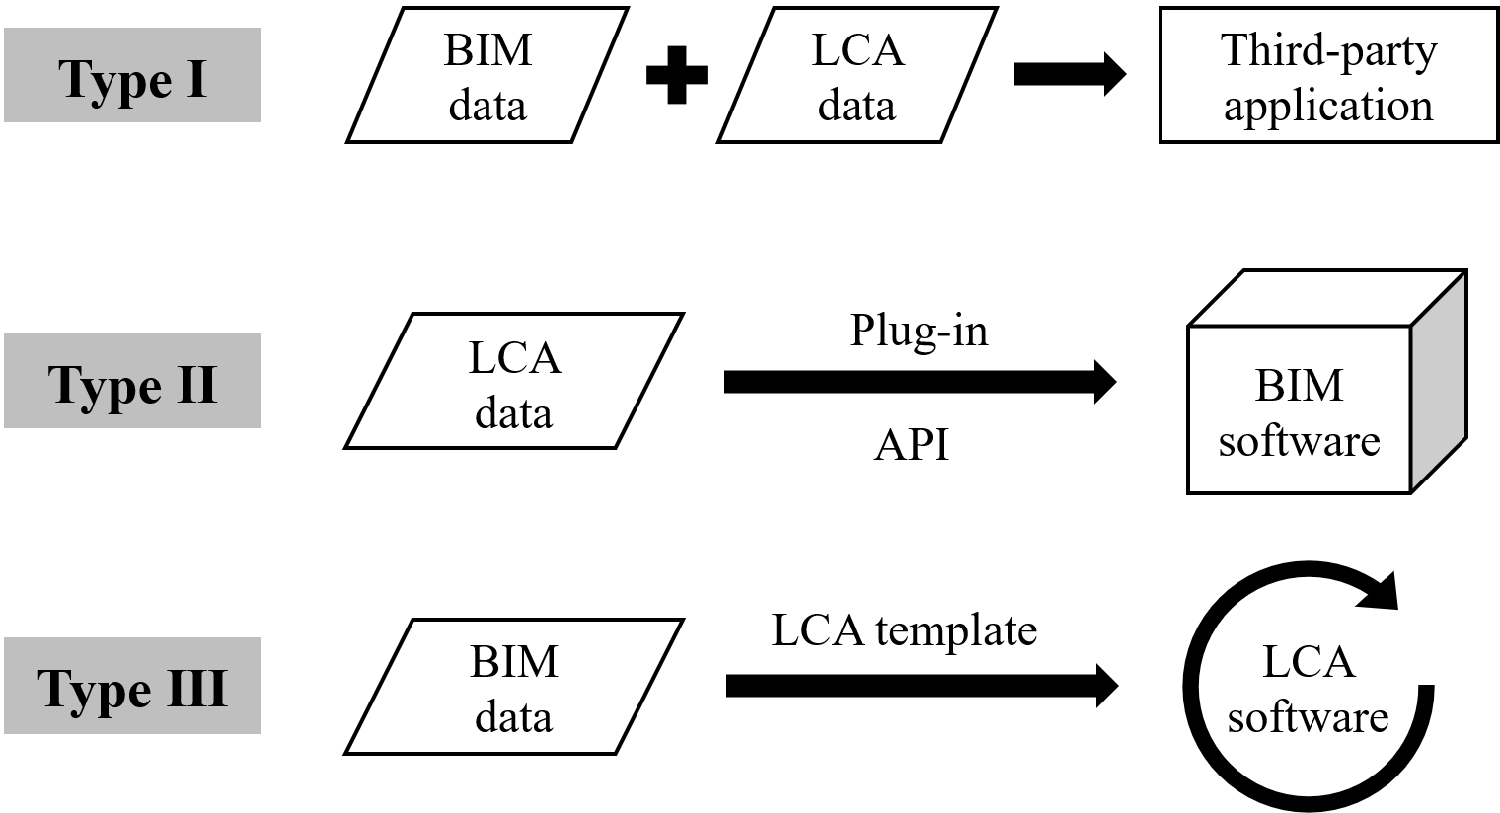
Fig. 1. Three types of BIM-integrated LCA approaches pertaining to data exchange flow (based on Teng et al. (2022))

Type Ⅰ integrates the data collected from BIM and LCA tools into a third-party application and obtains the carbon results through simple multiplication. Various BIM software, such as Autodesk Revit (Wang et al., 2018; Feng et al., 2020), ArchiCAD (Soust-Verdaguer et al., 2020), and Rhinoceros (Cavalliere et al., 2019) can be used to create models containing material quantities, which are then exported and combined with carbon emission factors from diverse LCA databases (Cheng et al., 2020; Palumbo et al., 2020). The calculation is usually implemented in Excel spreadsheets or specifically developed tools using programming languages (Jun et al., 2015; Cang et al., 2020; Theißen et al., 2020). Despite its simplicity and quick feedback, this approach is only suitable for simplified LCA with basic calculations.

Type Ⅱ incorporates carbon emission factors into the BIM environment by developing plug-ins or using application programming interfaces (APIs) (Eleftheriadis et al., 2018; Santos et al., 2019; Jalaei et al., 2020). This approach takes full advantage of BIM technology as a data repository and a visualization platform, while the data mapping process of carbon emission factors and BIM objects is still labor-intensive because of the disparity in material definitions such as units, types, and names (Röck et al., 2018; Hollberg et al., 2020). Moreover, the developed LCA function is dominated by researchers’ subjective perceptions and lack of expert consideration.

Type Ⅲ is advantageous in terms of professionalism and reliability by importing necessary BIM data into dedicated LCA software tools for an accurate and comprehensive LCA. This approach should be emphasized because it provides sufficient LCA data with embedded databases in LCA tools and enables a connection between the informative BIM model and professional LCA execution. Nevertheless, data interoperability between BIM and LCA tools remains a significant challenge and has impeded the intensive exploration of this type of approach. Table 2 presents several BIM-integrated LCA methods developed in relevant studies. The review results indicate a general data exchange mechanism in previous research in which the LCA model of buildings should be established manually and separately in the LCA tool based on information captured from BIM, such as materials and activities (Jrade and Jalaei, 2013; Ajayi et al., 2015; Vandervaeren et al., 2022). In addition, because the embedded material databases of BIM tools are usually different from those of LCA tools in terms of definitions, names, and units, LCA practitioners need to select some similar materials based on their experience or construction codes (Yang et al., 2018; Rezaei et al., 2019). Revit was the most common BIM tool owing to its prevalence in construction design. Various LCA tools were selected, including the Athena Impact Estimator, eBalance, openLCA, and SimaPro. No study has addressed the data interoperability between BIM and LCA tools, regardless of which LCA tool was selected. Inefficient data input into LCA tools also calls for an automatic data exchange mechanism between BIM and LCA tools.

Table 2 The third type of BIM-integrated LCA methods in previous research
Authors | BIM tool | LCA tool | Data exchange
Jrade and Jalaei (2013) | Revit | Athena Impact Estimator | Importing BoQ as text exchange file with manual description of different assemblies
Ajayi et al. (2015) | Revit | Athena Impact Estimator | Establishing components and corresponding materials manually based on BIM data
Yang et al. (2018) | Revit,  Glondon BIM5D | eBalance | Selecting materials manually in eBalance based on LCI data obtained from BIM model
Rezaei et al. (2019) | Revit | openLCA | Bridging BIM data and ecoinvent processes in the openLCA based on expert judgement and construction codes
Su et al. (2021) | Revit | eBalance | Entering demolition waste information into eBalance from BIM data
Vázquez-Rowe et al. (2021) | Not mentioned | SimaPro | Establishing building models in both tools separately
Vandervaeren et al. (2022) | Revit | SimaPro | Associating product and activities inventory from Revit to upstream substances flows in SimaPro

The limitations and observations identified from the literature review are summarized as follows. First, data interoperability between BIM and LCA tools is a significant challenge that hinders the development and adoption of approaches using both professional tools. The lack of a common data structure makes mutual data exchanges difficult. However, practitioners will be more willing to conduct carbon assessments during the design phase if this problem can be addressed because BIM engineers and LCA experts will only be responsible for their own tasks. To improve the data interoperability, developing a data exchange tool based on an open data format such as IFC is recommended rather than using specific plug-ins of certain BIM software. Second, the manual establishment of a carbon assessment model in the LCA tool is usually performed based on the captured BIM data, leading to inefficient and prone-to-error data input. A construction project may involve numerous material types and complex construction activities. Thus, an automatic data exchange tool is necessary to facilitate more efficient carbon assessment. Third, there is a lack of a BIM-integrated LCA method for assessing the carbon emissions of prefabricated buildings at multiple spatial levels. Most previous studies calculated the total carbon emissions for the whole building, failing to address standardized prefabricated products at different levels (i.e., component, assembly, flat), thus reducing the efficiency of carbon assessment of buildings. This paper addresses these knowledge gaps by developing a BIM-integrated LCA solution to automate the embodied carbon assessment of prefabricated buildings using a five-level analytical framework.

Proposed BIM-integrated LCA solution
A BIM-integrated LCA solution was developed in this paper (Fig. 2), involving three modules: (1) BIM data preparation, (2) data extraction and integration, and (3) embodied carbon assessment. A five-level analytical framework proposed by Pan et al. (2019), contextualized to the design and construction of typical prefabricated high-rise buildings in Hong Kong, was applied throughout the development process to advocate a standardized and consistent reporting format. The five levels were defined as material (e.g., concrete and steel), component (e.g., precast slab, precast staircase), assembly (e.g., non-volumetric precast facade and volumetric precast kitchen pod), flat (a residential unit), and building (the entire building). To better understand and explain the element hierarchy of prefabricated buildings, the concept of set theory was employed (Fig. 3) to demonstrate the hierarchical relationship among the five-level elements. For example, Set B represented all the compositions of the whole building, including all flats (F), precast assemblies (A2) and components (C2) that directly constituted a building (e.g., precast refuse chute, precast connecting slab), and onsite elements (∁_{B}(A2∪C2∪F)). Precast assemblies and components that formed a residential flat were collected in Set A1 and Set C1 while ∁_{F}(A1∪C1) comprised onsite elements for building flats (e.g., cast-in-situ walls). The materials used for the different sets of elements were distributed in the corresponding material sets (M1-M6) and the combination of all material sets was used to calculate the embodied carbon at the material level.

The three modules were implemented in sequence. First, a BIM model was established according to the specific modeling rules regarding the five-level prefabrication system and supplementary carbon-related data. Then, the BIM data were exported as an IFC model, based on which the necessary data were extracted, reconstructed, and integrated into LCA templates using the developed data transfer tool. Finally, the LCA model was automatically created and then analyzed to report prefabricated buildings' five-level embodied carbon results. Because IFC was adopted in the proposed solution, any BIM software tool that supports property customization and IFC export should be available (e.g., Revit, SketchUp, Tekla, and ArchiCAD). Revit was selected to describe the development procedures explicitly because of its popularity. Regarding professional LCA tools, SimaPro was chosen because it is one of the leading LCA software programs worldwide and has been integrated with diverse popular LCA databases such as Ecoinvent, ETH-ESU 96, and U.S. LCI, which are able to provide sufficient carbon emission factors for materials and energy (Speck et al., 2016). Several studies have compared SimaPro with other LCA software tools (e.g., GaBi and OpenLCA) and demonstrated its reliability and accuracy (Herrmann and Moltesen, 2015). The development processes and functions of these three modules are described in the following sections.

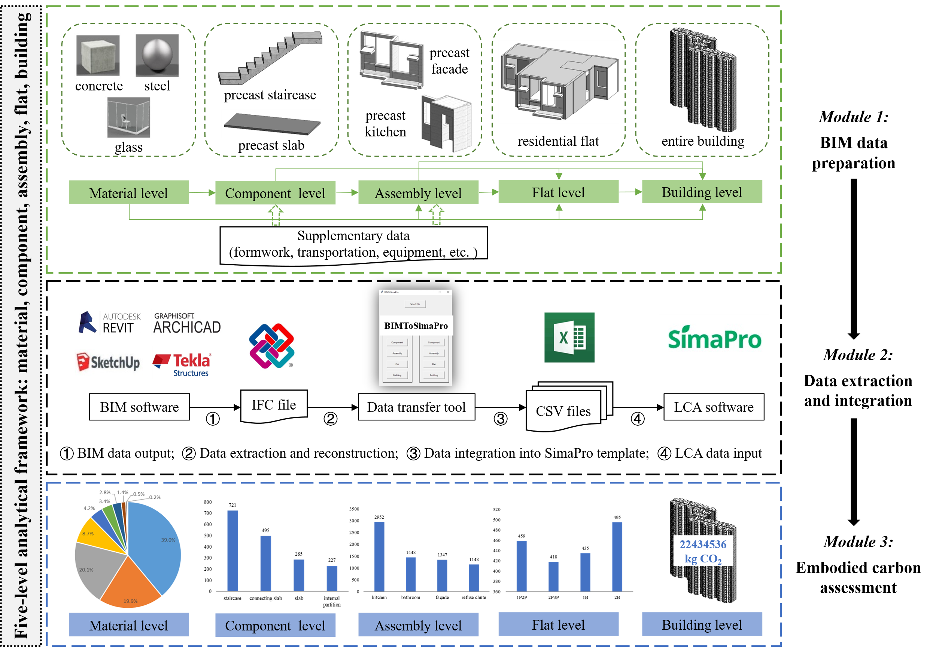
Fig. 2 Framework of the developed BIM-integrated LCA solution

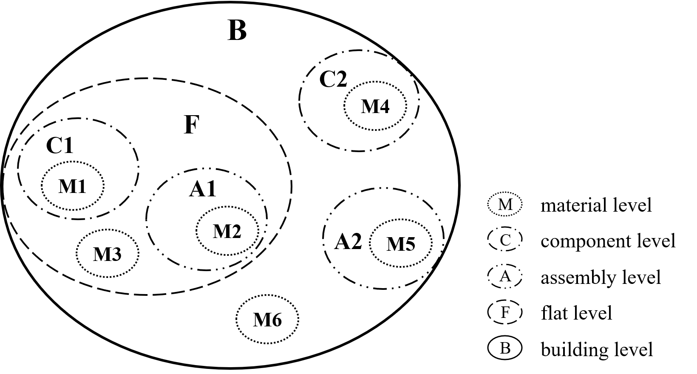
Fig. 3 Element hierarchy of prefabricated buildings based on the five-level framework

Module 1: BIM Data preparation
The first module prepared construction activity data for carbon assessment using standardized BIM modeling. Although BIM modeling appears to be a common issue, two additional modeling rules are required to support subsequent carbon assessments. The first rule was to clearly define the five spatial levels of prefabricated buildings, i.e., material, component, assembly, flat, and building, so that standardized prefabricated products could be addressed for more efficient carbon evaluations. The second rule was to incorporate LCA-related data into the properties of the building elements, including their physical and functional properties. Physical properties include object types (e.g., slab, staircase, bathroom unit), geometric profiles (e.g., dimensions and volumes), and construction materials (e.g., concrete, steel). Functional properties are user-defined and should be determined by LCA data requirements. Thus, it is essential to clarify the scope of LCA, system boundaries, and carbon sources before BIM modeling.

The scope of this paper was restricted to the assessment of cradle-to-end-of-construction embodied carbon, which covered six life cycle stages: raw material extraction (S1), transport from extraction site to factory (S2), manufacturing (S3), prefabrication (S4), transportation to building site (S5), and onsite construction/installation (S6), as described by Pan (2014). According to the description of LCA data requirements and corresponding data sources by Teng and Pan (2019), LCA data sources are divided into three categories, as presented in Table 3. The material-related data were directly obtained from the design BIM model. Other supplementary data (e.g., formwork, transportation, and equipment) were collected from construction documents or personal interviews with stakeholders.

Table 3 Data sources for conducting embodied carbon assessment of buildings
Category | Data description | Data sources
Material-related | - Quantities and types of raw materials (fuel and electricity consumed for the extraction, transportation, and manufacturing of raw materials have been considered in the carbon emission factors provided by SimaPro databases);  - Quantities and ingredients of construction materials for each precast element;  - Quantities and types of materials used by the formwork;  - Quantities and ingredients of onsite materials; | SimaPro;  BIM model; documents/  interviews
Transport-related | - Transportation modes and distances in S5;  - Fuel consumed for transportation; | SimaPro;  documents/  interviews;  Google Maps
Equipment-related | - Catalog and running time of equipment (in S4 and S6);  - Energy consumed by construction equipment. | SimaPro; documents/  interviews;

A BIM model was then established based on these modeling rules. Building elements were first created as basic constituents, where onsite elements were created using existing family types (e.g., slabs, walls), and prefabricated elements at the component and assembly levels were created as new family types. The material specifications (e.g., concrete and C30) were defined by customizing new material types. Note that one element may contain both precast and cast-in-situ parts. However, they can be easily distinguished using a material definition. For example, a prefabricated column's upper and lower ends were established as separate parts with cast-in-situ concrete. The remainder was established with offsite concrete so that the material quantities could be counted respectively. A preparatory step was conducted with well-created building elements to assign all the constituents of a residential flat encompassing precast and onsite elements into a group for recognizing the flat. Thus, the hierarchical relationships between material, component, assembly, flat, and building levels were clearly defined.

Physical properties (i.e., object types, geometric profiles, and construction materials) were determined along with the modeling of individual building elements. The functional properties were customized by inputting supplementary data (i.e., formwork, transportation, and equipment) as shared parameters. A common naming convention (e.g., material name, transportation mode, and formwork definition) was formulated and applied. To enhance automatic data mapping between the BIM model and carbon emission factors from LCA databases in subsequent procedures. An example of the addition of the transportation parameter to a prefabricated slab in Revit is shown in Fig. 4. The transportation mode was adjusted with local data to better reflect reality. With all the supplementary data incorporated into the BIM model, LCA-related data were combined into one data repository, eliminating the demand for data collection, processing, and integration from diverse sources.
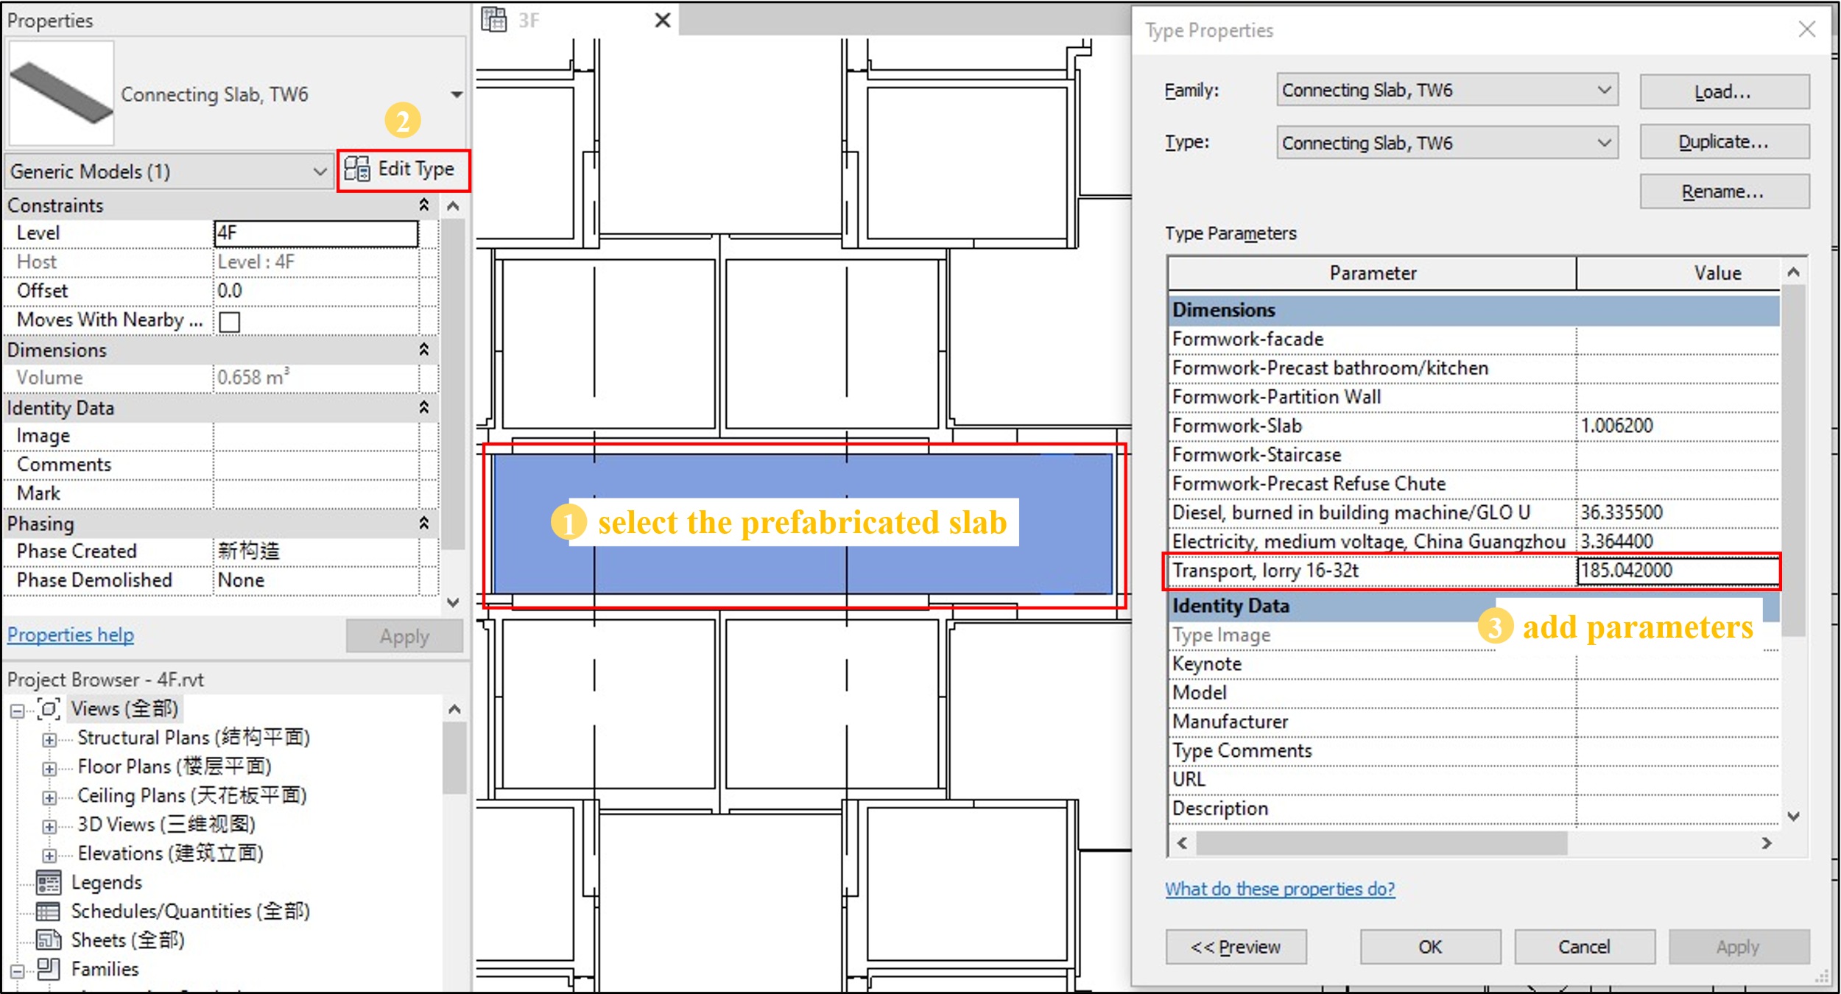
Fig. 4 The process of adding the transportation parameter to a prefabricated slab in Revit

Module 2: Data extraction and integration
The second module addressed data communication between BIM and LCA tools using a developed data transfer tool with improved interoperability. The necessary data were automatically extracted from the output BIM data and integrated into the developed SimaPro templates for LCA data input. This module involves four tasks: (1) BIM data output, (2) data extraction and reconstruction, (3) data integration into SimaPro template, and (4) LCA data input. As illustrated in Fig. 2, task (1) was implemented through export functions in BIM tools, and task (4) was conducted using the LCA tool, SimaPro. For tasks (2) and (3), an IFC-enabled data transfer tool named BIMToSimaPro (illustrated in Fig. 5) was developed using Python to automate data extraction, reconstruction, and integration. IFC represents a neutral international openBIM standard for interoperable data sharing and exchange among various participants in construction projects (buildingSMART, 2019). Despite the many studies devoted to IFC processing, it has rarely been utilized as a medium for data communication between BIM and LCA tools. Therefore, IFC4 was used in the developed solution.
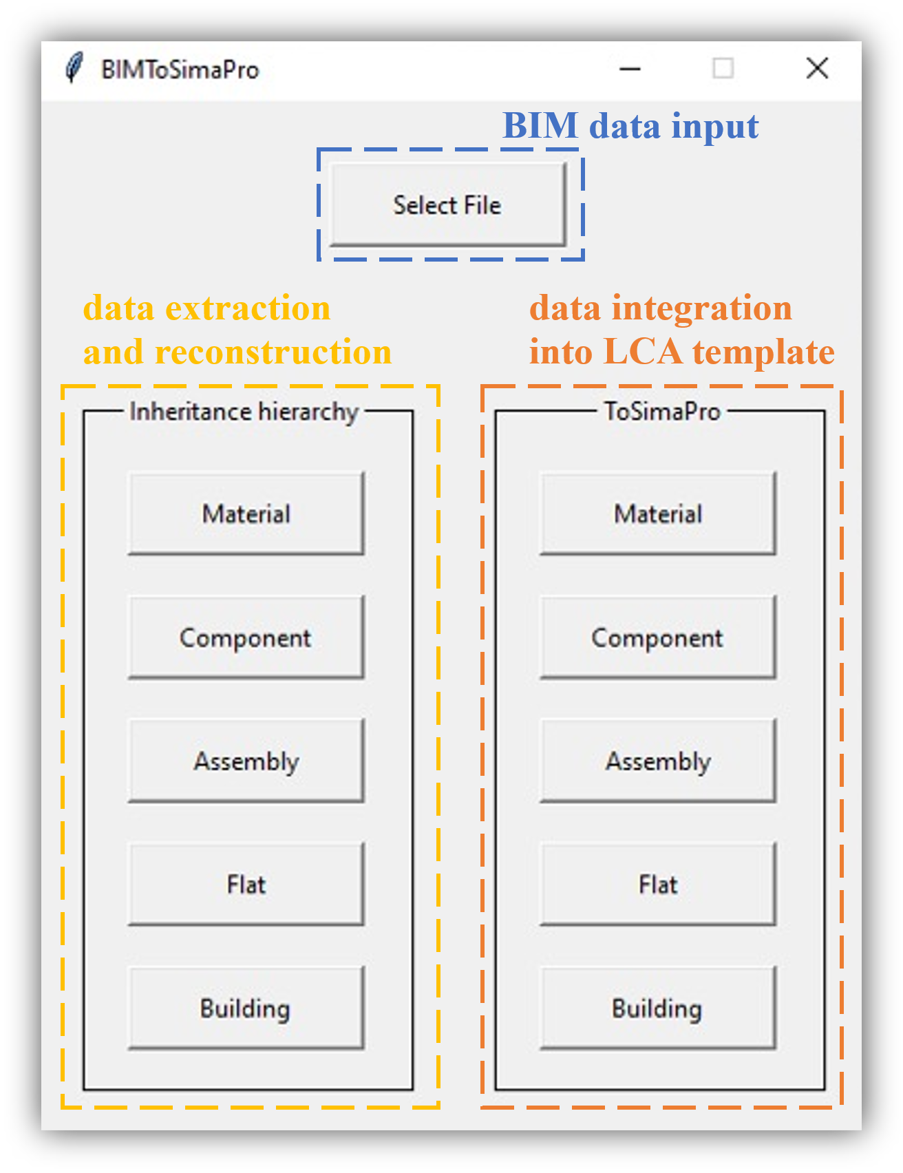
Fig. 5 Interface of the developed data transfer tool “BIMToSimaPro”

Task 1: BIM data output
The well-established design BIM model was exported to an IFC data model, which could be supported by various common BIM software such as Revit, ArchiCAD, SketchUp, and Tekla. BIM data were accordingly represented using the IFC schema, which was conducive to data manipulation in subsequent tasks.

Task 2: Data extraction and reconstruction
Two types of data were extracted from the BIM and restructured to adapt to the LCA data structure (Fig. 6). LCI data were included in the physical and functional properties of BIM objects, namely, object type, material quantity, material type, formwork data, transportation data, and equipment data. The five-level hierarchical relationship of the prefabricated buildings was described through the containment relationship in the BIM model.
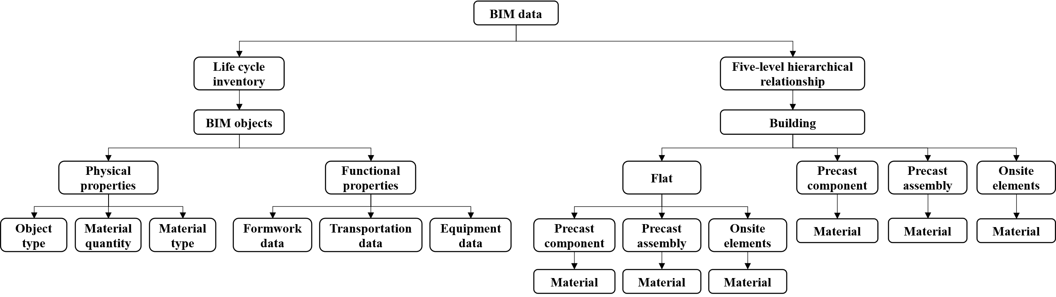
Fig. 6 Necessary data to be extracted from the BIM model

Life cycle inventory data
In the IFC data model of prefabricated buildings, IfcBuildingElementProxy was adopted to describe user-defined precast elements. LCI data were associated with this instance through different attributes. Fig. 7 presents the IFC data structure of an instance's physical and functional properties. For physical properties, the object type was directly placed in the “Name” attribute; for example, “Precast Slab, S1” represents a type of precast slab. The material type and quantity were queried using the inverse attributes HasAssociations.RelatingMaterial and IsDefinedBy.RelatingPropertyDefinition. Functional properties were defined under the type instance IfcBuildingElementProxyType, which was linked to the element instance through the inverse attribute IsTypedBy.RelatingType. The data relating to formwork, transportation, and equipment were retrieved in instances of IfcPropertySingleValue, where “Name” attribute depicts the process name such as “Formwork-Slab”, “Transport, lorry 16-32t”, “Diesel, burned in building machine/GLO U” and “NominalValue” attribute provides corresponding value such as “0.6961p”, “523.57tkm”, and “102.8MJ”. Based on the understanding of the IFC data structure, the life cycle inventory data were extracted using the proposed algorithm, as shown in Fig. 8. By inputting the IFC file of a prefabricated building model, a list of precast elements with the corresponding LCI information in terms of material, transportation, and equipment was acquired as an output. An iterative search was conducted for all IFC entities.

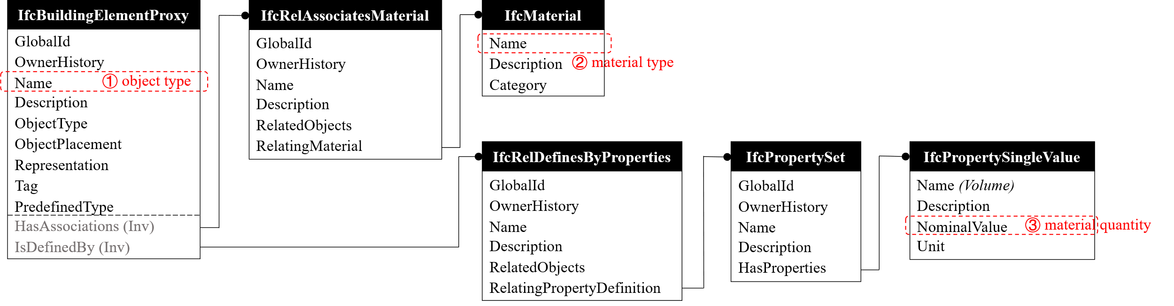
(a)
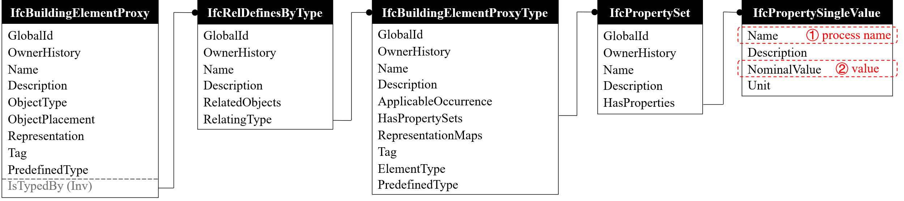
(b)
Fig. 7 IFC data structure of (a) physical properties, (b) functional properties for an instance

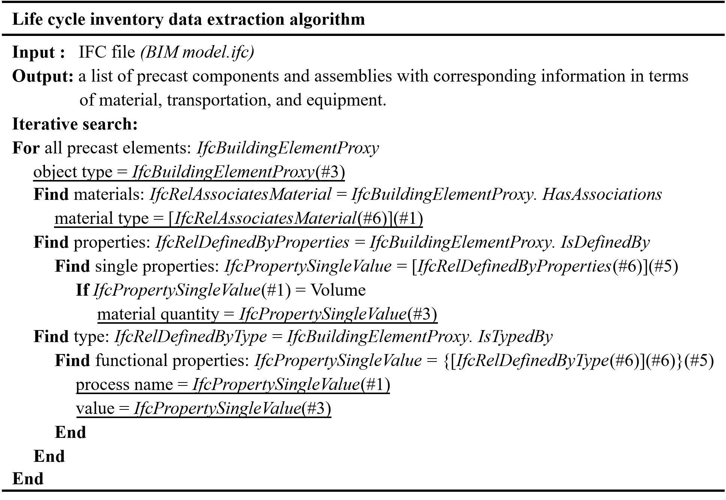
Fig. 8 Life cycle inventory data extraction algorithm

Five-level hierarchical relationship
Fig. 9 illustrates the IFC data structure of the inheritance hierarchy at the five levels. All building elements were correlated with the building through IfcBuildingStorey. Flats were defined by instances of IfcGroup, and constituent building elements were queried using the inverse attribute IsGroupedBy. However, owing to the lack of a direct link between the building level and the flat level in the IFC schema, further analysis was required to determine whether a flat was subordinate to a building. Among all the building elements, precast assemblies and components could be identified by searching IfcBuildingElementProxy, and the rest were recognized as onsite elements, such as IfcWall and IfcSlab. Materials were attached to building elements using the inverse attribute HasAssociations.RelatingMaterial. To retrieve the correct data into different sets, an extraction algorithm (Fig. 10) was proposed after analyzing the IFC data structure and the datasets representing the five levels (material, component, assembly, flat, and building) for prefabricated buildings were obtained.
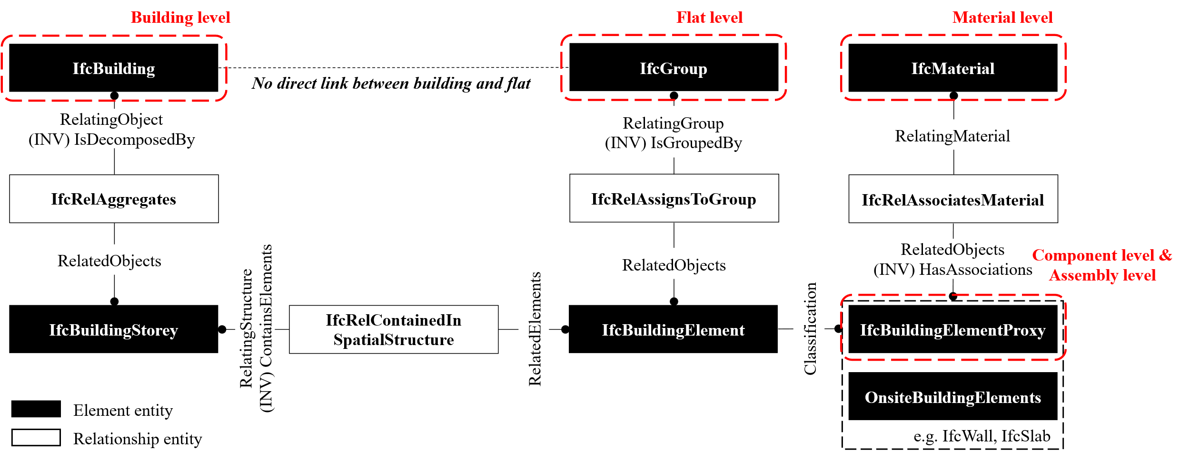
Fig. 9 IFC data structure of the inheritance hierarchy among five levels

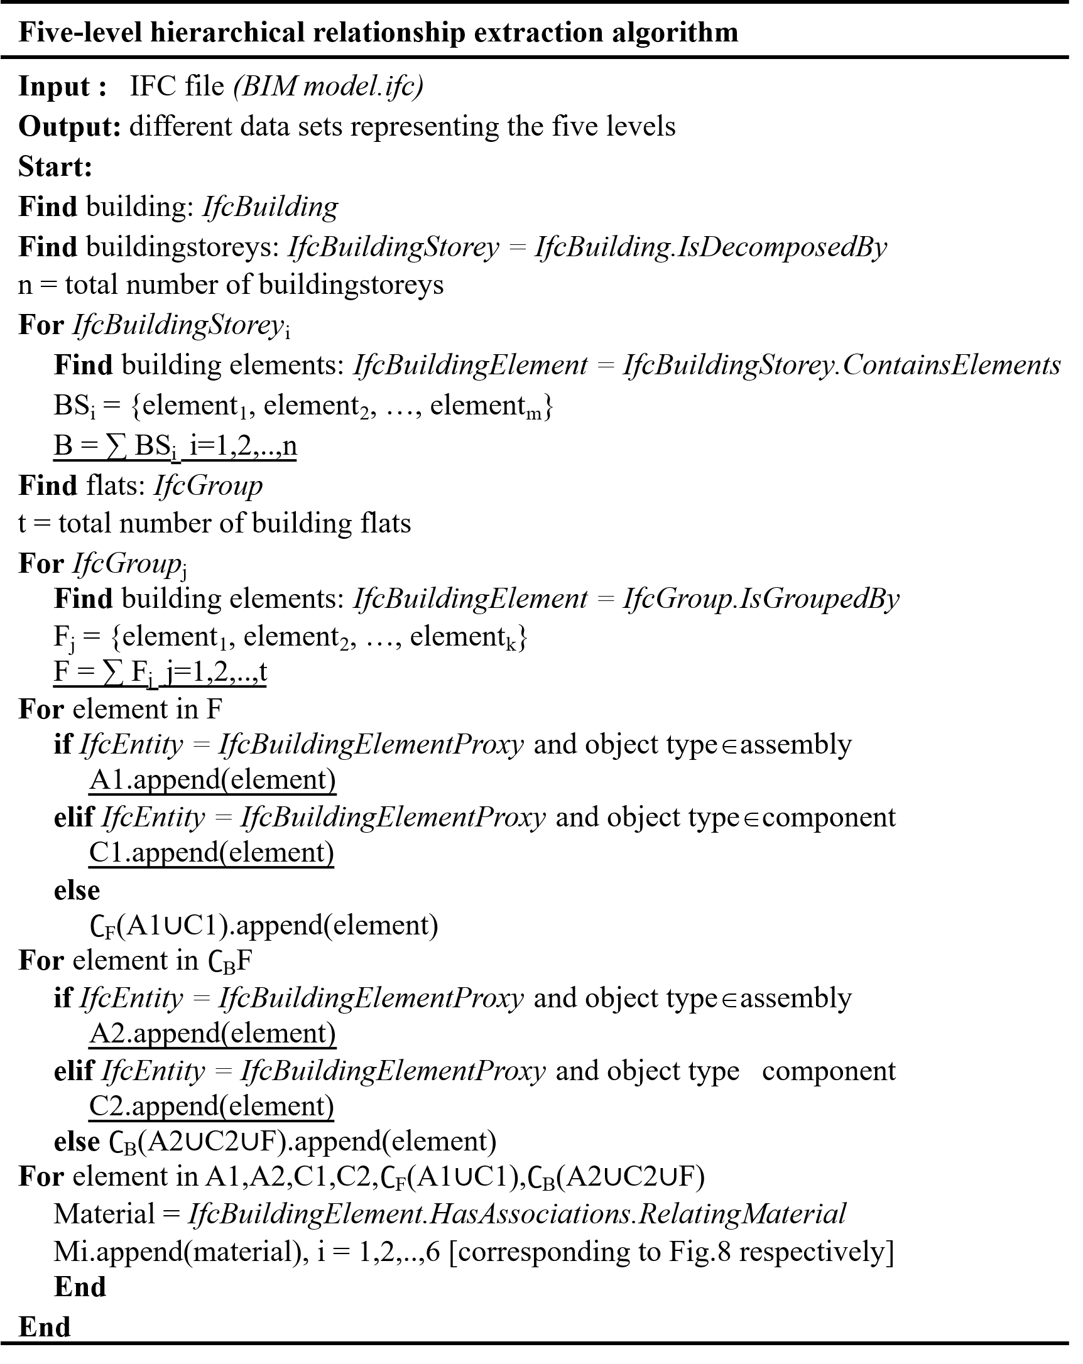
Fig. 10 Five-level hierarchical relationship extraction algorithm

Task 3: Data integration in SimaPro template
It is feasible to establish the LCA model in SimaPro using its import function by complying with a specific format. Therefore, a SimaPro template was developed, as shown in Fig. 11. The template was initially verified using different project data to ensure feasibility and accuracy. Two types of data were required: head data and process data. Head data consisted of basic project information (e.g., SimaPro version, project name) and selected LCA databases. Process data comprised multiple products and their compositions at five levels, accounting for embodied carbon calculation. In the process data, the five-level building elements were all defined as a product that constituted a process together with their compositions. For example, a precast assembly named “Precast Facade, T1&T1r_4F” was created as a product in the process data and was associated with relevant material, transportation, and equipment data. A Python-based script was developed to create numerous five-level processes and integrate them into one template for the LCA data input.
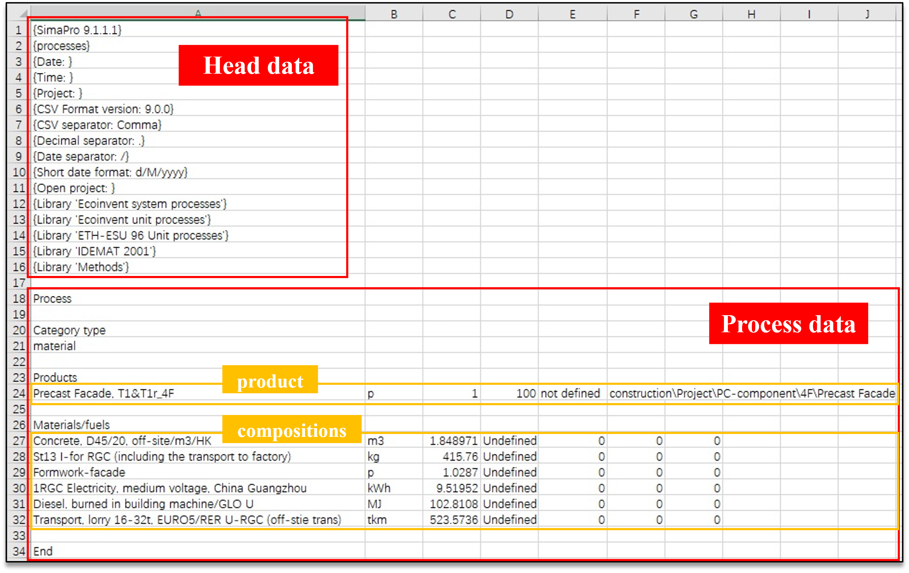
Fig. 11 SimaPro template for LCA data input

Task 4: LCA data input
After automatic data extraction, reconstruction, and integration, BIM data were successfully adapted to the SimaPro-accessible data structure for the LCA data input. By importing the generated CSV files into SimaPro, the LCA model was automatically established to conduct embodied carbon assessment.

Module 3: Embodied carbon assessment
The third module performed a comprehensive embodied carbon assessment of prefabricated buildings using dedicated LCA software. According to ISO 14044 (ISO, 2006), PAS 2050 (BSI, 2011b), and European Norm (EN) 15978 (BSI, 2011a), the embodied carbon emissions can be quantified by multiplying the activity data and corresponding emission factors as follows:
Emissions = AD × EF (1)
where AD refers to the activity data (e.g., volume, mass, energy) and EF denotes the emission factor that provides the carbon volume per unit activity (kg CO₂ per unit).

By importing the generated CSV files into SimaPro, the activity data were multiplied by emission factors from the embedded LCA databases to calculate the embodied carbon based on the LCA model. The embodied carbon results of the prefabricated buildings were reported at five levels: material, component, assembly, flat, and building.

Case study in a real prefabricated building using the developed solution

Case building description
The real-life case was a 30-story prefabricated residential building in Hong Kong. The building comprises 870 flats and thousands of precast components and assemblies, which is conducive to assessing the efficiency of the developed solution in a large-scale project. This case was selected because it represents the status quo of typical prefabricated residential buildings in Hong Kong. The embodied carbon results of the case building have already been calculated using traditional manual LCA in a previous study (Teng and Pan, 2019). The research conducted by Teng and Pan (2019) was also based on the life cycle stages defined by Pan (2014), and reported the embodied carbon emissions of the case building on the five-level analytical framework (Pan et al., 2019). This present paper further improves the LCA method by integrating it with BIM technology. Thus, it is possible to validate the accuracy and efficiency of the developed solution by comparing it with a reference case. Project data relevant to materials, transportation, and equipment were collected from the BIM model, construction documents, and personal interviews. Detailed case information can be found in a previous study (Teng and Pan, 2019).

Application of the developed solution
Three modules of the developed solution were successively applied to the case building. A BIM model was first established using Revit based on the building drawings. Fig. 12 presents the BIM model and the standard layout of a typical floor. Four shared parameters were incorporated into building elements to provide the data of formwork, diesel, electricity, and transportation, where “formwork” refers to the consumption of materials in formwork; “diesel” denotes the consumed energy by construction equipment; “electricity” indicates the electric use of construction equipment; “transportation” represents the multiplication of material quantity and transport distances. The BIM model was exported as an IFC data model and imported into BIMToSimaPro for data extraction and integration. Examples of the extraction results for life cycle inventory data, including physical and functional data, are presented in Tables 4(a) and 4(b), respectively. Fig. 13 shows only part of the extracted results for the hierarchical relationship because the entire prefabrication system is too complex, including thousands of elements. The developed data transfer tool allowed automatic data integration into the SimaPro template. After importing the generated CSV files into SimaPro, the LCA model of the case building was automatically established, and the embodied carbon results at the five levels were calculated by analyzing the corresponding products. The carbon emission factors for materials and activities in the construction stage of the case study building are provided in Table A1 in Appendix A.
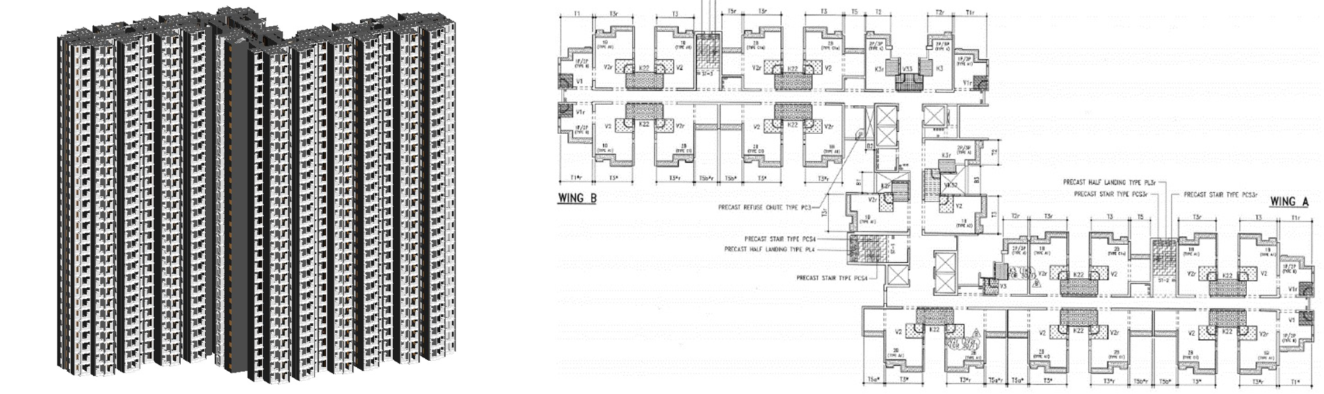
Fig. 12 BIM model and the standard layout of the case building

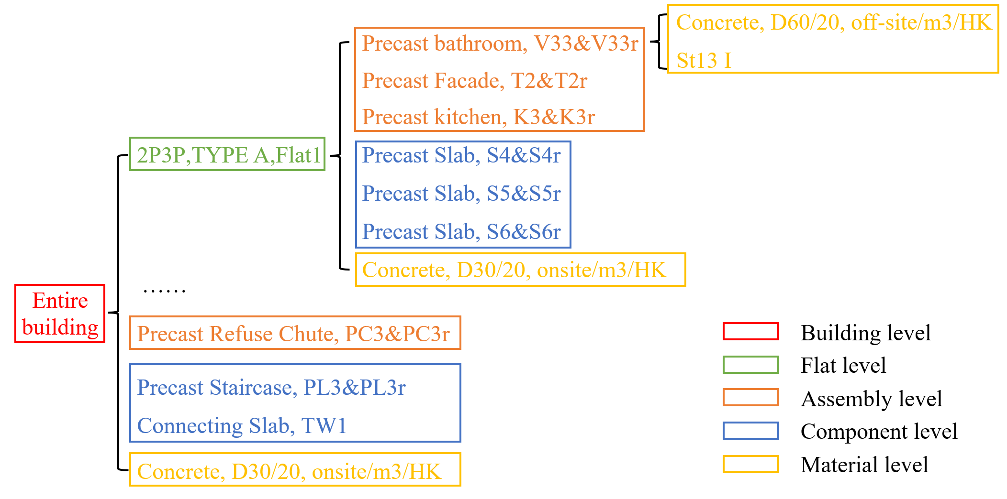
Fig. 13 Part of the extracted results for the hierarchical relationship

Table 4 (a) Examples of the extracted life cycle inventory data (physical data)
Object | Concrete | Quantity(m³) | Steel | Quantity(kg)
Precast Facade, T1&T1r | Concrete, D45/20, off-site/m3/HK | 1.849 | St13 I | 415.76
Precast Slab, S4&S4r | Concrete, D45/20, off-site/m3/HK | 0.418 | St13 I | 64.58
Precast kitchen, K3&K3r | Concrete, D60/20, off-site/m3/HK | 2.232 | St13 I | 437.16
Partition Wall, PW1&PW1r | Concrete, D30/20, off-site/m3/HK | 0.503 | St13 I | 58.23
Precast Staircase, PL3&PL3r | Concrete, D35/20, off-site/m3/HK | 0.997 | St13 I | 135.6
Table 4 (b) Examples of the extracted life cycle inventory data (functional data)
Object | Formwork | Factor(p) | Electricity | Amount(kWh) | Diesel | Amount(MJ) | Transportation | Amount(tkm)
Precast Facade, T1&T1r | Formwork-facade | 1.0287 | Electricity, medium voltage, China Guangzhou | 9.519 | Diesel, burned in building machine /GLO U | 102.81 | Transport, lorry 16-32t | 523.57
Precast Slab, S4&S4r | Formwork-Slab | 0.6961 | Electricity, medium voltage, China Guangzhou | 2.145 | Diesel, burned in building machine /GLO U | 23.17 | Transport, lorry 16-32t | 117.98
Precast kitchen, K3&K3r | Formwork-Precast bathroom/kitchen | 1.3784 | Electricity, medium voltage, China Guangzhou | 11.818 | Diesel, burned in building machine /GLO U | 127.64 | Transport, lorry 16-32t | 650.01
Partition Wall, PW1&PW1r | Formwork-Partition wall | 1.1919 | Electricity, medium voltage, China Guangzhou | 1.989 | Diesel, burned in building machine /GLO U | 21.47 | Transport, lorry 16-32t | 109.37
Precast Staircase, PL3&PL3r | Formwork-Staircase | 1.8168 | Electricity, medium voltage, China Guangzhou | 5.023 | Diesel, burned in building machine /GLO U | 54.25 | Transport, lorry 16-32t | 276.28

Results of embodied carbon assessment of the case building
The embodied carbon of the case building was assessed at five levels, and the results are presented in Fig. 14.
- At the material level, cast-in-situ concrete, precast concrete, and steel were the top three contributors among the diverse materials, accounting for 39.0%, 20.1%, and 19.9%, respectively. Timber was responsible for 8.7% of the materials’ embodied carbon due to timber formwork for in-situ concrete works on site (Fig. 14 a).
- At the component level, the embodied carbon of precast components includes the carbon emissions generated from S1 to S4. Staircases produced the most considerable amount of embodied carbon among the precast components, with an average of 721 kg CO₂ per unit. The averaged embodied carbon generated per unit of connecting slabs, slabs, and internal partitions were 495, 285, and 227 kg CO₂, respectively (Fig. 14 b).
- At the assembly level, the embodied carbon of precast assemblies also includes carbon emissions generated from S1 to S4. Kitchens generated the most embodied carbon (averaged 2952 kg CO₂ per unit), followed by bathrooms (averaged 1448 kg CO₂ per unit), facades (averaged 1347 kg CO₂ per unit), and refuse chutes (averaged 1148 kg CO₂ per unit) (Fig. 14 c). Because the standard types of precast components and assemblies were adopted in Hong Kong, the embodied carbon results at these two levels were meaningful for cross-case comparisons and benchmarking.
- At the flat level, the embodied carbon of a particular residential flat involves the carbon emissions generated from the cradle to the end of construction. “1P2P”, “2P3P”, “1B”, and “2B” are four standard residential flat designs in Hong Kong. The averaged embodied carbon emissions per gross floor area for the four types were 459, 418, 435, and 495 kg CO₂/m² (Fig. 14 d).
- At the building level, the total cradle-to-end-of-construction embodied carbon of the case building was calculated as 22434.5t CO₂ by analyzing the product of the whole building in SimaPro (Fig. 14 e).
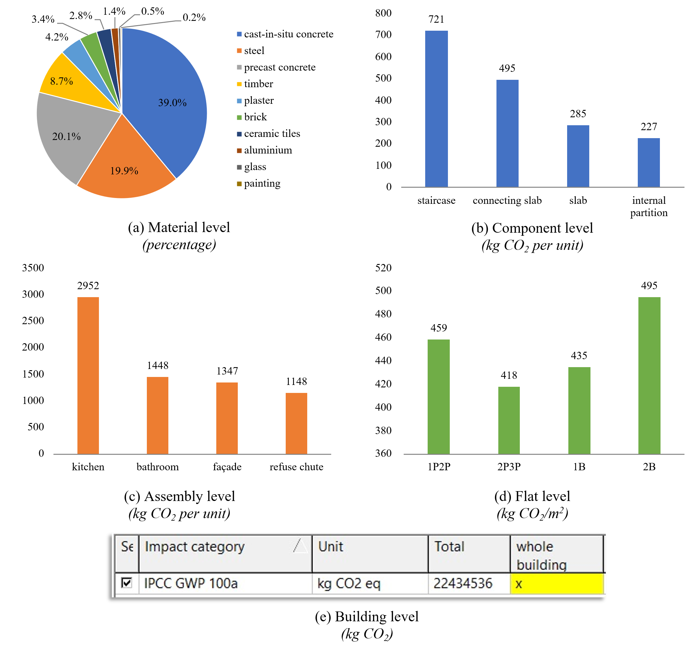
Fig. 14 Embodied carbon results of the case building at the five levels: material, component, assembly, flat, and building

Performance validation of the developed solution
Given the aim and objectives of this paper, it is essential to assess the developed solution in terms of (1) accuracy of the embodied carbon results and (2) efficiency improvement of the LCA process.

Accuracy of the embodied carbon results
The accuracy was assessed by comparing the embodied carbon results generated using the developed solution with those obtained using traditional manual LCA. The total cradle-to-end-of-construction embodied carbon of the case building was calculated as 561 kg CO₂/m² using the developed solution and 568 kg CO₂/m² using the traditional method (Teng and Pan, 2019), indicating a 1% margin of error. The discrepancy was mainly attributed to the differences between BIM model quantities and the quantities in manual construction BoQ reports, which was inevitable owing to the disparity in design and construction. Considering the large scale of the entire building, an error of 1% is relatively small and acceptable, thereby demonstrating the accuracy and reliability of the developed solution.

Efficiency improvement of the LCA process
Traditional manual LCA is a time-consuming and labor-intensive process because a large quantity of data must be collected and then applied to establish the LCA model manually. The developed solution automates LCA modeling in SimaPro using the data transfer tool and SimaPro templates. To validate the extent to which the developed solution achieved time reduction, the total time required for automatic LCA model establishment was compared with that of manual LCA modeling.

The results of the LCA modeling time of the case building at the five levels are compared in Fig. 15. The time measurement was based on the key researcher’s operation of LCA model establishment using the developed solution and traditional manual LCA to eliminate the uncertainty of personal factors (e.g., software proficiency and operation habits). It took approximately 60 min at the material level for both methods to modify the material parameters in LCA databases to adapt to the local context. For traditional manual LCA, it was difficult to precisely measure the total time because several days were necessary for the entire process based on the modeler’s software proficiency and familiarity with the case. Therefore, a rough estimation was applied by multiplying the average modeling time for creating one product by the number of products at each level. Ten products at each level were randomly selected as samples to calculate the average modeling time. In this case, it took an average of 2, 2, 3, and 20 min to establish one product at the component, assembly, flat, and building levels, respectively. In addition, three types of typical floors existed in the case building, so three products were established at the building level to represent all the floors, resulting in an estimation of 60 min for modeling. The modeling time at the other three levels was estimated accordingly. The manual LCA modeling process was estimated to take 729 min, whereas the LCA modeling using the developed solution only took approximately 62 min. Regarding the five levels, a significant efficiency improvement above 99% was achieved at the component, assembly, flat, and building levels, as shown in Fig.15, and a total enhancement of 91.5% was achieved considering the inevitable modification process at the material level. The results indicate a considerable improvement in the efficiency of the embodied carbon assessment of prefabricated buildings.

It is worth mentioning that the derived efficiency improvement was limited to the carbon assessment procedure, and none of the programming and development processes were considered in the time calculation. One reason was that it was difficult to estimate the total time, including exploration and development. Besides, suppose the programming and development processes are counted for the BIM-integrated LCA solution; the long-period data collection procedures should also be counted in the time calculation of traditional LCA. Additionally, the developed solution is generally applicable in the Hong Kong context because most of the public prefabricated buildings in Hong Kong adopt the five-level prefabrication system (Pan et al., 2019). Therefore, if the developed solution is used in multiple prefabrication cases, the average programming and development time will be decreased. For other prefabrication systems worldwide, only some simple adaptions should be made because the basic concepts of prefabricated element hierarchy are similar (Teng and Pan, 2019). Thus, the time measurement should be able to reflect the efficiency improvement despite its simplicity.
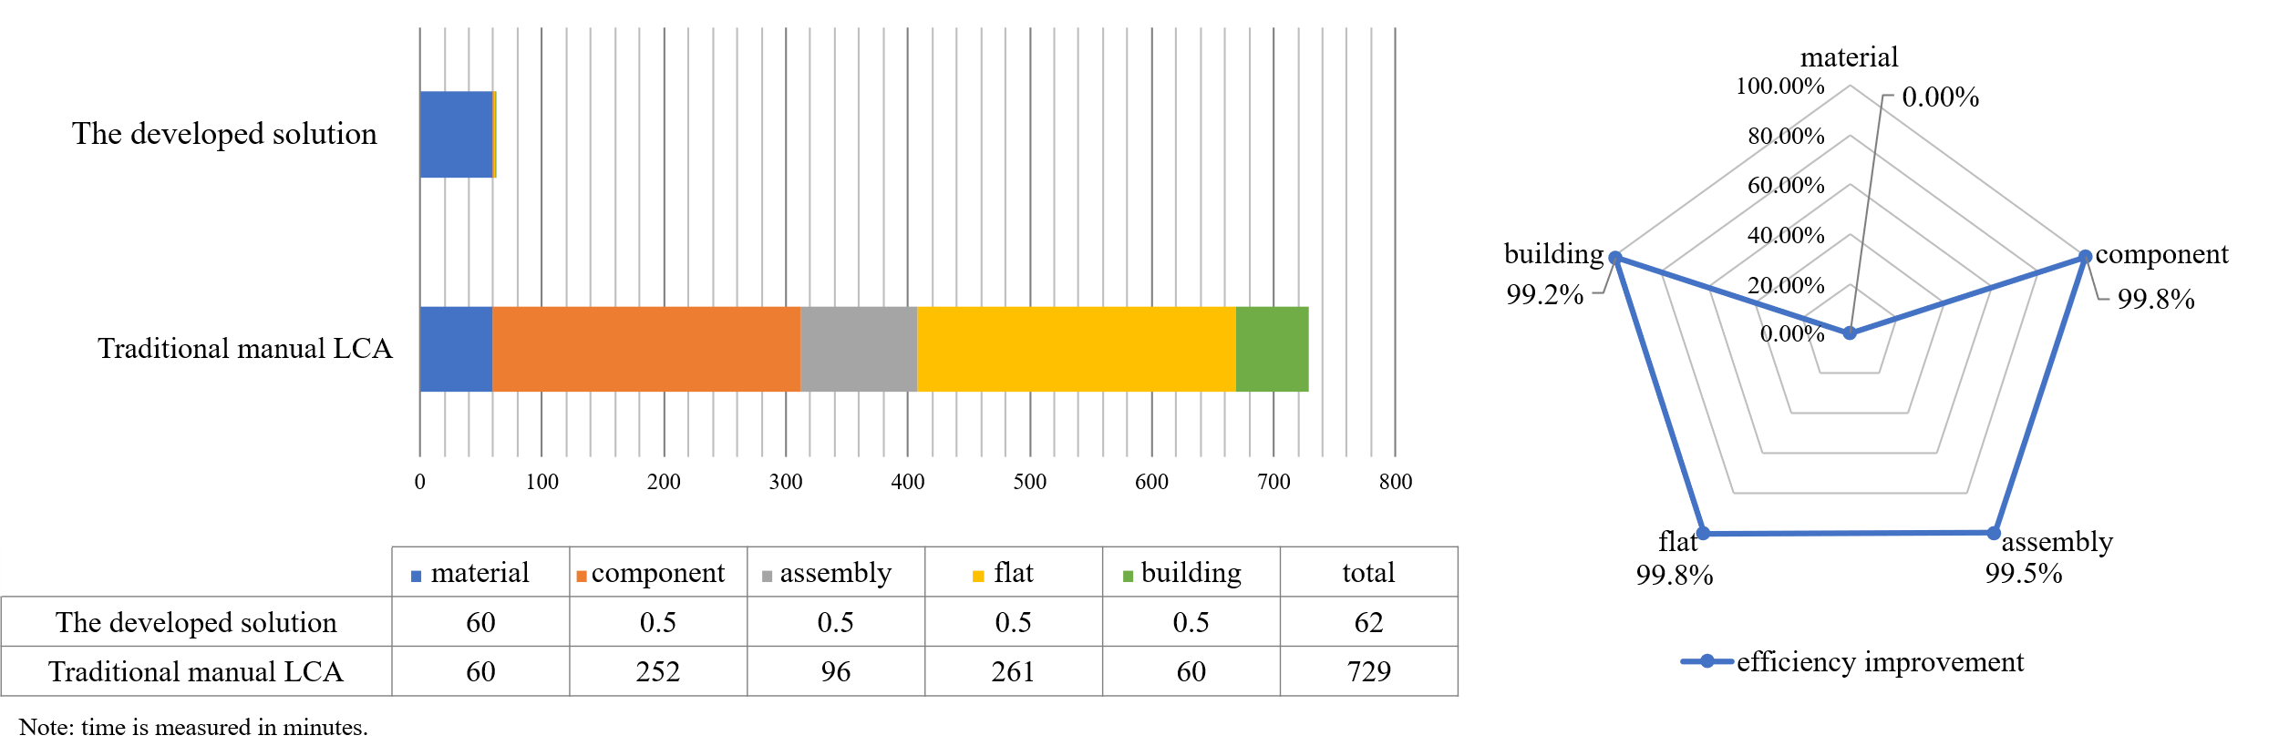
Fig. 15 Comparative results of LCA modeling time of the case building

Discussion
This paper has addressed three significant research gaps identified in the literature review part. The innovations are discussed below to demonstrate the advantages of the proposed solution compared to other BIM-integrated LCA solutions and its contributions to knowledge.

First, from a theoretical perspective, a five-level analytical framework for prefabricated buildings was applied throughout the development of the BIM-integrated LCA solution. Some researchers have adopted BIM to facilitate carbon assessment of prefabricated buildings. Still, the embodied carbon of prefabricated buildings has been reported only at the material or building level, failing to address the embodied carbon of standardized prefabricated products at different spatial levels (Ding et al., 2020; Hao et al., 2020; Li et al., 2021). By adopting the five-level framework proposed by Pan et al. (2019), the developed solution can obtain the embodied carbon of prefabricated buildings using a standardized and consistent format at five levels: material, component, assembly, flat, and building, facilitating more efficient carbon evaluations. It is also conducive to identifying effective carbon reduction measures from various aspects instead of considering materials only. Besides, although the developed solution was built on the five-level framework in Hong Kong, it can also be applied to other prefabrication systems worldwide because the basic concepts of prefabricated element hierarchy are similar although different classifications may be used (Teng and Pan, 2019). Only simple adaptions should be made, such as adding/deleting the element levels in the data extraction algorithm.

Second, from a methodological perspective, the developed data transfer tool addressed the data interoperability between BIM and LCA tools through the IFC format, achieving automatic data mapping. Disparate data structures have been identified as a major issue hindering mutual data exchanges (Yang et al., 2018; Rezaei et al., 2019). Consequently, the LCA model should be established manually based on information captured from BIM in previous BIM-integrated LCA experiences (Jrade and Jalaei, 2013; Ajayi et al., 2015; Vandervaeren et al., 2022). The developed solution achieved data mapping between BIM and SimaPro through automatic data extraction, reconstruction, and integration based on the IFC standard. After investigating the respective data structures, modeling rules were defined to establish BIM models to incorporate LCA-related data into building elements' physical and functional properties. A SimaPro template was also developed to access the LCA data structure. Valid and efficient data algorithms were proposed after clarifying the data requirements and analyzing the corresponding IFC data structure. Moreover, considering the selected tools, the developed solution was more adaptable than previous BIM-integrated LCA solutions. The utilization of IFC standards not only tackled data interoperability but also eliminated the dependence on specific BIM software in most existing experiences (Santos et al., 2019; Hollberg et al., 2020). Additionally, as SimaPro is a market-leading LCA software used in more than 80 countries and is more flexible in dealing with complex building models than other tools (Lu and Lee, 2015), the developed solution should apply to a wide range of carbon assessment practices.

Third, from a practical perspective, the developed solution significantly increased the efficiency of the carbon assessment process by automating data mapping and LCA modeling procedures, which would undoubtedly increase practitioners’ willingness to conduct carbon assessment in the building design stage for quick feedback on carbon emissions. Manual data mapping is usually applied to match BIM objects with impact factors, for example, extracting the BoQ report from the BIM model to an Excel spreadsheet and searching for appropriate impact factors (Wang et al., 2018; Soust-Verdaguer et al., 2020) or directly adding the impact factor to the parameters of BIM objects (Röck et al., 2018; Santos et al., 2020). In addition, the manual establishment of the building model in LCA tools has also been a common case in previous studies (Su et al., 2021; Vázquez-Rowe et al., 2021). Thus, such procedures took a large quantity of time, especially for large-scale projects. The developed solution enabled the automatic adaption of BIM data into the SimaPro-accessible LCA data structure and helped establish the LCA model, as validated in the case study, which achieved a 91.5% efficiency improvement regarding the LCA modeling process. It thus facilitated effective and efficient cooperation between the BIM engineers and LCA experts. Besides, although numerous studies have integrated BIM into LCA to simplify the data collection, few have measured the total implementation time and clarified the time reduction (Teng et al., 2022). This paper compared the LCA modeling process to reflect the efficiency improvement from the LCA perspective.

Conclusions
To address the data interoperability between BIM and LCA tools and promote automatic data exchange, this paper developed a BIM-integrated LCA solution to automate the embodied carbon assessment of prefabricated buildings at five levels: material, component, assembly, flat, and building. An empirical case study in Hong Kong was conducted to validate the feasibility of the developed solution and evaluate its accuracy and efficiency compared to traditional manual LCA. The main findings and conclusions are as follows.

First, the developed BIM-integrated LCA solution was accurate and efficient for evaluating the embodied carbon emissions of prefabricated buildings by integrating IFC data into SimaPro. The empirical study reported the cradle-to-end-of-construction embodied carbon of the case building as 561 kg CO₂/m², showing only a 1% discrepancy with the reference case calculated by traditional manual LCA, which is acceptable because of the inevitable disparity in material quantities between design and construction. The total LCA modeling time was reduced from 729 min to 62 min, indicating a 91.5% efficiency improvement in the embodied carbon assessment. The derived efficiency improvement was limited to the carbon assessment procedure instead of the entire process as it was difficult to estimate the total time, including programming and development. However, the development process should have little impact because of the general applicability of the developed solution. Thus, it can practically increase practitioners’ willingness to conduct LCA at an early design stage with less labor and quick feedback, facilitating more efficient embodied carbon evaluations, and guiding effective low-carbon building designs. Second, the developed data transfer tool BIMToSimaPro effectively addressed the interoperability between BIM and LCA tools by adapting BIM data to the LCA data structure based on the IFC standard. The feasibility and reliability of the data transfer tool were verified using a real-life case study. The developed tool proved to be effective in automatically associating BIM data with carbon impact factors embedded in LCA tools based on a neutral format, significantly enhancing the data reliability and promoting the automation of BIM-integrated LCA solutions. Third, the embodied carbon results based on the five-level theoretical framework provided systematic insights into the embodied carbon distributions of prefabricated buildings. Standardized formats make it possible to analyze carbon contributions from different products (e.g., components, assemblies, and flats) so that more effective and precise carbon reduction strategies can be proposed at diverse levels.

The developed solution has some limitations. First, the developed solution utilized the specified LCA software, and a data transfer tool was developed based on the data structure of SimaPro. However, as SimaPro is a market-leading LCA software used in more than 80 countries, the developed solution should apply to a wide range of carbon assessment practices. Apart from SimaPro, the idea of data structure adaptation makes it possible to extend the solution to other LCA tools by exploiting different templates. Second, the data backhaul from LCA to BIM was not considered in the developed solution. Thus, future research can investigate bidirectional data transfer between BIM and SimaPro to quickly reflect the embodied carbon results in a BIM model with a visual presentation. Third, considering the performance evaluation, this paper has performed a quantitative comparison with the traditional LCA method to demonstrate its accuracy and efficiency and a qualitative comparison with existing BIM-integrated LCA solutions to depict the innovations. Future research could further assess different BIM-integrated LCA solutions to compare their strengths and weaknesses more systematically.

Acknowledgments
This work was supported by a grant from the General Research Fund of the Hong Kong Research Grants Council [Project No.: 17203219]. Support from Hong Kong Housing Authority and Yau Lee Construction Ltd. for access to information of the case building is also acknowledged.

Appendix A.
Table A1 Carbon emission factors of materials and activities in the case study
Materials/Activities | Carbon emission factor | Unit
Concrete, 30/20D, off-site/m3/HK | 410 | kg CO₂/m³
Concrete, 35/20D, off-site/m3/HK | 435 | kg CO₂/m³
Concrete, 45/20D, off-site/m3/HK | 502 | kg CO₂/m³
Concrete, 60/20D, off-site/m3/HK | 513 | kg CO₂/m³
Concrete, 20/20D, on-site/m3/HK | 413 | kg CO₂/m³
Concrete, 30/20D, on-site/m3/HK | 421 | kg CO₂/m³
Concrete, 35/20D, on-site/m3/HK | 443 | kg CO₂/m³
Concrete, 45/20D, on-site/m3/HK | 512 | kg CO₂/m³
St13 I-for RGC (including the transport to factory) | 0.986 | kg CO₂/kg
Flat glass, uncoated, at plant/RER | 0.56 | kg CO₂/kg
Aluminum 0% recycled ETH | 13.6 | kg CO₂/kg
Base plaster, at plant/CH | 0.294 | kg CO₂/kg
Pressed raw panels, hardwood, at engineered wood flooring plant | 0.744 | kg CO₂/kg
Paint ETH | 1.81 | kg CO₂/kg
Ceramic tiles, at regional storage/CH | 0.827 | kg CO₂/kg
Brick, at plant/RER | 0.24 | kg CO₂/kg
1RGC Electricity, medium voltage, China Guangzhou | 0.985 | kg CO₂/kWh
1RGC Electricity, medium voltage, Hong Kong | 0.981 | kg CO₂/kWh
Diesel, burned in building machine/GLO U | 0.0913 | kg CO₂/MJ
Transport, lorry 16-32t, EURO5/RER (off-stie trans) | 0.239 | kg CO₂/tkm
Transport, lorry 16-32t, EURO5/RER on site reduction | 0.191 | kg CO₂/tkm

References
Abdelaal, F., Guo, B. H. W., 2022. Stakeholders’ perspectives on BIM and LCA for green buildings. J. Build. Eng. 48, 103931. https://doi.org/10.1016/j.jobe.2021.103931.
Ajayi, S. O., Oyedele, L. O., Ceranic, B., Gallanagh, M., Kadiri, K. O., 2015. Life cycle environmental performance of material specification: a BIM-enhanced comparative assessment. Int. J. Sustain. Build. Technol. Urban Dev. 6, 14-24. https://doi.org/10.1080/2093761X.2015.1006708.
Ansah, M. K., Chen, X., Yang, H., 2022. A holistic environmental and economic design optimization of low carbon buildings considering climate change and confounding factors. Sci. Total Environ. 821, 153442. https://doi.org/10.1016/j.scitotenv.2022.153442.
Ansah, M. K., Chen, X., Yang, H., Lu, L., Lam, P. T. I., 2021. Developing an automated BIM-based life cycle assessment approach for modularly designed high-rise buildings. Environ. Impact Assess. Rev. 90, 106618. https://doi.org/10.1016/j.eiar.2021.106618.
Antón, L. Á., Díaz, J., 2014. Integration of Life Cycle Assessment in a BIM Environment. Procedia Eng. 85, 26-32. https://doi.org/10.1016/j.proeng.2014.10.525.
Azhar, S., 2011. Building Information Modeling (BIM): Trends, Benefits, Risks, and Challenges for the AEC Industry. Leadersh. Manag. Eng. 11, 241-252. https://doi.org/10.1061/(ASCE)LM.1943-5630.0000127.
BSI, 2011a. EN 15978:2011. Sustainability of construction works-Assessment of environmental performance of buildings-Calculation method. In London: British Standards Institution.
BSI, 2011b. PAS 2050:2011. Specification for the assessment of the life cycle greenhouse gas emissions of goods and services. In London: British Standards Institution.
Bueno, C., Fabricio, M. M., 2018. Comparative analysis between a complete LCA study and results from a BIM-LCA plug-in. Autom. Constr. 90, 188-200. https://doi.org/10.1016/j.autcon.2018.02.028.
buildingSMART, 2019. IFC4_1, https://standards.buildingsmart.org/IFC/RELEASE/IFC4_1/. last access Jul 25, 2022.
Cang, Y., Luo, Z., Yang, L., Han, B., 2020. A new method for calculating the embodied carbon emissions from buildings in schematic design: Taking “building element” as basic unit. Build Environ. 185, 107306. https://doi.org/10.1016/j.buildenv.2020.107306.
Cavalliere, C., Habert, G., Dell'Osso, G. R., Hollberg, A., 2019. Continuous BIM-based assessment of embodied environmental impacts throughout the design process. J. Clean. Prod. 211, 941-952. https://doi.org/10.1016/j.jclepro.2018.11.247.
Cheng, B., Li, J., Tam, V. W. Y., Yang, M., Chen, D., 2020. A BIM-LCA Approach for Estimating the Greenhouse Gas Emissions of Large-Scale Public Buildings: A Case Study. Sustain. 12, https://doi.org/10.3390/su12020685.
Ding, Z., Liu, S., Luo, L., Liao, L., 2020. A building information modeling-based carbon emission measurement system for prefabricated residential buildings during the materialization phase. J. Clean. Prod. 264, 121728. https://doi.org/10.1016/j.jclepro.2020.121728.
Du, Q., Bao, T., Li, Y., Huang, Y., Shao, L., 2019. Impact of prefabrication technology on the cradle-to-site CO2 emissions of residential buildings. Clean Technol Environ Policy. 21, 1499-1514. https://doi.org/10.1007/s10098-019-01723-y.
Eleftheriadis, S., Duffour, P., Mumovic, D., 2018. BIM-embedded life cycle carbon assessment of RC buildings using optimised structural design alternatives. Energy Build. 173, 587-600. https://doi.org/10.1016/j.enbuild.2018.05.042.
Eleftheriadis, S., Mumovic, D., Greening, P., 2017. Life cycle energy efficiency in building structures: A review of current developments and future outlooks based on BIM capabilities. Renew. Sust. Energ. Rev. 67, 811-825. https://doi.org/10.1016/j.rser.2016.09.028.
Feng, H., Liyanage, D. R., Karunathilake, H., Sadiq, R., Hewage, K., 2020. BIM-based life cycle environmental performance assessment of single-family houses: Renovation and reconstruction strategies for aging building stock in British Columbia. J. Clean. Prod. 250, 119543. https://doi.org/10.1016/j.jclepro.2019.119543.
Gibb, A. G. F., 1999. Off-site fabrication: prefabrication, pre-assembly and modularisation, 187032577X.
Hao, J. L., Cheng, B., Lu, W., Xu, J., Wang, J., Bu, W., Guo, Z., 2020. Carbon emission reduction in prefabrication construction during materialization stage: A BIM-based life-cycle assessment approach. Sci. Total Environ. 723, 137870. https://doi.org/10.1016/j.scitotenv.2020.137870.
Herrmann, I. T., Moltesen, A., 2015. Does it matter which Life Cycle Assessment (LCA) tool you choose? – a comparative assessment of SimaPro and GaBi. J. Clean. Prod. 86, 163-169. https://doi.org/10.1016/j.jclepro.2014.08.004.
Hollberg, A., Genova, G., Habert, G., 2020. Evaluation of BIM-based LCA results for building design. Autom. Constr. 109, 102972. https://doi.org/10.1016/j.autcon.2019.102972.
IPCC, 2014. Climate Change 2014: Synthesis Report, Geneva, Switzerland: https://www.ipcc.ch/report/ar5/syr/. last access Jul 25, 2022.
ISO, 2006. ISO 14044:2006. Environmental management — Life cycle assessment — Requirements and guidelines. In Geneva: International Organization for Standardization
Jalaei, F., Guest, G., Gaur, A., Zhang, J., 2020. Exploring the effects that a non-stationary climate and dynamic electricity grid mix has on whole building life cycle assessment: A multi-city comparison. Sustain. Cities Soc. 61, 102294. https://doi.org/10.1016/j.scs.2020.102294.
Jiang, B., Li, H., Dong, L., Wang, Y., Tao, Y., 2019. Cradle-to-Site Carbon Emissions Assessment of Prefabricated Rebar Cages for High-Rise Buildings in China. Sustain. 11, https://doi.org/10.3390/su11010042.
Jrade, A., Jalaei, F., 2013. Integrating building information modelling with sustainability to design building projects at the conceptual stage. Build Simul. 6, 429-444. https://doi.org/10.1007/s12273-013-0120-0.
Jun, H., Lim, N., Kim, M., 2015. BIM-based Carbon Dioxide Emission Quantity Assessment Method in Korea. J. Asian Archit. Build. Eng. 14, 569-576. https://doi.org/10.3130/jaabe.14.569.
Kong, A., Kang, H., He, S., Li, N., Wang, W., 2020. Study on the Carbon Emissions in the Whole Construction Process of Prefabricated Floor Slab. Appl. Sci. 10, https://doi.org/10.3390/app10072326s.
Li, X.-J., Lai, J.-y., Ma, C.-y., Wang, C., 2021. Using BIM to research carbon footprint during the materialization phase of prefabricated concrete buildings: A China study. J. Clean. Prod. 279, 123454. https://doi.org/10.1016/j.jclepro.2020.123454.
Li, X.-j., Xie, W.-j., Xu, L., Li, L.-l., Jim, C. Y., Wei, T.-b., 2022. Holistic life-cycle accounting of carbon emissions of prefabricated buildings using LCA and BIM. Energy Build. 266, 112136. https://doi.org/10.1016/j.enbuild.2022.112136.
Liu, B., Rodriguez, D., 2021. Renewable energy systems optimization by a new multi-objective optimization technique: A residential building. J. Build. Eng. 35, 102094. https://doi.org/10.1016/j.jobe.2020.102094.
Liu, G., Gu, T., Xu, P., Hong, J., Shrestha, A., Martek, I., 2019. A production line-based carbon emission assessment model for prefabricated components in China. J. Clean. Prod. 209, 30-39. https://doi.org/10.1016/j.jclepro.2018.10.172.
Lu, Q., Lee, S., 2015. An eeBIM-Based Platform Integrating Carbon Cost Evaluation for Sustainable Building Design. J. Comput. Civ. Eng. 371-378. https://doi.org/10.1061/9780784479247.046.
Lu, Y., Le, V. H., Song, X., 2017. Beyond Boundaries: A Global Use of Life Cycle Inventories for Construction Materials. J. Clean. Prod. 156, 876-887. https://doi.org/10.1016/j.jclepro.2017.04.010.
Omar, W. M. S. W., Doh, J.-H., Panuwatwanich, K., Miller, D., 2014. Assessment of the embodied carbon in precast concrete wall panels using a hybrid life cycle assessment approach in Malaysia. Sustain. Cities Soc. 10, 101-111. https://doi.org/10.1016/j.scs.2013.06.002.
Palumbo, E., Soust-Verdaguer, B., Llatas, C., Traverso, M., 2020. How to Obtain Accurate Environmental Impacts at Early Design Stages in BIM When Using Environmental Product Declaration. A Method to Support Decision-Making. Sustain. 12, https://doi.org/10.3390/su12176927.
Pan, W., 2014. System boundaries of zero carbon buildings. Renew. Sust. Energ. Rev. 37, 424-434. https://doi.org/10.1016/j.rser.2014.05.015.
Pan, W., Li, K., Teng, Y., 2018. Rethinking system boundaries of the life cycle carbon emissions of buildings. Renew. Sust. Energ. Rev. 90, 379-390. https://doi.org/10.1016/j.rser.2018.03.057.
Pan, W., Li, K., Teng, Y., 2019. Briefing: Life-cycle carbon assessment of prefabricated buildings: challenges and solutions. Proceedings of the Institution of Civil Engineers - Engineering Sustainability. 172, 3-8. https://www.icevirtuallibrary.com/doi/abs/10.1680/jensu.17.00063.
Pan, W., Pan, M., 2018. A dialectical system framework of zero carbon emission building policy for high-rise high-density cities: Perspectives from Hong Kong. J. Clean. Prod. 205, 1-13. https://doi.org/10.1016/j.jclepro.2018.09.025.
Rezaei, F., Bulle, C., Lesage, P., 2019. Integrating building information modeling and life cycle assessment in the early and detailed building design stages. Build Environ. 153, 158-167. https://doi.org/10.1016/j.buildenv.2019.01.034.
Röck, M., Hollberg, A., Habert, G., Passer, A., 2018. LCA and BIM: Visualization of environmental potentials in building construction at early design stages. Build Environ. 140, 153-161. https://doi.org/10.1016/j.buildenv.2018.05.006.
Santos, R., Costa, A. A., Silvestre, J. D., Pyl, L., 2019. Integration of LCA and LCC analysis within a BIM-based environment. Autom. Constr. 103, 127-149. https://doi.org/10.1016/j.autcon.2019.02.011.
Santos, R., Costa, A. A., Silvestre, J. D., Vandenbergh, T., Pyl, L., 2020. BIM-based life cycle assessment and life cycle costing of an office building in Western Europe. Build Environ. 169, 106568. https://doi.org/10.1016/j.buildenv.2019.106568.
Soust-Verdaguer, B., Llatas, C., García-Martínez, A., Gómez de Cózar Juan, C., 2018. BIM-Based LCA Method to Analyze Envelope Alternatives of Single-Family Houses: Case Study in Uruguay. J. Archit. Eng. 24, 05018002. https://doi.org/10.1061/(ASCE)AE.1943-5568.0000303.
Soust-Verdaguer, B., Llatas, C., Moya, L., 2020. Comparative BIM-based Life Cycle Assessment of Uruguayan timber and concrete-masonry single-family houses in design stage. J. Clean. Prod. 277, 121958. https://doi.org/10.1016/j.jclepro.2020.121958.
Speck, R., Selke, S., Auras, R., Fitzsimmons, J., 2016. Life Cycle Assessment Software: Selection Can Impact Results. J Ind Ecol. 20, 18-28. https://doi.org/10.1111/jiec.12245.
Su, S., Li, S., Ju, J., Wang, Q., Xu, Z., 2021. A building information modeling-based tool for estimating building demolition waste and evaluating its environmental impacts. Waste Manag. 134, 159-169. https://doi.org/10.1016/j.wasman.2021.07.025.
Teng, Y., Li, K., Pan, W., Ng, T., 2018. Reducing building life cycle carbon emissions through prefabrication: Evidence from and gaps in empirical studies. Build Environ. 132, 125-136. https://doi.org/10.1016/j.buildenv.2018.01.026.
Teng, Y., Pan, W., 2019. Systematic embodied carbon assessment and reduction of prefabricated high-rise public residential buildings in Hong Kong. J. Clean. Prod. 238, 117791. https://doi.org/10.1016/j.jclepro.2019.117791.
Teng, Y., Xu, J., Pan, W., Zhang, Y., 2022. A systematic review of the integration of building information modeling into life cycle assessment. Build Environ. 221, 109260. https://doi.org/10.1016/j.buildenv.2022.109260.
Theißen, S., Höper, J., Drzymalla, J., Wimmer, R., Markova, S., Meins-Becker, A., Lambertz, M., 2020. Using Open BIM and IFC to Enable a Comprehensive Consideration of Building Services within a Whole-Building LCA. Sustain. 12, https://doi.org/10.3390/su12145644.
Vandervaeren, C., Galle, W., Stephan, A., De Temmerman, N., 2022. More than the sum of its parts: Considering interdependencies in the life cycle material flow and environmental assessment of demountable buildings. Resour. Conserv. Recycl. 177, 106001. https://doi.org/10.1016/j.resconrec.2021.106001.
Vázquez-Rowe, I., Córdova-Arias, C., Brioso, X., Santa-Cruz, S., 2021. A Method to Include Life Cycle Assessment Results in Choosing by Advantage (CBA) Multicriteria Decision Analysis. A Case Study for Seismic Retrofit in Peruvian Primary Schools. Sustain. 13, 8139. https://doi.org/10.3390/su13158139.
Wang, J., Wu, H., Duan, H., Zillante, G., Zuo, J., Yuan, H., 2018. Combining life cycle assessment and Building Information Modelling to account for carbon emission of building demolition waste: A case study. J. Clean. Prod. 172, 3154-3166. https://doi.org/10.1016/j.jclepro.2017.11.087.
Wastiels, L., Decuypere, R., 2019. Identification and comparison of LCA-BIM integration strategies. IOP Conference Series: Earth and Environmental Science. 323, 012101. http://dx.doi.org/10.1088/1755-1315/323/1/012101.
WorldGBC, 2020. Advancing Net Zero Status Report 2020, https://www.worldgbc.org/advancing-net-zero-status-report-2020. last access Jul 25, 2022.
Xu, J., Shi, Y., Xie, Y., Zhao, S., 2019. A BIM-Based construction and demolition waste information management system for greenhouse gas quantification and reduction. J. Clean. Prod. 229, 308-324. https://doi.org/10.1016/j.jclepro.2019.04.158.
Yang, X., Hu, M., Wu, J., Zhao, B., 2018. Building-information-modeling enabled life cycle assessment, a case study on carbon footprint accounting for a residential building in China. J. Clean. Prod. 183, 729-743. https://doi.org/10.1016/j.jclepro.2018.02.070.
Zhang, S., Ocłoń, P., Klemeš, J. J., Michorczyk, P., Pielichowska, K., Pielichowski, K., 2022. Renewable energy systems for building heating, cooling and electricity production with thermal energy storage. Renew. Sust. Energ. Rev. 165, 112560. https://doi.org/10.1016/j.rser.2022.112560.

