Parametric study on module wall-core system of concrete modular high-rises considering the influence of vertical inter-module connections
Zhen Wang, Wei Pan*, and Yang Zhang
Department of Civil Engineering, The University of Hong Kong, Pokfulam, Hong Kong, China
Abstract: High-rise modular buildings are attractive for metropolises, but few applications exist. One reason is the lack of relevant knowledge about their lateral force resistance. Existing high-rise modular buildings generally adopt cast-in-situ concrete cores, which can work with precast module walls in concrete modular buildings to resist lateral loads together. This study aims to parametrically examine the module wall-core system. A typical 40-story public residential building in Hong Kong was selected as the case building and re-designed to be a concrete modular building. A method called generalized modulus reduction method was adopted to consider the influence of vertical grouted connections on lateral behavior of slender precast concrete walls. A three-dimensional finite element model using this method was established to study the influence of three parameters on the structural responses of the case building under the Hong Kong code-specified wind loads, which were the module wall thickness, the reduced lateral stiffness of module walls, and the defect distribution scenarios of vertical inter-module connections. Results show that the developed method can well consider the influence of vertical grouted connections. The module wall-core system can provide sufficient stiffness and strength for the case building, and module walls play a leading or even a major role. It is beneficial to increase the thickness of module walls due to reduced site work for core walls without adverse effects on the structural responses of buildings. With the reduced lateral stiffness of module walls, the case building’s deflection increases speedily, with more serious wind-induced vibration and more vulnerable core walls. When more defective vertical inter-module connections are concentrated on the bottom stories, there are relatively small impacts on overall structural responses of the case building, while strong adverse impacts on core walls at the corresponding bottom stories. For ensuring safer structural design, the influence of vertical inter-module connections on the global lateral force resistance of concrete modular high-rises cannot be ignored.
Keywords: high-rise building; modular integrated construction; precast concrete; vertical inter-module connection; parametric study

1. Introduction
Although prefabricated construction has developed rapidly in recent years, the productivity of the entire construction industry is still relatively lower compared to other manufacturing industries [1]. Meanwhile, in some developed countries, the construction industry has become gradually unsustainable due to a series of problems such as costly manpower, serious labor shortage, and aging workforce [2-3]. Modular construction has received more and more attention, which is considered as the highest level of prefabricated construction and a game-changing construction technology encouraging the sustainability of the construction industry [4-5]. Modular construction adopts three-dimensional prefinished volumetric elements instead of traditional one-dimensional or two-dimensional precast components [6-9], enabling the precast ratio over 70% for the whole building [10]. Compared with onsite construction, modular construction can further reduce construction time by 50%, cost by 20%, and onsite waste by 90% according to recent projects [10]. Based on the above advantages, many countries including the U.S., Germany, the U.K., Australia, Canada, and China have extensively applied modular construction to low-rise buildings [11-12].
Modular construction can better take its advantages when used for high-rise buildings with many repeated units [13], but actually high-rise modular buildings are rare, which is partially due to the lack of relevant knowledge about their structural responses under lateral loads such as seismic and wind loads [10]. Currently there are a few studies about the lateral load resistance performance of high-rise modular buildings. A design concept was put forward to use modules to bear only vertical loads and use concrete cores to resist lateral loads, which has been adopted in steel high-rise modular buildings [14-15]. A 12-story steel modular building adopted a primary framing structure as the main bearing system to resist all the vertical and horizontal loads, with steel modules inserted inside the framing structure as non-structural elements [16]. A novel lateral force-resisting system without cores was developed for a 20-story building, using stiff concrete walls in steel modules to resist all the lateral loads [17]. Another lateral force-resisting system with corrugated steel plate walls to replace cores was proposed for a 20-story modular building, of which seismic performance was investigated considering the effects of module layouts [18]. The lateral stability of a 40-story high-rise modular building with steel modules and concrete cores under wind loads was investigated considering the semi-rigid effect of inter-steel module connections [19]. A study was conducted on the feasibility of a 40-story building using steel modules and concrete cores under large wind loads specified in Hong Kong (HK) code [20]. A 40-story building composed of only concrete modules without cores was proven to be feasible under wind and seismic loads [21], and replaceable steel coupling beams were further proposed to enable the modular building to be earthquake resilience [2].
The above-mentioned studies mostly focused on high-rise buildings that use steel modules. However, concrete modular high-rises are also used among the tallest high-rise modular buildings worldwide [10], due to the benefits of concrete modules in fire resistance, acoustic insulation, thermal performance, and vibration control [7]. For existing concrete high-rise modular buildings such as 40-story Clement Canopy in Singapore, cast-in-situ concrete cores are adopted to work together with concrete module walls to resist lateral loads, and a module wall-core system is actually formed [22]. Those module walls with vertical grouted inter-module connections are generally considered to provide equivalent lateral bebavior of cast-in-situ concrete counterparts, which means that the influence of vertical grouted inter-module connections is ignored. The equivalent design consideration of module walls contributes to simplified modeling, maximizing the lateral force resistance of module walls, and minimizing the thickness and material amount of cast-in-situ concrete cores. However, it may bring potential risks in overestimating the lateral stiffness of module walls. Existing research reports that the vertical inter-module connections can weaken the lateral stiffness of a 6-story steel modular building [23]. No research has reported the influence of the vertical grouted inter-module connections on the structural responses of concrete modular high-rises under lateral loads.
To fill the research gap and promote the application of concrete modular high-rise buildings, this study aims to parametrically examine the module wall-core system considering the influence of the vertical inter-module connections. The structure of the paper is as bellow. First, a typical high-rise public residential building in HK is selected as the case building, in which concrete modules are used and horizontal as well as vertical connections are re-designed. Second, a generalized modulus reduction method (GMRM) is developed and incorporated into a three-dimensional finite element (FE) model of the case building to consider the influence of vertical inter-module connections on the lateral force resistance of module walls. Third, based on the FE model, parametric analysis is sequentially conducted on three parameters, i.e. the thickness and reduced lateral stiffness of module walls, as well as the defect distribution scenarios of vertical inter-module connections, to investigate their impacts on the structural responses of the case building under the HK code-specified wind loads. Conclusions are drawn at the end of this paper.

2. Methods
The study on which this paper reports was conducted through the case study method given the newness of the researched module wall-core system and fewness of modular high-rises. A typical high-rise public residential building in HK was selected as the case building, which was re-designed to be a concrete modular building. The method GMRM was adopted to consider the influence of vertical grouted connections on the lateral behavior of slender precast concrete walls.

2.1. A Hong Kong high-rise public residential building for case study
In HK, public housing led by the government has been crucial to providing housing supply for lower-income residents [24], being an important category of new buildings in HK. Meanwhile, public housing has a long history of the application of precast elements [25] and adopts four standard modular flat types including 1/2P, 2/3P, 1B, and 2/3P to composite various floor plans [26], which is beneficial for the adoption of modular construction. Therefore, this study selects a 40-story public residential building as the case (Fig. 1). The case building has a cruciform floor plan type, which locates the public area in the core and the private area in the wings for better architectural functions such as traffic, lighting, and ventilation [27]. The plan dimension is 58.7 m × 48.5 m, and the private area at each story is composed of four 1/2P flats, six 2/3P flats, eight 1Bflats, and ten 2/3P flats. More detailed information can be found in Fig. 1.
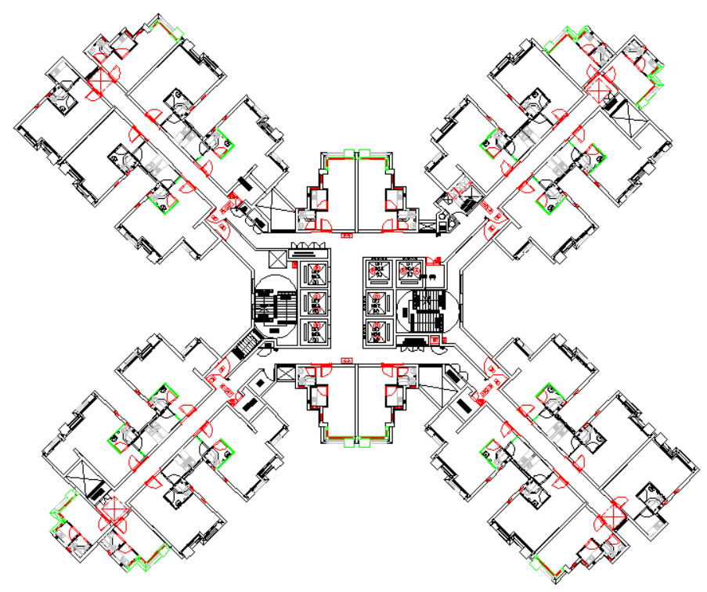
S
N
W
E
1B flat type
2/3P flat type
2B flat type
1/2P flat type
48.5
58.7

Fig. 1. Floor plan of the case building composed of four standard modular flat types (unit: m)

2.2. Modular design scheme of the case building
A modular design scheme is proposed for the case building, of which the core adopts cast-in-situ construction and the wings adopt modular construction. Cast-in-situ core walls are distributed properly to enhance the lateral force resistance of the case building, while standard modular flats in the wings are subdivided into concrete modules following a series of rules as below. The modularization of flats should not change the area and architectural function. It should meet transportation and lifting requirements, and also minimize total module types and maximize construction efficiency. Among the rules, transportation requirements influence the most on the modularization directly. When a module needs shipping, its maximum width should be no greater than 2.345 m [28]. When road transportation is needed, the maximum module width should be no more than 2.5 m and the maximum height without protruding bars is better to be in 3 m [29].
Following the above rules, a modularization scheme of the flats is recommended as shown in Fig. 2. The four standard flat types can be composed of 8 module types named by M-1 ~ M-8, respectively. M-1, M-4, and M-8 have the same external horizontal dimensions of 1.6 m (width) × 3.5 m (length). Similarly, M-2 is 2.2 m × 4 m. M-3 and M-6 are 1.6 m × 1.6 m, and M-5 and M-7 are 2.3 m × 6 m. All the module types have the same height of 2.67 m. The modularized and original areas of the four standard flats are further compared in Table 1, which presents that the modularization scheme does not vary the area of the flats. All the module types' dimensions can meet the transportation requirements in HK. The eight module types have only four external dimension types, minimizing the template types in the factory. To sum up, the modularization scheme of the flats is deemed to be feasible and suitable.
Core wall
Coupling beam
Cast-in-situ core
Cast-in-situ corridor slab
M-8
M-6
M-7
M-5
M-4
M-3
M-2
M-1
1.6
3.5
2.3
6.0
1.6
1.6
6.0
2.3
1.6
3.5
1.6
1.6
4.0
2.2
3.5
1.6
2B flat type
1B flat type
2/3P flat type
1/2P flat type
Fig. 2. Floor plan of core walls and concrete modules for the case building (unit: m)
Table 1 Areas of the four standard flat types before and after modularization
 | M-1 | M-2 | M-3 | M-4 | M-5 | M-6 | M-7 | M-8 | Modularization area (m²) | Original area (m²)
1/2P flat type |  |  |  |  |  |  |  |  | 14.4 | 14.1 ~ 14.5
2/3P flat type |  |  |  |  |  |  |  |  | 22.0 | 21.6 ~ 22.0
1B flat type |  |  |  |  |  |  |  |  | 30.2 | 30.2 ~ 30.9
2B flat type |  |  |  |  |  |  |  |  | 35.8 | 35.0 ~ 35.9

2.3. Horizontal and vertical connections
Horizontal and vertical connections are crucial for integrating concrete modules and cast-in-situ core into a whole structure. For the case building, a cast-in-situ reinforced concrete layer on the precast parts of the ceiling and corridor slabs within concrete modules is adopted as the horizontal connection (Fig. 3). Dependent on the horizontal connections, the ceiling slabs, corridor slabs, and core slabs at the same level are connected to form a rigid diaphragm, which is a basis for all the lateral force-resisting elements of the case building to jointly work. Similar horizontal connection design has been used in a real engineering project, i.e. the Fire Services Department Staff Quarters in HK [30]. It is noted that the cast-in-situ reinforced concrete layer has no direct connections with the floor slabs within the concrete modules at the above level.
Bar mesh
Bar of module wall for vertical connection
Module wall
Precast part of corridor slab
Cast-in-situ part of corridor slab
Core slab
Tie bar of core slab
Precast part of ceiling slab
Floor slab
Cast-in-situ part of ceiling slab
Fig. 3. The proposed horizontal connection for the case building
The vertical connection of the case building in this study refers to the vertical inter-module connection that is used to connect module walls of the upper and lower stories, which stems from the two recommended grouted wall-to-wall connection types by the HK precast concrete code [31]. Longitudinal bars in the boundary zone of module walls are connected using grouted lapped splices while others in the web of module walls are done using grouted corrugated ducts (Fig. 4). The lapped splice connections in the boundary adopt the horizontally grouting, while the corrugated duct connections in the web use the top-down grouting, which indicates that no extra working space is required when the vertical connection is applied to the adjacent module walls. It is noted that no special details are used to connect the adjacent module walls except for the horizontal connections.
Nut
Traverse bar ring in recess
Bar of module wall for vertical connection
Grouted duct
Module wall
Recess for grouting
Cast-in-situ part of ceiling slab
Fig. 4. The proposed vertical connection for the case building

2.4. Generalized modulus reduction method
Compared with a slender monolithic concrete wall, a precast counterpart has different lateral deformation mechanism (Fig. 5): besides the elastic lateral deformation of the wall body, the plastic lateral deformation is provided by concrete cracks at the bottom for a monolithic one, while it is provided by the joint opening at the bottom for a precast one [32]. When there are no suitable measures to ensure the interface bond strength between the foundation and wall body of a precast concrete wall, these bottom joints are viewed as initial defects, which easily lead to larger lateral deformation under the same lateral loads [33-38]. Meanwhile, both slender monolithic and precast concrete walls have identical lateral strength mechanism, which depends on the bottom section bending capacity formed by the tensile force provided by the reinforcement in the tension zone as well as the compressive force provided by the concrete compression zone. Thus, a slender precast concrete wall has close lateral strength to that of a monolithic counterpart. Based on the above analysis, the influence of vertical grouted connections on lateral performance of a slender precast concrete wall focuses more on lateral stiffness rather than lateral strength.
Concrete crack  Longitudinal bar  Foundation | Foundation  Longitudinal bar  Joint opening
(a) Monolithic concrete wall | (b) Precast concrete wall
Fig. 5. Lateral deformation mechanism of slender monolithic and precast concrete walls
The conclusion has been further verified by existing experimental results. Although some experimental studies show that precast concrete walls with vertical grouted connections have the comparative lateral performance with monolithic concrete walls [33-34], other test results present that existing grouted vertical connections can reduce the lateral stiffness of precast concrete walls by 10% ~ 20% [35-36] and even up to 25% [37], which may be dependent on connection type or construction quality [38]. Based on the proposed vertical inter-module connections, a slender precast concrete wall can be composed of a series of tandem module walls along the building. Therefore, the influence of vertical inter-module connections on the lateral stiffness of precast module walls should be considered for the case building.
The GMRM is thus adopted to model the condition that the existence of vertical inter-module connections can reduce the precast module wall's lateral stiffness and has no obvious influence on its lateral strength. Actually, the concept of GMRM has been established to consider the lateral stiffness reduction of cracked concrete walls, and now is developed further to indirectly and implicitly represent the vertical inter-module connections' behavior. In common FE software such as ETABS, OpenSees, and ABAQUS, the material constitutive relationships of both concrete and steel bar are determined by defining a series of characteristic points. According to GMRM, when a slender precast concrete wall is expected to have the lateral stiffness of αK_{eff,mon} and the lateral strength of F_{u,mon} in a FE model (α is the modulus reduction factor; K_{eff,mon} and F_{u,mon} are the lateral stiffness and strength of the monolithic counterpart, respectively.), the strains of those characteristic points of both concrete and steel bar can be changed to be 1/α times original values and the corresponding stresses keep unvaried. When a traditional modeling method of slender concrete walls incorporates GMRM, it is expected to have the capacity to predict lateral behavior of slender precast concrete walls considering the influence of vertical grouted connections.
Fig. 6 shows a typical FE modeling method for a slender concrete wall. The model is composed of a series of tandem nonlinear beam-column elements, of which each has two nodes at ends and several integration points in the middle. Each integration point is defined by a fiber section, which has many fibers with different material constitutive relationships representing unconfined concrete, confined concrete, or steel bar, respectively. The above modeling method can be implemented in common software [39] and is verified by experimental results to have the capacity to re-produce the lateral force-displacement curves of both monolithic concrete walls and precast concrete walls with emulative connections (Fig. 7). More detailed information of monolithic concrete wall specimens PW1 and RW2 as well as precast concrete wall specimens PW-D and Wall7 with grouted duct connections can be found in references [35, 40-42], respectively.
FE model
Nonlinear beam-column element
Concrete model
Steel bar model
Fiber section
Strain
Strain
Confined concrete fiber in the web
Confined concrete fiber in the boundary
Characteristic point of material model
Bar fiber
Integration point
Node
Unconfined concrete fiber in the cover
Stress
Stress
Cyclic load
Axial load
Concrete wall
Fig. 6. Schematic diagram for modeling a slender concrete wall
(a) PW1 [40] | (b) RW2 [41]
(c) PW-D [35] | (d) Wall7 [42]
Fig. 7. Experimental verification of the modeling method of a slender concrete wall
Two cases in which specimen PW-D is respectively under the axial load ratios of 0.065 and 0.13 were adopted to validate whether GMRM can achieve the expected goal (i.e. α can control the lateral stiffness of concrete walls and has no significant effects on the lateral strength). Herein, the axial load ratio refers to the ratio of the applied axial load to the product of the measured concrete cubic compressive strength and the gross section of specimen. The calculated lateral force-displacement curves of the two cases are presented in Fig. 8 (α is respectively equal to 1, 0.8, 0.6, and 0.4). With α decreased from 1 to 0.4, the variation of lateral strength is no more than 5% while the location of yield point is affected. The yield point is determined according to the Park method [43] which is commonly used for concrete walls and squat concrete columns, and the effective stiffness is viewed as the secant modulus corresponding to the yield point (Fig. 9a). As shown in Fig. 9b, the effective stiffness is decreased with a smaller α, and the decreased ratio (the detailed value is listed for each column in Fig. 9b) agrees well with α for the two cases. Therefore, GMRM can achieve the expected goal, which means that a modeling method of monolithic concrete walls incorporating GMRM can quantitatively consider the effects of vertical grouted inter-module connections on the lateral performance of precast module walls.
 | Yield point
(a) Axial load ratio 0.065 | (b) Axial load ratio 0.13
Fig. 8. Lateral force-displacement curves of the selected cases with varied α
C  B  A  F  F_{max}  0.75F_{max}  F_{y}  k_{eff}  Δ  Δ_{y}  O | 1.00  0.80  0.40  0.80  0.60  1.00  0.41  0.61
(a) Park method used to determine effective stiffness | (b) Effective stiffness
Fig. 9. Effective stiffness of the selected cases with varied α

3. Modeling structural responses of the case building under wind loads

3.1. FE model of the case building
Some simplifications are done for establishing a FE model of the concrete modular building, which adopts the proposed horizontal and vertical connections integrating concrete modules into an entire building (Fig. 10). First, the ceiling slabs between adjacent modules at the same level are continuous to form a rigid diaphragm, due to the adopted connection type explained in Section 2.3. Second, floor slabs are equivalent to uniformly distributed loads and their contributions to the global structure are not considered. Third, adjacent module walls at the same level have no additional connections, and module walls with the same plan location compose a slender precast wall depending on continuous vertical wall joints, of which the influence is considered using GMRM. In this regard, for concrete material, the elastic modulus E_{c} and shear modulus G_{c} are defined to be 1/α times original values. When the nonlinear material model of concrete is used, the strains of those characteristic points are varied to be 1/α times original values with the corresponding stresses unvaried. For steel bar material, the elastic modulus E_{s} is defined to be 1/α times original value. When the nonlinear material model of steel bar is used, the same operations are implemented as concrete material.
Continuous wall joint
No connection between adjacent module walls
Continuous ceiling slab joint
Rigid slab diaphragm
Uniformly distributed load of floor slab
Module wall
Module
Fig. 10. Schematic diagram for modeling a concrete modular building
According to the above simplifications, a FE model was established for the case building using ETABS software. Membrane elements were used to model semi-precast concrete ceiling slabs of modules and cast-in-situ concrete core slabs, while shell elements were used to model precast concrete module walls and cast-in-situ concrete core walls. No connections existed between the shell elements that were used to model the adjacent module walls or the close module and core walls at the same level. Fig. 11 presents the FE model of the case building. Detailed material and geometric information of the case building is provided in Section 4 for establishing the FE model.
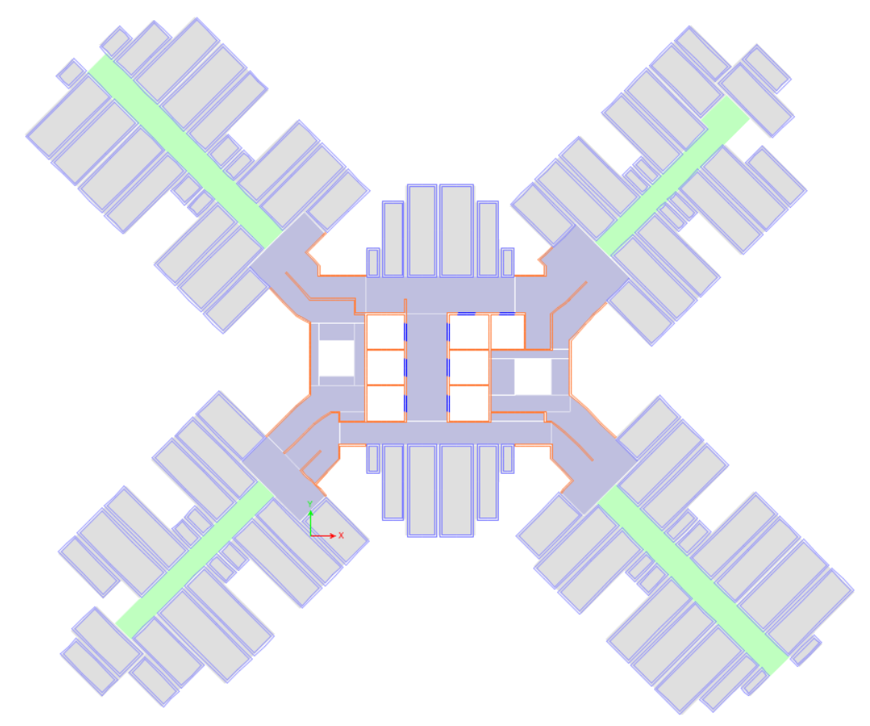  Y  X  Shell element  Membrane element  No connection | 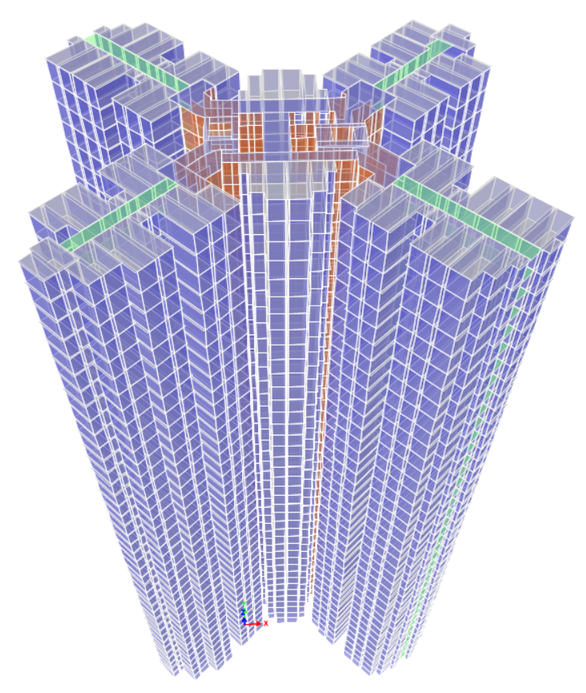
(a) Plan view | (b) 3-D view
Fig. 11. FE model of the case building

3.2. Calculation of the HK code-specified wind loads
According to the new wind load code [44], the wind pressure along the height of the case building can be determined as
(1)
(2)
where Q_{z} is the design wind pressure; Q_{o,z} is the wind reference pressure; S_{t} is the topography factor; S_{θ} is the wind directionality factor; Z_{e} is the effective height taking account of surroundings. Different from the old version, the new version takes more adverse factors, such as the across-wind, directional wind, directional shelter, corner shape, and building size effects, into account, and adopts three wind load combinations to replace two wind load components along the main axes for validating whether a building has the sufficient capacity to resist the HK wind loads. Each wind load combination is composed of two horizontal forces along the main axes (Fig. 11) and a torsional moment around the vertical axis, of which the combination factors are listed in Table 2. Only positive values are considered for the case building due to its superior plan symmetry. When the FE model of the case building is subject to a wind load combination in ETABS software, the horizontal forces and torsional moment at each story are imposed on the rigidity center of the corresponding story. According to the new HK code [44], the calculation of wind loads depends on the structural characteristics of building, such as structural periods. Hence, the detailed wind loads will be given for a specified case in the following section.
Table 2 Wind load combination factors for buildings [44]
Combination | Horizontal force F_{x} along X axis | Horizontal force F_{y} along Y axis | Torsional moment T_{z} around Z axis
Wind1 | ±1.00 | ±0.55 | ±0.55
Wind2 | ±0.55 | ±1.00 | ±0.55
Wind3 | ±0.55 | ±0.55 | ±1.00

4. Influence of the thickness of module walls
The thickness t_{mw} of module walls is an important parameter that affects the contribution of module walls to the lateral force resistance of a concrete high-rise modular building. t_{mw} needs to meet the HK code requirements of concrete walls in terms of the minimum lateral slenderness [45], maximum axial load ratio [45], and minimum thickness for fire resistance period of 1h [46], which suggest that t_{mw} is better to be no less than 100 mm. For the case building, the module types M-5 and M-7 have the maximum external plan dimensions of 2.3 m × 6 m. When a M-5 concrete module has a thickness of 80 mm for precast ceiling and floor slabs, its lifting weight is respectively presented in Fig. 12 with varied t_{mw}. When t_{mw} varies from 100 mm to 200 mm, the lifting weight of a M-5 concrete module is increased by 63.4% and up to 25 t. In HK engineering practices, when the lifting weight of a precast element is more than 20 t [13], the rental cost of required tower cranes is significantly increased. Therefore, in this section, t_{mw} is selected to be 100 mm, 120 mm, and 140 mm, for investigating its influence on structural responses of the case building under the HK code-specified wind loads.

Fig. 12. Lifting weight of a M-5 concrete module with different wall thicknesses
For the FE model of the case building, all the structural elements adopt C40 concrete except for core walls adopting C60 concrete. All the steel bars have yield strength of 500 MPa. Fig. 13 presents the detailed reinforcement layout of the longest module wall at each story, while other module walls have the identical reinforcement layout except for a shorter web in the middle. The same situation applies to the longest core wall (Fig. 14) and others. When t_{mw} is known, a trial-and-error method is adopted to get the thickness t_{cw} of core walls, which is gradually increased from 100 mm with the increment of 50 mm and eventually determined once the drift ratio of the case building at the top is no more than 0.2% under each wind load combination [44]. When the t_{mw} is 100 mm, 120 mm, and 140 mm, the corresponding t_{cw} is respectively 200 mm, 150 mm, and 100 mm, and the corresponding cases are respectively marked by M100C200, M120C150, and M140C100. The adopted steel bar types of the three cases are listed in Table 3. Meanwhile, the cast-in-situ part of ceiling slab, entire corridor slab, and core slab has the thicknesses of 80 mm, 350 mm, 160 mm, respectively.
625
250×19
25
100
2700
25
25
25
200×2
200×2
250×18
Boundary zone
Hoops
Grouted corrugated duct
Web
Longitudinal bars
Constructional bar
625
Fig. 13. Reinforcement layout of the longest module wall at each story
100
25
25
2700
25
7350
25
25
200×5
320×15
200×5
Web
Longitudinal bars
25
Boundary zone
Hoops
Fig. 14. Reinforcement layout of the longest core wall at each story
Table 3 Steel bar types of the three cases with different wall thicknesses
Case | Module wall |  |  |  |  | Core wall
Case | Longitudinal bars |  |  | Transverse bars |  | Longitudinal bars |  |  | Transverse bars
Case | Bar in web | Bar in boundary | Area ratio (%) | Bar | Volume ratio (%) | Bar in web | Bar in boundary | Area ratio (%) | Bar | Volume ratio (%)
M100C200 | D16 | D16 | 1.04 | D8 | 0.81 | D16 | D25 | 1.23 | D12 | 1.1
M120C150 | D16 | D20 | 1.05 | D8 | 0.70 | D16 | D20 | 1.26 | D10 | 0.94
M140C100 | D16 | D25 | 1.16 | D10 | 0.97 | D12 | D16 | 1.14 | D8 | 0.83
Based on the FE model, the first two natural periods are listed in Table 4 for cases M100C200, M120C150, and M140C100. Their natural periods are very close due to the relative error of no more than 5% for the first natural period T₁ and 10% for the second natural period T₂.
Table 4 Natural periods of the three cases with different wall thicknesses
 | M100C200 | M120C150 | M140C100
T₁ (along X axis) (s) | 4.76 | 4.87 | 4.97
T₂ (along Y axis) (s) | 3.97 | 4.15 | 4.32
Notably, the three cases have a larger T₁ than the prediction using the equations of T₁ proposed by Su et al. [47] for real concrete high-rise buildings in HK, which may be due to three reasons. The first is that the cases just meet the deflection limit requirement of 0.2% under wind loads, which have smaller stiffness than that of real concrete high-rise buildings with a more conservative structural design. The second is that the double-slab system including adjacent ceiling and floor slabs at one level leads to a larger mass for the cases, compared with traditional monolithic counterparts. The third is that the existence of numerous shorter module walls caused by modular construction can lead to a larger mass-to-stiffness ratio of the cases.
As mentioned above, the double-slab system increases the mass of MiC concrete high-rises, which presents challenges to foundation design. The speed of modular construction leads to a quicker handover that may be able to compensate the increase of initial construction cost of the foundation. However, this argument is outside of the scope of this present paper, and is thus recommended for future research.
Due to the identical structure-independent factors and close natural periods, the three cases have basically identical design wind loads including the horizontal forces F_{x} and F_{y} and torsional moment T_{z} around the vertical axis (Fig. 15). Meanwhile, the close natural periods mean a close elastic lateral stiffness for a building. Hence, the three cases have similar drift ratios at each story under each wind load combination (Fig. 16). Among the three wind combinations, Wind1 combination makes the three cases have the maximum drift ratios of less than 0.2% at each story (Fig. 16), which indicates that the three cases have sufficient stiffness to avoid excessive deflection under wind loads according to the HK code [45].
(a) Horizontal force F_{x} along X axis | (b) Horizontal force F_{y} along Y axis | (c) Torsional moment T_{z} around Z axis
Fig. 15. Design wind loads of the three cases with different wall thicknesses
(a) Wind1 | (b) Wind2 | (c) Wind3
Fig. 16. Drift ratios of the three cases with different wall thicknesses under wind load combinations
The new HK wind code [44] adds the specifications to limit the peak acceleration A_{acc} of buildings caused by wind loads for occupant comfort. According to the proposed calculated method of A_{acc} in the new code [44], the maximum value of A_{acc} reaches at the top of a building. Hence, the demand-to-capacity ratio of peak acceleration is defined for a building as
(3)
where A_{acc,top} is the peak acceleration at the top story and can be calculated according to the new code [44] when structural design parameters of a building are known; A_{cc,lim} is the upper limit of peak acceleration and can be determined based on a chart provided in the new code [44]. Fig. 17 presents the demand-to-capacity ratios of peak acceleration along X and Y axes for the three cases under wind loads with the return periods of 1 and 10 years. All the demand-to-capacity ratios are far less than 1.0 for the three cases, which are viewed to have the capacity to avoid uncomfortable wind vibration. Due to A_{cc,top} and A_{cc,lim} being dependent on the natural periods of buildings, the corresponding demand-to-capacity ratios are very close for the three cases.
(a) 1-year peak acceleration | (b) 10-year peak acceleration
Fig. 17. Demand-to-capacity ratios of peak acceleration for the three cases with different wall thicknesses under wind loads
Strength examination is necessary for structural safety of a building under wind loads. In general, for a concrete wall of high-rise buildings, its lateral force is related to lateral stiffness that is dependent on the third power of length, while its section bending and shear capacities are dependent on the second and first powders of length, respectively. Therefore, when a high-rise building is subject to lateral loads, its concrete wall with greater length is more vulnerable in terms of strength. The most critical module and core walls at each story are selected for strength examinations of the three cases (Fig. 18), and they have the greatest lengths and shear forces, compared with all the other counterparts.
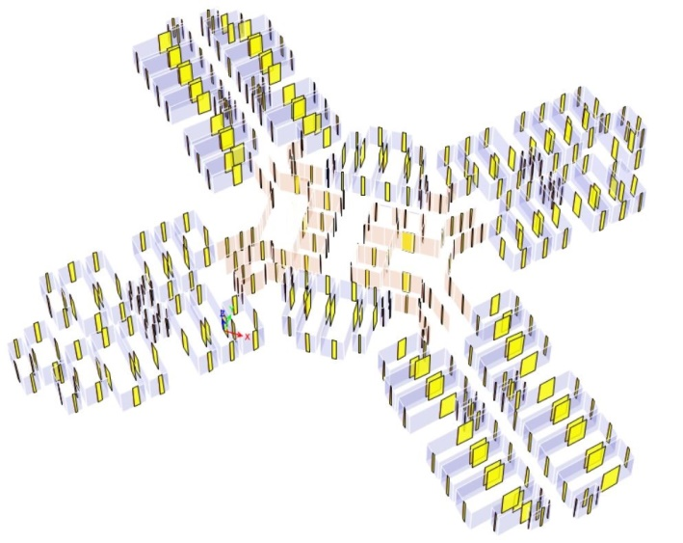
Core wall
Module wall
Fig. 18. The most critical module and core walls at each story
A fiber section model is adopted to determine the axial load-moment capacity curves of the selected module and core walls for the three cases (Fig. 19) [2]. Here, the section moment capacity M_{cp} refers to the yield moment. The HK concrete code [45] is used to determine the shear capacity V_{cp} of concrete walls as
(4)
where v_{c} is the design ultimate shear stress of concrete and equal to 0.79(100ρ_{l})^{0.33}/1.25 [45]; A_{c} and b are the cross-section area and width of a concrete wall, respectively; N, V, and M are the subjected axial loading, shear force, and moment of a concrete wall, respectively; f_{yv}, A_{sv}, and s_{v} are the yield strength, area, and spacing of transverse reinforcement, respectively; d is the effective depth of the tension reinforcement.
(a) Module wall | (b) Core wall
Fig. 19. Axial load-moment capacity curves of the selected module and core walls
The demand-to-capacity ratios M_{dm}/M_{cp} and V_{dm}/V_{cp} of moment and shear force are presented in Fig. 20 for the selected module and core walls at each story. The selected core walls at each story have the moment demand M_{dm} and shear force demand V_{dm} under Wind2 combination, while the selected module walls at each story have M_{dm} under Wind1 combination and V_{dm} under Wind2 combination. All the demand-to-capacity ratios of moment and shear force are far less than 1, which indicates that the entire module wall-core system can meet the strength requirements for the three cases under wind loads. For the selected module walls of the three cases, M_{dm}/M_{cp} reaches the maximum value of close to 0.3 at the bottom story while V_{dm}/V_{cp} is less than 0.1 at all the stories, which means that the module walls of the three cases are vulnerable to flexural failure at the bottom story. For the selected core walls of the three cases, M_{dm}/M_{cp} reaches the maximum value of close to 0.25 at the bottom story and V_{dm}/V_{cp} reaches the maximum value of about 0.20 at the 10th story, which indicates that the core walls of the three cases are vulnerable to flexural failure at the bottom story and shear failure at the 10th story. The increased t_{mw} and decreased t_{cw} have a small influence on M_{dm}/M_{cp} and V_{dm}/V_{cp} of the module walls as well as M_{dm}/M_{cp} of the core walls, and make the core walls have 11.5% larger V_{dm}/V_{cp} at the 10th story. When a larger t_{mw} is used for the case building, there are no obvious adverse effects on the strength safety of module and core walls.
(a) Moment | (b) Shear force
Fig. 20. Demand-to-capacity ratios of moment and shear force for the selected module and core walls of the three cases with different wall thicknesses
Fig. 21 presents the shear forces of all the module and core walls at each story for the three cases under the horizontal forces of wind loads. It is easily found that increased t_{mw} and decreased t_{cw} can make module walls provide more contributions to resisting the horizontal forces along X and Y axes. Detailed information about the contributions of module walls to the horizontal forces is shown in Fig. 22 for the 1st ~ 5th stories of the three cases. The module walls of case M100C200 resist more than 50% of the horizontal forces, while those of case M140C100 resist up to more than 80%. The module walls play a leading or even a major role in the module wall-core system of concrete high-rise module buildings, which are different from the high-rises using steel modules that are proven to have limited contributions to resisting lateral forces of entire buildings [20].
(a) Along X axis | (b) Along Y axis
Fig. 21. Shear forces of all the module and core walls for the three cases with different wall thicknesses
(a) Along X axis | (b) Along Y axis
Fig. 22. Contribution of module walls for the three cases with different wall thicknesses
As shown in Fig. 23, greater t_{mw} can increase precast concrete usage and decrease cast-in-situ concrete usage. Precast ratio refers to the volume ratio of precast concrete usage to total concrete usage. According to the Chinese code [48], when a precast concrete structure has a precast ratio of no less than 60%, it is deemed to have an excellent industrialized construction level. With t_{mw} up from 100 mm to 140 mm, the precast ratio increases from 67% to 76% that can have the excellent level for the three cases. Greater t_{mw} is deemed to be helpful to improve the modular construction efficiency for concrete high-rise modular buildings.
28%
24%
72%
33%
Fig. 23. Concrete usages of the three cases with different wall thicknesses

5. Influence of the reduced lateral stiffness of module walls
As aforementioned, the existence of vertical grouted inter-module connections may have reduced influence on the lateral stiffness of module walls. The neglection of the reduced effects can lead to a more unsafe design scheme of concrete high-rise modular buildings under lateral loads. In this section, case M140C100 is re-named by case MW1.0 as a benchmark, and other cases MW0.8, MW0.6, and MW0.4 have the identical design parameters except for the modulus reduction factor α of module walls being 0.8, 0.6, and 0.4, respectively.
The first two natural periods are listed in Table 5 for the four cases. With α varied from 1.0 to 0.4, T₁ and T₂ are respectively increased by 44.9% and 38.2%, which indicates that the elastic lateral stiffness of concrete high-rise modular buildings can be obviously weakened by decreased α of module walls.
Table 5 Natural periods of the four cases building with different α of module walls
 | MW1.0 | MW0.8 | MW0.6 | MW0.4
T₁ (along X axis) (s) | 4.97 | 5.47 | 6.16 | 7.20
T₂ (along Y axis) (s) | 4.32 | 4.71 | 5.23 | 5.97
Due to the largest natural periods and other identical parameters, case MW0.4 has the greatest design wind loads [44]. Compared with MW1.0, case MW0.4 has the increased F_{x}, F_{y}, and T_{z} at the top story by 34.7%, 11.5%, 11.5%, respectively (Fig. 24).
(a) Horizontal force F_{x} along X axis | (b) Horizontal force F_{y} along Y axis | (c) Torsional moment T_{z} around Z axis
Fig. 24. Design wind loads of the four cases with different α of module walls
For the four cases, a smaller α of module walls can result in a weakened lateral stiffness and greater design wind loads, which lead to an accelerated growth of deformation (Fig. 25). Under Wind1 combination, the four cases have the maximum drift ratio at each story, and the drift ratio at the top story of case MW0.4 is 2.64 times that of case MW1.0. The deflection of concrete high-rise modular buildings is very sensitive to α of module walls. The reduced lateral stiffness of module walls should be considered in the design process for enabling concrete high-rise modular buildings to have enough lateral stiffness.
(a) Wind1 | (b) Wind2 | (c) Wind3
Fig. 25. Drift ratios of the four cases with different α of module walls under wind combinations
Fig. 26 presents the demand-to-capacity ratios of peak acceleration along X and Y axes for the four cases under wind loads with the return periods of 1 and 10 years. With α varied from 1.0 to 0.4, the corresponding demand-to-capacity ratios of peak acceleration are increased by 25% ~ 30%. The reduced lateral stiffness of module walls has an obvious amplified effect on wind vibration of concrete high-rise module buildings.
(a) 1-year peak acceleration | (b) 10-year peak acceleration
Fig. 26. Demand-to-capacity ratio of peak accelerations for the four cases with different α of module walls
Fig. 27 presents M_{dm}/M_{cp} and V_{dm}/V_{cp} of the selected module and core walls at each story for the four cases. α of module walls does not notably influence M_{dm}/M_{cp} and V_{dm}/V_{cp} of the selected module walls, while it can significantly increase M_{dm}/M_{cp} and V_{dm}/V_{cp} of the selected core walls. With α varied from 1.0 to 0.4, M_{dm}/M_{cp} of the selected core walls at the bottom story is raised by 107.1% and V_{dm}/V_{cp} of the selected core walls at the 10th story is increased by 108.6%. The reduced lateral stiffness of module walls makes the core walls vulnerable more easily to flexural failure at the bottom story and shear failure at the 10th story. It is necessary to consider the reduced lateral stiffness of module walls for ensuring the strength safety of core walls in concrete high-rise modular buildings.
(a) Moment | (b) shear force
Fig. 27. Demand-to-capacity ratios of moment and shear force for the selected module and core walls of the four cases with different α of module walls
Fig. 28 presents the shear forces of all the module and core walls at each story when the four cases are subject to the horizontal forces of wind loads. Smaller α can reduce module walls' contribution to resisting the horizontal forces along X and Y axes. At the 1st ~ 5th stories, the module walls of case MW1.0 resist more than 80% of the horizontal forces, while those of case MW0.4 still resist more than 60% (Fig. 29). The reduced lateral stiffness can weaken but not change the major role of module walls in the module wall-core system of concrete high-rise module buildings.
(a) Along X axis | (b) Along Y axis
Fig. 28. Shear forces of all the module and core walls for the four cases with different α of module walls
(a) Along X axis | (b) Along Y axis
Fig. 29. Contribution of module walls for the four cases with different α of module walls

6. Influence of the defect distribution scenario of vertical inter-module connections
In actual engineering projects, it is usually inevitable that some module walls in a certain area may have defects in vertical inter-module connections, which can lead to severely weakened α. In this section, four cases are used to investigate the effects of the defect distribution scenario of vertical inter-module connections on structural responses of concrete high-rise modular buildings under wind loads. Case MW0.8 is re-named by MW0.8-U as a benchmark which represents no significant defects of vertical inter-module connections and has α of 0.8 for all the module walls. For cases MW0.8-8s, MW0.8-4s, and MW0.8-2s, 5% of module walls are defective and have α of 0.42, while other module walls have α of 0.82. Notably, here 5% is a volume ratio. All the module walls of the four cases have the average α of 0.8. Case MW0.8-8s has the defective module walls located at the 1st ~ 8th stories, and similar situations apply to cases MW0.8-4s and MW0.8-2s. According to the analysis in Section 4 and Section 5, the module walls in higher story are safer under wind loads, thus the defect distribution in higher than the 8th story is not considered. Fig. 30 presents detailed floor plan of the defective module walls (purple) for the four cases.
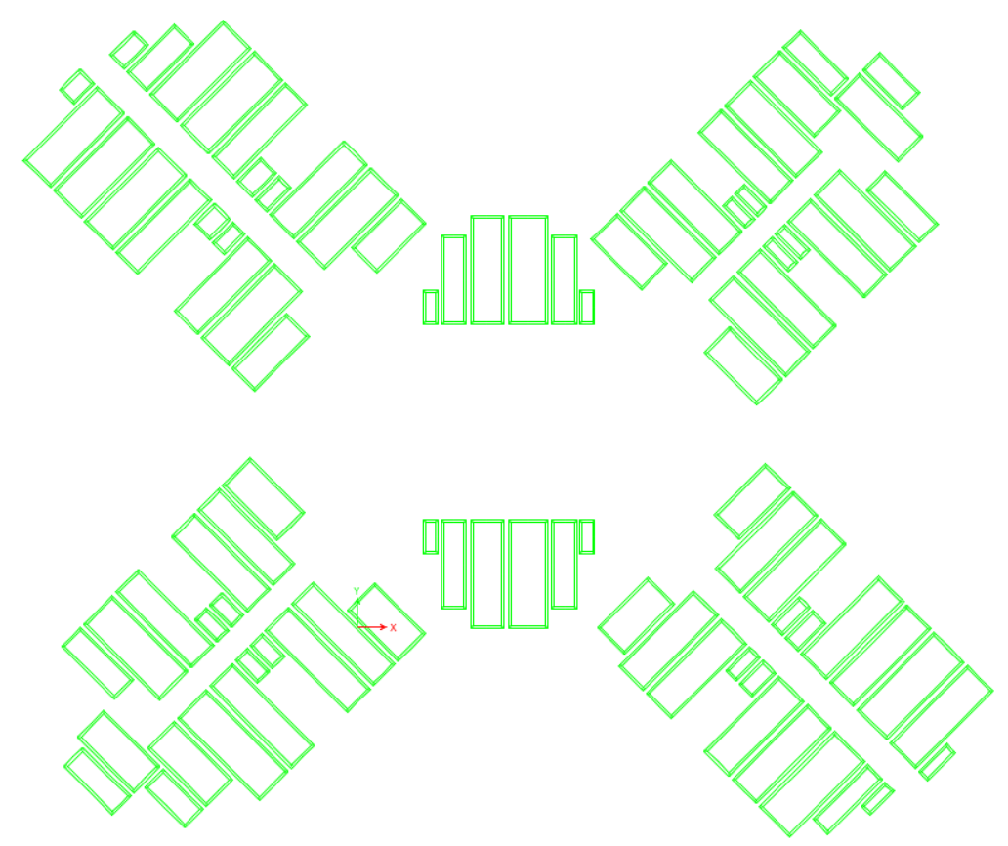 | 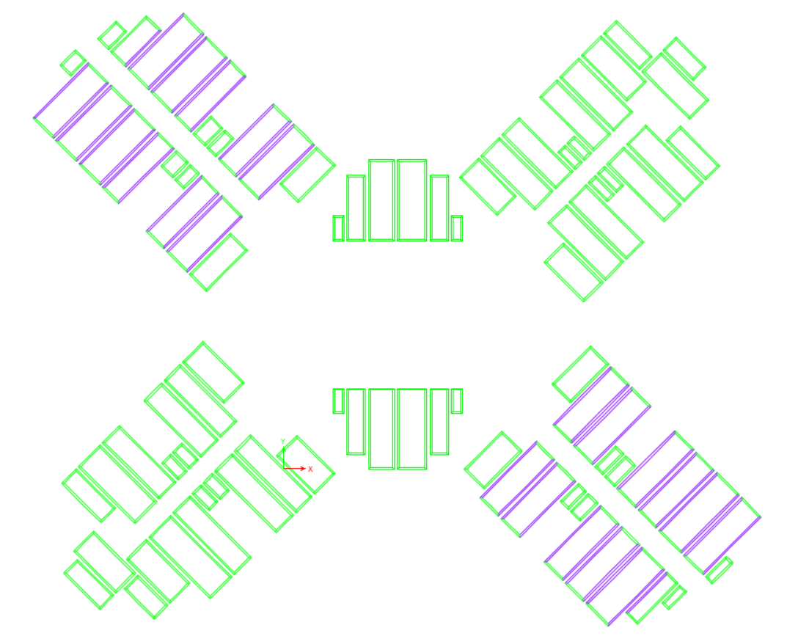
(a) MW0.8-U | (b) MW0.8-8s
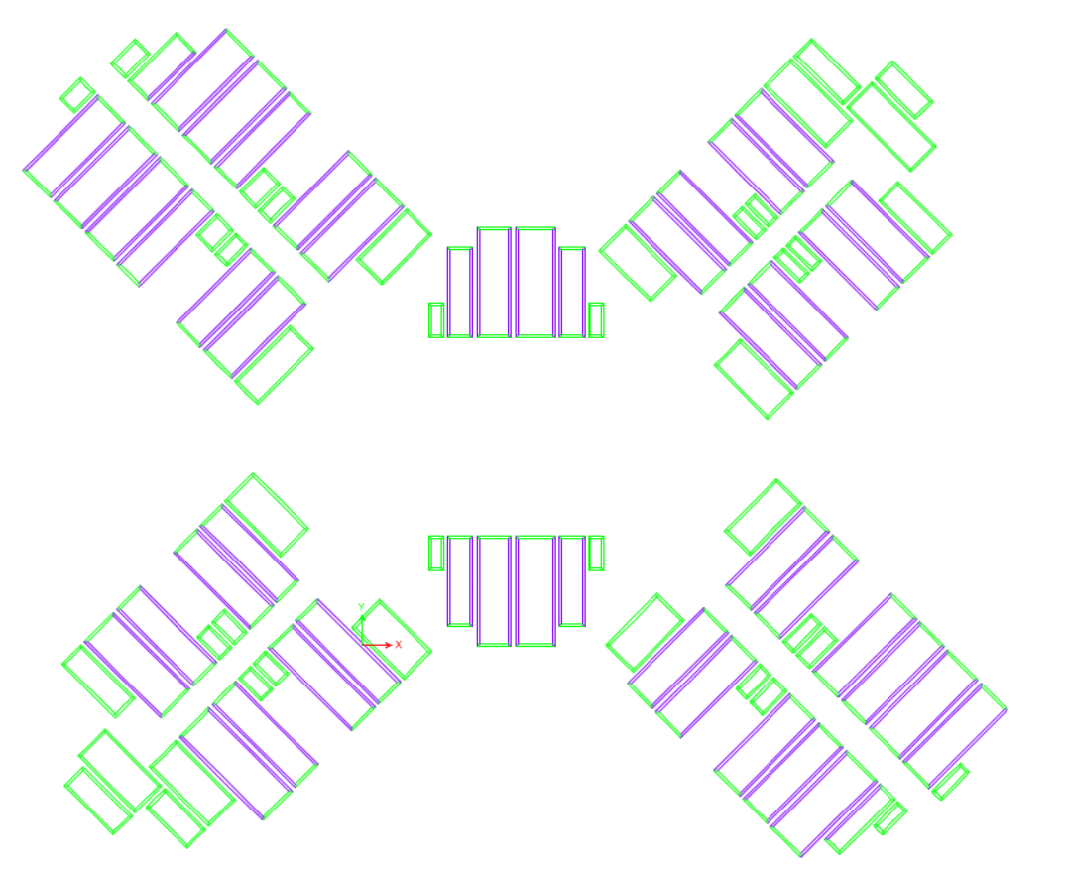 | 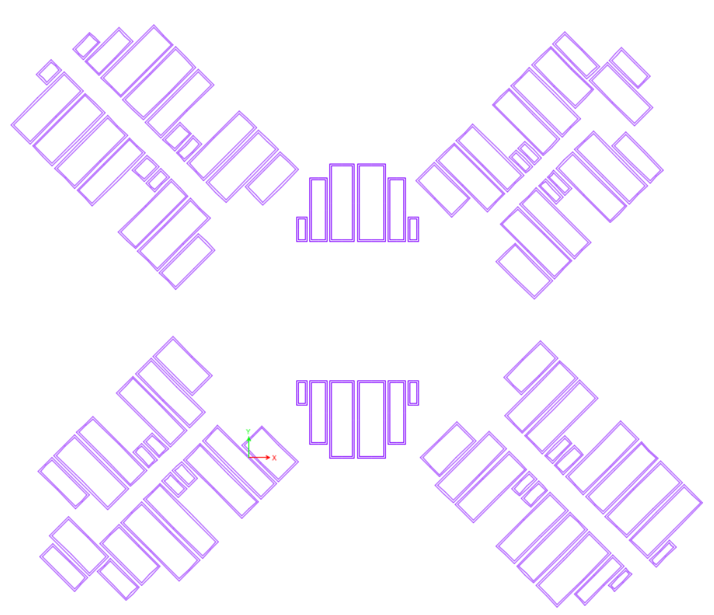
(c) MW0.8-4s | (d) MW0.8-2s
Fig. 30. Defect distribution scenarios of vertical inter-module connections for the four cases
As listed in Table 6, the more defective module walls are concentrated at the bottom stories, the longer the natural periods become for the four cases. Compared with case MW0.8-U, case MW0.8-2s increases T₁ by 5.7% and T₂ by 5.1%, which means that defect distribution scenarios basically have no influence on the elastic lateral stiffness of concrete high-rise modular buildings when average α of all the module walls is unvaried.
Table 6 Natural periods of the four cases with different defect distribution scenarios
 | MW0.8-U | MW0.8-8s | MW0.8-4s | MW0.8-2s
T₁ (along X axis) (s) | 5.47 | 5.60 | 5.65 | 5.78
T₂ (along Y axis) (s) | 4.71 | 4.80 | 4.85 | 4.95
Due to the close natural periods and other identical parameters, the design wind loads including F_{x}, F_{y}, and T_{z} are basically unvaried for the four cases (Fig. 31).
(a) Horizontal force F_{x} along X axis | (b) Horizontal force F_{y} along Y axis | (c) Torsional moment T_{z} around Z axis
Fig. 31. Design wind loads of the four cases with different defect distribution scenarios
For the four cases, more defective module walls concentrated at the bottom stories have a limited influence on the deflection of buildings (Fig. 32) due to the close lateral stiffness and natural periods. Under Wind1 combination, the drift ratio at each story reaches the maximum value for the four cases, and the drift ratio at the top story of case MW0.8-2s is 12.7% larger than that of case MW0.8-U. When suitable quality control measures are adopted to prevent all the module walls at the bottom two stories from being defective, the deflection predication of concrete high-rise modular buildings does not need to consider the influence of defect distribution scenarios of vertical inter-module connections.
(a) Wind1 | (b) Wind2 | (c) Wind3
Fig. 32. Drift ratios of the four cases with different defect distribution scenarios under wind combinations
For the four cases with different defect distribution scenarios, the corresponding demand-to-capacity ratios are increased by no more than 5% (Fig. 33). The effects of the defect distribution scenario of vertical inter-module connections are deemed to have no influence on wind vibration of concrete high-rise modular buildings.
(a) 1-year peak acceleration | (b) 10-year peak acceleration
Fig. 33. Demand-to-capacity ratio of peak accelerations for the four cases with different defect distribution scenarios
For the selected module walls of the four cases, the existence of defective module walls can reduce M_{dm}/M_{cp} at the stories with defective module walls and V_{dm}/V_{cp} at the surrounding stories where the defective and the normal module walls are vertically connected (Fig. 34), which may be attributed to that normal module and core walls at the same stories bear greater lateral force due to relatively enlarged lateral stiffness. Defective vertical inter-module connections can make the corresponding module walls have a lower risk of failure.
For the selected core walls of the four cases, the existence of defective module walls has an amplified effect on M_{dm}/M_{cp} at the bottom story and limited effects on that at other stories, while it makes V_{dm}/V_{cp} have a sudden increase at the story where the defective and normal module walls are vertically connected and gradually disappear toward neighboring stories (Fig. 34). With more defective module wall concentrated at the bottom stories, M_{dm}/M_{cp} at the bottom story is significantly increased, while the sudden increment of V_{dm}/V_{cp} becomes greater. Compared with case MW0.8-U, case MW0.8-2s has 22.3% larger M_{dm}/M_{cp} at the bottom story and 3.5 times larger V_{dm}/V_{cp} at the 3rd story. Defective vertical inter-module connections at the bottom stories makes the core walls have a little higher risk of flexural failure at the bottom story and become more vulnerable to shear failure at the story where the defective and normal module walls are vertically connected.
(a) Moment | (b) shear force
Fig. 34. Demand-to-capacity ratios of moment and shear force for the selected module and core walls of the four cases with different defect distribution scenarios
As shown in Fig. 35, the existence of defective vertical inter-module connections makes the shear force of all the module walls have a sudden decrease at the story where the defective and normal module walls are vertically connected and gradually disappear toward neighboring stories, while it makes the shear force of all the core walls have the opposite change tendency at the corresponding stories. As shown in Fig. 36, the existence of defective vertical inter-module connections can make the contributions of module walls at the 2nd story from 82.5% of case MW0.8-U to 22.3% of case MW0.8-2s. The existence of defective vertical inter-module connections can make module walls provide fewer contributions for resisting horizontal forces, and even drastically change the major role of module walls at local stories.
(a) Along the X axis | (b) Along the Y axis
Fig. 35. Shear forces of all the module and core walls for the four cases with different defect distribution scenarios
(a) Along the X axis | (b) Along the Y axis
Fig. 36. Contribution of module walls for the four cases with different defect distribution scenarios

7. Conclusions
This study conducted a parametric analysis on the module wall-core system, which is generally adopted in concrete modular high-rise buildings as lateral force-resisting system. A 40-story high-rise public residential building in HK was selected as the case building, in which concrete modules were used and the horizontal as well as vertical connections were re-designed. The generalized modulus reduction method (GMRM) was adopted to consider the influence of vertical grouted connections on the lateral behavior of slender precast concrete walls by setting a modulus reduction factor α. Using GMRM, the strains of those characteristic points can be changed to be 1/α times original values and the corresponding stresses keep unvaried for the material constitutive relationships of both concrete and steel bar. A three-dimensional finite element model incorporating the use of GMRM was established to study the influence of three parameters, which are the module wall thickness, the reduced lateral stiffness of module walls, and the defect distribution scenarios of vertical inter-module connections, on the structural responses of the case building under the HK code-specified wind loads. Based on the calculated results, the main conclusions of this paper are as follows:
- GMRM can well consider the influence of vertical grouted connections on the lateral behavior of slender precast concrete walls. Through theoretical analysis, the existence of vertical grouted connections is deemed to have reduced effects on lateral stiffness and no influence on lateral strength for slender precast concrete walls, which conforms to some existing experiment results in literature. According to the calculated results of concrete walls with different α, GMRM can set α to quantificationally lower lateral stiffness and have no influence on lateral strength for slender precast concrete walls.
- When the module weight can meet lifting requirements, it is beneficial to increase the thickness of module walls due to the improved precast rate without adverse effects on structural responses of module and core walls under wind loads. Module walls with a thickness of 100 mm ~ 140 mm can work together with cores to meet the code requirements for the 40-story high-rise modular buildings, in terms of deflection, vibration, and strength under the HK code-specified wind loads, and play a leading or even a major role in the module wall-core system.
- With the reduced lateral stiffness of module walls, the case building has accelerating increase of deflection, more serious wind-induced vibration, and more vulnerable core walls under wind loads. The reduced lateral stiffness of module walls can obviously weaken lateral stiffness of the case building and enlarge design wind loads. With α varied from 1.0 to 0.4 for all the module walls of the case building, the drift ratio at the top story is increased by 1.64 times under Wind1 combination. The demand-to-capacity ratios of peak acceleration are increased by 25% ~ 30%. The demand-to-capacity M_{dm}/M_{cp} of moment is raised by 107.1% for the selected core wall at the bottom story, and the demand-to-capacity V_{dm}/V_{cp} of shear force is increased by 108.6% for the selected core wall at the 10th story. The reduced lateral stiffness of module walls can weaken but not change the major role in the module wall-core system.
- When more defective vertical inter-module connections are concentrated on the bottom stories, there are relatively small impacts on overall structural responses of the case building under wind loads, while strong adverse impacts on core walls at the corresponding bottom stories. Defective vertical inter-module connections at the bottom stories have limited influence on deflection and wind-induced vibration of the case building, as well as the strength safety of module and core walls at all the stories, except for the stories where the defective module walls are located or close. When all the module walls are defective at the bottom two stories, M_{dm}/M_{cp} of the selected core wall at the bottom story is 22.3% larger and V_{dm}/V_{cp} of the selected core wall at the 3rd story is 3.5 times larger, compared with those of the case without defective module walls.
The findings of this study fill the knowledge gap about the influence of vertical grouted inter-module connections on the structural responses of concrete modular high-rises under lateral loads. This study provides a reference for researchers from various countries and regions when they conduct similar structural analysis on concrete high-rise modular buildings that are based on their local engineering practices and codes. Notably, the current seismic codes in HK have not been officially promulgated, thus the structural design method in this study is developed to meet current HK codes except for seismic loads. Compared with traditional monolithic counterparts, MiC concrete high-rises tend to have a higher natural period that may cause a higher seismic displacement demand. When seismic design is required in HK in near future, MiC concrete high-rises may need a thicker core wall to meet the higher seismic displacement demand, which may weaken the attractiveness of MiC technology to high-rises. This issue is worth attention of future research. Experimental studies are required to validate the lateral behavior of module walls with specified vertical inter-module connections. The influence of the openings in module walls is not studied in the FE model of the case building in this paper, and future research is recommended to examine the influence of module wall openings with different size and location on concrete high-rise modular buildings.

Declaration of competing interest
The authors declare that they have no known competing financial interests or personal relationships that could have appeared to influence the work reported in this paper.

Acknowledgements
The work presented in this paper was supported by a grant from the Research Impact Fund of the Hong Kong Research Grants Council (Project No. HKU R7027-18).

References
- Pan M, Linner T, Pan W, Cheng H, Bock T. Influencing factors of the future utilisation of construction robots for buildings: A Hong Kong perspective. J Build Eng 2020; 30: 101220.
- Wang Z, Pan W. A hybrid coupled wall system with replaceable steel coupling beams for high-rise modular buildings. J Build Eng 2020; 31: 101355.
- Srisangeerthanan S, Hashemi MJ, Rajeev P, Gad E, Fernando S. Review of performance requirements for inter-module connections in multi-story modular buildings. J Build Eng 2020; 28: 101087.
- Fathieh A, Mercan O. Seismic evaluation of modular steel buildings. Eng Struct 2016; 122: 83-92.
- Sharafi P, Mortazavi M, Samali B, Ronagh H. Interlocking system for enhancing the integrity of multi-storey modular buildings. Automat Constr 2018; 85: 263-272.
- Zheng Z, Zhang Z, Pan W. Virtual prototyping-and transfer learning-enabled module detection for modular integrated construction. Automat Constr 2020; 120: 103387.
- Lacey AW, Chen W, Hao H, Bi K. Review of bolted inter-module connections in modular steel buildings. J Build Eng 2019; 23: 207-219.
- Belleri A, Torquati M, Riva P, Nascimbene R. Vulnerability assessment and retrofit solutions of precast industrial structures. Earthq Struct 2015; 8(3): 801-820.
- Casotto C, Silva V, Crowley H, Nascimbene R, Pinho R. Seismic fragility of Italian RC precast industrial structures. Eng Struct 2015; 94: 122-136.
- Thai HT, Ngo T, Uy B. A review on modular construction for high-rise buildings. Structures 2020, 28: 1265-1290.
- Ye Z, Giriunas K, Sezen H, Wu G, Feng DC. State-of-the-art review and investigation of structural stability in multi-story modular buildings. J Build Eng 2021; 33: 101844.
- Shan S, Looi D, Cai Y, Ma P, Chen MT, Su R, Young B, Pan W. Engineering modular integrated construction for high-rise building: a case study in Hong Kong. P I Civil Eng-Civ Eng 2019; 172: 51-57.
- Liew JYR, Chua YS, Dai Z. Steel concrete composite systems for modular construction of high-rise buildings. Structures 2019, 21: 135-149.
- Lawson RM, Richards J. Modular design for high-rise buildings. P I Civil Eng-Civ Eng 2010; 163: 151-164.
- Lawson RM, Ogden RG, Bergin R. Application of modular construction in high-rise buildings. J Archit Eng 2012; 18: 148-154.
- Park HK, Ock JH. Unit modular in-fill construction method for high-rise buildings. KSCE J Civ Eng 2016; 20: 1201-1210.
- Gunawardena T, Ngo T, Mendis P, Alfano J. Innovative flexible structural system using prefabricated modules. J Archit Eng 2016; 22: 05016003.
- Shi F, Wang H, Zong L, Ding Y, Su J. Seismic behavior of high-rise modular steel constructions with various module layouts. J Build Eng 2020: 101396.
- Chua Y, Liew JR, Pang S. Modelling of connections and lateral behavior of high-rise modular steel buildings. J Constr Steel Res 2020; 166: 105901.
- Shan S, Pan W. Structural design of high-rise buildings using steel-framed modules: a case study in Hong Kong. Struct Des Tall Spec 2020; 29: e1788.
- Wang Z, Pan W, Zhang Z. High-rise modular buildings with innovative precast concrete shear walls as a lateral force resisting system. Structures 2020; 26: 39-53.
- Brunesi E, Nascimbene R, Casagrande L. Seismic analysis of high-rise mega-braced frame-core buildings. Eng Struc 2016; 115: 1-17.
- Lacey AW, Chen W, Hao H, Bi K. Effect of inter-module connection stiffness on structural response of a modular steel building subjected to wind and earthquake load. Eng Struct 2020; 213: 110628.
- Yeung K, Lai W. Paradigm shift in Hong Kong public housing developments: from standard block to site specific block with modular flat design. In: Proc. for the Construction and Housing in the 21st Century, HKU-HKHA International Conference Hong Kong; 2013.
- Teng Y, Pan W. Systematic embodied carbon assessment and reduction of prefabricated high-rise public residential buildings in Hong Kong. J Clean Prod 2019; 238: 117791.
- THB. Modular Flat Design for Public Housing Development of the Hong Kong Housing Authority. Legislative Council Panel on Housing, Transport and Housing Bureau, Hong Kong; 2013.
- Chan DW, Chan AP. Public housing construction in Hong Kong: a review of its design and construction innovations. Archit Sci Rev 2002; 45: 349-359.
- Hayes P. Structural design of high rise volumetric building systems using hot-rolled steel. P I Civil Eng-Civ Eng 2019; 172: 45-50.
- Road Users' Code. Transport Department, Hong Kong; 2000.
- Lee RSM. Modular Integrated Construction Semi-Precast Concrete MiC System. CENRC Technical Seminar, Hong Kong; 2019.
- Code of Practice for Precast Concrete Construction. Buildings Department, Hong Kong; 2016.
- Wang Z, Wang J, Tang Y, Gao Y, Zhang J. Lateral behavior of precast segmental UHPC bridge columns based on the equivalent plastic-hinge model. J Bridge Eng-ASCE 2019; 24(3): 04018124.
- Xu G, Wang Z, Wu B, Bursi OS, Tan X, Yang Q, Wen L. Seismic performance of precast shear wall with sleeves connection based on experimental and numerical studies. Eng Struct 2017; 150: 346-358.
- Soudki KA, West JS, Rizkalla SH, Blackett B. Horizontal connections for precast concrete shear wall panels under cyclic shear loading. PCI J 1996; 41(3): 64-80.
- Zhu Z, Guo Z. In-plane quasi-static cyclic tests on emulative precast concrete walls. KSCE J Civ Eng 2018; 22(8), 2890-2898.
- Peng YY, Qian JR, Wang YH. Cyclic performance of precast concrete shear walls with a mortar–sleeve connection for longitudinal steel bars. Mater Struct 2016; 49(6): 2455-2469.
- Zhi Q, Guo Z, Xiao Q, Yuan F, Song J. Quasi-static test and strut-and-tie modelling of precast concrete shear walls with grouted lap-spliced connections. Constr Build Mater 2017; 150: 190-203.
- Shen SD, Pan P, Miao QS, Li WF, Gong RH. Test and analysis of reinforced concrete (RC) precast shear wall assembled using steel shear key (SSK). Earthq Eng Struct D 2019; 48(14): 1595-1612.
- Lu X, Xie L, Guan H, Huang Y, Lu X. A shear wall element for nonlinear seismic analysis of super-tall buildings using OpenSees. Finite Elem Anal Des 2015; 98: 14-25.
- Thomsen IV, John H, Wallace JW. Displacement-based design of slender reinforced concrete structural walls-experimental verification. J Struct Eng-ASCE 2004; 130(4): 618-630.
- Birely A, Lehman D, Lowes L, Kuchma D, Hart C, Marley K. Investigation of the seismic behavior and analysis of reinforced concrete structural walls. In: Proc. 14th World Conference on Earthquake Engineering, Beijing; 2008.
- Seifi P, Henry RS, Ingham JM. In-plane cyclic testing of precast concrete wall panels with grouted metal duct base connections. Eng Struct 2019; 184: 85-98.
- Park R. Evaluation of ductility of structures and structural assemblages from laboratory testing. Bull New Zealand Natl Soc Earthq Eng 1989; 22(3): 155-166.
- Code of Practice on Wind Effects in Hong Kong. Buildings Department, Hong Kong; 2019.
- Code of Practice for Structural Use of Concrete. Buildings Department, Hong Kong; 2013.
- Precast Concrete Construction Handbook. Structural Division, The Hong Kong Institution of Engineers, Hong Kong; 2015.
- Su RKL, Chandler AM, Lee PKK, To AP, Li JH. Dynamic testing and modelling of existing buildings in Hong Kong. Trans Hong Kong Inst Eng 2003; 10(2): 17-25.
- Standard for Assessment of Industrialized Building. China Architecture & Building Press, Beijing; 2015 [in Chinese].

*Corresponding author. E-mail address: wpan@hku.hk

