Module equivalent frame method for structural design of concrete high-rise modular buildings
Wei Pan, Zhen Wang*, and Yang Zhang
Department of Civil Engineering, The University of Hong Kong, Pokfulam, Hong Kong, China
Abstract: Despite the increasing adoption of modular construction worldwide, it is still largely limited to low-to-medium-rise buildings. One of the main reasons is the knowledge gap regarding the structural design of modular high-rises. This provides a significant opportunity for research and development as high-rise buildings are more competitive in metropolises. This study aims to develop a novel module equivalent frame method (MEFM) for structural design of concrete high-rise modular buildings based on the concept that modules bear vertical loads and transfer lateral loads to cores that mainly resist such loads. A typical Hong Kong high-rise public residential building was used for the case study. The modular structural design scheme was considered as the case study building based on three aspects, i.e. floor plan, connection types, and modular components. A new procedure was established to determine the strength grades of module walls for unifying their thickness at different stories while satisfying the structural performance. An analytical method was established to determine an equivalent frame system with significant vertical resistance and limited lateral resistance to model the walls within a concrete module according to the equivalent principle of concrete volume, size, and shape requirements. The structural responses of the 30-, 40-, and 50-story cases under wind load were calculated using the developed MEFM and compared with the results using the ‘equivalent shear wall method’, which considers the module walls as shear walls. Results show that the MEFM is feasible for achieving structural design solutions of concrete high-rise modular buildings. Moreover, the MEFM is found to be more suitable for the 30-story case than for the 50-story case owing to the reduced precast ratio with an increase in building height. Furthermore, the MEFM is more appropriate than the equivalent shear wall method for simulating module walls because it can better balance the structural safety, material consumption, and precast ratio. The procedure for determining the strength grades of module walls can reduce the lifting weight owing to the higher strength concrete used in the module walls at lower stories. The proposed modularisation scheme is typical and representative and can be adopted for standard flat types of high-rise public residential buildings in Hong Kong.
Keywords: high-rise building; modular integrated construction; precast concrete; structural design; public housing

1. Introduction
In the past few decades, productivity has been growing slowly in the building and construction industry worldwide, lagging behind that of many manufacturing industries [1]. One of the main reasons is that the conventional cast-in-situ construction starts almost from scratch for each building, despite having numerous simple, repetitive works [2]. In addition, the adverse effects of increasing manpower costs, labour shortage, and aging workforce gradually become more prominent, especially in metropolises [3, 4]. Modular construction is deemed as a game-changing technology for building construction and the industry [5, 6]. By using this technology, the entire building is designed into a set of standard volumetric modules prefabricated in an offsite factory. Then, the modules are transported and integrated onsite to construct the entire building. Modular construction transfers most of the construction activities to the factory, which can reduce the demand for onsite employees and improve the construction site environment [7]. Meanwhile, the production of standard modules in an offsite factory will significantly improve productivity and quality and reduce the waste of materials [8, 9]. Thus, modular construction has been promoted and applied in many countries such as the UK, Germany, Singapore, the US, Australia, and China [10].
Currently, the applications of modular construction are mainly limited to low-to-medium-rise buildings [4, 11]. This is partly due to the insufficient understanding of the structural performance of high-rise modular buildings, especially under lateral loads such as seismic, wind, and other accidentally imposed loads [3, 12]. However, high-rise modular buildings are more competitive in metropolises with limited land resources and high labour costs. Some researchers have begun to explore the feasibility of adopting modular construction for high-rise buildings. Unlike low-rise modular buildings, which mainly rely on pure modules to resist lateral loads, additional concrete cores or structural frames are normally required for high-rise modular buildings. Lawson and Richard [13] first put forward a design concept in which cores are designed to provide lateral force resistance for high-rise modular buildings, whereas modules are designed to resist vertical load and transfer the lateral load to the cores to reduce the chance of structure failure in modules under seismic and wind loads. The feasibility of this design concept was validated using three actual project cases in the UK that adopted steel modules and concrete cores [14]. A 12-story pilot case was reported to introduce a modular in-fill method, in which the steel modules were designed to be independent and in-filled into a cast-in-situ concrete frame on site [15]. Gunawardena et al. [16] developed steel modules within stiff concrete walls to replace monolithic concrete cores to resist wind and seismic loads in a 20-story modular building. The robustness of the corner column removal scenario was first investigated [17], and then the lateral stability was studied considering the semi-rigid effect of inter-module connections [18] in a 40-story high-rise modular building with steel modules and concrete coupled cores. Hayes [19] proposed some design guidance for high-rise modular buildings using hot-rolled steel modules. Shi et al. [20] investigated the effects of module layouts on the seismic performance of a 20-story steel high-rise modular building using corrugated steel plate shear walls within the steel modules to replace cores.
In Hong Kong (HK), research on the feasibility of modular construction was investigated through 31- and 40-story building cases with steel modules and concrete cores under the high wind load context of the city [10, 21]. Wang et al. [12] validated the feasibility of a novel lateral force resistance system relying only on concrete module walls through a 40-story building case, which was further proposed to improve the seismic resilience using a hybrid coupled wall system with replaceable steel coupling beams [3].
According to a literature review, existing studies on the structural performance of high-rise modular buildings are limited and mainly focused on steel modular structures. Despite a few applications of concrete high-rise modular buildings, such as the 40-story Clement Canopy Condominium in Singapore [22], the design details are generally unavailable in public domains. There is also a lack of clear design concepts and modelling analysis methods. A significant research gap exists in the structural design of concrete high-rise modular buildings. This has significantly hindered the application of concrete high-rise modular buildings, which are more easily accepted by residents compared with the steel counterparts [12].
HK is a typical high-density city with scarce developable land resources and exorbitant labour costs. Thus, the HK government has vigorously promoted the application of the modular integrated construction (MiC) [23]. Owing to the high wind speed, the structural design of HK's high-rise buildings is dominated by wind load, especially according to the new wind load code released in September 2019 [24], which considers more adverse effects. It is crucial to establish a reliable structural design method for high-rise modular buildings to ensure their lateral stability under wind load. This study aims to develop a novel structural design method, namely, the module equivalent frame method (MEFM), for concrete high-rise modular buildings where the structural design is controlled by wind load. This MEFM is based on the concept that concrete modules are mainly designed to resist the vertical load and transfer the lateral load to the cores, whereas cores are mainly intended to resist the lateral load. To achieve this aim, this work first selects a typical HK high-rise public residential building with the new cruciform floor plan as a case study. Then, it determines the modular structural design scheme of the case study building considering three aspects, i.e. floor plan, connection types, and modular components. Next, it proposes an analytical method to determine an equivalent frame system to model the walls within a concrete module in the numerical model of the case study building. Finally, it predicts the structural responses of 30-, 40-, and 50-story cases under wind load using the developed MEFM, which is assessed by comparing it with the equivalent shear wall method that considers module walls as shear walls.

2. Engineering background

2.1. Design and construction characteristics of public residential buildings in Hong Kong
Since the first project in 1953, public residential buildings in HK have progressively become crucial for providing housing supply [25]. As they are led by the government, many innovative design and construction technologies obtain greater support and earlier promotion in the public residential buildings. Among the innovative technologies, the most interesting one is the combination of standardised designs and prefabricated production [26]. On the one hand, all the provided standard block floor plans are composed of four standard modular flat types (Fig. 1) [27]. On the other hand, public residential buildings have widely adopted many precast elements including facades, staircases, parapets, partition walls, semi-precast slabs, structural walls, and even precast volumetric elements such as kitchens and bathrooms [28]. The standardised design and prefabricated production are also the basis of modular construction, which indicates that it is more easily accepted in HK for public residential buildings.
(a) 1/2P flat type | (b) 2/3P flat type | (c) 1B flat type | (d) 2B flat type
Fig. 1. Four standard modular flat types for Hong Kong public residential buildings [25]

2.2. Case study: a Hong Kong high-rise public residential building
A HK high-rise public residential building with a new cruciform floor plan was selected for the case study. The case study building was designed to be no less than 30 stories, with plan dimensions of 58.7 m × 48.5 m. Considering architectural functions such as natural ventilation, lighting provision, and human comfort, the floor plan located the public area in the core zone and the private living area in the wing zones [29]. Each floor consisted of 28 flats, for which four standard modular flat types were adopted. The detailed floor plan of the case study building is shown in Fig. 2.
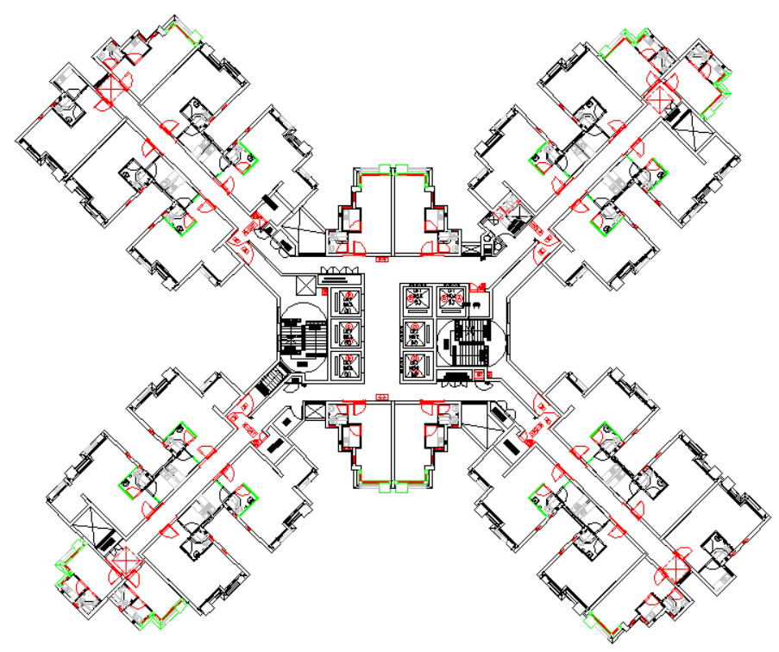
58.7
1/2P flat
2/3P flat
1B flat
2B flat

48.5
Fig. 2. Floor plan of the case building (unit: m)

3. Modular structural design scheme of the case study building

3.1. Floor plan considering modularisation requirements
The layouts of high-rise modular buildings can be generally divided into two types: 1) cluster arrangement, which means cluster modules around a core, and 2) corridor arrangement, which means that the modules are accessed from the core through a corridor, as shown in Fig. 3 [14]. The case study building combined the two types of layout owing to the plan characteristics of HK public residential buildings (Fig. 4): the module layout in each wing conformed to the corridor type, and the module layout of the entire story adopted the cluster type when each wing was regarded as a ‘big’ module. Meanwhile, the case study building was designed based on the design concept in which the core is mainly designed to resist the lateral loads and the concrete modules are only intended to bear axial compression and transfer the lateral load to the core. The design concept and floor plan enabled all the shear walls to be allocated in the core zone and all the modules to form the private living area, in which thin module walls could be adopted.
Stair  Lift  Module  Core zone | Modules  Stair  Lift  Core zone  Corridor
(a) Cluster arrangement | (b) Corridor arrangement
Fig. 3. Typical floor plans of high-rise modular buildings [14]
Precast module
Cast-in-situ coupling beam
Cast-in-situ core
Cast-in-situ core wall
Cast-in-situ corridor slab
Fig. 4. The proposed modular floor plan of the case building

3.1.1. Cast-in-situ core walls
Concrete core walls are critical to ensure the overall structural stability of the case study building. Thus, the core zone still adopted the traditional cast-in-situ construction method, which is deemed to be more reliable for owners and residents. On the premise that the use function of the public zone should be satisfied, as many core walls as possible were assigned (Fig. 4), aiming to resist the strong wind load in HK. The thickness of the core walls was determined so as to avoid an excessive overall deflection under wind load, as explained below.

3.1.2. Modularisation scheme
A reasonable modularisation scheme is the foundation of modular construction. Because the private living area was composed of four standard modular flat types, the modularisation scheme was mainly intended to determine the external dimensions of the modules that suited the flat types in the case study building. The proposed principles included the following ones:
- Keeping the area of the flat types unvaried.
- Satisfying the architectural function.
- Being adaptable to the transportation limitations.
- Meeting the lifting capacity requirements on site.
- Minimising the module types.
- Facilitating the continuation of site construction, such as the installation of various pipelines.
Among the above factors, the influence of transportation was more significant for the modularisation scheme. When shipping is needed for module logistics, the module width should be no greater than 2.345 mm to match the width of common shipping containers [19]. For road logistics in HK streets, the module width must be no greater than 2.5 m and its height must be no greater than 4.6 m from the road surface [30]. Considering the vehicle board height and the protruding bar length from the top surface of the modules, it is preferable that the module height be no greater than 3 m.
A modularisation scheme was proposed for the standard modular flat types of HK public residential buildings (Fig. 5). Except for interior decorations, the scheme enabled the modules to include only four types of structural dimensions, which minimised the types of templates required in the factory. The concrete module types M-5 and M-7 had the maximum outer dimension of 2.3 m × 6 m, which conformed to the transportation limitations. The area of the flat types did not change after the modularisation (Table 1). The entire modular floor plan of the case study building is shown in Fig. 4.
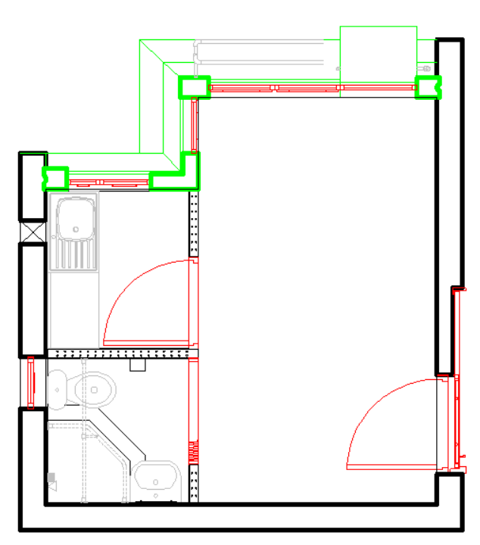  2.2  M-2  1.6  3.5  4.0  M-1 | 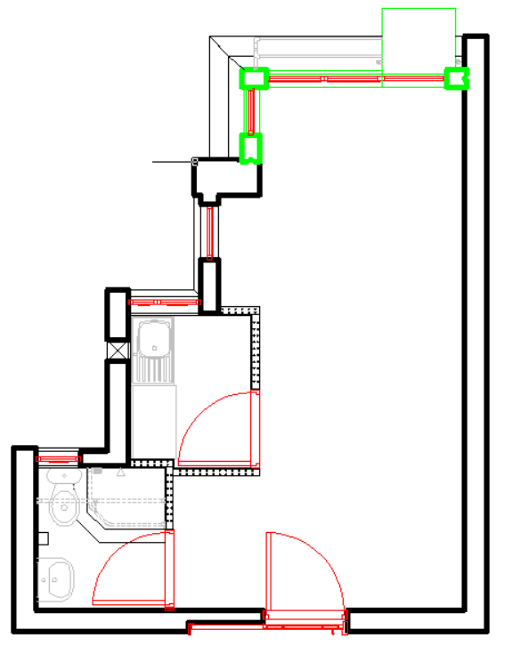  2.3  6.0  1.6  1.6  1.6  1.6  3.5  M-3  M-44  M-5 | 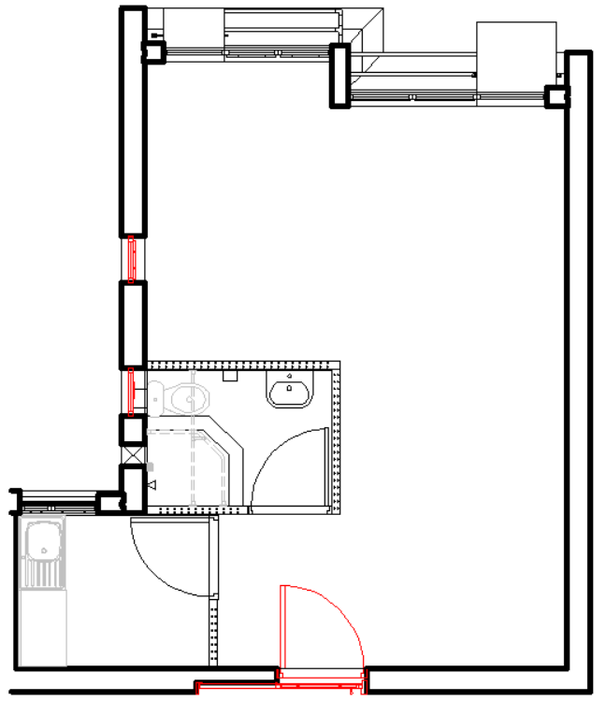  2.3  6.0  6.0  2.3  1.6  M-5  M-7  M-6 | 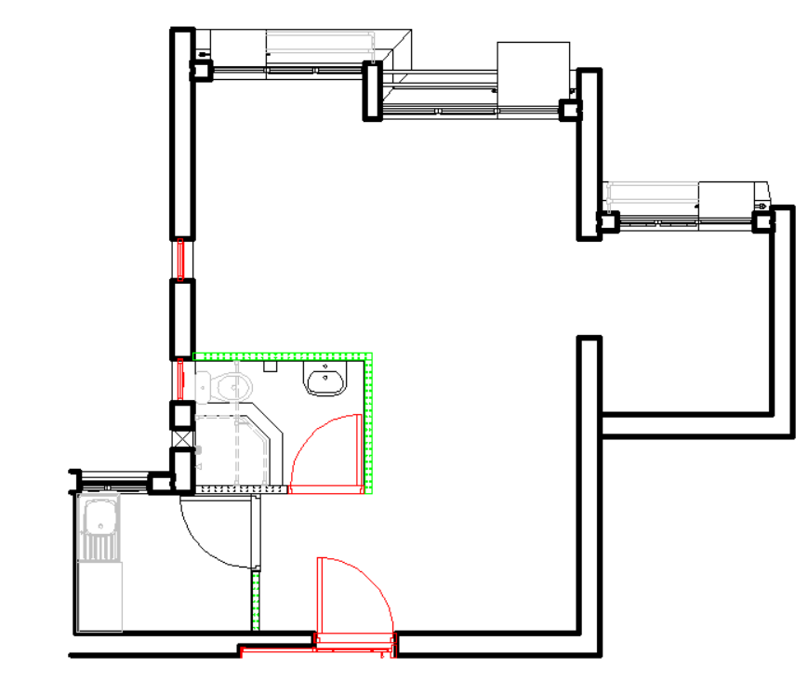  1.6  1.6  3.5  2.3  6.0  2.3  6.0  1.6  M-5  M-8  M-7  M-6
(a) 1/2P flat type | (b) 2/3P flat type | (c) 1B flat type | (d) 2B flat type
Fig. 5. The proposed modularization scheme for the standard modular flat types (unite: m)
Table 1 Comparison of the area of the flat types before and after modularization
 | 1/2P flat type | 2/3P flat type | 1B flat type | 2B flat type
Area of modularization scheme (m²) | 14.4 | 22.0 | 30.2 | 35.8
Area of original scheme (m²) | 14.1 ~ 14.5 | 21.6 ~ 22.0 | 30.2 ~ 30.9 | 35.0 ~ 35.9

3.2. Connection types for concrete high-rise modular buildings
Reliable connections are crucial to ensure the structural integrity of high-rise modular buildings. The existing literature and engineering practices have shown that bolted connections are widely used to link the corner posts or edge beams of adjacent steel modules [7, 22], whereas the ceiling and/or floor slabs within steel modules are separated [17, 18]. However, the bolted inter-module connections are not suitable for concrete modules because the rigid diaphragm effect becomes the basis for the structural integrity of concrete modular high-rises [3, 12]. In this work, based on the case study building, detailed horizontal and vertical connections are proposed for concrete modular high-rises.

3.2.1. Horizontal connections
The horizontal connections of concrete modular high-rises aim to form a ‘rigid diaphragm’ at each story. Semi-precast slabs have been widely used for HK public residential buildings as one of the innovative technologies [26]. They were recommended for one of the pilot MiC projects, the Fire Services Department Staff Quarters, which adopted concrete modules to build five blocks of 16–17 stories [31]. The technology was further developed to form a set of horizontal connections including module-to-module, module-to-corridor slab, module-to-core slab, and corridor slab–core slab connections using the case study building for illustration. The detailed construction process is depicted in Fig. 6. The concrete modules of the same story are installed after the cast-in-situ core zones are built (Fig. 6(a)); the curved bars of core slab are straightened for being embedded in the late-cast part of the ceiling slab (Fig. 6(b)); the precast slab of the modules acts as the formwork for the cast-in-situ part of the corridor slab in which the protruding bars of modules are embedded (Fig. 6(c)); an additional bar mesh is laid on the top surface of the modules and the corridor slab (Fig. 6(d)); and the late-cast concrete is poured to build the cast-in-situ part of the ceiling slab (Fig. 6(e)). All the ties should meet the requirement of the HK concrete code of practice regarding the anchorage bond length [32], which is generally 12 times the bar diameter. It is preferable that the cast-in-situ part of the ceiling slab be of no less than 80 mm in thickness considering the requirements of double steel mesh, cover thickness, and sufficient diaphragm effect.
Tie bar of module for corridor slab  Curved tie bar of core slab  Bar of module for vertical connection  Precast slab of module for corridor slab  Core slab  Module | Straightened tie bar of core slab
(a) Installing concrete modules | (b) Straightening the tie bars of core slab
Cast-in-situ part of corridor slab | Bar mesh
(c) Casting concrete for the cast-in-situ part of corridor slab | (d) Laying bar mesh for the cast-in-situ part of ceiling slab
Cast-in-situ part of ceiling slab
(e) Casting concrete for the cast-in-situ part of ceiling slab
Fig. 6. Construction process of horizon connections in concrete modular high-rises

3.2.2. Vertical connections
The vertical connections in concrete modular high-rises mainly refer to the wall-to-wall connections between concrete modules at the upper and lower stories. The HK precast concrete code of practice [33] provides two types of vertical wall-to-wall connections. One type uses late-cast concrete to build the two ends of the wall and duct-filled grout to anchor the vertical bars at the centre of the wall. The other type uses a semi-precast wall as formwork and the overlap method for connecting the vertical bars. The former type requires grouting inside the module walls, which may damage the prefinished interior decoration, whereas the latter type involves construction difficulties considering the mutual influence of adjacent module walls at the same story during the construction period. Thus, a new connection was proposed for the case study building combining the advantages of the two connection types, as shown in Fig. 7. The walls of adjacent concrete modules at the lower story are installed (Fig. 7(a)); the top of the module walls is covered by the aforementioned cast-in-situ part of the ceiling slab (Fig. 7(b)); the tie bars are set for the vertical bars of the adjacent modules (Fig. 7(c)); the vertical bars at the centre of the wall are lengthened using nuts for the grout-filled duct connections (Fig. 7(d)); the concrete module lifted for the upper story has recesses at the two ends of the wall where the transverse bar rings as constraints and the vertical bars as overlap parts are set for the protruding vertical bars (Fig. 7(e)); and the concrete modules are installed at the upper story and grout is poured into the recesses and ducts (Fig. 7(f)). The vertical connections can improve the construction efficiency and enhance the structural integrity between adjacent modules at the same story and also at the upper and lower stories. The lap length of the vertical bars should meet the requirement set in the HK concrete code of practice [32].
Modular wall  Bar for vertical connection | Cast-in-situ part of ceiling slab | Tie bar between adjacent modules
(a) Installing lower module walls | (b) Casting concrete for ceiling slab | (c) Setting tie bars for vertical bars
Nut | Recess for grouting  Duct  Traverse bar ring in recess | Grout  Grout
(d) Lengthen vertical bars using nuts | (e) Lifting upper module for assembly | (f) Casting grout for recesses/ducts
Fig. 7. Construction process of vertical connections in the walls of concrete modular high-rises

3.3. Structural design of modular components considering the effects of multi-period loads
There are mainly three types of concrete modules: six-sided, five-sided excluding ceiling, and five-sided excluding floor. Compared with the two other types, the six-sided concrete module is the most commonly used type in practical engineering. It can take full advantage of the prefinished interior decoration, although it leads to additional vertical loads due to the existence of a double-slab system, which refers to ceiling and floor slabs at one floor level. Thus, the case study building adopted the six-sided concrete module, including four walls, precast part of the ceiling slab, and floor slab (Fig. 8).
Modular wall
Precast part of ceiling slab
Opening
Protruding bar for corridor slab

Precast slab for corridor slab
Protruding bar for vertical connection
Module
Door opening
Floor slab
Fig. 8. Basic components of a typical six-sided precast concrete module in the case building
The effect of multi-period loads should be considered for designing modular components. The floor slab was designed to bear only its self-weight during the transportation and lifting periods owing to the relatively limited prefinished decorations of public residential buildings compared with those of their private counterparts, and it was deemed to have no contribution to resisting vertical loads during the service period. The precast part of the ceiling slab acted as a template for the cast-in-situ part, which means that it was designed to bear its self-weight and the cast-in-situ part's weight during the erection period. The superimposed ceiling slab was designed to resist the dead and live loads from the upper layer within its area during the service period. The precast part of the module walls was designed to bear the dead load of the precast module during transportation. The lifting anchors embedded in the module walls were required to be verified considering the lifting load. The module walls needed to bear the vertical loads from the modules at the story and above during the erection and service period. The detailed design loads are listed for the modular components in Table 2.
Table 2 Design load for components within modules
Modular components | Transportation |  | Lifting |  | Erection |  | Service
Modular components | Bearing | Load | Bearing | Load | Bearing | Load | Bearing | Load
Ceiling slab | Precast | α_{tr}r_{f,G}G_{cs,p} | Precast | α_{tr}r_{f,G}G_{cs,p} | Precast | α_{er}r_{f,G}(G_{cs,p} + G_{cs,c}) | Entire | r_{f,G}(G_{cs,p} + G_{cs,c} + G_{fl}) + r_{f,im}q_{im}A_{cs}
Floor slab | Precast | α_{tr}r_{f,G}G_{fl} | Precast | α_{tr}r_{f,G}G_{fl} | — | — | — | —
Modular wall | Precast | α_{tr}r_{f,G}G_{mod,p} | Lifting insert | α_{li}r_{f,G}G_{mod,p}/n_{li} | Entire | α_{er}r_{f,G}G_{mod}n_{ab} | Entire | (r_{f,G}G_{mod} + r_{f,im}q_{im}A_{cs})n_{ab}
α_{tr} is the equivalent load factor considering the dynamic effect during transportation and equal to 1.5; r_{f,G} is the appropriate partial safety factor for the dead load and equal to 1.4; G_{cs,p} is the dead load due to the precast part of ceiling slab; α_{er} is the equivalent load factor considering the dynamic effect during erection and equal to 1.2; G_{cs,c} is the dead load due to the cast-in-situ part of ceiling slab; G_{fl} is the dead load due to the floor slab; r_{f,im} is the appropriate partial safety factor for the imposed load and equal to 1.6; q_{im} is the imposed load due to the residential activities and equal to 2.0 kN/m²; A_{cs} is the area of the ceiling slab; G_{w,p} is the dead load due to the precast part of wall; α_{li} is the safety factor for lifting insert and equal to 4; G_{mod,p} is the dead load due to the precast part of module; n_{li} is the number of lifting inserts; G_{mod} is the dead load due to the entire module including cast-in-situ part; and n_{ab} is the number of modules at this story and above.
The structural details specified in the HK codes needed to be met for designing the modular components, such as the minimum cover thickness required by fire demand. Eventually, it was concluded that when the ceiling and floor slab dimensions met the specified structural details, their resistance to multi-period loads was generally sufficient. That is, the specified structural details were dominant in determining the ceiling and floor slabs' dimensions. In this study, the thickness was proposed to be 80 mm for the floor slab and the precast part of the ceiling slab considering the double steel mesh and cover thickness. It should be noted that the superimposed ceiling slabs were regarded to meet the minimum thickness requirement set for the fire limit state and the minimum span-to-depth ratio requirement set for the serviceability limit state. The floor slabs within modules were only under short term load during the transportation and lifting periods, which indicated that they did not need to meet the requirements regarding the fire/serviceability limit states.
When a concrete wall is designed to only bear vertical loads, its thickness t_{w} is determined by two specifications according to the HK concrete code of practice [32]. Owing to the requirement of slenderness, t_{w} should be no less than the minimum limit t_{sd,min} as
(1)
where l_{w,o} is the clear height of the wall between the ceiling and floor slabs. Further, t_{w} should be large enough to ensure that the axial load ratio η of the wall is no greater than the allowable maximum value η_{max}, which is calculated as
(2)
The axial load of a module wall is linearly increased with n_{ab}. For the convenience of prefabrication and erection, the same type of modules at different stories was considered to have the same module wall thickness. Thus, the modules at lower stories needed to adopt higher strength concrete to prefabricate the module walls. However, there has been no research on the determination of the strength grade of module walls at a particular story. According to the full strength design and optimisation principles for structural components [34], when η = η_{max} is satisfied for a module wall at any story, it is deemed to reach the maximum material utilisation. According to the above principle, the following procedure was proposed to determine the strength grades of module walls at different stories (Fig. 9):
(1) An initial value is given for t_{w}, which should be no less than l_{w,o}/40 in accordance with Eq. 1.
(2) When t_{w} is known, the axial loads of the wall at the first story during different construction/service periods can be identified and the allowable maximum value η_{max} can be calculated.
(3) The dominant axial load P_{wd,1} of the wall at the first story (ground level) can be determined. The dominant axial load P_{wd,i} of the wall at the i-th story can be determined as
(3)
where n_{tol} is the total number of stories of the case study building.
(4) The minimum strength demand f_{c,de,min,i} of the wall at the i-th story should satisfy the following equation:
(4)
where A_{w} is the section area of a module wall. Eq. 3 is substituted into Eq. 4, and f_{c,de,min,i} can be calculated as
(5)
(5) According to Eq. 5, the minimum strength demand f_{c,de,min,1} of the wall at the first story can be calculated as
(6)
(6) The upper limit f_{c, low, lim} and lower limit f_{c, up, lim} are proposed for f_{c,de,min,1}. When f_{c,de,min,1} < f_{c, low, lim}, the given t_{w} is deemed to be too large and should become smaller. When f_{c,de,min,1} > f_{c, low, lim}, the given t_{w} is deemed to be too small and should become larger. Then, a renewed t_{w} will be given to repeat the above steps (1)–(5).
(7) When f_{c, low, lim} ≤ f_{c,de,min,1} ≤ f_{c, up, lim}, a strength grade scheme for the module walls can be developed according to the variation of f_{c,de,min,i}.
Fig. 9. Flow-chart of determining the strength grades of module walls at different building stories
For the case study building with l_{w,o} = 2.5 m, n_{tol} = 50, f_{c, low, lim} = 30 MPa, and f_{c, up, lim} = 80 MPa, the distribution of f_{c,de,min,i} was determined according to the proposed procedure when t_{w} was 80 mm, 100 mm, 120 mm, 140 mm, and 160 mm, respectively (Fig. 10). The required maximum concrete grade was C35 when t_{w} = 140 mm; it changed to C40 when t_{w} = 120 mm; and it changed to be C50 when t_{w} = 100 mm. In this study, t_{w} = 80 mm was selected and the detailed strength grade scheme of the module walls was as follows: C70 was used at the 1st–10th stories, C55 was used at the 11st–20th stories, C45 was used at the 21st–30th stories, and C30 was used at the 31st–50th stories (Fig. 10 (a)). Compared with the other schemes which individually adopted C35, C40, and C50 to build module walls, the selected scheme could respectively reduce the lifting weight of concrete modules by 30.3%, 22.5%, and 12.7% (Fig. 10 (b)).
(a) The minimum strength demand of module walls | (b) The lifting weight of precast concrete modules
Fig. 10. The strength grade schemes of module walls for different wall thicknesses

4. Modelling concrete modular high-rises using MEFM
The ETABS software was adopted to establish a numerical model of the case study building. According to the design concept in this study, the module walls were intended to bear vertical loads and transfer lateral loads to the cores. Thus, it should be preferable not to model the module walls using a shell element, which is generally used for modelling shear walls with high lateral resistance. In the numerical model of this research, according to the MEFM, the walls within a concrete module were equivalent to a frame system (Fig. 11), which could be modelled using frame elements and be able to provide great vertical resistance and limited lateral resistance. The equivalent principles are proposed below.
(1) The volume M_{tol} of walls within a concrete module is unvaried before and after the equivalent treatment.
(2) The equivalent beams along the long and short sides have the same sectional width t_{b}, which is no less than 200 mm, and different sectional heights h_{b,l} and h_{b,s}, which are equal to 1/10 of the corresponding wall lengths l_{w,l} and l_{w,s} [35].
(3) The equivalent columns have a square section with length t_{c} no shorter than t_{b}, a clear height no shorter than 4t_{c} [35], and a sectional area that is no larger than that of a module wall along the short side.
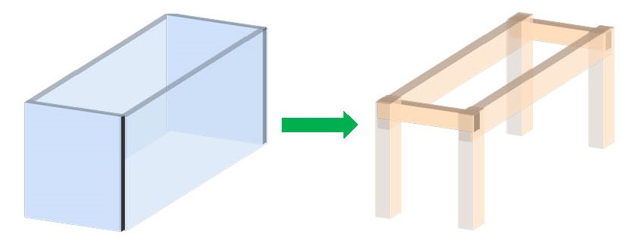
Module walls
h_{b,s}
t_{b}
l_{w,s}
Beam
Column
Long side
Short side
Equivalent frame system
l_{w,s}
l_{w,l}
t_{b}
l_{w,o}
t_{c}
t_{c}
h_{b,l}
t_{w}
l_{w,o}
l_{w,l}
Fig. 11. Schematic design for walls within a concrete module being equivalent to a frame system
The first principle aims to ensure that the equivalent treatment does not change the self-weight of module walls. There are two purposes of the second and third principles: one aims to ensure that the equivalent frame system has good structural performance in accordance with the Chinese code [35], whereas the other aims to minimise the unknown parameters. According to the second and third principles, there are only two pending parameters, t_{c} and t_{b}, which need to meet the following limits:
(7)
where t_{c,up,lim} is the upper limit of t_{c}.
According to the first principle, the following equation can be obtained:
(8)
The substitutions of h_{b,l} = 1/10 l_{w,l} and h_{b,s} = 1/10 l_{w,s} into Eq. 8 lead to
(9)
When t_{c} is given, t_{b} can be uniquely determined. The t_{c}–t_{b} relations of the adopted module types are presented in Fig. 12 according to Eq. 9. The available combinations of t_{c} and t_{b} are located in the closed zone formed by t_{c} = t_{b}, t_{b} = 200 mm, and t_{c} = t_{c,up,lim}. Fig. 12 illustrates the selected plans for the module types, considering t_{c} as large as possible to enhance the vertical bearing capacity of the equivalent columns. The details of the equivalent frame systems for the module types are listed in Table 3.

Fig. 12. The t_{c}-t_{b} relations of the used module types according to Eq. 9
Table 3 Details of the equivalent frame systems for the used module types
Module type | Section of beam along long side |  | Section of beam along short side |  | Section of column
Module type | h_{b,l} (mm) | t_{b} (mm) | h_{b,s} (mm) | t_{b} (mm) | t_{c} (mm) | t_{c} (mm)
M-1, M-4, M-8 | 350 | 330 | 160 | 330 | 350 | 350
M-2 | 400 | 210 | 220 | 210 | 420 | 420
M-3, M-6 | 160 | 210 | 160 | 210 | 330 | 330
M-5, M-7 | 600 | 220 | 230 | 220 | 420 | 420
Meanwhile, there are a few points requiring extra attention when a numerical model is established to simulate the case study building. The continuous rigid diaphragm is still available for the entire case study building based on the superposed ceiling slabs, which are continuous and work together with the cast-in-situ slabs in corridor and core zones. Floor slabs are considered in the form of a uniformly distributed load, which aims to not consider their contribution to vertical loads. At the same story, adjacent modules have no joint–joint or beam–beam connections (Fig. 13), and there are no other connections between the cast-in-situ core zone and the concrete modules except for the continuous rigid diaphragm effect.
Fig. 14 illustrates the plan and 3-D views for the numerical model of the case study building with 40 stories using the MEFM. The module walls were modelled using frame elements. The precast and cast-in-situ slabs were modelled using membrane elements, and the monolithic core walls were modelled using shell elements. No connections existed between adjacent columns or between neighbouring columns and core walls.
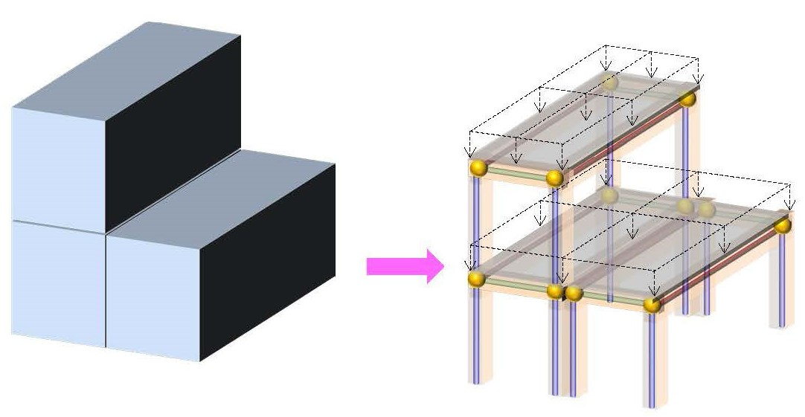
Fig. 13. Schematic diagram design for modeling concrete modules of the case building
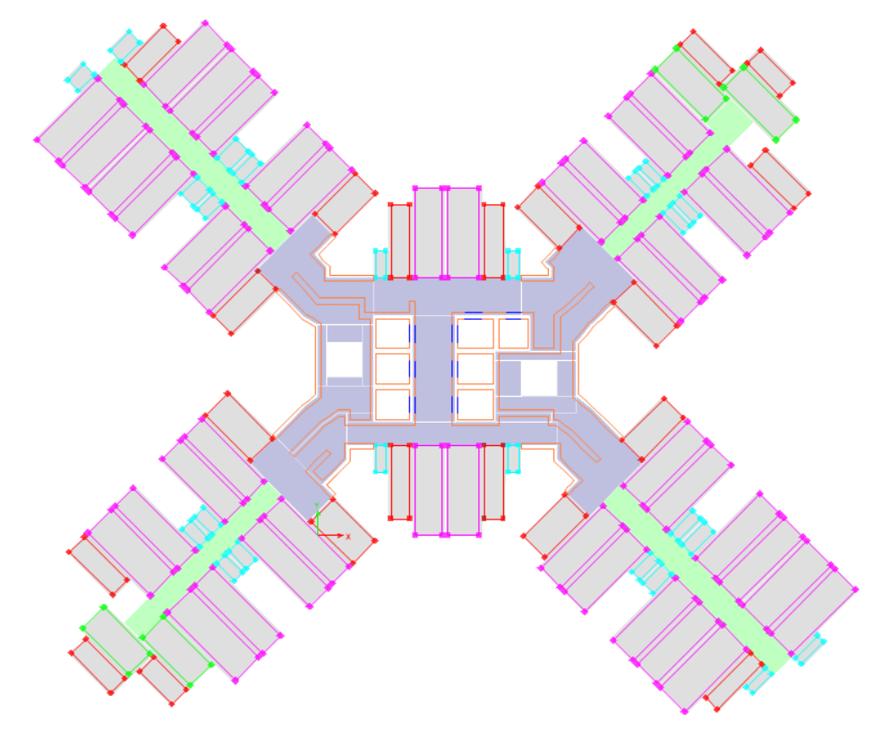  No connection  Frame element  Membrane element  Shell element | 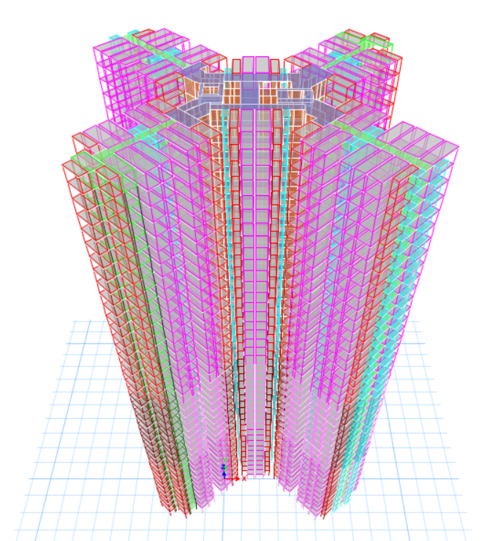
(a) Plan view | (b) 3-D view
Fig. 14. ETABS model of the case building with 40 stories using MEFM

5. Structural responses of the case study building under wind load

5.1. Calculation of the specified wind load in the new HK code
A new wind load code [24] has been enforced in HK. Compared with the old version, there are many additional specifications in the new version that consider the adverse effects of the wind load, including the across-wind, directional wind, directional shelter, corner shape, and building size effects. Meanwhile, in the old version, the internal force and deflection of a building under wind load are separately calculated along the two main-axis directions, whereas in the new version the structural responses are separately calculated under three wind load combinations. Each combination simultaneously includes two horizontal loads along the main-axis directions and a torsional moment around the vertical direction. In the numerical model, the horizontal loads and torsional moment were imposed on the rigidity centre of each story. Based on the case study building, the effect of building height was investigated using three cases with 30, 40, and 50 stories, for which wind loads were respectively determined (Fig. 15). The combination factors are listed in Table 4 [24] for the three wind load combinations. Due to the good plan symmetry, the calculated results are only presented for the three cases when the combination factors are positive.
(a) Horizontal force F_{x} along X axis | (b) Horizontal force F_{y} along Y axis | (a) Torsional moment T around Z axis
Fig. 15. Wind load for the case building with different story numbers
Table 4 Wind load combination factors for buildings [24]
Combination | Horizontal force F_{x} along X axis | Horizontal force F_{y} along Y axis | Tensional moment T around Z axis
Wind1 | ±1.00 | ±0.55 | ±0.55
Wind2 | ±0.55 | ±1.00 | ±0.55
Wind3 | ±0.55 | ±0.55 | ±1.00

5.2. Calculated results of the case study building using MEFM
In the numerical model, the thickness of core walls started from 100 mm and increased with intervals of 50 mm, and it can be determined once the deflection of the building does not exceed 500/H under the wind load combinations (H is the building height) [32]. According to the above method, the thickness of core walls was respectively 100, 450, and 1050 mm for the 30-, 40-, and 50-story cases along the entire building height. Fig. 16 illustrates the drift ratios of the three cases with the proposed core wall thickness under the three wind load combinations using the MEFM. It can be found that the three cases reach the maximum drift ratio, which is very close but no greater than 0.20% under Wind1 combination, indicating that the proposed core wall thickness values are optimised.
(a) 30-story case | (b) 40-story case | (c) 50-story case
Fig. 16. Drift ratios of the three cases using MEFM
The new code adds the upper limit A_{acc,lim} for peak acceleration A_{acc} caused by wind load, which aims to consider the occupant comfort. The peak acceleration at height Z can be calculated as
(10)
where G_{ry} is the peak factor, which can be determined with the fundamental frequency N_{acw} for the mode mainly aligned with the across-wind direction; ξ_{acw} is the ratio of damping to critical damping in the across-wind direction of vibration; (BD)_{b} is the plan area of the enclosing rectangle; S_{r} is the return period factor; Q_{h} is the wind reference pressure at the effective building height; ρ_{a} is the mass density of air; I_{v,h} is the wind turbulence intensity at the building height; H_{b} is the height of building above the ground level; M_{h} is the mass of the building above 2H_{b}/3; and η_{acw} is the parameter used to depict the approximate mode deflection variation with height.
N_{acw} and M_{h} can be obtained from the ETABS model. Other parameters can be determined based on the basic information of the cases in accordance with the new code. N_{acw} and M_{h} can be obtained from the ETABS model. According to Eq. 10, the maximum value of peak acceleration is located at the top story. The demand-to-capacity ratio of peak acceleration is defined as
(11)
where A_{acc,top} is the peak acceleration at the top story. When N_{acw} is known, A_{cc,lim} can be obtained using the chart provided in the new code. When γ_{d-c,acc} is less than 1.0, the building is deemed to have sufficient capacity to avoid an excessively large wind vibration. The new code suggests two return periods, including 1 and 10 years, to consider the wind acceleration. As shown in Fig. 17, γ_{d-c,acc} is far less than 1.0 for the 1-year and 10-year peak accelerations, indicating that the three cases can ensure occupant comfort using the design scheme.
(a) 1-year peak acceleration | (b) 10-year peak acceleration
Fig. 17. Demand-to-capacity ratios of peak acceleration using MEFM
Fig. 18 shows the shear forces of the core and module walls calculated using the MEFM to validate whether the concept is satisfied or not. For the three cases, the shear force of the module walls at the top is almost unvaried and it is generally reduced to a lower value at the bottom, whereas that of the core walls significantly increases from the top to the bottom. Meanwhile, when the case study building is higher, the shear force of the module walls slightly decreases at the same story, whereas that of the core walls obviously increases. This indicates that the core walls of the 50-story case resist a greater proportion of shear force than those of the 30-story case at the same story.
(a) Shear force along X axis under Wind1 combination | (b) Shear force along Y axis under Wind2 combination
Fig. 18. Shear forces of core walls and modular walls using MEFM
A contribution ratio of the modules at the i-th story is defined to quantify the contribution of module walls to lateral force resistance of the building, as follows:
(12)
where F_{mw,i} and F_{cw,i} are the shear forces of the module walls and the core walls at the i-th story along a particular direction. The maximum internal force of structural components is generally located at the bottom stories, which are crucial to determine the design state of those components. Thus, the bottom five stories are selected to show the contribution ratio of the modules. As shown in Fig. 19, the closer the story is to the ground, the lower the module contribution ratio is. At the bottom two stories, the contribution ratios are lower than 0.20 for the 30-story case, whereas they are reduced to approximately 0.05 for the 40- and 50-story cases. It means that at the bottom stories, the module walls provide limited lateral force resistance for the 30-story case and their contribution can even be neglected for the 40- and 50-story cases. Thus, the calculated results using the MEFM can match the concept that is the basis of the method, indicating that the method can justify itself.
(a) Along X axis under Wind1 combination | (b) Along Y axis under Wind2 combination
Fig. 19. Contribution of modules at the bottom five stories using MEFM

5.3. Comparison between MEFM and equivalent shear wall method
To further assess the MEFM, a numerical model was established considering the module walls as shear walls (i.e., the equivalent shear wall method), which means that the contribution of the module walls to lateral force resistance of the building is maximised. For the numerical model using the equivalent shear wall method, the module walls were modelled using shell elements, and no connections existed between adjacent module walls and between neighbouring module walls and core walls (Fig. 20). Other modelling details were the same as those in the model using the MEFM.
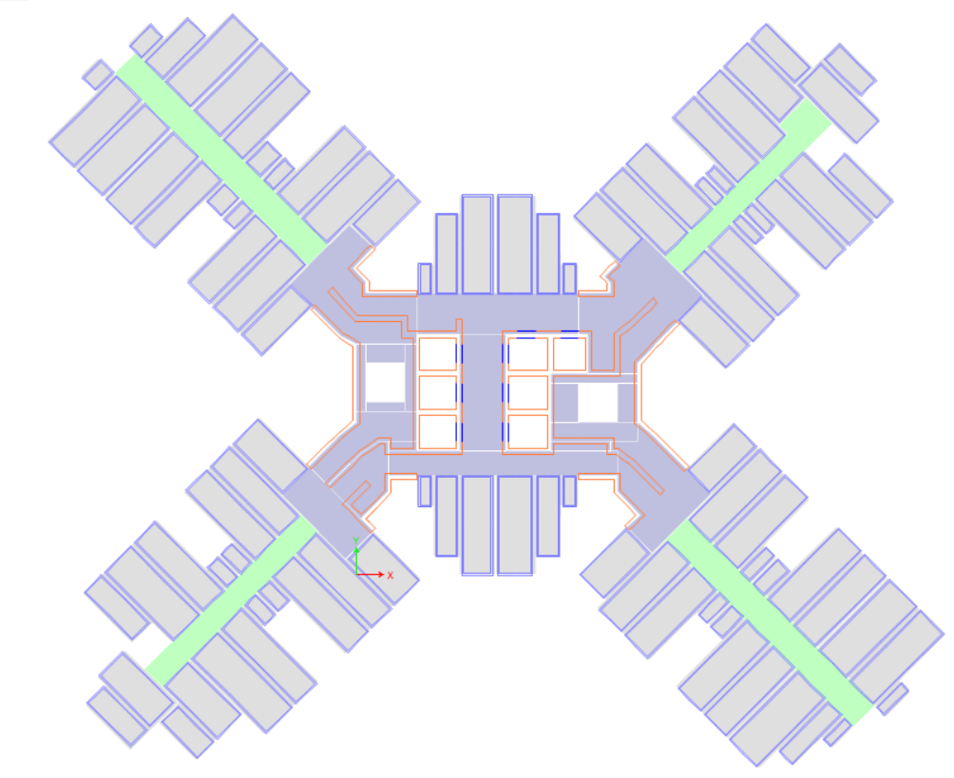  Shell element  No connection  Membrane element  No connection  Shell element | 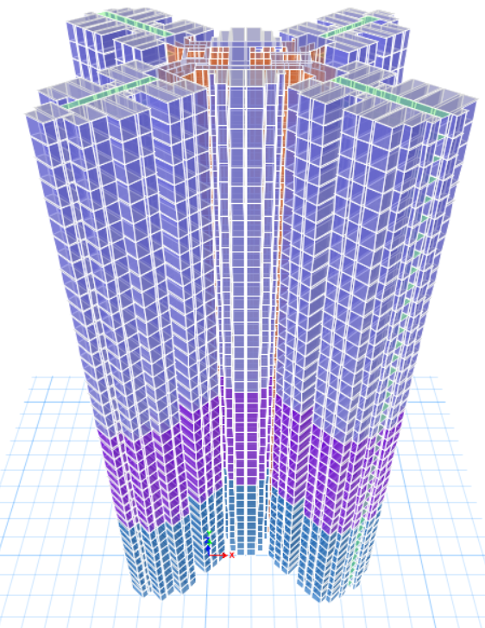
(a) Plan view | (b) 3-D view
Fig. 20. ETABS model of the case building with 40 stories using the equivalent shear wall method
The new numerical model was used to re-calculate the structural responses of the three cases with the same thickness of core walls under the three wind combinations. Fig. 21 compares the maximum drift ratios of the three cases based on the two methods. It is easily found that the maximum drift ratio based on the equivalent shear wall method is significantly smaller, and the descending range becomes greater for the case with lower building height. For instance, under the wind1 combination, the descending range is respectively 30.4%, 16.4%, and 7.4% for the 30-, 40-, and 50-story cases, which is due to a larger contribution of the core walls to lateral force resistance for the case with higher building height.
(a) Wind1 combination | (b) Wind2 combination
(c) Wind3 combination
Fig. 21. Comparisons of the maximum drift ratios under wind load using the two methods
The demand-to-capacity ratios of peak acceleration were also re-calculated using the new numerical model and compared with the previous results using the MEFM (Fig. 22). Although the demand-to-capacity ratio of peak acceleration using the equivalent shear wall method is still smaller than that of the model using the MEFM, the difference is not significant. For instance, for 1-year peak acceleration along the X axis, the descending range of the demand-to-capacity ratio is respectively 14.4%, 3.7%, and 5.3% for the 30-, 40-, and 50-story cases. Compared with the equivalent shear wall method, the MEFM is deemed to have the capacity to provide a conservative and close prediction for the demand-to-capacity ratios of peak acceleration.
(a) 1-year peak acceleration | (b) 10-year peak acceleration
Fig. 22. Comparisons of the demand-to-capacity ratios of peak acceleration using the two methods
The frame efficiency factor α_{fe} is defined as the ratio of the shear force of all the module walls using the MEFM to that using the equivalent shear wall method. The factor is adopted to measure the degree to which the former considers the shear wall effect of module walls. Fig. 23 shows the frame efficiency factors at the bottom five stories. It is found that for the same case, α_{fe} decreases at the story closer to the bottom, while for the higher case α_{fe} at the same story decreases. At the bottom two stories, α_{fe} is respectively reduced to approximately 0.20, 0.10, and 0.06 for the 30-, 40-, and 50-story cases along the X axis under Wind1 combination or the Y axis under Wind2 combination. Thus, the MEFM considers the module walls' shear wall effect for the 30- and 40-story cases in a low degree, and it is deemed to ignore the shear wall effect for the 50-story case.
(a) Along X axis under Wind1 combination | (b) Along Y axis under Wind2 combination
Fig. 23. Frame efficiency factors at the bottom five stories
Meanwhile, it can be seen that the numerical model established by the equivalent shear wall method reduces the contribution of the core walls to the lateral force resistance of the building. The reduced factor β_{rf} of core walls is defined as the ratio of the shear force of core walls using the equivalent shear wall method to that using the MEFM. As shown in Fig. 24, at the bottom five stories, β_{rf} is varied in the range of 0.20–0.40 for the 30 story-case, 0.40–0.60 for the 40-story case, and 0.60–0.80 for the 50-story case. The closer the story is to the bottom, the smaller value β_{rf} has. The significantly reduced internal force at critical locations may lead to an unsafe design of core walls, which will be a disaster for the entire building. This is also a reason why the equivalent shear wall method is not preferred to model module walls in the structural design of concrete modular high-rises.
(a) Along X axis under Wind1 combination | (b) Along Y axis under Wind2 combination
Fig. 24. Reduced factor of core walls at the bottom five stories
The equivalent shear wall method was used to re-design the three cases in terms of the thickness of core walls. For the 30-story case, the thickness of core walls adopting 100 mm could not be further reduced considering the out-of-plane stability of shear walls [36]. The thickness of core walls was respectively decreased to 350 and 950 mm for the 40- and 50-story cases. Fig. 25 shows the detailed drift ratios of the re-designed cases under wind load. Except for the 30-story case, the other cases reach a maximum drift ratio that is very close but no greater than 0.20% under Wind1 combination, which means that the re-designed core wall thickness values are optimised. As shown in Fig. 26, γ_{d-c,acc} is also used to validate whether the re-designed cases meet the code requirement regarding peak acceleration under wind load. Considering that γ_{d-c,acc} is far less than 1.0 for the 1- and 10-year peak accelerations, the re-designed cases can ensure occupant comfort under wind load.
(a) 30-story building case with 100 mm-thickness core walls | (b) 40-story with 350 mm-thickness core walls | (c) 50-story with 950 mm-thickness core walls
Fig. 25. Drift ratios of the re-designed cases using the equivalent shear wall method
(a) 1-year peak acceleration | (b) 10-year peak acceleration
Fig. 26. Demand-to-capacity ratios of peak acceleration for the re-designed cases using the equivalent shear wall method
A comparison of concrete usage was conducted between the design schemes based on the two methods for the three cases (Fig. 27(a)). The precast concrete usage per story is almost constant for any of the three cases in both methods. The cast-in-situ concrete usage per story dramatically increases with the total number of stories of the case according to either of the two methods. From 30 to 50 stories, the cast-in-situ concrete usage per story increases by 1.93 times based on the MEFM, whereas it increases by 1.73 times based on the equivalent shear wall method. When the module walls are modelled by the equivalent shear wall method rather than the MEFM, the cast-in-situ concrete usage per story decreases by 6.6% and 6.9% for the 40- and 50-story cases, respectively. The precast ratio γ_{p} refers to the volume ratio of the precast concrete usage to the total concrete usage [37]. According to the Chinese code [38], when assessing the industrialised construction level of precast concrete structures, γ_{p} ≥ 60% is excellent; 40% ≤ γ_{p} < 60% is high, 30% ≤ γ_{p} < 40% is moderate; and 20% ≤ γ_{p} < 30% is low. Fig. 27 shows that γ_{p} can reach up to 67.8% for the 30-story case, which means that concrete high-rise buildings can reach an excellent industrialised construction level by adopting modular construction. When the number of stories varies from 30 to 50, γ_{p} is significantly weakened from 67.8% to approximately 40%. This reveals that the concept whereby the modules are intended to resist the vertical load and cores are meant to resist the lateral load gradually becomes unfeasible for buildings with more than 30 stories. In addition, the relative error of γ_{p} of the two equivalent methods is less than 5.0% for the 40- and 50-story cases, which indicates that the MEFM almost does not influence γ_{p}.
(a) Concrete usage per story | (b) Precast ratio
Fig. 27. Comparison of concrete usage and precast ratio according to the two methods

6. Conclusions
This paper proposed a novel structural design method, MEFM, for concrete high-rise modular buildings where wind load dominates the structural design. The developed MEFM is based on the structural design concept whereby modules are intended to resist the vertical load but transfer the lateral load to cores, while cores are mainly meant to resist the lateral load. A typical high-rise public residential building in HK was used for the case study, which has the new cruciform floor plan – the most typical and representative floor plan for public housing in HK. For the case study building, a floor plan composed of core zones and concrete modules was proposed according to the modularisation requirements. The available horizontal and vertical connection types were shown to ensure structural integrity and a continuous rigid diaphragm effect. Structural design details were reported for modular components considering the effects of multi-period loads. A new procedure was developed to determine the strength grades of modular walls for unifying their thickness at different stories. An analytical method was established to determine an equivalent frame system with great vertical resistance and limited lateral resistance to model walls within a concrete module. A numerical model based on the MEFM was used to analyse the structural responses of case study buildings with 30, 40, and 50 stories under wind load. The calculated results were compared with those of the numerical model considering the module walls as shear walls.
The main conclusions of this paper are as follows:
- The developed new method, MEFM, is found to be feasible for achieving structural design solutions of concrete high-rise modular buildings. The method can ensure that the designed case study building under wind load has structural responses that meet the code requirements and an internal force distribution that matches the design concept, which justifies the developed MEFM method.
- The MEFM is also found to be more suitable for the 30-story case than for the 50-story case owing to the reduction in precast ratio with increasing building height. According to the method, the precast ratio is 67.8% for the 30-story case but 41.7% for the 50-story case, which is due to the large amount of cast-in-situ concrete used for the cores. It is necessary to adopt stronger structural systems such as an out-rigger or tube system, or to utilise other technologies such as dampers to improve the lateral force resistance of the 50-story case under wind load.
- Further, the MEFM is observed to be more appropriate than the equivalent shear wall method to simulate module walls because it can better balance the structural safety, material consumption, and precast ratio. The use of the MEFM can help reduce the designed force in the shear walls of modules while enhancing the design of the cores, which in turn can reduce the failure probability of the whole structure. In comparison, the MEFM is found to be not too conservative to predict the structural responses of concrete modular high-rises within the average relative error of 10%–20%, and it increases the cast-in-situ concrete usage by no more than 7% and decreases the precast ratio by no more than 5%. Notably, the equivalent shear wall method can sharply reduce the shear force of the core walls, which may be unsafe for the structure.
- The proposed procedure for the strength grades of module walls can help reduce the lifting weight for the modules owing to the higher strength concrete used in the module walls at the lower stories. The optimised scheme can respectively reduce the lifting weight of concrete modules by 30.3%, 22.5%, and 12.7%, compared with the schemes that individually adopt C35, C40, and C50 to build the module walls.
- The proposed modularisation scheme is typical and representative for HK public residential high-rises. It requires no change to the area of the four standard modular flat types being adopted for the general layout of high-rise public residential buildings in HK. Moreover, the modules can be minimised to include only four types of structural dimensions. The maximum external width of these module types can satisfy the transportation limitations.
The findings of this study fill the research gap about the structural design of concrete high-rise modular buildings. Notably, the current seismic codes in HK have not been officially promulgated. Thus, the structural design method is developed to meet current HK codes and does not consider the effects of seismic load. Further, the effect of openings on module walls is not considered in this work. Moreover, this study is mainly focused on the global structural modelling method of high-rise modular buildings and discusses the feasibility of the method for different building heights. Thus, the connection details of modules are not fully considered, nor are the construction process and design details for ensuring the performance of the joints. These limitations and their influence on the structural design of high-rise modular buildings will be studied in future research.

Declaration of competing interest
The authors declare that they have no known competing financial interests or personal relationships that could have appeared to influence the work reported in this paper.

Acknowledgements
The work presented in this paper was supported by a grant from the Research Impact Fund of the Hong Kong Research Grants Council (Project No. HKU R7027-18).

References
[1] Pan M, Linner T, Pan W, Cheng H-m, Bock T. Influencing factors of the future utilisation of construction robots for buildings: A Hong Kong perspective. Journal of Building Engineering, 2020; 30: 101220.
[2] Javed AA, Pan W, Chen L, Zhan W. A systemic exploration of drivers for and constraints on construction productivity enhancement. Built Environment Project and Asset Management, 2018; 8: 239-252.
[3] Wang Z, Pan W. A hybrid coupled wall system with replaceable steel coupling beams for high-rise modular buildings. Journal of Building Engineering, 2020: 101355.
[4] Srisangeerthanan S, Hashemi MJ, Rajeev P, Gad E, Fernando S. Review of performance requirements for inter-module connections in multi-story modular buildings. Journal of Building Engineering, 2019: 101087.
[5] Fathieh A, Mercan O. Seismic evaluation of modular steel buildings. Engineering Structures, 2016; 122: 83-92.
[6] Sharafi P, Mortazavi M, Samali B, Ronagh H. Interlocking system for enhancing the integrity of multi-storey modular buildings. Automation in Construction, 2018; 85: 263-272.
[7] Lacey AW, Chen W, Hao H, Bi K. Review of bolted inter-module connections in modular steel buildings. Journal of Building Engineering, 2019; 23: 207-219.
[8] Srisangeerthanan S, Hashemi MJ, Rajeev P, Gad E, Fernando S. Numerical study on the effects of diaphragm stiffness and strength on the seismic response of multi-story modular buildings. Engineering Structures, 2018; 163: 25-37.
[9] Ferdous W, Bai Y, Ngo TD, Manalo A, Mendis P. New advancements, challenges and opportunities of multi-storey modular buildings–A state-of-the-art review. Engineering Structures, 2019; 183: 883-893.
[10] Shan S, Looi D, Cai Y, Ma P, Chen M-T, Su R, Young B, Pan W. Engineering modular integrated construction for high-rise building: a case study in Hong Kong. Proceedings of the Institution of Civil Engineers-Civil Engineering, 2019; 172: 51-57.
[11] Lacey AW, Chen W, Hao H, Bi K. Structural response of modular buildings–an overview. Journal of Building Engineering, 2018; 16: 45-56.
[12] Wang Z, Pan W, Zhang Z. High-rise modular buildings with innovative precast concrete shear walls as a lateral force resisting system. Structures, 2020; 26: 39-53.
[13] Lawson RM, Richards J. Modular design for high-rise buildings. Proceedings of the Institution of Civil Engineers-Structures and Buildings, 2010; 163: 151-164.
[14] Lawson RM, Ogden RG, Bergin R. Application of modular construction in high-rise buildings. Journal of Architectural Engineering, 2012; 18: 148-154.
[15] Park HK, Ock J-H. Unit modular in-fill construction method for high-rise buildings. KSCE Journal of Civil Engineering, 2016; 20: 1201-1210.
[16] Gunawardena T, Ngo T, Mendis P, Alfano J. Innovative flexible structural system using prefabricated modules. Journal of Architectural Engineering, 2016; 22: 05016003.
[17] Chua YS, Liew JYR, Pang SD. Robustness of prefabricated prefinished volumetric construction (PPVC) high-rise building. Proceedings of the 12th International Conference on Advances in Steel-Concrete Composite Structures ASCCS 2018, 2018: 913-919.
[18] Chua Y, Liew JR, Pang S. Modelling of connections and lateral behavior of high-rise modular steel buildings. Journal of Constructional Steel Research, 2020; 166: 105901.
[19] Hayes P. Structural design of high rise volumetric building systems using hot-rolled steel. Proceedings of the Institution of Civil Engineers-Civil Engineering, 2019; 172: 45-50.
[20] Shi F, Wang H, Zong L, Ding Y, Su J. Seismic behavior of high-rise modular steel constructions with various module layouts. Journal of Building Engineering, 2020: 101396.
[21] Shan S, Pan W. Structural design of high-rise buildings using steel-framed modules: a case study in Hong Kong. The Structural Design of Tall and Special Buildings, 2020; 29: e1788.
[22] Liew J, Chua Y, Dai Z. Steel concrete composite systems for modular construction of high-rise buildings. Structures, 2019; 21: 135-149.
[23] Pan W, Hon CK. Modular integrated construction for high-rise buildings. Proceedings of the Institution of Civil Engineers-Municipal Engineer, 2018: 1-5.
[24] Code of Practice on Wind Effects in Hong Kong. Hong Kong: Buildings Department; 2019.
[25] Yeung K, Lai W. Paradigm shift in Hong Kong public housing developments: from standard block to site specific block with modular flat design. Proceedings for the Construction and Housing in the 21st Century, HKU-HKHA International Conference Hong Kong, 2013.
[26] Tam VW, Fung IW, Sing MC, Ogunlana SO. Best practice of prefabrication implementation in the Hong Kong public and private sectors. Journal of Cleaner Production, 2015; 109: 216-231.
[27] Pan W, Qin H, Zhao Y. Challenges for energy and carbon modeling of high-rise buildings: The case of public housing in Hong Kong. Resources, Conservation and Recycling, 2017; 123: 208-218.
[28] Jaillon L, Poon CS. The evolution of prefabricated residential building systems in Hong Kong: A review of the public and the private sector. Automation in Construction, 2009; 18: 239-248.
[29] Chan DW, Chan AP. Public housing construction in Hong Kong: a review of its design and construction innovations. Architectural Science Review, 2002; 45: 349-359.
[30] Road Users' Code. Hong Kong: Transport Department; 2000.
[31] Lee RSM. Modular Integrated Construction Semi-Precast Concrete MiC System. CENRC Technical Seminar; 2019.
[32] Code of Practice for Structural Use of Concrete. Hong Kong: Buildings Department; 2013.
[33] Code of Practice for Precast Concrete Construction. Hong Kong: Buildings Department; 2016.
[34] Xie YM, Steven GP. Evolutionary Structural Optimization. London: Springer; 1997.
[35] 3-2010 J. Technical Specification for Concrete Structures of Tall Building. Beijing: China Architecture & Building Press Beijing; 2010.
[36] Dashti F. Out-of-plane instability of rectangular reinforced concrete walls under in-plane loading. Canterbury: Universiy of Canterbury; 2017.
[37] Hong J, Shen GQ, Li Z, Zhang B, Zhang W. Barriers to promoting prefabricated construction in China: A cost–benefit analysis. Journal of Cleaner Production, 2018; 172: 649-660.
[38] Standard for Assessment of Industrialized Building. Beijing: China Architecture & Building Press; 2015.

*Corresponding author. E-mail address: zw1990@hku.hk

