Novel discrete diaphragm system of concrete high-rise modular buildings
Wei Pan, Zhen Wang*, and Yang Zhang
Department of Civil Engineering, The University of Hong Kong, Pokfulam, Hong Kong, China
Abstract: Modular high-rises are attractive for metropolises, but few applications exist, partly due to the lack of knowledge about their lateral behaviors. Existing concrete modular high-rises usually adopt a time-consuming and labor-intensive cast-in-situ concrete layer on modules to satisfy the continuous rigid diaphragm assumption. This study aims to develop an innovative discrete diaphragm system for concrete modular high-rises without a cast-in-situ concrete layer. A private residential building in Hong Kong (HK) was selected as the case building, in which the novel horizontal and vertical connection designs were proposed. A simplified spring model considering in-plane axial and shear behaviors was proposed to simulate the horizontal connections. A three-dimensional finite element model of the case building with discrete diaphragms was established using the spring model. A parametric study was conducted to examine the influence of horizontal connections on the deflection and natural periods of the case building under the HK code-specified wind loads. A comparative study was conducted using five cases with different connection stiffness sets to systematically investigate the influence of horizontal connections on the structural responses of the case building under the wind loads. Results show that the discrete diaphragm system is feasible for concrete modular high-rises in HK. Effects of horizontal connections on the lateral behavior of concrete modular high-rises should be considered in the structural design when the discrete diaphragms are adopted. This study breaks through the continuous rigid diaphragm assumption and proves that appropriate flexible horizontal connections are a feasible option for concrete modular high-rises under wind loads.
Keywords: high-rise building; modular integrated construction; precast concrete; discrete diaphragm; horizontal connection

Introduction
Modular construction, which is a construction method that adopts precast three-dimensional modules prefinished in offsite factories and assembled onsite to form a permanent building, is deemed as a game-changing technology for the building construction industry [1-4]. As the highest level of prefabricated construction, modular construction can easily guarantee a precast ratio over 70% [5-8], advancing conventional prefabricated construction which uses one-dimensional components such as precast beams and columns or two-dimensional panels such as precast slabs and walls. Meanwhile, modular construction enhances the utilization of automation and robotics for reducing manual works during the module production, transportation, hoisting, and installation [9-12], which relieves the problems such as labor shortage and aging workforce in the construction industry. Compared with traditional cast-in-situ construction, modular construction can reduce construction time by around 50% and cost by around 20% [13]. Modular construction has been applied to low- to mid-rise buildings in many countries such as the U.S., the U.K., Australia, and Singapore [14-15].
The characteristics of using repetitive modules in modular construction reveal that it is more suitable for high-rise buildings in metropolises with limited available land resources [16]. Different from low- to mid-rise buildings, the structure of high-rise buildings tends to be more controlled by lateral loads such as wind loads [17]. For example, wind loads are usually dominant in structural design of high-rise buildings in Hong Kong (HK) [18]. High-rise modular buildings are attractive for metropolises, but rare application exists, partly due to the lack of knowledge about their structural behavior under lateral loads. In recent years some researchers have conducted relevant studies on the lateral behavior of high-rise modular buildings to fill the research gap. Lawson et al. [19-20] proposed the cast-in-situ concrete cores to resist lateral loads and modules to only bear vertical loads in high-rise modular buildings. Park and Ock [21] reported a new modular in-fill construction method adopting a primary framing structure with inserted modules as non-structural components. To replace the cast-in-situ concrete cores, Gunawardena et al. [22] suggested using novel stiff concrete walls within steel modules while Shi et al. [23] recommended corrugated steel plate walls within steel modules. Chua et al. [24] investigated the effects of the flexibility of inter-module connections and diaphragm discontinuity on the lateral behavior of steel high-rise modular buildings with cast-in-situ concrete cores. Shan et al. [25] conducted the feasibility study of steel high-rise modular buildings with cast-in-situ concrete cores under the HK code-specified wind loads. Wang et al. [26] proved the feasibility of using modules without cores to resist the HK code-specified wind loads for concrete high-rise modular buildings. Wang et al [27] proposed replaceable steel coupling beams for concrete high-rise modular buildings without cores to improve earthquake resilience. Wang et al. [7] parametrically studied the effects of vertical inter-module connections on the lateral behavior of concrete high-rise modular buildings with cores, based on a public housing building in HK. Sanches et al. [28] investigated the seismic performance of braced steel high-rise modular buildings using numerical analysis. Previous studies on high-rise modular buildings focused on advanced structural schemes of lateral force-resisting system, but fell short in examining the effects of horizontal connections on the structural responses under lateral loads.
The assumption of continuous rigid diaphragms can ensure all the lateral force-resisting components at the same level as a whole to resist lateral loads, which is deemed to be available for traditional high-rise buildings that generally adopt monolithic concrete slabs [29]. In some concrete high-rise modular buildings, a thick cast-in-situ concrete layer is proposed on the modules’ precast ceiling slabs to guarantee the availability of continuous rigid diaphragms [7], which significantly harms the high construction efficiency of modular buildings. Moreover, the cast-in-situ concrete layer combined with the double slab system including floor slabs from upper modules and ceiling slabs from lower modules can lead to a thick and uneconomical slab in modular buildings compared with traditional construction. Concrete high-rise modular buildings have been perceived by the general public in some places like HK to provide better living comfort and fire resistance compared with steel counterparts, which makes the concrete high-rise modular buildings more attractive to residents due to the social culture especially in East and South Asia countries [30]. Thus, how to develop a more economical diaphragm scheme with higher construction efficiency for concrete modular high-rises is of great practical importance [14].
Different from some concrete high-rise modular buildings, the assumption of continuous rigid diaphragms is naturally not practical for steel high-rise modular buildings due to discontinuous precast slabs within steel modules connected by horizontal inter-module connections [12, 31-32]. It is still feasible that steel high-rise modular buildings with a discrete diaphragm system can resist the code-specified lateral loads when horizontal inter-module connections are elaborately designed [24]. Inspired by such research, a discrete diaphragm system may be a potential scheme for concrete modular high-rises. However, different from the discrete diaphragms in steel modular buildings, in general only concrete diaphragms take the role of the horizontal connections in concrete modular high-rises, and a discrete diaphragm system indicates a relatively flexural diaphragm action, which may impose challenges to the structural safety of high-rises under large lateral loads, hence demanding specific research. Meanwhile, actually only few studies focused on the diaphragm action of concrete modular high-rises. Some studies [33-34] on precast concrete floors in low- to mid-rise buildings are helpful, but their results cannot be directly applicable for discrete diaphragms in concrete modular high-rises due to different application scenarios between precast and modular buildings. Therefore, there is a critical research gap about the diaphragm action of concrete modular high-rises.
This study aims to develop an innovative discrete diaphragm system for concrete high-rise modular buildings without adopting a cast-in-situ concrete layer, and to parametrically examine the system’s structural behavior considering the influence of horizontal connections. The structure of the paper is as follows. In Section 2, a typical private residential building in HK is selected as the case building, in which the novel horizontal and vertical connection designs with the advantage in construction efficiency are proposed. In Section 3, a three-dimensional finite element (FE) model of the case building with discrete diaphragms is established by adopting a simplified spring model considering in-plane axial and shear behaviors to simulate horizontal connections. In Section 4, a parametric study is conducted based on the FE model, to examine the influence of the axial and shear stiffnesses of different horizontal connection types on the deflection as well as the natural periods of the case building under the HK code-specified wind loads. In Section 5, a comparative study is further conducted using five cases with different connection stiffness sets to systematically investigate the influence of horizontal connections on the structural responses of the case building under the wind loads. Section 6 draws the conclusions of the paper.

2. Methods
The case study method was adopted for this research. A real-life concrete high-rise building was hypothesized to a 40-story modular case for analysis to represent the features of typical private residential buildings in HK. The case building's floor plan was based on the real case but neutralized to remove some specific design features to make the analysis even more generalizable. Innovative vertical and horizontal connections with advantages in accelerated construction were proposed for the case building, providing a practical basis for discussing the influence of horizontal connections. A simplified spring model considering in-plane axial and shear behaviors was proposed to simulate the influence of horizontal connections. The method can be applied to other concrete high-rise modular buildings in other cities as well, but detailed design schemes should be checked to meet the requirements of their local codes.

2.1. A concrete high-rise modular building for case study
The case building is designed to have the plan dimension of 43 m × 15 m and the height of 110 m. Two cast-in-situ concrete cores for enhancing the lateral force resistance of the entire building are adopted, surrounded by twenty-four concrete modules distributed on both sides in each story (Fig. 1a). The simplified floor plan, which meets the building’s functional requirements, can contribute to focusing this study on the effect of horizontal connections on the wind-induced structural responses and eliminating the potential influence from the building shape. Each concrete module has the unified external dimension of 6.5 m × 2.5 m × 2.75 m (length × width × height) which can meet the HK road transportation specifications [35], and is six-sided including four-module walls, a floor slab, and a ceiling slab with extended corridor slab (Fig. 1b). According to the specifications of the HK design code of concrete structures [36], the module walls, ceiling slabs, floor slabs, and corridor slabs are designed to have thicknesses of 100 mm, 125 mm, 75 mm, and 150 mm, respectively. The design of components in all the modules is the same to simplify the case building. The weight of the concrete module is close to but less than 20 tons, which can reduce the capacity requirements and cost of tower cranes [13]. All the core walls are designed with the thickness of 350 mm and all the coupling beams are designed with the thickness of 350 mm and height of 300 mm, for controlling the drift ratio at the top of building less than 0.2% under wind loads [36]. All the core slabs are designed with the same thickness as the corridor slabs. The concrete for the case building adopts Grade C40, except for core walls and coupling beams, which adopts Grade C60.
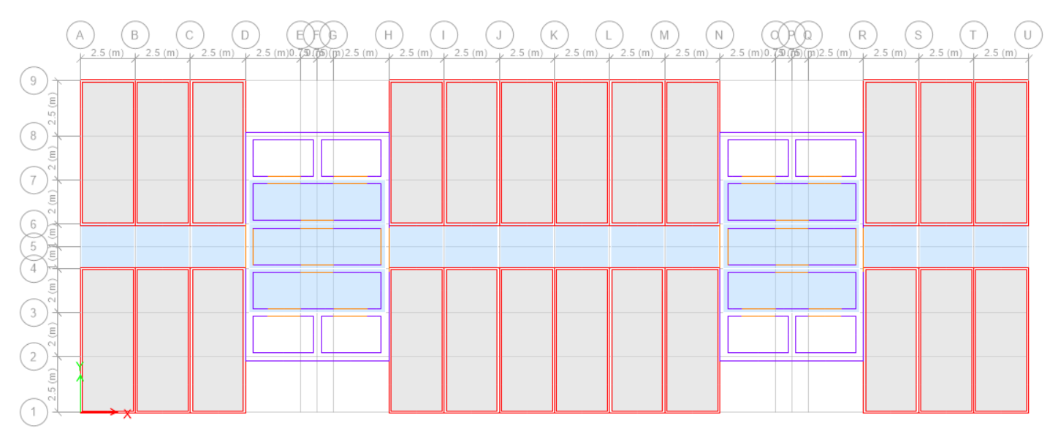
(a) Floor plan
Floor slab
Module wall
Corridor slab
Core wall
Ceiling slab
Coupling beam
Module
(b) 3D view of each story
Fig. 1. Modular design scheme of the case building

2.2. Horizontal and vertical connection types
Connections are critical for modular buildings to ensure structural integrity. In some concrete modular buildings, a thick cast-in-situ concrete layer is adopted for the entire story area on the modules to form continuous rigid diaphragms [37]. However, this horizontal connection type is time-consuming, labor-intensive and uneconomical. In this study, a distributed horizontal connection type composed of embedded bars in ceiling slabs of adjacent modules, cast-in-situ lapped bars and grout is proposed (Fig. 2). Compared with the horizontal connection type using cast-in-situ concrete layer, the proposed horizontal connection type can be more economically attractive for private buildings due to less in-situ works and less cost. According to the connected objects, the horizontal connections are divided into S-S connections between corridor slabs, M-M connections between modules' ceiling slabs, and M-C connections between modules' ceiling slabs and core walls, as shown in Fig. 2. The vertical connection type adopts novel noncontact lap-spliced bars (Fig. 3) based on grouted corrugated duct connection technology, which only requires grouting from the top to the bottom of the grout ducts after protruding bars are inserted into the ducts. The novel vertical connection can reduce the requirement and amount for lateral grouting of module walls which are often impacted by the mutual influence of adjacent modules, with the potential of enhancing construction efficiency.
M-M connection
M-C connection
Protruding bar
Cast-in-situ grout
Cast-in-situ lapped bar
Embedded bar
S-S connection
Core wall
Module
Fig. 2. Proposed horizontal connection types of the case building
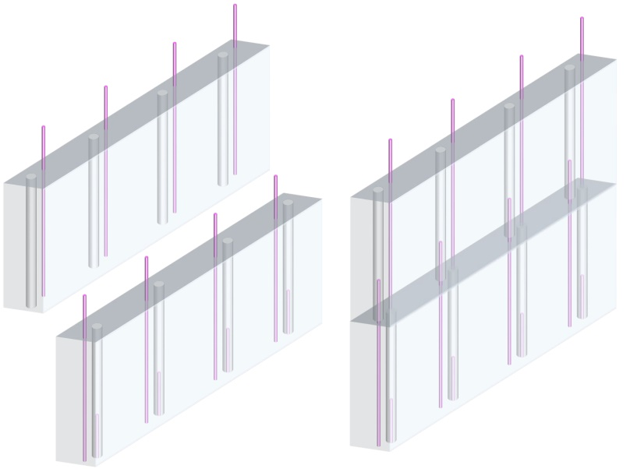
Grouted duct
Module wall
Protruding bar
Fig. 3. Proposed vertical connection type of the case building

2.3. A simplified spring model for the proposed horizontal connections
Fig. 4 presents typical diaphragm behaviors of adjacent modules under lateral loads. The deformation of modules is not considered due to the much larger stiffness of the six-sided modules as a whole compared with the horizontal connection area. The lateral loads perpendicular to the axis of horizontal connections can induce the axial and shear deformations of horizontal connections, while the lateral loads along the axis of horizontal connections can lead to only the axial deformation of the horizontal connections [32]. When the adjacent modules are subject to lateral loads, the axial and shear in-plane behaviors of horizontal connections are dominant, and the out-of-plane behavior of horizontal connections are inapparent [32, 38]. Thus, in this study, only the in-plane behaviors of horizontal connections are considered. According to general structural design concept, connections are more critical than structural components and should remain elastic for buildings under lateral loads. Thus, a simplified spring model considering in-plane axial and shear stiffnesses is adopted to define the mechanical behavior of the horizontal connections. Notably, when relevant experimental tests are conducted on the horizontal connections between diaphragms, the spring model can be re-defined using the actual force-deformation relationships for the horizontal connections in the numerical model of concrete modular high-rises. Thus, the spring model in this study is expandable and useful for future research.
Connection shear  Connection axial | Connection axial
(a) Lateral loads perpendicular to the axis of the connections | (b) Lateral loads along the axis of the connections
Fig. 4. Typical diaphragm behaviors of adjacent modules under lateral loads
As the influence of the number and location of horizontal connections on the structural responses of the case building under wind loads is beyond the scope of this study, the distribution of horizontal connections is therefore unvaried (Fig. 5). All the horizontal connections of the same type have identical axial and shear stiffnesses to simplify and reduce the module type, which contribute to keeping the advantages of modular construction.
M-M connection
S-S connection
M-C connection
Fig. 5. Plane distribution of horizontal connections with in-plane axial and shear stiffnesses

3. Modeling structural responses of the case building under wind loads

3.1. FE model of the case building with discrete diaphragms
In order to focus on the influence of horizontal connections on global lateral behavior of the case building under wind loads, the FE model adopts some simplifications as below. First, a continuous rigid diaphragm at each story is not required. At the same level, the ceiling and corridor slabs within a module form an integrated diaphragm [32], as well as the core slabs within each core form an integrated diaphragm (Fig. 6) [24]. Each of these diaphragms is rigid in its own range with an independent center of rigidity, while they are discrete in each story with horizontal connections between them. Second, the adverse effects of vertical connections on lateral stiffness of module walls are not considered [39]. The precast module walls are deemed to have the same lateral behavior as the monolithic counterparts. The influence of vertical inter-module connections on the lateral behavior of module walls will be carefully considered after relevant experimental studies are conducted. Third, the effects of the opening of module walls are not considered [7].
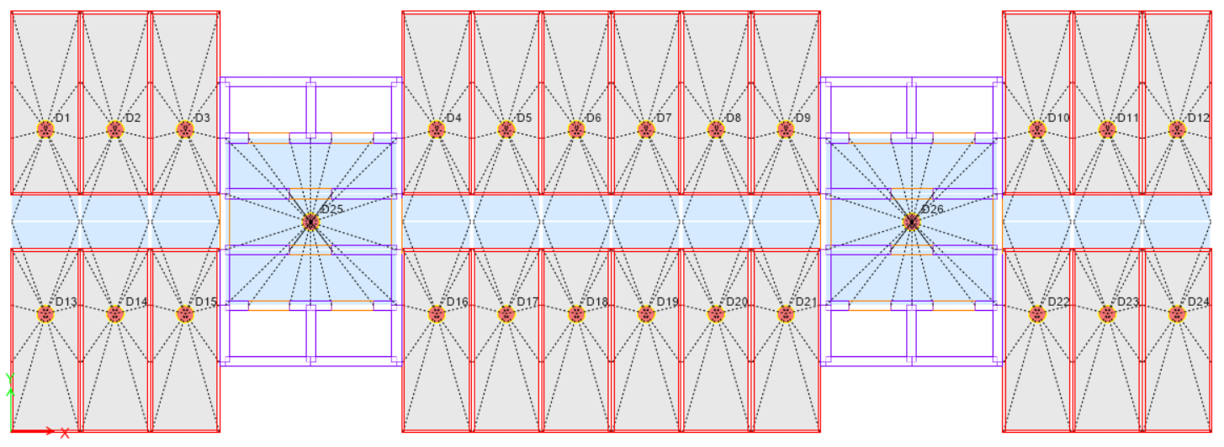
Center of rigidity of discrete diaphragm
Discrete diaphragm
Fig. 6. Discrete diaphragms of the FE model at each story
Based on the simplifications, a FE model was established using ETABS software for the case building with discrete diaphragms considering the influence of horizontal connections. The shell elements were used to model module and core walls, as well as ceiling and corridor slabs within modules and core slabs (Fig. 7). Spring elements with the defined axial and shear stiffnesses were adopted to model horizontal connections including S-S connection, M-M connection, and M-C connection (Fig. 7). At each story, the ceiling and corridor slabs within a module were assigned with a rigid diaphragm, and the core slabs within each core were set identically. Twenty-six discrete diaphragms existed at each story for the FE model (Fig. 6). Notably, the adjacent module or core walls had no connections except for the horizontal connections at the same level.
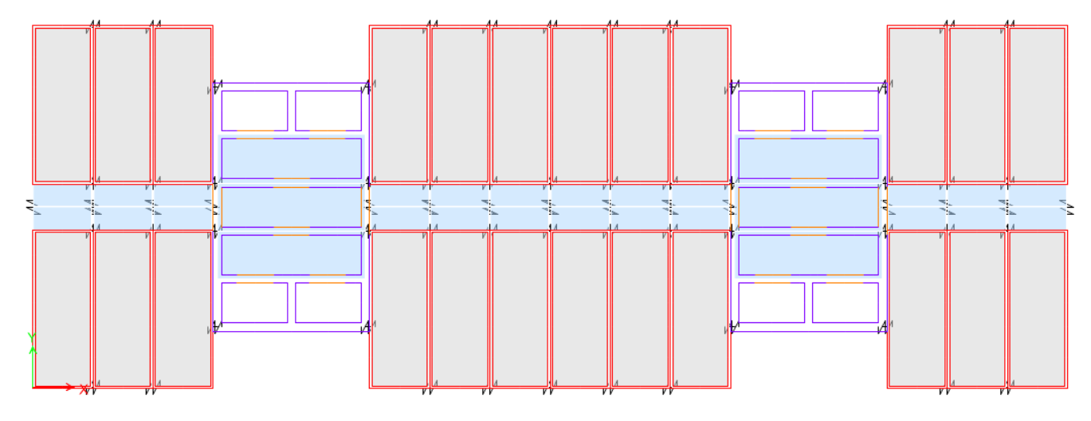  Spring element  Shell element  Shell element | 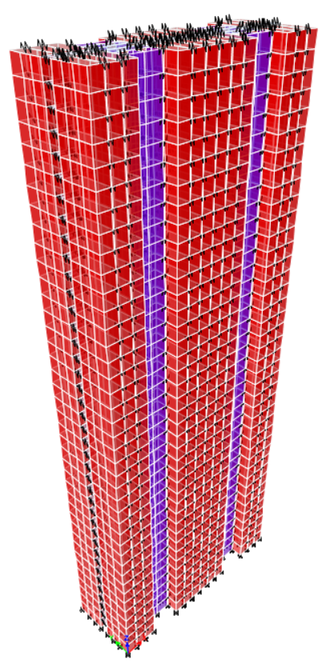  Y  Z  X
(a) Plan view | (b) 3D view
Fig. 7. FE model of the case building with discrete diaphragms

3.2. Calculation of the specified wind loads in HK code
The new HK wind load code [40] provides a new calculation method of wind loads for buildings. Instead of two wind load components along the main axes of buildings, three wind load combinations are proposed for verifying the structural safety of buildings under wind loads, containing three components called two horizontal forces F_{x} and F_{y} along the main axes (X and Y axes shown in Fig. 8) and a torsional moment T_{z} around the vertical axis (Z axis shown in Fig. 8). Three combinations, i.e., WindComb1, WindComb2, and WindComb3 select F_{x}, F_{y}, and T_{z} as the main component with the combination factor of ±1.00, with the rest as the secondary components using the combination factor of ±0.55, respectively. The case building has good plan symmetry, thus only positive values are adopted for the combined factors in this study. Due to the calculation of F_{x}, F_{y}, and T_{z} dependent on the structural characteristics of buildings, the wind loads are calculated for a specified case with determined structural parameters.
For the FE model with discrete diaphragms, the wind loads along the building height cannot be directly assigned to the center of rigidity of each story [7]. In this study, the wind loads at each story are equivalent to uniform area loads on the external walls at the corresponding story [24]. The detailed methods of assigning F_{x}, F_{y}, T_{z}, on the case building are presented in Fig. 8 for the FE model, by which the total wind loads on each story are the same as that for applying on the center of rigidity. To be equivalent to T_{z} at each story, two uniform area loads with the same value and opposite directions are applied on the external walls at the two ends of the building. The same value is obtained when T_{z} is divided by the distance between the centers of the two uniform area loads.
(a) Horizontal force F_{x} along X axis
(b) Horizontal force F_{y} along Y axis
(c) Torsional moment T_{z} around Z axis
Fig. 8. Wind load assignment on the outer walls of the FE model with discrete diaphragms

4. Influence of horizontal connections
A parametric study is conducted to investigate the influence of horizontal connections on the lateral behavior of the case building under wind loads, using the FE model of the case building with discrete diaphragms. The studied parameters include the horizontal connection types and properties such as axial and shear stiffnesses. The selected benchmark case (BM) represents the case building with continuous rigid diaphragms, in which all the horizontal connections are set with very huge axial and shear stiffnesses in the FE model [32]. For comparison, all the cases in this section select the same design wind loads including F_{x}, F_{y}, and T_{z} as case BM (Fig. 9).
(a) Horizontal force F_{x} along X axis | (b) Horizontal force F_{y} along Y axis | (c) Torsional moment T_{z} around Z axis
Fig. 9. Design wind loads of case BM
Compared with continuous rigid diaphragms, discrete diaphragms can lead to a larger deflection of buildings under wind loads due to the flexibility of horizontal connections (Fig. 10). For high-rise buildings in HK, the structural design scheme of the lateral force-resisting system is controlled by the deflection of buildings under wind loads, which indicates that more flexibility of horizontal connections may lead to a larger number or bigger dimensions of lateral force-resisting components such as module and core walls. For buildings with discrete diaphragms composed of rigid slabs and horizontal connections (Fig. 10), an amplified factor α of deflection is used to measure the diaphragm flexibility as [32]
(1)
where Δ_{inc} is the increased lateral diaphragm displacement of buildings due to the effects of discrete diaphragms, Δ_{con} and Δ_{dis} are the lateral diaphragm displacement of building with continuous rigid diaphragms and discrete diaphragms under lateral loads, respectively.
Lateral force resisting system
Plan view for undeformed status
3D view for undeformed status
Lateral force-resisting system
Lateral force-resisting system
Plan view for deformed status with continuous rigid diaphragm
Plan view for deformed status with discrete diaphragm
3D view for deformed status with discrete diaphragm
3D view for deformed status with continuous rigid diaphragm
Lateral load
Rigid slab
Flexural horizontal connection
Δ_{inc}
Δ_{dis}
Lateral load
Rigid slab
Rigid horizontal connection
Lateral load
Horizontal connection
Rigid slab
Δ_{con}
Fig. 10. Definition of α for buildings with discrete diaphragms composed of rigid slabs and horizontal connections
According to some codes [41-43], α ≤ 0.5 is to define rigid diaphragm, 0.5 < α ≤ 2.0 is to define stiff diaphragm, and α > 2.0 is to define flexible diaphragm, for buildings under lateral loads. However, the proposals concerning α seem to be not suitable for high-rises. For example, although α = 0.5 means rigid diaphragm, it also indicates that the discrete diaphragms can increase the lateral diaphragm displacement by 50%, which is prone to fail the original lateral force-resisting system scheme of the high-rises with continuous rigid diaphragms. A stricter classification standard of diaphragm behavior should be proposed for high-rises based on α_{top}, which is the amplified factor α of deflection at the top of buildings under lateral loads. For example, α_{top} ≤ 0.1 is to define rigid diaphragms of high-rises, 0.1 < α_{top} ≤ 0.5 is to define stiff diaphragms of high-rises, and α_{top} > 0.5 is to define flexible diaphragms of high-rises. More specific studies are needed to determine general recommendations for the ranges and limits of α_{top} in other cases with different layouts and dimensions of the building plan. However, as the case building in this study represents a common type of building design in HK, the results presented in this study should offer a useful reference to other buildings with similar designs. In this section, the influence of horizontal connections on the lateral behavior of the case building is measured by α_{top} as well as natural periods that can most represent structural characteristics of buildings.

4.1. Corridor slab-corridor slab connections (S-S connections)
To focus on the influence of S-S connections, a large value of 1.0e12 kN/m is given for the axial stiffness k_{a,m-m} and shear stiffness k_{sh,m-m} of M-M connections as well as the axial stiffness k_{a,m-c} and shear stiffness k_{sh,m-c} of M-C connections, which can eliminate the influence of the two connection types [32]. Compared with case BM, case S-S 0-0, which indicates the case without the axial stiffness k_{a,s-s} and shear stiffness k_{sh,s-s} of S-S connections, has the basically same drift ratios under wind load combinations (Fig. 11) and the close first four natural periods (Fig. 12). The results indicate that S-S connections can be canceled when M-M connections and M-C connections have sufficient axial and shear stiffnesses. The reason is that the limited lateral force is transmitted through S-S connections, which are distributed along the long module walls with strong lateral force resistance. Thus, the case building is proposed to set without S-S connections for further improving modular construction efficiency.
(a) WindComb1 | (b) WindComb2 | (c) WindComb3
Fig. 11. Comparison of drift ratios at each story between case BM and case S-S 0-0

Fig. 12. Comparison of the first four natural periods between case BM and case S-S 0-0

4.2. Module slab-module slab connections (M-M connections)
With k_{a,s-s} = 0, k_{sh,s-s} = 0, k_{a,m-c} = 1.0e12 kN/m, k_{sh,m-c} = 1.0e12 kN/m, a series of cases with different pairs (k_{a,m-m}, k_{sh,m-m}) are adopted to study the effects of M-M connections on the deflection of the case building. Fig. 13 presents the varied α_{top} of the case building with different in-plane axial and shear stiffness combinations of M-M connections within a widespread value range under different wind load combinations, which directly reflects the effects of the M-M connection stiffnesses on α_{top} and provides a basis for determining a feasible value range for (k_{a,m-m}, k_{sh,m-m}) when a target value of α_{top} is suggested. Under different wind load combinations, the same conclusion is found that the increased k_{a,m-m} and k_{sh,m-m} can decrease α_{top} from over 20 to close to zero. Also k_{a,m-m} has a stronger effect on α_{top} (Fig. 13). The reason is that more lateral force needs to be transmitted between modules along the axis of M-M connections, which is parallel to the short module walls with weak lateral force resistance.
α_{top}
(a) WindComb1
α_{top}
(b) WindComb2
k_{a,m-m} (kN/m)
(c) WindComb3
Fig. 13. α_{top} varied with k_{a,m-m} and k_{sh,m-m} under wind load combinations
When k_{a,m-m} is fixed, k_{sh,m-m} is changed to calculate the corresponding α_{top} using the FE model of the case building. When a relative error of no more than 1% is found between the calculated α_{top} and the target α_{top}, the corresponding (k_{a,m-m}, k_{sh,m-m}) is deemed to be located in the target constant α_{top} line. Through repeating the above operation, a series of (k_{a,m-m}, k_{sh,m-m}) are determined to be located in the target constant α_{top} line that can be eventually generated. Three constant α_{top} lines are further given concerning (k_{a,m-m}, k_{sh,m-m}) under the critical wind load combination WindComb1 which can lead to the largest deflection of the case building among the three wind load combinations (Fig. 14). When a value of α_{top} is suggested for a concrete high-rise modular building, a feasible value range of the stiffness combination (k_{a,m-m}, k_{sh,m-m}) can be determined according to the constant α_{top} line with α_{top} of the suggested value, which indicates that the constant α_{top} line corresponding to the in-plane axial and shear stiffnesses of M-M connections has the potential to become a useful tool to design the M-M connections for meeting the requirement of the target α_{top}.
The constant α_{top} lines put a higher demand for k_{a,m-m} than k_{sh,m-m}, which agrees with that k_{a,m-m} has a stronger effect on α_{top} as aforementioned. To keep α_{top} no more than 0.1, k_{a,m-m} is required to be more than 10000 kN/m and k_{sh,m-m} is required to be more than 1000 kN/m. According to a test database [44] including over 200 precast concrete diaphragm connections, the axial stiffness is over 100000 kN/m and the shear stiffness is over 10000 kN/m when the concrete diaphragm connections belong to the low deformability category, of which the tensile deformation capacity is no more than 3.8 mm and the shear deformation capacity is no more than 7.6 mm. Therefore, it is feasible to adjust M-M connections to enable the case building with rigid diaphragms when M-C connections are set to be perfectly rigid. Of course, additional tests on the recommended vertical connection type are required to further validate the mechanical performance of M-M connections. The joint effects of M-M and M-C connections will be elaborately studied in the following section.

Fig. 14. Constant α_{top} lines concerning k_{a,m-m} and k_{sh,m-m} under Windcomb1
Fig. 15 presents the first four natural periods varied with increased k_{sh,m-m} and constant α_{top}, and the black dotted lines represent the first four natural periods of case BM. As shown in Fig. 14, for constant α_{top} lines, k_{sh,m-m} has a more widespread distribution range than k_{a,m-m}, and each value of k_{sh,m-m} is corresponding to the only value of k_{a,m-m}. Hence, it is more suitable to select k_{sh,m-m} as x axis of Fig. 15 compared with k_{a,m-m}. With unvaried α_{top} = 2.0, only the 1st natural period can be stable with k_{sh,m-m} and close to that of case BM (Fig. 15a). With unvaried α_{top} = 0.5, the first two natural periods can be stably varied with k_{sh,m-m} and close to those of case BM (Fig. 15b). With unvaried α_{top} = 0.1, the first four natural periods tend to be stable with k_{sh,m-m} and close to those of case BM (Fig. 15c). According to the new HK wind load code [40], the wind loads are calculated dependent on the first two natural periods. Moreover, the deflection of buildings under wind loads is dependent on the lateral stiffnesses along the two main axes, which are closely relative to the first two natural periods. With no S-S connections and perfectly rigid M-C connections, α_{top} of no more than 0.5 may be a good strategy for M-M connections to ensure the case building with discrete diaphragms to have similar structural responses to case BM under the wind loads.
(a) α_{top} = 2.0 | (b) α_{top} = 0.5
(c) α_{top} = 0.1
Fig. 15. The variation of natural periods with increased k_{sh,m-m} and constant α_{top}

4.3. Module slab-core connections (M-C connections)
With k_{a,s-s} = 0, k_{sh,s-s} = 0, k_{a,m-m} = 1.0e12 kN/m, k_{sh,m-m} = 1.0e12 kN/m, a series of cases with different pairs (k_{a,m-c}, k_{sh,m-c}) are adopted to study the effects of M-C connections on the deflection of the case building. Under different wind load combinations, the same conclusion can be drawn that the increased k_{a,m-c} and k_{sh,m-c} can decrease α_{top} from over 8 to close to zero and k_{a,m-c} has a stronger effect on α_{top} (Fig. 16), because more lateral force need to be transmitted from modules to cores along the axis of M-C connections, which is parallel to the short module walls with weak lateral force resistance.
(a) Windcomb1
α_{top}
(b) Windcomb2
(c) Windcomb3
Fig. 16. α_{top} varied with k_{a,m-c} and k_{sh,m-c} under wind load combinations
Three constant α_{top} lines are further given concerning (k_{a,m-c}, k_{sh,m-c}) under WindComb1 (Fig. 17). The constant α_{top} lines put a higher demand for k_{a,m-c} than k_{sh,m-c}, which agrees with that k_{a,m-c} has a stronger effect on α_{top} as aforementioned. To keep α_{top} no more than 0.1, k_{a,m-c} is required to be more than 6000 kN/m and k_{sh,m-c} is required to be more than 1000 kN/m. Compared with M-M connections, smaller axial and shear stiffnesses are required for M-C connections to maintain the same α_{top}, because the external module walls can resist part of the wind loads and less lateral force need to be transmitted from M-C connections. According to the test database of precast concrete diaphragm connections [44], it is feasible to design M-C connections to enable concrete modular high-rises to have rigid diaphragms when M-M connections are set to be perfectly rigid.

Fig. 17. Constant α_{top} lines concerning k_{a,m-c} and k_{sh,m-c} under Windcomb1
Fig. 18 presents the first four natural periods varied with increased k_{sh,m-c} and constant α_{top}, and the black dotted lines represent the first four natural periods of case BM. With unvaried α_{top} = 2.0, only the 1st natural period stably tends to be close to that of case BM (Fig. 18a). With unvaried α_{top} = 0.5, the first two natural periods can be close to those of case BM (Fig. 18b). With unvaried α_{top} = 0.1, the first four natural periods can be stable varied with k_{sh,m-c} and close to those of case BM (Fig. 18c). Similarly, with no S-S connections and perfectly rigid M-M connections, α_{top} of no more than 0.5 may also be a good strategy for M-C connections.
(a) α_{top} = 2.0 | (b) α_{top} = 0.5
(c) α_{top} = 0.1
Fig. 18. The variation of natural periods with k_{sh,m-c} under constant α_{top}

5. Comparison between potential schemes of horizontal connections
Based on the results of parametric study, it is a good strategy to keep α_{top} no more than 0.5 for M-M and M-C connections of the case building, and S-S connections are unnecessary for the case building when M-M connections and M-C connections are sufficient. Four cases are selected to further investigate the combined effects of different horizontal connection types on the structural responses of the case building with discrete diaphragms under the HK code-specified wind loads, through the comparison with case BM. The detailed stiffness values for horizontal connections of the four cases are presented in Table 1, and they are shown by colored dots in α_{top} = 0.5 and α_{top} = 0.1 lines of Fig. 14 as well as α_{top} = 0.5 and α_{top} = 0.1 lines of Fig. 17. For the label of the four cases, the first alphabet represents that M-M connections are stiff or rigid, and the second alphabet represents that M-C connections are stiff or rigid. The four cases have no S-S connections.
Table 1 Stiffness values for horizontal connections of the four cases
 | k_{a,m-m} (kN/m) | k_{sh,m-m} (kN/m) | k_{a,m-c} (kN/m) | k_{sh,m-c} (kN/m)
Case S-S | 3000 | 500 | 1450 | 500
Case S-R | 3000 | 500 | 8500 | 3000
Case R-S | 15000 | 3000 | 1450 | 500
Case R-R | 15000 | 3000 | 8500 | 3000

5.1. Natural periods
As shown in Fig. 19, the four cases with discrete diaphragms have nearly the same 1st and 2nd natural periods to case BM with their relative errors less than 5%. The 3rd and 4th natural periods of the four cases are different from case BM, although increased horizontal connection stiffnesses can narrow the difference. Fig. 20 and Fig. 21 further provide the first four mode shapes for case BM and the four cases, respectively. The four cases have the same first three mode shapes as case BM: the 1st mode shape along X axis, the 2nd mode shape along Y axis, and the 3rd mode shape around Z axis. For the 4th mode shape, the four cases have a hybrid mode shape around Z axis and along Y axis, while case BM has a higher-order mode shape along X axis. Based on the results of the above parametric analysis, the joint work of M-M and M-C connections can further amplify the effects of discrete diaphragms on the structural characteristics such as natural periods and mode shapes of concrete modular high-rises when comparing with the cases that singly adopt M-M or M-C connections.

Fig. 19. Comparison of natural periods between case BM and the four cases with discrete diaphragms
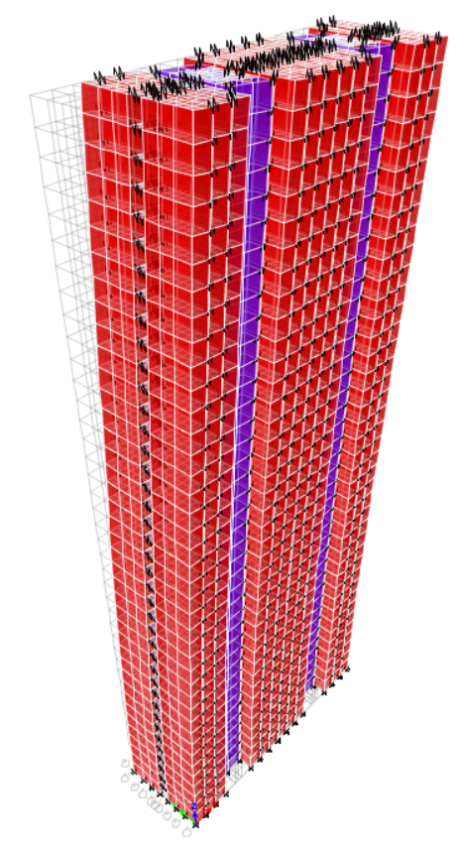 | 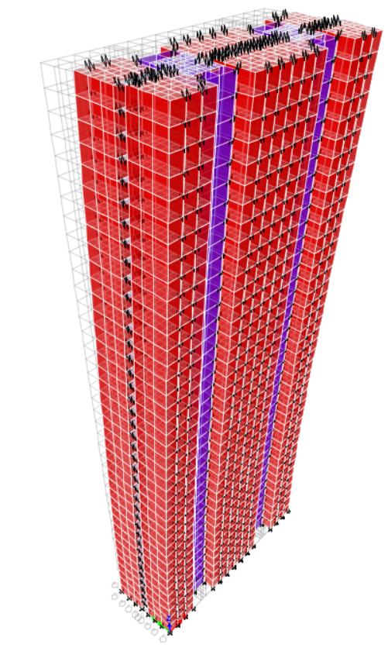 | 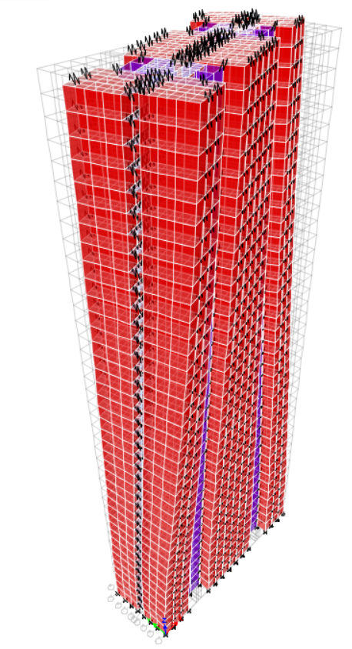 | 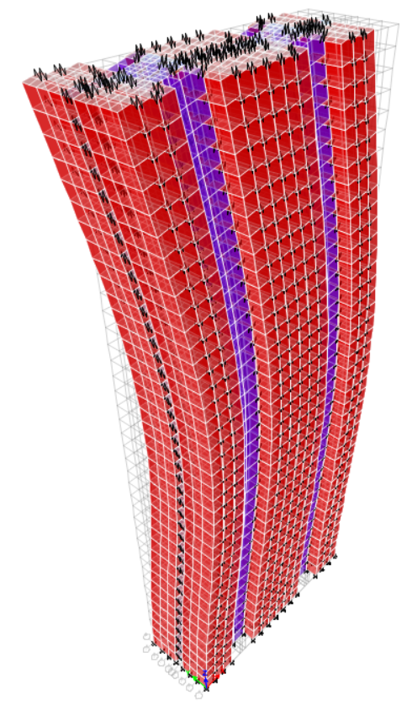
(a) 1st mode along X axis | (b) 2nd mode along Y axis | (c) 3rd mode around Z axis | (d) 4th mode along X axis
Fig. 20. The first four mode shapes of case BM
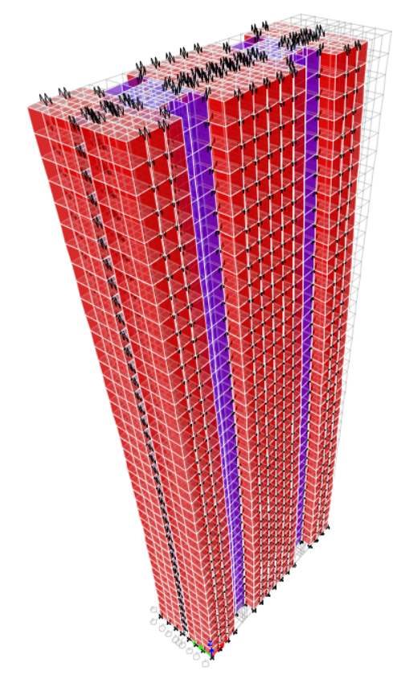 | 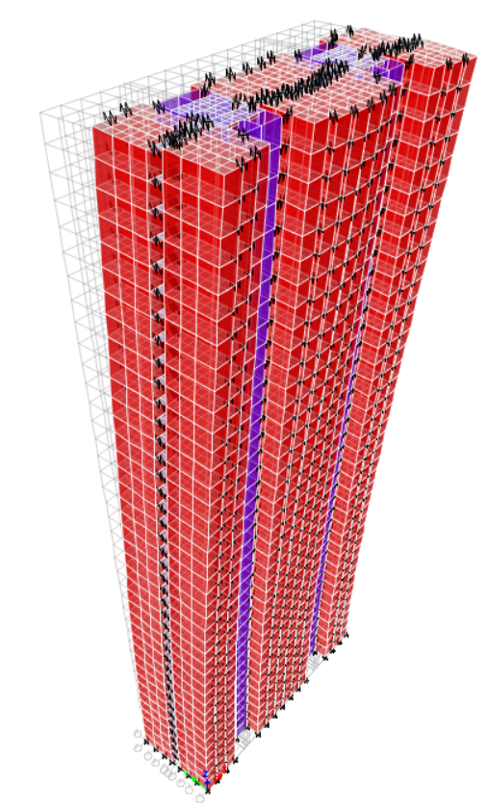 | 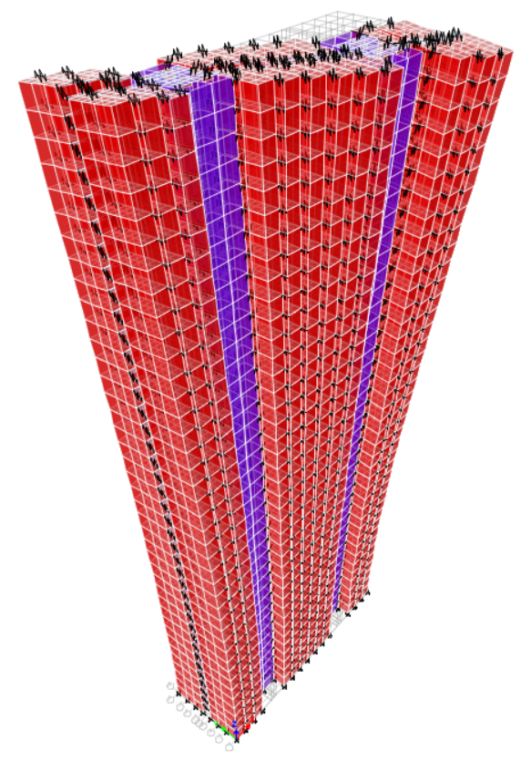 | 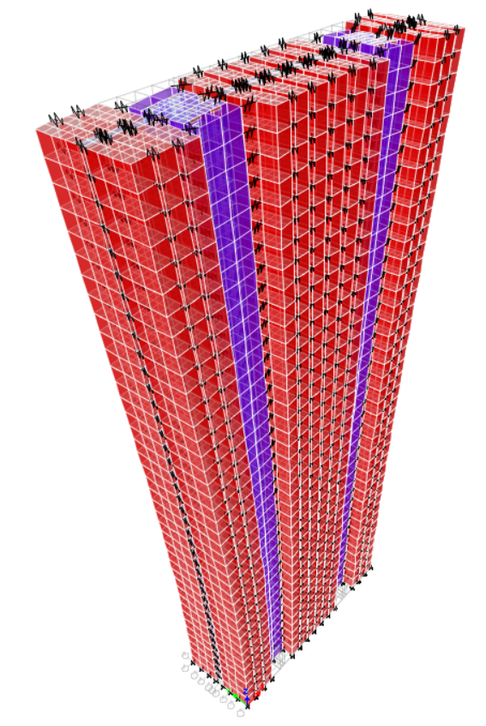
(a) 1st mode along X axis | (b) 2nd mode along Y axis | (c) 3rd mode around Z axis | (d) 4th mode as hybrid mode
Fig. 21. The first four mode shapes of the four cases with discrete diaphragms

5.2. Design wind loads
According to the new HK wind code [40], design wind forces on buildings are determined depending on wind pressure distribution, geometric parameters of building, and fundamental frequency for mode mainly aligned with the along-wind direction. For the cases with different stiffnesses of horizontal connections, they have the same wind pressure distribution and geometric parameters of building. According to the results of natural periods, the first two natural periods are corresponding to the modes along X and Y axes, and they are very close for all the cases. As expected, the design wind loads are basically the same between the four cases and case BM with a relative error of no more than 1.2% (Fig. 22). Therefore, the effects of discrete diaphragms on design wind loads of concrete modular high-rises are negligible even when the horizontal connections are not very rigid.
(a) Horizontal force F_{x} along X axis | (b) Horizontal force F_{y} along Y axis | (c) Torsional moment T_{z} around Z axis
Fig. 22. Design wind loads of the four cases with discrete diaphragms and case BM

5.3. Lateral deformation
Under the basically identical design wind loads, the discrete diaphragms can amplify the deflection of buildings that is positively related to the flexibility of horizontal connections (Fig. 23). Except for case R-R, the other three cases with discrete diaphragms have a deflection of more than 0.2% under the wind loads, which can not meet the requirement of the structural design code of HK [36].
(a) WindComb1 | (b) WindComb2 | (c) WindComb3
Fig. 23. Drift ratios of the cases under wind load combinations
α_{top} is calculated for the four cases under different wind load combinations (Fig. 24). For all the four cases, α_{top} under WindComb1 is smaller than that under the other two wind load combinations because the axial stiffness is larger than the shear stiffness for both M-M and M-C connections. Meanwhile, the joint work of M-M and M-C connections can increase α_{top}, compared with the cases that singly adopt M-M or M-C connections.

Fig. 24. α_{top} of the four cases with discrete diaphragms under wind load combinations
The principle of linear superposition is generally available for elastic structures. High-rises are designed to maintain basically elastic under wind load combinations. For one case from the four cases with discrete diaphragms, when the axial and shear stiffnesses of M-M connections are assigned the same values to that of the case and M-C connections are assigned to be perfect rigidity, an individual contribution of M-M connections to α_{top} can be obtained under one wind load combination. Similarly, an individual contribution of M-C connections to α_{top} can be obtained for the case under the same wind load combination. Under the wind load combination, the prediction value of α_{top} according to the principle of linear superposition is obtained by the sum of the two individual contributions of M-M and M-C connections to α_{top}. The comparison of α_{top} between the actual values and the predicted values according to the principle of linear superposition was conducted for all the four cases under different wind load combinations (Fig. 25). It can be found that all the actual values are very close to but a little larger than the corresponding predicted values. Therefore, the joint effects of M-M and M-C connections on α_{top} can be conservatively deemed to be the linear superposition of the single effects of M-M or M-C connections, which may combine with the constant α_{top} lines that are established separately considering the effects of M-M or M-C connections, to provide a basis for a novel α_{top}-based design method of discrete diaphragms.

Fig. 25. Comparison of α_{top} between the actual and predicted values for the four cases

5.4. Wind vibration
A demand-to-capacity ratio of peak acceleration is defined for a building as [7]
(2)
where A_{acc,top} and A_{cc,lim} are the peak acceleration at the top of buildings and the upper limit of peak acceleration, respectively. They can be determined according to the new HK wind load code [40]. As shown in Fig. 26, all the γ_{d-c,acc}s along X and Y axes are less than 1.0 for the four cases and case BM, under wind loads with the return periods of 1 and 10 years, which means that all the cases can resist wind-induced vibration. A_{cc,top} and A_{cc,lim} are dependent on the natural periods along the main axes of buildings that are the first two natural periods for the case building. Because the first two natural periods between the four cases and case BM are very close, their corresponding demand-to-capacity ratios are nearly the same.

Fig. 26. Demand-to-capacity ratios of peak acceleration for the cases under wind loads

5.5. Distribution of shear force between module and core walls
Fig. 27 presents the distribution of shear force between the module and core walls under wind loads. At higher levels, the varied horizontal connections have no obvious effects on the shear force distribution between module and core walls, while at the bottom levels the stronger horizontal connections can result in more contributions of core walls to resisting the shear force, which indicates that the higher stiffnesses of horizontal connections contribute to more shear force transmission from modules to cores.
(a) Along X axis under WindComb1 | (b) Along Y axis under WindComb2
Fig. 27. Shear forces of module and core walls for the cases
Fig. 28 further shows the detailed information about the contribution of module walls to resisting the shear force at the bottom five stories. For the shear force along X axis under WindComb1, the contribution of module walls is 22.8% ~ 28.3% for case BM while it is 32.1% ~ 35.7% for case S-S, which means that the module walls of case S-S at the bottom five stories bear more shear forces by over 25%. Meanwhile, for the shear force along Y axis under WindComb2, the module walls of case S-S at the bottom five stories bear more shear forces by 5% ~ 8% compared with case BM, which is not significant. It can be concluded that the effects of horizontal connections on the distribution of shear force between module and core walls along the weak axis of buildings are stronger due to more shear forces transmitted from modules to cores.
(a) Along X axis under WindComb1 | (b) Along Y axis under WindComb2
Fig. 28. Contribution of module walls for the cases

5.6. Internal forces of module and core walls
A strength validation is conducted on the module and core walls of the cases under different wind combinations. Fig. 29 presents the most critical module and core walls at each story due to their highest demand-to-capacity ratios of internal forces among the counterparts at the same story. Fig. 30 and Table 2 show the detailed design schemes for the most critical module and core walls, of which all the steel bars have the yield strength of 500 MPa according to the HK concrete code [36]. Based on the designed schemes, the moment and shear capacities are determined for the module and core walls.
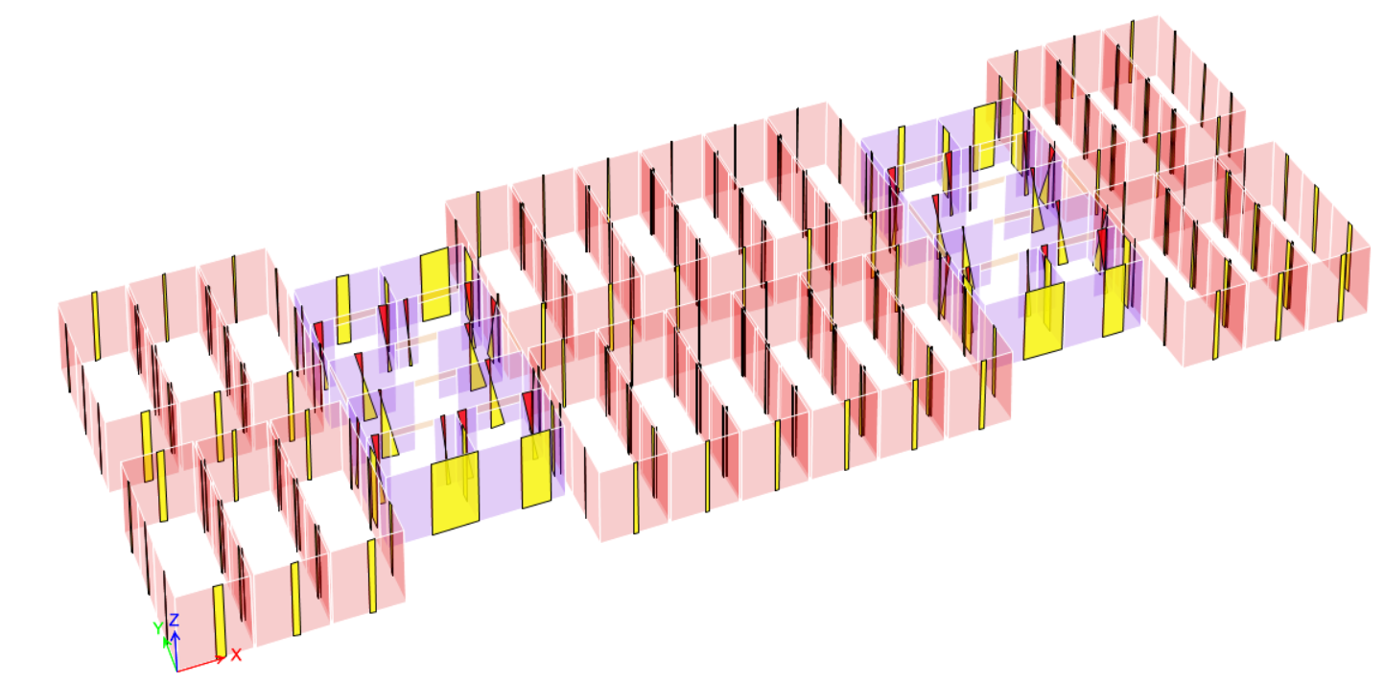
Module wall
Core wall
Fig. 29. The most critical module and core walls at each story
25  100  25  350  2700  100  2700  130  156  130  25  25  250  200×4  248  200×4  156  250  Duct  Main bar  Hoop  Constructional bar  200×10 | 1975  Hoop  Main bar  300×5  200×3  237.5  200×3  237.5  25  25  100  25  637.5  637.5  25
(a) Module wall | (b) Core wall
Fig. 30. Reinforcement layout for the most critical module and core walls at each story
Table 2 Steel bar types of the cases
Module wall |  |  |  | Core wall
Longitudinal bars |  | Transverse bars |  | Longitudinal bars |  | Transverse bars
Bar | Area ratio (%) | Bar | Volume ratio (%) | Bar | Area ratio (%) | Bar | Volume ratio (%)
D16 | 1.13 | D8 | 0.75 | D25 | 1.21 | D12 | 0.84
In this study, the yield moment is regarded as the moment capacity M_{cp} of concrete walls, which is calculated using a fiber section model based on OpenSees software [45]. The fiber section model is established using a zero-length section element which is composed of unconfined concrete fibers, confined concrete fibers, and steel bar fibers. The detailed modeling process can refer to Wang et al. [27]. Fig. 31 presents the axial load-moment capacity curves for the module and core walls. Within the common range of axial load, the simple expressions are given to approximately predict the moment capacities of the module and core walls with the axial load known as
(3)
(4)
where M_{cp,mw} and M_{cp,cw} are the moment capacities of the module and core walls, respectively, in kN∙m; N_{mw} and N_{cw} are the axial loads of the module and core walls, respectively, in kN.
Compressive
(a) Module wall | (b) Core wall
Fig. 31. Axial load-moment capacity curves of the most critical module and core walls
The shear capacity V_{cp} of concrete walls are calculated according to the HK concrete code [36] as
(5)
where v_{c} is the concrete shear contribution and equal to 0.79(100ρ_{l})^{0.33}/1.25; ρ_{l} is the area ratio of longitudinal bars; A_{c} and b are the area and width of a concrete wall, respectively; N, V, and M are the axial load, shear force, and moment of a concrete wall, respectively; f_{yv}, A_{sv}, and s_{v} are the yield strength, area, and spacing of transverse reinforcement, respectively; d is the effective depth of the tension reinforcement.
Both the most critical module and core walls reach the moment and shear force demands under WindComb1. For the module and core walls, the demand-to-capacity ratios of moment and shear force are far less than 1.0 (Fig. 32), which means that the case building with the proposed discrete diaphragm system can meet the strength requirements under the HK code-specified wind loads. The demand-to-capacity ratios of moment and shear force reach the highest values at the bottom story and the former is greater than the latter, which means that the module and core walls tend to have flexural failure at the bottom story. The varied horizontal connections basically have no effects on the demand-to-capacity ratios of moment and shear force for the most critical core walls due to the relative change rate of less than 10%, while they can significantly change the demand-to-capacity ratios of moment and shear force for the most critical module walls. Compared with case BM, case S-S has the increased demand-to-capacity ratios of moment and shear force by 139.5% and 125.8% for the most critical module walls at the bottom, indicating that flexible horizontal connections can largely increase the risk of failure but not change the failure mode of the module walls. Hence, when flexible horizontal connections are adopted, the module walls are required to be more carefully designed to ensure their strength safety under the wind loads.
(a) Moment | (b) Shear force
Fig. 32. Demand-to-capacity ratios of internal forces for the most critical module and core walls

5.7. Internal forces of horizontal connections
The maximum axial force of M-M connections at each story becomes larger at a higher story under each wind load combination (Fig. 33). The axial force demand of M-M connections is obtained at the top of the case building under WindComb1 of which the dominant horizontal force is along the axial direction of M-M connections. The axial force demand of M-M connections is no more than 65 kN, which is easily met for diaphragm connections that have the axial capacity of over 97.4 kN when they belong to the low deformability category [44]. Compared with case BM, more flexural M-M connections of case S-S can decrease the axial force demand of M-M connections by no more than 8%, which indicates that the effects of horizontal connections on the axial force demand of M-M connections are not very obvious.
(a) Windcomb1 | (b) Windcomb2 | (c) Windcomb3
Fig. 33. Maximum axial force of M-M connections at each story under wind load combinations
The maximum shear force of M-M connections at each story also becomes larger with building height under each wind load combination (Fig. 34). The shear force demand of M-M connections is obtained at the top of the case building under WindComb2 of which the dominant horizontal force is perpendicular to the axial direction of M-M connections. The shear force demand of M-M connections is not more than 35 kN, which is easily met for diaphragm connections that have the shear force capacity of over 36.9 kN when they belong to the low deformability category [44]. Compared with case BM, more flexural M-M connections of case S-S can decrease the shear force demand of M-M connections by 31%, which should be appropriately considered to get a more economic design scheme of M-M connections.
(a) Windcomb1 | (b) Windcomb2 | (c) Windcomb3
Fig. 34. Maximum shear force of M-M connections at each story under wind load combinations
Similarly to M-M connections, the axial force demand of M-C connections is obtained at the top of buildings under WindComb1 (Fig. 35). The axial force demand of M-C connections is not more than 65 kN, which is easily met for diaphragm connections that have the axial capacity of over 95 kN when they belong to the low deformability category [44]. Compared with case BM, more flexural M-C connections of case S-S decrease the axial force demand of M-C connections by 12.1%, which indicates that the effects of horizontal connections on the axial force demand of M-C connections may be conservatively neglected.
(a) Windcomb1 | (b) Windcomb2 | (c) Windcomb3
Fig. 35. Maximum axial force of M-C connections at each story under wind load combinations
Similarly to M-M connections, the shear force demand of M-C connections is obtained at the top of buildings under WindComb2 (Fig. 36). The shear force demand of M-C connections is not more than 55 kN, which is still easily met for the majority of diaphragm connections that belong to the low deformability category [44]. Compared with case BM, more flexural M-C connections of case S-S can decrease the shear force demand of M-C connections by no more than 25.3%, which should also be carefully considered to get a more economic design scheme of M-C connections.
(a) Windcomb1 | (b) Windcomb2 | (c) Windcomb3
Fig. 36. Maximum shear force of M-C connections at each story under wind load combinations

6. Conclusions
This paper has developed an innovative discrete diaphragm system for concrete high-rise modular buildings. This system offers higher construction efficiency by using novel distributed horizontal and vertical connection designs over traditional high-rise modular buildings with a cast-in-situ layer on top of each module. A private residential building with typical design in Hong Kong (HK) was selected for the case building, and was re-designed as a 40-story concrete modular building. A three-dimensional finite element (FE) model of the case building with discrete diaphragms was established using the spring model considering in-plane axial and shear behaviors for simulating the horizontal connections. A strict classification standard of diaphragm behavior was proposed for concrete modular high-rises based on the amplified factor α_{top} of deflection at the top of buildings. A series of structural analyses were conducted to examine the influence of different horizontal connection types on the structural responses such as deflection and natural periods of the case building under the wind loads. The main conclusions of this paper are as follows:
- The developed discrete diaphragm system is feasible to provide sufficient stiffness and strength for concrete high-rise modular buildings to resist the HK code-specified wind loads. When the horizontal connections have the stiffness and strength demands similar to common diaphragm connections that can be easily achieved by noncontact lapped bars, the case building with the discrete diaphragm system can satisfy the code-specified requirements on the wind-induced global deflection and peak acceleration, as well as the internal forces in all the module and core walls.
- Discrete diaphragm system can maintain the basically unvaried fundamental natural periods and mode shapes along the two horizontal main axes of concrete modular high-rises. When relatively rigid M-M and M-C connections are used in the case building with discrete diaphragms, the first two natural periods and first three mode shapes are similar, compared with those of the counterpart with continuous rigid diaphragms.
- The influence of horizontal connection types on the lateral behavior of concrete high-rise modular buildings depends on the distribution direction of module walls. When the horizontal connections (i.e. S-S connections) have the axial direction along the strong axis of module walls, they can even be cancelled due to their low influence in the case building. When the horizontal connections (i.e. M-M and M-C connections) have the axial direction along the weak axis of module walls, their axial stiffness influences the whole structural response more significantly than that of their shear stiffness.
- Horizontal connections can affect the shear force distribution between the module and core walls of concrete high-rise modular buildings under the wind loads. At higher levels, more rigid horizontal connections have insignificant effects on the shear force distribution, while at the bottom levels it can result in more shear forces in core walls. Meanwhile, the effects of horizontal connections on the distribution of shear force along the weak axis of the case building are stronger due to more shear forces transmitted from modules to cores.
- More flexible horizontal connections basically have no adverse effects on the strength safety of core walls, but bring a huge risk to the strength safety of module walls under the wind loads. The varied horizontal connections basically have no effects on the demand-to-capacity ratios of moment and shear force for the most critical core walls, while they can significantly increase that for the most critical module walls. When more flexible horizontal connections are adopted, module walls are required to be more carefully designed to ensure their strength safety under the wind loads.
- The internal force demands of horizontal connections under the wind loads can be lowered with more flexible horizontal connections. Compared with the continuous rigid diaphragms, the discrete diaphragms with relatively flexible horizontal connections can decrease the axial load demands by about 10% and the shear force demands by about 30% for M-M and M-C connections of the case building. The decrease of the shear force demands caused by more flexible horizontal connections is suggested to be considered appropriately for a more economic design scheme of horizontal connections.
The findings of this study fill the research gap about the influence of horizontal connections on the structural responses of concrete modular high-rise buildings under wind loads. Notably, the effects of the opening of module walls are not considered in the FE model of the case building. Meanwhile, the influence of the number and location of the horizontal connections on the structural responses of buildings is not investigated in this study. Because the seismic codes in HK have not been officially implemented, this study does not examine the structural safety of the case building with discrete diaphragms under seismic loads. However, it is still necessary to validate the feasibility of the discrete diaphragm system for concrete high-rise modular buildings in seismic zones according to local seismic codes when discrete diaphragms are applied to actual engineering in seismic zones. These areas are recommended for future research.

Declaration of competing interest
The authors declare that they have no known competing financial interests or personal relationships that could have appeared to influence the work reported in this paper.

Acknowledgements
The work presented in this paper was supported by a grant from the Research Impact Fund of the Hong Kong Research Grants Council (Project No. HKU R7027-18). Also acknowledged is support from Sun Hung Kai Properties Ltd regarding high-rise private residential building in Hong Kong.

References
- De La Torre ML, Sause R, Slaughter S, Hendricks RH. Review and analysis of modular construction practices. ATLSS Report no. 94-11. Bethlehem (PA): Lehigh University; 1994.
- Gibb AGF. Off-site fabrication: prefabrication, pre-assembly and modularization. Scotland (UK): Whittles Publishing; 1999.
- Yang Y, Pan M, Pan W, Zhang Z. Sources of uncertainties in offsite logistics of modular construction for high-rise building projects. J Manage Eng 2021; 37(3): 04021011.
- Pan W, Hon CK. Briefing: Modular integrated construction for high-rise buildings. P I Civil Eng-Munic 2020; 173(2): 64-68.
- Smith RE. Prefab architecture: a guide to modular design and construction. Hoboken (NJ): John Wiley & Sons; 2010.
- Lawson M, Ogden R, Goodier C. Design in modular construction. Boca Raton (FL): CRC Press; 2014.
- Wang Z, Pan W, Zhang Y. Parametric study on module wall-core system of concrete modular high-rises considering the influence of vertical inter-module connections, Eng Struct 2021; 241: 112436.
- Ye Z, Giriunas K, Sezen H, Wu G, Feng DC. State-of-the-art review and investigation of structural stability in multi-story modular buildings. J Build Eng 2021; 33: 101844.
- Zheng Z, Zhang Z, Pan W. Virtual prototyping-and transfer learning-enabled module detection for modular integrated construction. Automat Constr 2020; 120: 103387.
- Yang Y, Pan M, Pan W. ‘Co-evolution through interaction’of innovative building technologies: The case of modular integrated construction and robotics. Automat Constr 2019; 107: 102932.
- Pan M, Linner T, Pan W, Cheng H, Bock T. Influencing factors of the future utilisation of construction robots for buildings: A Hong Kong perspective. J Build Eng 2020; 30: 101220.
- Srisangeerthanan S, Hashemi MJ, Rajeev P, Gad E, Fernando S. Review of performance requirements for inter-module connections in multi-story modular buildings. J Build Eng 2020; 28: 101087.
- Thai HT, Ngo T, Uy B. A review on modular construction for high-rise buildings. Structures 2020; 28: 1265-1290.
- Lacey AW, Chen W, Hao H, Bi K. Structural response of modular buildings–an overview. J Build Eng 2018; 16: 45-56.
- Ferdous W, Bai Y, Ngo TD, Manalo A, Mendis P. New advancements, challenges and opportunities of multi-storey modular buildings–A state-of-the-art review. Eng Struct 2019; 183: 883-893.
- Liew JYR, Chua YS, Dai Z. Steel concrete composite systems for modular construction of high-rise buildings. Structures 2019; 21: 135-149.
- Su RKL, Tang TO, Liu KC. Simplified seismic assessment of buildings using non-uniform Timoshenko beam model in low-to-moderate seismicity regions. Eng Struct 2016; 120: 116-132.
- Pan W, Su R, Cai Y, Young B. Engineering modular systems for high-rise buildings: an update. P I Civil Eng-Civ En 2018; 171(4): 148-148.
- Lawson RM, Richards J. Modular design for high-rise buildings. P I Civil Eng-Civ En 2010; 163(3): 151-164.
- Lawson RM, Ogden RG, Bergin R. Application of modular construction in high-rise buildings. J Archit Eng 2012; 18(2): 148-154.
- Park HK, Ock JH. Unit modular in-fill construction method for high-rise buildings. KSCE J Civ Eng 2016; 20(4): 1201-1210.
- Gunawardena T, Ngo T, Mendis P, Alfano J. Innovative flexible structural system using prefabricated modules. J Archit Eng 2016; 22(4): 05016003.
- Shi F, Wang H, Zong L, Ding Y, Su J. Seismic behavior of high-rise modular steel constructions with various module layouts. J Build Eng 2020; 31: 101396.
- Chua Y, Liew JR, Pang S. Modelling of connections and lateral behavior of high-rise modular steel buildings. J Constr Steel Res 2020; 166: 105901.
- Shan S, Pan W. Structural design of high-rise buildings using steel-framed modules: a case study in Hong Kong. Struct Des Tall Spec 2020; 29(15): e1788.
- Wang Z, Pan W, Zhang Z. High-rise modular buildings with innovative precast concrete shear walls as a lateral force resisting system. Structures 2020; 26: 39-53.
- Wang Z, Pan W. A hybrid coupled wall system with replaceable steel coupling beams for high-rise modular buildings. J Build Eng 2020; 31: 101355.
- Sanches R, Tao J, Fathieh A, Mercan O. Investigation of the seismic performance of braced low-, mid-and high-rise modular steel building prototypes. Eng Struct 2021; 234: 111986.
- Lee DG, Kim HS, Chun MH. Efficient seismic analysis of high-rise building structures with the effects of floor slabs. Eng Struct 2002; 24(5): 613-623.
- Pan W, Yang Y, Zhang Z, Luo Z, Chan S. Modularisation for Modernisation: A Strategy Paper Rethinking Hong Kong Construction. Hong Kong: The University of Hong Kong and Development Bureau of HKSAR Government; 2019.
- Lacey AW, Chen W, Hao H, Bi K. Review of bolted inter-module connections in modular steel buildings. J Build Eng 2019; 23: 207-219.
- Srisangeerthanan S, Hashemi MJ, Rajeev P, Gad E, Fernando S. Numerical study on the effects of diaphragm stiffness and strength on the seismic response of multi-story modular buildings. Eng Struct 2018; 163: 25-37.
- Zhang D, Fleischman RB, Schoettler MJ, Restrepo JI, Mielke M. Precast diaphragm response in half-scale shake table test. J Struct Eng 2019; 145(5): 04019024.
- Zhang D, Fleischman RB. Establishment of performance-based seismic design factors for precast concrete floor diaphragms. Earthq Eng Struct D 2016; 45(5): 675-698.
- Road Users' Code. Hong Kong: Transport Department; 2000.
- Code of Practice for Structural Use of Concrete. Hong Kong: Buildings Department; 2013.
- Lee RSM. Modular Integrated Construction Semi-Precast Concrete MiC System. CENRC Technical Seminar, Hong Kong; 2019.
- Wan G, Zhang D, Fleischman RB, Naito CJ. A coupled connector element for nonlinear static pushover analysis of precast concrete diaphragms. Eng Struct 2015; 86: 58-71.
- Xu G, Wang Z, Wu B, Bursi OS, Tan X, Yang Q, Wen L. Seismic performance of precast shear wall with sleeves connection based on experimental and numerical studies. Eng Struct 2017; 150: 346-358.
- Code of Practice on Wind Effects in Hong Kong. Buildings Department, Hong Kong; 2019.
- ASCE/SEI 7-10: Minimum Design Loads for Buildings and Other Structures. Reston: American Society of Civil Engineers; 2010.
- NZS 1170.5: Structural design actions: Part 5: Earthquake actions-New Zealand. Wellington: Standards New Zealand; 2004.
- AS 1170.4: Structural design actions: Part 4: Earthquake actions in Australia. Sydney: Standards Australia; 2007.
- Ren R, Naito CJ. Precast concrete diaphragm connector performance database. J Struct Eng 2013; 139(1): 15-27.
- Mazzoni S, McKenna F, Scott MH, Fenves GL. OpenSees command language manual. Berkeley: Pacific Earthquake Engineering Research (PEER) Center; 2006.

*Corresponding author. E-mail address: zw1990@hku.hk

